# Technical Design Document: SheliaSportsman_ProgrammingExercise2
Name: Shelia Sportsman
Date: February 13, 2026
Program Description: A simple keyword-based tool that analyzes an email message and calculates how likely it is to be spam.
Spam Detection Program
1. Program Overview
The purpose of this application is to analyze an email message and determine the likelihood that it is spam. The program uses a predefined list of 30 common spam-related keywords and phrases. It scans the user’s message, counts occurrences of these keywords, calculates a “spam score,” and then assigns a rating based on that score. Finally, it displays the score, the rating, and a list of the keywords that were found.
This program is written in Python and uses multiple functions to ensure modularity, readability, and maintainability.
2. Program Requirements
- The program must contain at least two functions (this implementation uses four).
- The program must:
  - Allow the user to enter a multi-line email message.
  - Compare the message against 30 spam keywords/phrases.
  - Add one point for each occurrence of each keyword.
  - Calculate a total spam score.
  - Rate the likelihood of spam based on the score.
  - Display the score, rating, and matched keywords.
- The program must include comments explaining why code is written a certain way.
3. Functional Decomposition
The program is divided into four main functions:
3.1 get_keywords()
Purpose:
Returns a list of 30 commonly used spam keywords and phrases.
Reasoning:
Separating the keyword list into its own function makes the program easier to update and keeps the main logic clean.
3.2 calculate_spam_score(message, keywords)
Purpose:
Scans the user’s message and counts how many times each spam keyword appears.
Inputs:
- message — the full email text entered by the user
- keywords — the list returned from get_keywords()
Outputs:
- spam_score — total number of keyword occurrences
- matched_keywords — list of tuples showing which words were found and how many times
Processing Steps:
- Convert the message to lowercase to ensure case-insensitive matching.
- Loop through each keyword and count occurrences using .count().
- Add each count to the total score.
- Store any matched keywords for later display.
3.3 rate_spam(score)
Purpose:
Returns a human-readable rating based on the numeric spam score.
Reasoning:
This function isolates the rating logic, making it easy to adjust thresholds without modifying other parts of the program.
Rating Scale: | Score Range | Rating | |-------------|---------| | 0 | Very unlikely spam | | 1–2 | Unlikely spam | | 3–6 | Possibly spam | | 7–12 | Likely spam | | 13+ | Almost certainly spam |
3.4 main()
Purpose:
Controls the overall flow of the program.
Responsibilities:
- Display the program header.
- Collect multi-line user input until a blank line is entered.
- Call get_keywords() to retrieve the keyword list.
- Call calculate_spam_score() to compute the score and matched words.
- Call rate_spam() to determine the spam likelihood.
- Display the results to the user.
Reasoning:
Using a main() function organizes the program and allows the script to be run cleanly using the if __name__ == "__main__": block.
4. Input and Output Specifications
4.1 Input
- Multi-line email message entered by the user.
- Input ends when the user presses ENTER on a blank line.
4.2 Output
The program displays:
- Spam Score — total number of keyword matches
- Spam Likelihood Rating — based on the score
- List of Matched Keywords — each keyword and how many times it appeared
- If no keywords are found, a message stating so
5. Data Structures
- List of strings for spam keywords
- List of tuples for matched keywords (e.g., ("free", 2))
- String for the user’s full message
- Integer for the spam score
These structures were chosen for simplicity and readability.
6. Error Handling and Assumptions
- The program assumes the user will enter text normally.
- No special characters or formatting are required.
- The program does not attempt to validate email structure; it only scans text.
- Keywords are matched using simple substring searches, not full-word matching.
7. Program Flowchart (Text Version)
START | v Display program header | v Collect multi-line user input | v Call get_keywords() | v Call calculate_spam_score(message, keywords) | v Call rate_spam(score) | v Display score, rating, and matched keywords | v END
8. Conclusion
This program fulfills the assignment requirements by using multiple functions, scanning for 30 spam keywords, calculating a spam score, and rating the likelihood of spam. The modular design makes the program easy to maintain and expand, and the clear output provides meaningful feedback to the user.
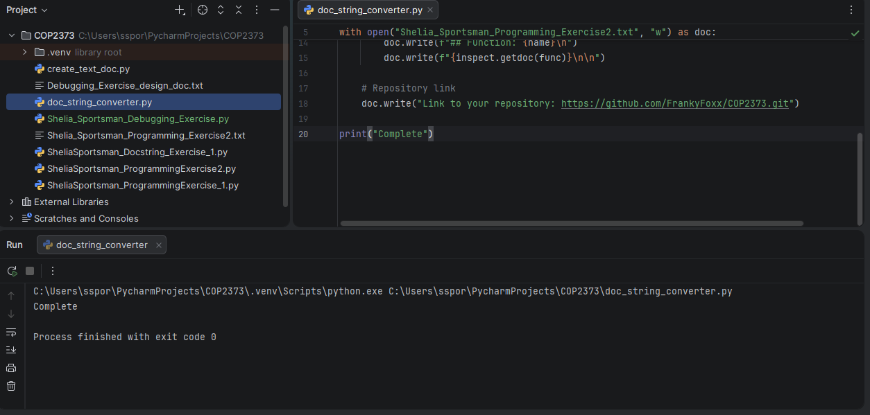
Link to your repository: https://github.com/FrankyFoxx/COP2373.git

