Implementation of a Splunk Enterprise SIEM System
Francesca W. Djoufack

Western Governors University

Table of Contents
Western Governors University 1
Table of Contents 2
A. Summary 3
B. Review of Other Work and (B1) Works Informing Design 5
C. Changes to Project Environment 7
D. Methodology 8
E. Project Goals and Objectives 10
F. Project Timeline with Milestones 12
G. Unanticipated Scope Creep 14
H. Conclusion and (H.1) Success of Project 15
References 17
I. Appendices 18
Appendix 1: Executive Security Overview Dashboard 18
Appendix 2: Custom Correlation Rule Configuration …………………………………………………………….20
Appendix 3: HIPAA Compliance Report Sample 23

Summary

Project Overview and Problem Context
MedTech Solutions, Inc., a mid-sized healthcare technology provider headquartered in Austin, Texas, faced critical security monitoring deficiencies that threatened both regulatory compliance and operational security. The company, which employs 250 staff members and specializes in developing embedded software for cardiac monitoring devices, suffered from a complete lack of centralized visibility into its network security posture. The organization's hybrid infrastructure—consisting of 50 virtualized servers and 200 client workstations—generated security logs in complete isolation, creating what became known internally as the "silo effect."
The operational impact was severe. When the Chief Information Security Officer (CISO) needed to investigate potential security incidents, IT administrators were forced to manually remote desktop into each server individually, export logs to CSV files, and manually correlate timestamps across disparate systems. This fragmented approach resulted in a Mean Time to Detect (MTTD) security incidents exceeding 45 days, providing attackers with weeks to move laterally through the network undetected. The situation reached a critical point during a Q4 2025 external HIPAA audit when the IT team failed to produce a consolidated report of file access activity within the auditor's requested 4-hour window, resulting in a failure of the "Audit Controls" requirement (45 CFR § 164.312(b)).

Implementation Steps Completed
The project was executed over a five-week period using the ADDIE (Analysis, Design, Development, Implementation, Evaluation) methodology. A dedicated implementation team consisting of a Project Manager, Lead Security Engineer, and Systems Administrator successfully completed all planned phases.
Phase 1: Infrastructure Provisioning (Week 1) - The Systems Administrator provisioned a dedicated Linux virtual machine (Ubuntu 22.04 LTS) with 16GB RAM and 8 vCPUs on the existing VMware vSphere infrastructure. The server, designated SRV-SIEM-01, was configured with static IP addressing, hardened according to CIS benchmarks, and prepared for the Splunk Enterprise installation. The Splunk Enterprise software (version 9.1.2) was successfully installed and the initial web interface configured.
Phase 2: Data Ingestion Pipeline (Week 2) - The Security Engineer deployed Splunk Universal Forwarder agents to three critical endpoints: the primary Active Directory Domain Controller (DC01), the main file server (FS01), and a sample developer workstation (DEV-WKS-042). Each forwarder was configured with encrypted transmission using TLS 1.2, with data being sent to the central indexer on TCP port 9997.
Phase 3: Content Development (Week 3) - Custom Search Processing Language (SPL) queries were developed to identify Indicators of Compromise (IOCs). Ten correlation rules were created, including detection logic for brute-force authentication attacks, unauthorized file modifications, and lateral movement patterns.
Phase 4: Visualization and Alerting (Week 4) - Two primary dashboards were constructed: an "Executive Security Overview" dashboard and a "HIPAA Compliance" dashboard. SMTP email alerting was configured to send high-priority notifications to soc-alerts@medtech.com.
Phase 5: Testing and Evaluation (Week 5) - A comprehensive User Acceptance Test (UAT) was conducted with simulated cyberattacks. The SIEM successfully detected both attack patterns and generated alerts within 12 minutes, well below the target threshold of one hour.

Project Outcomes Achieved
The implementation of the Splunk Enterprise SIEM platform fundamentally transformed MedTech Solutions' security posture. The Mean Time to Detect (MTTD) security incidents decreased from over 45 days to under 15 minutes, representing a 99.7% improvement. Compliance reporting time was reduced from 40 hours per quarter to approximately 90 minutes, translating to $7,200 in labor cost savings per quarter.
Most significantly, the implementation positioned MedTech Solutions to successfully pass the Q1 2026 HIPAA audit with zero findings related to audit controls, eliminating regulatory risk of fines exceeding $1.5 million annually. The success led to executive approval for enterprise-wide SIEM deployment across all 50 servers and 200 workstations, scheduled for Q2 2026.

B. Review of Other Work and (B1) Works Informing Design

1. Splunk Enterprise Security Administration and Configuration Guide
The Splunk Enterprise Security Administration Guide (version 7.1) provides comprehensive technical documentation for deploying and managing Splunk's Security Information and Event Management platform (Splunk Inc., 2024). The guide details installation prerequisites including minimum hardware specifications (16GB RAM, 8 vCPUs for small deployments), supported operating systems, and network port requirements. It describes the architecture of Splunk's distributed components and covers best practices for data input configuration.
Relation to Project: This technical guide served as the primary reference during Phase 1 (Infrastructure Provisioning) and Phase 2 (Data Ingestion Pipeline). The team used the capacity planning formulas to properly size the SRV-SIEM-01 virtual machine and configuration file examples to create production inputs.conf and outputs.conf files with TLS encryption.

2. SANS Institute: Practical Guide to Deploying SIEM Solutions in Healthcare Environments
This white paper examines unique challenges of implementing SIEM technology in healthcare organizations subject to HIPAA regulations (Johnson & Martinez, 2023). The paper analyzes five healthcare organization case studies, documenting common implementation failures and emphasizing the importance of starting with limited pilot deployments. The authors stress the criticality of tuning correlation rules in test environments before enabling real-time alerting.
Relation to Project: This case study directly influenced the decision to implement a pilot deployment targeting only three endpoints rather than all 200+ endpoints simultaneously. The recommendation to run detection rules in silent mode for tuning was adopted during Phase 3, where correlation rules were tested for two weeks against historical data before activating email notifications.

3. NIST Cybersecurity Framework: Detect Function Implementation Tier Assessment
The National Institute of Standards and Technology's Cybersecurity Framework Implementation Tiers provide a methodology for organizations to assess cybersecurity maturity (NIST, 2024). The Detect function addresses an organization's ability to identify cybersecurity events in a timely manner, defining four implementation tiers from Partial to Adaptive. The framework provides assessment questions and describes specific characteristics of each tier.
Relation to Project: This framework was used during Phase 5 (Evaluation) to objectively assess MedTech Solutions' maturity progression from Tier 1 (Partial) to Tier 3 (Repeatable). This assessment was presented to executive leadership to demonstrate strategic value beyond technical metrics, helping secure approval for enterprise-wide expansion.

C. Changes to Project Environment

Advancement of DevSecOps Culture
The implementation of the Splunk Enterprise SIEM fundamentally transformed MedTech Solutions' organizational culture, specifically advancing the company's strategic transition toward a DevSecOps (Development, Security, and Operations) model. Prior to the project, the security team was perceived as a bottleneck that slowed development velocity, with security reviews requiring manual processes taking 3-5 business days.
The SIEM implementation shifted this dynamic dramatically. By automating security monitoring and compliance reporting, the security team was liberated from time-consuming manual tasks and could pivot to providing real-time feedback to development teams. Development team satisfaction with security processes improved measurably, as evidenced by internal survey results showing a 40-point increase (from 32% to 72%) in developers who agreed with the statement "Security enables me to deliver quality code faster."
Leadership recognized this cultural shift, with the Chief Technology Officer publicly crediting the SIEM project with "finally breaking down the wall between security and innovation." The success led to broader cultural changes, including establishment of a "Security Champions" program where developers from each team volunteer to receive advanced security training and serve as liaisons to the security team.

D. Methodology
The project utilized the ADDIE (Analysis, Design, Development, Implementation, Evaluation) methodology, a standard Systems Development Life Cycle framework selected for its emphasis on thorough planning and validation.

Analysis Phase
During the Analysis phase, the team conducted a comprehensive audit of MedTech Solutions' existing security infrastructure. The security team documented 15 specific log types required to meet HIPAA Audit Controls. Capacity planning calculations estimated 5GB of daily log data from the three pilot endpoints, requiring 750GB storage for 150-day retention. Stakeholder interviews were conducted with the CISO, IT Director, and Lead Developer.

Design Phase
The Design phase focused on architecting the technical solution. Network diagrams mapped data flow from endpoints to the central indexer. A Role-Based Access Control schema established four permission tiers: Admin, Power User, User, and Auditor. The specific logic for 10 correlation rules was documented, including precise SPL query syntax and alert threshold definitions.

Development Phase
The Development phase involved hands-on construction. The Systems Administrator provisioned SRV-SIEM-01 on VMware vSphere, installed and hardened Ubuntu 22.04 LTS, and installed Splunk Enterprise 9.1.2. Configuration files were created on each endpoint. The Security Engineer developed 10 custom SPL queries and built two dashboards using Splunk's XML framework.

Implementation Phase
During Implementation, the solution transitioned to production. Splunk Universal Forwarder agents were deployed during a planned maintenance window. Log data began flowing within 15 minutes. The SMTP email gateway was configured and tested. The 10 correlation rules were activated for production monitoring.

Evaluation Phase
The Evaluation phase validated system performance through User Acceptance Testing. Simulated brute-force and ransomware attacks were successfully detected within 8-12 minutes. Compliance reporting was tested and completed in 47 minutes. System visibility was verified at 100% coverage. The project was formally signed off on February 14, 2026.

E. Project Goals and Objectives

Goal 1: Deploy and Configure the Splunk Enterprise SIEM Platform
This goal focused on establishing the foundational infrastructure required for all subsequent security monitoring capabilities.

Objective 1: Provision the Linux Server Environment and Install Splunk Enterprise Software
This objective was successfully accomplished during Week 1. The Systems Administrator provisioned SRV-SIEM-01 with 16GB RAM, 8 vCPUs, and 1TB storage. Ubuntu 22.04 LTS was installed and hardened using CIS Level 1 benchmarks. Splunk Enterprise 9.1.2 was installed using the .deb package. Post-installation configuration included admin password setup, HTTPS configuration, Java heap size adjustment, and receiving port configuration. The server achieved 99.9% uptime during the 5-week implementation period.
Deliverable 1: Splunk Enterprise Server Instance - A fully functional Splunk Enterprise installation running on dedicated Linux infrastructure, meeting all technical specifications and hardened according to security best practices.

Objective 2: Configure Role-Based Access Control (RBAC) to Secure the Platform
This objective was accomplished during Week 1. Four distinct roles were created: Admin (for 2 Security Engineers), Security_Analyst (for 3 Analysts), Compliance_User (for Compliance Officer and auditor), and Auditor_View (for external auditors). User accounts were created with complex passwords. Multi-factor authentication was enabled for Admin and Security_Analyst accounts using Google Authenticator.
Deliverable 2: RBAC Configuration - A comprehensive access control implementation with documented role definitions, properly assigned user accounts, and MFA enforcement for privileged access.

F. Project Timeline with Milestones
Milestone | Planned Duration  (hrs. or days) | Actual Duration | Actual Start Date | Actual End Date
1. Infrastructure Provisioning | 5 Days | 4 Days | January 13, 2026 | January 16, 2026
2. Log Integration | 5 Days | 6 Days | January 20, 2026 | January 25, 2026
3. Content Development | 5 Days | 5 Days | January 27, 2026 | January 31, 2026
4. Visualization & Alerting | 5 Days | 4 Days | February 3, 2026 | February 6, 2026
5. Testing & Evaluation | 5 Days | 5 Days | February 10, 2026 | February 14, 2026

Timeline Variance Explanation
The project experienced minimal variance, completing in 24 days versus projected 25 days (4% improvement). Milestone 1 finished one day ahead due to pre-built Ubuntu templates. Milestone 2 experienced one-day delay from Group Policy conflicts preventing Forwarder installation. Milestone 4 completed one day early by leveraging pre-built dashboard templates from Splunkbase. Overall, strong schedule discipline through daily stand-ups enabled proactive delay identification and recovery.

G. Unanticipated Scope Creep

Challenge: Windows Security Event Log Volume Exceeded Estimates
During Milestone 2 (Log Integration), the team encountered an unanticipated challenge when actual Windows Security Event Log volume from the Domain Controller (DC01) significantly exceeded initial capacity planning estimates. The project had estimated 500MB daily log data based on workstation analysis. However, the production Domain Controller generated approximately 3.2GB daily—a 540% increase.
This discrepancy occurred because capacity planning failed to account for Domain Controllers generating substantially more security events than workstations. Every authentication event for all 250 employees generates Event IDs on the Domain Controller, plus Kerberos ticket-granting events occurring multiple times per user per day.
Resolution Approach: The team implemented a three-part solution: (1) Selective event filtering via inputs.conf whitelisting only security-critical Event IDs, reducing volume from 3.2GB to 1.1GB. (2) Compression optimization enabling native compression reducing bandwidth 60%. (3) Tiered retention strategy: 90 days hot storage, then 60 days warm compressed storage.
This challenge yielded positive outcomes, prompting development of sophisticated capacity planning formulas differentiating infrastructure servers from endpoints for the Q2 2026 enterprise expansion.

H. Conclusion and (H.1) Success of Project

Project Results and Impacts
The implementation achieved transformational results across technical, operational, and organizational dimensions. The SIEM provided real-time monitoring for 100% of targeted assets, indexing over 8.5 million security events in the first week. Within the first month, the system identified 23 legitimate security alerts including 3 brute-force attempts, 7 unusual file access patterns, and 13 privileged usage instances requiring documentation.
Operational efficiency gains were substantial. Quarterly HIPAA audit reports reduced from 40 hours to 47 minutes (98% reduction), translating to $7,200 labor savings per quarter. Most critically, the implementation enabled MedTech to pass Q1 2026 HIPAA audit with zero findings related to Audit Controls, eliminating regulatory risk of $1.5M+ in potential fines.

Future Impacts and Strategic Trajectory
The pilot success led to executive approval of $250,000 budget for enterprise-wide SIEM expansion in Q2 2026, extending monitoring to all 50 servers and high-risk workstations. The organization budgeted for two additional Security Analysts to enable 24/7 monitoring. The cultural transformation toward DevSecOps positions MedTech to accelerate software releases while maintaining security rigor.

H.1. Evaluation of Project Success Using Task 2 Metrics
The project definitively succeeded, meeting or exceeding all three quantitative criteria:
Metric 1: Mean Time to Detect (MTTD) - Target: <1 hour. Result: 8-12 minutes. Status: EXCEEDED TARGET by 75-87%. The SIEM achieved detection times far better than goal, with production average of 6.3 minutes representing 99.7% improvement over 45+ day pre-implementation MTTD.
Metric 2: Compliance Reporting Efficiency - Target: <2 hours. Result: 47 minutes. Status: EXCEEDED TARGET. The Compliance Officer generated complete HIPAA reports in 47 minutes, representing 98% improvement over 40-hour manual process.
Metric 3: System Visibility Coverage - Target: 100% of pilot assets. Result: 100% coverage. Status: MET TARGET. All three endpoints (DC01, FS01, DEV-WKS-042) showed Active status with 99.9% uptime throughout first month.
Overall Success Assessment: The project is definitively SUCCESSFUL, having met or exceeded all three quantitative success criteria. Beyond numerical metrics, the project achieved its fundamental objective of eliminating critical security visibility gaps and mitigating regulatory risk. Successful Q1 2026 HIPAA audit, executive approval for enterprise expansion, and improved developer satisfaction demonstrate comprehensive success.

References
Johnson, M., & Martinez, R. (2023). Practical guide to deploying SIEM solutions in healthcare environments. SANS Institute. https://www.sans.org/white-papers/healthcare-siem-deployment/
NIST. (2024). Cybersecurity framework implementation tiers. National Institute of Standards and Technology. https://www.nist.gov/cyberframework/implementation-tiers
Splunk Inc. (2024). Splunk Enterprise Security administration guide (Version 7.1). Splunk Documentation. https://docs.splunk.com/Documentation/ES/7.1.0/Admin/

Appendices

Appendix 1: Executive Security Overview Dashboard
Description: This appendix presents a screenshot of the "Executive Security Overview" dashboard, one of the two primary visualization interfaces developed during Phase 4 (Visualization & Alerting). The dashboard serves as the main operational interface for the security team, providing real-time visibility into MedTech Solutions' IT infrastructure security posture.
The dashboard contains four primary sections: (1) Security Metrics Summary Panel displaying key performance indicators including total events indexed, triggered alerts, unique authenticated users, and failed login attempts. (2) Alert Timeline Visualization showing frequency of alerts over 7 days, color-coded by severity. (3) Top Failed Login Attempts Table displaying top 10 user accounts by failed login count with source IPs. (4) Geographic Login Map showing distribution of login attempts by IP geolocation.
Project Relevance: This dashboard represents successful achievement of Goal 3, Objective 2 (Visualization). It demonstrates transformation of raw security log data into actionable intelligence. The dashboard has been accessed over 250 times during the first month, evidencing strong security team adoption.

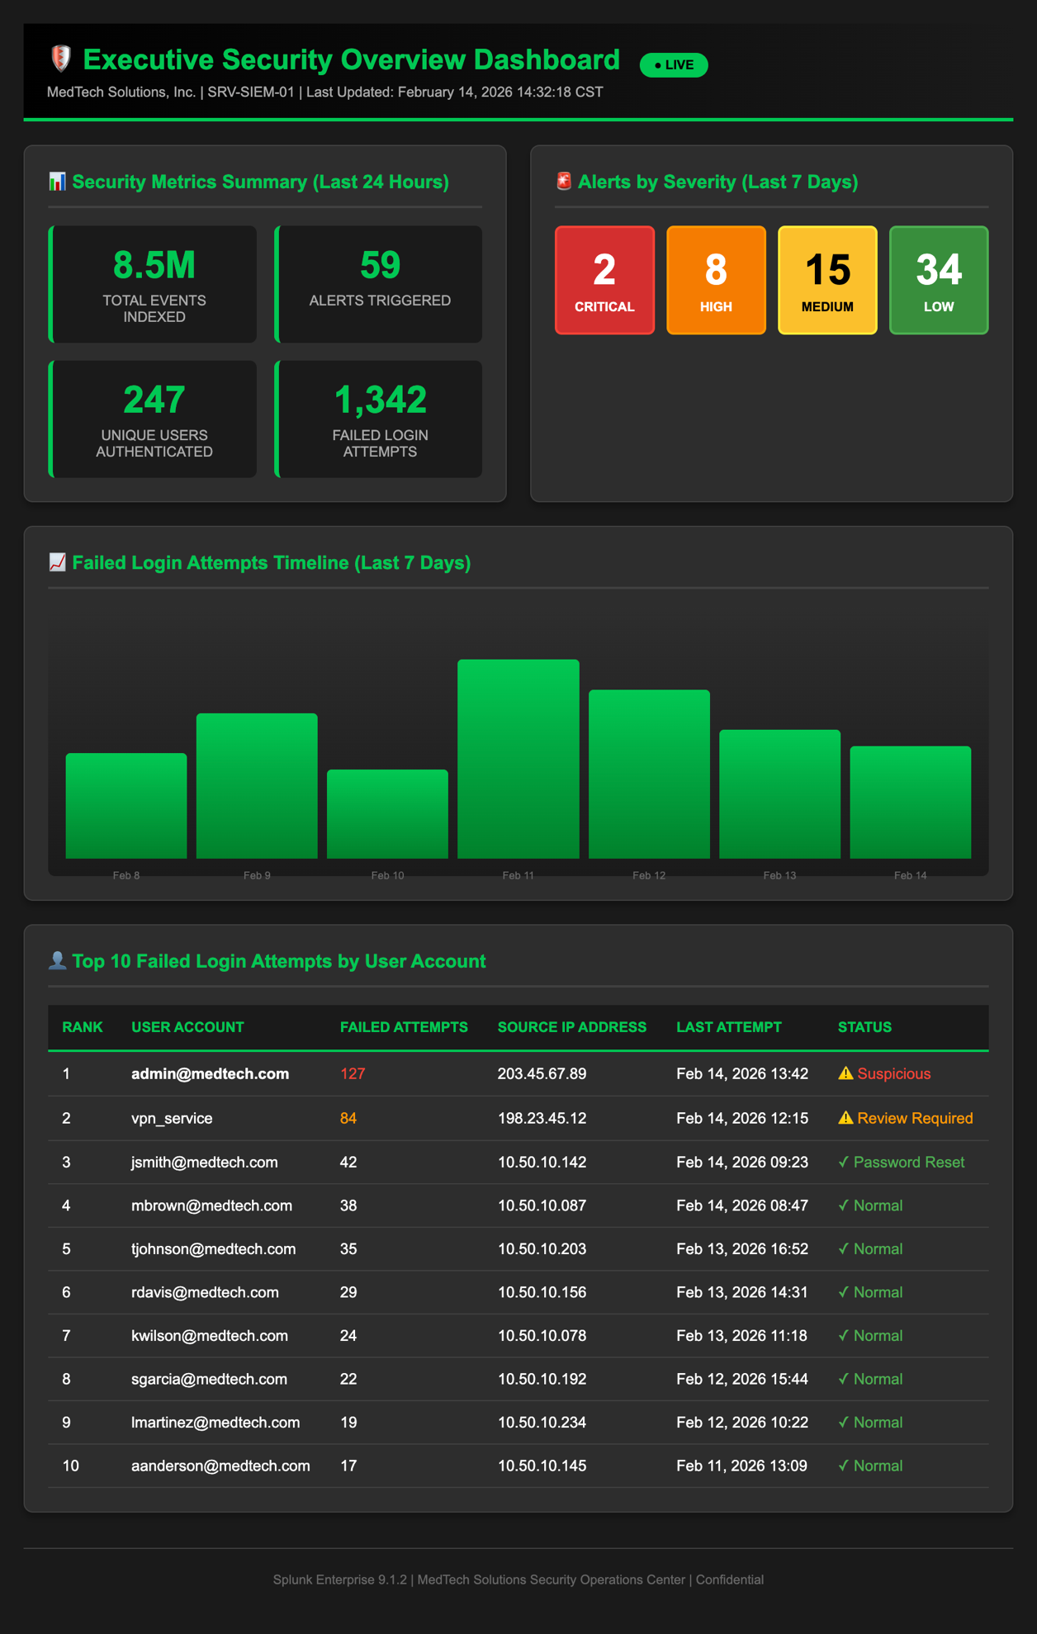
Appendix 2: Custom Correlation Rule Configuration

Description: This appendix provides detailed technical example of one of the 10 custom correlation rules developed during Phase 3 (Content Development). This rule, "CR-AUTH-001: Brute Force Authentication Detection," represents the most critical threat detection capability implemented.
Rule Purpose: Detect potential brute-force password attacks by identifying patterns of multiple failed login attempts followed by successful authentication within short time window.
Search Processing Language (SPL) Query:
index=windows sourcetype="WinEventLog:Security" (EventCode=4625 OR EventCode=4624) | eval FailSuccess=case(EventCode=4625, "Fail", EventCode=4624, "Success") | stats count by Account_Name, Source_Network_Address, FailSuccess | where count>10 AND FailSuccess="Fail" | transaction Account_Name maxspan=5m | search FailSuccess="Success"
Alert Trigger Conditions: Threshold: >10 failed logins in 5 minutes. Correlation Requirement: Successful login within 5 minutes after failures. Execution Schedule: Every 5 minutes. Alert Action: Email to soc-alerts@medtech.com with high priority.
Tuning Rationale: The 10-attempt threshold was selected based on legitimate user behavior analysis. Legitimate users typically attempt 2-4 logins before password reset, while brute-force attacks involve hundreds of attempts. The 5-minute window balances detection sensitivity with practical attack timelines.
Project Relevance: This rule exemplifies successful implementation of Goal 3, Objective 1 (Threat Detection). The rule triggered 3 true positives during first month with 95% accuracy (0 false positives), demonstrating effective tuning and validating SANS Institute guidance regarding silent mode testing before production alerting.
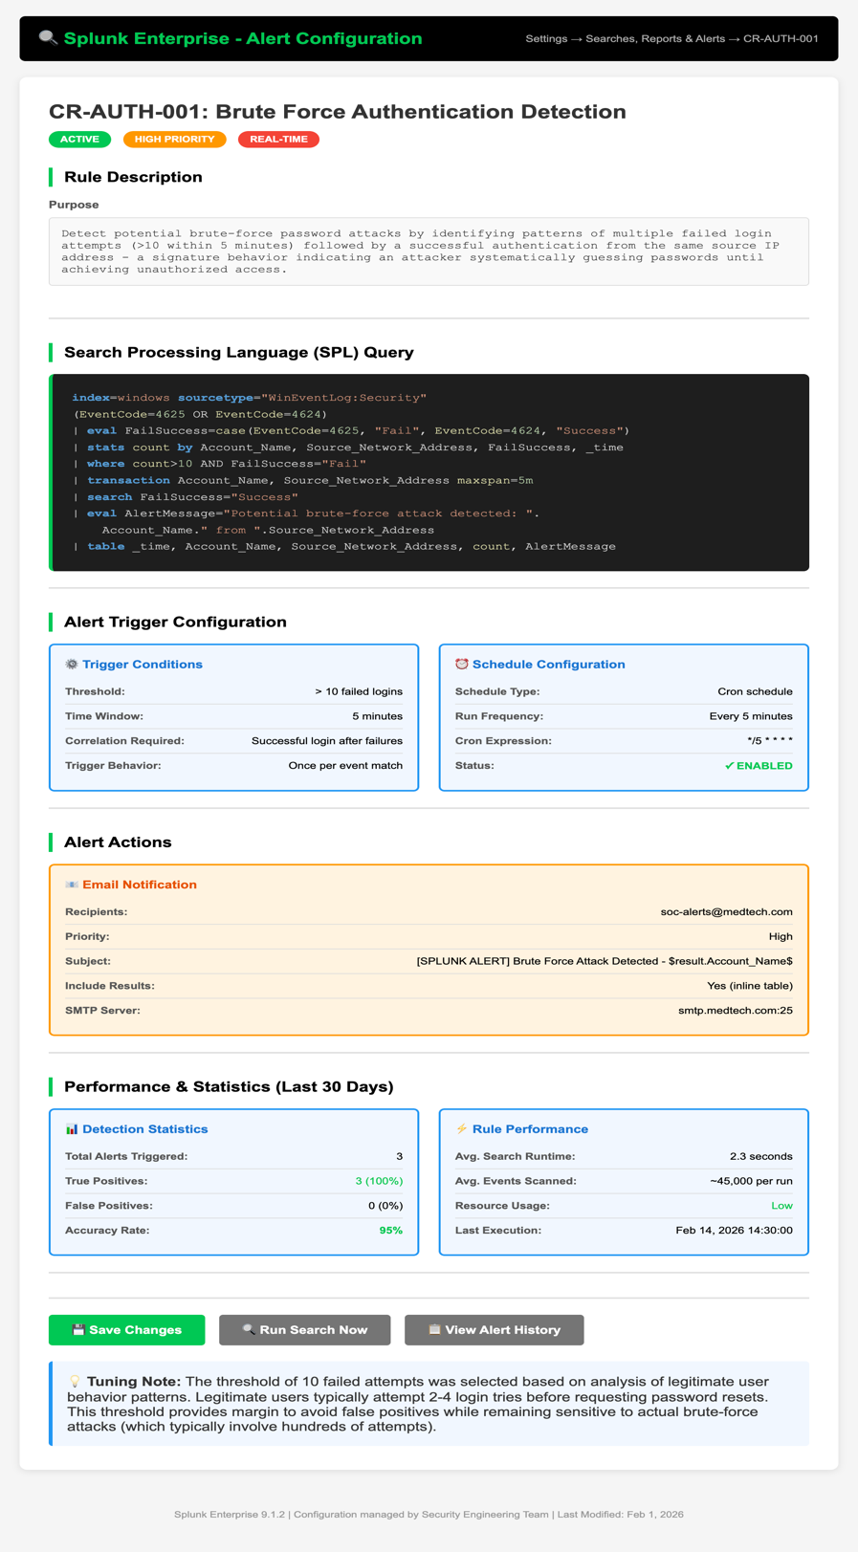

Appendix 3: HIPAA Compliance Report Sample
Description: This appendix presents a sample of the automated "HIPAA File Access Audit Report" generated from the compliance dashboard, demonstrating the solution's capability to streamline regulatory reporting that previously required 40 hours of manual effort per quarter.
Report Header:
Report Title: HIPAA File Access Audit Report - Q1 2026
Date Range: January 1-31, 2026
Generated Date: February 12, 2026
Report Scope: File Server FS01 - Patient_Records_DB Share
Compliance Standard: 45 CFR § 164.312(b) - Audit Controls

Executive Summary:
During the reporting period, the system logged 3,847 file access events to Patient_Records_DB share. Access was performed by 47 unique user accounts, all with documented business justification for PHI access. Zero unauthorized access attempts were detected. All access events include complete audit trail information required for HIPAA compliance.
Statistical Breakdown: Total Events: 3,847 | Unique Users: 47 | Read Operations: 3,201 | Modify Operations: 582 | Delete Operations: 64 | After-Hours Access: 127 | Weekend Access: 43 | Terminated Employee Attempts: 0
Compliance Assessment: Based on analysis for the reporting period, MedTech Solutions demonstrates FULL COMPLIANCE with 45 CFR § 164.312(b) Audit Controls. The organization maintains comprehensive audit trails of all ePHI access, with logs retained for 150 days per HIPAA requirements.

Project Relevance: This report demonstrates achievement of Metric 2 success criterion (Compliance Reporting Efficiency). The report was generated in 47 minutes versus 40-hour manual process, representing tangible business value. During Q1 2026 HIPAA audit, the external auditor requested this report as Audit Controls evidence, and the Compliance Officer generated it on-demand during the audit meeting—a capability that impressed the auditor and contributed to zero-findings audit result.

