Business Analytics

JADS expert program

**Case: Portfolio optimization**

You are given the sample average returns and sample variances of $N=100$ stocks[1]. Balancing the average return and risk, you create the portfolio according to the *mean-variance* portfolio optimization model:

$$Maximize \sum_{i=1}^{N}{\overline{r_{i}}{*x}_{i}}-α\sum_{i=1}^{N}{\sum_{j=1}^{N}{s_{ij}{*x}_{i}*x_{j}}}$$

$$such that:\sum_{i=1}^{N}{x_{i}}=1$$

${ x}_{i}≥0, i=1,…,N,$

here, the decision variable $x_{i}$ is the amount of asset $i$ chosen, $\overline{r_{i}}$ the sample average return of asset $i$, $s_{ij}$ the sample covariance between asset $i$ and asset $j$ for all $i=1,…,N, j=1,…,N$. The parameter $α$ is the so-called *risk-aversion* parameter.

# **Tasks**

1. Implement and solve the mean-variance portfolio optimization model above in Excel using risk-aversion parameter $α=0.012$. The sample means and sample covariances are given in the file “MeanVarPortfolio.xlsx”.
2. Plot the (sample) mean and covariance of the portfolio found in the Figure given in the second sheet of the Excel file.
3. (*\*Bonus extension question*).* In the current model *short-selling* is not allowed: you cannot have negative positions in assets ( ${ x}_{i}≥0$). Change the model formulation to allow for short positions. However, a restriction put forth by the regulators is that the total short position cannot be more than $10\%$ of the total long position.  
     
   (Hint: Introduce two new variables $x_{i}^{long}≥0$ and $x_{i}^{short}≥0$, together with the constraint $x_{i}= x_{i}^{long}-x_{i}^{short}$. You still have introduce a constraint on the total short position to comply with the regulations regarding the total short position $\sum_{i=1}^{N}{x_{i}^{short}}$ and the total long position $\sum_{i=1}^{N}{x_{i}^{long}}$.)

# **Excel tips**

Here we describe how you can calculate the value of the objective term $\sum_{i=1}^{N}{\sum_{j=1}^{N}{s_{ij}{*x}_{i}*x_{j}}}$ in Excel. Suppose there are three assets, $N=3$ (just for simplicity in the explanation below), and that the values of $s_{ij}$ for all $i$ and $j$ equal to the numbers in the red cells in the figure below. The values for $x_{i}$ are given in green.

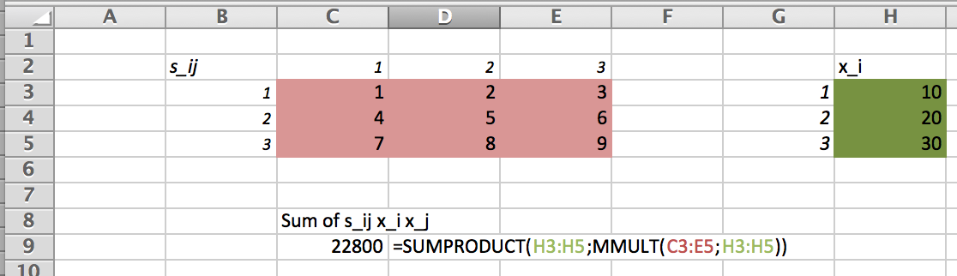

Then the value of $\sum_{i=1}^{N}{\sum_{j=1}^{N}{s_{ij}{*x}_{i}*x_{j}}}$ can be computed by the formula:

=SUMPRODUCT(H3:H5;MMULT(C3:E5;H3:H5)).

(In more technical mathematical terms, this calculates $x^{'}Sx$, where $x$ is a vector and $S$ a matrix.)

1. Original data for this case came from the website of Kennet French (from the famous Fama-French Model): <http://mba.tuck.dartmouth.edu/pages/faculty/ken.french/data_library.html>