# TODO:

* **Read title folders from a specified route**
* **Open titles folders and read episodes files**
* **Open episodes files with mpv**
* **Save episode file position**
* **Mark episodes watched**
* **Mark series watched as completed**
* Print episode metadata (API)
* Print episode thumbnail
* Search title
* GUI

# How-to:

## Read title folders from a specified route

**for file in fs::read_dir("PATH/TO/DIR").unwrap() {**

**println!("{}", file.unwrap().path().display());**

**}**

## Open titles folders and read episodes files

Same as before.

## Open episodes files with mpv

**use** **std::process::Command**;

let output = Command::new("sh")

.arg("-c")

.arg(command)

.output()

.expect("failed to execute process");

## Save episode file position

mpv --write-filename-in-watch-later-config –save-position-on-quit [file_path]

Saved position is in a file located inside “$HOME/.config/mpv/watch_later”, the name is a md5sum of the whole file path.

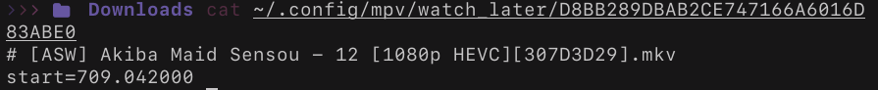If we open the video without “-save-positon-on-quit” the file could be deleted.

Instead of relaying on “-save-positon-on-quit”, we made a lua script “save_info.lua” that saves {duration, current_time, remaining_time} and start the file with “--start=current_time”.

## Mark episodes watched

With the same lua script we calculate a “Status” if the remaining_time is less than 10 seconds then the “Status” is “watched”, saved as boolean for a more easy process.

## Mark series watched as completed

Scan all the episodes metadata for the Status watched. The metadata should be generated for all the episodes, even if they haven’t been opened before.

How to pre-generate the metadata :

mpv --no-video --end=0.1 [file_path]

## Print episode metadata

Search Rust REST and MyAnimeList API

## Print episode thumbnail

ffmpegthumbnailer -i "${FILE_PATH}" -o "${IMAGE_CACHE_PATH}” -s 0 -t 5%

## Search title

Just a filter in the series folder array.

## GUI

https://github.com/iced-rs/iced

# Structure:

series/

|-------- serie_1/

| |-------- .cache/

| | |-------- ep_1-md/

| | | |-------- “serie_1 ep_1.md”

| | | |-------- thumbnail.jpg

| | |-------- ep_2-md/

| | | |-------- …

| |-------- ep_1.mkv

| |-------- ep_2.mkv

| |-------- …

# UI:



