IT342 Phase 2: Mobile Development Completion Report
Project Name: BidWarsOnline
Student Name: Sanchez

1. Submission Requirements
- GitHub Repository: https://github.com/Franz-Raven/IT342-Sanchez-BidWarsOnline
- Final Commit Message: IT342 Phase 2 – Mobile Development Completed
- Commit Hash: 61a45e22e0194061a1b71969e22d95a1b936cbb2

2. Application Screenshots
A. Registration Screen
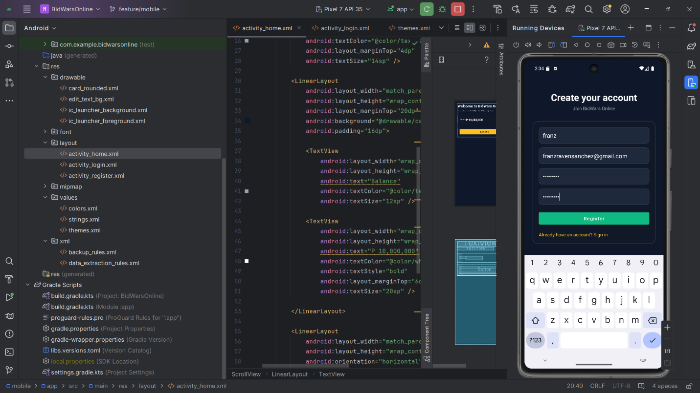
The user interface for creating a new account, featuring fields for Username, Email, and Password.
B. Successful Registration & Login
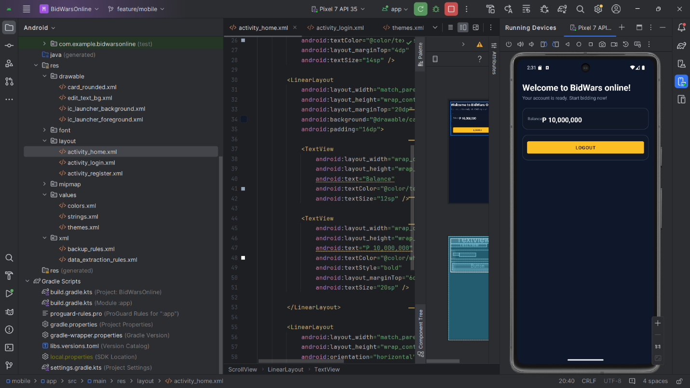Confirmation of the account creation process and successful authentication.
C. Login Screen
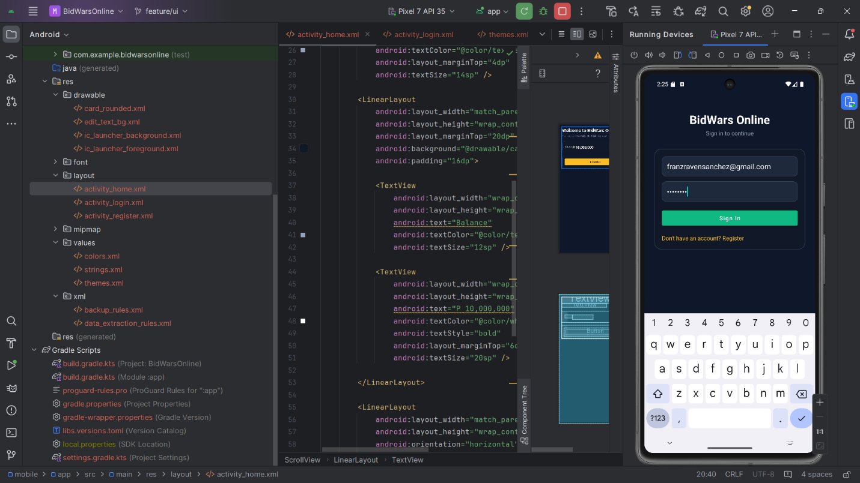The secure sign-in portal for returning users.
D. After Login (Home Dashboard)
 The main application dashboard showing the user's starting balance (₱10,000,000) and logout options.
E. Database Record (Supabase)
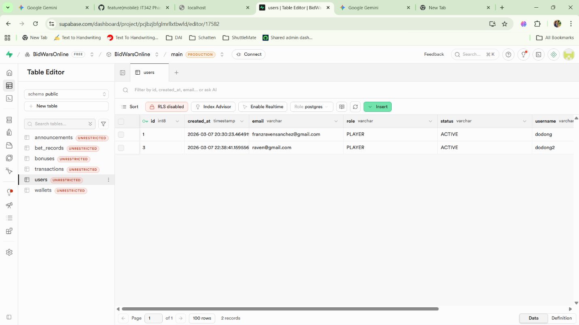The backend table showing the stored user data, including encrypted credentials and timestamps.

3. Project Summary
How Registration Works
The registration process captures the user's username, email, and password via the activity_register.xml layout. Upon clicking the "Register" button, the Android application validates the input fields and sends a POST request to the backend. The system ensures that the email is unique before creating a new entry in the users table. Once the user is successfully created, the app automatically navigates the user to the home screen.
How Login Works
The login system utilizes the activity_login.xml interface. Users provide their registered email and password. The application verifies these credentials against the database records. If the credentials match, a session is established, and the user is granted access to the main dashboard (activity_home.xml). Error handling is in place to alert users of incorrect passwords or non-existent accounts.
API Integration Used
This project utilizes Supabase as the backend-as-a-service (BaaS). The integration involves:
- PostgreSQL Database: Used to store user profiles and auction data.
- RESTful API: Facilitates communication between the Android front-end and the Supabase backend.
- Real-time Capabilities: Configured to allow for immediate updates in the bidding environment (as seen in the Supabase Table Editor configuration).

