IT342 Phase 3: Web Development Completion Report
Project Name: BidWarsOnline
Student Name: Sanchez

1. Submission Requirements
- GitHub Repository: https://github.com/Franz-Raven/IT342-Sanchez-BidWarsOnline
- Final Commit Message: IT342 Phase 3 – Web Development Completed
- Commit Hash: 61a45e22e0194061a1b71969e22d95a1b936cbb2

2. Application Screenshots
A. Plinko Game
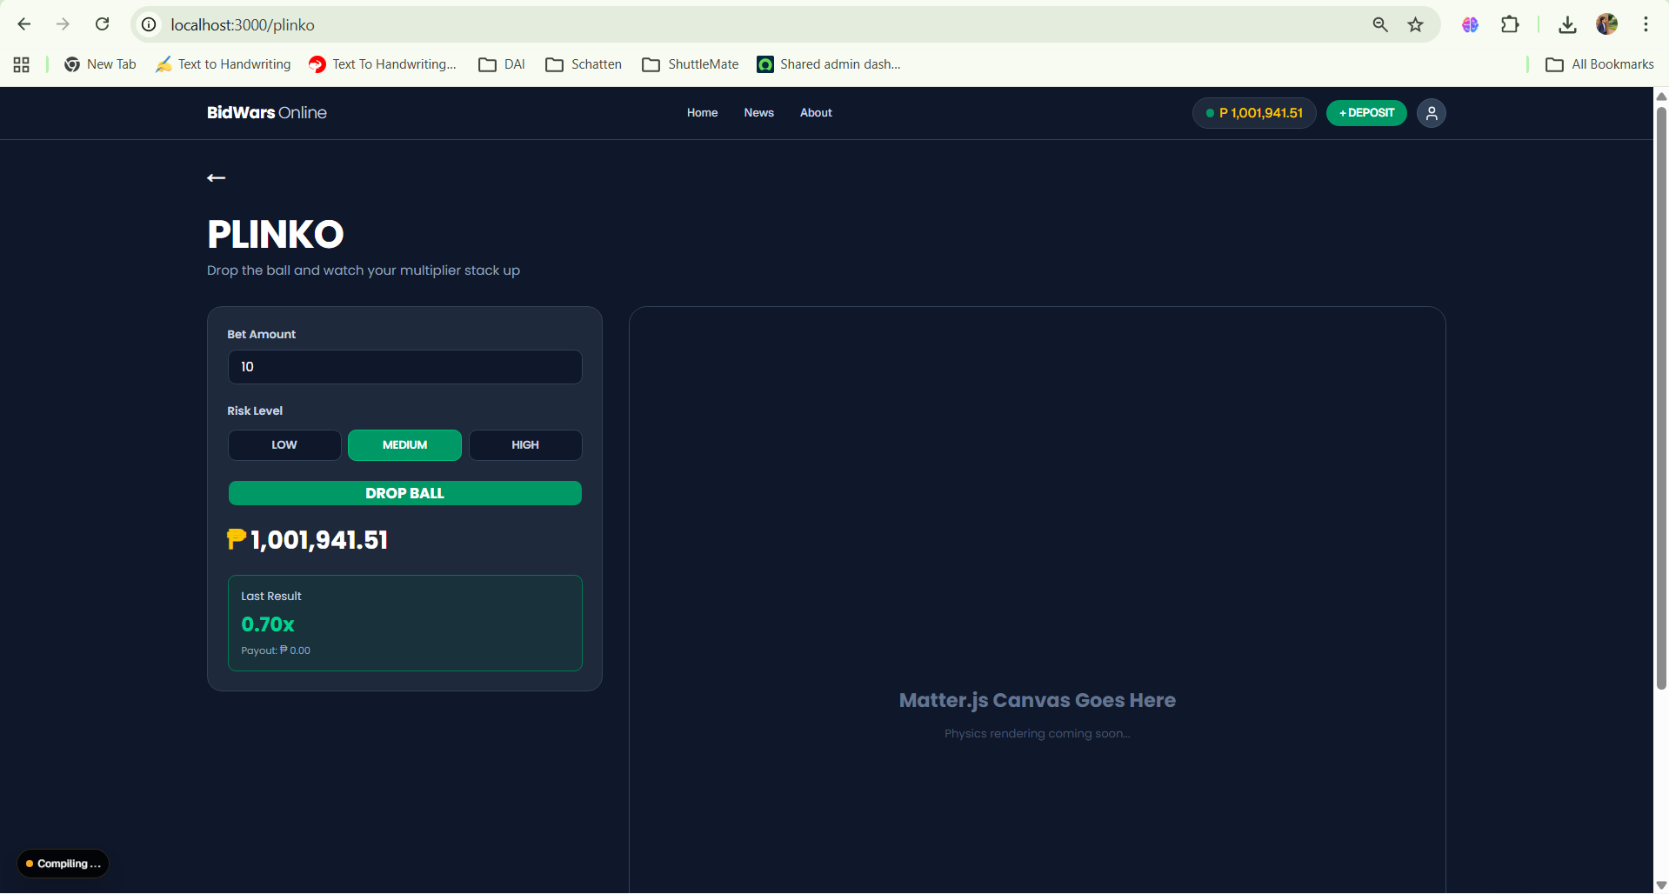
The user interface for playing the plinko game, matter.js UI onhold due to complexity.
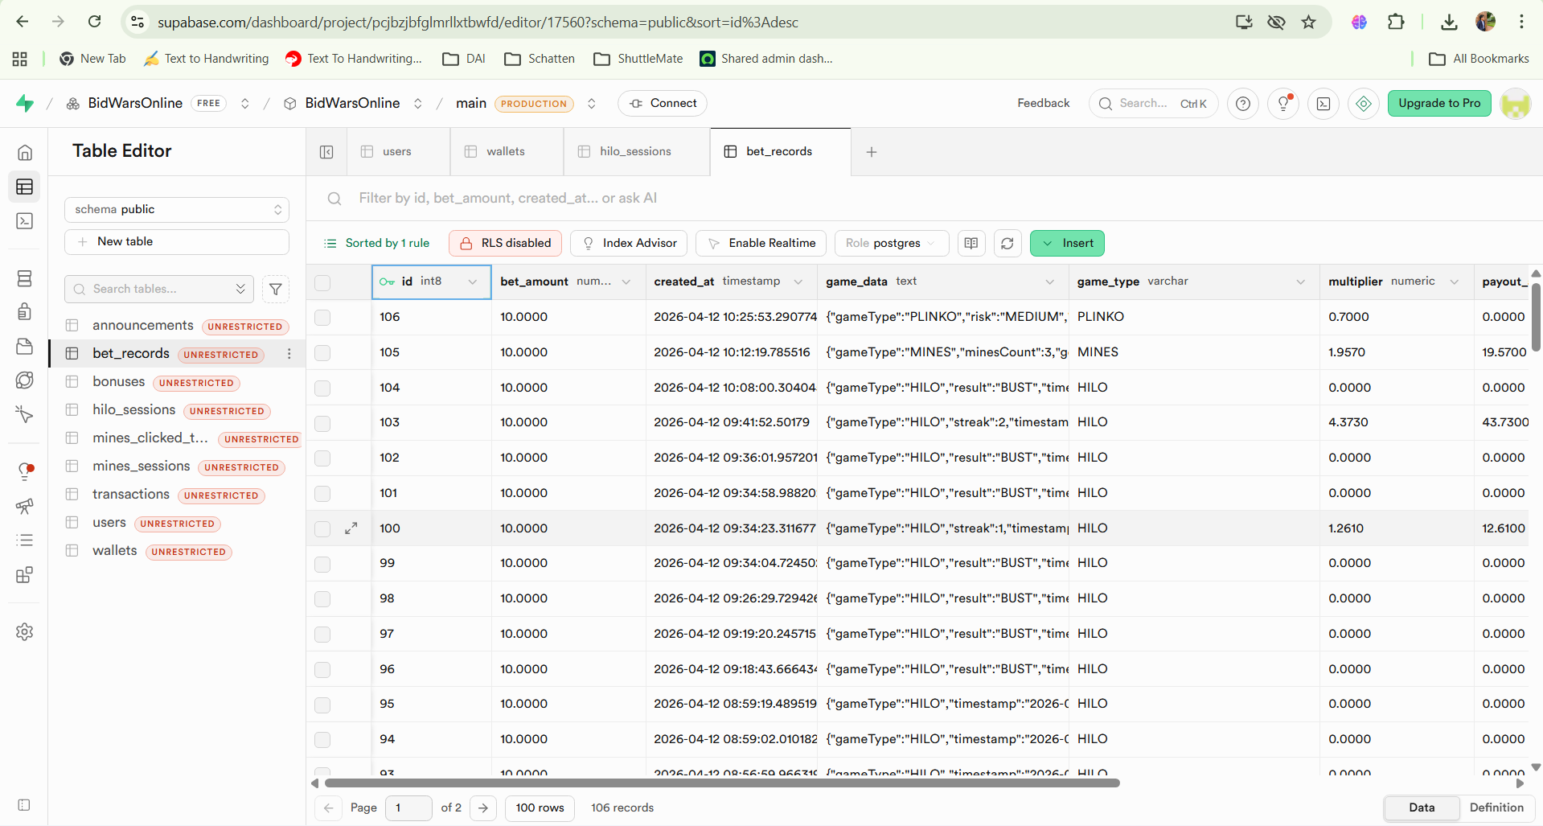
Database record for the plinko game
3. Project Summary
How the Mines Game Works
The Mines feature is a grid-based risk game where users navigate a 5x5 board to uncover gems while avoiding hidden explosives. The process begins when the user sets their bet amount and selects the number of active mines via the Next.js/Kotlin interface. Upon starting the game, the Spring Boot backend securely generates a randomized grid, intentionally withholding the mine locations from the front-end to ensure provable fairness and prevent cheating. As the user clicks individual tiles, the system checks the hidden grid state. Finding a gem dynamically increases the potential payout multiplier based on combinatorial probability. Hitting a mine instantly busts the session, resulting in a loss. Users can manually trigger a "Cash Out" action after any successful click to instantly transfer their accumulated winnings to their digital wallet.
Inputs and Validations Used
The system captures the user's betAmount, the minesCount, and the specific tileIndex (0-24) during gameplay. The backend rigorously validates these inputs by ensuring the user has a sufficient wallet balance before deducting the bet , restricting the minesCount strictly between 1 and 24, and verifying that a submitted tileIndex has not already been clicked in the active session.

