Ex.No: 9 | Processing Text Input with MapReduce
Date: 6.10.25 | Processing Text Input with MapReduce

Aim:
To process a dataset of daily weather records and find the maximum temperature recorded for each year using MapReduce in Hadoop.
Procedure:
- Prepare the input text file:
  - Create a plain text file sample.txt with several lines of text.
  - Example content:
  - 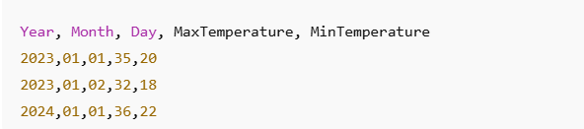
- Create Mapper Class:
Reads each line, extracts the year and the maximum temperature, and emits (year, max_temp).
- Create Reducer Class:
Receives all temperatures for a year and finds the maximum temperature for that year.
- Create Driver Class:
  - Configure the job with Mapper, Reducer, InputFormat, OutputFormat, etc.
- Compile the Java Program:
  - Use javac and jar to package the code into a .jar file.
- Copy input file to HDFS:
hdfs dfs -mkdir /input
hdfs dfs -put sample.txt /input/
- Run the MapReduce job:
hadoop jar TextProcessing.jar WordCount /input /output
- Check the output:
hdfs dfs -cat /output/part-r-00000

Program:
WordCountMapper.java
import java.io.IOException;
import org.apache.hadoop.io.IntWritable;
import org.apache.hadoop.io.LongWritable;
import org.apache.hadoop.io.Text;
import org.apache.hadoop.mapreduce.Mapper;

public class MaxTempMapper extends Mapper<LongWritable, Text, Text, IntWritable> {
private Text year = new Text();
private IntWritable temp = new IntWritable();

public void map(LongWritable key, Text value, Context context) throws IOException, InterruptedException {
String line = value.toString();
String[] fields = line.split(",");
if (!fields[0].equals("Year")) { // skip header
year.set(fields[0]);
temp.set(Integer.parseInt(fields[3]));
context.write(year, temp);
}
}
}
WordCountReducer.java
import java.io.IOException;
import org.apache.hadoop.io.IntWritable;
import org.apache.hadoop.io.Text;
import org.apache.hadoop.mapreduce.Reducer;

public class MaxTempReducer extends Reducer<Text, IntWritable, Text, IntWritable> {
private IntWritable result = new IntWritable();

public void reduce(Text key, Iterable<IntWritable> values, Context context) throws IOException, InterruptedException {
int maxTemp = Integer.MIN_VALUE;
for (IntWritable val : values) {
maxTemp = Math.max(maxTemp, val.get());
}
result.set(maxTemp);
context.write(key, result);
}
}
WordCountDriver.java
import org.apache.hadoop.conf.Configuration;
import org.apache.hadoop.fs.Path;
import org.apache.hadoop.io.IntWritable;
import org.apache.hadoop.io.Text;
import org.apache.hadoop.mapreduce.Job;
import org.apache.hadoop.mapreduce.lib.input.FileInputFormat;
import org.apache.hadoop.mapreduce.lib.output.FileOutputFormat;

public class MaxTemperature {
public static void main(String[] args) throws Exception {
Configuration conf = new Configuration();
Job job = Job.getInstance(conf, "Max Temperature");
job.setJarByClass(MaxTemperature.class);
job.setMapperClass(MaxTempMapper.class);
job.setCombinerClass(MaxTempReducer.class);
job.setReducerClass(MaxTempReducer.class);
job.setOutputKeyClass(Text.class);
job.setOutputValueClass(IntWritable.class);
FileInputFormat.addInputPath(job, new Path(args[0]));
FileOutputFormat.setOutputPath(job, new Path(args[1]));
System.exit(job.waitForCompletion(true) ? 0 : 1);
}}
Sample input file (weather.txt)
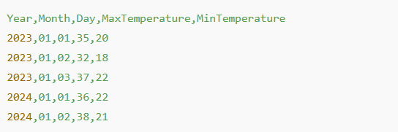

Output:



Result:
Thus, the program has been executed successfully and the output is also verified.

