Ex. No. 2 | Word Count Using Apache Spark
Youtube Link | https://youtu.be/-szhD_VHMDg
Date of Exercise | 6.10.25

AIM
To implement a Word Count program using Apache Spark and analyze how distributed processing works with transformations and actions.
Procedure:
            - Create Input File :
Apache Spark is fast
Spark is open source
Spark runs in memory
2. Launch PySpark:
3. Read the input file:
4. Tokenize lines into words:
5. Map each word to a key-value pair:
6. Aggregate the counts by word:
7. Display the result

Program:

from pyspark.sql import SparkSession
spark = SparkSession.builder.appName("WordCount").getOrCreate()
sc = spark.sparkContext

lines = sc.textFile("sample.txt")
words = lines.flatMap(lambda line: line.split())
wordPairs = words.map(lambda word: (word.lower(), 1))
wordCounts = wordPairs.reduceByKey(lambda a, b: a + b)
for word, count in wordCounts.collect():
print(f"{word} {count}")

spark.stop()

Output:
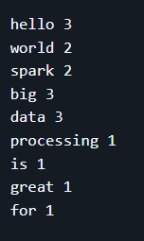

Result :
The Word Count application was successfully implemented using Apache Spark, demonstrating distributed processing using RDD transformations and actions.

