Ex. No. 3 | Image Classification
Date of Exercise | 03/08/2025

Aim:

To construct and train a convolutional neural network (CNN) on the CIFAR-10 image classification
dataset.

Description:

CIFAR-10 is a dataset of 60,000 color images in 10 classes. A CNN is used to classify images into
categories like airplane, car, bird, etc.
Code:

import tensorflow as tf
from tensorflow.keras import layers, models
from tensorflow.keras.datasets import cifar10

# Load dataset
(x_train, y_train), (x_test, y_test) = cifar10.load_data()
x_train, x_test = x_train / 255.0, x_test / 255.0

# Build CNN
model = models.Sequential([
layers.Conv2D(32, (3, 3), activation='relu', input_shape=(32, 32, 3)),
layers.MaxPooling2D((2, 2)),
layers.Conv2D(64, (3, 3), activation='relu'),

layers.Conv2D(64, (3, 3), activation='relu'),
layers.MaxPooling2D((2, 2)),
layers.Flatten(),
layers.Dense(64, activation='relu'),
layers.Dense(10, activation='softmax')
])

# Compile and train
model.compile(optimizer='adam', loss='sparse_categorical_crossentropy', metrics=['accuracy'])
model.fit(x_train, y_train, epochs=10, validation_data=(x_test, y_test))

Sample Output:
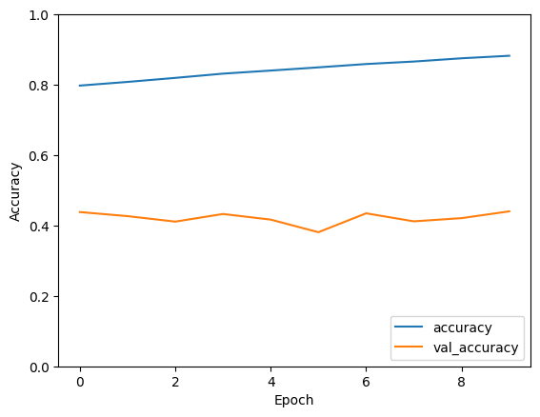

Youtube Model
https://youtu.be/FsDgPlH2MeE?si=sFlX583uJ5NpfAuf
Result
The code for Image classification using COnvolutional neural Network is Done successful and the output is been verified

