Ex. No. 2 | Regression
Date of Exercise | 21/07/2025

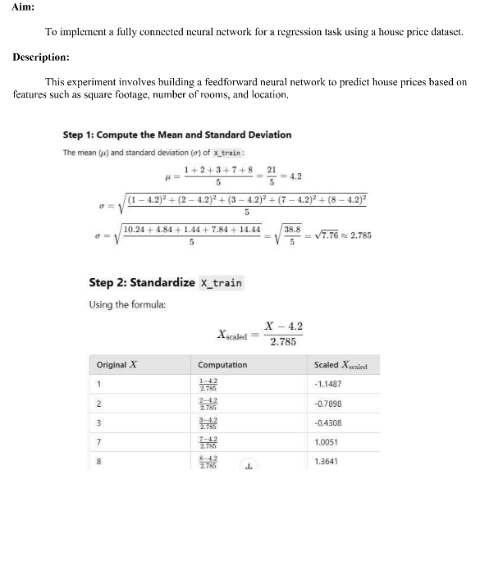

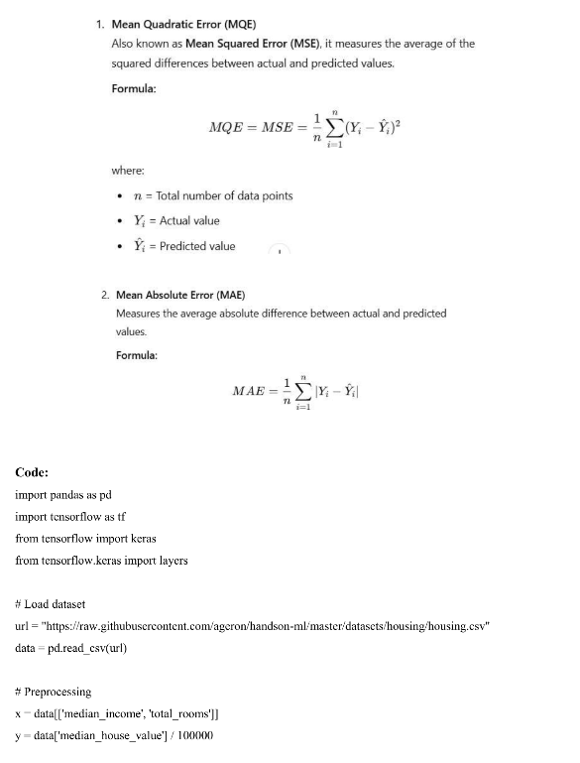

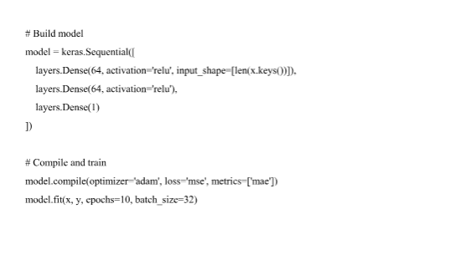
Output
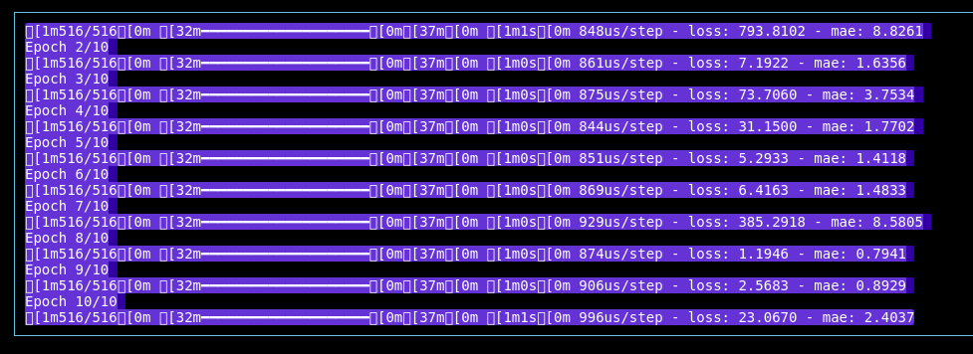

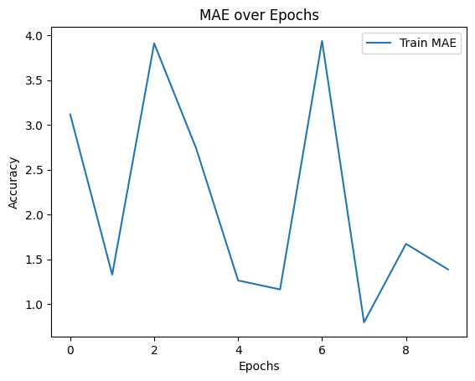

Youtube Link
https://youtu.be/vrpaJQakKlM?si=gUSmWOLZb9JmiDLK

Result
The above experiment of Multi Class Classification is done successfully and the output is been obtained

