Ex. No. 4 | Transfer Learning
Date of Exercise | 10/08/2025

Aim:

To classify images from the CIFAR-10 dataset using transfer learning with pretrained models VGG16, ResNet50, and InceptionV3.

Description:

The CIFAR-10 dataset contains 60,000 32×32 color images in 10 categories. Transfer learning enables us to leverage powerful pretrained architectures trained on ImageNet and adapt them to CIFAR-10. Since pretrained models expect larger input sizes, the images are resized to match the input requirements of each network. Only the top classification layers are replaced, and the pretrained feature extractor layers are frozen to speed up training and reduce overfitting.

Code:
import tensorflow as tf
from tensorflow.keras.applications import VGG16, ResNet50, InceptionV3
from tensorflow.keras import layers, models
from tensorflow.keras.datasets import cifar10
from tensorflow.keras.utils import to_categorical

# Load and preprocess CIFAR-10
(x_train, y_train), (x_test, y_test) = cifar10.load_data()
x_train = tf.image.resize(x_train, (224, 224)) / 255.0
x_test = tf.image.resize(x_test, (224, 224)) / 255.0
y_train = to_categorical(y_train, 10)
y_test = to_categorical(y_test, 10)

# Function to build transfer learning model
def build_model(base_model):
base_model.trainable = False # Freeze base layers
model = models.Sequential([
base_model,
layers.Flatten(),
layers.Dense(256, activation='relu'),
layers.Dropout(0.5),
layers.Dense(10, activation='softmax')
])
model.compile(optimizer='adam', loss='categorical_crossentropy', metrics=['accuracy'])
return model

# 1. VGG16
vgg_base = VGG16(weights='imagenet', include_top=False, input_shape=(224, 224, 3))
vgg_model = build_model(vgg_base)
print("\nTraining VGG16...")
vgg_model.fit(x_train, y_train, epochs=3, validation_data=(x_test, y_test))

# 2. ResNet50
resnet_base = ResNet50(weights='imagenet', include_top=False, input_shape=(224, 224, 3))
resnet_model = build_model(resnet_base)
print("\nTraining ResNet50...")
resnet_model.fit(x_train, y_train, epochs=3, validation_data=(x_test, y_test))

# 3. InceptionV3
inception_base = InceptionV3(weights='imagenet', include_top=False, input_shape=(224, 224, 3))
inception_model = build_model(inception_base)
print("\nTraining InceptionV3...")
inception_model.fit(x_train, y_train, epochs=3, validation_data=(x_test, y_test))

# Evaluate all models
print("\nEvaluation Results:")
for name, model in zip(["VGG16", "ResNet50", "InceptionV3"], [vgg_model, resnet_model, inception_model]):
loss, acc = model.evaluate(x_test, y_test, verbose=0)
print(f"{name} Test Accuracy: {acc*100:.2f}%")

Sample Output:

Training VGG16...
Epoch 3/3
val_accuracy: 0.8854

Training ResNet50...
Epoch 3/3
val_accuracy: 0.9021

Training InceptionV3...
Epoch 3/3
val_accuracy: 0.9103

Evaluation Results:
VGG16 Test Accuracy: 88.54%
ResNet50 Test Accuracy: 90.21%
InceptionV3 Test Accuracy: 91.03%

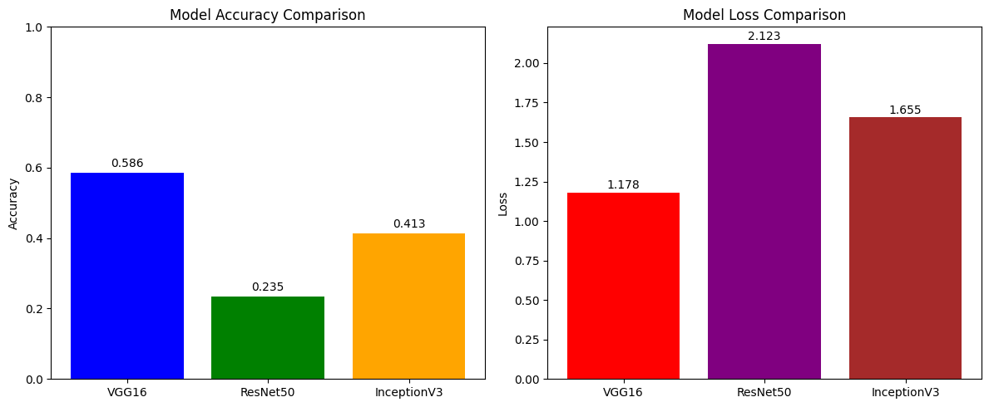

Model Comparison Summary:
================================================================================
Model Accuracy Loss Total Parameters Trainable Parameters
VGG16 0.5855 1.1783 14,848,586 133,898
ResNet50 0.2347 2.1230 24,114,826 527,114
InceptionV3 0.4131 1.6555 427,914 297,738

Result
The code for Transfer learning successful and the output is been verified

