Ex. No. 1 | Building a Basic Spark Application
Youtube Link | https://youtu.be/7D4cJNuqVD8
Date of Exercise | 6.10.25

AIM
To build a basic Spark application that creates a DataFrame, applies transformations such as filtering and column selection, and displays the results.

Procedure:
- Install and configure Apache Spark.
- Launch Spark (PySpark shell / Jupyter / VS Code).
- Create a SparkSession.
- Create a DataFrame from a list of records.
- Apply DataFrame operations:
- filter() to select specific rows
- select() to choose specific columns
Display the result using show().

Program:

from pyspark.sql import SparkSession
# Step 1: Create Spark session
spark = SparkSession.builder.appName("BasicSparkApp").getOrCreate()
# Step 2: Create DataFrame
data = [
("Alice", 22, "CSE"),
("Bob", 25, "ECE"),
("Charlie", 23, "CSE"),
("David", 21, "MECH")
]
columns = ["Name", "Age", "Department"]
df = spark.createDataFrame(data, columns)
# Step 3: Filter and select
result = df.filter(df.Department == "CSE").select("Name", "Age")
# Step 4: Display output
result.show()
# Stop Spark session
spark.stop()

Output:
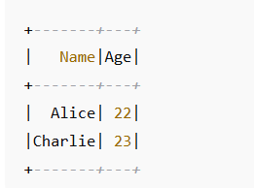

Result :
A basic Spark application was successfully created

