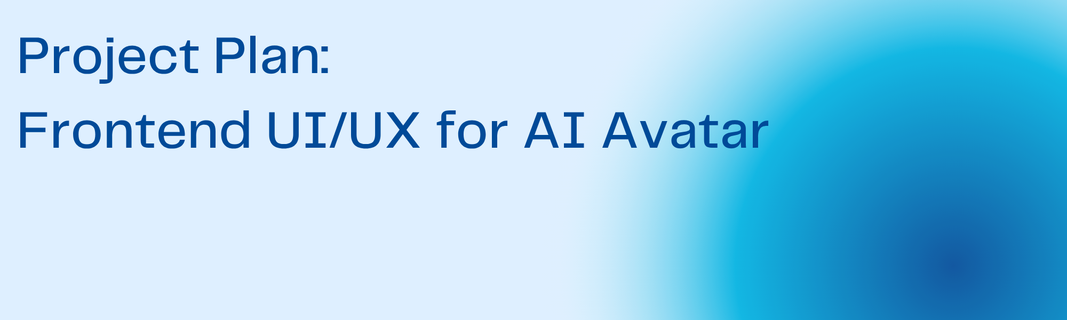
Prepared by: Franz Kingstein Nesakumar

Objective
To design and implement a real-time, interactive frontend interface for an AI-powered avatar. The interface will feature a chat window, animated avatar with lip-sync, a record button, and an audio player, built using React.js and Tailwind CSS with WebSocket support for real-time communication.
Phase Breakdown
1. Ideation Phase (Day 1)
Activities:- Brainstorming session with design and dev teams- Mind mapping user interaction flows- Research on UI/UX trends, user preferences, and market analysis- Decide on design theme, fonts, and color gradingDeliverables:- UI mood board- List of UI features- Initial user personas and flow diagrams
2. Prototyping Phase (Days 2–3)
Activities:- Create wireframes in Figma for all screens- Develop interactive prototypes- Collect stakeholder feedback (minimum 2 sessions)- Revise designs based on feedbackDeliverables:- Finalized Figma prototype- 2+ iterations based on feedback- Component library and design tokens
3. Coding Phase (Days 4–5)
Activities:- Setup React.js + Tailwind CSS environment- Implement chat window, avatar rendering, record button, and audio player- Integrate WebSocket to handle transcription and audio in real time- Ensure accessibility and responsivenessDeliverables:- Working UI components- WebSocket integrated functional prototype- Source code with modular structure
4. Final Review Phase (Day 6)
Activities:- Perform functional and usability testing- Fix UI bugs and improve based on user feedback- Ensure all interactions and animations sync correctly with backendDeliverables:- Final validated product- Feedback report from stakeholders- List of any remaining issues
5. Additional Considerations (Day 7)
Tasks:- Prepare deployment guide- Create brief user training doc (e.g., onboarding screen/tooltip)- Package codebase and finalize documentationDeliverables:- Deployment plan- User guide- Project archive and handoff materials
Timeline Summary
Day | Phase | Key Activities
1 | Ideation | Brainstorming, research, mood board
2 | Prototyping | Figma wireframes and mockups
3 | Prototyping | Prototype review and revisions
4 | Coding | Frontend environment setup, UI implementation
5 | Coding | WebSocket integration, final UI features
6 | Final Review | Testing, feedback, bug fixes
7 | Additional Tasks | Documentation, deployment planning

