Optimized Tajik Language Speech Recognition Training Schedule
Prepared by: Franz Kingstein Nesakumar

1. Objective
To develop a compact and effective speech recognition model for the Tajik language within a 12-day timeline. The model will transcribe spoken Tajik audio into text, using pre-trained architectures like Whisper-small or Wav2Vec2, adapted to work within laptop GPU constraints.

2. Requirements
- Data Collection:
  - Gather Tajik speech audio from radio, interviews, podcasts, and public recordings.
- Preprocessing:
  - Clean audio (WAV preferred), segment it, align it with transcripts, normalize file formats.
- Model Architecture:
  - Use a lightweight pretrained model such as Whisper-small or HuggingFace’s Wav2Vec2.
- Training Environment:
  - Python 3.9+, PyTorch, Hugging Face Transformers
  - Laptop GPU: NVIDIA RTX 30–60 series (4–8 GB VRAM)
  - Training Time: 1–3 hours/day for subset training
  - Tools: Google Colab (Pro), or local WSL2/Linux with CUDA

3. Condensed Training Schedule (12 Days)

Day 1–3: Data Collection & Preprocessing
- Gather and segment audio datasets
- Clean, tokenize, and align audio-text pairs

Day 4–5: Model Setup & Configuration
- Select model (Whisper-small, Wav2Vec2)
- Configure environment, verify dataset format

Day 6–8: Training (Subset)
- Train using small batches compatible with limited GPU
- Adjust learning rates and batch sizes as needed

Day 9–10: Evaluation & Fine-tuning
- Measure performance (Word Error Rate)
- Retrain on specific segments to improve accuracy

Day 11: Final Testing
- Test with unseen audio samples
- Note WER and model reliability across dialects

Day 12: Documentation & Presentation
- Summarize tools, data, and results
- Prepare presentation/report for stakeholders
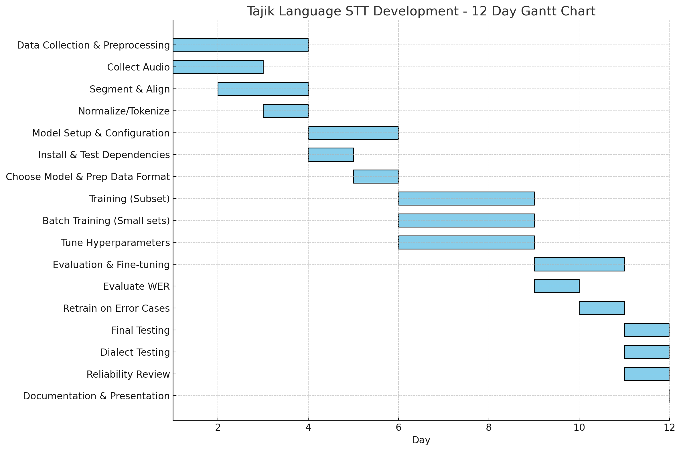

4. Pre-built Model Option
- Use existing multilingual STT models like Whisper or Vosk
- Faster deployment, avoids full training
- May need minor fine-tuning for Tajik

5. Recommendation
This revised 12-day plan provides a realistic, resource-aware schedule for building a Tajik STT module. Choose custom training for control and accuracy, or use pre-trained models for faster results on a limited budget and hardware.

