Teaching Modules in Computational Neuroscience 1 (2011)
The German Neuroinformatics Node – www.g-node.org

Course Module
Analysis of Directional Tuning in Single Unit Activity from the Monkey Motor Cortex

Martin Nawrot¹ and Alexa Riehle²

Theoretical Neuroscience and Neuroinformatics, Institute of Biology, Freie Universität Berlin, Königin Luisen Straße 1-3, D - 14195 Berlin, and Bernstein Center for Computational Neuroscience Berlin.

Institut de Neurosciences Cognitives de la Méditerranée, Centre National de la Recherche Scientifique (CNRS) and University of Aix-Marseille, F – 13402 Marseille

Synopsis

This course module introduces the student to the analysis of directional tuning in single unit recordings from the motor cortex of the behaving monkey. Goal of this module is to exercise the analysis of single-unit spike train data, to rehearse basic concepts of neuronal tuning curves and rate coding. The students will analyze the directional information present in single unit activity recorded from the monkey primary motor cortex during the preparation and execution of center-out arm reaching movements. The first part focuses on computing the classical ('static') directional tuning from the average firing rate in the actual movement phase. The second part investigates the dynamics of movement encoding using the time-resolved estimation of tuning measures during the experimental phase of movement preparation. This teaching module addresses master and graduate students from both, experimental and theoretical background. The module is designed for one course day including an introductory lecture, practical course work, and final presentation of results. The experiment and the data have been described in detail in a recent publication [1].

Supplemental Material

With this course module we provide additional data files for practical analysis. Data Courtsey: Alexa Riehle, Mediterranean Institute of Cognitive Neuroscience – Centre National de la Recherche Scientifique (CNRS) and University of Aix-Marseille, 13402 Marseille, France.

The supplemental material for this teaching module is available online at the following URL: www.g-node.org/teaching/xxx
Requirements

Practical work on this course module requires that you run Matlab Version 6 or higher. Supplemental data files (available online) are required for data analysis.

Introduction

In the early and mid 80's Georgopoulus and coworkers showed that a large proportion of neurons in the primary motor cortex of the behaving monkey show a dependence of their firing probability on the direction of an arm movement [2]. This was studied in an experimental paradigm known as the 'center-out task' where the monkey has to perform arm movements from a central starting position (center) to one out of several targets which are arranged on an outer circle (out) around the central starting position.
In the present exercises, you will analyze single unit recordings from the primary motor cortex (M1) of one monkey (monkey 1 in [1]), which performed a delayed center-out task. The experiments were carried out in the lab of Alexa Riehle. The task and the data are described in detail in [1]. For an introduction to directional tuning in the motor cortex refer to text books on neurophysiology. An in-depth coverage is found in [3].

Data sets

The data format is as follows. For each single neuron and each recording session there exists a single data file, e.g. joe105-6-C1-TS.mat. The filename encodes the monkey's name (joe), the experimental session number (105), and the number of the single unit (6), as well as the experimental condition (C1=one target information) and the temporal trigger (TS=trial start, MO=movement onset) that was used to temporally align all single trial spike trains. The spike data is stored with a time resolution of 1ms. When you load this data file in Matlab you obtain the struct SparseFormat which has 3 fields which are important for the exercises:

.TimeResolutionMS : resolution of data matrix relative to ms
.Data : spike data for all trials and all 6 directions
.CutIntervalMS : time interval of data recording relative to cut event trigger (TS/MO)

The .Data field is a cell array of length 6. The cells contain the binary spike matrices for the 6 directions. SparseFormat.Data{1} refers to direction 1 etc. Each cell contains a sparse matrix where the first dimension is time and the second trial. The number of trials varies for the different directions. To obtain the full matrix representation from the sparse representation use the command 'full', e.g for direction i

M = full(SparseFormat.Data{i});

Part 1 : Tuning curves

In this first part the goal is (1) to estimate single neuron tuning curves, i.e. the mean firing rate in relation to the direction of the arm movement, (2) to measure the signal-to-noise ratio of the direction signal, and (3) to present the results in an appropriate figure.
To measure the classical tuning curve we align the data to the time of movement onset (MO). This trigger time was detected during the experiment as the point in time when the monkey's hand left the central resting position (cf. Materials and Methods in [1]). The respective data files contain “MO” in their filename and each contains the spike data from 1000 ms before to 1000ms after MO. The classical tuning curve measures the trial-averaged firing rate for each direction during a certain time epoch around MO.

Tasks

- Choose one single data file and load it into memory
- The results shall be presented in Figure 1 with 2 x 2 panels. Use the ‘subplot’ command to generate several axes within one figure.
- Explore the spike train data by taking out one set of trials (e.g. for direction 1) and generate a raster plot (dot-display) using the proper time axis in the top left panel of Figure 1. To obtain spike times from the matrix you may use the find command:

[t,j] = find(full(SparseFormat.Data{i});

where t holds all spike times (1st matrix dimension) and j the corresponding trial number (2nd dim.). Using

plot(t,j,’.’,’color’,’k’)

readily produces the desired dot-display. Remember that for data that was cut relative to the temporal trigger MO, the index 1 in the first dimension (time) refers to the time point t=-1000ms before movement onset. How can you make sure that the time points are plotted relative to MO at t=0?
- Generate the Peri-Stimulus-Time Histogram (PSTH) for all six directions using a defined array of the histogram edges and the ‘histc’ command in Matlab. Tip: The variable t represents the spike times from all trials.
- Plot the outlines of the 6 different PSTHs into the top right panel using different line colors. You may use the 'stairs' command to do this. How does the PSTH look like? At a first glance, do the PSTHs look different for different directions?
- Choose a useful time interval around movement onset (MO) to compute tuning strength. Count the number of spikes within this time interval for each direction and each trial. Divide this number by the length of the time interval (in seconds) to obtain the firing rate. In the bottom left panel of Figure 1 generate a plot of the tuning curve where for each direction (1-6 on the x-axes) the trial-averaged firing rate is plotted on the y-aches. Add to this plot the individual trial rates to represent the trial-by-trial variability (cf. example figures in the appendix). Does the mean rate vary with direction? Does it vary strongly when taking into account the variations across trials?
- To quantify the strength of tuning calculate the signal to noise ratio SNR (explained in supplement of [4] and in [5]. It is defined as the ratio of the signal variance (cf. Lecture) and the noise variance. It expresses how strong the spike rate varies across direction (signal) in relation to how strong the spike rate varies across trials (noise).
Note: The variance of the signal is simply the variance of the trial-averaged firing rates for the 6 directions. To calculate the noise variance, first subtract the trial averaged rate from the single trial rates for each direction separately. Then compute the variance of the resulting numbers pooled from all 6 directions. Note, that this direct measure of the SNR is biased towards higher values (see Lecture), i.e. we overestimate the true values.
- Figure 1, bottom right axes: plot directional tuning in a vector plot using the matlab function 'compass'. This function requires x and y in Euclidian coordinates. Now compute the vector sum from all 6 directions and add this to the graph in a different color. This vector points into the preferred direction of this particular neuron. What is the preferred direction in degrees?
Note: You have for each direction the length of the vector given by the average rate. You can define the vector angle in radians (direction 1 is defined as 0 rad – between neighbouring directions there are 60 degrees or 1/6th * 2Pi in radians), and then translate to Euclidian coordinates.
- Compare results of SNR, tuning vector length, and preferred direction with other example neurons that had been chosen by your class mates.
- Optional: If you were fast, write a script that loops across all data files to compute the SNR for all neurons. Compute the histogram from all SNRs in a new Figure 1x. As a rule of thumb, only neurons with SNR ≥ 1 show a 'significant' tuning that could be reliably used e.g. for real-time decoding purposes. However, extracting simultaneously the information from many weakly tuned neurons might still result in a reasonable decoding power (population decoding, e.g.[1])

Part 2 : Time-resolved measures of tuning

This second part investigates the dynamic properties of directional tuning in single units. To this end we use the time resolved average firing rate as measured for each of the six directions and produce a color-coded visualization of the temporal and directional dependence of activity. Again, the SNR – now as a function of time – will serve as a one-dimensional quantity of the tuning strength, while the time resolved preferred direction shows constancy or rotation of the tuning vector. You should compose Figure 2 that displays all three time-resolved measures in three subplots that share the same time axes.

Tasks

- Choose a data set (one particular unit) where spike times are aligned to movement onset (MO). For each of the six directions separately measure time resolved firing rate for all trials by means of a moving average along time. A moving average of the 0/1 vector representation of a spike train is identical to the convolution (or filtering) of the spike time series with a rectangular "boxcar" kernel. If you are familiar with the method of kernel convolution [6], you may want to choose a different shape for the smoothing kernel.
- Construct a matrix with the trial-averaged rate function for each direction. Use ‘imagesc’ to produce a color-coded display of the matrix in the top panel of Figure 2. Make sure that you use the proper time axes as the horizontal axes.
Note: The command 'colorbar' produces an additional axis with the appropriate color scale. With the command 'caxis' you can set the scale for the color code, 'colormap' allows you to define the color mapping. You may also define your own color map.
- Optional: If you were fast, try out the interpolation of the discrete values across directions. To do this first construct a (time x 8) matrix, where the 6th direction is represented in the first column and the 1st direction is represented in the 2nd but also again in the 8th column to allow for a "wrap around" effect when interpolating. Then use the matlab function 'interp' (or 'interp2') for interpolation.
- Measure the time resolved signal-to-noise ratio SNR (see part 1), i.e. measure the SNR for each time step on the basis of the time-resolved rate estimates. Plot the SNR as a function of time in the second panel of Figure 2. If you wish, you may estimate and plot the time-resolved SNR for different single units and plot them in different colors.
- Optional: You may also try out other measures of tuning strength as e.g. described in the methods section of [1] and displayed in Fig. 3A of [1].
- Compute the preferred direction (see part 1) for each time step on the basis of the trial-averaged firing rates and plot it as a function of time in the third panel of Figure 2. Do you observe strong changes in the preferred direction? If so, do they occur during instances where the tuning was strong or during instances where the tuning is weak?
- Check whether all axes have been labeled correctly. Is the time axis identical for all three subplots?
- Compare results for different single neurons with your class mates.

References

[1] Rickert J, Riehle A, Aertsen A, Rotter S, Nawrot MP (2009) Dynamic encoding of movement direction in motor cortical neurons. Journal of Neuroscience 29: 13870-13882

[2] Georgopoulos et al. (1982) On the relations between the direction of two-dimensional arm movements and cell discharge in primate motor cortex. J Neurosci 2(11): 1527-37

[3] Motor Cortex in Voluntary Movements: a distributed system for distributed functions (2005) Alexa Riehle, Eilon Vaadia (Eds.) CRC Press, Boca Raton, Florida, USA

[4] Mehring et al. (2003) Inference of hand movements from local field potentials in monkey motor cortex. Nat Neurosci 6(12): 1253-54

[5] Strube-Bloss MF, Nawrot MP, Menzel R (2011) Mushroom body output neurons encode odor-reward associations. The Journal of Neuroscience 31: 3129–3140.

[6] Nawrot M, Aertsen A, Rotter S (1999) Single-trial estimation of neuronal firing rates - From single neuron spike trains to population activity. J Neurosci Meth 94: 81-92
Appendix: Example plots.

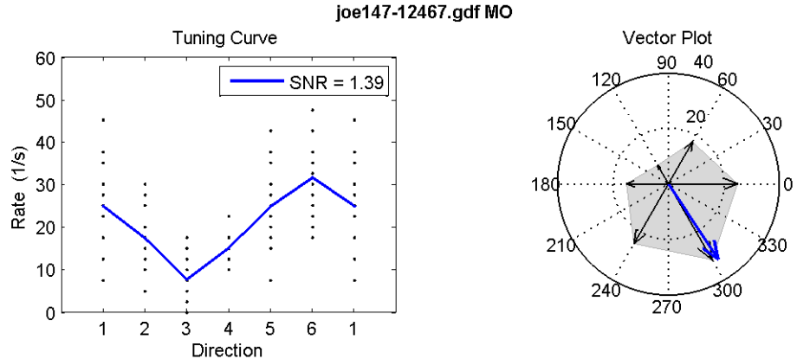

Example figure 1. Tuning measures for one single unit. Left: Single trial firing rates for directions 1 to 6 and average firing rates (blue line, tuning curve). Signal-to-noise ratio (SNR) as indicated. Right: Tuning vector (blue) results as vector sum from the individual direction vectors (black). The length of each direction vector equals the average firing rate for this direction. The time interval for rate estimation was chosen as T = (800ms, 1200ms].

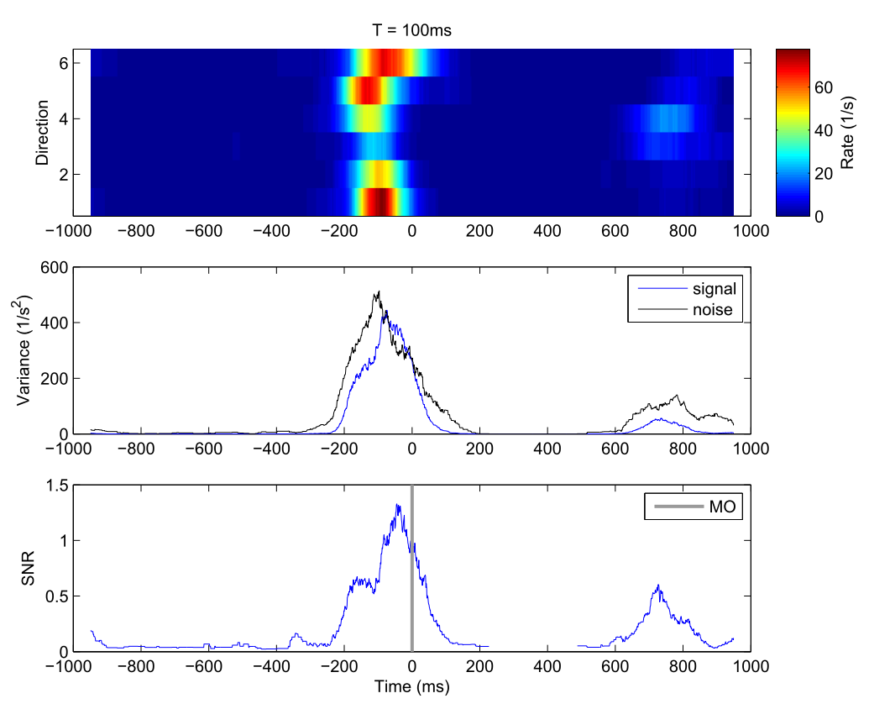

Example figure 2. Time resolved tuning analysis. Top: Color coded trial-averaged rate functions for all 6 directions estimated with a boxcar kernel (moving window) of width 100ms. Middle: Signal (Variance across the six trial-averaged firing rates) and noise (Variance across trials after subtraction of mean firing rates). Bottom: Trial-averaged signal-to-noise ratio (SNR) estimated from firing rates estimated with a boxcar kernel of width 100ms.

