Neurobiology. In the article “The neural code between neocortical pyramidal neurons depends on neurotransmitter release probability,” by Misha V. Tsodyks and Henry Markram, which appeared in number 2, January 23, 1997 of Proc. Natl. Acad. Sci. USA (94, 719–723), the following corrections should be noted. Equations 1 and 3 were incorrect as published. The corrected equations are shown below:
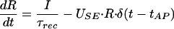 | 1

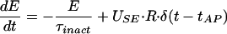

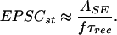 | 3

