**Configure Contador laser**

Guide: [✅ Programas para CNC Láser, Conexiones y Primer tallado. GRBL, LaserGRBL #6 (youtube.com)](https://www.youtube.com/watch?v=sisIhK61RTQ&ab_channel=ElprofeGarc%C3%ADa)

Step 1 : Download files…

Software for print:

[Download – LaserGRBL](https://lasergrbl.com/download/)

Lib for updload in Arduino Uno:

[gnea/grbl: An open source, embedded, high performance g-code-parser and CNC milling controller written in optimized C that will run on a straight Arduino (github.com)](https://github.com/gnea/grbl)

Download lib and copy this lib (grbl) in lib internal of the Arduino

Dir download file:

Dir Arduino lib:

Step 2: Load rgbl lib in Arduino

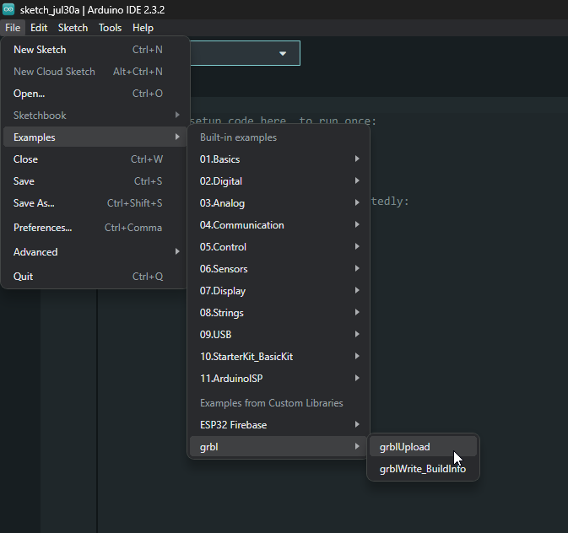

Step 3 : Upload lib in Arduino Uno

Step 4: Configure in Software RGBL

