Cross community indicator species

Franz Mueter

May 26, 2019

Evaluate Mantel correlations among different communities sampled during AMBON 2015. This is currently based on 65 stations sampled in 2015 where data for infauna (single grab sample), epifauna, demersal fish, zooplankton (150), and seabirds (within a 10km radius of each station) were available.

Data were examined and some taxa were grouped if they were not always identified to species. If aggregate groups made up a small fraction but were mostly identified to lower taxonomic level, I excluded them from the analysis. (Need to check Jackie / Katrin on resulting groups for infauna and epifauna, see epifauna_taxa.xlsxand infauna_taxa.xlsx).

Microbes are currently not included as they were colleced at fewer stations and at different vertical layers (plus I don’t have raw data).

Taxa that occurred at 3 or fewer stations (< 5%) were exluded from analysis. All abundances were effort standardized (per unit area or length of transect). The resulting densities of almost all taxa were highly right-skewed and were therefore 4th root transformed. For this analysis, I standardized all abundances to a maximum of 1 for each taxon (hence abundances always range from 0 to 1), such that each taxon has the same influence on the analysis, regardless of total numerical abundance or weight in the sample.

# Mantel correlations

I computed Mantel correlations between each pair of communities and used a permutation test to assess statistical significance of the resulting correlations (function mantel in *vegan* package). I use Spearman rank correlations for a more robust analysis that is less influenced by extreme values in the dissimilarity matrices, although dissimilarities were generally reasonable (see ‘CommunityAnalysis.R’).

Cross-community Mantel correlations and signficance values

|  |  |  |  |  |  |
| --- | --- | --- | --- | --- | --- |
|  | infauna | epifauna | fish | zoop | birds |
| infauna | NA | 0.0005000 | 0.0015000 | 0.0005000 | 0.0005 |
| epifauna | 0.5036575 | NA | 0.0005000 | 0.0005000 | 0.0005 |
| fish | 0.1565263 | 0.4138590 | NA | 0.0005000 | 0.0305 |
| zoop | 0.4481478 | 0.3524463 | 0.1848007 | NA | 0.0005 |
| birds | 0.3594055 | 0.3509486 | 0.0761684 | 0.4112157 | NA |

I identified key indicator species within a given community that are most strongly associated with other communities. I initially used bioenv with one community matrix as the ‘biological matrix’ and another community matrix as the ‘environmental matrix’, but the number of possible combination of even 3 or 4 species ranges in the billions, making it unrealistic to identify the ‘best’ combination of species in one community associated with another community through this brute-force approach (which it was not designed for).

I therefore assessed the relationship of each species in a given community to those in another community through a modeling approach similar to the ordisurf() function in the *vegan* package. The abundance of a given species (typically dominated by zeros) from community A was associated with the best NMDS ordination of community B using a Generalized Additive Model with a Tweedie distribution for zero-inflated data, and then visualized for assessing goodness of fit using these custom functions:

I visualized the associations between key species from a community with another community (assemblage) by overlaying observed and predicted abundances of the key species on the ordination. The size of the circles in the plots below represent actual (square-root transformed) CPUE of a key species, the green contour lines represent predicted values of their CPUE from the Generalized Additive Model that was the basis for evaluating associations (based on $R^{2}$ and p-values from the GAM), and the blue arrow represents the linear association of thekey species with the community represented in the ordination.

For interpretation of the ordination relative to environmental gradients, see ‘CommunityAnalysis.R’. I included ordinations for each community with environmental vectors overlaid below for interpretation.

# Function to identify species in one community matrix that are most strongly   
# associated with species in another community.  
  
sp.assoc <- function(X.mds,Y, gam.df=15, MIN=5) {  
# X.mds = NMDS ordination results for community X  
# Y = Matrix of transformed & standardized species abundances for   
# community Y, sampled at the same sites as community X   
# Columns assumed to be standardized to maximum 1  
# These are multiplied by 100 for an assumed sample size   
# of 100 indiviudals per sample  
# MIN = minimum number of stations with positive catch required  
# for a species to be included  
 X <- X.mds$points  
 # Eliminate species sampled at fewer than MIN stations:  
 Y <- Y[,apply(Y,2,function(x) sum(x>0)) >= MIN]  
 # "Standardize" to maximum of 100 'individuals' per station  
 Y <- apply(Y, 2, function(x) x/max(x) * 100)  
 out <- vector("list", ncol(Y))  
 names(out) <- colnames(Y)  
 # Fit GAM with negative binomial distribution  
 for(i in 1:ncol(Y)) {  
 dat <- data.frame(X, y=Y[,i])  
 RHS <- paste(colnames(X), collapse = ", ")  
 RHS <- paste("s(", RHS, ", k = gam.df)", sep="")  
 form <- formula(paste(c("y", RHS), collapse = " ~ "))  
 out[[i]] <- gam(form, data=dat, family=nb)  
 }  
 out  
}  
  
# Function to extract R2 and p-values  
summarize.sp.assoc <- function(assoc) {  
# assoc = List produced by function sp.assoc  
 out <- matrix(NA, nrow=length(assoc), ncol=2)  
 dimnames(out) <- list(names(assoc), c("R.sq", "p"))  
 for(i in 1:length(assoc)) {  
 sm <- summary(assoc[[i]])  
 out[i,"p"] <- sm$s.table[,"p-value"]  
 out[i,"R.sq"] <- sm$r.sq  
 }  
 out  
}  
  
# Function to examine relationships between CPUE and ordinations:  
ef.plot <- function(mds, y, ...) {  
 ordisurf(mds$points, y, family=nb, ...)  
 ef <- envfit(mds ~ y)  
 plot(ef, labels="", lwd=2)  
}  
  
library(plotrix)  
 plot.ord <- function(mds, ef, best, TITLE, vec.lab=T) {  
 col.fun <- colorRampPalette(c("lightblue", "darkblue"))  
 # COL <- col.fun(65)[rank(env.dat[,best[1]])]  
 COL <- col.fun(65)[rank(PSBTA.hauls$Latitude)]  
 par(mar=c(0,0,2,0))  
 plot(mds$points[,1:2], cex=1.6, pch=16, col=COL, axes=F, asp=1); box()  
 title(TITLE, line=0.5, cex.main=1.5)  
 if(vec.lab) {  
 plot(ef, col="red")   
 } else {  
 X <- ef$vectors$arrows[,1] * sqrt(ef$vectors$r)  
 Y <- ef$vectors$arrows[,2] * sqrt(ef$vectors$r)  
 arrows(0, 0, X, Y, lwd=2, length=0.12, col=2)  
 }  
 plot(mds$points[,1:2], type="n", col=COL, axes=F, asp=1); box()  
 title(TITLE, line=0.5, cex.main=1.5)  
 text(mds, cex=0.6, col=4)  
 }

## Summary of results

For this and subsequent cross-community linkages, I selected species with a (Pseudo-) $R^{2}$ value of at least 0.2 that were significantly related (95% significance level) to the community ordination. In some cases, I eliminated species based on visual assessment of the results, in particular if the relationship was clearly driven by a single large value.

Infaunal species significantly associated with epifaunal community:

|  |  |  |
| --- | --- | --- |
|  | R.sq | p |
| COROPHIIDAE COROPHIUM SP. | 0.9999836 | 0.0000000 |
| ECHINARACHNIIDAE ECHINARACHNIUS PARMA | 0.9994591 | 0.0000000 |
| PECTINARIIDAE PECTINARIA HYPERBOREA | 0.5096207 | 0.0072523 |
| CIRRATULIDAE | 0.4118195 | 0.0000131 |
| LUMBRINEREIDAE SCOLETOMA [LUMBRINERIS] SP. | 0.3960587 | 0.0000000 |
| OSTRACODA | 0.3939295 | 0.0000000 |
| AMPELISCIDAE AMPELISCA BIRULAI | 0.3378288 | 0.0078153 |
| AMPELISCIDAE BYBLIS SP. | 0.3358269 | 0.0000306 |
| MALDANIDAE RHODINE SP. | 0.3177136 | 0.0184153 |
| NUCULIDAE ENNUCULA TENUIS [NUCULA BELLOTI] | 0.3119812 | 0.0000002 |
| OPHIACTIDAE OPHIOPHOLIS SP. | 0.3060902 | 0.0027337 |
| NUCULANIDAE NUCULANA PERNULA | 0.3006188 | 0.0000000 |
| TEREBELLIDAE | 0.3004787 | 0.0417956 |
| ONUPHIDAE ONUPHIS PARVA | 0.2715654 | 0.0000236 |
| PONTOPOREIIDAE [HAUSTORIIDAE] PONTOPOREIA FEMORATA | 0.2689443 | 0.0000972 |
| PARAONIDAE ARICIDEA LOPEZI | 0.2515807 | 0.0001050 |
| GOLFINGIIDAE [SIPUNCULIDAE] GOLFINGIA MARGARITACEA | 0.2487438 | 0.0048368 |
| PARAONIDAE LEVINSENIA SP. | 0.2315241 | 0.0002411 |
| OPHIURIDAE OPHIURA SARSI | 0.2267601 | 0.0036832 |
| COSSURIDAE COSSURA SP. | 0.2265284 | 0.0250972 |
| AMPELISCIDAE HAPLOOPS SP. | 0.2238116 | 0.0000132 |
| STENOTHOIDAE | 0.2198981 | 0.0043410 |
| UNGULINIDAE DIPLODONTA SP. | 0.2154453 | 0.0013472 |
| NEPHTYIDAE NEPHTYS CAECA | 0.2113852 | 0.0035041 |

### Ordinations of epifaunal community with observed and predicted abundancs of key infaunal species

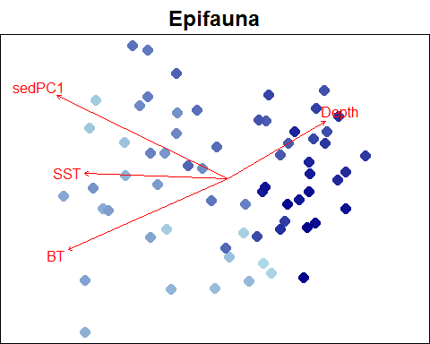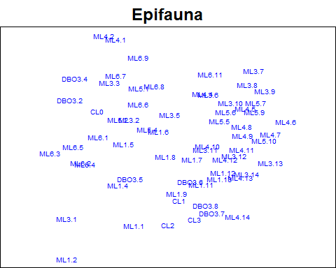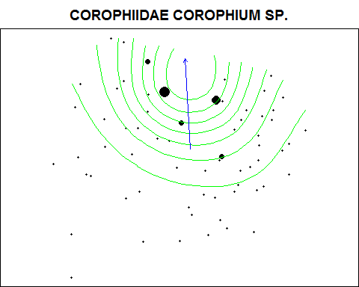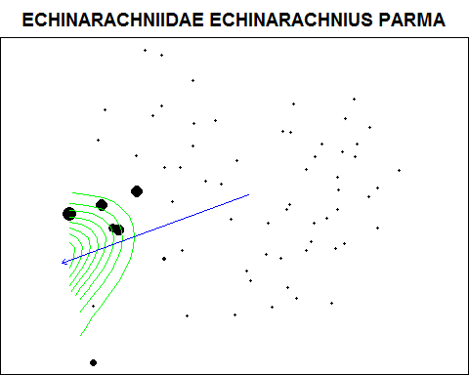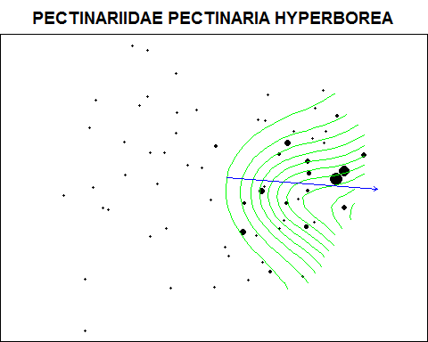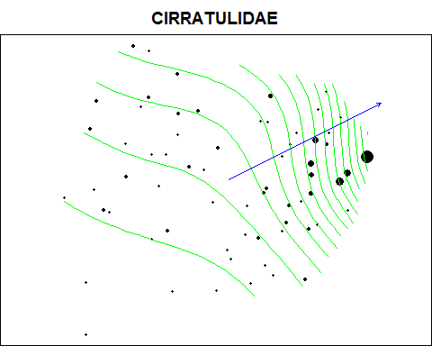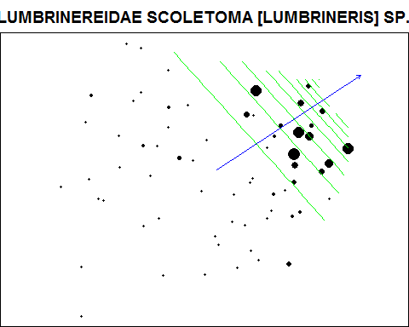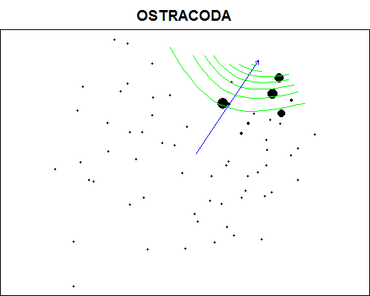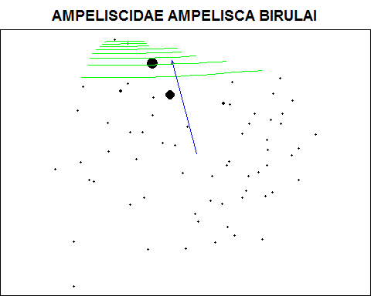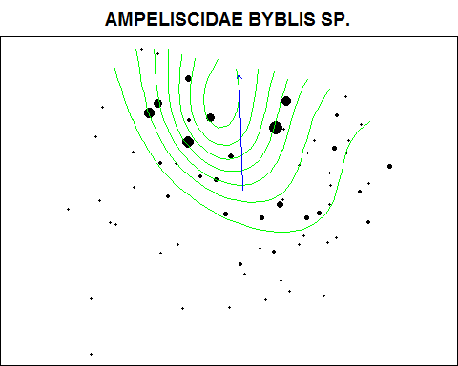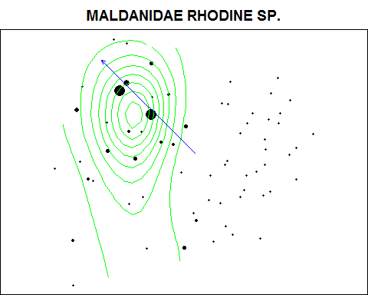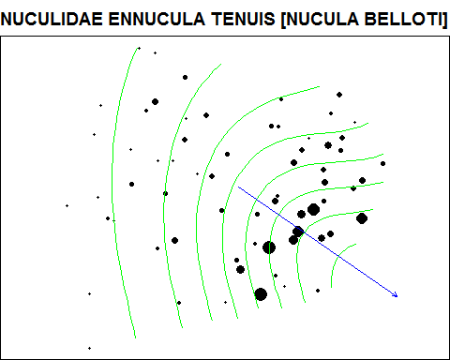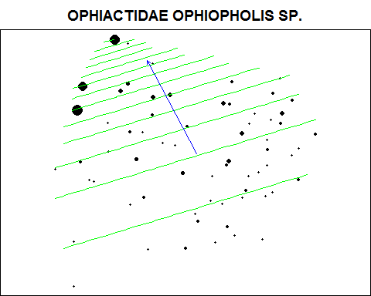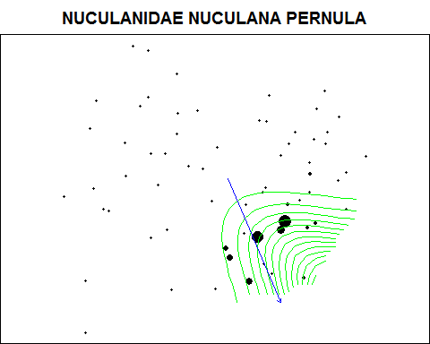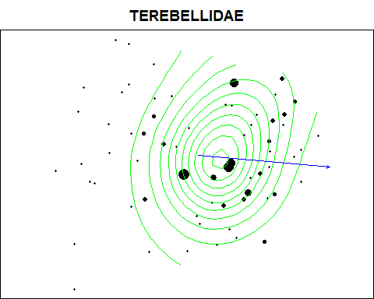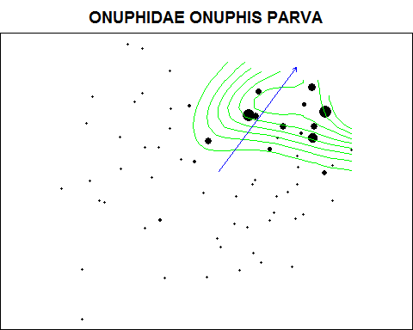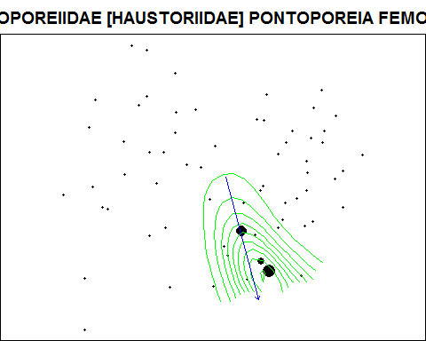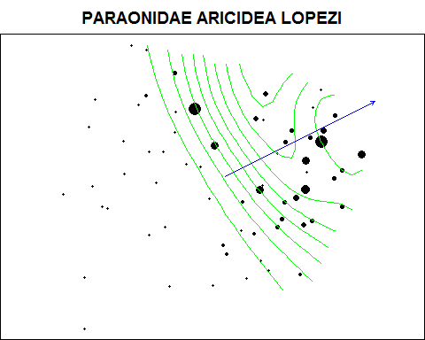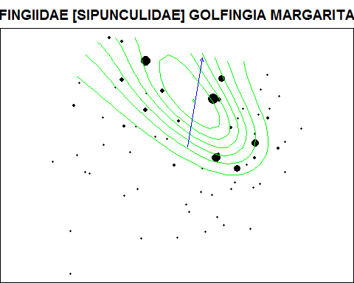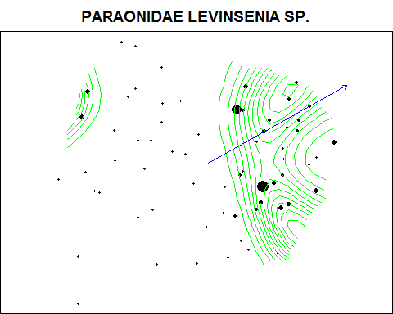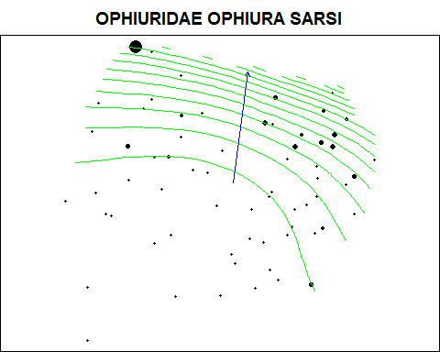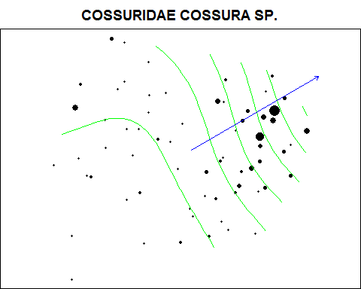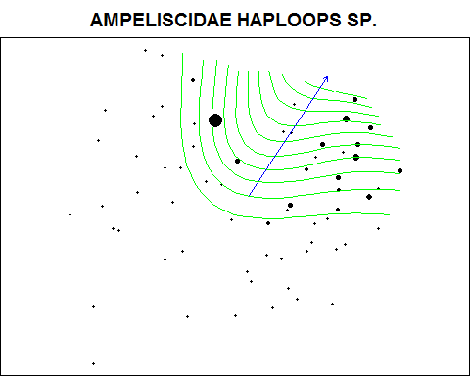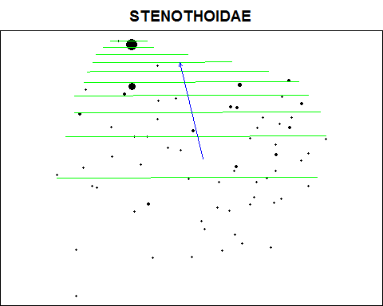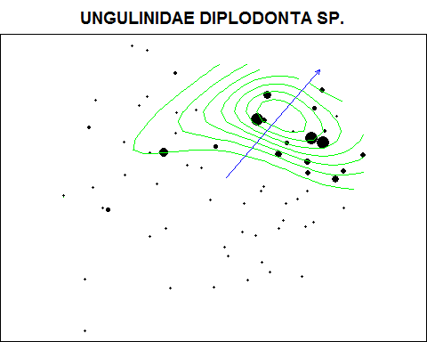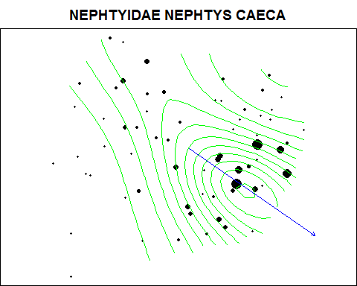

Infaunal species significantly associated with fish community

|  |  |  |
| --- | --- | --- |
|  | R.sq | p |
| FLABELLIGERIDAE BRADA VILLOSA | 0.5728554 | 0.0301566 |
| OSTRACODA | 0.3112342 | 0.0002916 |
| NUCULIDAE ENNUCULA TENUIS [NUCULA BELLOTI] | 0.2334780 | 0.0027260 |
| CIRRATULIDAE | 0.2102334 | 0.0000000 |

### Ordinations of fish community with observed and predicted abundancs of key infaunal species

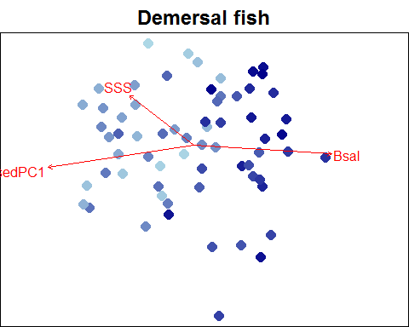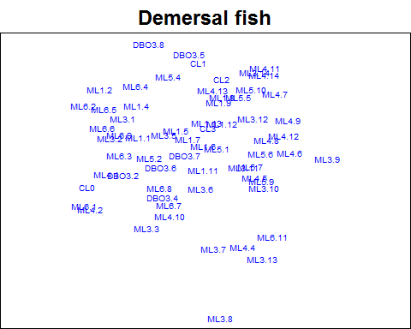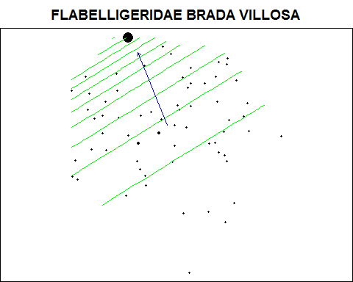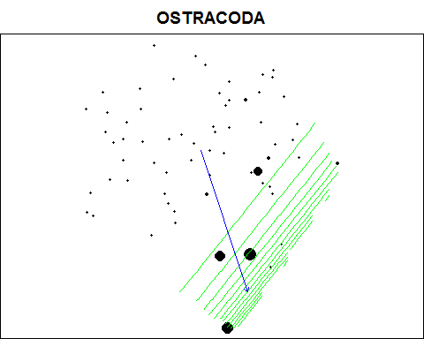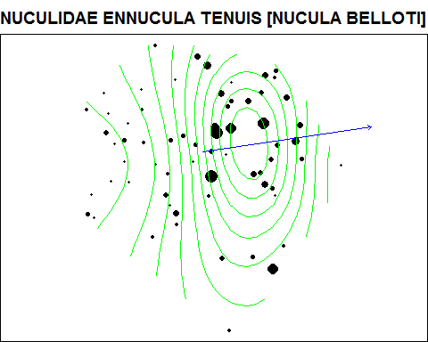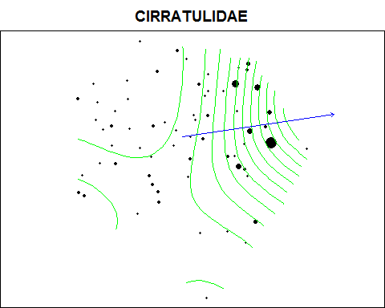

Infaunal species significantly associated with zooplankton community

|  |  |  |
| --- | --- | --- |
|  | R.sq | p |
| FLABELLIGERIDAE BRADA VILLOSA | 0.9978517 | 0.0000000 |
| LUMBRINEREIDAE SCOLETOMA [LUMBRINERIS] SP. | 0.3951645 | 0.0000012 |
| TELLINIDAE MACOMA CALCAREA | 0.3114257 | 0.0000019 |
| PHOLOIDAE [SIGALIONIDAE] PHOLOE MINUTA | 0.3104816 | 0.0099923 |
| PHYLLODOCIDAE ETEONE LONGA | 0.2527911 | 0.0033737 |
| PHOXOCEPHALIDAE HARPINIA SP. | 0.2437883 | 0.0002511 |
| COSSURIDAE COSSURA SP. | 0.2407798 | 0.0003132 |
| OPHELIIDAE TRAVISIA FORBESII | 0.2378435 | 0.0491558 |
| MONTACUTIDAE KURTIELLA [MYSELLA] PLANATA | 0.2297901 | 0.0174467 |

### Ordinations of zooplankton community with observed and predicted abundancs of key infaunal species

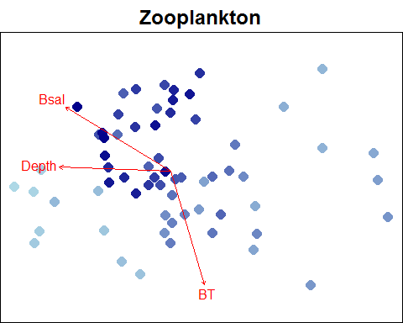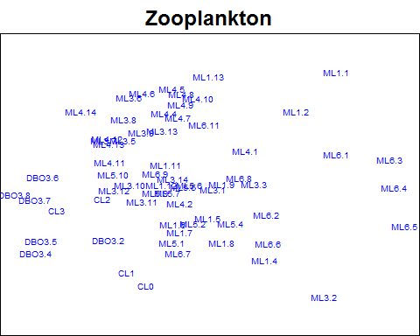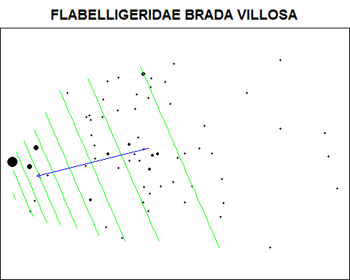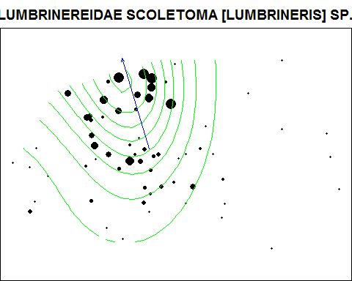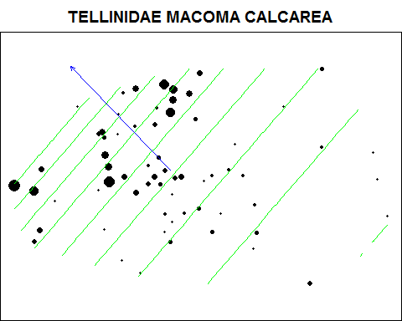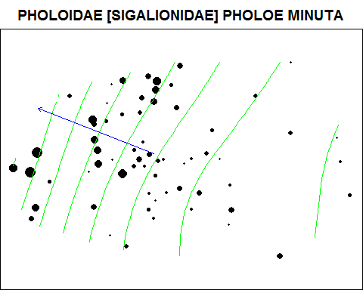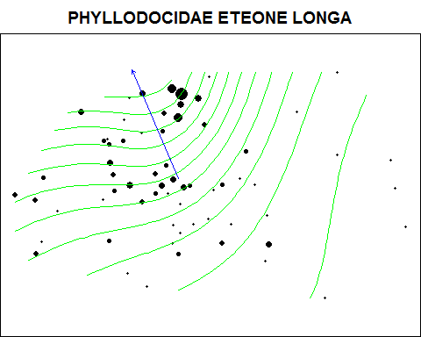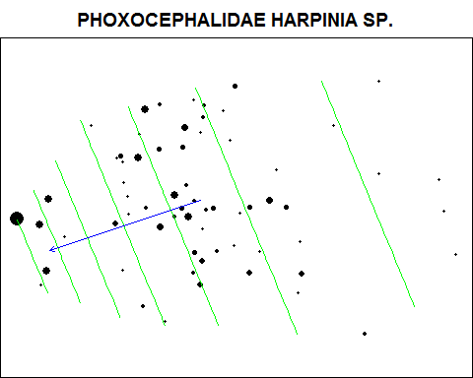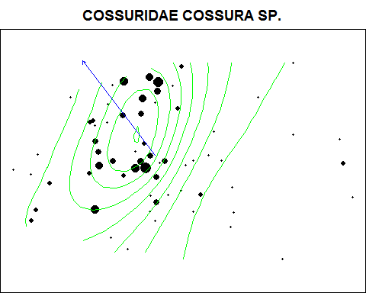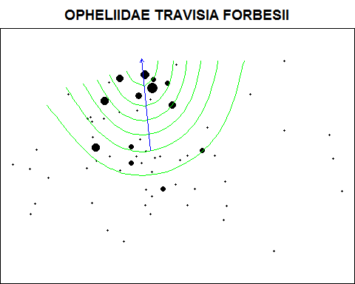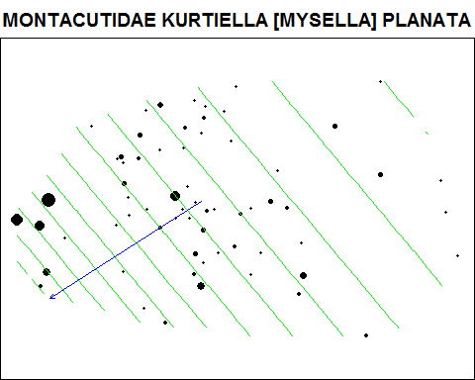

Infaunal species significantly associated with seabird community

|  |  |  |
| --- | --- | --- |
|  | R.sq | p |
| PONTOPOREIIDAE [HAUSTORIIDAE] PONTOPOREIA FEMORATA | 0.6764560 | 0.0000203 |
| FLABELLIGERIDAE BRADA VILLOSA | 0.2510791 | 0.0127645 |
| PHOLOIDAE [SIGALIONIDAE] PHOLOE MINUTA | 0.2268767 | 0.0188355 |
| CAPITELLIDAE HETEROMASTUS SP. | 0.2058145 | 0.0003802 |

### Ordinations of seabird community with observed and predicted abundancs of key infaunal species

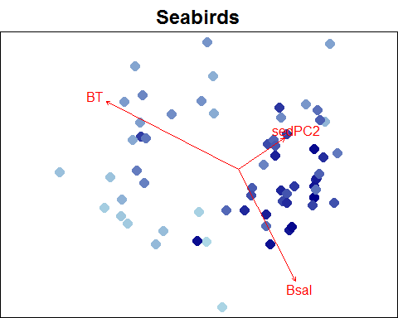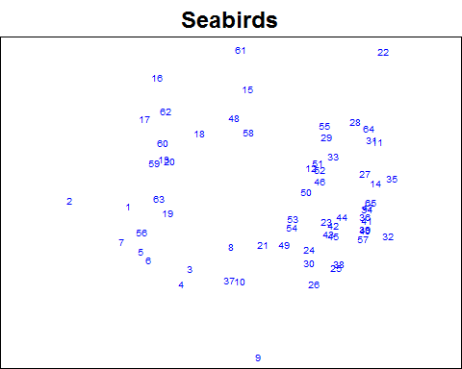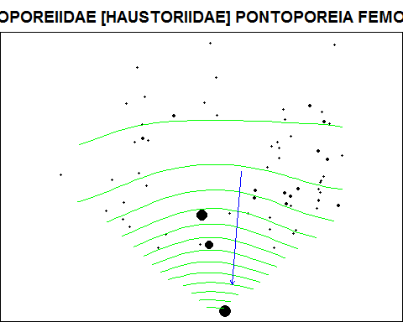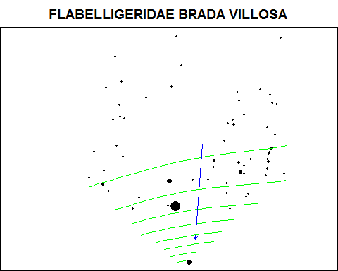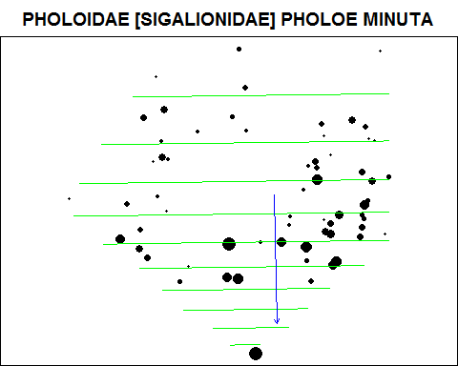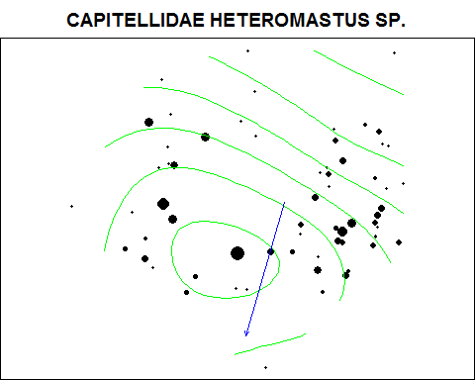

Epifaunal species significantly associated with fish community

|  |  |  |
| --- | --- | --- |
|  | R.sq | p |
| Oenopota sp. | 0.5400849 | 0.0000000 |
| Buccinum polare | 0.4509124 | 0.0001319 |
| Serripes groenlandicus | 0.3707395 | 0.0084625 |
| Stegophiura nodosa | 0.3636326 | 0.0250628 |
| Nemertea | 0.3439449 | 0.0000103 |
| Myriotrochus rinkii | 0.3183230 | 0.0001141 |
| Eualus gaimardii belcheri | 0.3164232 | 0.0000162 |
| Pycnogonidae | 0.2856410 | 0.0000053 |
| Anonyx sp. | 0.2576402 | 0.0261607 |
| Labidochirus splendescens | 0.2317347 | 0.0060581 |
| Pagurus capillatus | 0.2254640 | 0.0000000 |
| Eualus gaimardii gaimardii | 0.2025502 | 0.0000086 |

### Ordinations of fish community with observed and predicted abundancs of key epifaunal species

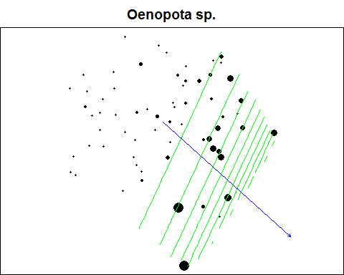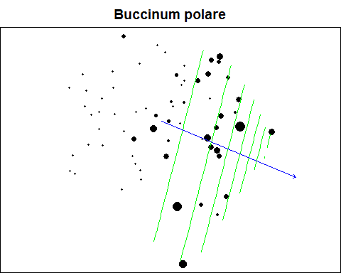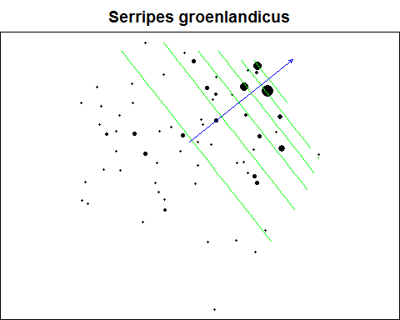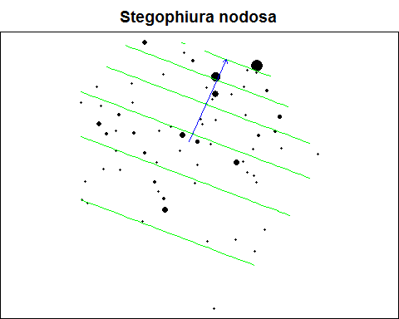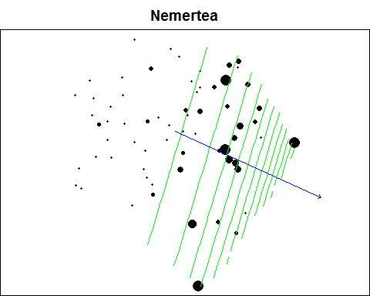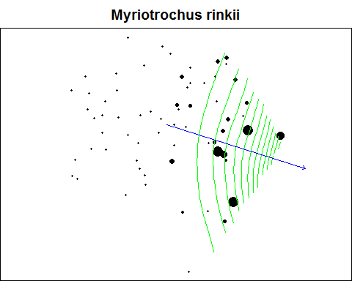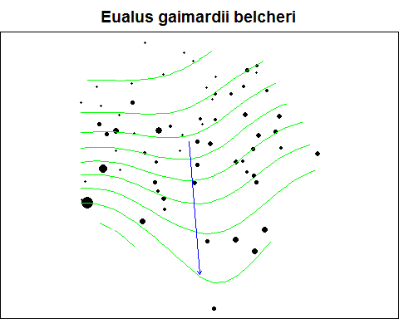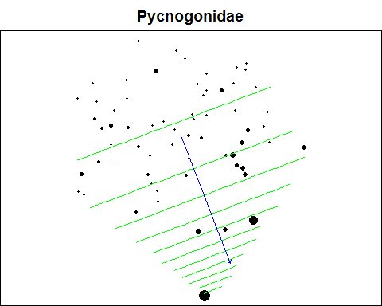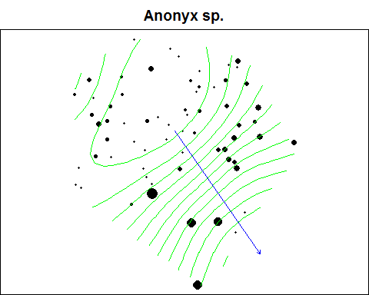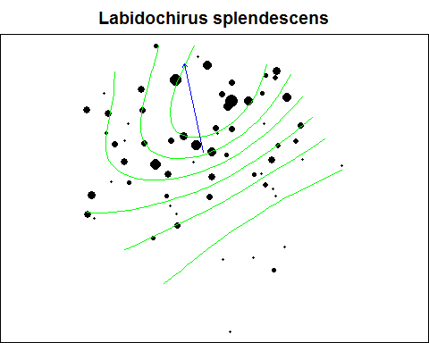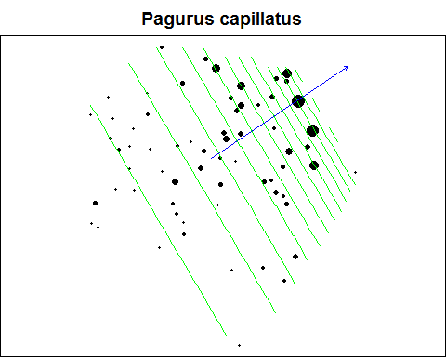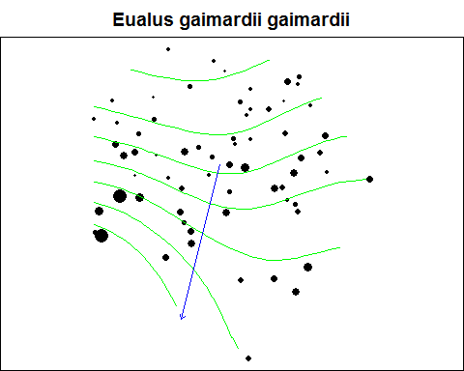

Epifaunal species significantly associated with zoopolankton community

|  |  |  |
| --- | --- | --- |
|  | R.sq | p |
| Echinarachnius parma | 0.4275319 | 0.0015560 |
| Phyllodoce groenlandica | 0.3454727 | 0.0002876 |
| Margarites helicinus | 0.3024404 | 0.0015641 |
| Propebela nobilis | 0.2446365 | 0.0469642 |

### Ordinations of zooplankton community with observed and predicted abundancs of key epifaunal species

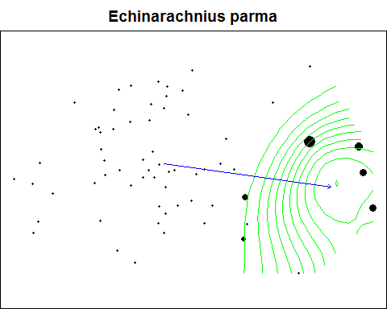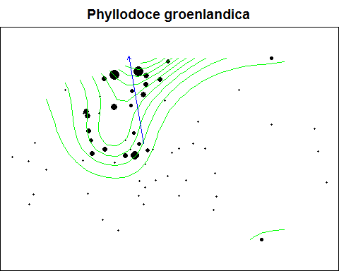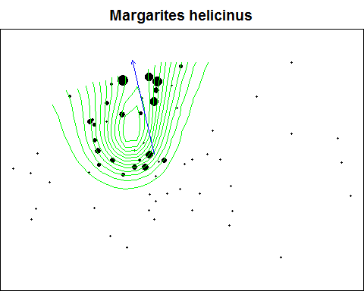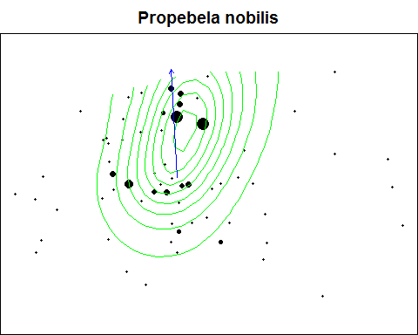

Epifaunal species significantly associated with infaunal community

|  |  |  |
| --- | --- | --- |
|  | R.sq | p |
| Diastylis sp. | 0.8058736 | 0.0016576 |
| Sclerocrangon boreas | 0.7732357 | 0.0000000 |
| Leptasterias groenlandica | 0.7114976 | 0.0000009 |
| Tachyrhynchus sp. | 0.6917308 | 0.0000000 |
| Argis sp. | 0.6694591 | 0.0000000 |
| Margarites helicinus | 0.6316829 | 0.0000006 |
| Actiniaria | 0.6017923 | 0.0018381 |
| Stomphia sp. | 0.4652904 | 0.0086756 |
| Eualus gaimardii gaimardii | 0.4196377 | 0.0003214 |
| Boltenia echinata | 0.3836737 | 0.0031259 |
| Anonyx sp. | 0.3714973 | 0.0000133 |
| Oenopota sp. | 0.3523231 | 0.0000000 |
| Eualus gaimardii belcheri | 0.2809178 | 0.0002705 |
| Margarites costalis | 0.2791890 | 0.0001429 |
| Pycnogonidae | 0.2575687 | 0.0020133 |
| Hyas coarctatus | 0.2076748 | 0.0000410 |

### Ordinations of infaunal community with observed and predicted abundancs of key epifaunal species

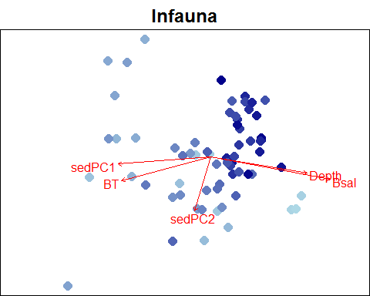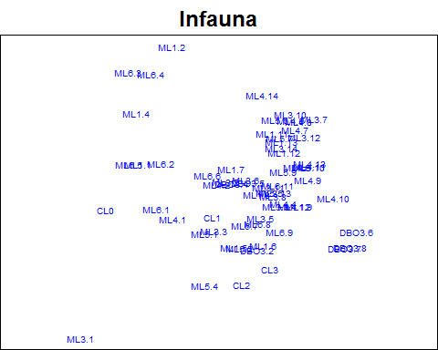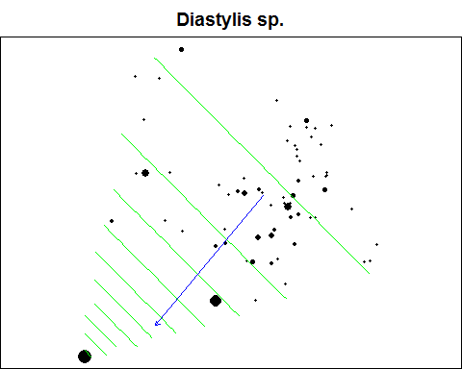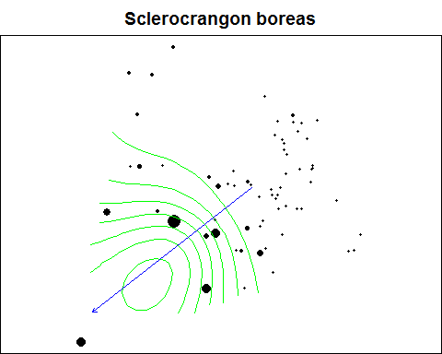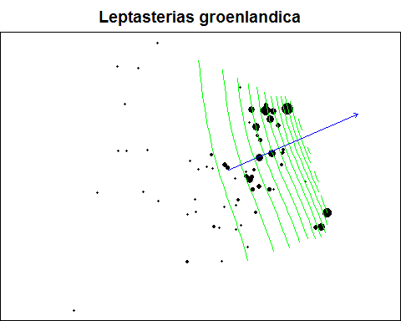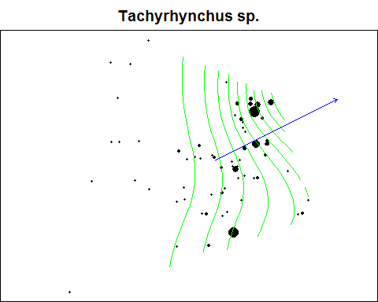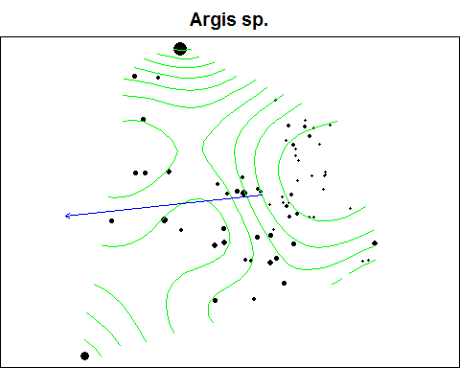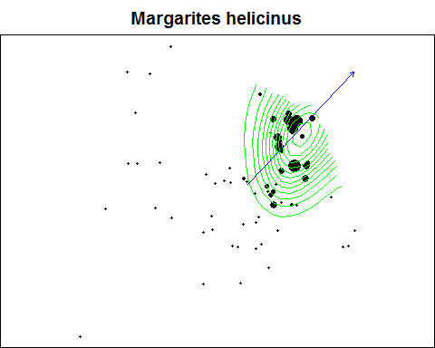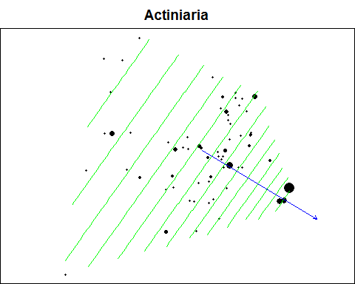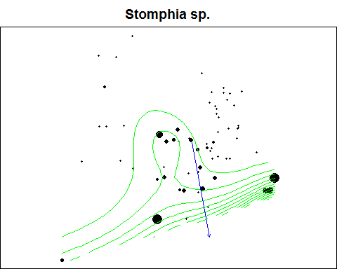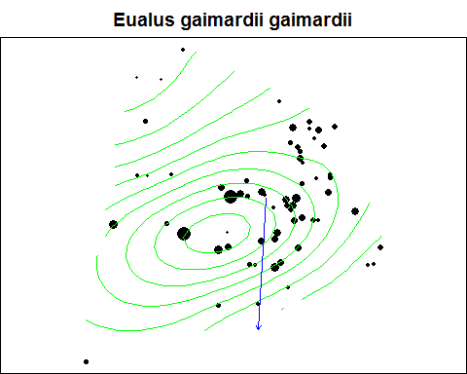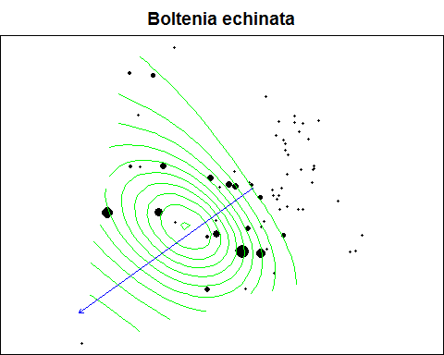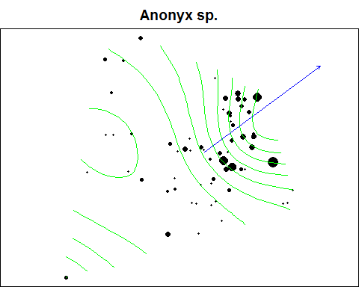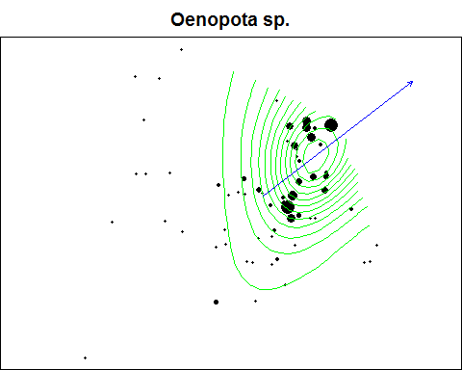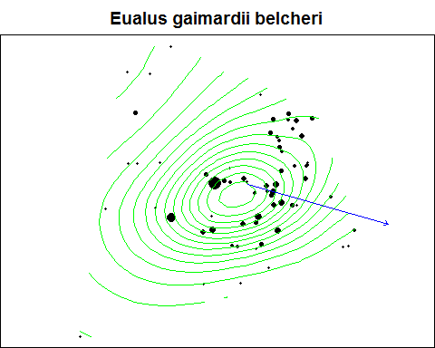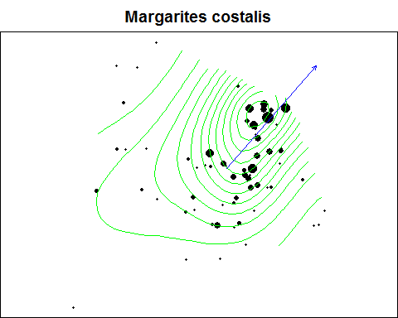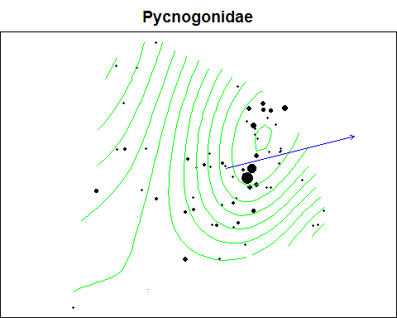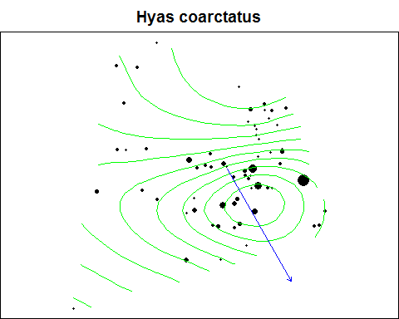

Zooplankton species significantly associated with fish community

|  |  |  |
| --- | --- | --- |
|  | R.sq | p |
| Metridia.pacifica | 0.6518387 | 0.0000028 |
| Triconia.borealis | 0.6489953 | 0.0000008 |
| Pseudocalanus.spp | 0.2420211 | 0.0000001 |
| Oithona.similis | 0.2127982 | 0.0026297 |
| Cirripedia | 0.2116689 | 0.0000092 |
| Bryozoa | 0.2035335 | 0.0450804 |

### Ordinations of fish community with observed and predicted abundancs of key zooplankton species

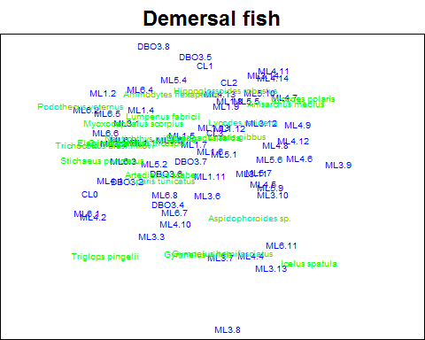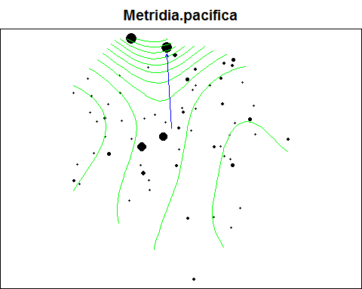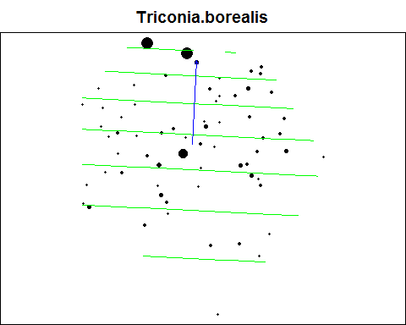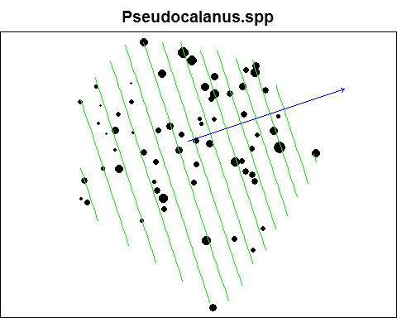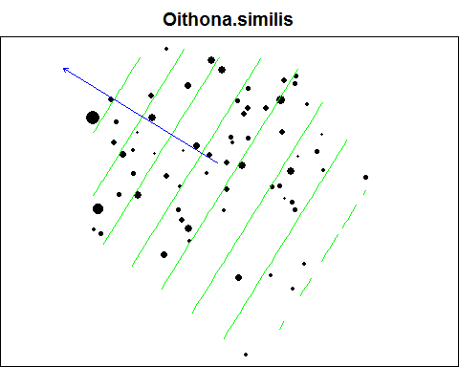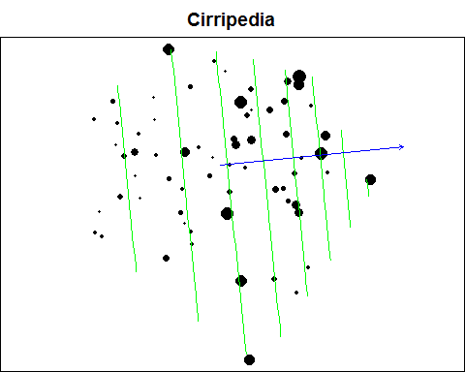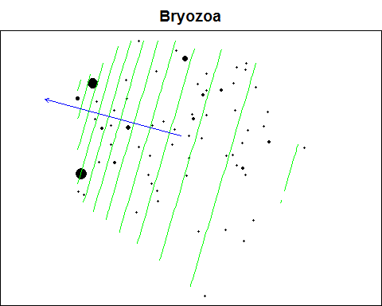

Zooplankton species significantly associated with seabird community

|  |  |  |
| --- | --- | --- |
|  | R.sq | p |
| Oithona.similis | 0.5299532 | 0.0000057 |
| Acartia.longiremis | 0.4798641 | 0.0001091 |
| Cirripedia | 0.3182995 | 0.0000013 |
| Neocalanus.flemingeri | 0.2910472 | 0.0000004 |
| Bryozoa | 0.2670364 | 0.0025559 |
| Echinodermata | 0.2476776 | 0.0010784 |
| Polychaeta | 0.2289565 | 0.0000098 |

### Ordinations of seabird community with observed and predicted abundancs of key zooplankton species

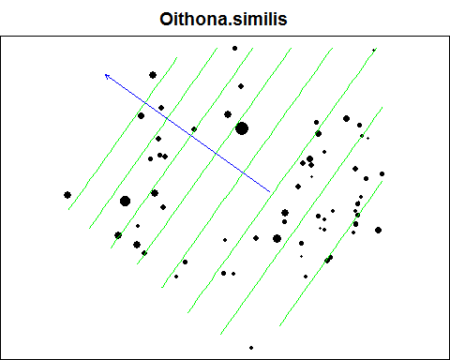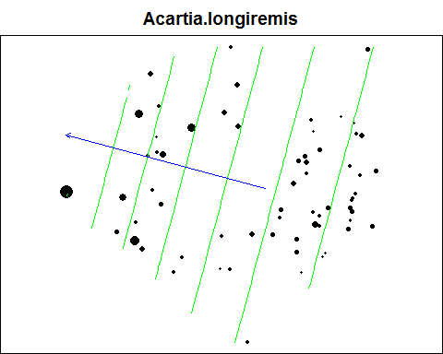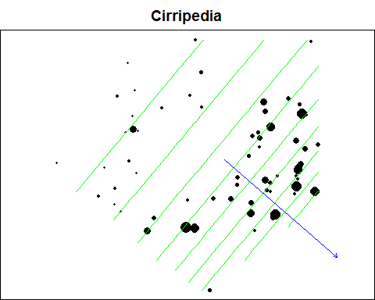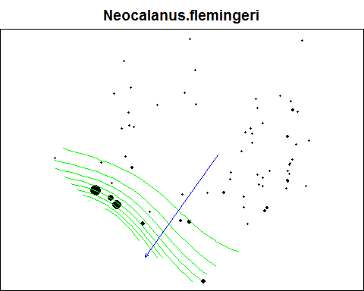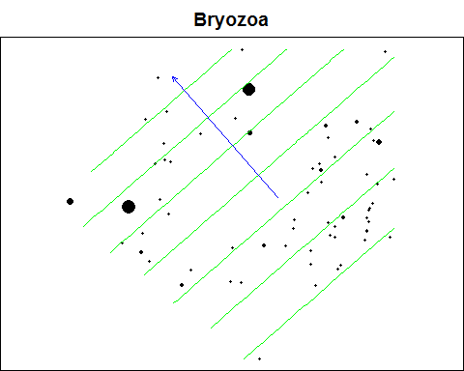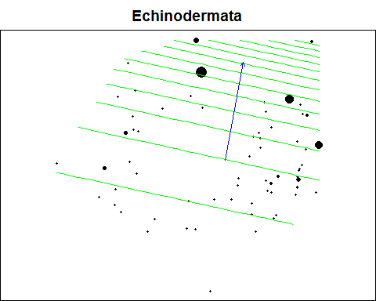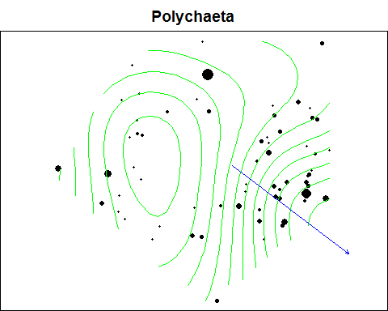

Demersal fish species significantly associated with zooplankton community

|  |  |  |
| --- | --- | --- |
|  | R.sq | p |
| Gymnocanthus tricuspis | 0.3525148 | 0.0000000 |
| Eleginus gracilis | 0.3311762 | 0.0241606 |
| Lumpenus fabricii | 0.2260017 | 0.0000222 |
| Boreogadus saida | 0.2046582 | 0.0001766 |

### Ordinations of zooplankton community with observed and predicted abundances of key fish species

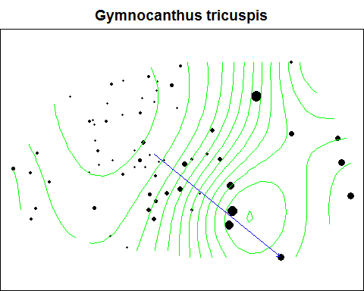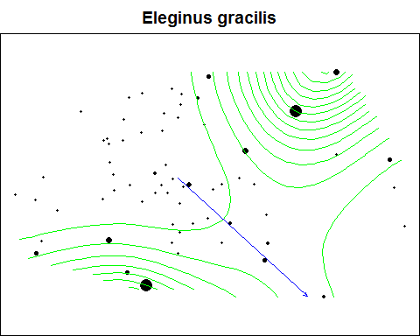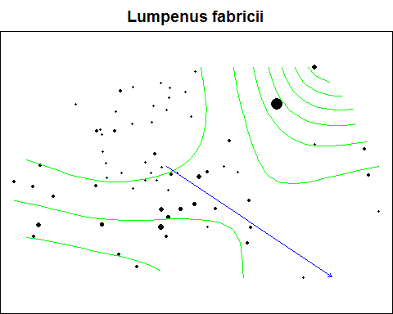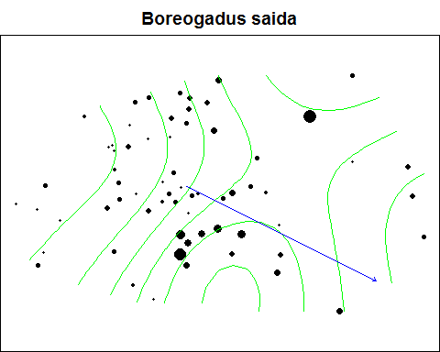

Demersal fish species significantly associated with seabird community

|  |  |  |
| --- | --- | --- |
|  | R.sq | p |
| Myoxocephalus scorpius | 0.6803773 | 0.00e+00 |
| Gymnocanthus tricuspis | 0.3376754 | 0.00e+00 |
| Boreogadus saida | 0.2325732 | 4.16e-05 |
| Lumpenus fabricii | 0.2179354 | 4.52e-04 |

### Ordinations of seabird community with observed and predicted abundancs of key fish species

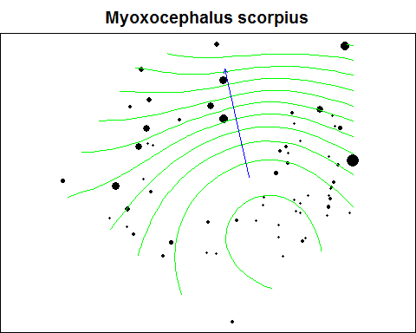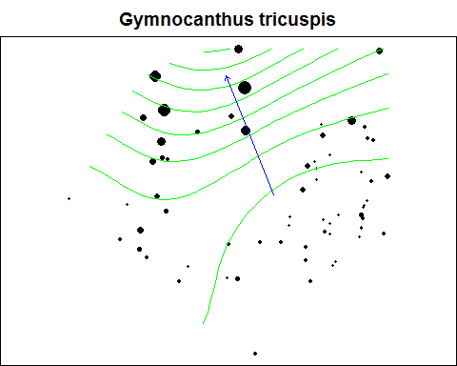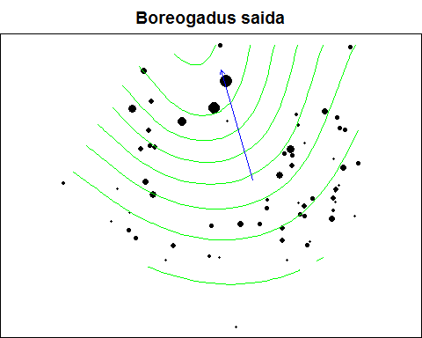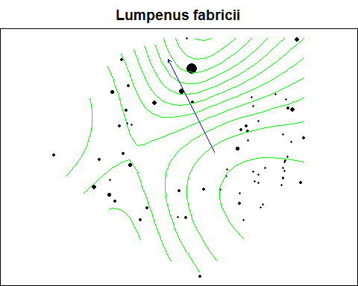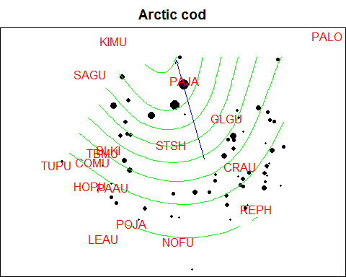

Demersal fish species significantly associated with seabird community

|  |  |  |
| --- | --- | --- |
|  | R.sq | p |
| LEAU | 0.8504291 | 0.0000000 |
| TBMU | 0.1432810 | 0.0054096 |
| STSH | 0.1352446 | 0.0000006 |

### Ordinations of zooplankton community with observed and predicted abundancs of key seabird species

