**Activity 5**

Franz Dave E. Apid BSIT3A-ST

CIT 218 System Administration and Maintenance

First step.

Use the help command to gather information, and what kind of alias you want to add.

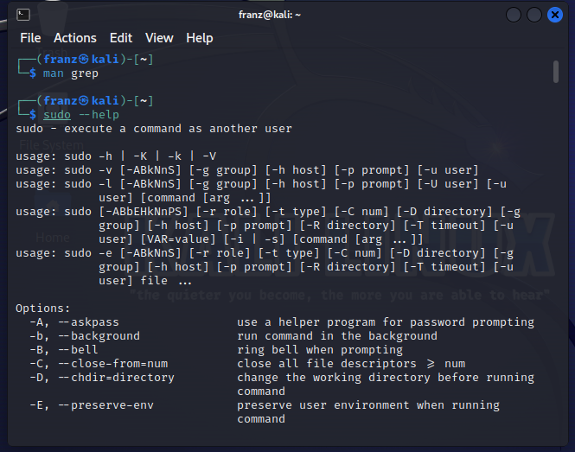

Second step.

When you find what you are looking for, add it to your aliases.

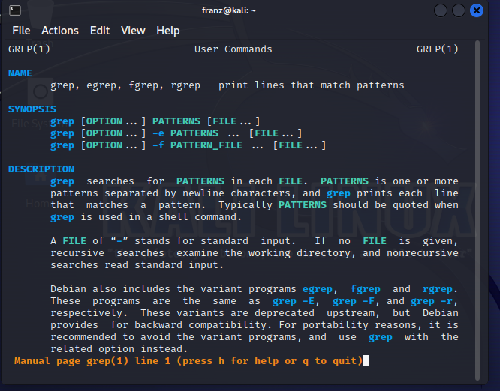

Explanation:

I added the clear alias since, when I type my code, I have errors and it became a messy sight in the command prompt and I often reset my work and that’s where I use the command clear, so I shorten it to “c” for efficiency.

