Appendix A.4
Database Schema and Data Management
A.4.1 Relational Database Model, Database Definition, and Normalized Architecture (3NF)
A.4.1.1 Formal Database Definition and Persistence Engine Specifications
The Human Resource Management System (HRMS) for the Grand Imperium Hotel & Suites utilizes a dedicated, highly optimized relational persistence architecture. The database specifications and storage parameters are formally established as follows:
- Database Name: hotel_hr
- Database Management System (DBMS): MySQL 8.0+ / MariaDB 10.4.27+ Enterprise Relational Database Server.
- Default Character Set & Collation: utf8mb4 character set with utf8mb4_unicode_ci collation, providing complete 4-byte UTF-8 encoding support for international hospitality guest and employee names, multi-language diacritics, localized text content, and serialized emoji reactions in the social recognition module.
- Storage Engine: InnoDB Transactional Storage Engine across all 55 relational tables. InnoDB enforces strict ACID compliance (Atomicity, Consistency, Isolation, Durability), foreign key referential integrity constraints (FOREIGN_KEY_CHECKS = 1), row-level concurrency locking for high-frequency timekeeping and applicant ingestion, and Write-Ahead Logging (WAL via Redo/Undo transaction logs).
- Schema Management & Versioning: Managed declaratively through Laravel 12 database migrations with deterministic schema versioning, foreign key cascading constraints, and structured database seeders.
A.4.1.2 Third Normal Form (3NF) Relational Foundations and Domain Clustering
To eliminate functional redundancies, ensure storage optimality, and prevent insertion, update, and deletion anomalies, the entire relational schema is strictly normalized to Third Normal Form (3NF):
- First Normal Form (1NF): Every table contains a unique primary key (BIGINT UNSIGNED AUTO_INCREMENT surrogate key or deterministic natural key), and all attribute values are atomic. Semi-structured payloads (such as extracted spaCy NLP entities, qualification match rubrics, candidate flags, and system settings) are stored in standardized JSON columns validated via MySQL CHECK (json_valid(...)) integrity constraints.
- Second Normal Form (2NF): All non-key attributes are fully functionally dependent on the entire primary key, eliminating partial key dependencies across composite associative entities (e.g., attendance_records, leave_balances, role_permissions).
- Third Normal Form (3NF): Transitive dependencies are eliminated by decoupling organizational units, job titles, compensation brackets, security roles, and applicant status stages into dedicated reference tables (departments, positions, salary_grades, system_roles, screening_reference_data).
The database architecture comprises 55 distinct relational tables logically partitioned into 11 functional domain clusters, providing comprehensive coverage across the entire human capital lifecycle:
- Authentication, Role-Based Access Control (RBAC), and Security Auditing Domain (8 tables)
- Organizational Hierarchy, Position Architecture, and Core HCM Domain (8 tables)
- Talent Acquisition, Job Requisitions, and Applicant Tracking Domain (6 tables)
- AI / NLP Automated Resume Screening and Taxonomic Benchmark Domain (5 tables)
- New Hire Onboarding, Digital Checklists, and Pre-Employment Compliance Domain (5 tables)
- Time, Attendance, and Shift Scheduling Domain (2 tables)
- Employee Self-Service (ESS), Leave Quotas, and AI Chatbot Support Domain (5 tables)
- Performance Evaluation, Social Recognition, and Merit Recommendations Domain (4 tables)
- Learning and Development (L&D) Domain (2 tables)
- Payroll Computation, Pay Periods, and Statutory Benefits Domain (4 tables)
- Application Framework, Session Persistence, and Infrastructure Domain (6 tables)

A.4.2 Enterprise Entity-Relationship Diagrams (ERD)
The relational architecture is visually modeled using standard Crow's Foot notation. The primary key (PK) and foreign key (FK) relationships enforce referential constraints across domain boundaries.
Figure A.4.1
_Master High-Level Enterprise Entity-Relationship Architecture (Core Domain Hubs)_
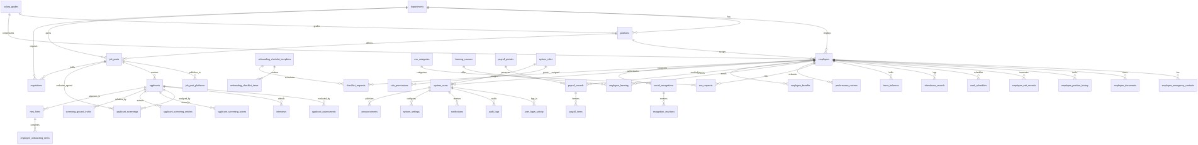

_Note._ Master architectural diagram illustrating primary entity interconnections, foreign key constraints, and relational flow across the 11 functional domains of the hotel_hr database.

Figure A.4.2
_Domain-Specific Relational Architecture Sub-Diagrams_
A. Talent Acquisition & AI/NLP Resume Screening Pipeline ERD
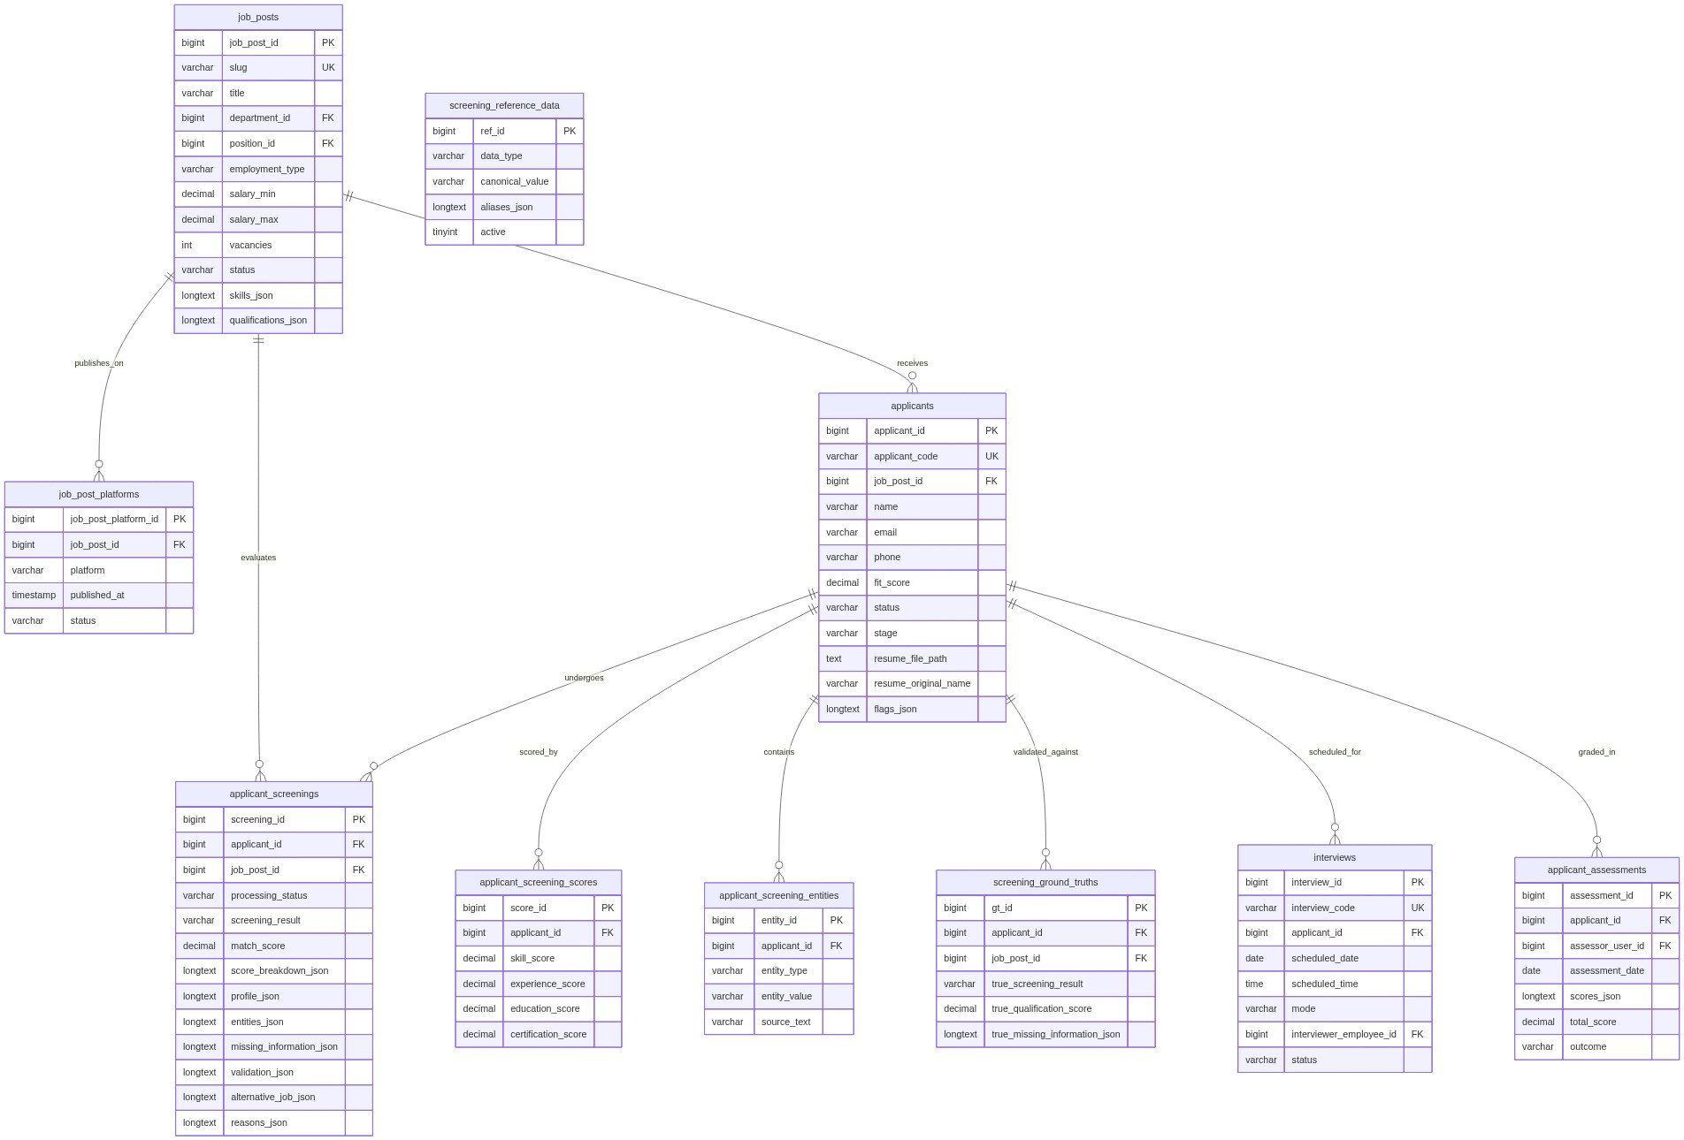

B. Core HCM, Employee 201 Dossier, and Onboarding ERD
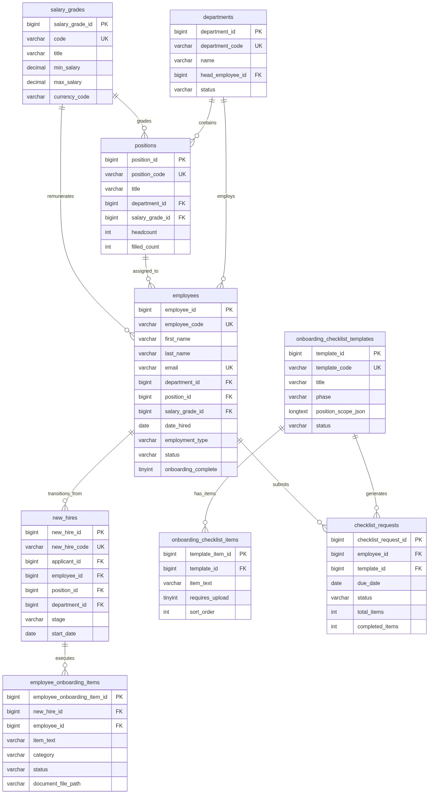

C. Attendance, Payroll, ESS, and Social Engagement ERD
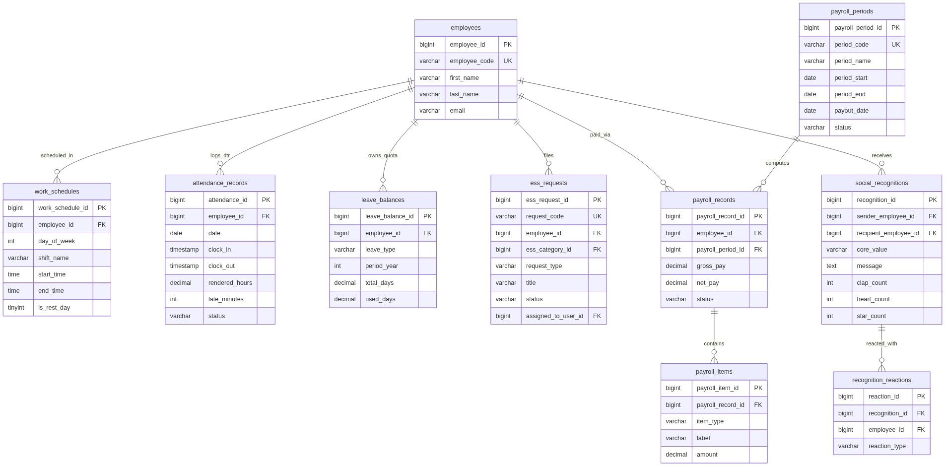

A.4.3 Comprehensive Relational Database Data Dictionary (All 55 Tables)
The schema structure, primary keys, foreign key constraints, column definitions, and business logic for all 55 relational tables in the hotel_hr database are exhaustively detailed across Tables A.4.1 through A.4.11.
Table A.4.1
_Authentication, Role-Based Access Control (RBAC), and Security Auditing Domain_
Governs system authentication, encrypted credentials, role hierarchies, permission mapping, login monitoring, and immutable transaction audit trails.
Domain Table | Primary Key | Foreign Key Relationships | Core Purpose and Schema Contents
system_users | system_user_id (BigInt) | employee_id &rarr; employees(employee_id)  role_id &rarr; system_roles(role_id) | Purpose: Stores authenticated user accounts, encrypted password hashes (bcrypt), two-factor authentication (2FA OTP) status, role assignments, linked employee records, and security login tracking.  Attributes: system_user_id (PK), username (UQ), email (UQ), password_hash, full_name, department_name, employee_id (FK), role_id (FK), status, otp_enabled, last_login_at, last_login_ip, created_at, updated_at  Integrity Rules: UNIQUE(username), UNIQUE(email), ON DELETE RESTRICT on employee_id, ON DELETE RESTRICT on role_id
system_roles | role_id (BigInt) | None (Master Role Entity) | Purpose: Defines security roles (Super Admin, HR Admin, HR Staff, Department Head, Employee) and system protection flags.  Attributes: role_id (PK), role_name (UQ), description, is_super_admin, is_protected, created_at, updated_at  Integrity Rules: UNIQUE(role_name), is_protected prevents accidental drop of root roles
role_permissions | role_permission_id (BigInt) | role_id &rarr; system_roles(role_id) (ON DELETE CASCADE) | Purpose: Establishes fine-grained module-level authorization matrix specifying access tiers across modules.  Attributes: role_permission_id (PK), role_id (FK), module_name, permission_level (none/read/write/admin), created_at, updated_at  Integrity Rules: UNIQUE(role_id, module_name), ON DELETE CASCADE
user_login_activity | login_activity_id (BigInt) | system_user_id &rarr; system_users(system_user_id) (ON DELETE CASCADE) | Purpose: Maintains an immutable historical record of user login attempts, source IP addresses, client user agents, and status.  Attributes: login_activity_id (PK), system_user_id (FK), login_at, ip_address, device_info, user_agent, status  Integrity Rules: ON DELETE CASCADE, indexed on system_user_id and login_at
audit_logs | audit_log_id (BigInt) | system_user_id &rarr; system_users(system_user_id) (ON DELETE SET NULL) | Purpose: Immutable administrative audit trail capturing all system mutations, actor roles, severity tiers, and request details.  Attributes: audit_log_id (PK), system_user_id (FK), actor_role, actor_department, occurred_at, action, module_name, target_type, target_id, details (JSON/text), severity, ip_address, device_info, url  Integrity Rules: ON DELETE SET NULL, Append-only partition, indexed on occurred_at and module_name
system_settings | setting_id (BigInt) | updated_by_user_id &rarr; system_users(system_user_id) | Purpose: Persists global application key-value configurations, system thresholds, notification triggers, and active maintenance flags.  Attributes: setting_id (PK), setting_key (UQ), setting_value (text), updated_by_user_id (FK), created_at, updated_at  Integrity Rules: UNIQUE(setting_key), ON DELETE RESTRICT on updated_by_user_id
notifications | notification_id (BigInt) | system_user_id &rarr; system_users(system_user_id) (ON DELETE CASCADE) | Purpose: Stores real-time in-app alerts and notifications delivered to authenticated users across recruitment and HR events.  Attributes: notification_id (PK), system_user_id (FK), type, title, body, module_name, target_type, target_id, is_read, read_at, created_at  Integrity Rules: ON DELETE CASCADE, indexed on (system_user_id, is_read)
announcements | announcement_id (BigInt) | created_by_user_id &rarr; system_users(system_user_id) | Purpose: Maintains organization-wide bulletin board announcements, job fair bulletins, training advisories, and policy broadcasts.  Attributes: announcement_id (PK), published_date, title, body, audience, created_by_user_id (FK), status, created_at, updated_at  Integrity Rules: ON DELETE RESTRICT, indexed on status and published_date

_Note._ Managed via InnoDB engine with utf8mb4_unicode_ci character collation and transaction isolation.
Table A.4.2
_Organizational Hierarchy, Position Architecture, and Core HCM Domain_
Establishes enterprise organizational units, standardized job titles, salary grades, complete employee 201 personnel records, uploaded compliance files, and career progression history.
Domain Table | Primary Key | Foreign Key Relationships | Core Purpose and Schema Contents
departments | department_id (BigInt) | head_employee_id &rarr; employees(employee_id) | Purpose: Defines hotel operational divisions (Front Office, Food & Beverage, Housekeeping, Culinary, HR, Finance) and department heads.  Attributes: department_id (PK), department_code (UQ), name, description, location, head_employee_id (FK), status, created_at, updated_at  Integrity Rules: UNIQUE(department_code), ON DELETE RESTRICT
positions | position_id (BigInt) | department_id &rarr; departments(department_id)  salary_grade_id &rarr; salary_grades(salary_grade_id) | Purpose: Catalogs distinct job titles, organizational department mapping, salary grade linkages, and authorized headcount limits.  Attributes: position_id (PK), position_code (UQ), title, department_id (FK), salary_grade_id (FK), level, headcount, filled_count, created_at, updated_at  Integrity Rules: UNIQUE(position_code), ON DELETE RESTRICT
salary_grades | salary_grade_id (BigInt) | None (Master Compensation Entity) | Purpose: Standardized compensation grade table establishing minimum and maximum salary brackets and currency codes.  Attributes: salary_grade_id (PK), code (UQ), title, min_salary, max_salary, currency_code, level, notes, created_at, updated_at  Integrity Rules: UNIQUE(code), min_salary <= max_salary check
employees | employee_id (BigInt) | department_id &rarr; departments(department_id)  position_id &rarr; positions(position_id)  salary_grade_id &rarr; salary_grades(salary_grade_id)  supervisor_employee_id &rarr; employees(employee_id) | Purpose: Comprehensive employee 201 dossier storing demographic data, statutory IDs (SSS, TIN, PhilHealth, Pag-IBIG), status, and supervisor links.  Attributes: employee_id (PK), employee_code (UQ), first_name, middle_name, last_name, email (UQ), personal_email, phone, address, birth_date, gender, civil_status, nationality, sss_number, philhealth_number, pagibig_number, tin_number, position_id (FK), department_id (FK), employment_type, date_hired, supervisor_employee_id (FK), status, onboarding_complete, salary_grade_id (FK), salary_step, employee_record_last_updated_at, created_at, updated_at  Integrity Rules: UNIQUE(employee_code), UNIQUE(email), ON DELETE RESTRICT on organizational FKs
employee_emergency_contacts | emergency_contact_id (BigInt) | employee_id &rarr; employees(employee_id) (ON DELETE CASCADE) | Purpose: Stores employee emergency contacts, relationships, priority phone numbers, and physical addresses.  Attributes: emergency_contact_id (PK), employee_id (FK), contact_name, relationship, primary_phone, secondary_phone, email, address, is_primary, created_at, updated_at  Integrity Rules: ON DELETE CASCADE
employee_documents | document_id (BigInt) | employee_id &rarr; employees(employee_id) (ON DELETE CASCADE)  verified_by_user_id &rarr; system_users(system_user_id) | Purpose: Maintains physical metadata and encrypted storage paths for uploaded employee 201 compliance files (BIR 2316, NBI, Medical).  Attributes: document_id (PK), employee_id (FK), document_type, document_name, file_path, file_size, mime_type, status, verified_by_user_id (FK), verified_at, notes, created_at, updated_at  Integrity Rules: ON DELETE CASCADE on employee_id
employee_position_history | position_history_id (BigInt) | employee_id &rarr; employees(employee_id) (ON DELETE CASCADE)  position_id &rarr; positions(position_id)  department_id &rarr; departments(department_id)  salary_grade_id &rarr; salary_grades(salary_grade_id) | Purpose: Logs career progression, department transfers, title changes, promotion milestones, and historical salary grade adjustments.  Attributes: position_history_id (PK), employee_id (FK), position_id (FK), department_id (FK), salary_grade_id (FK), effective_date, end_date, movement_type, remarks, created_at  Integrity Rules: ON DELETE CASCADE on employee_id
employee_exit_records | exit_record_id (BigInt) | employee_id &rarr; employees(employee_id) (ON DELETE CASCADE) | Purpose: Captures employee offboarding, resignation filings, exit interviews, clearance completion, and rehire eligibility status.  Attributes: exit_record_id (PK), employee_id (FK), separation_type, resignation_date, effective_date, reason, clearance_status, eligible_for_rehire, notes, created_at, updated_at  Integrity Rules: ON DELETE CASCADE

_Note._ Managed via InnoDB engine with utf8mb4_unicode_ci character collation and transaction isolation.
Table A.4.3
_Talent Acquisition, Job Requisitions, and Applicant Tracking Domain_
Facilitates manpower requests, public vacancy publishing, multichannel recruitment syndication, candidate applications, interview scheduling, and assessment scorecards.
Domain Table | Primary Key | Foreign Key Relationships | Core Purpose and Schema Contents
requisitions | requisition_id (BigInt) | converted_job_post_id &rarr; job_posts(job_post_id)  department_id &rarr; departments(department_id)  position_id &rarr; positions(position_id)  requested_by_user_id &rarr; system_users(system_user_id) | Purpose: Tracks department manpower requisition requests, authorized headcounts, urgency baselines, justification, and job post conversions.  Attributes: requisition_id (PK), requisition_code (UQ), position_id (FK), position_title, department_id (FK), requested_by_user_id (FK), requested_count, urgency, justification, status, requested_at, converted_job_post_id (FK), created_at, updated_at  Integrity Rules: UNIQUE(requisition_code), ON DELETE RESTRICT
job_posts | job_post_id (BigInt) | department_id &rarr; departments(department_id)  position_id &rarr; positions(position_id) | Purpose: Stores public job vacancy postings, required skills arrays, qualification criteria, salary bands, and vacancy quotas.  Attributes: job_post_id (PK), slug (UQ), title, department_id (FK), position_id (FK), employment_type, schedule, salary_min, salary_max, vacancies, filled_count, posted_date, status, active, experience_level, education_level, summary, description, responsibilities_json, qualifications_json, skills_json, benefits_json, picture, created_at, updated_at  Integrity Rules: UNIQUE(slug), CHECK(json_valid(skills_json)), ON DELETE RESTRICT
job_post_platforms | job_post_platform_id (BigInt) | job_post_id &rarr; job_posts(job_post_id) (ON DELETE CASCADE) | Purpose: Maintains multichannel publication state across external recruitment boards (Indeed, JobStreet, LinkedIn, Hotel Careers Portal).  Attributes: job_post_platform_id (PK), job_post_id (FK), platform, published_at, status, created_at  Integrity Rules: ON DELETE CASCADE
applicants | applicant_id (BigInt) | job_post_id &rarr; job_posts(job_post_id) | Purpose: Stores candidate profiles, contact details, resume file storage paths, overall fit scores, pipeline stages, and NLP evaluation flags.  Attributes: applicant_id (PK), applicant_code (UQ), job_post_id (FK), name, email, phone, applied_at, fit_score, status, stage (Screened/Interview/Offer/Accepted/Hired/Rejected), source, resume_file_path, resume_original_name, summary, flags_json, created_at, updated_at  Integrity Rules: UNIQUE(applicant_code), CHECK(json_valid(flags_json)), ON DELETE RESTRICT on job_post_id
interviews | interview_id (BigInt) | applicant_id &rarr; applicants(applicant_id) (ON DELETE CASCADE)  interviewer_employee_id &rarr; employees(employee_id) | Purpose: Schedules candidate interviews, logistics (in-person, online, phone), assigned interviewers, and interview outcome status.  Attributes: interview_id (PK), interview_code (UQ), applicant_id (FK), scheduled_date, scheduled_time, mode, interviewer_employee_id (FK), interviewer_name, status, created_at, updated_at  Integrity Rules: UNIQUE(interview_code), ON DELETE CASCADE on applicant_id
applicant_assessments | assessment_id (BigInt) | applicant_id &rarr; applicants(applicant_id) (ON DELETE CASCADE)  assessor_user_id &rarr; system_users(system_user_id) | Purpose: Stores interviewer evaluation rubrics (Guest Service, Technical Skill, Grooming, Communication), rubric scores, and hire recommendations.  Attributes: assessment_id (PK), applicant_id (FK), assessor_user_id (FK), assessment_date, scores_json, total_score, outcome, remarks, created_at, updated_at  Integrity Rules: CHECK(json_valid(scores_json)), ON DELETE CASCADE on applicant_id

_Note._ Managed via InnoDB engine with utf8mb4_unicode_ci character collation and transaction isolation.
Table A.4.4
_AI / NLP Automated Resume Screening and Taxonomic Benchmark Domain_
Persists natural language processing (NLP) extracted entity tokens, weighted multi-criteria qualification scoring, reference taxonomy dictionaries, and gold-standard evaluation benchmarks.
Domain Table | Primary Key | Foreign Key Relationships | Core Purpose and Schema Contents
applicant_screenings | screening_id (BigInt) | applicant_id &rarr; applicants(applicant_id) (ON DELETE CASCADE)  job_post_id &rarr; job_posts(job_post_id) | Purpose: Comprehensive record of spaCy AI inference runs, score breakdowns, extracted entity profiles, missing criteria, and classification.  Attributes: screening_id (PK), applicant_id (FK), job_post_id (FK), processing_status, screening_result, match_score, score_breakdown_json, profile_json, entities_json, missing_information_json, validation_json, alternative_job_json, reasons_json, model_info_json, error_message, processed_at, created_at, updated_at  Integrity Rules: CHECK(json_valid(score_breakdown_json)), ON DELETE CASCADE on applicant_id
applicant_screening_scores | score_id (BigInt) | applicant_id &rarr; applicants(applicant_id) (ON DELETE CASCADE) | Purpose: Normalized mathematical sub-score breakdown storing individual weighted scores (Skills, Experience, Education, Certifications).  Attributes: score_id (PK), applicant_id (FK), skill_score, experience_score, education_score, certification_score, created_at  Integrity Rules: ON DELETE CASCADE
applicant_screening_entities | entity_id (BigInt) | applicant_id &rarr; applicants(applicant_id) (ON DELETE CASCADE) | Purpose: Individual named entity spans (PERSON, SKILL, EDUCATION, JOB_TITLE, CERTIFICATION) extracted by custom spaCy NLP pipeline.  Attributes: entity_id (PK), applicant_id (FK), entity_type, entity_value, source_text, created_at  Integrity Rules: ON DELETE CASCADE, indexed on (applicant_id, entity_type)
screening_reference_data | ref_id (BigInt) | None (Master Taxonomy Dictionary) | Purpose: Master canonical taxonomy dictionary containing 71+ standardized hospitality skills, job titles, education levels, and aliases.  Attributes: ref_id (PK), data_type, canonical_value, aliases_json, active, created_at, updated_at  Integrity Rules: CHECK(json_valid(aliases_json)), indexed on (data_type, canonical_value)
screening_ground_truths | gt_id (BigInt) | applicant_id &rarr; applicants(applicant_id) (ON DELETE CASCADE)  job_post_id &rarr; job_posts(job_post_id) | Purpose: Gold-standard human-annotated resume dataset used for automated benchmarking, accuracy scoring, and research validation.  Attributes: gt_id (PK), applicant_id (FK), job_post_id (FK), true_screening_result, true_qualification_score, true_missing_information_json, true_unrecognized_skills_json, notes, created_at, updated_at  Integrity Rules: ON DELETE CASCADE on applicant_id

_Note._ Managed via InnoDB engine with utf8mb4_unicode_ci character collation and transaction isolation.
Table A.4.5
_New Hire Onboarding, Digital Checklists, and Pre-Employment Compliance Domain_
Automates pre-employment workflow transitions, checklist template configurations, document verification, and onboarding task fulfillment.
Domain Table | Primary Key | Foreign Key Relationships | Core Purpose and Schema Contents
new_hires | new_hire_id (BigInt) | applicant_id &rarr; applicants(applicant_id)  employee_id &rarr; employees(employee_id)  position_id &rarr; positions(position_id)  department_id &rarr; departments(department_id) | Purpose: Transitions accepted applicants into pre-employment onboarding dossiers, tracking checklist progress and target employment start dates.  Attributes: new_hire_id (PK), new_hire_code (UQ), applicant_id (FK), employee_id (FK), name, email, phone, position_id (FK), department_id (FK), stage, start_date, created_at, updated_at  Integrity Rules: UNIQUE(new_hire_code), ON DELETE RESTRICT
onboarding_checklist_templates | template_id (BigInt) | None (Master Checklist Template) | Purpose: Configures standardized onboarding checklist templates categorized by departmental scope and employment phases.  Attributes: template_id (PK), template_code (UQ), title, phase, position_scope_json, status, created_at, updated_at  Integrity Rules: UNIQUE(template_code), CHECK(json_valid(position_scope_json))
onboarding_checklist_items | template_item_id (BigInt) | template_id &rarr; onboarding_checklist_templates(template_id) (ON DELETE CASCADE) | Purpose: Individual requirement items within an onboarding template (e.g., NBI Clearance, Medical Exam, Uniform Sizing, Bank Details).  Attributes: template_item_id (PK), template_id (FK), item_text, instructions, requires_upload, upload_placeholder, sort_order, created_at  Integrity Rules: ON DELETE CASCADE
employee_onboarding_items | employee_onboarding_item_id (BigInt) | new_hire_id &rarr; new_hires(new_hire_id)  employee_id &rarr; employees(employee_id)  completed_by_user_id &rarr; system_users(system_user_id)  verified_by_user_id &rarr; system_users(system_user_id) | Purpose: Tracks fulfillment, verification, and file attachments for individual employee pre-employment onboarding tasks.  Attributes: employee_onboarding_item_id (PK), new_hire_id (FK), employee_id (FK), item_text, category, status, document_file_path, completed_at, completed_by_user_id (FK), verified_at, verified_by_user_id (FK), notes, created_at, updated_at  Integrity Rules: ON DELETE RESTRICT on completed_by_user_id
checklist_requests | checklist_request_id (BigInt) | employee_id &rarr; employees(employee_id)  template_id &rarr; onboarding_checklist_templates(template_id)  requested_by_user_id &rarr; system_users(system_user_id) | Purpose: Stores formal document/task fulfillment requests dispatched to new hires and employees with progress counters.  Attributes: checklist_request_id (PK), employee_id (FK), template_id (FK), requested_by_user_id (FK), due_date, status, total_items, completed_items, remarks, created_at, updated_at  Integrity Rules: ON DELETE RESTRICT

_Note._ Managed via InnoDB engine with utf8mb4_unicode_ci character collation and transaction isolation.
Table A.4.6
_Time, Attendance, and Shift Scheduling Domain_
Maintains employee shift rosters, scheduled rest days, biometric clock-in/out timestamps, tardiness/undertime calculations, and daily time records (DTR).
Domain Table | Primary Key | Foreign Key Relationships | Core Purpose and Schema Contents
work_schedules | work_schedule_id (BigInt) | employee_id &rarr; employees(employee_id) (ON DELETE CASCADE) | Purpose: Manages employee shift assignments, scheduled rest days, work locations, and start/end time windows.  Attributes: work_schedule_id (PK), employee_id (FK), day_of_week, shift_name, start_time, end_time, location, is_rest_day, effective_from, effective_to, created_at, updated_at  Integrity Rules: ON DELETE CASCADE, indexed on (employee_id, day_of_week)
attendance_records | attendance_id (BigInt) | employee_id &rarr; employees(employee_id) (ON DELETE CASCADE) | Purpose: Daily Time Records (DTR) capturing microsecond biometric clock-in/out timestamps, total rendered hours, tardiness, and undertime.  Attributes: attendance_id (PK), employee_id (FK), date, clock_in, clock_out, rendered_hours, late_minutes, undertime_minutes, overtime_hours, status (present/absent/late/leave), source, remarks, created_at, updated_at  Integrity Rules: UNIQUE(employee_id, date), ON DELETE CASCADE, indexed on (employee_id, date)

_Note._ Managed via InnoDB engine with utf8mb4_unicode_ci character collation and transaction isolation.
Table A.4.7
_Employee Self-Service (ESS), Leave Quotas, and AI Chatbot Support Domain_
Governs statutory and company leave allocations, employee service requests, workflow approvals, and conversational AI knowledge base FAQ lookups.
Domain Table | Primary Key | Foreign Key Relationships | Core Purpose and Schema Contents
leave_balances | leave_balance_id (BigInt) | employee_id &rarr; employees(employee_id) (ON DELETE CASCADE) | Purpose: Maintains annual statutory and company leave allocations (Vacation, Sick, Emergency, Maternity) and consumed balances per employee.  Attributes: leave_balance_id (PK), employee_id (FK), leave_type, period_year, total_days, used_days, created_at, updated_at  Integrity Rules: UNIQUE(employee_id, leave_type, period_year), ON DELETE CASCADE
ess_categories | ess_category_id (BigInt) | None (Master ESS Category) | Purpose: Configures categories for Employee Self-Service requests (Leave, Certificate of Employment, Schedule Adjustment, Info Update).  Attributes: ess_category_id (PK), code (UQ), name, description, icon, sla_hours, active, created_at, updated_at  Integrity Rules: UNIQUE(code)
ess_requests | ess_request_id (BigInt) | employee_id &rarr; employees(employee_id)  ess_category_id &rarr; ess_categories(ess_category_id)  assigned_to_user_id &rarr; system_users(system_user_id) | Purpose: Stores self-service tickets filed by employees, attachment files, resolution status, assigned HR agents, and approval timestamps.  Attributes: ess_request_id (PK), request_code (UQ), employee_id (FK), ess_category_id (FK), request_type, title, details, attachment_file_path, status (pending/approved/rejected), assigned_to_user_id (FK), resolution_notes, resolved_at, created_at, updated_at  Integrity Rules: UNIQUE(request_code), ON DELETE RESTRICT on assigned_to_user_id
chatbot_faqs | faq_id (BigInt) | None (Master Chatbot FAQ) | Purpose: Knowledge base of frequently asked HR questions and answers used by the conversational AI support bot.  Attributes: faq_id (PK), category, question, answer, keywords_json, view_count, active, created_at, updated_at  Integrity Rules: CHECK(json_valid(keywords_json))
chatbot_unanswered | id (BigInt) | system_user_id &rarr; system_users(system_user_id) | Purpose: Logs unrecognized user queries submitted to the HR chatbot for administrator review and knowledge base enrichment.  Attributes: id (PK), user_question, system_user_id (FK), frequency, resolved, created_at, updated_at  Integrity Rules: indexed on resolved

_Note._ Managed via InnoDB engine with utf8mb4_unicode_ci character collation and transaction isolation.
Table A.4.8
_Performance Evaluation, Social Recognition, and Merit Recommendations Domain_
Captures formal competency reviews, peer-to-peer social recognitions, value-based reactions, and algorithmic promotion/salary recommendations.
Domain Table | Primary Key | Foreign Key Relationships | Core Purpose and Schema Contents
performance_reviews | performance_review_id (BigInt) | employee_id &rarr; employees(employee_id)  salary_grade_id &rarr; salary_grades(salary_grade_id)  evaluator_user_id &rarr; system_users(system_user_id) | Purpose: Formal periodic performance appraisal dossiers recording competency ratings, review periods, evaluator comments, and grade steps.  Attributes: performance_review_id (PK), employee_id (FK), review_period, review_date, competency_level, overall_rating, salary_grade_id (FK), salary_step, evaluator_user_id (FK), comments, created_at, updated_at  Integrity Rules: ON DELETE RESTRICT on employee_id
social_recognitions | recognition_id (BigInt) | sender_employee_id &rarr; employees(employee_id)  recipient_employee_id &rarr; employees(employee_id) (ON DELETE SET NULL) | Purpose: Peer-to-peer social recognition board where staff give public shout-outs tied to core hotel values (Excellence, Hospitality, Teamwork).  Attributes: recognition_id (PK), sender_employee_id (FK), recipient_employee_id (FK), sender_name, recipient_name, sender_role, recipient_role, core_value, message, clap_count, heart_count, star_count, fire_count, created_at, updated_at  Integrity Rules: ON DELETE SET NULL on recipient_employee_id
recognition_reactions | reaction_id (BigInt) | recognition_id &rarr; social_recognitions(recognition_id)  employee_id &rarr; employees(employee_id) (ON DELETE CASCADE) | Purpose: Captures employee emoji interactions (clap, heart, star, fire) on specific social recognition wall posts.  Attributes: reaction_id (PK), recognition_id (FK), employee_id (FK), reaction_type, created_at, updated_at  Integrity Rules: UNIQUE(recognition_id, employee_id, reaction_type), ON DELETE CASCADE
hr3_recommendations | recommendation_id (BigInt) | employee_id &rarr; employees(employee_id)  suggested_position_id &rarr; positions(position_id)  suggested_salary_grade_id &rarr; salary_grades(salary_grade_id)  evaluator_user_id &rarr; system_users(system_user_id) | Purpose: Automated merit and promotion recommendations derived from performance appraisal matrices and length of service.  Attributes: recommendation_id (PK), employee_id (FK), recommendation_type, justification, suggested_salary_grade_id (FK), suggested_position_id (FK), evaluator_user_id (FK), status, created_at, updated_at  Integrity Rules: ON DELETE RESTRICT

_Note._ Managed via InnoDB engine with utf8mb4_unicode_ci character collation and transaction isolation.
Table A.4.9
_Learning and Development (L&D) Domain_
Catalogs hospitality training courses, compliance programs, and individual employee course enrollment/completion progress.
Domain Table | Primary Key | Foreign Key Relationships | Core Purpose and Schema Contents
learning_courses | course_id (BigInt) | None (Master Course Catalog) | Purpose: Catalog of internal and external professional training courses, hospitality certifications, and mandatory compliance modules.  Attributes: course_id (PK), course_code (UQ), title, category, description, created_at, updated_at  Integrity Rules: UNIQUE(course_code)
employee_learning | employee_learning_id (BigInt) | course_id &rarr; learning_courses(course_id)  employee_id &rarr; employees(employee_id) | Purpose: Tracks employee course enrollments, completion percentage, certificate file paths, and completion timestamps.  Attributes: employee_learning_id (PK), employee_id (FK), course_id (FK), enrollment_date, completion_date, progress_percent, status, certificate_file_path, created_at, updated_at  Integrity Rules: ON DELETE RESTRICT on course_id

_Note._ Managed via InnoDB engine with utf8mb4_unicode_ci character collation and transaction isolation.
Table A.4.10
_Payroll Computation, Pay Periods, and Statutory Benefits Domain_
Calculates gross and net earnings, statutory deductions (SSS, PhilHealth, Pag-IBIG, Withholding Tax), pay periods, and itemized payslips.
Domain Table | Primary Key | Foreign Key Relationships | Core Purpose and Schema Contents
payroll_periods | payroll_period_id (BigInt) | None (Master Payroll Cycle) | Purpose: Defines semi-monthly and monthly payroll calculation cycles, cut-off dates, payout release dates, and closing statuses.  Attributes: payroll_period_id (PK), period_code (UQ), period_name, period_start, period_end, payout_date, status, created_at, updated_at  Integrity Rules: UNIQUE(period_code)
payroll_records | payroll_record_id (BigInt) | employee_id &rarr; employees(employee_id)  payroll_period_id &rarr; payroll_periods(payroll_period_id) | Purpose: Individual employee pay slips summarizing gross compensation, total tax/statutory deductions, and net take-home pay.  Attributes: payroll_record_id (PK), employee_id (FK), payroll_period_id (FK), pay_period_start, pay_period_end, payout_date, gross_pay, net_pay, status, created_at, updated_at  Integrity Rules: UNIQUE(employee_id, payroll_period_id), ON DELETE RESTRICT
payroll_items | payroll_item_id (BigInt) | payroll_record_id &rarr; payroll_records(payroll_record_id) (ON DELETE CASCADE) | Purpose: Itemized earnings (Basic, Night Differential, Overtime, Holiday) and deductions (SSS, PhilHealth, Pag-IBIG, Withholding Tax).  Attributes: payroll_item_id (PK), payroll_record_id (FK), item_type (earning/deduction/tax/reimbursement), label, amount, created_at  Integrity Rules: ON DELETE CASCADE on payroll_record_id
employee_benefits | employee_benefit_id (BigInt) | employee_id &rarr; employees(employee_id) (ON DELETE CASCADE) | Purpose: Maintains statutory and voluntary employee insurance policies, healthcare providers, policy numbers, and monthly contributions.  Attributes: employee_benefit_id (PK), employee_id (FK), benefit_type, provider_name, policy_number, coverage_amount, monthly_contribution, status, created_at, updated_at  Integrity Rules: ON DELETE CASCADE on employee_id

_Note._ Managed via InnoDB engine with utf8mb4_unicode_ci character collation and transaction isolation.
Table A.4.11
_Application Framework, Session Persistence, and Infrastructure Domain_
Maintains web session states, cache locking, API bearer tokens, password reset workflows, and Laravel database migration versioning.
Domain Table | Primary Key | Foreign Key Relationships | Core Purpose and Schema Contents
sessions | id (varchar) | user_id &rarr; system_users(system_user_id) | Purpose: Stores active HTTP web sessions, serialized user state, remote IP addresses, and user-agent fingerprints for session persistence.  Attributes: id (PK), user_id (FK), ip_address, user_agent, payload (longtext), last_activity  Integrity Rules: indexed on last_activity and user_id
cache | key (varchar) | None (Framework Cache Store) | Purpose: Application-level key-value cache store for fast temporary data retrieval and heavy query cache acceleration.  Attributes: key (PK), value (mediumtext), expiration (int)  Integrity Rules: Primary key index on key
cache_locks | key (varchar) | None (Framework Lock Store) | Purpose: Maintains distributed atomic mutex locks preventing race conditions during concurrent background payroll and screening jobs.  Attributes: key (PK), owner (varchar), expiration (int)  Integrity Rules: Primary key index on key
password_reset_tokens | email (varchar) | None (Framework Token Store) | Purpose: Stores cryptographically hashed, time-limited security tokens for user self-service password reset workflows.  Attributes: email (PK), token (varchar), created_at  Integrity Rules: 60-minute automated token expiry
personal_access_tokens | id (BigInt) | None (Polymorphic Token Table) | Purpose: Laravel Sanctum API Bearer tokens enabling secure stateless authentication for SPA and mobile client gateways.  Attributes: id (PK), tokenable_type, tokenable_id, name, token (UQ, varchar 64), abilities, last_used_at, expires_at, created_at, updated_at  Integrity Rules: UNIQUE(token), indexed on (tokenable_type, tokenable_id)
migrations | id (int) | None (Framework Migration Tracker) | Purpose: Tracks schema migration versions, execution batches, and migration rollbacks executed by the Laravel artisan engine.  Attributes: id (PK), migration, batch  Integrity Rules: Primary key AUTO_INCREMENT

_Note._ Managed via InnoDB engine with utf8mb4_unicode_ci character collation and transaction isolation.

A.4.4 Data Integrity Constraints, Foreign Keys, and Cascading Policies
A.4.4.1 Foreign Key Cascading Architecture
Referential integrity is guaranteed throughout the persistence layer through physical database foreign keys configured with deterministic cascading behaviors:
- `ON DELETE RESTRICT` (Protected Master Entities): Applied to foundational organizational entities (departments, positions, salary_grades, employees, job_posts, learning_courses) to prevent accidental orphaned references or data corruption when referenced by operational transactions.
- `ON DELETE CASCADE` (Dependent Child Entities): Applied to transient child entities whose lifecycle is strictly bound to parent records (applicant_assessments, applicant_screenings, applicant_screening_entities, applicant_screening_scores, attendance_records, leave_balances, employee_documents, employee_emergency_contacts, payroll_items, role_permissions, job_post_platforms, notifications). Deletion of a parent automatically purges associated child records to prevent database bloat.
- `ON DELETE SET NULL` (Historical Reference Decoupling): Applied to non-critical relational links where historical activity must be preserved even if the actor or recipient account is deactivated (e.g., audit_logs.system_user_id, social_recognitions.recipient_employee_id).
A.4.4.2 Unique Keys and JSON Validation Integrity Rules
- Deterministic Natural Keys: Unique constraints enforce system-wide uniqueness on operational identifiers: applicants.applicant_code, employees.employee_code, new_hires.new_hire_code, requisitions.requisition_code, job_posts.slug, interviews.interview_code, ess_requests.request_code, system_roles.role_name, system_settings.setting_key, and personal_access_tokens.token.
- Semi-Structured Document Validations: Tables storing nested JSON payloads (applicant_screenings.score_breakdown_json, job_posts.skills_json, job_posts.qualifications_json, applicant_assessments.scores_json, screening_reference_data.aliases_json) incorporate native MySQL CHECK (json_valid(...)) constraints, ensuring strict syntactical conformance before data persistence.

A.4.5 Indexing Strategy, B-Tree Query Optimization, and Execution Plans
A.4.5.1 B-Tree Indexing Architecture
To ensure sub-50ms query response times under high-volume concurrent operations, composite and secondary B-Tree indexes are deployed across high-frequency lookup paths:
Table Name | Index Identifier | Indexed Columns | Optimized Query Path / Purpose
applicants | uq_applicants_applicant_code | applicant_code (Unique) | O(1) candidate lookup by reference code
applicants | fk_applicants_job_post_id | job_post_id | Fast candidate filtering per job vacancy
applicant_screenings | idx_applicant_screenings_applicant_id | applicant_id | Rapid retrieval of AI screening dossiers
applicant_screenings | idx_applicant_screenings_job_post_id | job_post_id | Batch job applicant ranking and score sorting
applicant_screenings | idx_applicant_screenings_processing_status | processing_status | Asynchronous queue consumer polling
attendance_records | idx_attendance_records_employee_date | employee_id, date (Unique) | Sub-millisecond DTR retrieval and clock-in upserts
audit_logs | idx_audit_logs_occurred_at | occurred_at, severity | Chronological security auditing and compliance export
audit_logs | idx_audit_logs_system_user_id | system_user_id | User activity inspection and forensics
employees | uq_employees_employee_code | employee_code (Unique) | Primary organizational badge lookup
employees | uq_employees_email | email (Unique) | Unique employee communication routing
employees | idx_employees_department_status | department_id, status | Departmental roster rendering and headcount metrics
job_posts | uq_job_posts_slug | slug (Unique) | Public SEO career portal routing
job_posts | idx_job_posts_status_active | status, active | Public vacancy listings filtering
notifications | idx_notifications_user_read | system_user_id, is_read | Real-time unread alert badge counters
payroll_records | idx_payroll_records_employee_period | employee_id, payroll_period_id (Unique) | Idempotent payslip generation and tax computation
system_users | uq_system_users_username | username (Unique) | Authentication credential verification
system_users | uq_system_users_email | email (Unique) | SSO federation and password recovery dispatch

_Note._ All foreign key columns incorporate explicit secondary B-Tree indexes, preventing full table scans during relational JOIN executions.

A.4.6 Data Governance, Statutory Compliance (RA 10173), Retention, and Disaster Recovery
A.4.6.1 Philippine Data Privacy Act of 2012 (RA 10173) Compliance
In strict compliance with Philippine Republic Act No. 10173 (Data Privacy Act of 2012) and National Privacy Commission (NPC) regulatory standards:
- Principle of Proportionality and Purpose Specification: Personal Identifiable Information (PII) collected during recruitment (name, email, phone, government statutory IDs: SSS, PhilHealth, Pag-IBIG, TIN) is restricted to verified HR personnel via Role-Based Access Control (RBAC).
- Cryptographic Protection: Sensitive data at rest (user authentication credentials, personal documents, and API bearer tokens) are secured using industry-standard bcrypt hashing with work factor $\ge 12$ and AES-256 encrypted file storage for uploaded resumes and government clearance documents (storage/app/public/resumes/).
- Automated Data Retention and Anonymization: Rejected applicant records older than 12 months are flagged for automated soft-deletion and PII anonymization (masking candidate names, scrubbing contact details, and purging raw resume files while retaining anonymized statistical screening metrics for NLP model retraining).
A.4.6.2 Backup, Replication, and Disaster Recovery Runbook
- Automated Backup Snapshots: Automated daily logical backups (mysqldump) with compressed Gzip archiving, stored in off-site encrypted object storage.
- Point-in-Time Recovery (PITR): MySQL Binary Logging (log_bin = ON) is enabled with 14-day retention, allowing transaction roll-forward to any specific second in the event of hardware failure or accidental data mutation.
- High-Availability Replication: Supports asynchronous Master-Replica replication topologies where read-heavy analytics queries (e.g., HR dashboard charts, turnover reports) are offloaded to read replicas, ensuring zero latency impact on transactional core HR operations.

