APPENDICES A & B
Technical Manuscript & Defense Documentation
Capstone Title
Design and Development of Recruitment Management in Hotels and Restaurants using spaCy-based Natural Language Processing (NLP) for Role-Specific Applicant Screening using Named Entity Recognition (NER)
Scope note: This document compiles Appendices A.1, A.2, A.4, and A.7 of the technical manuscript, together with Appendix B (Oral Defense Q&A Preparation). Appendices A.3 (Use Case Specifications), A.5 (Testing & Validation Results), and A.6 (User Manual Excerpts) are maintained in the main manuscript body and are cross-referenced here where relevant; they are intentionally out of scope for this appendix set.

TABLE OF CONTENTS
Appendix A.1: System Architecture 3
Appendix A.2: Information Systems Integration (Laravel ↔ FastAPI ↔ React ↔ HR2 SSO) 5
Appendix A.4: Database Schema and Data Management 7
Appendix A.7: Security Measures (JWT, SSO, Auth, RBAC) 10
Appendix B: Oral Defense Q&A Preparation & Panel Guidelines 11
Note: This document contains Appendices A.1, A.2, A.4, A.7, and B only. Appendices A.3, A.5, and A.6 are located in the main manuscript body — see the scope note on the cover page.

APPENDIX A.1: System Architecture

1. Architectural Model & Paradigm
The system is constructed based on a Decoupled Multi-Tier Service-Oriented Architecture (SOA) with modular monolith characteristics on the core backend and dedicated microservices for intensive machine learning workloads. This architectural pattern ensures separation of concerns, high maintainability, fault isolation, and scalability.
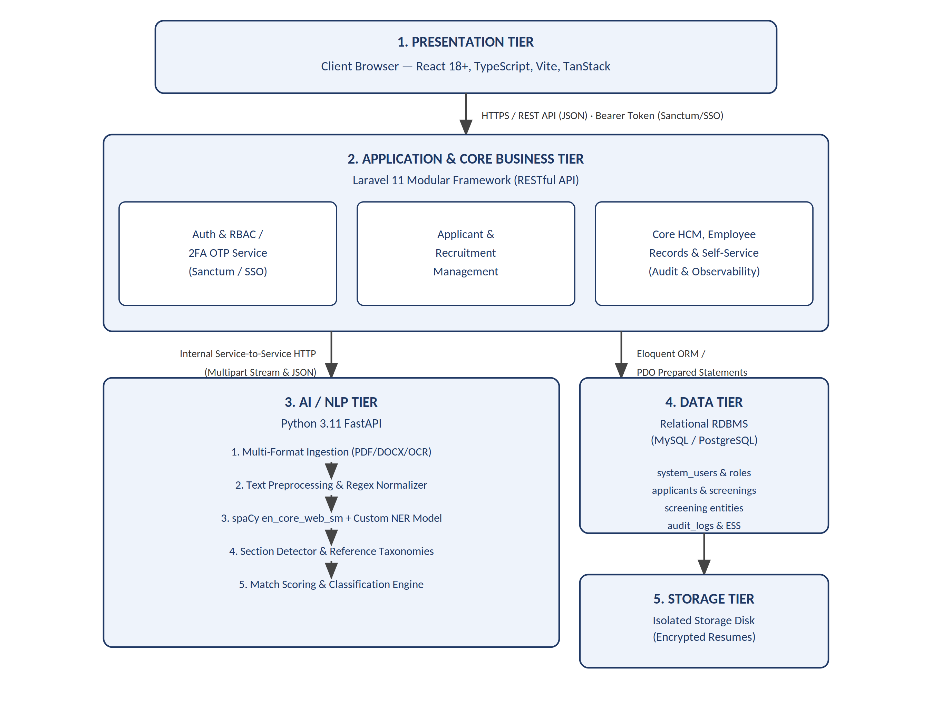

2. Tier Breakdown & Technology Stack
Layer | Technology | Primary Responsibilities
Presentation Tier | React 18, TypeScript, Vite, Tailwind CSS, TanStack Router | User interface rendering, interactive candidate kanban/pipelines, real-time screening dashboards, and resume preview interfaces.
Business Logic Tier | PHP 8.2+, Laravel 11, Modular Monolith (nwidart/laravel-modules) | Request handling, role authorization (RBAC), recruitment workflow orchestration, background job dispatching, and audit logging.
AI & NLP Tier | Python 3.11, FastAPI, spaCy 3.7+, pdfplumber, python-docx, Pillow | Optical Character Recognition (OCR), unstructured text extraction, Named Entity Recognition (NER), qualification matching, scoring.
Persistence Tier | Relational Database (MySQL / PostgreSQL / SQLite) | ACID-compliant transactional persistence, normalized entity storage, foreign key constraints, and relational queries.
File Storage Tier | Server Local Storage / S3 Adapter | Secure persistence of uploaded resume artifacts (PDF, DOCX, Images), each saved under a randomized filename (see Appendix A.7 SS3).

APPENDIX A.2: Information Systems Integration
(Laravel <-> FastAPI <-> React <-> HR2 SSO)
The system achieves seamless cross-platform communication between the frontend client, the core business engine, the AI service, and the external enterprise single sign-on provider.

1. Integration Interaction & Data Flow Diagram
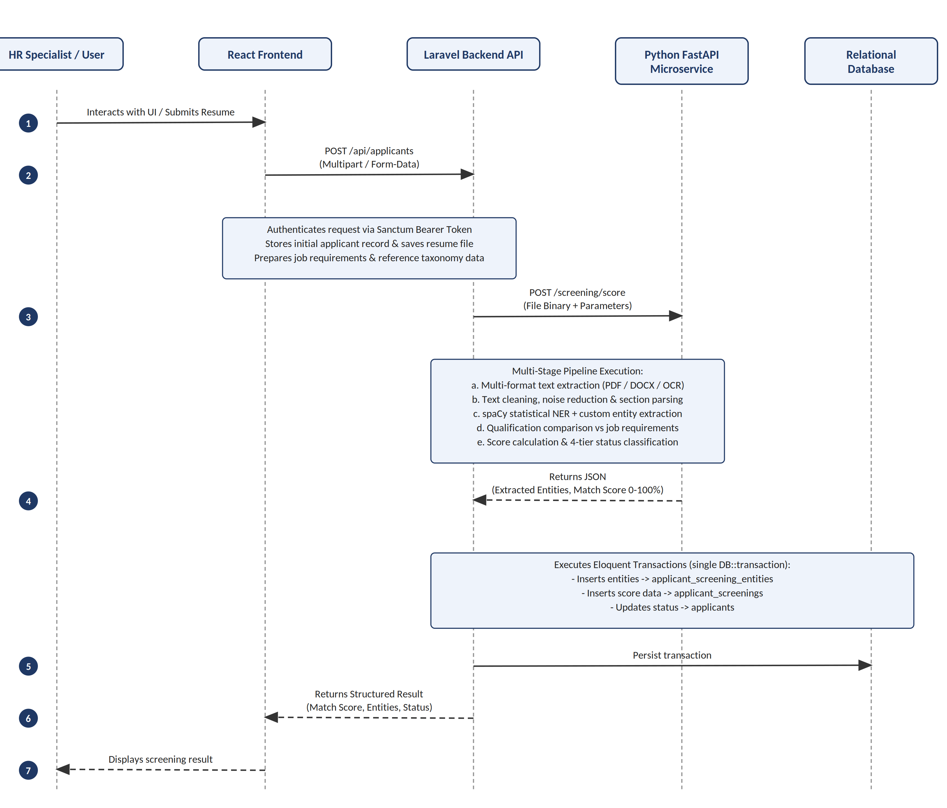

2. Subsystem Interface Protocols

A. Frontend (React) <-> Backend (Laravel)
Format: RESTful JSON over HTTPS.
Authentication: Authorization: Bearer <Sanctum_Token> attached to Axios request headers via interceptors.
Error Handling: Standardized HTTP status codes (200 OK, 201 Created, 401 Unauthorized, 422 Unprocessable Entity, 500 Internal Error) with structured JSON error messages.

B. Backend (Laravel) <-> AI Microservice (FastAPI)
Protocol: Internal synchronous HTTP via Laravel Http::timeout(30)->attach(...).
Key Endpoints:
- GET /health: Model availability and liveness verification.
- POST /extract-resume: Fast pre-parse for form autofilling during applicant registration.
- POST /screening/score: Full multi-criteria screening evaluation receiving binary files and structured job requirements.

C. Enterprise HR2 Single Sign-On (SSO) Integration
Mechanism: Token validation handshake and federated identity reconciliation.
Workflow:
1. User authenticates via the centralized HR2 SSO portal.
2. HR2 SSO returns signed identity claims to the client.
3. Client forwards claims to Laravel (/api/auth/sso-login).
4. Laravel verifies payload signatures, reconciles system_users credentials, syncs assigned role permissions, and creates an authenticated session token.

APPENDIX A.4: Database Schema and Data Management

1. Entity-Relationship Overview
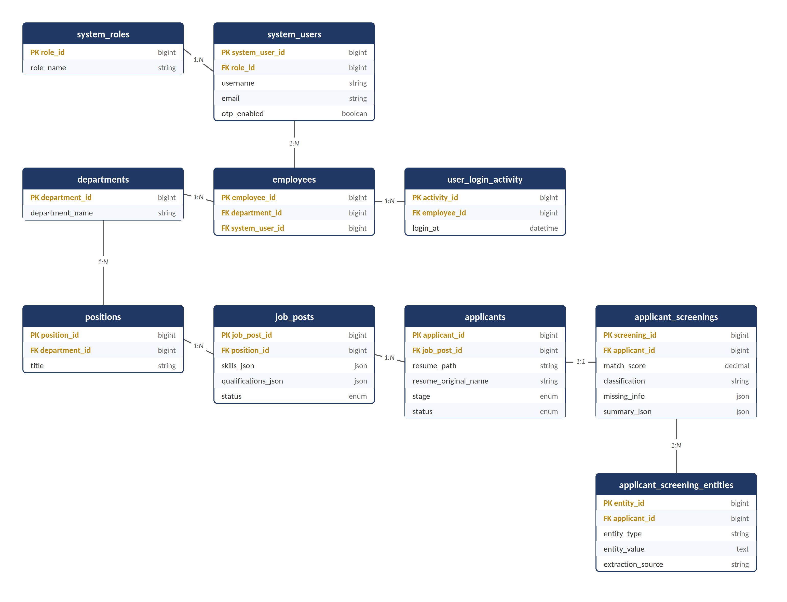

2. Core Data Dictionaries

Table: job_posts
Stores open vacancies together with structured, screenable job requirements used by the NLP scoring engine.
Column | Type | Constraints | Description
job_post_id | BIGINT UNSIGNED | PK, Auto Increment | Unique job posting identifier
position_id | BIGINT UNSIGNED | FK -> positions.position_id | Linked organizational position
title | VARCHAR(150) | NOT NULL | Publicly displayed job title
skills_json | JSON | NOT NULL | Structured list of required/weighted skills used as the matching reference taxonomy
qualifications_json | JSON | NOT NULL | Structured education, certification, and experience requirements used for scoring
status | ENUM | DEFAULT 'Open' | Open, Closed, On-Hold

Table: applicants
Stores applicant demographic records, assigned job vacancies, application pipeline stage, and file references.
Column | Type | Constraints | Description
applicant_id | BIGINT UNSIGNED | PK, Auto Increment | Unique applicant identifier
job_post_id | BIGINT UNSIGNED | FK -> job_posts.job_post_id | Applied job position
first_name | VARCHAR(100) | NOT NULL | Candidate first name
last_name | VARCHAR(100) | NOT NULL | Candidate last name
email | VARCHAR(150) | NOT NULL | Candidate contact email
contact_number | VARCHAR(50) | NULLABLE | Phone / mobile number
resume_path | VARCHAR(255) | NULLABLE | Server storage path using a randomized filename (see A.7 SS3); never the client's original name
resume_original_name | VARCHAR(255) | NULLABLE | Original client filename, retained only as a display label in the UI
stage | ENUM | NOT NULL | Screening, Interview, Assessment, Hired, Rejected
status | ENUM | NOT NULL | fit, credential, other-role, not-fit, pending
created_at | TIMESTAMP | DEFAULT CURRENT_TIMESTAMP | Registration timestamp

Table: applicant_screenings
Stores calculated match scores, classification results, and missing information flags. This single table is the target of the score-breakdown insert described in Appendix A.2 SS1, Step 6.
Column | Type | Constraints | Description
screening_id | BIGINT UNSIGNED | PK, Auto Increment | Unique screening record ID
applicant_id | BIGINT UNSIGNED | FK -> applicants.applicant_id | Reference to candidate
match_score | DECIMAL(5,2) | NOT NULL | Computed score (0.00 to 100.00%)
classification | VARCHAR(50) | NOT NULL | Perfect for the Job, Invalid Credential, Fit for Other Job, Not Fitted to Job
missing_info | JSON | NULLABLE | Array of missing essential details
summary_json | JSON | NULLABLE | Detailed breakdown of matched/missing criteria against job_posts.skills_json / qualifications_json

Table: applicant_screening_entities
Stores granular named entities extracted by the spaCy NLP pipeline with traceability back to the extraction technique.
Column | Type | Constraints | Description
entity_id | BIGINT UNSIGNED | PK, Auto Increment | Unique entity record ID
applicant_id | BIGINT UNSIGNED | FK -> applicants.applicant_id | Associated applicant
entity_type | VARCHAR(50) | NOT NULL | PERSON, SKILL, JOB_TITLE, EDUCATION, CERTIFICATION, ORGANIZATION
entity_value | TEXT | NOT NULL | Raw or normalized text value extracted
extraction_source | VARCHAR(50) | NOT NULL | Method: custom_ner, spacy_base, section_rule, regex

Table: system_users & system_roles
Controls user accounts, authentication states, two-factor settings, and RBAC privileges.
Column | Type | Constraints | Description
system_user_id | BIGINT UNSIGNED | PK, Auto Increment | Unique user identifier
role_id | BIGINT UNSIGNED | FK -> system_roles.role_id | Assigned role
username | VARCHAR(100) | UNIQUE, NOT NULL | System username
email | VARCHAR(150) | UNIQUE, NOT NULL | Account email
password_hash | VARCHAR(255) | NOT NULL | Bcrypt / Argon2 hashed password
otp_enabled | BOOLEAN | DEFAULT TRUE | 2FA is mandatory for all interactive accounts by policy; may only be disabled by a Super Admin for designated non-interactive service accounts
status | ENUM | DEFAULT 'Active' | Active, Inactive, Suspended

3. Data Integrity & Management Rules
Referential Integrity: Cascading actions and foreign keys protect against orphaned records.
Transactional Consistency: Multi-table insertions (Applicant + Entities + Screening) execute inside atomic database transactions (DB::transaction).
Flexible Schemas: JSON columns (skills_json and qualifications_json in job_posts; missing_info and summary_json in applicant_screenings) allow evolving skill taxonomies and criteria without recurring schema migrations.

APPENDIX A.7: Security Measures
(JWT, SSO, Auth, RBAC)

1. Authentication & Session Management
1. Stateless API Bearer Authentication (Laravel Sanctum): Client requests carry cryptographically secure SHA-256 hashed bearer tokens, validated upon every incoming request through Sanctum middleware.
2. Two-Factor Authentication (2FA / OTP): Secondary verification using time-limited (TTL: 300s) 6-digit one-time passwords delivered via email; enforced by default for every interactive account (see system_users.otp_enabled, Appendix A.4). Brute-force protection uses strict rate limiting on OTP attempts.
3. Session Revocation: Token invalidation on logout completely deletes the database access token record, preventing session reuse.

2. Role-Based Access Control (RBAC)
Granular Permissions: Permissions are mapped to specific role IDs (e.g., recruitment.screen, applicant.view, user.manage).
Middleware Guard: Routes are protected by \App\Http\Middleware\PermissionMiddleware, verifying user role permissions prior to executing controller logic.
Protected System Roles: Super Admin and default administrative roles possess is_protected and is_super_admin flags to prevent privilege escalation or accidental deletion.

3. Threat Mitigation & Safeguards
Security Dimension | Threat Vector | Mitigation Strategy
Data Layer | SQL Injection (SQLi) | Strict utilization of Eloquent ORM and PDO prepared statements with parameter binding. Raw concatenations are prohibited.
Client Layer | Cross-Site Scripting (XSS) | Automated JSX output encoding in React and strict server-side input sanitization via Laravel Form Requests.
File Ingestion | Malicious File Uploads / RCE | Client and server-side MIME-type verification (PDF, DOCX, standard image formats), file size constraints (max 10MB), and randomized server filename generation (see applicants.resume_path, Appendix A.4).
Account Security | Credential Compromise | Password hashing using Bcrypt (work factor >= 12); automated security alerts dispatched when logins originate from an unfamiliar IP address.
Accountability | Repudiation / Unauthorized Edits | Universal ActivityObserver and AuditLogger writing immutable audit logs containing user ID, IP address, user agent, module, and detailed event payloads.

APPENDIX B: Oral Defense Q&A Preparation & Panel Guidelines

Core Defense Questions & Exemplary Responses
Q1: Why did you separate the NLP engine into a Python FastAPI microservice instead of running it inside Laravel?
Answer: PHP is optimized for I/O-bound web request-response cycles, whereas NLP and machine learning require dedicated libraries (like spaCy, PyTorch, NumPy, and OCR engines) that are native to Python. By isolating the NLP pipeline into a FastAPI microservice, we ensure that resource-intensive resume parsing and entity recognition do not block or degrade the performance of the core HRMS web server. It also enables independent scaling of the AI service.
Q2: How does the system determine the 4 screening classification categories?
Answer: The screening classification evaluates three key criteria, in order: (1) Missing Essential Information -- if mandatory contact information (Name, Email, Contact Number) is missing, or key credentials are invalid, the applicant is classified as Invalid Credential. (2) Role-Specific Score Threshold -- if an applicant meets or exceeds 80% match against the target job's required skills, education, and experience (job_posts.skills_json / qualifications_json), they are classified as Perfect for the Job. (3) Cross-Job Matching -- if the applicant scores below 60% against the target job, the engine automatically compares their extracted profile against all other active vacancies; a score of 80% or higher against any other posting flags them as Fit for Other Job, otherwise they are designated Not Fitted to Job. Scores between 60% and 80% against the target job are held as Pending for recruiter review rather than auto-classified.
Q3: What happens if a user uploads a scanned image or non-selectable PDF resume?
Answer: The FastAPI pipeline implements a multi-format extractor fallback. If direct digital text extraction (via pdfplumber or docx2txt) yields insufficient characters, the service automatically routes the document through an OCR preprocessor using image filtering and OCR extraction before passing the text to the spaCy NER pipeline.
Q4: How is data privacy and security maintained for uploaded resumes?
Answer: Uploaded resumes are saved in a protected, non-public directory under a randomized server filename; the applicant's original filename is retained separately only as a UI display label and is never used as the storage path. Access to download or view a resume is strictly gated through authenticated Laravel API endpoints requiring a valid Sanctum bearer token and verified applicant.view role permission.
Q5: Why does the ER diagram show a single applicant_screenings table rather than separate entity and score tables?
Answer: Extracted entities and computed scores serve different purposes and are read at different times, so they are kept in two tables: applicant_screening_entities holds the raw/normalized NER output for traceability and audit, while applicant_screenings holds the derived match_score, classification, and summary_json for that applicant. Both are written inside the same atomic transaction described in Appendix A.2, so they are always consistent with one another.

Panel Guidelines
Panelists are encouraged to probe: (1) consistency between the data flow diagrams and the underlying schema, (2) the exact, non-illustrative thresholds used for classification, (3) the fallback behavior of the NLP pipeline under malformed or low-quality input, and (4) the chain of custody for uploaded resume files from ingestion to storage to access.

