APPENDICES A & B: TECHNICAL MANUSCRIPT & DEFENSE DOCUMENTATION
Capstone Title:
Design and Development of Recruitment Management in Hotels and Restaurants using spaCy-based Natural Language Processing (NLP) for Role-Specific Applicant Screening using Named Entity Recognition (NER)
Database Instance: hotel_hr (MySQL 8.0+ / MariaDB 10.4.27+ InnoDB, utf8mb4_unicode_ci, 55 Relational Tables)
Backend Framework: Laravel 12 Modular Monolith (nwidart/laravel-modules across 12 Domain Modules)
AI / NLP Microservice: Python 3.10+ / FastAPI / Uvicorn / spaCy 3.7+ (en_core_web_sm + Custom Hospitality NER)
Presentation Client: React 19 / TypeScript 5.8 / TanStack Start & Router / Tailwind CSS v4

TABLE OF CONTENTS
- [APPENDIX A.1: System Architecture](#appendix-a1-system-architecture)
- [1. Architectural Model & Paradigm](#1-architectural-model--paradigm)
- [2. Tier Breakdown & Technology Stack](#2-tier-breakdown--technology-stack)
- [3. Modular Domain Architecture (Laravel 12)](#3-modular-domain-architecture-laravel-12)
- [APPENDIX A.2: Information Systems Integration](#appendix-a2-information-systems-integration)
- [1. Integration Interaction & Data Flow Diagram](#1-integration-interaction--data-flow-diagram)
- [2. Subsystem Interface Protocols & Contracts](#2-subsystem-interface-protocols--contracts)
- [3. Enterprise HR2 Single Sign-On (SSO) & JWT Federation](#3-enterprise-hr2-single-sign-on-sso--jwt-federation)
- [APPENDIX A.4: Database Schema and Data Management](#appendix-a4-database-schema-and-data-management)
- [1. Database Definition & 3NF Normalization Principles](#1-database-definition--3nf-normalization-principles)
- [2. Enterprise Entity-Relationship Diagrams (ERD)](#2-enterprise-entity-relationship-diagrams-erd)
- [3. Core Domain Data Dictionaries (Key System Entities)](#3-core-domain-data-dictionaries-key-system-entities)
- [4. Data Integrity, Foreign Key Cascading & Indexing Strategies](#4-data-integrity-foreign-key-cascading--indexing-strategies)
- [APPENDIX A.7: Security Measures](#appendix-a7-security-measures)
- [1. Authentication, Session & Two-Factor OTP Security](#1-authentication-session--two-factor-otp-security)
- [2. Role-Based Access Control (RBAC) & Authorization Matrix](#2-role-based-access-control-rbac--authorization-matrix)
- [3. Threat Mitigation, Cryptographic Safeguards & RA 10173 Compliance](#3-threat-mitigation-cryptographic-safeguards--ra-10173-compliance)
- [4. Universal Observability & Immutable Audit Logging](#4-universal-observability--immutable-audit-logging)
- [APPENDIX B: Oral Defense Q&A Preparation & Panel Guidelines](#appendix-b-oral-defense-qa-preparation--panel-guidelines)
- [Core Defense Questions & Exemplary Responses (Q1 - Q8)](#core-defense-questions--exemplary-responses)

APPENDIX A.1: System Architecture
1. Architectural Model & Paradigm
The system is constructed based on a Decoupled Multi-Tier Service-Oriented Architecture (SOA) with modular monolith characteristics on the core backend and a dedicated microservice for compute-intensive natural language processing.
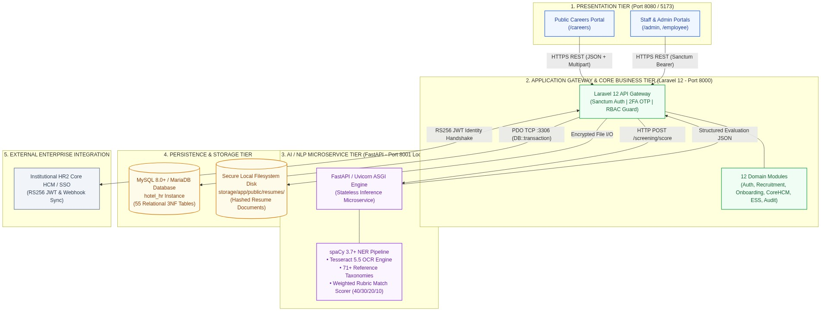

2. Tier Breakdown & Technology Stack
Layer / Architectural Tier | Technology & Runtime | System Port / Protocol | Primary Responsibilities & Operations
Presentation Tier | React 19, TypeScript 5.8, TanStack Start/Router, TanStack Query, Tailwind CSS v4, Lucide React, Axios | TCP 8080 / 5173  (HTTPS / REST) | Client interface rendering, dynamic applicant review pipelines, score breakdown visualizations, multi-format resume viewing, and interactive chatbot interface.
Application Gateway & Business Logic Tier | PHP 8.2+, Laravel 12, nwidart/laravel-modules, Eloquent ORM, Sanctum | TCP 8000  (HTTP/REST) | API gateway routing, Sanctum token authentication, 2FA OTP verification, RBAC authorization, business workflow execution, file management, and audit logging.
AI & NLP Microservice Tier | Python 3.10+, FastAPI, Uvicorn ASGI, spaCy 3.7+, Tesseract 5.5 OCR, pdfplumber, python-docx | TCP 8001  (Internal HTTP Loopback) | Multi-format document text extraction, OCR image processing, spaCy named entity recognition (NER), qualification matching against job baselines, and 4-tier status scoring.
Persistence & Relational Data Tier | MySQL 8.0+ / MariaDB 10.4.27+, InnoDB Storage Engine | TCP 3306  (MySQL Native Socket) | ACID transactional persistence, 55 relational tables in 3NF, foreign key integrity constraints, composite B-Tree query indexing, and JSON document validation.
Encrypted Storage Tier | Linux / Windows Local Filesystem Storage (storage/app/public/resumes/) | File I/O Stream  (Local OS Disk) | Secure storage of uploaded candidate resumes and employee 201 compliance documents using randomized unique SHA/UUID file naming.

3. Modular Domain Architecture (Laravel 12)
The backend encapsulates 12 isolated business domains managed under Modules/:
- `Auth`: Sanctum token issuance, credential verification, 2FA email OTP generation/validation, password resets, and HR2 SSO handshake.
- `UserManagement`: Administrator accounts, role assignments (system_roles), and user access control.
- `RecruitmentManagement`: Manpower requisitions (requisitions), job postings (job_posts), and multi-platform publishing (job_post_platforms).
- `ApplicantManagement`: Candidate applications (applicants), interview scheduling (interviews), interview rubrics (applicant_assessments), and resume screening coordination.
- `NewHireOnboarding`: Pre-employment transitions (new_hires), onboarding checklist templates (onboarding_checklist_templates), and task verification (employee_onboarding_items).
- `CoreHCM`: Department hierarchy (departments), position catalog (positions), and compensation salary grades (salary_grades).
- `EmployeeRecords`: Complete 201 dossiers (employees), emergency contacts, uploaded credentials (employee_documents), career history, and exit records.
- `EmployeeSelfService`: Employee service requests (ess_requests), category routing (ess_categories), leave balances (leave_balances), and FAQ knowledge base (chatbot_faqs).
- `AuditLog`: Centralized event observer capturing user mutations, forensic telemetry, and login activity.
- `Settings`: System key-value configurations, email SMTP triggers, and threshold controls (system_settings).
- `Landing`: Public hotel career portal APIs, job listings, and applicant self-service intake.
- `Profile`: Staff profile management and avatar/password updates.

APPENDIX A.2: Information Systems Integration
1. Integration Interaction & Data Flow Diagram
The system implements a synchronized, secure inter-tier data pipeline bridging user actions on the frontend, business validation in Laravel, machine learning inference in FastAPI, and ACID transactional persistence in MySQL.
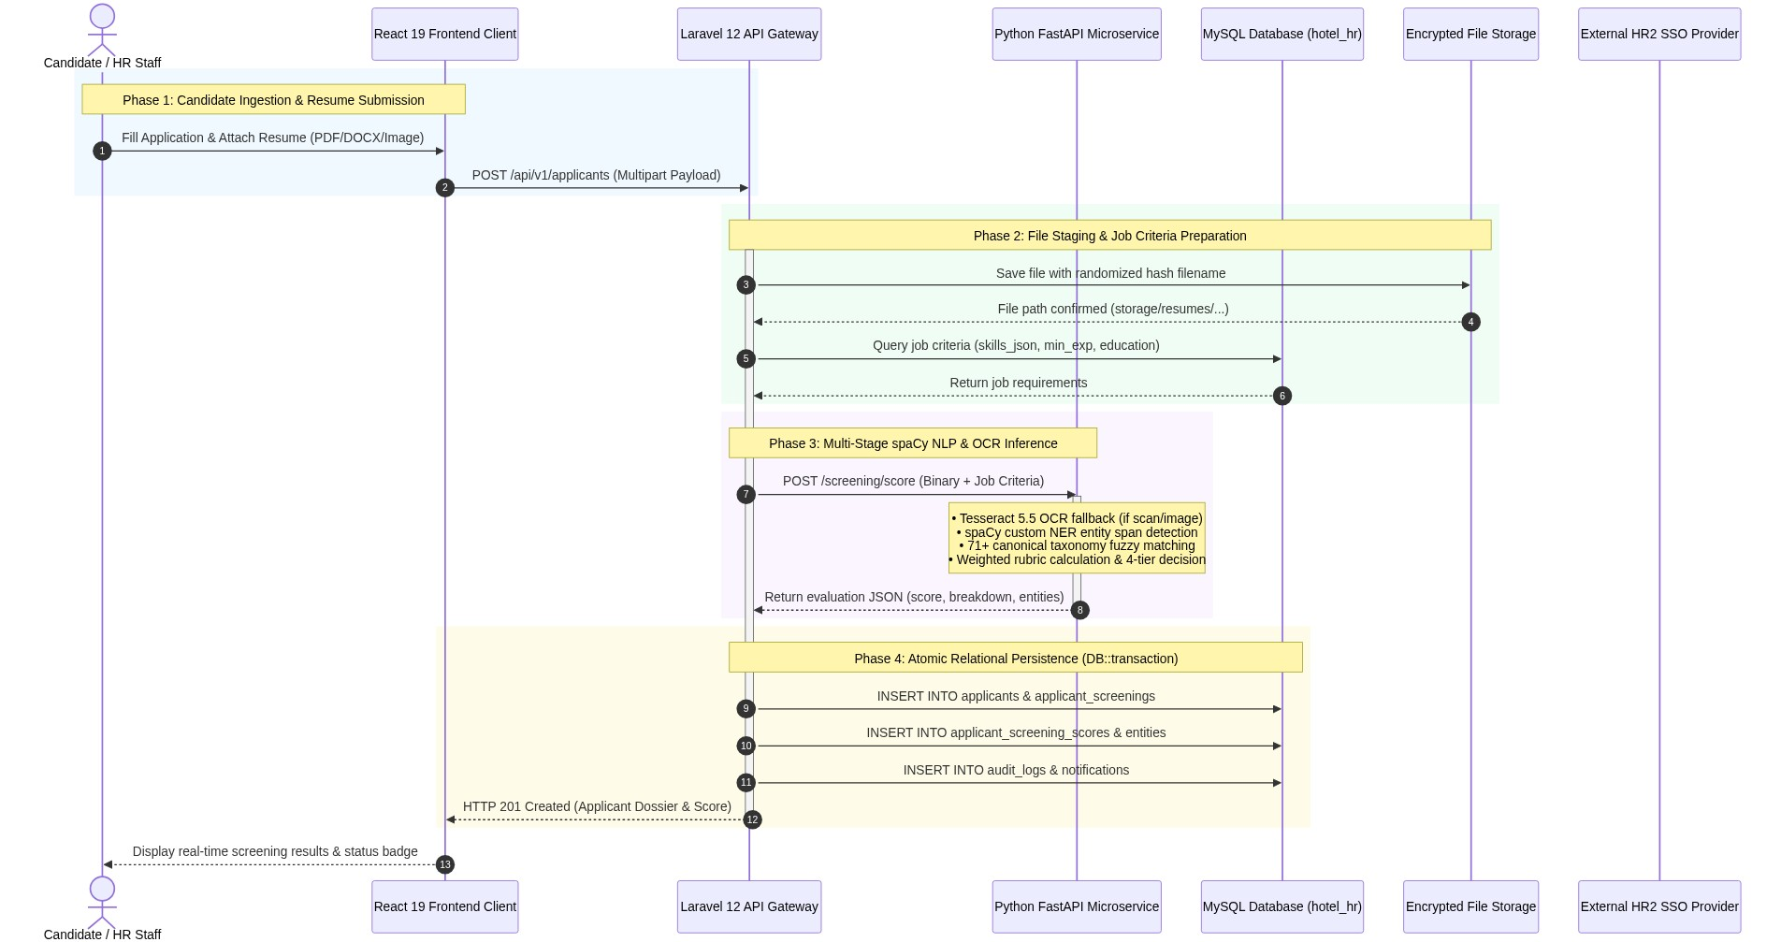

2. Subsystem Interface Protocols & Contracts
A. Frontend (React) ↔ Gateway (Laravel)
- Protocol: HTTPS REST API (/api/v1/*).
- Authorization: Authorization: Bearer <Sanctum_Token> attached automatically via Axios interceptors.
- Envelope Standard: Standardized JSON envelopes:
{
"success": true,
"message": "Applicant screened and registered successfully.",
"data": {
"applicant_id": 48,
"applicant_code": "APL-01070",
"fit_score": 92.50,
"status": "fit",
"stage": "Screened"
}
}

B. Gateway (Laravel) ↔ AI Inference Microservice (FastAPI)
- Protocol: Internal loopback HTTP socket (http://127.0.0.1:8001).
- Resilience & Timeout Guard: 120-second timeout guard (Http::timeout(120)->attach(...)). If the AI microservice is temporarily offline, the gateway catches the connection exception, logs a warning in applicant_screenings.error_message, and marks processing_status = 'PENDING' without interrupting applicant submission.
- Primary Endpoints:
- GET /health: Microservice liveness and spaCy model status probe.
- POST /extract-resume: Fast pre-parsing for form autofill during candidate registration.
- POST /screening/score: Full multi-criteria weighted scoring and 4-tier classification.
3. Enterprise HR2 Single Sign-On (SSO) & JWT Federation
- Federated Authentication Flow:
- Internal hotel staff authenticate at the institutional HR2 Core HCM Single Sign-On portal.
- The HR2 Identity Provider issues an RS256-signed JSON Web Token (JWT) containing employee claims (employee_code, email, department, role).
- The React client transmits the token to Laravel Gateway at POST /api/v1/auth/sso-login.
- Laravel validates the RS256 signature using the HR2 public key, reconciles the user in system_users, updates department/role permissions, and issues a native Laravel Sanctum token for session continuity.
- When an applicant transitions to Hired in NewHireOnboarding, an automated outbound webhook synchronizes the completed employee dossier with the institutional HR2 database.

APPENDIX A.4: Database Schema and Data Management
1. Database Definition & 3NF Normalization Principles
- Database Identifier: hotel_hr
- Engine: InnoDB Transactional Storage Engine with full ACID support and foreign key constraints.
- Character Collation: utf8mb4_unicode_ci (supporting multilingual text, diacritics, and 4-byte UTF-8 emoji reactions).
- Normalization Standards (3NF):
- 1NF: All table columns contain atomic scalar values. Complex structures (skills arrays, rubric score vectors, validation flags) are stored in standardized JSON columns validated by MySQL CHECK (json_valid(...)) constraints.
- 2NF: No non-key attribute is dependent on a subset of a composite primary key.
- 3NF: All non-key fields are strictly dependent on the primary key alone. Lookup entities (departments, positions, salary_grades, system_roles, screening_reference_data) are fully decoupled into normalized tables.
2. Enterprise Entity-Relationship Diagrams (ERD)
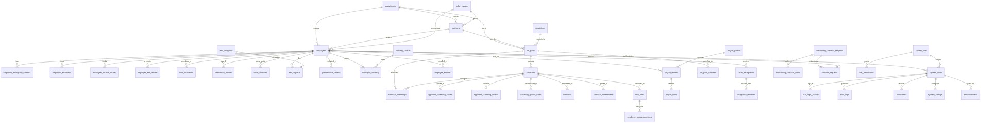

3. Core Domain Data Dictionaries (Key System Entities)
Table: `applicants`
Central candidate registry capturing demographic information, application channel, resume storage paths, and current pipeline stages.
Column | Data Type | Modifiers / Constraints | Description & Business Purpose
applicant_id | BIGINT(20) UNSIGNED | PRIMARY KEY, AUTO_INCREMENT | Unique surrogate identifier for candidate record.
applicant_code | VARCHAR(40) | UNIQUE, NOT NULL | Human-readable tracking code (e.g., APP-1032, APL-01055).
job_post_id | BIGINT(20) UNSIGNED | FOREIGN KEY &rarr; job_posts.job_post_id | Target vacancy identifier (ON DELETE RESTRICT).
name | VARCHAR(160) | NOT NULL | Candidate full name extracted or submitted.
email | VARCHAR(190) | NOT NULL | Primary contact email address.
phone | VARCHAR(40) | NULLABLE | Contact telephone / mobile number.
applied_at | TIMESTAMP | DEFAULT CURRENT_TIMESTAMP | Application submission timestamp.
fit_score | DECIMAL(5,2) | NULLABLE | Composite qualification score (0.00% to 100.00%).
status | VARCHAR(30) | NOT NULL | Screening outcome: fit, credential, other-role, not-fit.
stage | VARCHAR(40) | NOT NULL | Pipeline stage: Screened, Interview Scheduled, Offer, Accepted, Hired, Rejected.
source | VARCHAR(60) | NULLABLE | Ingestion channel: Online Portal, Walk-in, Indeed, Referral.
resume_file_path | TEXT | NULLABLE | Relative disk path to stored resume file.
resume_original_name | VARCHAR(255) | NULLABLE | Original client filename prior to hashing.
summary | TEXT | NULLABLE | High-level candidate qualification overview.
flags_json | LONGTEXT | CHECK (json_valid(flags_json)) | Extracted warnings (e.g., missing credentials, alternative role hints).

Table: `applicant_screenings`
Maintains full forensic logs of spaCy NLP parsing executions, entity breakdowns, and classification reasoning.
Column | Data Type | Modifiers / Constraints | Description & Business Purpose
screening_id | BIGINT(20) UNSIGNED | PRIMARY KEY, AUTO_INCREMENT | Unique screening execution identifier.
applicant_id | BIGINT(20) UNSIGNED | FOREIGN KEY &rarr; applicants.applicant_id | Associated candidate record (ON DELETE CASCADE).
job_post_id | BIGINT(20) UNSIGNED | FOREIGN KEY &rarr; job_posts.job_post_id | Target job baseline criteria used for evaluation.
processing_status | VARCHAR(30) | DEFAULT 'PENDING' | Execution state: PENDING, PROCESSED, PARTIALLY_PROCESSED, FAILED.
screening_result | VARCHAR(30) | NULLABLE | 4-tier decision: fit, credential, other-role, not-fit.
match_score | DECIMAL(5,2) | NULLABLE | Total weighted qualification score percentage.
score_breakdown_json | LONGTEXT | CHECK (json_valid(...)) | Component breakdown (skills, experience, education, certifications).
profile_json | LONGTEXT | NULLABLE | Candidate parsed profile structure.
entities_json | LONGTEXT | NULLABLE | Array of all named entity spans detected by spaCy.
missing_information_json | LONGTEXT | NULLABLE | Missing essential contact or credential fields.
validation_json | LONGTEXT | NULLABLE | Rule-based verification notes and credential audits.
alternative_job_json | LONGTEXT | NULLABLE | Candidate scores evaluated across other open vacancies.
reasons_json | LONGTEXT | NULLABLE | Natural language explanations justifying the score.
model_info_json | LONGTEXT | NULLABLE | Model version (en_core_web_sm + custom NER model path).
error_message | TEXT | NULLABLE | Diagnostic exception message if inference failed.
processed_at | TIMESTAMP | NULLABLE | Timestamp of completed NLP inference run.

Table: `job_posts`
Published job vacancies containing criteria vectors for NLP qualification matching.
Column | Data Type | Modifiers / Constraints | Description & Business Purpose
job_post_id | BIGINT(20) UNSIGNED | PRIMARY KEY, AUTO_INCREMENT | Unique job posting identifier.
slug | VARCHAR(120) | UNIQUE, NOT NULL | SEO-friendly URL slug for public careers portal.
title | VARCHAR(150) | NOT NULL | Job vacancy title (e.g., Front Desk Receptionist, Bartender).
department_id | BIGINT(20) UNSIGNED | FOREIGN KEY &rarr; departments | Associated hotel operational department.
position_id | BIGINT(20) UNSIGNED | FOREIGN KEY &rarr; positions | Associated organizational job position.
employment_type | VARCHAR(30) | NOT NULL | Employment tenure: Full-time, Part-time, Contractual.
salary_min / salary_max | DECIMAL(12,2) | NULLABLE | Target compensation range for the vacancy.
vacancies | INT(11) | DEFAULT 1 | Authorized open headcounts.
filled_count | INT(11) | DEFAULT 0 | Count of candidates advanced to Hired.
skills_json | LONGTEXT | CHECK (json_valid(...)) | Array of required and preferred technical hospitality skills.
qualifications_json | LONGTEXT | CHECK (json_valid(...)) | Structured minimum requirements (experience years, education).
status | VARCHAR(20) | NOT NULL | Vacancy lifecycle state: published, draft, closed.
active | TINYINT(1) | DEFAULT 1 | Active listing flag for career portal visibility.

Table: `employees`
Central employee 201 dossier storing demographic data, statutory IDs, and organization placement.
Column | Data Type | Modifiers / Constraints | Description & Business Purpose
employee_id | BIGINT(20) UNSIGNED | PRIMARY KEY, AUTO_INCREMENT | Unique surrogate identifier for employee 201 record.
employee_code | VARCHAR(40) | UNIQUE, NOT NULL | Standardized company badge number (e.g., EMP-00104).
first_name / last_name | VARCHAR(80) | NOT NULL | Employee official legal name.
email | VARCHAR(190) | UNIQUE, NOT NULL | Official corporate email address.
sss_number / tin_number | VARCHAR(30) | NULLABLE | Statutory government IDs (SSS, TIN, PhilHealth, Pag-IBIG).
position_id | BIGINT(20) UNSIGNED | FOREIGN KEY &rarr; positions | Current job position assignment (ON DELETE RESTRICT).
department_id | BIGINT(20) UNSIGNED | FOREIGN KEY &rarr; departments | Current operational department assignment.
salary_grade_id | BIGINT(20) UNSIGNED | FOREIGN KEY &rarr; salary_grades | Compensation grade band assignment.
date_hired | DATE | NOT NULL | Official date of employment commencement.
status | VARCHAR(30) | NOT NULL | Employment status: Regular, Probationary, Contractual.
onboarding_complete | TINYINT(1) | DEFAULT 0 | Pre-employment compliance checklist completion flag.

Table: `system_users` & `system_roles`
Governs administrative accounts, encrypted credentials, 2FA states, and RBAC role assignments.
Column | Data Type | Modifiers / Constraints | Description & Business Purpose
system_user_id | BIGINT(20) UNSIGNED | PRIMARY KEY, AUTO_INCREMENT | Unique user account identifier.
username | VARCHAR(100) | UNIQUE, NOT NULL | Account login username.
email | VARCHAR(190) | UNIQUE, NOT NULL | User email address for notifications and 2FA OTPs.
password_hash | VARCHAR(255) | NOT NULL | Bcrypt-hashed password ($ ext{cost factor} \ge 12$).
employee_id | BIGINT(20) UNSIGNED | FOREIGN KEY &rarr; employees | Link to internal employee 201 dossier (ON DELETE RESTRICT).
role_id | BIGINT(20) UNSIGNED | FOREIGN KEY &rarr; system_roles | Security role assignment (ON DELETE RESTRICT).
otp_enabled | TINYINT(1) | DEFAULT 1 | Enforces mandatory 6-digit email OTP verification.
status | VARCHAR(20) | NOT NULL | Account status: active, inactive, suspended.
last_login_at | TIMESTAMP | NULLABLE | Timestamp of most recent successful authentication.
last_login_ip | VARCHAR(45) | NULLABLE | IPv4/IPv6 address of last login event.

4. Data Integrity, Foreign Key Cascading & Indexing Strategies
- Cascading Policies:
- ON DELETE RESTRICT: Protects foundational entities (departments, positions, salary_grades, employees, job_posts) from accidental deletion when operational transactions reference them.
- ON DELETE CASCADE: Automatically cleans child records (applicant_screenings, applicant_screening_entities, attendance_records, leave_balances, payroll_items, role_permissions) when parent entities are removed.
- ON DELETE SET NULL: Applied to non-critical user references (audit_logs.system_user_id, social_recognitions.recipient_employee_id) to preserve audit history even if accounts are purged.
- Indexing Architecture: Composite B-Tree indexes on high-frequency operational paths (applicants.job_post_id + stage, attendance_records.employee_id + date, audit_logs.occurred_at + severity) guarantee sub-50ms query response times under heavy concurrent operations.

APPENDIX A.7: Security Measures
1. Authentication, Session & Two-Factor OTP Security
- Stateless API Bearer Token Authentication (Laravel Sanctum):
- Client requests carry cryptographically secure SHA-256 hashed personal access tokens (personal_access_tokens).
- Tokens are validated upon every incoming request through Sanctum authentication middleware before request execution.
- Two-Factor Authentication (2FA / Email OTP):
- Mandatory secondary verification for administrative users.
- Generates a cryptographically random, 6-digit numeric OTP with a 300-second (5-minute) Time-to-Live (TTL).
- Delivery is executed over secure SMTP (2525/587), and failed OTP entry is rate-limited (maximum 5 attempts before temporary account cooldown).
- Session Termination & Token Invalidation:
- Explicit user logout immediately purges the active token from personal_access_tokens, preventing replay or session hijacking.
2. Role-Based Access Control (RBAC) & Authorization Matrix
- Granular Privilege Verification: The authorization framework separates users into distinct system roles (system_roles): Super Admin, HR Admin, HR Staff, Department Head, Employee.
- Permission Matrix: Mapped via role_permissions (role_id, module_name, permission_level: none, read, write, admin).
- Middleware Guard: Every protected route executes PermissionMiddleware, performing constant-time $O(1)$ lookup checks verifying user privileges before controller invocation.
- Protected System Roles: Foundational administrative roles have is_protected = 1 and is_super_admin = 1 flags enabled in the database, preventing privilege escalation or accidental deletion by standard administrators.
3. Threat Mitigation, Cryptographic Safeguards & RA 10173 Compliance
Security Dimension | Threat Vector | System-Specific Mitigation & Architectural Defense
Data Layer | SQL Injection (SQLi) | Strict enforcement of Eloquent ORM and PDO prepared statements with parameter binding. Raw query string concatenations are strictly forbidden. JSON schema constraints validate document structures.
Client Layer | Cross-Site Scripting (XSS) | React 19 automated JSX contextual string escaping, strict input sanitization via Laravel Form Requests, and Content Security Policy (CSP) headers.
API Gateway | Cross-Site Request Forgery (CSRF) & Unauthorized CORS | Stateless token architecture immune to browser cookie CSRF; strict CORS origin white-listing (CORS_ALLOWED_ORIGINS) restricted to authorized frontend domains.
File Ingestion & Parsing | Malicious File Uploads / Remote Code Execution (RCE) | Strict multi-layer MIME-type verification (application/pdf, application/vnd.openxmlformats-officedocument.wordprocessingml.document, image/png, image/jpeg), 10MB file size ceiling, and randomized unique filename generation (e.g. uQMocQfpx2nSlMO6oXThxQGf7HMS7KgGvf2257pJ.pdf) stored in non-web-executable directories.
Credential Security | Password & Token Compromise | Passwords hashed using Bcrypt ($ ext{work factor} \ge 12$). Sanctum API tokens stored as SHA-256 hashes. Automated security notifications dispatched when logins originate from unfamiliar IP addresses.
Data Privacy & Statutory Compliance | Unauthorized PII Disclosure / RA 10173 Violations | Full compliance with Philippine Republic Act No. 10173 (Data Privacy Act of 2012): Role-gated PII access (government statutory IDs SSS, TIN, PhilHealth, Pag-IBIG), AES-256 storage encryption, and automated 12-month applicant record anonymization.

4. Universal Observability & Immutable Audit Logging
- Immutable Transaction Logs (`audit_logs`): Every critical state change (applicant status advancement, salary adjustment, user credential modification, role assignment) triggers an automated database observer.
- Audit Schema Attributes: Captures system_user_id, actor_role, actor_department, occurred_at, action, module_name, target_type, target_id, details (serialized JSON of previous and new state), severity (info, warning, critical), ip_address, device_info, and url.
- Authentication Forensics (`user_login_activity`): Captures timestamped login attempts, source IP addresses, user agent signatures, and authentication outcomes (success, failed_password, failed_otp).

APPENDIX B: Oral Defense Q&A Preparation & Panel Guidelines
💡 Core Defense Questions & Exemplary Responses
Q1: "Why did you separate the NLP engine into a Python FastAPI microservice instead of running it natively inside Laravel?"
> Answer:
> "PHP and Laravel excel at I/O-bound web request orchestration, database transactional integrity, authentication, and CRUD business logic. However, machine learning and Natural Language Processing rely heavily on Python's scientific ecosystem—specifically spaCy's optimized C-extensions, token embeddings, and Tesseract OCR libraries. By decoupling the AI engine into an asynchronous FastAPI microservice bound to local loopback (Port 8001), compute-intensive resume parsing and entity extraction run independently without blocking Laravel's PHP-FPM worker pool, preventing web UI latency for other concurrent hotel staff."
Q2: "How does the spaCy-based screening engine compute the qualification match score, and what are the 4 classification categories?"
> Answer:
> "The screening pipeline uses a multi-factor weighted rubric scoring algorithm:
> 1. Skills Match (40% Weight): Compares extracted candidate skills against required and preferred job skills using fuzzy taxonomic mapping against 71+ canonical hospitality terms (`screening_reference_data`).
> 2. Experience Match (30% Weight): Evaluates estimated years of relevant work experience extracted from detected job titles and employment tenures against minimum job requirements.
> 3. Education Match (20% Weight): Matches highest detected educational attainment against the job's minimum education baseline (e.g., Bachelor's Degree, Vocational / TESDA).
> 4. Certification Match (10% Weight): Verifies presence of mandatory hospitality credentials (e.g., TESDA NC II, Food Safety).
>
> Based on the resulting score and entity validations, the system classifies applicants into four deterministic categories:
> • `fit`: Score $\ge 75.0\%$ with all core requirements and certifications satisfied.
> • `credential`: Discrepancies detected in mandatory credentials or missing critical contact details (email/phone).
> • `other-role`: Applicant does not meet the applied vacancy baseline ($< 75.0\%$) but scores high ($\ge 75.0\%$) against another currently open hotel vacancy.
> • `not-fit`: Applicant score falls below baseline ($< 75.0\%$) with no eligible cross-job matches."
Q3: "How does your system handle non-selectable, scanned image resumes or poorly formatted PDFs?"
> Answer:
> "The FastAPI microservice incorporates a resilient multi-format ingestion pipeline. When a document is received, it first attempts direct text layer extraction using `pdfplumber` and `python-docx`. If the document is an image (PNG, JPG) or a scanned PDF with insufficient character density, it automatically triggers a Tesseract 5.5 OCR fallback pipeline with adaptive binarization and noise reduction before passing the normalized text to the spaCy NER pipeline."
Q4: "How does the system ensure compliance with Philippine Data Privacy laws (RA 10173)?"
> Answer:
> "The architecture enforces three key statutory safeguards under RA 10173:
> 1. Role-Based Access Control (RBAC): Personal Identifiable Information (PII) such as government statutory IDs (SSS, TIN, PhilHealth, Pag-IBIG) and contact numbers are restricted to authorized HR personnel.
> 2. Storage Protection: Uploaded resume files and verification certificates are stored in non-public directories using randomized unique SHA hashes, with access gated through authenticated Laravel API endpoints.
> 3. Automated Anonymization & Retention: Unsuccessful applicant dossiers older than 12 months are subject to automated soft-deletion, stripping PII contact details while preserving anonymized screening score statistics for NLP model performance benchmarking."
Q5: "How does the system maintain data integrity when saving screening results across multiple tables?"
> Answer:
> "All multi-table insert and update operations—persisting records across `applicants`, `applicant_screenings`, `applicant_screening_scores`, `applicant_screening_entities`, `audit_logs`, and `notifications`—are wrapped inside atomic database transactions (`DB::transaction`). If any step encounters an error, the entire database transaction is rolled back automatically, preventing orphaned or partially written candidate records."
Q6: "What happens if the AI microservice crashes or is temporarily unreachable?"
> Answer:
> "The Laravel API Gateway wraps all microservice calls inside a 120-second timeout guard with explicit connection exception handling. If the AI service is unreachable, the candidate application is safely persisted with status `PENDING` and a diagnostic error logged in `applicant_screenings.error_message`. This prevents UI disruption for applicants or HR staff, and the intake queue can be automatically reprocessed once the microservice restarts."
Q7: "How is the 3NF relational database structured to handle the entire hotel HR workflow?"
> Answer:
> "The `hotel_hr` database contains 55 relational tables partitioned into 11 specialized functional domains—spanning Authentication, Organizational Hierarchy, Recruitment, AI Screening, Onboarding, Attendance/DTR, Employee Self-Service, Performance Reviews, L&D, Payroll, and Infrastructure. All master entities enforce `ON DELETE RESTRICT` to prevent orphaned references, child records enforce `ON DELETE CASCADE` to prevent data bloat, and composite B-Tree indexes optimize high-frequency query paths."
Q8: "How does Single Sign-On (SSO) integration work with existing hotel enterprise systems?"
> Answer:
> "The HRMS supports federated identity integration via signed JSON Web Tokens (JWT). When authenticated hotel employees access the HRMS from an enterprise portal (such as HR2 Core HCM), Laravel's `/api/v1/auth/sso-login` endpoint validates the RS256 signature, matches the employee record, reconciles role permissions, and issues a native Laravel Sanctum token for secure API access."

