SLATE: FREIGHT MANAGEMENT HR IV SYSTEM WITH PREDICTIVE ATTRITION FOR HR ANALYTICS
DASHBOARD USING TENSORFLOW

A Capstone
Presented to the Faculty of
The College of Computer Studies
Bestlink College of the Philippines

In Partial Fulfillment
Of the Requirements for the Degree of
Bachelor of Science in Information Technology

EDMON D. ABUYABOR
DAVID JOHN C. FABABIER
JONATHAN M. PEROS
MARIEL A. RAMOS
ELDRIAN TAY

September 2025
APPROVAL SHEET

This thesis entitled SLATE: FREIGHT MANAGEMENT HR IV SYSTEM WITH PREDICTIVE ATTRITION FOR HR ANALYTICS DASHBOARD USING TENSORFLOW, prepared and submitted by Edmon D. Abuyabor, David John C. Fababier, Jonathan M. Peros, Mariel A. Ramos and Eldrian Tay in partial fulfillment of the requirements for the degree of Bachelor of Science in Business Administration major in Marketing Management, has been examined and is recommended for acceptance and approval for Oral Examination.
RICHELYN A. VILLASOR
Adviser
__________________________________________________________
THESIS REVIEW PANEL

Approved by the Committee on Oral Examination with a grade of ____

MR. VINCENT CARLO T. GARADOS MR. ROMEO S. ALIX JR.
Member Member

DR. ROMMEL J. CONSTANTINO
Chairperson
Accepted and approved in partial fulfillment of the requirements for the degree of Bachelor of Science in Information Technology.
ROSICAR E. ESCOBER, Ph. D
Dean, College of Computer Studies

Date of Final Defense: January 26, 2026
ACKNOWLEDGMENT
The researchers would like to express their heartfelt thanks and gratitude to the following persons who, in one way or another, has contributed much, and extended willingness and support needed to make this research possible:
Dr. Maria M. Vicente, President/CEO, Bestlink College of the Philippines, for her generosity and kind heart in establishing this institution and giving opportunities to those less fortunate students to continue their studies and pursue their dreams;
Ms. Edith M. Vicente, Executive Vice President, for providing the needed information to complete this research;
Dr. Charlie I. Cariño, Vice President for Academic Affairs, for his support and encouragement to make this thesis writing possible;
Engr. Diosdado T. Lleno, Vice President for Administration and
Finance, for his words of encouragement and motivation;
Dr. Joy Evelyn A. Ignacio, Director, Center for Research and Development, for her good heart to extend her help needed by the researchers;
Dr. Rosicar E. Escober, Dean, College of Computer Studies of Bestlink College of the Philippines, for his critical appraisal and
highly valuable suggestions that have aided in the process of this research;
Mr. Rommel J. Constantino, Program Head, Bachelor of Science in Information Technology, for all the assistance and guidance we gave to make this research study possible;
Mr. Richelyn A. Villasor, Capstone Adviser, for his patient supervision in guiding the researchers in preparation of this manuscript;
Panelists, Mr. Vincent Carlo T. Garados, Mr. Romeo S. Alix Jr., and Dr. Rommel J. Constantino, who extended their effort and time to be able to constructively criticize this thesis and share their knowledge with them to deepen and widen their needed information;
Respondents, who cooperated and spent time in answering questionnaires, and made it possible to accomplish this research;
Families and Friends, for all the financial and moral support that have enabled the researchers to triumph all the challenges, especially during the lowest time that served as their inspiration to complete this study; and
Above all, to the Almighty God, for the strength and knowledge that were used for the accomplishment of this research journey.

THE RESEARCHERS
DEDICATION

We truly dedicate our capstone project to everyone who has helped and supported us along this research journey. Above all, we dedicate this work to ourselves, the researchers, for our dedication, time, effort, support, courage, and sacrifice in making this study a success.
We are grateful to our parents, whose unwavering belief in our skills has served as our constant compass. Your unending sacrifices, moral, spiritual, emotional, and financial support, as well as your nocturnal encouragement, kept us motivated during the darkest days of our research. To our loved ones, acquaintances, and colleagues who transformed many hours of writing, research, and coding into moments of camaraderie and mutual learning: your humor, support, and enlightening criticism kept us going.
Above all, we give thanks to God Almighty for providing us with the insight to solve complicated difficulties, mental clarity and strength, protection, skills, and grace to see this project through to completion. We humbly dedicate all of them to you. This achievement is equally yours and ours.

THE RESEARCHERS
ABSTRACT

Title: SLATE: FREIGHT MANAGEMENT HR IV SYSTEM WITH PREDICTIVE ATTRITION FOR HR ANALYTICS DASHBOARD USING TENSORFLOW.
Authors: ABUYABOR, EDMON D.
FABABIER, DAVID JOHN C.
PEROS, JONATHAN M.
RAMOS, MARIEL A.
TAY, ELDRIAN
Degree: Bachelor of Science in Information Technology
Major: INFORMATION MANAGEMENT, INFORMATION SECURITY AND NETWORK ADMINISTRATION
Date of Completion: September 2025
The study concludes that the development of SLATE: Freight Management System – Human Resources IV (HR-IV) with an integrated Predictive Attrition HR Analytics Dashboard powered by TensorFlow provides a comprehensive solution to long-standing challenges in human resource management within freight organizations. Traditional HR processes, such as payroll handling and system updates, are often delayed, inconsistent, and prone to human error due to their reliance on
manual methods and outdated systems. By adopting an event-driven, automated, and AI-assisted framework, the proposed system not only accelerates payroll processing and ensures timely employee compensation but also delivers near real-time updates across HR functions, improving transparency and trust. Furthermore, the integration of predictive analytics allows organizations to anticipate workforce issues such as attrition, performance fluctuations, and workforce planning needs, enabling more strategic decision-making. Beyond improving efficiency, accuracy, and consistency, the system empowers HR departments to transition from being reactive to becoming proactive, supporting both organizational growth and employee well-being through technology-driven innovation.
The study adopts a design science research methodology, which involves building, piloting, and evaluating the proposed system in real-world settings. The implementation process is structured into phases: requirements gathering, system design, development of event-driven payroll and HR modules, integration of real-time data pipelines, and deployment of TensorFlow models for predictive analytics. Pilot testing is carried out in selected freight depots to measure payroll accuracy, processing speed, and update latency, followed by iterative refinements based on user feedback and performance results. The system is implemented through modular microservices, a real-time data backbone,
and a streamlined payroll engine that ensures timely and error-free compensation. At the same time, AI models provide predictive insights into attrition and workforce trends, enabling proactive HR planning. Overall, this methodology ensures that the HR-IV system not only resolves existing inefficiencies but also delivers sustainable improvements in accuracy, employee satisfaction, and organizational decision-making.

TABLE OF CONTENTS
TITLE i
APPROVAL SHEET ii
ACKNOWLEDGMENT iii
DEDICATION v
ABSTRACT vi
TABLE OF CONTENTS viii
LIST OF TABLES xi
LIST OF FIGURES xii
LIST OF APPENDICES xiv

Date of Completion: September 2025 vi
CHAPTER I 1
1 INTRODUCTION 1
1.1 Background of the Capstone Project 1
1.2 Context and Scope 3
1.3 Problem Statement 5
1.5 Significance and Relevance 8
1.6 Structure of the Document 16
CHAPTER II 18
2 REVIEW OF RELATED LITERATURE 18
2.1 Agile Scrum Methodology Overview 18
2.2 Enterprise Architecture Concepts 22
2.3 Microservices Architecture 24
2.4 DevOps and CI/CD 26
2.5 Relevant Studies and Research 28
2.6 Integration of Information Systems in Enterprise Environment 33
CHAPTER III 37
3 METHODOLOGY 37
3.1 Agile Scrum Methodology in the Project 37
3.2 Roles (Scrum Master, Product Owner, Development Team) 45
3.3 Sprint Cycles (Planning, Standups, Review) 50
3.4 Scrum Artifacts (Product Backlog, Sprint Backlog) 53
3.5 Microservices Architecture 97
3.6 DevOps Implementation 99
3.7 Integration Approach for Information System 102
3.8 Introduction to TOGAF and the Four Architectural Domains 105
CHAPTER IV 109
4 REQUIREMENT ANALYSIS 109
4.1 Stakeholder Identification 109
4.2 Requirements Gathering Technique 111
4.3 User Stories and Use Cases 113
4.4 Functional Requirements for Integration 116
5 BUSINESS PROCESS ARCHITECTURE 117
5.1 Identification of Business Process 117
5.2 Business Process Diagrams 119
5.3 Alignment of Integrated System with Business Processes 133
5.4 Business Process Improvements 134
6. APPLICATION ARCHITECTURE 143
6.1 Components of Application Architecture 143
6.2 Application Architecture Diagrams 151
6.3 Integration of Software Modules 152
6.4 Communication and Interaction Patterns 159
7 DATA ARCHITECTURE 167
7.1 Data Sources and Types 167
7.2 Data Flow Diagrams 171
7.3 Data Storage and Management 178
7.4 Data Synchronization Across Systems 185
8 TECHNOLOGY ARCHITECTURE 191
8.1 Technology Stack and Infrastructure 191
8.2 Software Technologies 195
8.3 Scalability and Performance Considerations 200
9. DEVELOPMENT PROCESS 203
9.1 Agile Scrum Roles and Responsibilities 203
9.2 Sprint Planning and Backlog Management 208
9.3 Sprint Execution and Deliverables 232
9.4 Challenges Faced in the Development Process 237
10 IMPLEMENTATIONS 239
10.1 Technical Implementation Details 239
10.2 Tools and Technologies Used 241
10.3 Code Integration and Interoperability 246
10.4 Integration Testing and Debugging 250
11 TESTING 257
11.1 Testing Strategies and Methodologies 257
11.2 Test Cases and Test Data 260
11.3 Test Results and Bug Reports 267
11.4 Quality Assurance Measures 271
12 RESULTS AND EVALUATION 275
12.1 Project Outcomes and Deliverables 275
12.2 Alignment with Project Objectives 278
12.3 Stakeholder and User Feedback 282
12.4 Lessons Learned 285
13 CONCLUSION AND RECOMMENDATIONS 290
13.1 Key Takeaways and Summary 290
13.2 Project Achievements and Contributions 290
13.3 Future Work and Enhancements 291
13.4 Closing Remarks 292

LIST OF TABLES

Table 1 Comparative Analysis 32
Table 2 Roles and Responsibilities Table 49
Table 3 Sprint Cycles 51
Table 4 Product Backlog 62
Table 5 Product Backlog for EIS Information Security 65
Table 6 Product Backlog for EIS Standards 68
Table 7 Product Backlog for EIS Integration 72
Table 8 Product Backlog for Analytics 76
Table 9 EIS Analytics 81
Table 10 Sprint Backlog (User Stories) 92
Table 11 Increment Table 96
Table 12 System Modules Specification Table 97
Table 13 Project Tech Stack Overview 100
Table 14 TOGAF 4 Architectural Domain 107
Table 15 Stakeholder list and Responsibilities table 109
Table 16 Functional Requirements Table 109
Table 17 Non-Functional Requirements Table 110
Table 18 User Stories Table 113
Table 19 Use case table 114
Table 20 Business Process Inventory Table 140
Table 21 Comparison Table 142
Table 22 Application Components Table 148
Table 23 Module Integration Table 156
Table 24 API Endpoints Table 162
Table 25 System Interface Specification Table 164
Table 26 Data Source Inventory Table 170
Table 27 Data Dictionary 179
Table 28 Database Table Definitions 180
Table 29 Data Sync Schedule 186
Table 30 Technology Stacks Table 192
Table 31 Roles and Responsibilities Table 207
Table 32 Product Backlog (User Stories) 219
Table 33 SPRINT Backlog (User Stories) 229
Table 34 Tools and Technologies used 243
Table 35 Integration Summary Table 249
Table 36 Configuration Settings Table 255
Table 37 Test Case 262
Table 38 Test Data 265
Table 39 Quality Assurance Checklist Table 273
Table 40 Project Deliverables Table 276
Table 41 Evaluation of Objectives Tables 281
Table 42 Stakeholder Feedback and Summary Table 283
Table 43 Lessons Learned Table 288

List of Figures

Figure 1 Agile Scrum Framework 38
Figure 2 Sprint Burndown Chart 93
Figure 3 Microservices Architecture Diagram 98
Figure 4 CI/CD Pipeline 100
Figure 5 Use case Diagram 114
Figure 6 Context Diagram (LVL0 DFD) 115
Figure 7 Payroll as-is Diagram 119
Figure 8 Compensation as-is Diagram 120
Figure 9 Cor Human Capital as-is Diagram 121
Figure 10 HR Analytics Dashboard as-is Diagram 122
Figure 11 HMO and Benefits as-is Diagram 123
Figure 12 Payroll to-be Diagram 124
Figure 13 Compensation Planning to-be Diagram 125
Figure 14 Core Human to-be Diagram 126
Figure 15 HR Analytics Dashboard to-be Diagram 127
Figure 16 HMO to-be Diagram 128
Figure 17 Flowchart Diagram 129
Figure 18 BPA Diagram 130
Figure 19 Application Architecture Diagram 150
Figure 20 Component Diagram 151
Figure 21 Module Integration Diagram 153
Figure 22 Sequence Diagram 157
Figure 23 System Interaction Diagram 165
Figure 24 Data Flow Diagram – Level 1 171
Figure 25 Data Flow Diagram – Level 2: Core Human Capital 172
Figure 26 Data Flow Diagram – Level 2: Payroll Management 173
Figure 27 Data Flow Diagram – Level 2: Compensation Planning 174
Figure 28 Data Flow Diagram – Level 2: HR Analytics Dashboard 175
Figure 29 Data Flow Diagram – Level 2: HMO & Benefits Registration 176
Figure 30 Entity–Relationship Diagram 182
Figure 31 Database Schema Diagram 183
Figure 32 Data Flow Architecture Diagram 186
Figure 33 Data Synchronization Workflow Diagram 188
Figure 34 Technology Stacks Diagram 193
Figure 35 Network Topology Diagram 199
Figure 36 Infrastructure Architecture Diagram 201
Figure 37 Agile scrum process diagram 230
Figure 38 Sprint Cycle Diagram 231
Figure 39 Backlog Management Workflow Diagram 234
Figure 40 Implementation Diagram 235
Figure 41 System Deployment Diagram 244
Figure 42 Integration Testing Workflow Diagram 250
Figure 43 Code Integration and CICD Pipeline Diagram 253
Figure 44 Testing Process Diagram 258
Figure 45 Bug Tracking Workflow Diagram 268
Figure 46 Test Case Executive Workflow Diagram 269

LIST OF APPENDICES
Appendix A Detailed Technical Documentation
Appendix B Documents/URLs
Appendix C Certificate of Originality
Appendix D Certificate of Grammarian
Appendix E Grammarian Curriculum Vitae
Appendix F Technical Adviser Curriculum Vitae
Appendix G Research Adviser Curriculum Vitae
Appendix H Researcher’s Curriculum Vitae

CHAPTER I

1 INTRODUCTION

1.1 Background of the Capstone Project
The Capstone project is a requirement in every educational institution for students pursuing a Bachelor of Science in Information Technology (BSIT).
Employees are among the greatest assets of a company. Not only do they make up the entire workforce, but they are also responsible for ensuring smooth operations. A sudden decline in the workforce can result in a significant loss for the company. Additionally, employees contribute not only to daily business functions but also to shaping the work environment. Through their ideas and initiatives, they can help drive growth, boost efficiency, and influence positive change within the organization.
Aside from reducing the company’s workforce, employee loss also impacts efficiency and performance. Departing employees often take valuable institutional knowledge with them, and frequent turnover disrupts team collaboration and project continuity. Moreover, high employee turnover can damage the company’s reputation. Therefore, identifying and understanding the factors that influence employee retention can help prevent these issues before they arise.
This project aims to enhance the existing Freight Management System by integrating solutions that specifically address critical issues within Human Resource IV. The initiative seeks to resolve recurring challenges such as high employee turnover, which is often driven by stressful work environments, limited opportunities for career advancement, and the absence of predictive insights to support strategic HR decision-making. Recognizing that these concerns are prevalent across many freight and logistics companies, the researchers propose the use of machine learning frameworks to develop intelligent, data-driven tools capable of forecasting attrition, improving workforce planning, and ultimately contributing to a more resilient and efficient organizational ecosystem.
The project will primarily utilize TensorFlow as the core artificial intelligence and machine learning framework for predicting employee turnover, enabling the development of a predictive attrition model that enhances the HR-IV system. By integrating this capability, the system will not only provide data-driven insights to anticipate and mitigate workforce risks but also deliver significant benefits to logistics companies by improving employee retention, optimizing resource allocation, and strengthening overall organizational performance.

1.2 Context and Scope
Project Scope and Context This project aims to develop an SLATE HR-IV system for a Freight Management System. The core objective is to create a comprehensive HR platform that goes beyond traditional data tracking by integrating TensorFlow to provide predictive insights, specifically focusing on employee attrition.
The system will address key issues identified within the Freight Management System's HR department, which include:
- High Employee Turnover: The current system lacks the ability to identify employees at risk of leaving, leading to the loss of valuable knowledge and increased costs.
- Ineffective HR Analytics: The existing dashboard can track turnover rates, but it doesn't provide the necessary insights to predict which specific employees are likely to leave, hindering proactive retention strategies.
- Payroll Errors: The system will address the challenge of potential overpayments or errors during final pay processing.
- Inefficient Compensation and Benefits: The project will help ensure that benefits and compensation are allocated effectively by helping to predict employee turnover, which is crucial for retaining high-performing employees.
The scope of this project is to develop a fully integrated system that combines several HR modules to create a unified and intelligent platform.
System Modules
The SLATE HR-IV system will be comprised of the following modules:
- HR Analytics Dashboard: This module will be the central hub for the system. It will not only display standard HR metrics but will also incorporate a predictive model powered by TensorFlow.js to identify employees at risk of leaving. This will enable HR personnel to take proactive measures to retain talent.
- Payroll Management: This module will handle all aspects of payroll, including automated salary computation and final pay processing. The aim is to minimize errors, particularly during employee separation.
- Core Human Capital Management (HCM): This module will manage fundamental employee data, from hiring to separation. It will serve as the database for employee information, attendance tracking, and other essential records that feed into the other modules.
- HMO & Benefits Administration: This module will manage employee benefits, including health maintenance organization (HMO) plans. By integrating with the predictive analytics, it can help HR tailor benefits packages to increase employee satisfaction and retention.
- Compensation Planning: This module will assist in the allocation of raises, bonuses, and other compensation. It will use data from the predictive model to help ensure that high performers are appropriately rewarded, which is critical for preventing attrition.

1.3 Problem Statement
Freight and Logistics Companies often experience employee turnover, and the reasons are the following:
1. HR departments struggle to anticipate which employees are likely to resign- Sudden employee resignations can significantly disrupt workforce planning by creating unexpected staffing gaps, forcing managers to reallocate resources, delay projects, or hastily recruit replacements, which can ultimately impact productivity, team morale, and long-term organizational goals.
2. HR decisions are often based on guesswork or limited insights - HR decisions are often based on guesswork or limited insights, relying on incomplete data, subjective judgments, or outdated information, which can lead to misaligned strategies, overlooked talent risks, and missed opportunities for improving workforce performance and retention.
3. Companies are unaware of what specific factors (salary, tenure, workload, etc.) are driving employees to leave. - Benefits packages may not align with employee needs, resulting in dissatisfaction and eventual resignations.
4. Without predictive insights, HR often reacts too late to resignations. - Payroll forecasting becomes inaccurate when employees leave unexpectedly, as sudden departures can disrupt salary projections, alter benefits and tax calculations, and create unplanned financial adjustments that complicate budget planning and cash flow management.
5. Pay raises, bonuses, or benefits may be poorly allocated if high-performers leave before receiving them. - Pay raises, bonuses, or benefits may be poorly allocated if high-performing employees leave before receiving them, resulting in wasted budget resources, reduced return on investment in talent, and missed opportunities to reward and retain the individuals who contribute most to organizational success.
Our project plans to resolve these challenges by generating a human resource system with Predictive Attrition to forecast employee reduction and support data-driven decisions through a visual HR Analytics Dashboard.

1.4 Objectives and Goals
The researcher’s goal is to Implement a fully integrated HR–IV system that unifies Core HCM, Payroll Management, Compensation planning, HR Analytics Dashboard, and the HMO & Benefits Administration, and embed a TensorFlow-based Predictive Attrition Model to identify employees at risk of leaving, trigger early-warning alerts, and guide targeted retention actions that protect workforce continuity, reduce hiring costs, and improve organizational performance.
The researchers will need to establish several clear and well-defined objectives that will serve as a roadmap, guiding their efforts, providing direction throughout the study, and ensuring that each step taken contributes meaningfully toward the successful achievement of the overall goal. And these objectives are:
1. Integrate the five HR IV submodules, namely the Core Human Capital Management, Payroll Management, Compensation planning, HR Analytics Dashboard, and the HMO & Benefits Administration, and ensure a systematic integration with seamless data exchange and integrity.
2. Successfully implement the use of Tensorflow artificial intelligence and machine learning to predict employee turnover in HR-IV
3. Design an HR Analytics Dashboard to visualize attrition predictions, workforce demographics, department-wise turnover trends, risk scoring, and recommendations.
4. Ensure Real-Time Data Flow between employee records, predictive outputs, and dashboard analytics.
5. Enhance the system by changing the approach from reactive retention to a proactive one, basically saying from a system that only reacts after the employee leaves to one that uses an early warning system.

1.5 Significance and Relevance
The development of the SLATE HR-IV system addresses one of the most critical and costly challenges facing modern businesses - employee attrition, particularly in the freight and logistics industry where turnover rates often exceed 90% annually. This system is important because it transforms traditional reactive HR management into a proactive, data-driven approach that can predict which employees are likely to leave before they make that decision. By integrating five comprehensive modules - HR analytics dashboard, payroll management, core human capital management, HMO & benefits administration, and compensation planning - the system not only predicts attrition but identifies the specific variables and factors that influence employee departure decisions, enabling companies to implement targeted retention strategies. The use of TensorFlow.js for predictive analytics is particularly significant as it provides real-time processing capabilities while maintaining data privacy and reducing infrastructure costs, making advanced AI accessible to mid-sized companies that may not have extensive IT resources. Beyond its immediate business impact, this study contributes valuable insights to the academic community regarding the practical implementation of artificial intelligence in human resource management, while providing the development team with comprehensive experience in machine learning, system integration, and business process optimization. The significance extends to the broader economy as well, since improved workforce stability in the critical freight and logistics sector enhances supply chain reliability, ultimately benefiting consumers and businesses that depend on efficient goods transportation. This system represents a paradigm shift from intuition-based HR decisions to intelligent, evidence-based workforce management that can reduce the trillion-dollar annual cost of employee turnover while improving job satisfaction and career development opportunities for workers across industries.
This are the personnel who will operate the system HR Analytics Dashboard
- Chief Executive Officers (CEOs)
- Gain comprehensive workforce visibility through integrated analytics dashboard
- Access predictive insights for strategic workforce planning and budget allocation
- Receive early warning alerts for potential talent retention risks
- Benefit from reduced hiring costs and improved organizational stability
- Chief Human Resources Officers (CHROs)
- Transform from reactive to proactive HR management approach
- Access real-time workforce analytics for informed decision-making
- Implement data-driven retention strategies based on predictive models
- Streamline HR operations across all five integrated modules
- Chief Financial Officers (CFOs)
- Achieve cost savings through reduced employee turnover and hiring expenses
- Access accurate payroll management and compensation planning data
- Improve budget forecasting with predictive attrition insights
- Optimize benefits administration costs through integrated HMO management

HR Department Personnel
- HR Managers and Directors
- Utilize comprehensive Core Human Capital Management for employee lifecycle management
- Access integrated HR Analytics Dashboard for departmental performance monitoring
- Implement targeted retention strategies based on predictive risk scoring
- Streamline administrative processes across all HR functions
- HR Specialists and Coordinators
- Benefit from automated payroll management processes reducing manual errors
- Access unified employee data across all HR modules
- Utilize compensation planning tools for fair and competitive salary structures
- Manage HMO and benefits administration efficiently through integrated systems
- HR Business Partners
- Receive early warning alerts for employees at risk of attrition in their assigned departments
- Access department-wise turnover trends for targeted interventions
- Utilize predictive analytics to guide retention conversations and strategies
- Provide data-driven recommendations to department managers

Department Managers and Team Leaders
- Operations Managers
- Receive alerts about potential attrition risks within their teams
- Access workforce demographics and performance analytics for their departments
- Benefit from improved workforce continuity and reduced disruption
- Utilize retention recommendations tailored to their specific teams
- Project Managers
- Gain insights into team stability for better project planning
- Access predictive data to anticipate potential staffing changes
- Benefit from reduced project risks due to unexpected employee departures
- Improve resource allocation based on retention predictions
- Team Supervisors
- Receive early warning notifications about at-risk team members
- Access employee performance and engagement data through integrated systems
- Implement proactive retention measures before employees decide to leave
- Benefit from improved team morale and productivity

Employees at All Levels
- Individual Contributors
- Experience streamlined payroll processes with accurate and timely payments
- Access comprehensive benefits information through integrated HMO administration
- Benefit from fair compensation planning based on systematic evaluation
- Experience improved job security through organizational focus on retention
- High-Performing Employees
- Receive targeted retention efforts when identified as flight risks
- Benefit from proactive career development discussions
- Access to enhanced compensation and benefits packages
- Experience improved workplace stability and reduced uncertainty
- IT Department and System Administrators
- IT Managers
- Benefit from unified system architecture reducing maintenance complexity
- Access integrated data flows eliminating data silos
- Implement TensorFlow-based analytics with real-time processing capabilities
- Manage fewer system integrations and data inconsistencies
- Database Administrators
- Maintain unified employee data with improved data integrity
- Benefit from streamlined data exchange between integrated modules
- Reduce data redundancy and inconsistencies across HR systems
- Implement more efficient backup and recovery processes
Finance and Accounting Teams
- Payroll Administrators
- Utilize automated payroll management reducing manual processing time
- Access integrated compensation data for accurate salary calculations
- Benefit from reduced payroll errors and compliance issues
- Streamline benefits deductions and HMO premium calculations
- Budget Analysts
- Access predictive data for more accurate workforce budget planning
- Benefit from reduced unexpected hiring and training costs
- Utilize compensation planning data for salary budget forecasting
- Access real-time employee cost analytics

Organizational Stakeholders
- Board of Directors and Investors
- Receive insights into workforce stability and retention metrics
- Benefit from improved organizational performance and reduced operational risks
- Access data-driven evidence of HR investment effectiveness
- Gain confidence in organization's ability to maintain key talent
- External Auditors and Compliance Officers
- Access comprehensive and accurate payroll and benefits data
- Benefit from integrated systems providing audit trails
- Utilize standardized reporting across all HR modules
- Ensure compliance with labor regulations through systematic processes

Long-term Beneficiaries
- Future Employees
- Enter an organization with mature, data-driven HR processes
- Benefit from proactive retention culture and employee-focused policies
- Experience streamlined onboarding through integrated Core HCM
- Access comprehensive benefits and compensation information from day one
- Industry Partners and Clients
- Benefit from organizational stability and consistent service delivery
- Experience reduced project disruptions due to improved employee retention
- Partner with organizations demonstrating advanced HR maturity
- Gain confidence in long-term business relationship stability
The HR-IV system's significance extends beyond immediate operational improvements, creating a foundation for sustainable workforce management that benefits all stakeholders through improved efficiency, reduced costs, enhanced employee satisfaction, and strategic organizational growth.

1.6 Structure of the Document
This study is presented in five chapters, each addressing specific components essential to the development and evaluation of the Soliera Hotel and Restaurant Financial Management System.
Chapter 1 provides an introduction to the study, presenting the background and context of the project, the identified challenges in financial operations within hotel and restaurant enterprises, the general and specific objectives, as well as the scope, significance, and rationale for the system.
Chapter 2 contains the review of related literature and studies. It discusses relevant theories, prior research, and supporting technologies that guided the study. Furthermore, it examines the Agile Scrum methodology, microservices architecture, and DevOps practices, which serve as the foundation for the system’s iterative and collaborative development approach.
Chapter 3 explains the research methodology adopted in the study. It outlines the project framework and lifecycle, describes the roles and responsibilities of the project team, and details the sprint structure, task tracking, and review processes. This chapter also emphasizes the application of microservices principles and the integration of DevOps tools and version control to ensure efficiency, scalability, and seamless collaboration.
Chapter 4 presents the system development and implementation. It discusses the requirements analysis process, business process workflows, and the design of the system architecture, including the application, data, and technology layers. This chapter further elaborates on the development tools and programming environments used, as well as the testing strategies, debugging processes, and quality assurance measures employed to validate the functionality of the system.
Chapter 5 provides the summary, conclusions, and recommendations. It synthesizes the entire project journey from planning to implementation, highlights the major contributions and impact of the system, and offers practical recommendations for further improvements and future enhancements.
Lastly, the appendices include supplementary materials such as technical documentation, system diagrams, data models, database schemas, test cases, user manuals, and deployment procedures, as well as transcripts, approvals, and references to project repositories.

CHAPTER II

2 REVIEW OF RELATED LITERATURE
In this section, the students review different literature sources that support the conceptual framework of the project. For the project’s development, which requires a rich body of literature covering various aspects, such as development methodologies, enterprise architecture, microservice architecture, DevOps and CI/CD, employee turnover prediction, and the use of TensorFlow, it is necessary.

2.1 Agile Scrum Methodology Overview
Agile Scrum is a highly collaborative and flexible methodology used by companies of all sizes to manage project-based work with a focus on high-end collaboration and efficiency. While Agile and Scrum are distinct concepts, their combined benefits make the Agile Scrum methodology a leading choice for project teams.
Agile is a mindset and a set of values defined in the Agile Manifesto. It emphasizes a process that allows a team to more efficiently manage a project by breaking it down into several stages, each of which allows for consistent collaboration with stakeholders to promote steady improvements at every stage. (Sean Peek, 2024).
Scrum, on the other hand, is a specific framework for implementing the Agile mindset. It is built on three core principles:
Transparency: All aspects of the process, including progress, challenges, and team capacity, are visible to everyone involved. This is achieved through shared artifacts like the Product Backlog and Sprint Backlog, as well as regular meetings.
Inspection: The team and stakeholders regularly check on the project's progress to identify any variances or problems. This happens during key events such as the Daily Scrum and the Sprint Review.
Adaptation: Based on the inspection, the team makes necessary adjustments to improve the process and the product. The Sprint Retrospective is a dedicated time for the team to adapt their practices.
Key Practices of Scrum
The Scrum framework is defined by specific roles, events, and artifacts.
Scrum Roles:
Product Owner: The single person responsible for managing the Product Backlog and ensuring the team builds the right product.
Scrum Master: The facilitator and coach who ensures the Scrum process is followed correctly and helps the team remove obstacles.
Development Team: A self-organizing and cross-functional group of professionals responsible for delivering a potentially shippable Increment of the product.
Scrum Events (Meetings):
Sprint: A short, time-boxed period (typically 1-4 weeks) during which a 'done,' usable, and potentially releasable product Increment is created.
Sprint Planning: The team decides what to work on during the upcoming Sprint.
Daily Scrum (Stand-up): A 15-minute meeting where the team synchronizes activities and plans for the next 24 hours.
Sprint Review: The team demonstrates the work completed during the Sprint to stakeholders and gathers feedback.
Sprint Retrospective: The team inspects how the Sprint went and plans for improvements in the next one.
Scrum Artifacts:
Product Backlog: A prioritized, dynamic list of all features, functions, requirements, and enhancements needed for the product.
Sprint Backlog: The subset of Product Backlog items selected for the Sprint, along with a plan for delivering them.
Increment: The sum of all the Product Backlog items completed during a Sprint, plus the value of all previous Increments.
Relevance to the SLATE Project
Implementing the Agile Scrum Methodology is highly beneficial for building the SLATE: Freight Management HR IV System. By breaking down the system's development into short, manageable Sprints, your team can build the most crucial and essential functions of each sub-module first and steadily improve them after every stage.
Here's how Scrum will be applied to your system modules:
Product Backlog: The features for all modules—the HR analytics dashboard, payroll, core human capital management, HMO & benefits, and compensation planning—will be documented and prioritized in a single Product Backlog.
Sprints: The team will work in 2-week Sprints. Each Sprint will focus on delivering a small, usable increment of one or more modules. For example, Sprint 1 might focus on developing the foundational data collection for the HR analytics dashboard, while Sprint 2 could add a key feature to the Payroll management module.
Daily Scrums: The team will hold a daily stand-up to quickly discuss progress and address any impediments to development.
Sprint Reviews: At the end of each Sprint, the team will demonstrate the progress on modules like the Core Human Capital Management system to stakeholders, allowing for consistent feedback and collaboration. This ensures that the system is always aligned with their evolving needs.
Sprint Retrospectives: The team will regularly reflect on its process to identify ways to work more efficiently and improve the quality of the system over time.

2.2 Enterprise Architecture Concepts
Frameworks like The Open Group Architecture Framework (TOGAF) provide a methodology for developing and managing an enterprise's architecture. TOGAF is not a specific architecture but rather a set of best practices and tools for creating an EA that is tailored to a company's needs. Its primary goal is to help an organization define its business and IT requirements before a project begins. This structured approach helps in organizing cross-departmental IT efforts, leading to faster execution and fewer errors. By aligning IT efforts with business objectives, TOGAF ensures that technology investments support the company's strategic goals.
Our project, SLATE: FREIGHT MANAGEMENT HR IV SYSTEM WITH PREDICTIVE ATTRITION FOR HR ANALYTICS DASHBOARD USING TENSORFLOW.JS, can significantly benefit from an enterprise architecture approach, particularly by applying TOGAF principles. The system includes several modules: a Freight Management System, an HR Analytics Dashboard, Payroll Management, Core Human Capital Management, HMO & Benefits Administration, and Compensation Planning. Each of these modules has distinct functionalities but must work together seamlessly.
Using an EA framework would allow us to:
Align IT and Business Goals: The project's core is to integrate freight management with HR analytics. An EA approach ensures that the technology developed for the predictive attrition model (TensorFlow.js) and the various HR modules directly supports the business goal of improving workforce management and operational efficiency in a freight company.
Establish a Holistic View: It would help us map out how the different modules—such as payroll, benefits administration, and the predictive analytics dashboard—interact and share data. This prevents siloed development and ensures a cohesive system.
Prepare for Change: The dynamic nature of the business environment means a system must be flexible. Applying EA principles helps us design a scalable and adaptable system that can accommodate future changes, such as new HR regulations or different freight logistics models.
Minimize Errors and Delays: By using a framework like TOGAF, we can define and organize all requirements—from data flow to system security—before coding begins. This reduces the risk of errors and rework, ensuring a smoother and quicker development process. For instance, clearly defining the data points needed for the predictive attrition model from the payroll and core HR modules would prevent integration issues later on.

2.3 Microservices Architecture
The term “Microservice Architecture” has sprung up over the last few years to describe a particular way of designing software applications as suites of independently deployable services. While there is no precise definition of this architectural style, there are certain common characteristics around organization around business capability, automated deployment, intelligence in the endpoints, and decentralized control of languages and data.
“Microservices” - yet another new term on the crowded streets of software architecture. Although our natural inclination is to pass such things by with a contemptuous glance, this bit of terminology describes a style of software systems that we are finding more and more appealing. We've seen many projects use this style in the last few years, and results so far have been positive, so much so that for many of our colleagues this is becoming the default style for building enterprise applications. Sadly, however, there's not much information that outlines what the microservice style is and how to do it. (Lewis & Fowler, 2014)
Developing the SLATE HR-IV system follows the structure of Microservice Architecture, where the entire system is broken down into five independent submodules that communicate with each other through APIs. Although it is stated in related studies that there is not much information regarding the microservice architecture, but the positive result of many projects throughout the years are sufficient enough to support this project.
Principles
Developing the SLATE system follows the structure of Microservice Architecture, where the entire system is broken down into different independent departments that communicate with each other through APIs.
Each department is loosely connected and interacts with the other through system integration. Which means every department can develop and be deployed without affecting each other.
Benefits
Independent individual system service can benefit not only the HR-IV but the whole SLATE system, as it can optimize the usage of resources and system performance.
Challenges
As there are numerous services and processes present in the SLATE system, following the structure of microservice architecture, it makes the operation complex, such as data handling, workflow deployment coordination, and the overall system management.

2.4 DevOps and CI/CD
DevOps is a set of practices, tools, and a cultural philosophy that automate and integrate the processes between software development and IT teams. It emphasizes team empowerment, cross-team communication and collaboration, and technology automation. DevOps teams use tools to automate and accelerate processes, which helps to increase reliability. A DevOps toolchain helps teams tackle important DevOps fundamentals including continuous integration, continuous delivery, automation, and collaboration. (Atlassian, n.d.)
The primary focus of DevOps is to automate as many software development tasks as possible. This removes the challenges associated with manually testing, securing, and releasing. (Cowell, Lotz, & Timberlake, 2023)
Following the development of the SLATE system, implementing DevOps can help reduce time consumption as it automates as many software development tasks as possible while also empowering cross-team communication and collaboration, as mentioned earlier in previous studies.

Continuous integration (CI) is the practice of automating the integration of code changes from multiple contributors into a single software project. It’s a primary DevOps best practice, allowing developers to frequently merge code changes into a central repository where builds and tests then run. Automated tools are used to assert the new code’s correctness before integration. (Atlassian, n.d.)
With continuous integration, the system development of SLATE can be accelerated as students can change or update code in a single project, be it is two or multiple people troubleshooting and/or debugging the system.
A continuous delivery pipeline could have a manual gate right before production. A manual gate requires human intervention, and there could be scenarios in your organization that require manual gates in pipelines. Some manual gates might be questionable, whereas some could be legitimate. One legitimate scenario allows the business team to make a last-minute release decision. The engineering team keeps a shippable version of the product ready after every sprint, and the business team makes the final call to release the product to all customers, or a cross-section of the population, or perhaps to people who live in a certain geographical location. (Atlassian, n.d.)

2.5 Relevant Studies and Research
LOCAL
Sandrilito Abogada, & Laurence Usona. (2024). Early Warning System of Attrition in the BPO Industry Using Machine Learning Classification Models. Journal of Artificial Intelligence, Machine Learning and Neural Network , 4(03), 18–30.
Similarly, this study also uses machine learning to forecast employee attrition. Using this paper as a guide, the researchers can use the previous study as a reference on how to handle the data and use it to predict employee attrition. -1

Jennifer Anne A. Repaso, Elenita T. Capariño, Mary Grace G. Hermogenes, Joann G. Perez, " Determining Factors Resulting to Employee Attrition Using Data Mining Techniques", International Journal of Education and Management Engineering (IJEME), Vol.12, No.3, pp. 22-29, 2022. DOI: 10.5815/ijeme.2022.03.03
This study can show researchers how to simplify the data so they can use it for forecasting, because, unlike this study, they use data mining techniques. This also might help the researchers on which attributes are best to use for turnover prediction.-2

Freight Management System: Human Resource Part IV: Core Human Capital, Compensation Planning and Administration, Payroll, Human Resource Analytics. (2019). Ascendens Asia Singapore – Bestlink College of the Philippines Journal of Multidisciplinary Research, 1(1).
In the two previous studies, they focus on machine learning and forecasting, whereas in this paper, they emphasize the importance of each sub-module, as it provides a more systematic and integrated process compared to manual transactions that can lead to disorganization or data loss. -3

Freight Management System: Human Resource Part 3: Shift and Scheduling, Time and Attendance, Claims and Reimbursement, Leave Management, Timesheet Management. (2019). Ascendens Asia Singapore – Bestlink College of the Philippines Journal of Multidisciplinary Research, 1(1).
The concentration of this study is on the development of human resources and how it affects a company, how to improve it, and what the challenges are. Which aspects are both beneficial and important as a source of reference that can lead the proponents into building not just the HR-IV but the entire Human Resource departments. 4

FOREIGN
Raza, A., Munir, K., Almutairi, M., Younas, F., & Fareed, M. M. S. (2022). Predicting employee attrition using machine learning approaches. Applied Sciences, 12(13), 6424.
This paper provides findings that can give insight to the researchers into what the key predictors of attrition are, based on the Employee Exploratory Data Analysis (EEDA) provided by the previous study.

Li, W. (2023). A transformer-based deep learning framework to predict employee attrition. PeerJ Computer Science, 9, e1570.
Both studies use predictive models to minimize the costs associated with turnover. However, the only difference is the method used to predict employee turnover; one uses a Transformer-based neural network, while the other uses machine learning provided by Tensorflow.

Gardezi, S. H. I., Nair, B., Vidyadhar, R. R., Dutta, V., & Suman, S. (2025). Data-driven approaches to enhance supply chain resilience through HR analytics.
Showing how HR analytics are proven to enhance the operational and strategic decision-making to handle disruptions can help researchers to realize the importance and impact of HR analytics on the whole organization, as it is one of their five submodules.
Kannimuthu, S., & Premalatha, K. (2024, September 9). Human resource analytics: Performance analysis of machine learning algorithms for employee attrition analysis. In CTCNet ’24: Proceedings of the 2024 Asia Pacific Conference on Computing Technologies, Communications and Networking (pp. 105–113). ACM.
This study used and compared various machine learning methods to identify what’s best for predicting employee attrition; however, the study concludes that deep learning achieves a higher accuracy in prediction than traditional machine learning. This will be beneficial for the project, as it can show the researcher what is machine learning lacking as a tool for prediction and what the proponents can do to solve the dilemma.

Olawale, O., Ajayi, F. A., Udeh, C. A., & Odejide, O. A. (2024, April). Leveraging workforce analytics for supply chain efficiency: A review of HR data-driven practices. International Journal of Applied Research in Social Sciences, 6(4), 664–684.
This previous study utilizes HR analytics to improve supply chain management (SCM), supply chain is similar to Freight management and thus can be used to enhance the FMS using HR analytics in the same way it improves the SCM in the previous study.

FMS using HR analytics in the same way it improves the SCM in the previous study.
Features | Traditional HRIS / Manual Systems | Standard Machine Learning Approaches | Deep Learning Models | SLATE FMS (Proposed)
Integrated HR Modules | ✅ | ❌ | ❌ | ✅
HR Analytics Dashboard | ❌ | ✅ | ✅ | ✅
Predictive Attrition Model | ❌ | ✅ | ✅ | ✅
TensorFlow.js Implementation | ❌ | ❌ | ❌ | ✅
Freight Management System Integration | ❌ | ❌ | ❌ | ✅
Operational & Strategic Decision Making | ❌ | ✅ | ✅ | ✅
Table 1 Comparative Analysis

2.6 Integration of Information Systems in Enterprise Environment
IMPACT
Your project's impact stems from its ability to create a unified, data-driven system for a freight company's HR functions. The use of APIs as an integration method is key to this. Think of it as building a central nervous system for the company's HR and operations. Instead of separate systems for payroll, benefits, and HR data, everything talks to each other in real-time. This eliminates silos and creates a single source of truth for all employee information.
A crucial part of this is the HR Analytics Dashboard. This isn't just a fancy display; it's the brain of your system. By integrating data from all modules (payroll, core HCM, etc.), the dashboard can provide a holistic view of the workforce. For example, it can correlate compensation data with performance metrics or analyze benefits usage alongside employee retention rates. This allows HR managers to move from reactive decision-making (e.g., "someone just quit, what happened?") to proactive, strategic planning (e.g., "we're seeing a trend of people in this department leaving, what can we do to improve their experience?").
The most significant impact, however, is the Predictive Attrition model using TensorFlow.js. This is a powerful feature that goes beyond simple reporting. By analyzing historical data from all your modules—such as employee tenure, performance reviews, compensation changes, and even benefits usage—the system can identify patterns and predict which employees are at risk of leaving. This gives the company a critical advantage, as they can intervene with targeted retention strategies, like offering career development opportunities, adjusting compensation, or improving the work environment, before a valuable employee decides to resign. This directly impacts the company's bottom line by reducing the high costs associated with employee turnover.
CHALLENGES
Your text correctly identifies data consistency and security as major challenges. Let's look at how these manifest and how your project can address them.
Data Consistency: The risk of data alteration and duplication is real, especially when integrating disparate systems. A good analogy for this is translating a book from one language to another. If the translation isn't done carefully, you can lose meaning, alter facts, or even create duplicate sentences. To mitigate this, your project must implement robust data validation and synchronization protocols. For example, when an employee's salary is updated in the Compensation Planning module, the system must ensure that this change is immediately and accurately reflected in the Payroll Management module. This can be achieved through a well-designed API that includes strict data validation rules to prevent incorrect or incompatible information from being exchanged.
Security: Integrating multiple systems creates more potential entry points for a security breach. It's like building a house with many doors; each door must be securely locked. To address this, your project needs to implement strong security measures. This includes:
Authentication and Authorization: Ensuring that only authorized systems and users can access specific data. For example, the payroll system should only be able to access financial data, not sensitive personal information unrelated to pay.
Data Encryption: Encrypting data both "in transit" (as it's being sent between systems via the API) and "at rest" (when it's stored in a database). This makes it unreadable to anyone who might intercept it.
API Security: Implementing API keys, tokens, or other security protocols to verify the identity of the systems communicating with each other. This prevents external threats from "spoofing" a legitimate system and gaining access.
Technical Complexity: This is the practical challenge of making it all work. You've mentioned incompatible platforms, databases, and code errors. This is where strong software development practices come into play. Your team will need to:
Choose a robust and flexible integration platform: APIs are a great choice, but you must ensure they are designed with scalability and error handling in mind.
Perform thorough testing: Unit testing, integration testing, and end-to-end testing are critical to catch code errors and ensure data flows correctly between modules.
Plan for version control and maintenance: As systems change and update, your API must be flexible enough to handle these changes without breaking the entire integration.

CHAPTER III

3 METHODOLOGY

3.1 Agile Scrum Methodology in the Project
The capstone project “SLATE: FREIGHT MANAGEMENT HR IV SYSTEM WITH PREDICTIVE ATTRITION FOR HR ANALYTICS DASHBOARD USING TensorFlow.js” aims to streamline freight-related HR processes while offering intelligent workforce analytics. Because the project involves several independent yet connected modules—HR Analytics Dashboard, Payroll Management, Core Human Capital Management, HMO & Benefits Administration, and Compensation Planning—a structured but flexible development process is essential.
To achieve this, the team uses the Agile methodology, which supports short development cycles, frequent feedback, and continuous improvement. Agile allows each module to be developed in incremental releases, ensuring that functionality is validated early and adapted based on user or stakeholder insights.
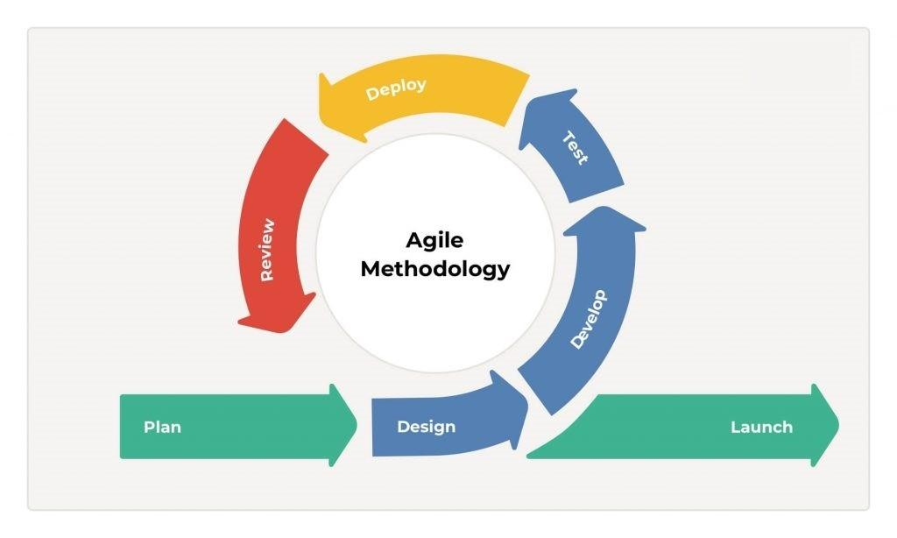
Figure 1 Agile Scrum Framework
The Agile Scrum methodology was chosen for the SLATE: Freight Management System – Human Resources 4 System with Predictive Attrition for Analytics Dashboard Using TensorFlow due to its flexibility, iterative nature, and emphasis on collaboration. This project involves multiple complex modules— Core Human Capital Management, Payroll Management, Compensation Planning, HR Analytics Dashboard, HMO & Benefits Administration—each requiring constant feedback, testing, and refinement. Agile Scrum provided a structured yet adaptable framework to manage these complexities effectively.
Agile Scrum methodology would serve as the framework for managing development, ensuring that your HR-IV system evolves in a flexible, iterative, and collaborative way. Instead of attempting to build the entire system in one long cycle, the work is divided into sprints—short, time-boxed iterations (usually 2–4 weeks). Each sprint delivers incremental improvements to modules such as payroll, HR analytics dashboards, freight management, and predictive attrition models.
At the beginning of each sprint, the team conducts Sprint Planning where the Product Owner (with input from the Business Analyst) selects high-priority items from the Product Backlog—for example, “automating payroll updates” or “integrating TensorFlow predictive models.” These are broken down into user stories with clear acceptance criteria, giving the development team a structured roadmap. During the sprint, the team collaborates daily in Scrum stand-up meetings, where each member shares progress, challenges, and next steps, ensuring alignment and transparency.
Throughout development, Scrum fosters cross-functional collaboration among the Project Manager, Programmers, Security Analyst, Document Specialist, and Business Analyst (stakeholders). For example, the Security Analyst continuously checks features for vulnerabilities, while the Business Analyst ensures that user stories remain aligned with HR needs such as reducing payroll delays or improving attrition insights. Meanwhile, Programmers implement features, test them iteratively, and integrate machine learning outputs into dashboards.
At the end of each sprint, the team demonstrates completed features in the Sprint Review, allowing HR staff, managers, and freight coordinators to provide direct feedback. This ensures that features like dashboards or payroll automation are validated early before moving forward. Then, in the Sprint Retrospective, the team reflects on what worked well, identifies bottlenecks (e.g., testing delays, unclear requirements), and decides how to improve processes for the next cycle.
By applying Scrum, your system benefits from:
Flexibility – requirements can adapt as HR and freight needs evolve.
Transparency – stakeholders see progress regularly, not only at the end.
Risk reduction – issues such as delayed payroll, slow updates, or inaccurate attrition predictions are identified and fixed early.
Continuous improvement – each sprint refines both the system and the team’s process.
In essence, Agile Scrum ensures that your HR-IV system with predictive analytics is delivered incrementally, validated frequently, secured continuously, and aligned closely with user needs, making it a practical approach for a complex project that combines freight management, HR automation, and AI-driven insights.

Agile Scrum methodology follows a cyclical process of short, iterative phases called sprints, which typically last 2–4 weeks. Each sprint focuses on delivering a functional increment of the system, ensuring adaptability and continuous improvement. Below is a detailed description of each step:
1. Sprint Planning
This is the starting point of each sprint. The team, led by the Project Manager (Scrum Master), collaborates with stakeholders and the Product Owner (Business Analyst role in your system) to define what features, tasks, or backlog items will be developed in the sprint. For example, in your HR-IV system, a sprint might focus on building the predictive attrition model in TensorFlow, improving payroll automation, or enhancing the freight management dashboard. The goal is to set realistic deliverables that align with business priorities, ensuring clarity of scope, resources, and timeline.
2. Development (Execution Phase)
Once planning is complete, the team begins executing the sprint tasks. Programmers, analysts, and security specialists work together to build, test, and integrate features. In the HR-IV context, this may involve coding payroll modules in PHP, designing employee dashboards with HTML/CSS/JavaScript, and training TensorFlow models for employee attrition prediction. Developers attend daily scrums (stand-up meetings) to share progress, identify blockers, and stay aligned. The Security Analyst also checks code for vulnerabilities, ensuring compliance with data protection standards like GDPR.
3. Sprint Review
At the end of the sprint, the team presents the completed features to stakeholders in a Sprint Review meeting. This demonstration ensures transparency and allows for early feedback before moving to the next sprint. For example, the team may showcase how the HR Analytics Dashboard visualizes workforce trends, or how the freight scheduling module improves delivery tracking. Stakeholders (like HR managers, freight operators, and executives) evaluate if the deliverables meet their expectations and suggest refinements for the backlog.
4. Sprint Retrospective
After the review, the team reflects on the sprint process itself, not just the product. The Retrospective focuses on identifying what went well, what challenges arose, and what can be improved in the next sprint. For instance, the team might recognize that bug fixes delayed payroll updates, or that integration between HR modules and freight scheduling took longer than expected. They then agree on improvements, such as automating more testing or refining task assignments. This ensures continuous improvement in both workflow and collaboration.
Cycle Repeats
The cycle begins again with a new Sprint Planning session, using feedback from the previous sprint. Over time, these incremental improvements lead to a fully functional, adaptive, and efficient system. By applying Scrum to your project, the HR-IV system evolves continuously, tackling real-world freight and HR challenges while maintaining flexibility to respond to user needs and organizational changes.
Agile Scrum methodology was selected for this project because it provides the flexibility, adaptability, and collaborative framework necessary to manage a system as complex and multi-dimensional as the HR-IV Freight Management System with Predictive Analytics. Unlike traditional methodologies such as Waterfall, which follow a linear and rigid sequence, Scrum divides work into short, iterative sprints that encourage continuous delivery of value, constant stakeholder engagement, and immediate feedback. This iterative process is critical for a project that integrates freight management, payroll automation, employee compensation, predictive attrition modeling using TensorFlow, and HR analytics dashboards—modules that are interconnected, data-intensive, and prone to changing requirements.
One of the primary reasons for adopting Scrum is its flexibility in handling evolving business needs. In HR and freight operations, requirements frequently shift due to policy updates, compliance regulations, staffing changes, or logistical challenges. Scrum allows the development team to reprioritize the product backlog in each sprint, ensuring that the most urgent and valuable features—such as reducing payroll delays, improving attrition prediction accuracy, or enhancing freight tracking efficiency—are addressed first. This dynamic prioritization reduces the risk of wasted effort and ensures that the system always aligns with real-world needs.
Scrum also promotes transparency and collaboration, which are essential for this system. Regular sprint reviews enable HR managers, freight coordinators, and executives to test features and provide feedback on dashboards, automated workflows, and AI-driven insights. This ongoing interaction ensures that deliverables are validated incrementally, not just at the end of the project, minimizing misunderstandings and enhancing user satisfaction. At the same time, the cross-functional nature of Scrum teams—involving a Project Manager, Business Analyst, Programmers, Security Analyst, and Document Specialist—ensures that every perspective is considered, from technical feasibility to data security to usability.
Another major advantage of Scrum is risk reduction. Complex systems such as HR-IV are vulnerable to issues like delayed payroll runs, inaccurate predictions, outdated employee records, or security breaches. By working in short iterations with continuous testing, risks are identified and mitigated early. For instance, vulnerabilities in payroll encryption or errors in predictive models can be discovered and corrected during the sprint, instead of becoming critical failures after deployment.
Finally, Scrum fosters a culture of continuous improvement. Through Sprint Retrospectives, the team reflects on what worked well and what must be improved, whether it involves automating testing pipelines, refining backlog management, or improving collaboration between roles. This ensures not only that the product evolves but also that the team’s efficiency and effectiveness increase over time.

3.2 Roles (Scrum Master, Product Owner, Development Team)
Here’s a clear definition of the roles and responsibilities you outlined, framed in the context of your SLATE: Freight Management System – Human Resources IV (HR-4) with Predictive Attrition for HR Analytics Dashboard using TensorFlow project:
Name | Role | Responsibilities
TAY, ELDRIAN | Project Manager | Facilitates all Scrum ceremonies including sprint planning, reviews, and retrospectives. Ensures project timelines, resources, and scope remain aligned while resolving blockers and managing risks. Serves as the primary communication bridge between the development team, stakeholders, and leadership. Tracks project progress using Agile KPIs such as sprint velocity, burndown charts, and cycle time to maintain transparency and ensure successful delivery.
FABABIER, DAVID JOHN C. | Business Analyst | Gathers and refines business requirements from HR staff, payroll officers, and freight managers through interviews, surveys, and workshops. Creates and prioritizes user stories with clear acceptance criteria based on business value. Supports product backlog management and validates developed features against original business needs. Acts as a translator between technical teams and non-technical stakeholders to ensure shared understanding of system features and goals.
ABUYABOR, EDMON D. | Security Analyst | Identifies and mitigates security risks throughout the system development lifecycle, focusing on protecting sensitive HR and payroll data. Implements data protection best practices including role-based access control, encryption, and strong authentication measures. Conducts regular vulnerability assessments during sprints and collaborates with developers to ensure secure coding practices. Ensures system compliance with security standards and regulations such as GDPR and local labor laws.
PEROS, JONATHAN M. | Programmer | Develops system features based on sprint backlog items including freight management, HR modules, and AI-powered predictive attrition functionality. Writes clean, efficient, and maintainable code while participating in daily scrums and code reviews. Integrates TensorFlow models into the HR analytics dashboard to enable real-time attrition risk predictions. Continuously fixes bugs and iteratively improves system features for better performance, usability, and scalability.
RAMOS, MARIEL A. | Document Specialist | Creates comprehensive technical specifications, user manuals, and training guides for system users including HR staff, payroll officers, and managers. Maintains detailed sprint logs, release notes, and project reports while collaborating with the Business Analyst to accurately capture requirements. Ensures all documentation remains current through proper version control practices and organizes deliverables in a centralized, easily accessible repository for team and stakeholder reference.
Table 2 Roles and Responsibilities Table

3.3 Sprint Cycles (Planning, Standups, Review)
To Do | In Progress | Done
 |  | Employee Demographics
 |  | Trend Turnover Graphs
 |  | Predictive Attrition Analysis
 |  | Employee time in and time out record
 |  | Performance-based Incentives
 |  | Employee Profile Records
 |  | Employee Information Management
 |  | Employee contract management
 |  | Workforce data graph
 |  | Analytic Dashboard
 |  | Employee HMO detail
 |  | Filter Function
 |  | Integrated attendance with payroll
 |  | Payroll release Schedule
 |  | Automated deduction
Employee
Performance Dashboard
Automated deduction
 |  | HMO and Benefits Report
 |  | Registration of employee HMO Plans
 |  | Employee Salary Detail
 |  | Performance-based compensation
 |  | Long Term Compensation Plan
 |  | Analytical Recommendation for Compensation
 | Link Compensation to Attrition Prediction | Role-based compensation packages
Table 3 Sprint Cycles

3.4 Scrum Artifacts (Product Backlog, Sprint Backlog)
3.4.1 1 Product Backlog (User Stories)
User Story No. | Features/ Task | User Stories | Priority | Status
CORE HUMAN CAPITAL
F1 | Employee Profile Records | As HR staff, I want to record and update employee personal profiles so that records are complete | HIGH | DONE
F2 | Employee Categorization  (filter function) | As HR staff, I want to categorize employees by department and role so that workforce data is organized. | HIGH | DONE
F3 | End user log-in page | As a user, I want to log in and view my personal records so I can check my own data | HIGH | DONE
F4 | Employee contract management | As HR staff, I want to manage employee contracts so that I can track employment status. | LOW | DONE
F5 | Leave request form | As HR staff, I want to manage employee leave requests so that I can process them digitally. | HIGH | DONE
F6 | Leave Request Assessment | As a manager, I want to approve or reject leave requests so that scheduling is ensured. | LOW | DONE
F7 | DATABASE | As a Manager, I want a Standard and Secure Database that Holds all the Employee master data | HIGH | DONE
F7 | Employee Demographics | As management, I want to generate employee demographic reports (age, tenure, role) so that I can analyze workforce distribution. | HIGH | DONE
HR ANALYTICS DASHBOARD
F8 | Employee  Performance Dashboard | As HR staff, I want to drill down into individual employee dashboards so that I can review performance. | HIGH | DONE
F9 | Trend Turnover Graphs | As a manager, I want to analyze turnover trends through visual graphs so that I can see retention | HIGH | DONE
F10 | Predictive attrition Analysis | As HR staff, I want to view predictive attrition risk analysis results so that I can identify high-risk employees. | HIGH | DONE
F11 | Workforce data graph | As management, I want to compare workforce data across multiple periods so that I can evaluate improvements. | LOW | DONE
F12 | Analytic Dashboard | As HR staff, I want to view dashboards with employee KPIs (attendance, attrition, performance) so that I can monitor trends. | HIGH | DONE
F13 | HR Report | As management, I want to generate summary HR reports so that I can make executive decisions. | LOW | DONE
F14 | Filter Function | As HR staff, I want to filter dashboards by department or date range so that I can customize views | Medium | DONE
HMO & BENEFITS ADMINISTRATION
F15 | Registration of employee HMO Plans | As HR staff, I want to register employees under company HMO plans so that medical coverage is documented. | MEDIUM | DONE
F22 | Employee Bio | As an employee, I want to update my dependent information so that my records remain accurate. | HIGH | DONE
F16 | Employee HMO detail | As an employee, I want to view my HMO plan details so that I know my coverage. | MEDIUM | DONE
F17 | HMO and Benefits Report | As management, I want to generate reports on HMO and benefits expenses so that budgeting is informed. | LOW | DONE
PAYROLL MANAGEMENT
F18 | Employee time in and time out | As payroll staff, I want to record employee working hours and overtime so that salary computations are accurate. | HIGH | DONE
F19 | Integrated attendance with payroll | As HR staff, I want to integrate attendance records with payroll so that manual work is reduced. | LOW | DONE
F20 | Employee Salary Detail | As an employee, I want to view my payslips online so that I can check my salary details. | HIGH | DONE
F21 | Automated deduction | As payroll staff, I want to automatically calculate deductions (tax, SSS, Pag-IBIG, PhilHealth, loans) so that compliance is ensured. | HIGH | DONE
F22 | Payroll release Schedule | As payroll staff, I want to schedule payroll releases (monthly/semi-monthly) so that payments are consistent. | MEDIUM | DONE
COMPENSATION PLANNING
F23 | Role-based compensation packages | As management, I want to set compensation packages for different roles so that salaries are standardized. | HIGH | DONE
F24 | Performance-based compensation | As HR staff, I want to plan salary adjustments based on performance evaluations so that rewards are fair. | HIGH | DONE
F25 | Link Compensation to Attrition Prediction | As management, I want to link compensation planning with attrition predictions so that retention strategies are informed | MEDIUM | DONE
F26 | Performance-based Incentives | As HR staff, I want to track merit-based bonuses and incentives so that rewards are managed. | MEDIUM | DONE
F27 | Long Term Compensation Plan | As HR staff, I want to manage long-term compensation plans (retirement, loyalty bonuses) so that employee benefits are structured. | HIGH | DONE
F28 | Analytical Recommendation for Compensation | As management, I want to receive recommendations from analytics on optimal compensation packages so that workforce satisfaction improves. | MEDIUM | DONE
Table 4 Product Backlog
3.4.2 Product Backlog for EIS Information Security
EIS NO. | EIS USER STORIES | EIS IS PRIORITY | Reversion Priority | Status
IS-1 | As an Employee, I want my sensitive information to be protected | 1 | 1 | DONE
IS-2 | As an HR Manager, I want to log in securely using multi-factor authentication so sensitive employee and freight data is protected from unauthorized access. | 1 | 1 | DONE
IS-3 | As a system administrator, I want to assign different access levels to managers, brokers, drivers, and HR staff so that each user can only access the data relevant to their role. | 1 | 1 | DONE
IS-4 | As an HR manager, I want employee and freight records to be encrypted both in transit and at rest so that confidential data remains secure against breaches. | 1 | 1 | DONE
IS-5 | As a security officer, I want the system to enforce strong password rules (minimum length, complexity, expiration) so that weak credentials do not compromise security. | 1 | 2 | DONE
IS-6 | As a user, I want the system to log me out automatically after inactivity so that unattended sessions cannot be exploited. | 1 | 2 | DONE
IS-7 | As a security officer, I want the system to detect unusual login attempts or data access patterns and send alerts so that threats can be addressed quickly. | 1 | 2 | DONE
IS-8 | As a system auditor, I want the system to generate detailed logs of user activities so that I can trace and investigate suspicious actions when necessary. | 2 | 2 | DONE
Table 5 Product Backlog for EIS Information Security
3.4.3 Product Backlog for EIS Standards
3.4.3.1 UI/UX (Icons, Color, etc…)
EIS Standard No. | EIS Standard User Stories | EIS Standard Priority | Revision Priority | Status
UI-1 | As an HR staff, I want consistent and intuitive icons across the dashboard so that I can easily navigate the system without confusion. | 1 | 2 | DONE
UI-2 | As a manager, I want the system to adjust smoothly on desktop, tablet, and mobile devices so that I can access the HR-IV system anytime, anywhere. | 1 | 2 | DONE
UI-3 | As a system administrator, I want standardized fonts, sizes, and branding across modules so that the system looks professional and unified. | 2 | 2 | DONE
UI-4 | As an HR manager, I want reports and analytics displayed using clear charts and graphs so that I can interpret workforce and freight data quickly. | 1 | 2 | DONE
UI-5 | As a user, I want a simple layout so that I can perform tasks without distraction or confusion. | 2 | 2 | DONE
UI-6 | As a user, I want a fast and easy-to-use search bar | 2 | 3 | DONE
UI-7 | As a system user, I want the system to use accessible color schemes (contrast-compliant) so that information is readable | 2 | 2 | DONE
UI-8 | As a first-time user, I want tooltips and help icons on buttons and forms so that I can understand features without needing external training. | 3 | 3 | DONE
Table 6 Product Backlog for EIS Standards

3.4.4 Product Backlog for EIS Integration
EIS Integration No. | EIS Integration User Stories | EIS Integration Priority | Revision Priority | Status
INT-1 | As an HR staff, I want Recruitment data to automatically feed into the Employee Master File so that new hires are seamlessly integrated into payroll and benefits. | 1 | 1 | DONE
INT-2 | As a Compensation officer, I want Performance Management results to flow into Compensation Planning so that bonuses and salary adjustments are data-driven. | 1 | 1 | DONE
INT-3 | As an HR manager, I want Succession Planning updates to adjust Compensation Planning so that promotions and salary increases are consistently applied. | 2 | 2 | DONE
INT-4 | As a Manager, I want Social Recognition rewards to feed into Compensation Planning so that employee recognition is reflected in bonuses. | 3 | 3 | DONE
INT-5 | As a Payroll officer, I want Compensation Planning adjustments/bonuses to reflect automatically in Payroll so that salaries are accurate without manual input. | 1 | 2 | DONE
INT- 6 | As a Payroll officer, I want Time & Attendance logs to integrate with Payroll so that overtime and absences are reflected in salary computations. | 1 | 2 | DONE
INT-7 | As a Payroll officer, I want Timesheet Management data (manual logs) to flow into Payroll so that additional work hours are properly compensated. | 1 | 1 | DONE
INT-8 | As a Payroll officer, I want Leave Management deductions to update Payroll so that unpaid leave is automatically deducted from salaries. | 2 | 3 | DONE
INT-9 | As an HR staff, I want HMO & Benefits Administration to reflect in Payroll so that deductions and company contributions are computed automatically. | 2 | 3 | DONE
INT-10 | As an HR analyst, I want Core Human Capital data (roles, positions, demographics) to feed into HR Analytics Dashboard so that workforce distribution can be visualized. | 1 | 2 | DONE
Table 7 Product Backlog for EIS Integration

3.4.5 Product Backlog for Analytics
3.4.5.1 Application System Analytics
EIS Integration No. | EIS Integration User Stories | EIS Integration Priority | Revision Priority | Status
ASA-1 | As an HR analyst, I want Payroll data (salaries, bonuses, deductions) integrated into HR Analytics so that I can monitor workforce cost trends. | 1 | 2 | DONE
ASA-2 | As a payroll officer I want the time in and time out of driver for proper salary computation | 1 | 2 | DONE
ASA-3 | As an HR officer, I want Core Human Capital data (demographics, job roles, departments) analyzed so that I can visualize workforce distribution. | 1 | 2 | DONE
ASA-4 | As a Compliance Officer, I want Attendance and Leave data included in Analytics so that I can track absenteeism and its impact on productivity. | 2 | 3 | DONE
ASA-5 | As a Compensation Manager, I want Performance Ratings from Performance Management to feed into Analytics so that I can correlate ratings with salary adjustments. | 1 | 2 | DONE
ASA-6 | As an HR executive, I want Succession Planning data integrated into Analytics so that I can track leadership pipeline readiness. | 1 | 2 | DONE
Table 8 Product Backlog for Analytics
3.4.5.2 EIS Analytics
EIS Analytics No. | EIS Analytics Stories | EIS Analytics Priority | Revision Priority | Status
EA-1 | As an HR manager, I want to analyze employee turnover trends so that I can identify attrition risks early. | 1 | 1 | DONE
EA-2 | As a compensation planner, I want to visualize the relationship between performance ratings and salary adjustments so that I can ensure fairness. | 1 | 1 | DONE
EA-3 | As a payroll officer, I want to generate analytics on salary distribution by department so that I can detect anomalies in pay. | 1 | 2 | DONE
EA-4 | As an HR analyst, I want predictive analytics on attrition using machine learning so that I can prevent high turnover in critical roles. | 1 | 1 | DONE
EA-5 | As an HR officer, I want to track headcount growth and attrition in Core HCM so that I can align with manpower planning. | 1 | 2 | DONE
EA-6 | As a compensation planner, I want to analyze bonus allocation by role and department so that I can measure equity in rewards. | 1 | 2 | DONE
EA-7 | As an HR analyst, I want the HR Analytics Dashboard to highlight workforce demographics so that I can identify diversity gaps. | 2 | 3 | DONE
EA-8 | As a payroll officer, I want analytics on overtime pay trends so that I can manage excessive costs. | 2 | 2 | DONE
Table 9 EIS Analytics

3.4.6 SPRINT Backlog (User Stories)

Task No. | User Story No. | User Stories | Tasks | Timeline | Responsible Team Member/s
SPRINT 1
S1_1 | UI-3 | As a system administrator, I want standardized fonts, sizes, and branding across modules so that the system looks professional and unified. | PLANNING, DESIGN, CODE, DOCUMENTATION | 14 | TAY, ELDRIAN; ABUYABOR, EDMON D.; PEROS, JONATHAN M.; FABABIER, DAVID JOHN C.; RAMOS, MARIEL A.
S1_2 | UI-1 | As an HR staff, I want consistent and intuitive icons across the dashboard so that I can easily navigate the system without confusion. | PLANNING, DESIGN, CODE, DOCUMENTATION | 14 | TAY, ELDRIAN; ABUYABOR, EDMON D.; PEROS, JONATHAN M.; FABABIER, DAVID JOHN C.; RAMOS, MARIEL A.
S1_3 | UI-4 | As an HR manager, I want reports and analytics displayed using clear charts and graphs so that I can interpret workforce and freight data quickly. | PLANNING, DESIGN, CODE, DOCUMENTATION | 14 | TAY, ELDRIAN; ABUYABOR, EDMON D.; PEROS, JONATHAN M.; FABABIER, DAVID JOHN C.; RAMOS, MARIEL A.
S1_4 | UI-5 | As a user, I want a simple layout so that I can perform tasks without distraction or confusion. | PLANNING, DESIGN, CODE, DOCUMENTATION | 7 | TAY, ELDRIAN; ABUYABOR, EDMON D.; PEROS, JONATHAN M.; FABABIER, DAVID JOHN C.; RAMOS, MARIEL A.
S1_5 | UI-6 | As a user, I want a fast and easy-to-use search bar | PLANNING, DESIGN, CODE, DOCUMENTATION | 14 | TAY, ELDRIAN; ABUYABOR, EDMON D.; PEROS, JONATHAN M.; FABABIER, DAVID JOHN C.; RAMOS, MARIEL A.
S1_6 | UI-7 | As a system user, I want the system to use accessible color schemes (contrast-compliant) so that information is readable | PLANNING, DESIGN, CODE, DOCUMENTATION | 7 | TAY, ELDRIAN; ABUYABOR, EDMON D.; PEROS, JONATHAN M.; FABABIER, DAVID JOHN C.; RAMOS, MARIEL A.
S1_7 | IS-1 | As an Employee, I want my sensitive information to be protected | PLANNING, DESIGN, CODE, DOCUMENTATION | 14 | TAY, ELDRIAN; ABUYABOR, EDMON D.; PEROS, JONATHAN M.; FABABIER, DAVID JOHN C.; RAMOS, MARIEL A.
SPRINT 2
S2_1 | F-6 | As management, I want to generate employee demographic reports (age, tenure, role) so that I can analyze workforce distribution. | PLANNING, DESIGN, CODE, DOCUMENTATION | 14 | TAY, ELDRIAN; ABUYABOR, EDMON D.; PEROS, JONATHAN M.; FABABIER, DAVID JOHN C.; RAMOS, MARIEL A.
S2_2 | F10 | As HR staff, I want to view predictive attrition risk analysis results so that I can identify high-risk employees. | PLANNING, DESIGN, CODE, DOCUMENTATION | 28 | TAY, ELDRIAN; ABUYABOR, EDMON D.; PEROS, JONATHAN M.; FABABIER, DAVID JOHN C.; RAMOS, MARIEL A.
S2_3 | F-18 | As management, I want to generate reports on HMO and benefits expenses so that budgeting is informed. | PLANNING, DESIGN, CODE, DOCUMENTATION | 14 | TAY, ELDRIAN; ABUYABOR, EDMON D.; PEROS, JONATHAN M.; FABABIER, DAVID JOHN C.; RAMOS, MARIEL A.
S2_4 | F19 | As payroll staff, I want to record employee working hours and overtime so that salary computations are accurate. | PLANNING, DESIGN, CODE, DOCUMENTATION | 14 | TAY, ELDRIAN; ABUYABOR, EDMON D.; PEROS, JONATHAN M.; FABABIER, DAVID JOHN C.; RAMOS, MARIEL A.
S2_5 | F-27 | As HR staff, I want to track merit-based bonuses and incentives so that rewards are managed. | PLANNING, DESIGN, CODE, DOCUMENTATION | 14 | TAY, ELDRIAN; ABUYABOR, EDMON D.; PEROS, JONATHAN M.; FABABIER, DAVID JOHN C.; RAMOS, MARIEL A.
S2_6 | F9 | As a manager, I want to analyze turnover trends through visual graphs so that I can see retention | PLANNING, DESIGN, CODE, DOCUMENTATION | 14 | TAY, ELDRIAN; ABUYABOR, EDMON D.; PEROS, JONATHAN M.; FABABIER, DAVID JOHN C.; RAMOS, MARIEL A.
SPRINT 3
S3_1 | IS-3 | As a system administrator, I want to assign different access levels to managers, and HR staff so that each user can only access the data relevant to their role. | PLANNING, DESIGN, CODE, DOCUMENTATION | 14 | TAY, ELDRIAN; ABUYABOR, EDMON D.; PEROS, JONATHAN M.; FABABIER, DAVID JOHN C.; RAMOS, MARIEL A.
S3_2 | UI-2 | As a manager, I want the system to adjust smoothly on desktop, tablet, and mobile devices so that I can access the HR-IV system anytime, anywhere. | PLANNING, DESIGN, CODE, DOCUMENTATION | 7 | TAY, ELDRIAN; ABUYABOR, EDMON D.; PEROS, JONATHAN M.; FABABIER, DAVID JOHN C.; RAMOS, MARIEL A.
S3_3 | EA-4 | As an HR analyst, I want predictive analytics on attrition using machine learning so that I can prevent high turnover in critical roles. | PLANNING, DESIGN, CODE, DOCUMENTATION | 14 | TAY, ELDRIAN; ABUYABOR, EDMON D.; PEROS, JONATHAN M.; FABABIER, DAVID JOHN C.; RAMOS, MARIEL A.
S3_4 | F1 | As HR staff, I want to record and update employee personal profiles so that records are complete | PLANNING, DESIGN, CODE, DOCUMENTATION | 7 | TAY, ELDRIAN; ABUYABOR, EDMON D.; PEROS, JONATHAN M.; FABABIER, DAVID JOHN C.; RAMOS, MARIEL A.
S3_5 | F2 | As HR staff, I want to categorize employees by department and role so that workforce data is organized | PLANNING, DESIGN, CODE, DOCUMENTATION | 14 | TAY, ELDRIAN; ABUYABOR, EDMON D.; PEROS, JONATHAN M.; FABABIER, DAVID JOHN C.; RAMOS, MARIEL A.
S3_6 | F3 | As HR staff, I want to manage employee contracts so that I can track employment status. | PLANNING, DESIGN, CODE, DOCUMENTATION | 7 | TAY, ELDRIAN; ABUYABOR, EDMON D.; PEROS, JONATHAN M.; FABABIER, DAVID JOHN C.; RAMOS, MARIEL A.
S3_7 | F22 | As payroll staff, I want to automatically calculate deductions (tax, SSS, Pag-IBIG, PhilHealth, loans) so that compliance is ensured. | PLANNING, DESIGN, CODE, DOCUMENTATION | 7 | TAY, ELDRIAN; ABUYABOR, EDMON D.; PEROS, JONATHAN M.; FABABIER, DAVID JOHN C.; RAMOS, MARIEL A.
S3_8 | UI-8 | As a first-time user, I want tooltips and help icons on buttons and forms so that I can understand features without needing external training. | PLANNING, DESIGN, CODE, DOCUMENTATION | 14 | TAY, ELDRIAN; ABUYABOR, EDMON D.; PEROS, JONATHAN M.; FABABIER, DAVID JOHN C.; RAMOS, MARIEL A.
SPRINT 4
S4_1 | INT-1 | As an HR staff, I want Recruitment data to automatically feed into the Employee Master File so that new hires are seamlessly integrated into payroll and benefits. | PLANNING, DESIGN, CODE, DOCUMENTATION | 7 | TAY, ELDRIAN; ABUYABOR, EDMON D.; PEROS, JONATHAN M.; FABABIER, DAVID JOHN C.; RAMOS, MARIEL A.
S4_2 | INT-2 | As a Compensation officer, I want Performance Management results to flow into Compensation Planning so that bonuses and salary adjustments are data-driven. | PLANNING, DESIGN, CODE, DOCUMENTATION | 7 | TAY, ELDRIAN; ABUYABOR, EDMON D.; PEROS, JONATHAN M.; FABABIER, DAVID JOHN C.; RAMOS, MARIEL A.
S4_3 | INT-3 | As an HR manager, I want Succession Planning updates to adjust Compensation Planning so that promotions and salary increases are consistently applied. | PLANNING, DESIGN, CODE, DOCUMENTATION | 7 | TAY, ELDRIAN; ABUYABOR, EDMON D.; PEROS, JONATHAN M.; FABABIER, DAVID JOHN C.; RAMOS, MARIEL A.
S4_4 | INT-4 | As a Manager, I want Social Recognition rewards to feed into Compensation Planning so that employee recognition is reflected in bonuses. | PLANNING, DESIGN, CODE, DOCUMENTATION | 7 | TAY, ELDRIAN; ABUYABOR, EDMON D.; PEROS, JONATHAN M.; FABABIER, DAVID JOHN C.; RAMOS, MARIEL A.
S4_5 | INT-5 | As a Payroll officer, I want Compensation Planning adjustments/bonuses to reflect automatically in Payroll so that salaries are accurate without manual input | PLANNING, DESIGN, CODE, DOCUMENTATION | 7 | TAY, ELDRIAN; ABUYABOR, EDMON D.; PEROS, JONATHAN M.; FABABIER, DAVID JOHN C.; RAMOS, MARIEL A.
S4_6 | INT-6 | As a Payroll officer, I want Time & Attendance logs to integrate with Payroll so that overtime and absences are reflected in salary computations. | PLANNING, DESIGN, CODE, DOCUMENTATION | 7 | TAY, ELDRIAN; ABUYABOR, EDMON D.; PEROS, JONATHAN M.; FABABIER, DAVID JOHN C.; RAMOS, MARIEL A.
S4_7 | INT-7 | As a Payroll officer, I want Timesheet Management data (manual logs) to flow into Payroll so that additional work hours are properly compensated. | PLANNING, DESIGN, CODE, DOCUMENTATION | 7 | TAY, ELDRIAN; ABUYABOR, EDMON D.; PEROS, JONATHAN M.; FABABIER, DAVID JOHN C.; RAMOS, MARIEL A.
S4_8 | INT-8 | As a Payroll officer, I want Leave Management deductions to update Payroll so that unpaid leave is automatically deducted from salaries. | PLANNING, DESIGN, CODE, DOCUMENTATION | 7 | TAY, ELDRIAN; ABUYABOR, EDMON D.; PEROS, JONATHAN M.; FABABIER, DAVID JOHN C.; RAMOS, MARIEL A.
S4_9 | INT-9 | As an HR staff, I want HMO & Benefits Administration to reflect in Payroll so that deductions and company contributions are computed automatically. | PLANNING, DESIGN, CODE, DOCUMENTATION | 14 | TAY, ELDRIAN; ABUYABOR, EDMON D.; PEROS, JONATHAN M.; FABABIER, DAVID JOHN C.; RAMOS, MARIEL A.
S4_10 | INT-10 | As an HR analyst, I want Core Human Capital data (roles, positions, demographics) to feed into HR Analytics Dashboard so that workforce distribution can be visualized. | PLANNING, DESIGN, CODE, DOCUMENTATION | 14 | TAY, ELDRIAN; ABUYABOR, EDMON D.; PEROS, JONATHAN M.; FABABIER, DAVID JOHN C.; RAMOS, MARIEL A.
Table 10 Sprint Backlog (User Stories)

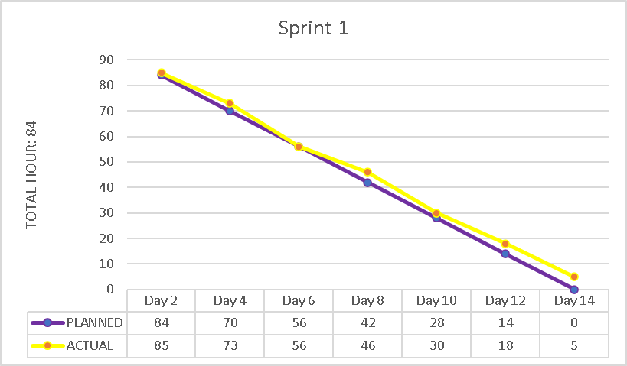
3.4.6.1 Sprint Burndown Chart
Figure SEQ Figure \* ARABIC 2 Sprint Burndown Chart
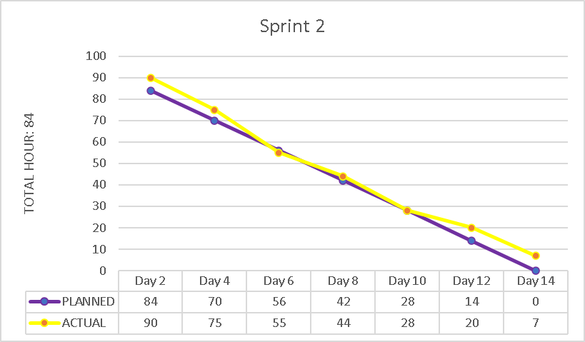

3.4.7. Increment
Sprint No. | Increment / Feature Delivered | User Story / Backlog Reference | Definition of Done (DoD) Criteria | Status | Remarks
Sprint 1 | -Standard Graph and Charts  -User Friendly Interface  -Search Bar | UI-3, UI-2, UI-4, UI-5, UI-6, UI-7 | -Basic User Interface,  -Standard and Consistent Icon  -Chart and Graph report  -Easy to use Search bar | Done | Basic User Interface design and functionality
Sprint 1 | -Database Creation | F-7 | -Functional Database | Done | Implemented for Testing and Review
Sprint 2 | Demographic Reports,  -Attrition Analysis,  -Employee data reports | F-6, F-10,  F-19, F-27, F-9 | -Employee data and information Handling | Done | Awaiting the integration of employee data from other HR departments.
Sprint 3 | -Role-Based Access Control  -Responsive UI  -Predictive Analytics | IS-3, UI-2, EA-4, | -Make data access limited based on role,  -Accessible to PC and CP  -Utilize machine learning for predictive analytics | In-Progress | Additional Function and Process to be implemented into the system
Sprint 3 | -Employee Profile Records,  - Employee Categorization  - Employee contract management  - Automated deduction  -Tooltips, Help Icons | F-1, F-2, F-3,  F-22, UI-8 | -Able to record and update Employee profile  -Organize data by categorization  -Track employment status  -Automatic calculation of deduction  -Available tooltips | In-Progress | Additional Function and Process to be implemented into the system
Sprint 4 | Seamless Data exchange with other HR departments | INT-1  INT-2  INT-3  INT-4  INT-5 | -Automatic transfer of recruitment data, Performance, and social recognition  Automatic input based on adjustments | To-Do | To be implemented
Table 11 Increment Table

3.5 Microservices Architecture
The HR-IV system was designed using a decoupled services approach, where each service (or module) is responsible for a specific business function. This modular design allows the system to be scalable, maintainable, and flexible, ensuring that updates or improvements to one service do not disrupt others.

Sub-Module | Role / Function | Decoupled Service Design
HR Analytics Dashboard | Provides real-time and predictive insights into HR metrics and workforce trends. | Runs as an independent analytics engine, gathers data from all modules via APIs, scalable for reporting workloads.
Payroll Management | Automates payroll processing, salary computation, deductions, and tax compliance. | Operates as a standalone payroll service, integrates with HCM and Analytics, can be updated without disruption.
Core Human Capital Management (HCM) | Central repository for employee records, serving as the system of record. | Functions as the core service, provides employee identity and lifecycle data via APIs to other modules.
Compensation Planning | Defines, manages, and evaluates compensation structures, salary bands, and bonuses. | Built as a separate service, connects with HCM and Payroll, shares insights with Analytics.
HMO & Benefits Administration | Manages healthcare, insurance, and employee benefits while ensuring compliance. | Runs as a self-contained benefits service, syncs with HCM and Payroll, provides compliance data to Analytics.
Table 12 System Modules Specification Table
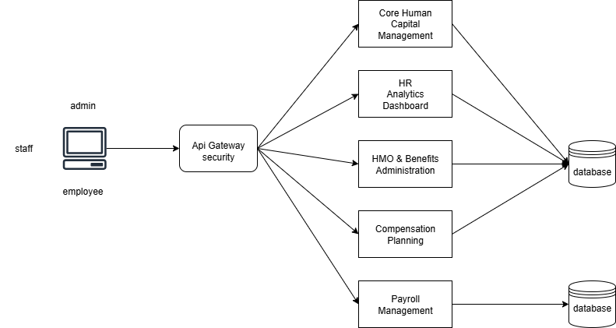
Figure 3 Microservices Architecture Diagram

3.6 DevOps Implementation
To initiate, develop, and successfully conclude the enhancement of the HR-IV system, the project applies DevOps principles to automate code building, testing, integration, and deployment. This approach ensures faster delivery cycles, higher reliability, and better collaboration between development, operations, and research teams. The following table summarizes the categories, tools, and processes used in the system’s implementation:
CATEGORY | TOOLS/PROCESS | FUNCTIONS
Frontend Development | HTML | Structures the content of web pages
Frontend Development | CSS | Styles and designs the user interface
Frontend Development | JavaScript | Adds interactivity, dynamic data visualizations, and smooth navigation in HR analytics dashboards.
Backend Development | PHP | Server-side scripting language for building application logic
Database Management | MySQL | Stores and manages user, booking, and system data
Local Server Stack | XAMPP | Provides Apache server, PHP, and MySQL for local development and testing
Machine Learning | TensorFlow | Builds and trains predictive models for employee attrition analysis
Version Control | Git / GitHub | Tracks code changes, manages branches, and supports collaborative development across multiple modules (freight, HR, AI).
Continuous Integration | GitHub Actions / Jenkins | Automates building, compiling, and running unit tests whenever new code is pushed, ensuring early detection of errors.
Table 13 Project Tech Stack Overview
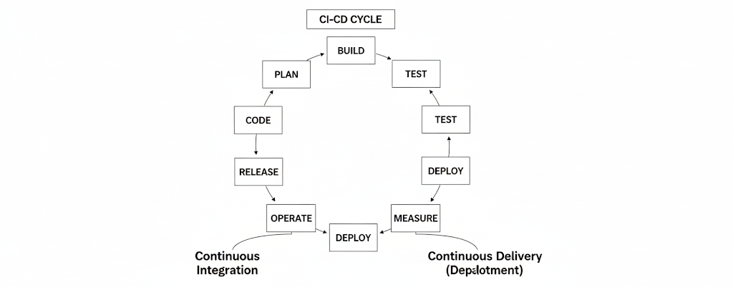
Figure SEQ Figure \* ARABIC 4 CI/CD Pipeline

3.7 Integration Approach for Information System
The SLATE project adopts a modular and incremental integration approach, combining top-down and API-driven methods to effectively connect its core components: Freight Management, HR System, Predictive Attrition Model using TensorFlow, and the HR Analytics Dashboard. Each module is developed and tested independently, then integrated through APIs and a shared MySQL database to ensure seamless data flow and functionality. Security is enforced through role-based access and JWT authentication, while the integration strategy allows for early testing, flexibility, and scalability, ensuring a reliable and efficient system deployment.
- Core Human Capital Management
- Acts as the backbone of the system because all employee-related data (roles, departments, performance, start dates, etc.) are stored here.
- This data flows into Payroll Management, HMO & Benefits Administration, Compensation Planning, and Leave Management.
- Ensures one source of truth for employee information across modules.
- Compensation Planning
Integrates with Performance Management and Recruitment Management by using employee roles, ratings, and new hire details.
- Passes bonus/allowance details into Payroll Management, which applies them during salary computation.
- Aligns with Succession Planning and Social Recognition to reward and prepare employees.
- Payroll Management
- A central hub for financial processing.
- Pulls employee master data from Core Human Capital Management.
- Applies allowances/bonuses from Compensation Planning.
- Uses data from Time & Attendance, Leave Management, and Driver/Trip Monitoring to compute pay accurately.
- Pushes disbursement instructions for salary release.
- Time and Attendance / Timesheet Management
- Feeds work hours, absences, or overtime records into Payroll for salary adjustments.
- Also supports Leave Management, ensuring accurate deduction of leave balances.
- HMO & Benefits Administration
- Uses employee details from Core Human Capital Management (start dates, job level, etc.) to assign benefits.
- Reflects benefits directly into payroll (e.g., deductions or allowances for insurance).
- Leave Management
- Integrated with Payroll (salary deductions for unpaid leaves).
- Connected to Core Human Capital Management to check eligibility (role, department, tenure).
- Learning Management

- Receives employee roles/department info from Core Human Capital Management to assign training.
- Training hours are recorded and passed to Payroll if tied to compensation.
- Works with HR Analytics Dashboard to measure training impact.
- HR Analytics Dashboard (TensorFlow-powered)
- Collects and processes data from Core Human Capital Management, Learning Management, Compensation Planning, and Payroll.
- Provides insights on attrition risks, workforce distribution, and performance trends.
- Feeds insights back into Business Intelligence and Freight Analytics to evaluate workforce impact on freight operations.
- Driver and Trip Performance Monitoring
- Specifically freight-related but integrated with Payroll for trip-based pay computation.
- Also provides performance data for analytics (e.g., fuel efficiency, delays, driver turnover).
- Business Intelligence & Freight Analytics
- Receives workforce and HR data from the HR Analytics Dashboard.
- Correlates HR insights (attrition, productivity, training outcomes) with freight performance (delivery speed, customer satisfaction).
- Bridges HR and freight management, ensuring the workforce’s efficiency directly supports freight operations.

3.8 Introduction to TOGAF and the Four Architectural Domains
In developing the SLATE: Freight Management System – Human Resources-IV System with Predictive Attrition for HR Analytics Dashboard using TensorFlow, the TOGAF (The Open Group Architecture Framework) provides a structured and scalable framework for aligning IT architecture with the organization’s strategic goals. TOGAF is based on the Architecture Development Method (ADM), which guides the systematic design, implementation, and governance of enterprise systems. It divides architecture into four key domains, each of which plays a critical role in ensuring that the SLATE system is cohesive, adaptable, and business-aligned:
1. Business Architecture defines the strategies, safety and compliance, governance, and processes of the HR-4 system. In the Core Human Capital Management module, this includes managing the employee lifecycle from recruitment and onboarding to performance evaluation and offboarding.
2. Application Architecture specifies the software modules of HR-4 and how they interact. For example, the Payroll module integrates with Compensation Planning to calculate salaries, bonuses, and deductions automatically. The HR Analytics Dashboard consolidates data from payroll, benefits, and performance records to provide insights for management decision-making. The HMO and Benefits Administration module also connects with payroll to reflect employee contributions and deductions.
3. Data Architecture manages the structure and flow of HR data across all submodules. Employee records, payroll histories, compensation details, and HMO or benefits information are maintained in a centralized database. Data integrity rules ensure that updates in one module, such as changes in salary within Compensation Planning, are reflected consistently in Payroll and Analytics.
4. Technology Architecture describes the technical infrastructure of HR-4. The system is deployed on a cloud-based environment for accessibility and scalability. Secure APIs are used to integrate Payroll with external banking systems.

TOGAF Architecture Domain | Business Architecture | Application Architecture | Data Architecture | Technology Architecture
Focus | Strategy, governance, and HR processes | Software systems and interactions | Structure and management of HR data | Infrastructure, platforms, and tools
Key Principles | Align HR strategy with freight management goals, ensure compliance, and support employee well-being | Ensure seamless integration between HR modules for efficiency and accuracy | Centralize HR data, ensure accuracy, security, and availability for decision-making | Provide scalable, secure, and reliable technology foundation
Slate FMS Module example | HMO & Benefits Administration | HR Analytics Dashboard | Core Human Capital Management | Payroll Management & Compensation Planning
Specific feature implementation | Automating employee healthcare benefits enrollment, eligibility verification, and claim processing to improve retention and reduce attrition risk | Predictive attrition model (TensorFlow) integrated with employee records and benefits data for proactive workforce planning | Unified employee profiles storing demographics, payroll, benefits, and attrition history for analytics and compliance | Cloud-based HR platform with secure database, TensorFlow ML engine, and role-based access for payroll and compensation processes
Table 14 TOGAF 4 Architectural Domain

CHAPTER IV

4 REQUIREMENT ANALYSIS

4.1 Stakeholder Identification
For the development of the SLATE Freight HR-IV system it needed the cooperation of numerous individuals, from direct contributors, instructors to individuals impacted by the system. Identifying these stakeholders is essential to ensure that the system meets organizational needs, supports workflows, and maintains secure and efficient freight operations.
Stakeholder | Responsibility
System Administrator | Includes personnels, responsible for managing accounts, maintaining system performances and security
IT Support & Developer | Handle system development, updates, troubleshooting, cybersecurity protocols, and system enhancements for HR4.
Document Specialist
Clients / Customers (Indirect Stakeholders | Though they may not use HR4 directly, they are impacted by its effectiveness in managing freight operations, scheduling, and service reliability.
Table 15 Stakeholder list and Responsibilities table
Function | Description
Log-in | The system shall allow users to register and log in securely.
Access Control | The system should support role-based access (HR Manager, HR Staff).
Employee Information Management | The system shall allow HR staff to add, edit, and update employee records.
Compensation & Benefits Management | The system shall allow HR to update benefits and deductions.
Compensation & Benefits Management | The system shall manage employee compensation plans.
Performance Management | The system should store employee performance evaluations.
Table 16 Functional Requirements Table

Non-Function | Description
Automatic log-off | The system shall shut down automatically after some time of inactivity
User Friendly UI | The system should provide a user-friendly and intuitive interface.
User Authentication | The system should require authentications for all users.
Security | The system shall protect against unauthorized access and data breaches.
Table 17 Non-Functional Requirements Table

4.2 Requirements Gathering Technique
To ensure that the HR-IV of SLATE meets the organizational goals and standards of stakeholders, various techniques and information gathering were used. These techniques helped collect accurate information about user expectations, workflows, and system functionalities.
Interviews
Direct interviews were conducted with key stakeholders, including HR personnel, to understand their pain points, daily tasks, and desired system improvements. This provided detailed insights into functional and non-functional requirements.
Document Review
Reviewing existing documents such as previous research and studies related to HR-IV of Freight Management System or usage of Artificial Intelligence for employee turnover prediction. Reviewing these documents allowed the team to determine required data fields, necessary system outputs, and compliance obligations.
Surveys & Questionnaires
Structured surveys were distributed to employees and drivers to collect feedback on common issues, improvement suggestions, and expected system features. This allowed gathering input from a larger group of users in a consistent format.
Personal Research
Each researcher that has responsibility for system creation, conveys research to their respective specific tasks.

4.3 User Stories and Use Cases
User Stories
User stories describe required features from the viewpoint of end users. The following user stories were identified for HR4 of SLATE Freight Management System
Story ID | User Role | User Story | Priority
US-1 | HR Staff | I want to generate payroll automatically so that I can reduce manual computation errors. | Medium
US-2 | HR Manager | I want the system to have user roles and access levels to ensure system security. | High
US-3 | HR Manager | I want a secure system to prevent sensitive data breaches. | High
US-4 | HR Staff | I want to create and update employee records so that employee information is accurate and up to date. | Medium
US-5 | HR Manager | I want to generate payroll reports so that salaries and deductions are processed. | Medium
US-6 | HR Manager/Staff | I want to securely log in to the system to protect my work and credential. | High
Table 18 User Stories Table
Use Case ID | Actor | Description | Use case name
UC-1 | HR-Manager/Staff | The system shall allow users to register and log in securely. | Log-in
UC-2 | HR-Manager | The system should support role-based access (HR Manager, HR Staff). | Access Control
UC-3 | HR-Staff | The system shall allow HR staff to add, edit, and update employee records. | Employee Information Management
UC-4 | HR-Manager | The system shall allow HR to update benefits and deductions. | Compensation & Benefits Management
UC-5 | HR-Manager | The system shall manage employee compensation plans. | Compensation & Benefits Management
UC-6 | HR-Staff | The system should store employee performance evaluations. | Performance Management
Table 19 Use case table

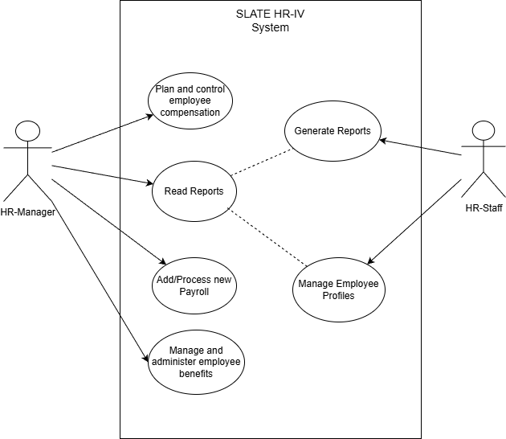
Figure 5 Use case Diagram
This Use case Diagram briefly shows how the two end users interact with the system, as shown in the image above the Hr-staff manage employee profiles and generate reports for the Manager to read and administer the system according to given information.

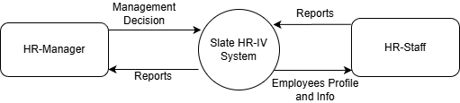
Figure 6 Context Diagram (LVL0 DFD)
This Context diagram provides a fundamental overview to the entire system, illustrating the system's boundaries and its interactions with external entities, without going into internal details.

4.4 Functional Requirements for Integration
To ensure proper and successful integration between components and systems there are a couple of specific features and behaviors the system must have. The system must support seamless integration between its modules to ensure data consistency, accuracy, and efficient workflows. The following functional requirements define the specific features and behaviors required for successful integration:
User Management Integration - The system shall ensure that changes in user status (active, inactive, terminated) are reflected in all integrated components.

Security and Access Control Integration - The system shall ensure secure data exchange between modules using authentication and authorization mechanisms.

Reporting and Analytics Integration - The system shall ensure data accuracy and consistency across all integrated reports.

Government Contributions and Tax Integration - The system shall integrate tax and government contribution data (e.g., SSS, PhilHealth, Pag-IBIG) with payroll computations.

5 BUSINESS PROCESS ARCHITECTURE

5.1 Identification of Business Process
This section identifies and describes the key business processes within the organization that are supported and automated by the HR-4 system. These processes aim to improve operational efficiency, accuracy, and consistency in human resource and payroll management.
Employee Recruitment and Onboarding - This process involves collecting applicant information, hiring new employees, and registering them into the system. The HR-4 system automates employee record creation, assignment of roles, and initialization of employment details.

Employee Information Management - This process manages employee personal data, employment status, job roles, and department assignments. The system ensures centralized storage and easy updating of employee records.

Payroll Processing - This process calculates employee compensation, including basic salary, gross pay, deductions, and net pay. The system automates payroll computation using employee data.

User Account and Role Management - This process controls system access based on user roles such as HR staff, payroll officers, and administrators. The system automates role-based access control to ensure data security.

Reporting and Documentation - This process generates operational and compliance reports related to employees, attendance, payroll, and government contributions. The system automates report creation and data consolidation.

5.2 Business Process Diagrams
To further understand the workflow of the system and provide more information, the following diagrams and visual tools are going to be presented to map out workflows and various process steps.
First is to present the Business Process Model and Notation (BPMN) which will be used to visually model the business process of the SLATE HR-IV system. It uses a standardized set of graphical symbols that map activities, decisions, and information. There will be two types of BPMN that will be used in this project, the As-is and To-be. As-is model will be used to describe the existing and current flow of the system whereas the To-be model maps out the desired future state, showing changes and improvement for more efficient process. The BPMN diagram will be used to represent the current workflow of the five subsystems falling under the HR-IV of SLATE Freight management system.

Business Process Model and Notation (BPMN) AS-IS
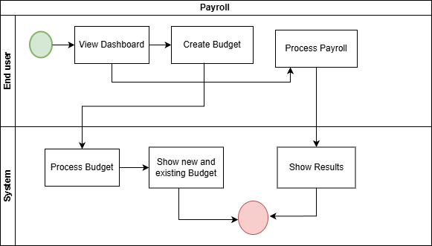
Figure 7 Payroll as-is Diagram
This diagram showcases the basic function of the payroll system in regular human resource system, it presents the primary flow, from viewing dashboard, creating budget to systems responsibility of processing budget and showing the newly created budget along with the previously existing ones.

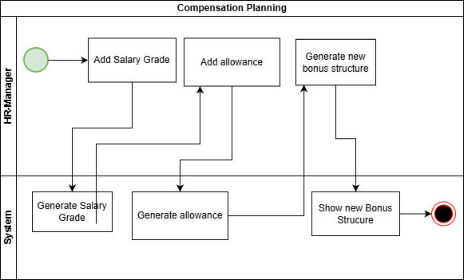
Figure 8 Compensation as-is Diagram
The Compensation Planning system starts when the HR Manager adds salary grades and allowances, which are then generated and processed by the system. Using these inputs, the HR Manager creates a new bonus structure, and the system compiles and displays it. Overall, the system automates compensation planning by organizing salary components efficiently and ensuring accuracy and consistency.

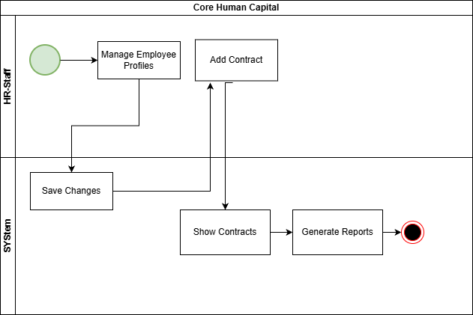
Figure 9 Cor Human Capital as-is Diagram
The Core Human Capital process begins when the HR Staff manages employee profiles and adds contracts. Any updates made are saved by the system to ensure employee records are kept accurate and up to date. Once contracts are added, the system displays the contract information and uses this data to generate reports. Overall, the system supports efficient employee record management, contract handling, and report generation.
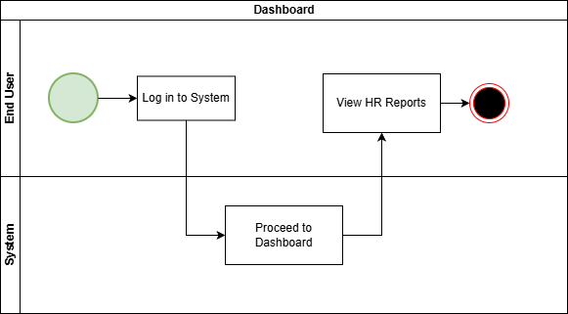
Figure 10 HR Analytics Dashboard as-is Diagram
The HR Analytics Dashboard has the simplest function out of the five subsystems, because it only shows the overall reports of from its four integrated modules. It starts with the user logging in to the system, then the end user proceeding to the dashboard to view the HR reports

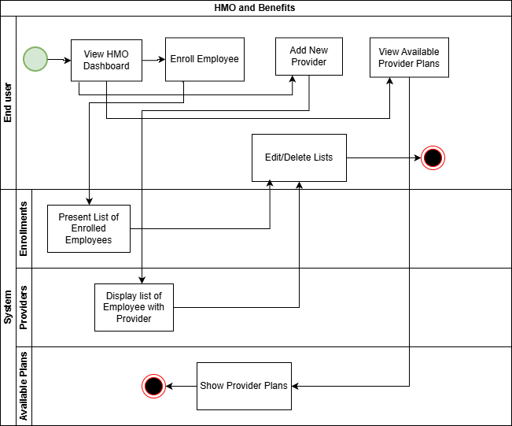
Figure 11 HMO and Benefits as-is Diagram
The HMO and Benefits process starts when the end user accesses the HMO dashboard to manage health benefits. From there, the user can enroll employees, add new HMO providers, and view available provider plans.

Business Process Model and Notation (BPMN) TO-BE
The following BPMN diagrams represent the To-Be state of the system and are presented to illustrate the desired future workflow. These diagrams demonstrate how the system is expected to operate after improvements are implemented, highlighting enhanced processes, better functionality, and increased efficiency compared to the current state.
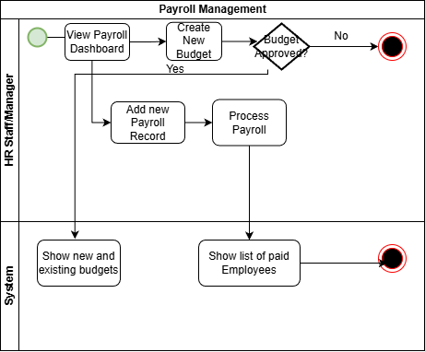
Figure 12 Payroll to-be Diagram
Unlike the previous as-is diagram this one requires the approval of highly authoritative, since payroll handles a lot of sensitive data and creating a budget requires approval from high authority. Aside from that there’s negligible to none changes from the as-is diagram as it has the same flow and function as the previous.The primary difference is that each task now includes more detailed steps, allowing the system’s flow and functions to be more easily visualized.
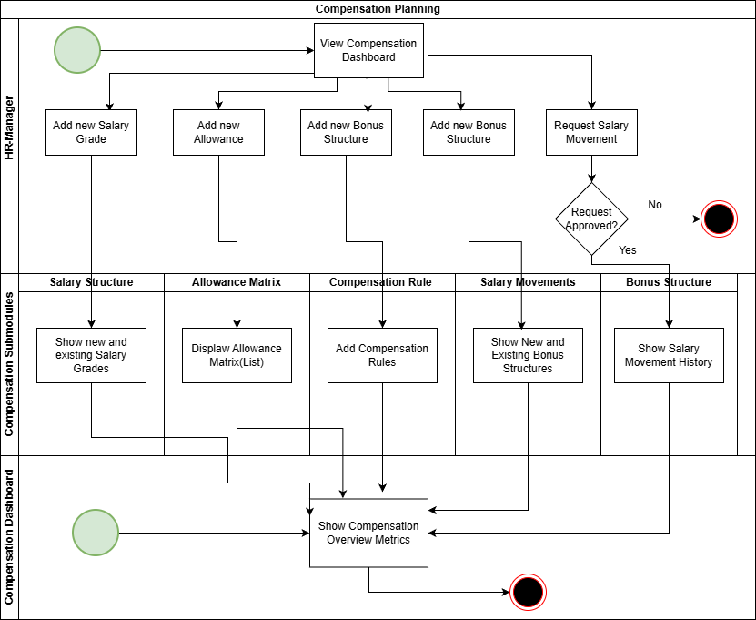
Figure 13 Compensation Planning to-be Diagram
Differing from the as-is diagram of Compensation planning where it was just straightforward and plain from one function to another, here it was divided into dashboards and the main compensation modules to be scalable and more user friendly.
The main compensation modules are then divided into six parts where each has their own major functions the salary structure, allowance matrix, compensation rule, salary movement, and lastly the bonus structure. Though compensation modules have six parts they all send simplified reports to compensation dashboard where all reported data are displayed through table like icons.
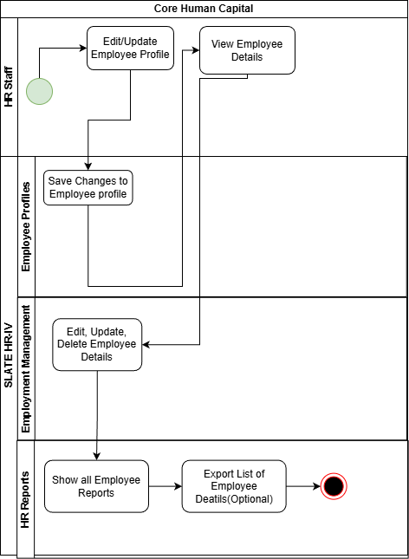
Figure 14 Core Human to-be Diagram
This Core Human Capital process shows how HR staff manage employee information within the system. HR staff can edit and update employee profiles, view employee details, and save changes to ensure accurate records. The process then moves to the SLATE HRM Employment Management module, where employee details can be edited, updated, or deleted. Finally, the HR Reports module allows HR staff to view employee reports and optionally export employee details, completing the employee information management process. Compared to the as-is where it vaguely presents the managing of employee profiles.

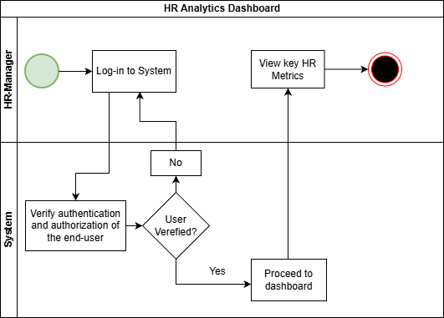
Figure 15 HR Analytics Dashboard to-be Diagram
Unlike the previous where the system does not check the authentication of the user for security reasons, the HR Analytics Dashboard diagram of to-be process begins when the HR Manager logs in to the system.

The system verifies the user’s authentication and authorization to ensure secure access. If the user is not verified, the process returns to the login step. Once verification is successful, the user is allowed to proceed to the dashboard, where the HR Manager can view key HR metrics. The process ends after the required analytics information is displayed.

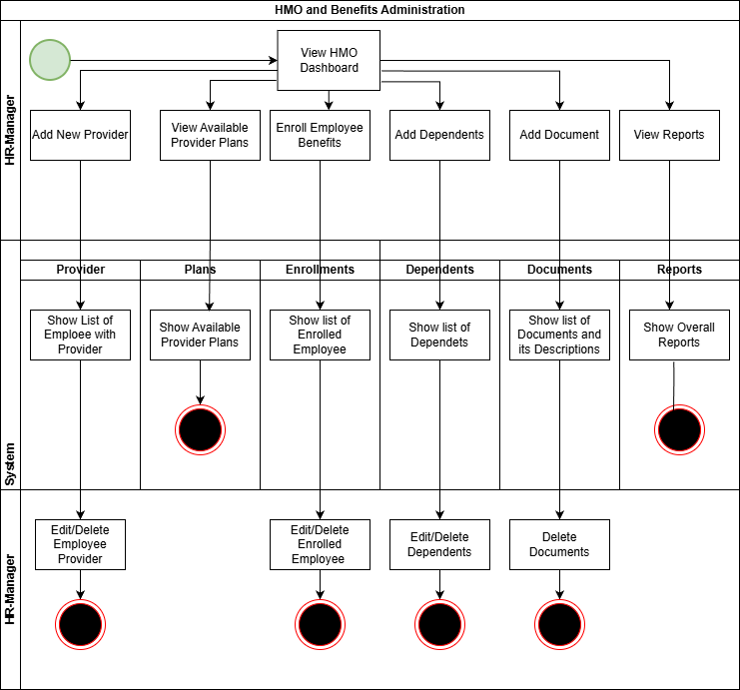
Figure 16 HMO to-be Diagram
The HMO and Benefits Administration process allows the HR Manager to manage employee healthcare benefits through a centralized dashboard. From the HMO dashboard, the HR Manager can add new providers, view available provider plans, enroll employees in benefits, add dependents, upload required documents, and view reports.
The system displays relevant lists such as providers, plans, enrolled employees, dependents, documents, and overall reports to support these actions. HR Managers can edit or delete providers, enrolled employees, dependents, and documents as needed. The process concludes after the required benefit management or reporting task is completed.
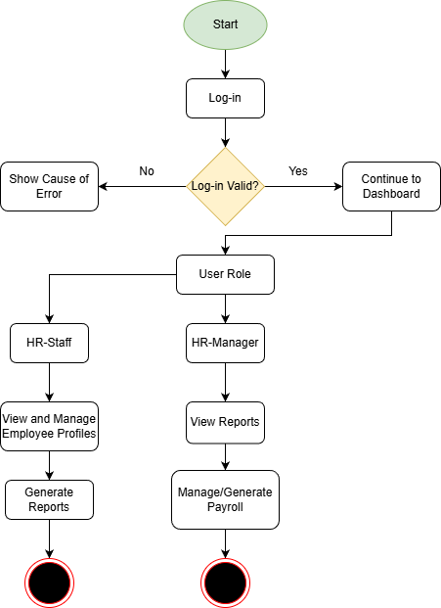
Figure 17 Flowchart Diagram
Flowchart diagram is a type of diagram that illustrates the workflow of the system starting from user authentication and then branching based on user roles. In the case of HR-IV SLATE Freight management system the process begins at Start, where the user attempts to log in to the system. The system then checks whether the login is valid. If the login is not valid, the user is shown the cause of the error and is recommended to try again. If the login is valid, the user is allowed to continue to the dashboard, after which the system identifies the user’s role. Based on this role, the flow splits into two paths. If the user is an HR Staff, they can view and manage employee profiles and then generate reports. If the user is an HR Manager, they can view reports and manage or generate payroll, and the process then ends as well. Overall, the diagram shows how authentication controls access and how different user roles determine the available system functions.

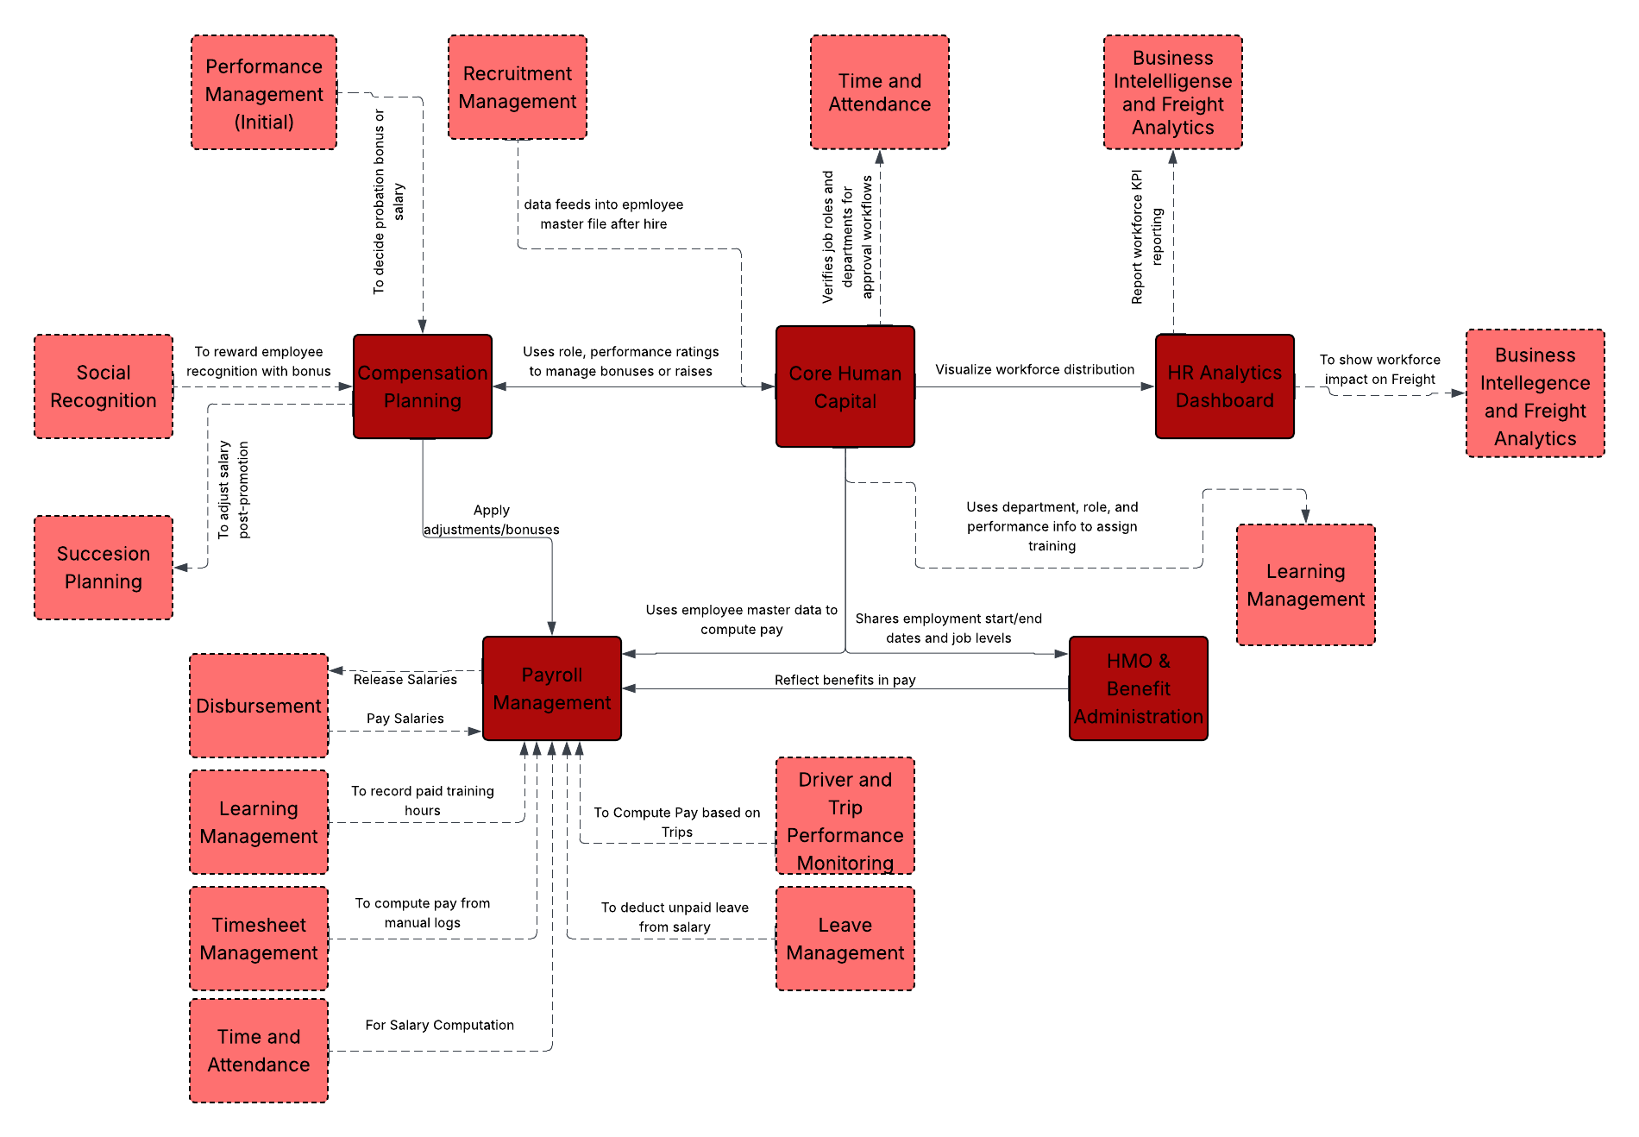
Figure 18 BPA Diagram
In HR-IV of Slate Freight Management System it is centered on Core Human Capital (Core HCM), which serves as the master employee record and receives new-hire data from Recruitment Management. Core HCM integrates with Time and Attendance, Learning Management, and HR Analytics to ensure accurate tracking of work hours, training history, workforce distribution, and performance insights. Performance Management, along with Social Recognition and Succession Planning, feeds into Compensation Planning to align pay increases, bonuses, and rewards with performance and talent strategy. Approved compensation changes are sent to Payroll Management, which consolidates salary data, attendance records, timesheets, leave usage, benefits deductions, and operational inputs such as Driver and Trip Performance Monitoring to calculate accurate pay. Payroll then connects to Disbursement to release salaries. Workforce and payroll data flow into HR Analytics Dashboards, which integrate with Business Intelligence and Freight Analytics to show how workforce performance impacts overall business and freight operations.

5.3 Alignment of Integrated System with Business Processes
The integrated system is designed to align closely with the organization’s existing business processes while enhancing efficiency, accuracy, and control. By automating manual tasks and integrating previously separate functions, the system supports seamless workflows across departments.
In the human resource management process, the system centralizes employee records, leave management, and performance data into a single platform. This alignment reduces data duplication, ensures consistency, and allows HR personnel to perform tasks more efficiently.
For the payroll process, the system integrates Pay Period, Basic Salary, Gross Pay, and deduction data directly into payroll computation. This minimizes human error, speeds up salary processing, and ensures compliance with organizational policies and labor regulations. The inclusion of approval workflows ensures that sensitive payroll and budget-related actions are reviewed and authorized by higher management, maintaining proper control and accountability.
In terms of management and decision-making, the system provides real-time reports and dashboards that align with managerial processes such as workforce planning, budgeting, and performance evaluation. These features allow decision-makers to access accurate and up-to-date information without disrupting existing approval hierarchies.

Overall, the integrated system does not replace core business processes but enhances and streamlines them by improving data flow, reducing manual effort, and supporting transparency and accountability across the organization.

5.4 Business Process Improvements
The implementation of the integrated system and more robust security significantly improves business processes by addressing the limitations of the existing (as-is) workflow and introducing a more efficient and reliable (to-be) process.
In the as-is process, many HR activities relied on manual data entry, lack data integrity, and no higher authority task approvals. These practices often resulted in security vulnerabilities, processing delays, higher risk of human error, and difficulty in tracking approvals and changes. Generating reports also required additional time, as data had to be collected from multiple sources.
In the to-be process, the integrated system automates key functions such as employee record management, attendance tracking, payroll computation, and approval workflows. Data is stored in a two centralized database and linked using APIs, allowing information to flow seamlessly between HR and payroll modules. This reduces redundant tasks, shortens processing time, and improves data accuracy.
Efficiency is further improved through automated approvals and real-time validation, ensuring that payroll and budget-related transactions are reviewed by authorized personnel before finalization. This enhances accountability while maintaining compliance with organizational policies.
In terms of quality improvement, the system provides accurate, real-time reports and dashboards that support better monitoring, auditing, and decision-making. Errors caused by manual calculations are minimized, and employee data is more secure and consistent.
Overall, the transition from the as-is to the to-be process results in faster operations, improved data integrity, enhanced transparency, and higher overall service quality across the organization.
Below is the table presenting the key business processes, and the identified gains/ quality brought by the system often by comparing the old (as-is) and new (to-be) processes.

Business Process Inventory Table
The table identifies the key business processes; their description and the submodule they belong to under the HR-IV of Slate Freight Management System
Inventory No. | Business Process | Description | Submodule
BP-1 | Dashboard Filter | This process allows authorized users to filter and view summarized system data based on specific criteria. | HR Analytics Dashboard
BP-2 | Reporting & Monitoring | Real-time system-generated reports and dashboards. | HR Analytics Dashboard
BP-3 | Employee Record Management | Covers the creation, updating, and maintenance of employee information. | Core Human Capital
BP-4 | Payroll Computation | The system automates computations to ensure accuracy, timeliness, and compliance with compensation policies. | Payroll Management
BP-5 | Approval of Payroll & Budget | Ensures financial accuracy, accountability, and proper control over sensitive payroll transactions. | Payroll Management
BP-6 | Creation of Salary Grade | This process defines and manages salary grade structures that determine compensation levels for different job roles or positions. | Compensation Planning
BP-7 | Addition of new Allowance | This process allows authorized personnel to define and configure new allowance types, including their values and applicability. | Compensation Planning
BP-8 | Addition of new Compensation Rule | Setting up new compensation rules such as overtime rates, deduction policies, or tax-related calculations. | Compensation Planning
BP-9 | Bonus Structure Creation | This process defines bonus schemes, eligibility criteria, and calculation methods for employees. The configured bonus structures are applied during payroll processing based on approved policies. | Compensation Planning
BP-10 | Approval of Salary Movement | Reviews and approves changes in employee salary due to promotion, merit increase, or adjustment. It ensures that salary changes are authorized and accurately reflected in the system. | Compensation Planning
BP-11 | Provider Addition and Management | manages the registration and maintenance of external providers such payroll-related service providers. | HMO and Benefits Administration
BP-12 | Data Security & Access Control | This process governs user access to the system by defining roles, permissions, and security policies. | Security
Table 20 Business Process Inventory Table
Comparison Table AS-IS Vs TO-BE
Submodule | As-is | To-be
HR Analytics Dashboard | Logging in to the system does not require multiple authentications, and role-based access control leaves the system vulnerable to security risks. | Checks not only the authentication of the end-user but also the authorization, what can and cannot be accessed by the user account.
Cor Human Capital | For a module that handles employee profile and information, there are way too few functions that can lead the HR staff to manually manipulate data. | Added more functions for employee master data handling, as well as additional employee details for more in-depth employee information.
Payroll Management | Lacks higher authority approval for a subsystem that handles the budget of the company | The subsystem will incorporate a formal higher-authority approval mechanism for all budget-related processes.
Compensation Planning | The workflow is linear and system-driven, with no built-in validation layers, approval checkpoints, or request evaluation mechanisms. | The compensation planning process will be enhanced through an integrated dashboard and clearly defined compensation submodules, ensuring better control and transparency.
HMO and Benefits Administration | While swim lanes are present, the responsibilities of each actor are not well defined, causing overlaps between end users, enrollments, and system functions. | More efficient because it clearly defines roles, responsibilities, and system boundaries.
Table 21 Comparison Table

6. APPLICATION ARCHITECTURE

6.1 Components of Application Architecture
The application architecture defines the structural organization of the system, outlining its major components, layers, and their respective responsibilities. For the Slate HR-IV System it follows a three-tier architecture to ensure scalability, maintainability, and security.
Presentation Layer - The Presentation Layer serves as the user interface of the system and facilitates interaction between users and the application. It is accessible through web browsers and provides role-based views for administrators, HR staff, and manager. This layer is responsible for:
- Displaying dashboards, forms, and reports
- Capturing user inputs and validating basic data
- Sending user requests to the Business Logic Layer
Business Logic Layer (Application Layer) - The Business Logic Layer processes the HR-IV system operations and enforces organizational rules and policies. It acts as the core of the application, coordinating data flow between the presentation and data layers. Its responsibilities include:
- Payroll computation and salary grade management
- Approval workflows for payroll, budget, and salary movements
- Implementation of compensation rules, allowances, and bonus structures
- Role-based access control and process validation
Data Layer (Database Layer) - The Data Layer manages all data storage, retrieval, and persistence. It ensures data integrity, consistency, and security by handling direct communication with the database system. This layer is responsible for:
- Storing employee records, payroll data, and compensation details
- Managing provider information and system configurations
- Supporting reporting, auditing, and historical data tracking
- Enforcing data security measures such as access restrictions and backups

Application Components Table

Component | Description | Main Responsibilities
Presentation Layer | User Interface of the system, can be accesed through web browser | Handle user inputs, Display Dashboard, form reports, etc.
Core Human Module | Manages employee-related information. | Employee records, salary grades, employee status updates.
Database Layer | Act as data storage | Stores employee, payroll, configuration, and employee data handling.
Payroll Module | Handles Salary Computation and Payroll Budget Management | Calculates payroll, manages salary processing, validates payroll data, and supports payroll approval workflows.
Compensation and HMO Benefits Module | Manages Compensation Structures and Benefits | Administers allowances, bonuses, compensation rules, and HMO benefit plans and provider details.
Reporting Module | Generates operational and management reports. | Produces payroll reports, employee summaries, compensation analytics, and compliance reports for decision-making.
Security & Access Control Module | Controls user access and system security. | Manages authentication, role-based access control, activity logging, and data protection mechanisms.
API(Application Programming Interface) | Making interaction and communication between different and independent system components possible | Facilitates secure data exchange, system integration, and interoperability with third-party or external systems.
Table 22 Application Components Table

6.2 Application Architecture Diagrams
Application architecture diagrams provide a visual representation of the system’s logical and physical design, illustrating how components are structured and how they interact with one another. These diagrams help stakeholders understand the system’s organization, data flow, and deployment environment.
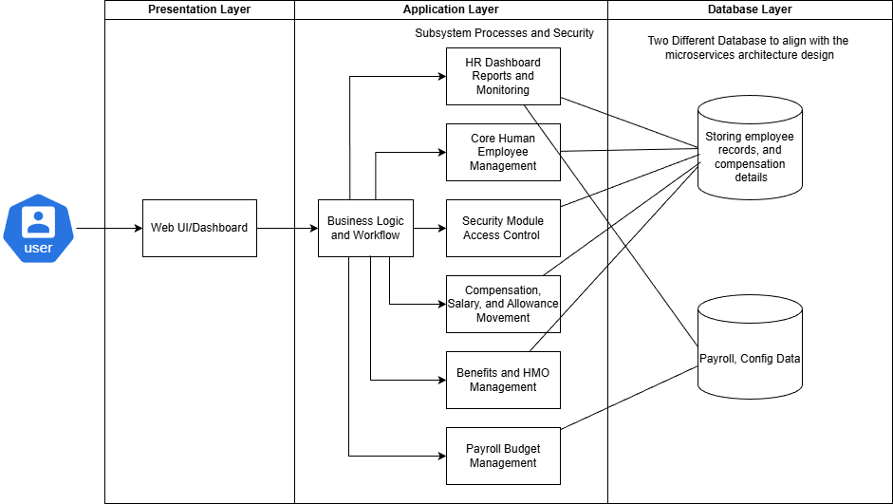
Figure 19 Application Architecture Diagram
The diagram visually represents the logical and physical design of the HR-IV System.
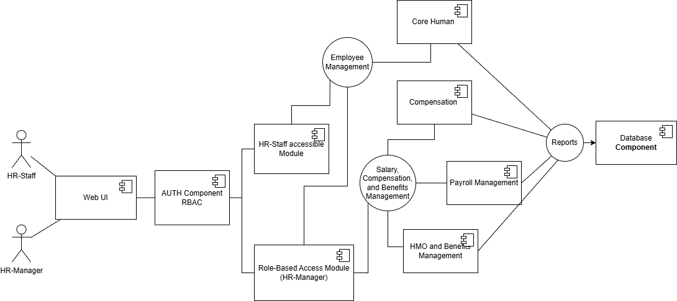
Figure 20 Component Diagram
This diagram illustrates the internal software components and their interactions.

6.3 Integration of Software Modules
The system is designed as an integrated set of software modules that work together to support human resource and payroll operations. Each module performs a specific function while sharing data through two databases linked using APIs to ensure consistency, accuracy, and seamless workflow execution, while also maintaining independently deployable services.
The Core Human Module manages employee records, salary grades, and employment-related information. Data maintained in this module serves as the primary input for other modules, particularly the Payroll Module. Any updates to employee information or salary structures are automatically reflected across the system.
The Payroll Module is responsible for computing employee salaries using data from the HCM Module, including attendance, salary grades, allowances, bonuses, and compensation rules. Once payroll computations are completed, the results are forwarded to the Approval Module for validation and authorization.
The Compensation and HMO Benefits Module manages workflow approvals for payroll processing, budget validation, and salary movements. Approved transactions are returned to the Payroll Module for final processing, ensuring that only authorized payroll data is finalized and recorded.
The Reporting and Monitoring Module for Dashboard integrates data from the Core Human Payroll and other submodules to generate real-time reports and dashboards. This allows management to monitor payroll status, employee information, and financial summaries efficiently.
The Security and Access Control Module integrates with all system modules by enforcing authentication, role-based access control, and permission validation. This ensures that only authorized users (HR-Manager) can access sensitive data and perform critical operations.
All 4 modules are connected through a centralized database while payroll has its own but still able to communicate using APIs, which serves as the single source of truth for employee and configuration data while payroll management has its own independent database. This integrated approach minimizes data redundancy, enhances system reliability, and supports efficient business process execution across the organization.
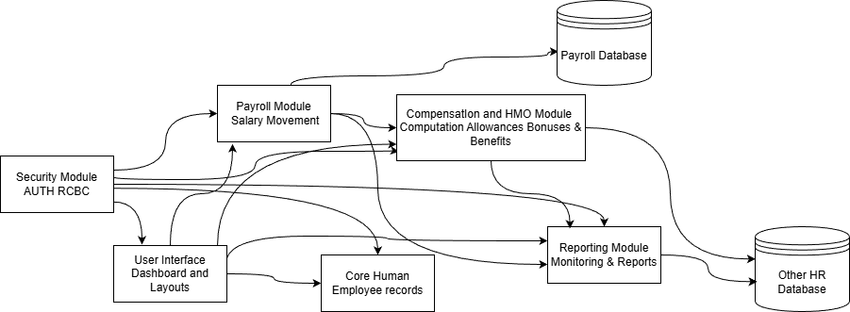
Figure 21 Module Integration Diagram
The Module Integration Diagram illustrates how the major system modules interact and share data within the application. From security authenticating the user to access the Dashboard to the UI layout making it possible for the user to access and manipulate the system, which includes the salary movement process of payroll module, the Compensation and HMO module that regulates the allowance and bonuses computation, etc. which all of them will fall to the database except the payroll which has its own database complying to align with the microservice architecture.

Module Integration Table
Source Module | Integrated Module | Type of Integration | Data / Interaction Description | Purpose of Integration
User Interface | Core Human Module | Functional | Employee information and salary grade inputs are submitted through forms. | Allows users to manage employee records and HR data.
User Interface | Payroll Module | Functional | Payroll Budget management, Process payroll, and Payroll Record | Enables users to execute and manage payroll processing.
Core Human | Payroll Module | Data sharing | Employee records and salary grades are provided to payroll computation. | Ensures accurate salary computation based on HR data.
All HR-IV Module | HR Analytics Dashboard | Data Sharing | Employee and salary-related data are supplied for report generation. | Supports HR monitoring and analysis.

External HR-IV Module | Payroll Module | Data sharing | Time and Attendance are used to compute salary | Ensures accurate salary computation based on HR data.
Security Module | All Modules | Control | Authentication, authorization, and role-based access validation. | Protects sensitive data and enforces access control.
All Modules except Payroll | Database | Data Storage | Employee and configuration data are stored and retrieved. | Ensures data consistency, storage and retrieval
Payroll Module | Database | Data Storage | Storage of Sensitive Payroll Data | Ensures data consistency, storage and retrieval
Table 23 Module Integration Table

This table presents the integration of software modules, highlighting the flow of data and interactions among system components. This module integration table highlights how the different components of the HR and payroll system work together to ensure smooth, secure, and accurate operations. The User Interface serves as the main entry point, allowing users to manage employee records and initiate payroll processes, while the Core Human and Payroll modules share critical employee, salary, and attendance data to ensure correct salary computation. Data from all HR-IV modules is consolidated into the HR Analytics Dashboard to support monitoring, reporting, and informed decision-making. The Security Module safeguards the entire system by enforcing authentication, authorization, and role-based access across all modules.
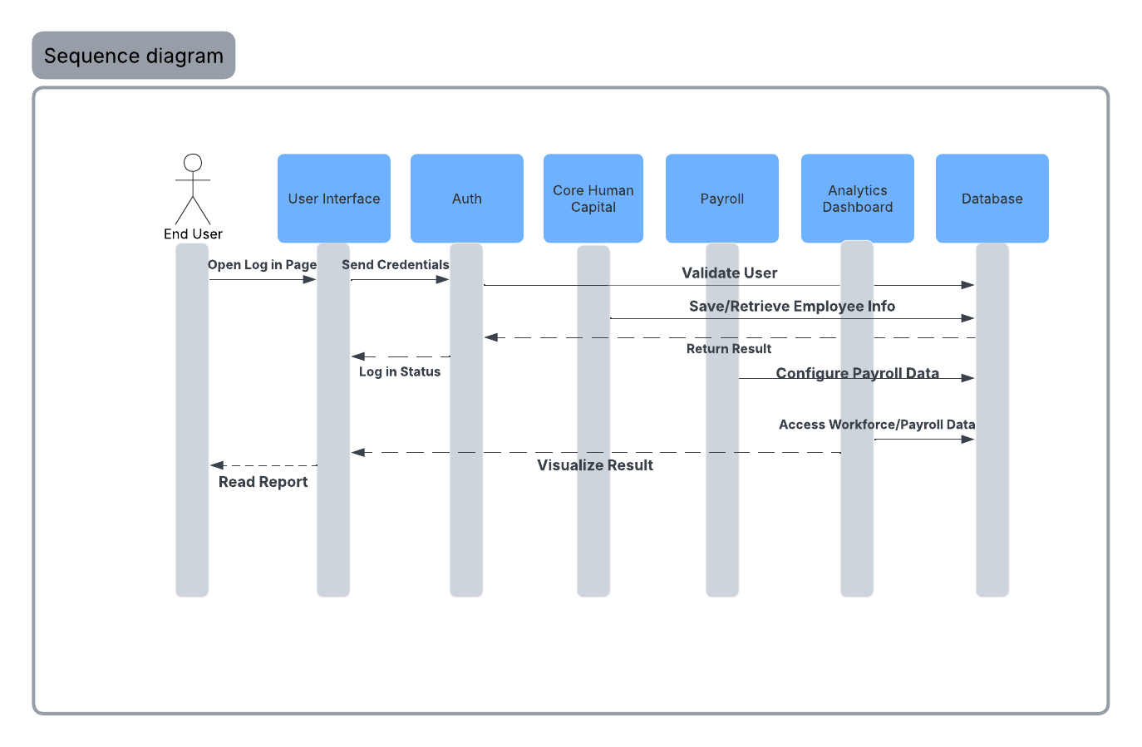
Figure 22 Sequence Diagram
This sequence diagram illustrates the step-by-step interaction between the user and the different system modules, showing how data flows during login, payroll processing, and reporting.
The process begins when the end user accesses the system through the User Interface and submits login credentials, which are verified by the Authentication module to ensure secure access.
Employee information from the Core Human Capital can be save or retrieve at Database modules, supporting accurate HR and payroll operations. The Payroll module configures payroll data using validated employee and attendance information, while the Analytics Dashboard accesses workforce and payroll data to generate reports that end users can view.
Overall, the diagram highlights the system’s functionality, coordination, and security by clearly showing how each module collaborates to deliver reliable payroll processing and meaningful HR insights.

6.4 Communication and Interaction Patterns
The system uses standard web-based communication protocols and structured interaction patterns to enable reliable data exchange among software components. These mechanisms ensure efficient, secure, and maintainable integration between modules.

Communication Protocols
The primary communication protocol used in the system is HTTP/HTTPS, which enables interaction between the client-side interface and the server-side application. All user requests submitted through web forms and dashboards are transmitted to the server using HTTP methods such as GET and POST.
For internal module interactions, the system follows a server-side method invocation pattern, where modules communicate through shared application services and a centralized database rather than direct peer-to-peer calls. This approach simplifies integration and improves system maintainability.
Interaction Patterns
The system adopts a request–response pattern, where the user interface sends a request to the application layer and waits for a response before displaying results. This pattern is used for operations such as employee record updates, payroll computation, and report generation.
A workflow-based interaction pattern is implemented for approval-related processes. In this pattern, payroll computations and salary movement requests are routed from the Payroll Module to the Approval Module, and only after approval are the results finalized. This ensures proper authorization and control.
The system also uses a data-sharing pattern via a centralized database, where modules read from and write to shared data repositories. This pattern enables consistent data access while avoiding duplication and synchronization issues.
Security and Control in Communication
To protect sensitive payroll and employee data, communication between the client and server is secured using HTTPS. Additionally, role-based access control is enforced during each interaction to ensure that only authorized users can perform specific actions or access sensitive information.
API Endpoints Table
API Endpoint | HTTP Method | Module | Description | Request Data | Response Data
/api/auth/login | POST | Authentication | Authenticates user credentials and grants system access | Username, Password  OTP | Auth token, user role
/api/employees | GET | Core Human Module | Retrieves employee records | Filters (optional) | Employee list
/api/employees | POST | Core Human Module | Adds a new employee record | Employee details | Success status
/api/employees/{id} | PUT | Core Human Module | Updates employee information | Updated employee data | Success status
/api/payroll/compute | POST | Payroll Module | Computes payroll based on salary rules and attendance | Employee ID, payroll period | Payroll computation result
/api/payroll/submit | POST | Payroll Module | Submits payroll for approval | Payroll batch ID | Submission status
/api/payroll/approve | POST | Approval Module | Approves or rejects payroll | Payroll batch ID, decision | Approval status
/api/salary-grades | POST | Compensation Module | Creates salary grades | Grade details | Success status
/api/allowances | POST | Compensation Module | Adds new allowance types | Allowance details | Success status
/api/bonuses | POST | Compensation Module | Defines bonus structures | Bonus rules | Success status
/api/reports/payroll | GET | Reporting Module | Generates payroll reports | Date range | Payroll report data
/api/audit/logs | GET | Security Module | Retrieves system activity logs | Filters (optional) | Audit logs
Table 24 API Endpoints Table
The API endpoints table defines the communication interface between system modules using RESTful services over HTTP. Each endpoint specifies the module responsible, the operation performed, and the data exchanged to ensure secure and consistent interaction among system components.

System Interface Specification Table
Interface Name | Source Component | Target Component | Interface Type | Protocol / Format | Description
User Login Interface | User | Web Interface | User Interface | HTTPS / Web Form | Allows users to authenticate and access the system
Employee Data Interface | Web Interface | Core Human Module | Application Interface | REST / JSON over HTTP | Requests and displays employee records
Payroll Computation Interface | Web Interface | Payroll Module | Application Interface | REST / JSON over HTTP | Initiates payroll computation process
Compensation Management Interface | Web Interface | Compensation Module | Application Interface | REST / JSON over HTTP | Manages salary grades, allowances, bonuses, and rules
Report Generation Interface | Web Interface | HR Analytics Dashboard | Application Interface | REST / JSON over HTTP | Generates and displays system reports
Security & Access Control Interface | Security Module | All Modules | Security Interface | Token-based (JWT) over HTTPS | Enforces authentication and role-based access
Data Storage Interface | System Modules | Database | Data Interface | SQL / Secure DB Connection | Stores and retrieves system data
Table 25 System Interface Specification Table
The system interface specification table defines how users and system components interact through well-defined interfaces. It identifies the source and target components, communication protocols, and the purpose of each interface to ensure reliable and secure data exchange.

System Interaction Diagram
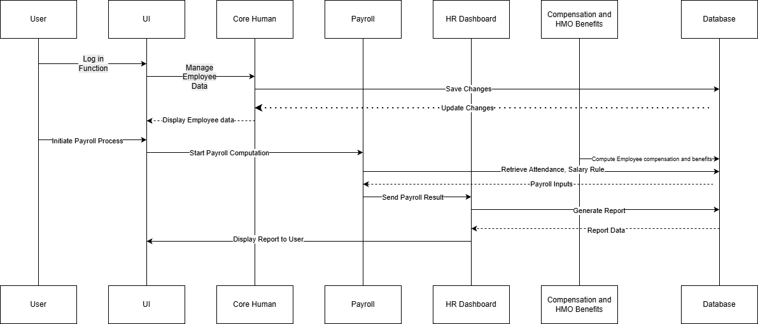
Figure 23 System Interaction Diagram
This diagram illustrates the sequence of interactions between the user, web interface, HR module, payroll module, approval module, reporting module, and the centralized database during payroll processing.

7 DATA ARCHITECTURE

7.1 Data Sources and Types
The SLATE system depends on a broad set of data inputs to support its TensorFlow based attrition engine and HR analytics dashboard. The system pulls data from internal modules and external devices such as ELDs and GPS units. Together, these sources form a detailed view of employee behavior, financial status, and operational performance.
The table below groups each data source by origin. It lists the type of data provided and the format used for system integration. This structure ensures consistent processing and reliable analytics across the platform.
Data Source | Data Category | Data Examples | Data Format
Core Human Capital | Profile & Compliance | CDL license types, HazMat endorsements, medical card status, hiring dates. | Structured (SQL)
Payroll Management | Financial | Mileage-based pay, detention pay, fuel bonuses, tax withholdings, 401(k) deductions. | Structured (SQL)
Time & Attendance | Operational | Hours of Service (HOS), 11-hour driving limits, warehouse shift logs, GPS/ELD pings. | Semi-Structured (JSON/XML)
Performance Management | Quality & Safety | Fuel efficiency, cargo damage rates, on-time delivery percentages, safety incident reports. | Structured (SQL)
Training & Development | Engagement | DOT compliance training completion, forklift certification renewals, defensive driving scores. | Structured (SQL)
Compensation Planning | Market Benchmarking | Regional market rates, sign-on bonus disbursements, total rewards valuations. | Structured (SQL)
HMO & Benefits | Wellness/Loyalty | Health insurance enrollment status, telemedicine usage, rider/pet program participation. | Structured (SQL)
External Devices (ELD/GPS) | Telematics | Real-time vehicle location, hard braking events, idle time, and route consistency. | Time-Series / Streaming
Performance Reviews | Qualitative | Manager feedback notes, employee sentiment, and reasons for home time requests. | Unstructured (Text)
Table 26 Data Source Inventory Table

7.2 Data Flow Diagrams
A Data Flow Diagram (DFD) maps out the flow of information for any process or system. For the SLATE system, the DFD illustrates how raw employee data (like GPS logs, license status, and pay rates) is transformed into high-value outputs like Predictive Attrition Risk Scores.
Below is a breakdown of the data movement within the SLATE architecture based on the provided system specifications.
The Level 1 data flow diagram shows how information moves through the SLATE system. It traces data from external sources and internal modules such as Core Human Capital, Payroll Management, and Benefits Registration.
The diagram explains how the system processes and stores this data. It also shows how all data streams combine before entering the TensorFlow predictive analytics engine. This engine produces attrition risk scores. The results feed directly into the HR analytics dashboard for monitoring and review.
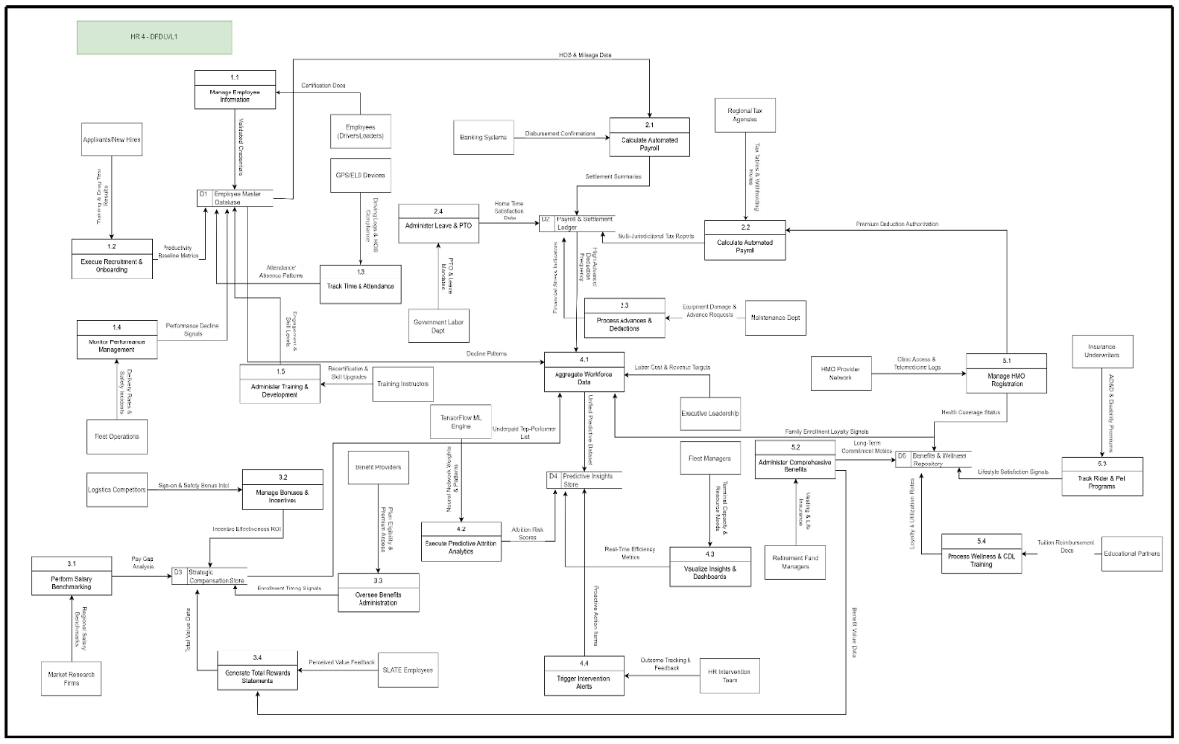
Figure 24 Data Flow Diagram – Level 1
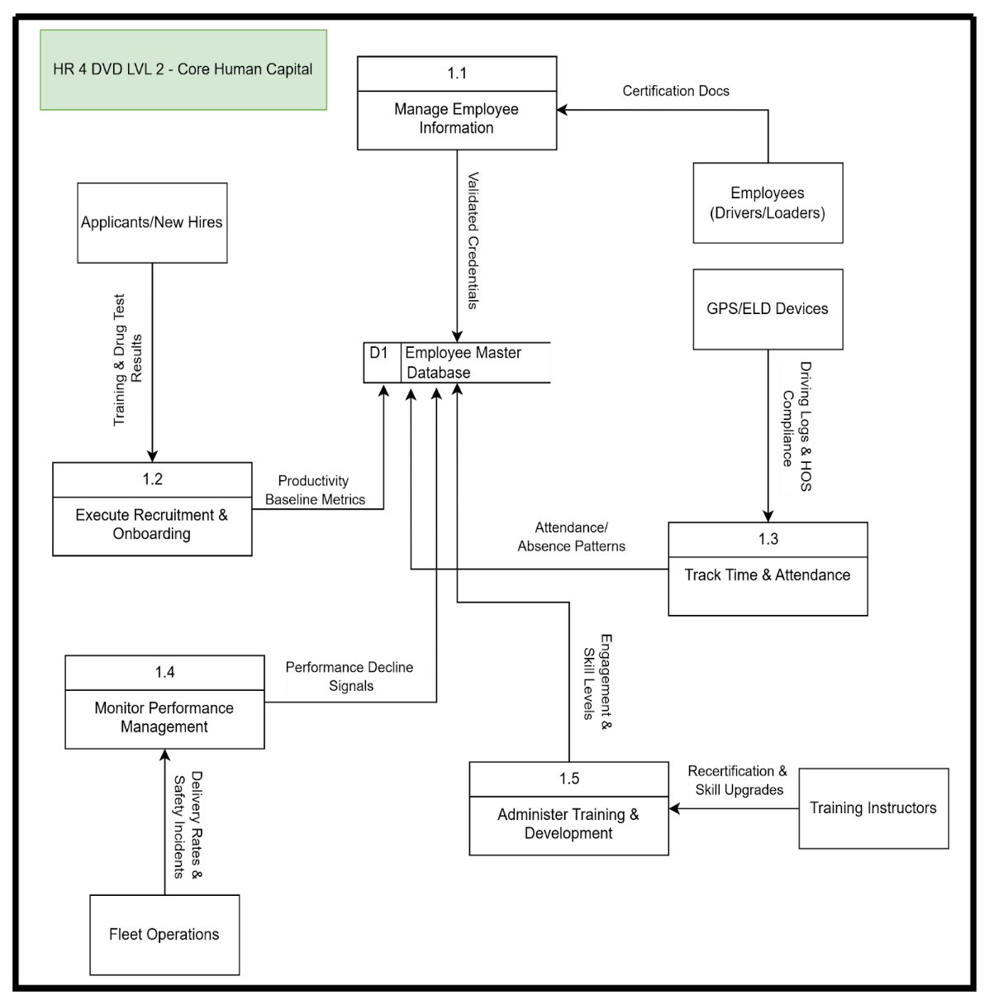
Figure 25 Data Flow Diagram – Level 2: Core Human Capital
This Level 2 data flow diagram shows the Core Human Capital module. It explains how the system collects and stores employee information.
Data enters the module from applicants, current employees, GPS and ELD devices, and fleet operations. The system processes this data through recruitment, performance tracking, and time monitoring functions.
All validated data moves into the D1 Employee Master Database. This database stores credentials, attendance records, and performance metrics. It serves as the main source of employee information for the system.

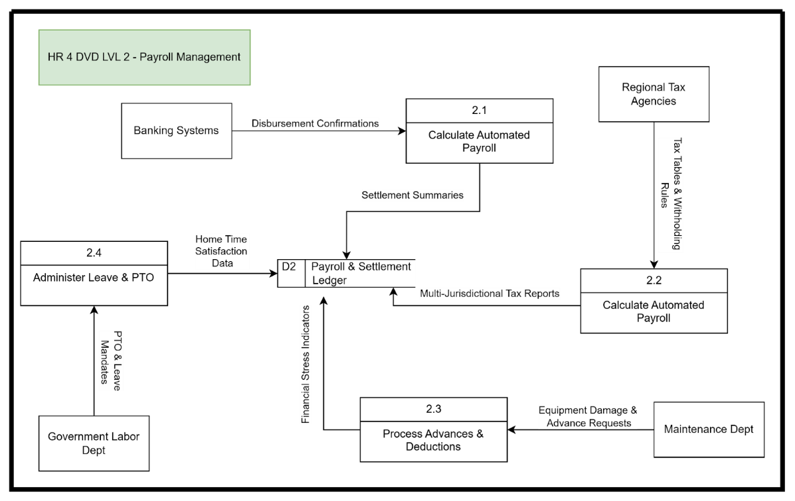
Figure 26 Data Flow Diagram – Level 2: Payroll Management
This Level 2 data flow diagram covers the Payroll Management module. It shows how the system processes and stores payroll data.
Payroll calculation combines bank disbursement confirmations with regional tax rules. The system applies tax withholdings and manages deductions for equipment damage. It also tracks leave based on government requirements.
The module produces settlement summaries and tax reports across jurisdictions. It also records financial stress indicators and home time satisfaction data. All results stored in the D2 Payroll and Settlement Ledger, which serves as the central payroll record.

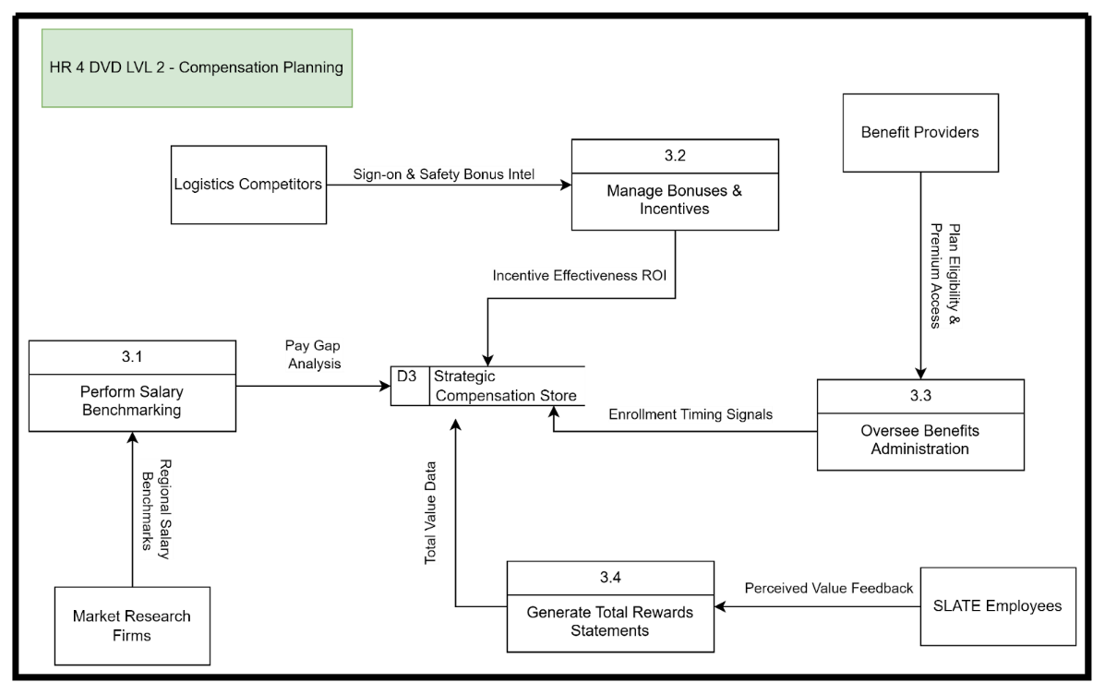
Figure 27 Data Flow Diagram – Level 2: Compensation Planning
This Level 2 data flow diagram explains the Compensation Planning process in the HR system. It shows how pay and benefits data move through the system.
The diagram maps interactions between internal processes, external entities, and data stores. It tracks how salary details, incentives, and benefits inputs process and update employee compensation records. The flow ensures pay decisions follow policy rules and remain consistent across the system.

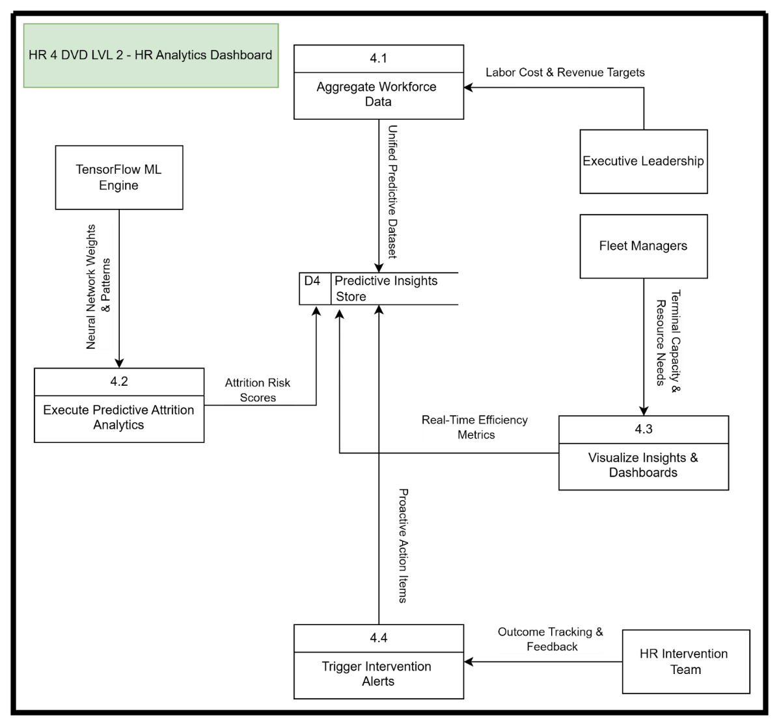
Figure 28 Data Flow Diagram – Level 2: HR Analytics Dashboard
The image is a Level 2 Data Flow Diagram (DFD) that outlines the Compensation Planning process within an HR system. It visualizes how information moves between different administrative functions and external sources to manage employee pay and benefits.

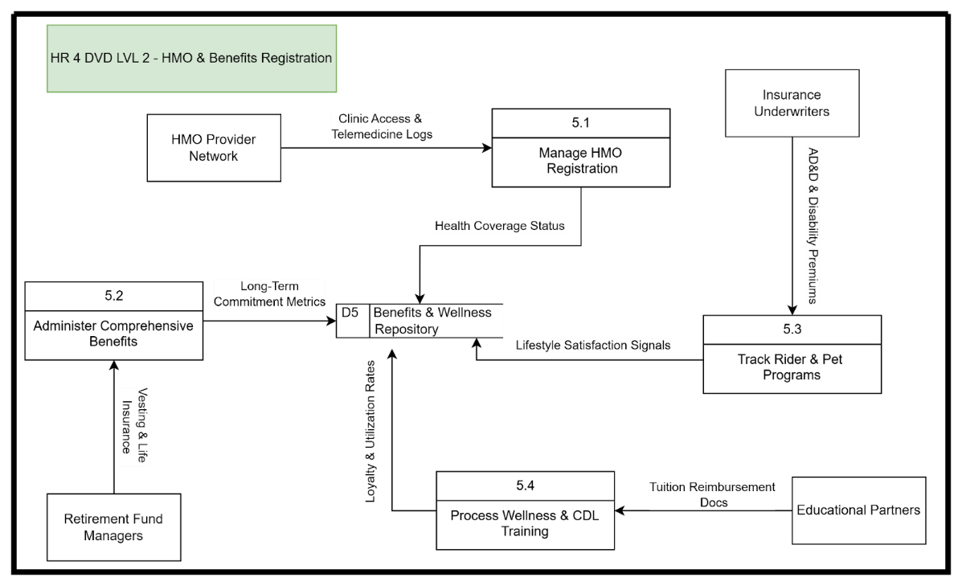
Figure 29 Data Flow Diagram – Level 2: HMO & Benefits Registration
This Level 2 data flow diagram focuses on the HMO and Benefits Registration process in the HR system. It shows how information moves through the process.
The diagram maps data from external providers and employees into internal registration and validation steps. Approved records then store in the system’s benefits database. This flow ensures accurate enrollment and consistent benefit tracking.

7.3 Data Storage and Management
The SLATE system uses a relational database for core HR transactions. Predictive model training relies on flat file exports in JSON and CSV formats.
Data follows a normalized structure. Each record links to a single employee ID. This link connects driver performance, telematics and hours of service data, and financial records. The structure protects data accuracy and keeps relationships consistent across the system.
Storage Methods
- Primary Database: The system uses a structured SQL database for live operations. This database supports create, read, update, and delete actions. It serves the Core Human Capital and Payroll modules during daily use.
- Analytical Storage: The system stores summarized data in a separate data warehouse. This data feeds the HR analytics dashboard. Complex reports run on this layer to avoid slowing down the live system.
- Model Weights: TensorFlow models store their weights and settings as H5 or SavedModel files. The system updates these files each month using the latest attrition results.
This table defines the standard data types and constraints used across the SLATE ecosystem.
Data Element | Definition | Data Type | Constraints
Employee_ID | Unique identifier for every freight employee | Integer | Primary Key, Auto-increment
CDL_Status | Current standing of Commercial Driver's License | String | {Active, Suspended, Expired}
Risk_Score | Probability of attrition generated by TensorFlow | Decimal (3,2) | Range: 0.00 to 1.00
HOS_Violation | Count of Hours of Service violations in 30 days | Integer | Non-negative
Pay_Type | Method of compensation calculation | String | {Mileage, Hourly, Split, Salary}
Home_Time_Sat | Driver satisfaction score with home frequency | Integer | 1 (Low) to 5 (High)
Last_Training_Date | Date of most recent DOT/Safety certification | Date | YYYY-MM-DD
Table 27 Data Dictionary
The following tables represent the core entities required to track freight-specific variables and feed the predictive models.
Table Name | Primary Purpose | Key Fields
tbl_Employee_Core | Stores baseline demographic and licensing data. | Emp_ID, Full_Name, Hire_Date, License_Type, Endorsements
tbl_Payroll_Settlements | Tracks mileage, fuel bonuses, and deductions. | Settlement_ID, Emp_ID, Total_KM, Rate_Per_KM, Net_Pay
tbl_Operational_Metrics | Captures HOS, fuel efficiency, and safety incidents. | Metric_ID, Emp_ID, Safety_Score, HOS_Hours, Fuel_Avg
tbl_Attrition_Predictions | Stores TensorFlow outputs for the dashboard. | Prediction_ID, Emp_ID, Risk_Score, Trigger_Factor, Timestamp
tbl_Benefits_Enrollment | Tracks HMO and life insurance participation. | Enroll_ID, Emp_ID, HMO_Plan, Dependent_Count, Premium_Cost
Table 28 Database Table Definitions
This image displays a comprehensive Entity Relationship Diagram (ERD) designed for a Human Resources Management System, specifically tailored for a logistics or transportation-heavy organization. It illustrates the structured data architecture and logical relationships between various HR domains, including:
- Employee Core Data: Centralized tracking of employee profiles, licensing (CDL), and employment status.
- Compensation & Payroll: Detailed mapping of payroll cycles, bonuses, deductions, and specific compensation plans.
- Performance & Training: Integration of performance reviews with training records and course requirements.
- Benefits & Wellness: Management of HMO enrollments and diverse benefit plans.
- Advanced Analytics: A specialized module for Attrition Prediction and subsequent Intervention strategies to improve employee retention.

This diagram serves as a technical blueprint for database administrators and developers to ensure data integrity across the organization’s workforce management software.
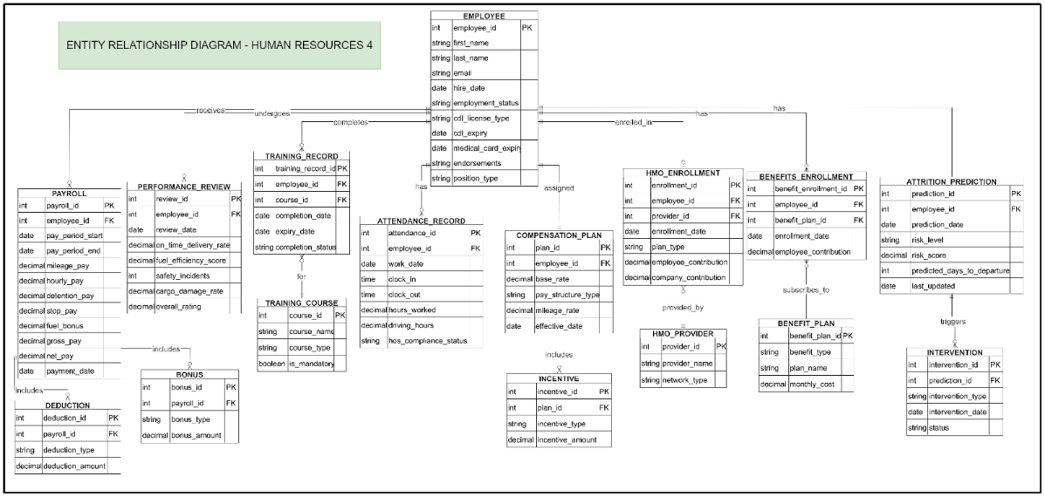
Figure 30 Entity–Relationship Diagram

This image presents a detailed Database Schema Diagram for a Human Resources management system, labeled "Human Resources 4". It serves as a technical map of the data architecture, defining how various employee-related tables interact within a relational database.
The schema includes several interconnected modules:
- Core Employee Management: At the center is the EMPLOYEE table, which stores primary identification, hiring dates, and specific commercial driving credentials such as CDL types and medical card expirations.
- Compensation and Payroll: This section tracks financial data through PAYROLL, PAYROLL_DEDUCTION, and PAYROLL_BONUS tables, along with structured COMPENSATION_PLAN and INCENTIVE details.
- Performance and Training: Data regarding employee development is managed via PERFORMANCE_REVIEW, TRAINING_RECORD, and TRAINING_COURSE tables.
- Operations and Attendance: The schema monitors daily activity through an ATTENDANCE_RECORD table that tracks work dates, clock-in/out times, and driving hours.
- Benefits Administration: Employee health and welfare are managed through HMO_ENROLLMENT and BENEFITS_ENROLLMENT modules.
- Predictive Analytics: A specialized section for ATTRITION_PREDICTION and INTERVENTION indicates a data-driven approach to managing employee retention and risk.
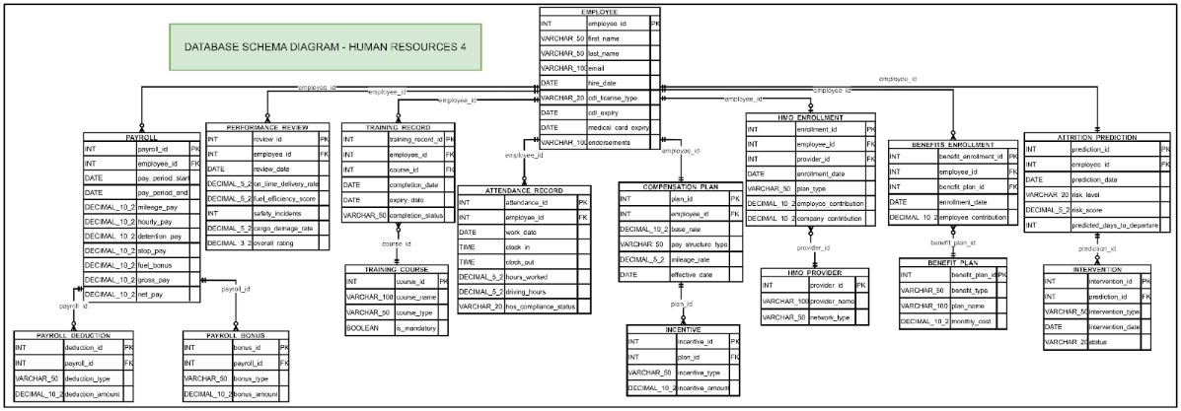
Figure 31 Database Schema Diagram

7.4 Data Synchronization Across Systems
To keep risk scores accurate, SLATE uses a layered synchronization approach. The system receives data from external sources such as ELDs for hours of service and GPS for mileage. These inputs first merge into the Core Human Capital module.
This step creates a single, consistent employee record. Only validated and aligned data moves forward. The Analytics Dashboard then processes this unified dataset. This flow prevents gaps and keeps predictive results reliable.
Synchronization Mechanisms
- Real time API hooks handle compliance data. When a driver records an hours of service violation through an ELD, the system sends the data at once to the Core Human Capital module. This triggers safety checks and alerts without delay.
- Batch processing handles non critical financial data. Mileage based pay and tax deductions sync once per day. This reduces system load and keeps performance steady.
- Bi directional synchronization links the HMO and Benefits module with Payroll. When an employee enrolls in benefits, payroll deductions update immediately. When payroll status changes, such as termination, the system cancels benefits automatically.

This table outlines the frequency and methods used to keep the SLATE ecosystem aligned.
Module/Source | Data Type | Sync Frequency | Sync Method
ELD / GPS Devices | HOS Compliance & Mileage | Real-Time | Webhook / REST API
Core Human Capital | Performance & Incident Reports | Hourly | Internal Event Bus
Payroll Management | Settlements & Deductions | Daily (EOD) | Batch Job (SQL)
HMO & Benefits | Enrollment & Health Usage | Weekly | SFTP / API
TensorFlow Engine | Risk Scores & Predictions | Weekly | ETL Pipeline
Compensation Planning | Market Benchmarking | Monthly | Manual / API
Table 29 Data Sync Schedule
This diagram presents the overall Data Flow Architecture of the Human Resources 4 system, showing how information travels across different system layers to support employee management, benefits administration, and financial decision-making.
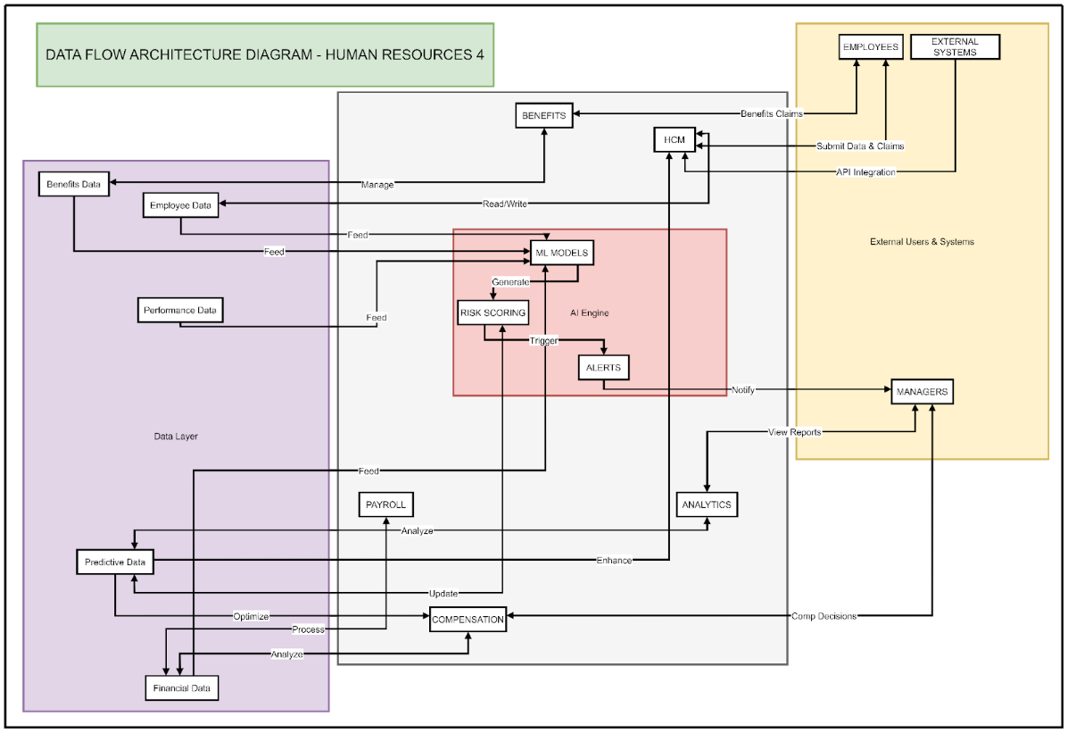
Figure 32 Data Flow Architecture Diagram
This Data Flow Architecture diagram illustrates how the Human Resources 4 system manages and transforms information across its layers to support employee management, benefits administration, and financial decision-making. Core employee, payroll, benefits, and performance data are first stored in a centralized data layer that serves as the system’s single source of truth. These records are then processed by a central application layer, where business rules such as payroll computation, eligibility validation, and compliance checks are applied to ensure consistency across all modules. The refined data is subsequently passed to the AI and analytics layer, which analyzes both historical and current information to generate insights, risk indicators, and decision support outputs. Finally, these results are delivered to end users—such as HR personnel, managers, and employees—through dashboards and system interfaces, enabling informed, data-driven actions while maintaining an efficient and structured flow of information throughout the system.

This image is a Data Synchronization Workflow Diagram for a system labeled "Human Resources 4." It uses a sequence diagram format to illustrate how data from external systems is processed, validated, and utilized for predictive insights.
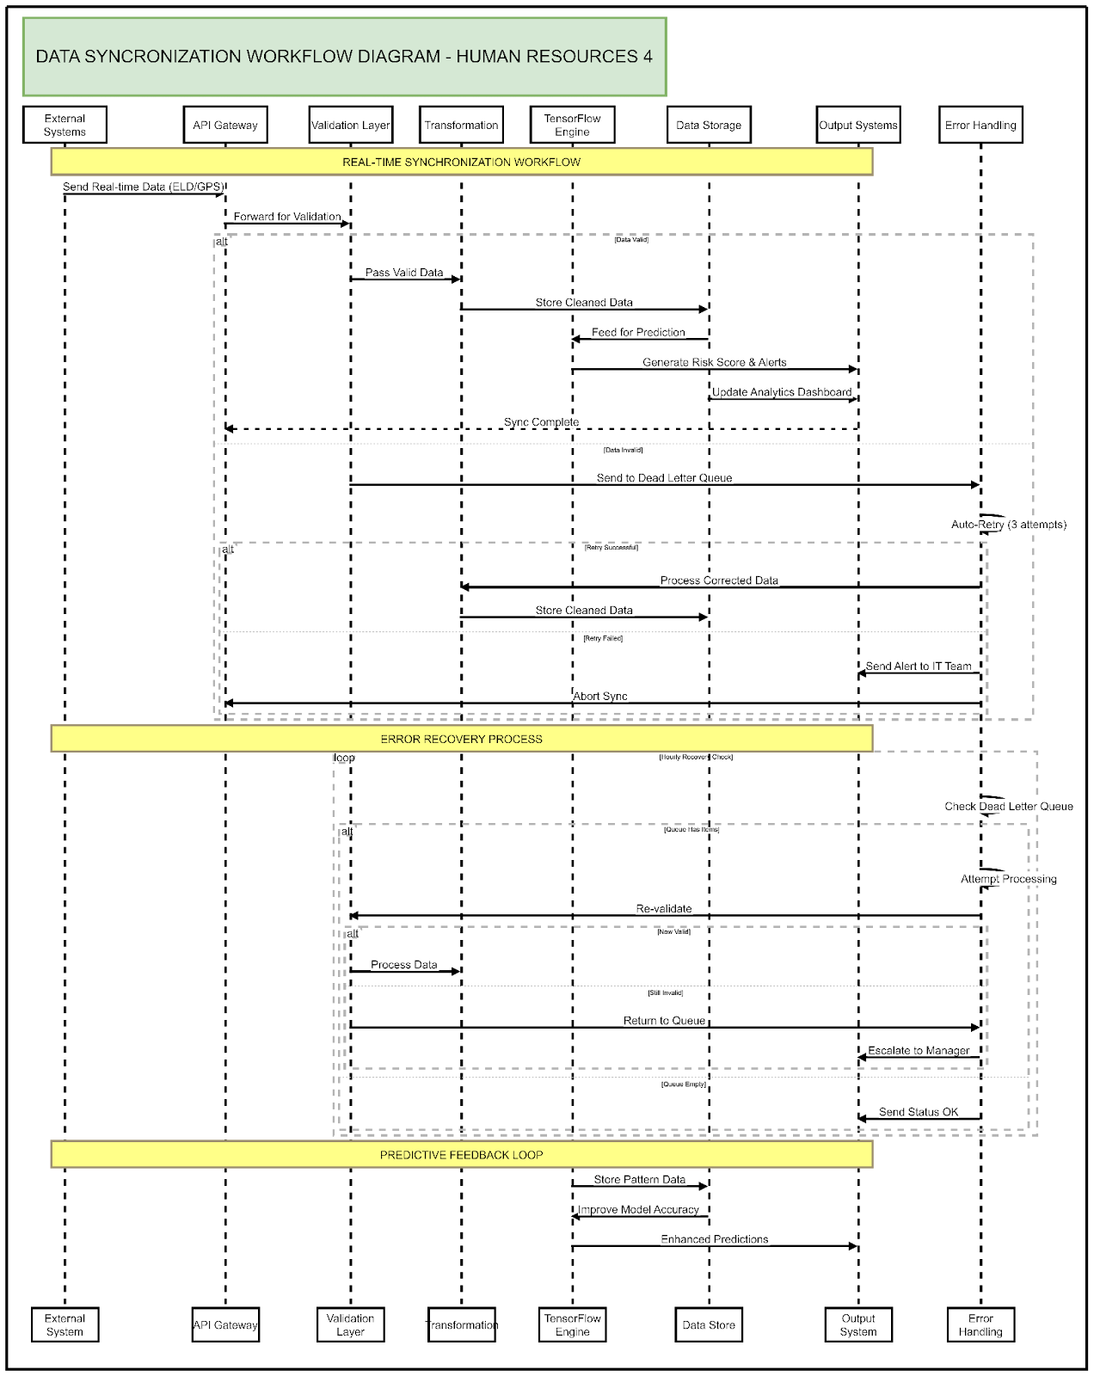
Figure 33 Data Synchronization Workflow Diagram

This Data Synchronization Workflow Diagram for the “Human Resources 4” system illustrates how information flows through multiple technical layers to support reliable analytics and decision-making. Data originates from external sources and enters the system through the API Gateway, where it undergoes validation, transformation, and secure storage before being processed by the TensorFlow Engine to generate predictive risk scores and system alerts. To maintain stability and data integrity, invalid or failed transactions are routed through an Error Recovery Process that uses a Dead Letter Queue, automated retry mechanisms, and escalation procedures for IT staff or managers when issues persist. The workflow concludes with a Predictive Feedback Loop, in which historical patterns and outcomes are fed back into the machine learning model, allowing continuous refinement and improving the accuracy of future predictions delivered to downstream output systems.

8 TECHNOLOGY ARCHITECTURE

8.1 Technology Stack and Infrastructure
Layer | Component | Technology / Tools Used | Purpose
Frontend | User Interface | HTML, CSS, JavaScript | Provides a fast, accessible, and responsive user interface for freight staff, dispatchers, and administrators across desktop and low-spec office devices
 | Data communication | JavaScript Fetch API | Handles asynchronous HTTP requests between the frontend and the backend for shipment, tracking, and logistics data
 | Styling Framework | Custom Lightweight CSS Framework | Ensures responsive and professional logistics-oriented design without heavy framework dependencies
Backend | Application Logic | Vanilla PHP | Processes freight operations including shipment creation, status updates, scheduling, and business rules
 | Web Server | Apache Web Server | Handles incoming HTTP requests and routes them to appropriate backend services
 | Database Access | PDO / MySQLi | Enables secure database interactions for freight records, shipment logs, and transaction data
 | Authentication & Security | Custom Session / Token Handler | Manages user authentication and role-based access control for administrators, dispatchers, and staff
Database & Storage | Database Management System | MySQL | Stores freight-related data including shipments, vehicles, routes, clients, invoices, tracking logs, and audit trails
 | Hosting Infrastructure | Hostinger Cloud Server | Hosts the freight management system and database in a cloud-based environment for availability and scalability
Table 30 Technology Stacks Table

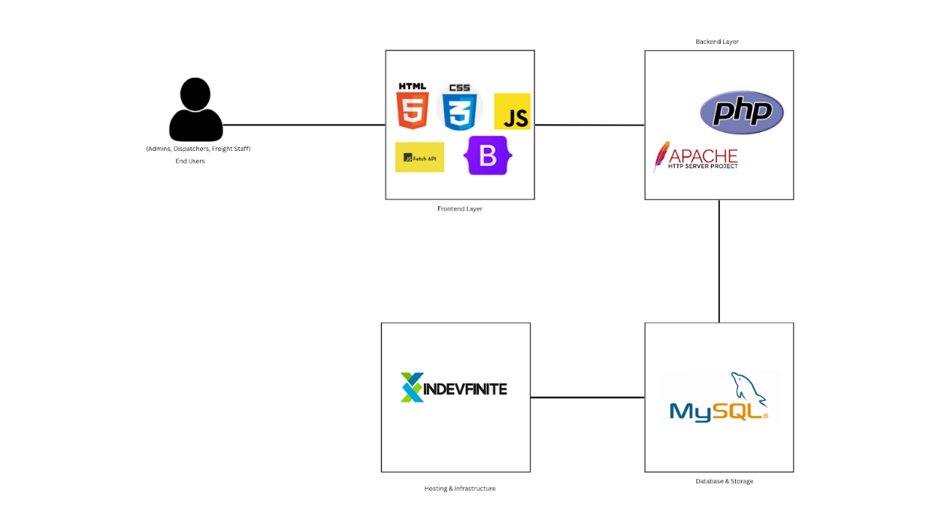
Figure 34 Technology Stacks Diagram

8.2 Software Technologies
This section details the software technologies used in the development of the Freight Management System. The technologies were selected based on stability, ease of maintenance, low resource requirements, and compatibility with logistics operations and typical office-level infrastructure and technical skill sets.
Frontend Development
- HTML – Markup language used for structuring all web pages and system content.
- CSS – Used for styling and implementing a responsive design suitable for desktop and mobile devices commonly used in logistics offices.
- JavaScript – Core scripting language for client-side interactivity, form validation, and dynamic content updates without reliance on external frameworks.
- Fetch API – Native JavaScript interface for making asynchronous HTTP requests to the backend API, enabling real-time updates for shipments, cargo status, and records.
Backend Development
- PHP (Vanilla) – Server-side scripting language chosen for its wide hosting support, minimal server requirements, and ease of integration with MySQL for freight data processing.
- Apache Web Server – Handles HTTP requests and supports .htacess for URL routing, access control, and security configurations.
- PDO (PHP Data Objects) – Provides a secure and consistent interface for database access using prepared statements to prevent SQL injection.
Database Management
- MySQL – Relational database management system used for storing all structured freight-related data including shipment details, cargo information, vehicle records, route assignments, client data, invoices, tracking logs, and system audit records.

Development & Deployment Tools
- Git – Version control system used for tracking source code changes and supporting collaborative development.
- GitHub / GitLab – Remote repository hosting platforms for source code management and versioning.
- XAMPP / WAMP – Local development environments used for testing and debugging the system on Windows-based machines.
- VS Code / Sublime Text – Code editors used for development with support for PHP, JavaScript, HTML, and CSS.
Security & Authentication
- Session-Based Authentication – Custom PHP session management for secure user login and role-based access control for administrators, dispatchers, and logistics staff.
- HTTPS / SSL – Transport Layer Security for encrypted data transmission between client and server.
- Input Sanitization & Validation – Custom PHP functions for validating and sanitizing user input to prevent XSS, SQL injection, and other common security threats.
Third-Party Integrations
- cURL Library – PHP extension used for making HTTP requests to external services such as SMS gateways, email services, and third-party logistics APIs.
Performance Optimization
- JavaScript Minification – Reduces script file sizes to improve page load times and frontend performance.
- CSS Compression – Optimized and combined CSS files for faster rendering.
- MySQL Indexing & Query Optimization – Database tuning techniques applied to enhance performance for shipment tracking, reporting, and data retrieval.
Backup & Maintenance
- MySQL Dump – Command-line tool used for database backup and restoration.
- Cron Jobs – Automated scheduled tasks for regular database backups, report generation, and routine system maintenance.
- Error Logging – Custom PHP error handling and logging mechanisms used to monitor system health and assist in debugging.
This selection of software technologies prioritizes simplicity, cost-effectiveness, and sustainability, ensuring that the Freight Management System remains reliable, scalable, and maintainable within operational and budgetary constraints typical of logistics organizations.
Network Topology Diagram
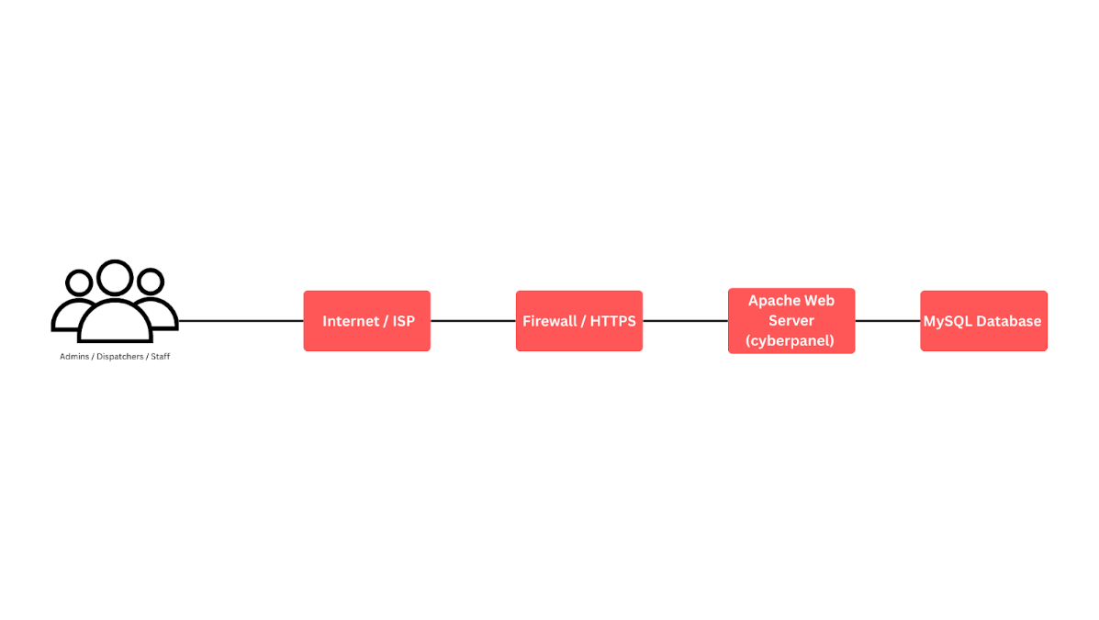
Figure 35 Network Topology Diagram
8.3 Scalability and Performance Considerations
Load Balancing
- Load balancing distributes incoming user requests across multiple servers to prevent any single server from becoming a performance bottleneck during high-traffic periods, such as peak shipment processing times, bulk data uploads, or simultaneous tracking and reporting activities. This ensures consistent system availability and stable performance.

Caching
- Frequently accessed data, including active shipment records, vehicle availability, route assignments, and recent transaction logs, is cached to reduce database query load and improve response times for operational dashboards and real-time tracking features.

Database Indexing and Optimization
- The database is optimized through proper indexing and query tuning to support fast retrieval of time-sensitive freight data such as shipment statuses, delivery schedules, cargo inventories, billing records, and system audit logs.

Data Storage Strategies
- Data is organized using a structured and normalized schema to ensure efficient storage, retrieval, and updates. This includes separation of real-time operational tables (active shipments and vehicle movements) from historical and archival data, as well as optimized storage strategies for documents such as invoices, delivery receipts, and cargo inspection images.

Modular and Stateless Design
- The system follows a modular architecture with stateless service components where applicable, allowing individual modules—such as shipment tracking, billing, reporting, or notification services—to scale independently without affecting overall system stability.

Asynchronous Processing
- Non-critical operations, including report generation, notification dispatch, billing processing, and scheduled backups, are handled asynchronously through background task queues. This approach minimizes response latency for real-time freight operations while ensuring that supporting processes are executed reliably.
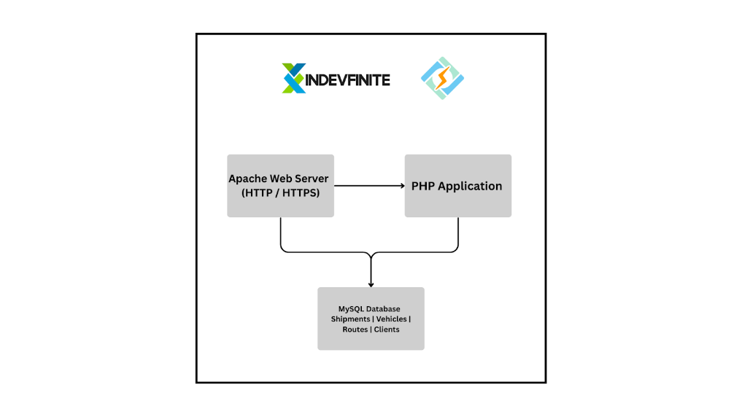
Figure 36 Infrastructure Architecture Diagram

9. DEVELOPMENT PROCESS

9.1 Agile Scrum Roles and Responsibilities
This section defines the actual Scrum roles involved in the project and outlines their specific responsibilities to ensure effective collaboration, accountability, and timely delivery of system features.
Scrum Master
Role Assignment: Project Manager / Team Lead
Scrum master is the one that facilitates scrum ceremonies such as sprint planning, daily scrum, sprint review, etc. Scrum master also ensures the team follows Agile–Scrum principles and practices while overseeing the flow of the project and removing variables that may affect the progress. They are also responsible for supporting team communication and collaboration and monitoring overall team progress.
Development Team
Role Assignment: System Developers, UI/UX Designer, Database Developer
Develops system features based on sprint backlog items including freight management, HR modules, and AI-powered predictive attrition functionality. Writes clean, efficient, and maintainable code while participating in daily scrums and code reviews. Integrates TensorFlow models into the HR analytics dashboard to enable real-time attrition risk predictions. Continuously fixes bugs and iteratively improves system features for better performance, usability, and scalability.

End Users
Role Assignment: HR Staff & HR Manager
Use the system in day-to-day operations after deployment

Stakeholders
Role Assignment: Document Specialist, Security Analyst, Business Analyst
The project team assigned three key roles to ensure effective documentation, secure system design, and accurate alignment with business needs. The Document Specialist was responsible for preparing, organizing, and maintaining all project documents, ensuring clarity, consistency, and compliance with required standards. The Security Analyst focused on identifying potential security risks, defining security requirements, and implementing measures to protect system data, user access, and overall system integrity. Meanwhile, the Business Analyst served as the bridge between stakeholders and the development team by gathering requirements, analyzing business processes, and translating organizational needs into clear system specifications. Together, these role assignments contributed to a well-documented, secure, and business-aligned project outcome.
In terms of more detailed and defined roles and responsibilities of the researchers, it is presented in the table below.
Name | Role | Responsibilities
TAY, ELDRIAN | Project Manager | Facilitates all Scrum ceremonies including sprint planning, reviews, and retrospectives. Ensures project timelines, resources, and scope remain aligned while resolving blockers and managing risks. Serves as the primary communication bridge between the development team, stakeholders, and leadership. Tracks project progress using Agile KPIs such as sprint velocity, burndown charts, and cycle time to maintain transparency and ensure successful delivery.
FABABEIR, DAVID JOHN C. | Business Analyst | Gathers and refines business requirements from HR staff, payroll officers, and freight managers through interviews, surveys, and workshops. Creates and prioritizes user stories with clear acceptance criteria based on business value. Supports product backlog management and validates developed features against original business needs. Acts as a translator between technical teams and non-technical stakeholders to ensure shared understanding of system features and goals.
ABUYABOR, EDMON D. | Security Analyst | Identifies and mitigates security risks throughout the system development lifecycle, focusing on protecting sensitive HR and payroll data. Implements data protection best practices including role-based access control, encryption, and strong authentication measures. Conducts regular vulnerability assessments during sprints and collaborates with developers to ensure secure coding practices. Ensures system compliance with security standards and regulations such as GDPR and local labor laws.
PEROS, JONATHAN M. | Programmer | Develops system features based on sprint backlog items including freight management, HR modules, and AI-powered predictive attrition functionality. Writes clean, efficient, and maintainable code while participating in daily scrums and code reviews. Integrates TensorFlow models into the HR analytics dashboard to enable real-time attrition risk predictions. Continuously fixes bugs and iteratively improves system features for better performance, usability, and scalability.
RAMOS, MARIEL A. | Document Specialist | Creates comprehensive technical specifications, user manuals, and training guides for system users including HR staff, payroll officers, and managers. Maintains detailed sprint logs, release notes, and project reports while collaborating with the Business Analyst to accurately capture requirements. Ensures all documentation remains current through proper version control practices and organizes deliverables in a centralized, easily accessible repository for team and stakeholder reference.
Table 31 Roles and Responsibilities Table

9.2 Sprint Planning and Backlog Management
Sprint planning and backlog management were conducted using Agile Scrum practices to ensure that system development was aligned with business priorities and delivered incrementally.
During Sprint Planning, the Product Owner presented the prioritized Product Backlog, which contained user stories derived from the system’s functional requirements. Backlog items were prioritized based on business value, system criticality, dependencies between modules, and risk level, with high-priority features such as employee record management, payroll computation, and access control addressed first.
The development team, together with the Scrum Master, reviewed the top backlog items and discussed technical requirements, scope, and dependencies. Tasks were then estimated using effort hours and broken down into smaller, manageable activities. Based on the team’s capacity and sprint duration, selected Product Backlog items were moved into the Sprint Backlog.
The Sprint Backlog served as the team’s working plan for the sprint. Each task was assigned to a team member and tracked using status indicators (To Do, In Progress, Done). Progress was monitored through daily stand-up meetings, allowing the team to identify blockers early and make necessary adjustments.
Backlog management was a continuous activity throughout the project. The Product Backlog was regularly refined and updated to reflect changing requirements, stakeholder feedback, and sprint review outcomes. Completed items were marked as done, while new or revised requirements were re-prioritized to ensure transparency and adaptability.
This approach ensured that development efforts remained focused, organized, and aligned with project goals, while enabling flexibility to respond to evolving system and business needs.

Product Backlog (User Stories)
User Story No. | Features/ Task | User Stories | Priority | Status
CORE HUMAN CAPITAL
F1 | Employee Profile Records | As HR staff, I want to record and update employee personal profiles so that records are complete | HIGH | DONE
F2 | Employee Categorization | As HR staff, I want to categorize employees by department and role so that workforce data is organized. | HIGH | DONE
F3 | End User log-in page | As a user, I want to log in and view the system so I can check my and work | HIGH | DONE
F4 | Employee contract management | As HR staff, I want to manage employee contracts so that I can track employment status. | LOW | DONE
F5 | Leave Request Assessment | As a manager, I want to approve or reject leave requests so that scheduling is ensured. | LOW | TO-DO
F6 | DATABASE | As a Manager, I want a Standard and Secure Database that Holds all the Employee master data | HIGH | DONE
F7 | Employee Demographics | As an HR Manager, I want to generate employee demographic reports (age, tenure, role) so that I can analyze workforce distribution. | HIGH | DONE
HR ANALYTICS DASHBOARD
F8 | Employee  Performance Dashboard | As HR staff, I want to drill down into employee dashboards so that I can review performance. | HIGH | DONE
F9 | Trend Turnover Graphs | As a manager, I want to analyze turnover trends through visual graphs so that I can see retention | HIGH | DONE
F10 | Predictive attrition Analysis | As HR staff, I want to view predictive attrition risk analysis results so that I can identify high-risk employees. | HIGH | DONE
F11 | Workforce data graph | As management, I want to compare workforce data across multiple periods so that I can evaluate improvements. | LOW | DONE
F12 | Analytic Dashboard | As HR Manager, I want to view dashboards with employee KPIs (attendance, attrition, performance) so that I can monitor trends. | HIGH | DONE
F13 | HR Report | As HR manageRt, I want to generate summary HR reports so that I can make executive decisions. | LOW | DONE
F14 | Filter Function | As HR Manager, I want to filter dashboards by department or date range so that I can customize views | Medium | DONE
HMO & BENEFITS ADMINISTRATION
F15 | Registration of employee HMO Plans | As HR staff, I want to register employees under company HMO plans so that medical coverage is documented. | MEDIUM | DONE
F22 | Employee Bio | As an employee, I want to update my dependent information so that my records remain accurate. | HIGH | DONE
F16 | Employee HMO detail | As an employee, I want to view my HMO plan details so that I know my coverage. | MEDIUM | DONE
F17 | HMO and Benefits Report | As management, I want to generate reports on HMO and benefits expenses so that budgeting is informed. | LOW | DONE
PAYROLL MANAGEMENT
F18 | Employee time in and time out | As payroll staff, I want to record employee working hours and overtime so that salary computations are accurate. | HIGH | DONE
F19 | Integrated attendance with payroll | As HR staff, I want to integrate attendance records with payroll so that manual work is reduced. | LOW | ON-GOING
F20 | Employee Salary Detail | As an employee, I want to view my payslips online so that I can check my salary details. | HIGH | DONE
F21 | Automated deduction | As payroll staff, I want to automatically calculate deductions (tax, SSS, Pag-IBIG, PhilHealth, loans) so that compliance is ensured. | HIGH | DONE
F22 | Payroll release Schedule | As payroll staff, I want to schedule payroll releases (monthly/semi-monthly) so that payments are consistent. | MEDIUM | DONE
COMPENSATION PLANNING
F23 | Role-based compensation packages | As management, I want to set compensation packages for different roles so that salaries are standardized. | HIGH | DONE
F24 | Performance-based compensation | As HR staff, I want to plan salary adjustments based on performance evaluations so that rewards are fair. | HIGH | DONE
F25 | Link Compensation to Attrition Prediction | As HR manager, I want to link compensation planning with attrition predictions so that retention strategies are informed | MEDIUM | ON-GOING
F26 | Performance-based Incentives | As HR staff, I want to track merit-based bonuses and incentives so that rewards are managed. | MEDIUM | DONE
F27 | Long Term Compensation Plan | As HR Manager, I want to manage long-term compensation plans (retirement, loyalty bonuses) so that employee benefits are structured. | HIGH | DONE
F28 | Analytical Recommendation for Compensation | As HR Manager, I want to receive recommendations from analytics on optimal compensation packages so that workforce satisfaction improves. | MEDIUM | TO-DO
Table 32 Product Backlog (User Stories)
SPRINT Backlog (User Stories)

Task No. | User Story No. | User Stories | Tasks | Timeline | Responsible Team Member/s
SPRINT 1
S1_1 | UI-3 | As HR Manager, I want standardized fonts, sizes, and branding across modules so that the system looks professional and unified. | PLANNING, DESIGN, CODE, DOCUMENTATION | 14 | TAY, ELDRIAN; ABUYABOR, EDMON D.; PEROS, JONATHAN M.; FABABIER, DAVID JOHN C.; RAMOS, MARIEL A.
S1_2 | UI-1 | As an HR staff, I want consistent and intuitive icons across the dashboard so that I can easily navigate the system without confusion. | PLANNING, DESIGN, CODE, DOCUMENTATION | 14 | TAY, ELDRIAN; ABUYABOR, EDMON D.; PEROS, JONATHAN M.; FABABIER, DAVID JOHN C.; RAMOS, MARIEL A.
S1_3 | UI-4 | As an HR manager, I want reports and analytics displayed using clear charts and graphs so that I can interpret workforce and freight data quickly. | PLANNING, DESIGN, CODE, DOCUMENTATION | 14 | TAY, ELDRIAN; ABUYABOR, EDMON D.; PEROS, JONATHAN M.; FABABIER, DAVID JOHN C.; RAMOS, MARIEL A.
S1_4 | UI-5 | As a user, I want a simple layout so that I can perform tasks without distraction or confusion. | PLANNING, DESIGN, CODE, DOCUMENTATION | 7 | TAY, ELDRIAN; ABUYABOR, EDMON D.; PEROS, JONATHAN M.; FABABIER, DAVID JOHN C.; RAMOS, MARIEL A.
S1_5 | UI-6 | As a user, I want a fast and easy-to-use search bar | PLANNING, DESIGN, CODE, DOCUMENTATION | 14 | TAY, ELDRIAN; ABUYABOR, EDMON D.; PEROS, JONATHAN M.; FABABIER, DAVID JOHN C.; RAMOS, MARIEL A.
S1_6 | UI-7 | As a system user, I want the system to use accessible color schemes (contrast-compliant) so that information is readable | PLANNING, DESIGN, CODE, DOCUMENTATION | 7 | TAY, ELDRIAN; ABUYABOR, EDMON D.; PEROS, JONATHAN M.; FABABIER, DAVID JOHN C.; RAMOS, MARIEL A.
S1_7 | IS-1 | As an Employee, I want my sensitive information to be protected | PLANNING, DESIGN, CODE, DOCUMENTATION | 14 | TAY, ELDRIAN; ABUYABOR, EDMON D.; PEROS, JONATHAN M.; FABABIER, DAVID JOHN C.; RAMOS, MARIEL A.
SPRINT 2
S2_1 | F-6 | As manager, I want to generate employee demographic reports (age, tenure, role) so that I can analyze workforce distribution. | PLANNING, DESIGN, CODE, DOCUMENTATION | 14 | TAY, ELDRIAN; ABUYABOR, EDMON D.; PEROS, JONATHAN M.; FABABIER, DAVID JOHN C.; RAMOS, MARIEL A.
S2_2 | F10 | As HR staff, I want to view predictive attrition risk analysis results so that I can identify high-risk employees. | PLANNING, DESIGN, CODE, DOCUMENTATION | 28 | TAY, ELDRIAN; ABUYABOR, EDMON D.; PEROS, JONATHAN M.; FABABIER, DAVID JOHN C.; RAMOS, MARIEL A.
S2_3 | F-18 | As management, I want to generate reports on HMO and benefits expenses so that budgeting is informed. | PLANNING, DESIGN, CODE, DOCUMENTATION | 14 | TAY, ELDRIAN; ABUYABOR, EDMON D.; PEROS, JONATHAN M.; FABABIER, DAVID JOHN C.; RAMOS, MARIEL A.
S2_4 | F19 | As payroll staff, I want to record employee working hours and overtime so that salary computations are accurate. | PLANNING, DESIGN, CODE, DOCUMENTATION | 14 | TAY, ELDRIAN; ABUYABOR, EDMON D.; PEROS, JONATHAN M.; FABABIER, DAVID JOHN C.; RAMOS, MARIEL A.
S2_5 | F-27 | As HR staff, I want to track merit-based bonuses and incentives so that rewards are managed. | PLANNING, DESIGN, CODE, DOCUMENTATION | 14 | TAY, ELDRIAN; ABUYABOR, EDMON D.; PEROS, JONATHAN M.; FABABIER, DAVID JOHN C.; RAMOS, MARIEL A.
S2_6 | F9 | As a manager, I want to analyze turnover trends through visual graphs so that I can see retention | PLANNING, DESIGN, CODE, DOCUMENTATION | 14 | TAY, ELDRIAN; ABUYABOR, EDMON D.; PEROS, JONATHAN M.; FABABIER, DAVID JOHN C.; RAMOS, MARIEL A.
SPRINT 3
S3_1 | IS-3 | As a system administrator, I want to assign different access levels to managers, and HR staff so that each user can only access the data relevant to their role. | PLANNING, DESIGN, CODE, DOCUMENTATION | 14 | TAY, ELDRIAN; ABUYABOR, EDMON D.; PEROS, JONATHAN M.; FABABIER, DAVID JOHN C.; RAMOS, MARIEL A.
S3_2 | UI-2 | As a manager, I want the system to adjust smoothly on desktop, tablet, and mobile devices so that I can access the HR-IV system anytime, anywhere. | PLANNING, DESIGN, CODE, DOCUMENTATION | 7 | TAY, ELDRIAN; ABUYABOR, EDMON D.; PEROS, JONATHAN M.; FABABIER, DAVID JOHN C.; RAMOS, MARIEL A.
S3_3 | EA-4 | As an HR analyst, I want predictive analytics on attrition using machine learning so that I can prevent high turnover in critical roles. | PLANNING, DESIGN, CODE, DOCUMENTATION | 14 | TAY, ELDRIAN; ABUYABOR, EDMON D.; PEROS, JONATHAN M.; FABABIER, DAVID JOHN C.; RAMOS, MARIEL A.
S3_4 | F1 | As HR staff, I want to record and update employee personal profiles so that records are complete | PLANNING, DESIGN, CODE, DOCUMENTATION | 7 | TAY, ELDRIAN; ABUYABOR, EDMON D.; PEROS, JONATHAN M.; FABABIER, DAVID JOHN C.; RAMOS, MARIEL A.
S3_5 | F2 | As HR staff, I want to categorize employees by department and role so that workforce data is organized | PLANNING, DESIGN, CODE, DOCUMENTATION | 14 | TAY, ELDRIAN; ABUYABOR, EDMON D.; PEROS, JONATHAN M.; FABABIER, DAVID JOHN C.; RAMOS, MARIEL A.
S3_6 | F3 | As HR staff, I want to manage employee contracts so that I can track employment status. | PLANNING, DESIGN, CODE, DOCUMENTATION | 7 | TAY, ELDRIAN; ABUYABOR, EDMON D.; PEROS, JONATHAN M.; FABABIER, DAVID JOHN C.; RAMOS, MARIEL A.
S3_7 | F22 | As payroll staff, I want to automatically calculate deductions (tax, SSS, Pag-IBIG, PhilHealth, loans) so that compliance is ensured. | PLANNING, DESIGN, CODE, DOCUMENTATION | 7 | TAY, ELDRIAN; ABUYABOR, EDMON D.; PEROS, JONATHAN M.; FABABIER, DAVID JOHN C.; RAMOS, MARIEL A.
S3_8 | UI-8 | As a first-time user, I want tooltips and help icons on buttons and forms so that I can understand features without needing external training. | PLANNING, DESIGN, CODE, DOCUMENTATION | 14 | TAY, ELDRIAN; ABUYABOR, EDMON D.; PEROS, JONATHAN M.; FABABIER, DAVID JOHN C.; RAMOS, MARIEL A.
SPRINT 4
S4_1 | INT-1 | As an HR staff, I want Recruitment data to automatically feed into the Employee Master File so that new hires are seamlessly integrated into payroll and benefits. | PLANNING, DESIGN, CODE, DOCUMENTATION | 7 | TAY, ELDRIAN; ABUYABOR, EDMON D.; PEROS, JONATHAN M.; FABABIER, DAVID JOHN C.; RAMOS, MARIEL A.
S4_2 | INT-2 | As a Compensation officer, I want Performance Management results to flow into Compensation Planning so that bonuses and salary adjustments are data-driven. | PLANNING, DESIGN, CODE, DOCUMENTATION | 7 | TAY, ELDRIAN; ABUYABOR, EDMON D.; PEROS, JONATHAN M.; FABABIER, DAVID JOHN C.; RAMOS, MARIEL A.
S4_3 | INT-3 | As an HR manager, I want Succession Planning updates to adjust Compensation Planning so that promotions and salary increases are consistently applied. | PLANNING, DESIGN, CODE, DOCUMENTATION | 7 | TAY, ELDRIAN; ABUYABOR, EDMON D.; PEROS, JONATHAN M.; FABABIER, DAVID JOHN C.; RAMOS, MARIEL A.
S4_4 | INT-4 | As a Manager, I want Social Recognition rewards to feed into Compensation Planning so that employee recognition is reflected in bonuses. | PLANNING, DESIGN, CODE, DOCUMENTATION | 7 | TAY, ELDRIAN; ABUYABOR, EDMON D.; PEROS, JONATHAN M.; FABABIER, DAVID JOHN C.; RAMOS, MARIEL A.
S4_5 | INT-5 | As a Payroll officer, I want Compensation Planning adjustments/bonuses to reflect automatically in Payroll so that salaries are accurate without manual input | PLANNING, DESIGN, CODE, DOCUMENTATION | 7 | TAY, ELDRIAN; ABUYABOR, EDMON D.; PEROS, JONATHAN M.; FABABIER, DAVID JOHN C.; RAMOS, MARIEL A.
S4_6 | INT-6 | As a Payroll officer, I want Time & Attendance logs to integrate with Payroll so that overtime and absences are reflected in salary computations. | PLANNING, DESIGN, CODE, DOCUMENTATION | 7 | TAY, ELDRIAN; ABUYABOR, EDMON D.; PEROS, JONATHAN M.; FABABIER, DAVID JOHN C.; RAMOS, MARIEL A.
S4_7 | INT-7 | As a Payroll officer, I want Timesheet Management data (manual logs) to flow into Payroll so that additional work hours are properly compensated. | PLANNING, DESIGN, CODE, DOCUMENTATION | 7 | TAY, ELDRIAN; ABUYABOR, EDMON D.; PEROS, JONATHAN M.; FABABIER, DAVID JOHN C.; RAMOS, MARIEL A.
S4_8 | INT-8 | As a Payroll officer, I want Leave Management deductions to update Payroll so that unpaid leave is automatically deducted from salaries. | PLANNING, DESIGN, CODE, DOCUMENTATION | 7 | TAY, ELDRIAN; ABUYABOR, EDMON D.; PEROS, JONATHAN M.; FABABIER, DAVID JOHN C.; RAMOS, MARIEL A.
S4_9 | INT-9 | As an HR staff, I want HMO & Benefits Administration to reflect in Payroll so that deductions and company contributions are computed automatically. | PLANNING, DESIGN, CODE, DOCUMENTATION | 14 | TAY, ELDRIAN; ABUYABOR, EDMON D.; PEROS, JONATHAN M.; FABABIER, DAVID JOHN C.; RAMOS, MARIEL A.
S4_10 | INT-10 | As an HR analyst, I want Core Human Capital data (roles, positions, demographics) to feed into HR Analytics Dashboard so that workforce distribution can be visualized. | PLANNING, DESIGN, CODE, DOCUMENTATION | 14 | TAY, ELDRIAN; ABUYABOR, EDMON D.; PEROS, JONATHAN M.; FABABIER, DAVID JOHN C.; RAMOS, MARIEL A.
Table 33 SPRINT Backlog (User Stories)
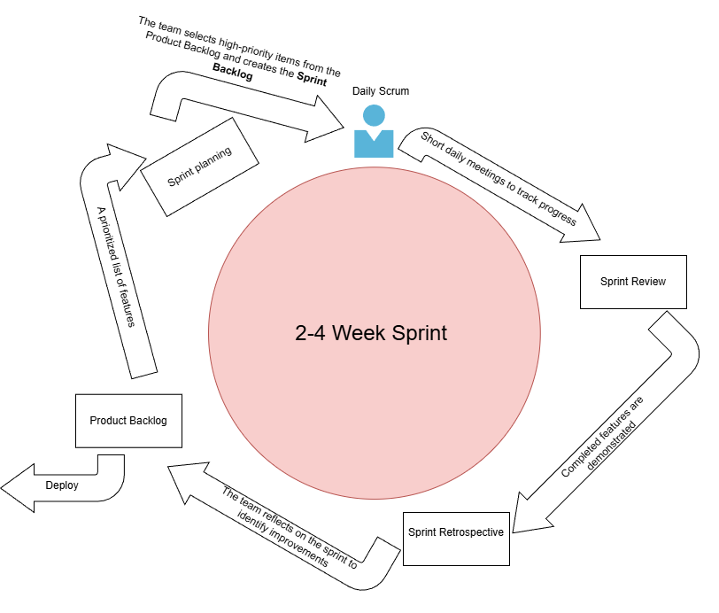
Figure 37 Agile scrum process diagram

Diagram shows the sequence of activities, artifacts, and ceremonies involved in an Agile project, arranged in a cyclical flow to emphasize iteration and continuous improvement.

Figure 38 Sprint Cycle Diagram
A Sprint Cycle Diagram it visually represents the iterative sequence of planning, development, review, and improvement activities that occur within a Scrum sprint.

9.3 Sprint Execution and Deliverables
Sprint execution was carried out through time-boxed sprints following Agile Scrum practices. Each sprint focused on delivering a set of prioritized features taken from the Sprint Backlog, resulting in a potentially deployable system increment at the end of every sprint.

Phase Activity | Description | Sprint1 | Sprint2 | Sprint3 | Sprint4 | Sprint5
Project Planning | Define project scope, objectives, and schedule | ✔️
Requirements Analysis | Gather and analyze functional and non-functional requirements | ✔️
System Design | Create system architecture, database, and workflow diagrams | ✔️ | ✔️
Security Planning | Identify risks and define security controls and policies |  | ✔️ | ✔️
Documentation Setup | Prepare templates and documentation standards | ✔️ | ✔️
System Development | Develop core system modules and features |  |  | ✔️ | ✔️
Security Implementation | Apply authentication, access control, and data protection |  |  | ✔️
Testing & Debugging | Conduct system testing and fix identified issues |  |  | ✔️
Documentation Finalization | Complete user manuals and technical documentation | ✔️ | ✔️ | ✔️ | ✔️
Deployment & Review | Deploy system and conduct final evaluation |  |  | ✔️ | ✔️ | ✔️
Table 34 Development Timeline/Gantt Chart
This table mainly shows when activities happened and their duration, each mark represents the duration of how long it takes to complete the specific Phase or Activity, it will help visualize workload distribution and makes it clear that some tasks cannot be rushed into one sprint.

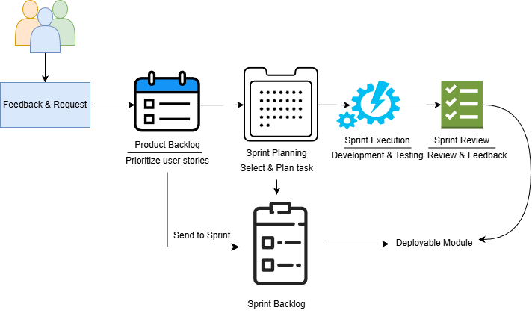
Figure 39 Backlog Management Workflow Diagram
The backlog management workflow ensures that stakeholder requests are systematically collected, prioritized, planned, developed, reviewed, and continuously improved through iterative sprint cycles.
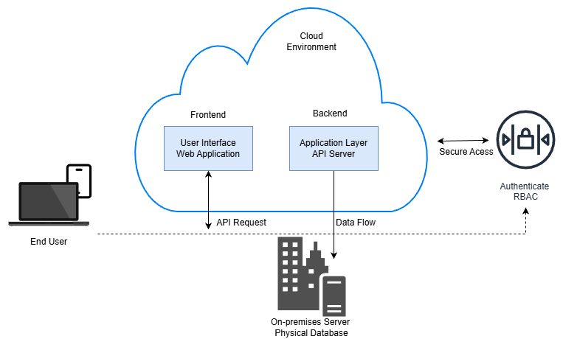
Figure 40 Implementation Diagram
This diagram visually models the physical environment, showing how software components are deployed onto hardware nodes (like servers, databases) and their connections, bridging the gap between logical design and physical reality for a system's execution.

9.4 Challenges Faced in the Development Process
During the development of the system, the team encountered several challenges that affected planning, implementation, and coordination. These obstacles were addressed using Agile Scrum practices to minimize their impact and ensure continuous progress.

Changing Requirements - Some system requirements evolved during development, particularly in payroll rules and compensation policies.
Resolution:
The team broke down payroll features into smaller tasks, implemented unit testing, and conducted frequent reviews during sprint execution to ensure correctness and compliance.

Time and Resource Constraints - Limited development time and team availability created pressure to deliver multiple modules within tight sprint schedules.
Resolution:
Tasks were prioritized based on business value, and sprint scope was adjusted according to team capacity. Non-critical features were deferred to later sprints to maintain quality.

Integration Between Modules - Integrating Core HR, Payroll, Compensation, and HMO modules posed technical and data consistency challenges especially to non HR-IV modules.
Resolution:
Integration testing was conducted at the end of each sprint, and shared data structures were standardized to ensure smooth module interaction.

Communication and Coordination - Aligning understanding among team members sometimes caused delays or rework especially some of the researchers are working students resulting in increase of workload.
Resolution:
Daily Scrum meetings and sprint reviews improved transparency, encouraged collaboration, and allowed early identification of issues to easily distribute the workload.

Despite these challenges, the use of Agile Scrum enabled the team to adapt quickly, manage risks effectively, and deliver functional system increments through continuous feedback and improvement.

10 IMPLEMENTATIONS

10.1 Technical Implementation Details
This part of the capstone paper describes the step-by-step technical deployment process of the system, including the environments used and key configuration settings applied to ensure proper functionality, security, and performance. In case of HR-IV of Slate Freight Management system, the steps will include development environment setup, database configuration, application configuration, integration and module deployment, testing environment, system deployment, and lastly security and performance configuration.
Development Environment Setup - The system was developed in a local development environment using XAMPP, which includes Apache, PHP, and MySQL. This environment allowed developers to write, test, and debug HR-IV system features without affecting live data. Source code was managed within structured directories following MVC-style separation to improve maintainability.
Database Configuration - A MySQL database was created to store system data such as user accounts, employee records, payroll details, and configuration settings. Database tables were designed with primary and foreign keys to maintain data integrity. Connection settings were configured in a centralized PHP configuration file to allow secure and reusable database access.
Application Configuration - Core system configurations, such as database credentials, session handling, role-based access control, and file upload paths, were defined in environment-specific configuration files. PHP sessions were used to manage authenticated user access, ensuring that only authorized roles could access restricted modules.
Integration and Module Deployment - Individual modules (e.g., Employee Management, Payroll, Compensation, and Benefits) were integrated incrementally. Each module was tested independently before being connected to the core system to minimize deployment errors. Internal APIs and shared services were used to enable data flow between modules.
Testing Environment - Before system deployment, the system was deployed to a staging/testing environment that mirrored the production setup. Functional testing, integration testing, and user acceptance testing (UAT) were conducted to validate system behavior, data accuracy, and performance under real-world scenarios.
System Deployment - After successful testing, the system was deployed to the production environment. The Apache web server was configured to host the application, and the production database was initialized with required baseline data. File permissions and security settings were adjusted to prevent unauthorized access.
Security and Performance Configuration - Security measures included input validation, password hashing, role-based authorization, and restricted database access. Performance optimizations such as indexed database queries and efficient session management were applied to ensure stable operation under concurrent user access.

10.2 Tools and Technologies Used
To properly create a functional and efficient HR-IV system it needed numerous tools and technologies to execute each phases from plan to development to testing and deployment of the system.

For the Development of the system, it requires a lot of tools ranging from primary server-side programming language that is used to implement system logic and business processes, front-end server language used to build the user interface that includes a framework that create a responsive and consistent design, database technologies a relational database management system that will be used to store structured data such as employee records, payroll info, etc., deployment tools that will host the web application, to system unrelated tools but still plays an important role in system creation guidance and monitoring such as the documentation tools, used for writing system documentation, reports, and user manuals.
The table below provides a more deeper understanding by presenting more detailed information in a tabular format

Category | Tool / Technology | Purpose / Description
Development | PHP | Server-side scripting language used to implement system logic and business processes
Development | HTML5 | Structure and content presentation of web pages
Development | CSS3 | Styling and layout of the user interface
Development | JavaScript | Client-side interactivity and dynamic behavior
Front-End Framework | Bootstrap | Responsive and consistent UI design
Development Environment | XAMPP | Local server environment including Apache, PHP, and MySQL
Code Editor | Visual Studio Code | Source code writing, editing, and debugging
Database | MySQL | Relational database for storing structured system data
Database Management | phpMyAdmin | Database administration and query management
Web Server | Apache | Hosts the web application and handles HTTP requests
Version Control | Git | Tracks source code changes and supports version management
Repository Hosting | GitHub | Enables team collaboration and centralized code storage
Testing | Browser Developer Tools | Debugging, responsiveness testing, and performance inspection
Documentation | Microsoft Word | Preparation of system documentation and reports
Diagramming | Draw.io | Creation of system diagrams, flowcharts, and UML models
Table 34 Tools and Technologies used

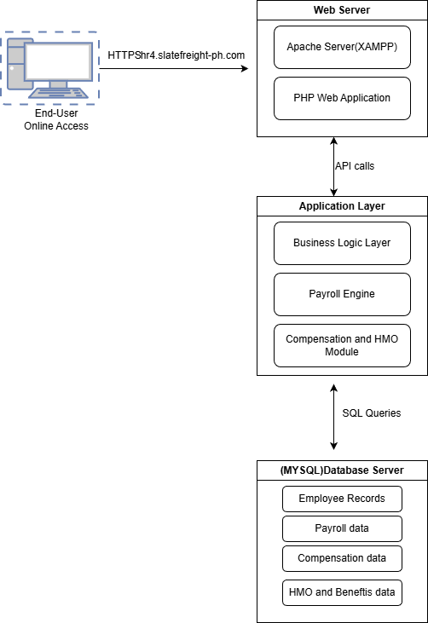
Figure 41 System Deployment Diagram

10.3 Code Integration and Interoperability
This section explains how the different code modules of the system were integrated and how interoperability and compatibility were ensured across all components.
Module-Based Architecture - The system was designed using a modular architecture, where each functional component, such as Core Human, Payroll Management, Compensation, and Benefits was developed as an independent module. Each module encapsulated its own business logic while following shared coding standards to ensure consistency across the application.
Shared Database and Data Consistency - All modules interacted with a centralized MySQL and one payroll database. Common database schemas, standardized table structures, and foreign key relationships were implemented to enable seamless data exchange between modules. This approach ensured that updates in one module (e.g., employee status changes) were automatically reflected in related modules (e.g., payroll computation).
Common Configuration and Reusable Components - Reusable components such as database connection handlers, authentication checks, and session management scripts were centralized in shared configuration files. This reduced code duplication and ensured uniform behavior across all modules. Changes to core configurations could be applied system-wide without modifying individual modules.
API-Like Internal Integration - The system utilized internal function calls and shared PHP scripts to enable communication between modules. Defined input and output formats were used to standardize data exchange, ensuring that each module could correctly interpret and process shared data.
Compatibility Assurance - To ensure interoperability, the system adhered to standard web technologies, including HTTP, HTML5, CSS3, and JavaScript, which are supported across modern web browsers. Server-side compatibility was maintained by using consistent PHP versions across development, testing, and production environments.
Error Handling and Validation - Data validation and error handling mechanisms were implemented at both module and system levels. Input validation ensured that only compatible and correctly formatted data was exchanged between modules, preventing integration failures and data inconsistency.
Testing and Verification - Integrated testing was conducted after module integration to verify correct data flow and system behavior. Functional and integration tests ensured that all modules operated cohesively as a unified system without conflicts or compatibility issues.

Integration Summary Table
Integrated Module | Integrated With | Purpose | Data Exchanged | Integration Method
Core Human | Payroll Module | Provides employee and employment data required for payroll computation | Employee ID, job position, salary grade, employment status | Internal system API
Payroll | Compensation Module | Applies allowances, bonuses, and deductions during payroll processing | Allowance data, bonus rules, deduction values | Internal service calls
Payroll Module | HMO & Benefits Module | Includes benefits contributions in payroll computation | HMO provider details, employee contribution amounts | Internal service calls
Payroll Module | Application Server | Sends user requests and receives processed results | User inputs, validation results, payroll reports | RESTful API (HTTPS)
Web Application (UI) | Database Server | Stores and retrieves system data | Employee records, payroll transactions, audit logs | SQL queries
Application Server | All System Modules | Ensures secure and role-based access to system features | User credentials, role permissions | Token-based authentication
Authentication Module | Payroll & HR Modules | Generates reports for monitoring and compliance | Payroll summaries, employee statistics | Database queries
Table 35 Integration Summary Table

10.4 Integration Testing and Debugging
To verify that all system modules function properly and correctly together, this section is needed, this will describe the integration testing activities. This section also includes debugging techniques applied to resolve issues identified during testing.
Integration Testing Approach
Integration testing was conducted after individual modules were completed and unit tested. The primary objective was to validate data flow, functional interactions, and dependencies between modules such as Employee Management, Payroll Processing, Compensation, and Benefits. Testing focused on ensuring that outputs from one module served as correct and valid inputs for another.
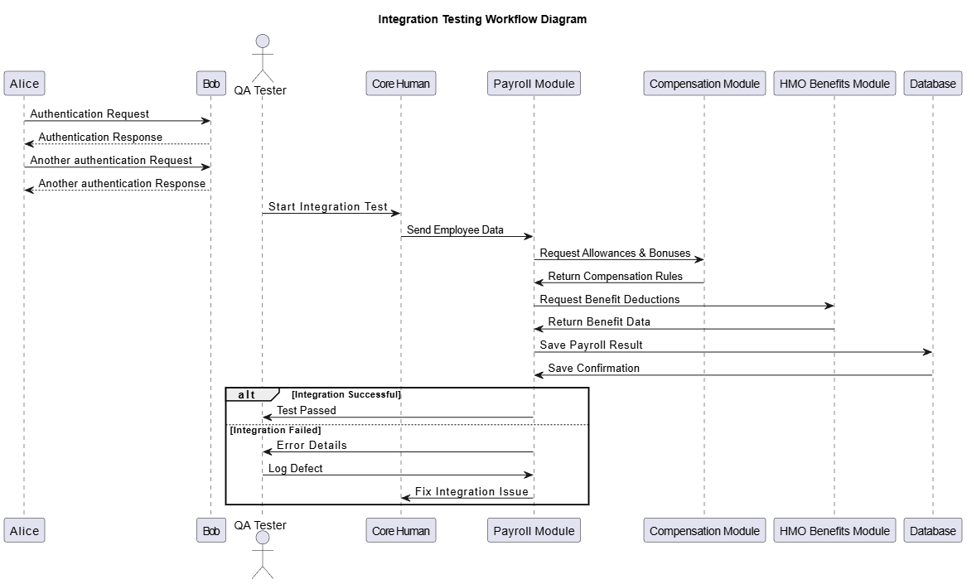
Figure 42 Integration Testing Workflow Diagram

Test Scenarios and Data Flow Validation
Realistic test data were used to simulate actual system usage. Key scenarios included employee record creation and updates, payroll computation based on employee data, and the application of compensation and benefits rules. These scenarios confirmed that shared data stored in the database was accurately accessed and processed by all dependent modules.
Debugging Techniques Applied
When integration issues were detected, debugging was performed using a combination of:
- PHP error reporting and logging to identify server-side issues
- Browser developer tools to inspect client-side errors and network requests
- Step-by-step code tracing to locate logic and data handling errors
Identified bugs included data mismatches, incorrect parameter passing between scripts, and session handling issues.
Bug Fixes and Code Refinement
Resolved issues were addressed by correcting database queries, standardizing function parameters, and improving validation checks. Reusable components were updated to prevent similar issues from recurring across multiple modules. Code refactoring was applied where necessary to improve readability and maintainability without altering system behavior.
Regression and Verification Testing
After fixes were applied, regression testing was performed to ensure that resolved issues did not introduce new errors or affect existing functionalities. Successful test results confirmed that all integrated modules operated as a cohesive and stable system.
Testing Outcome
The integration testing and debugging process confirmed that the system modules interacted seamlessly, maintained data consistency, and met the defined functional requirements. All critical integration issues were resolved prior to production deployment.

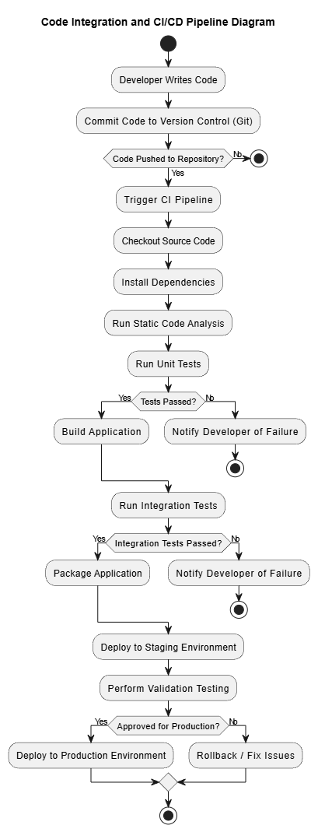
Figure 43 Code Integration and CICD Pipeline Diagram

The CI/CD pipeline diagram illustrates the automated process of integrating code changes, executing tests, building the application, and deploying it to staging and production environments. This ensures code quality, early defect detection, and reliable system delivery.
Configuration Settings Table
The configuration settings table lists the key system parameters and settings required to install, deploy, run, and maintain the HR-IV System correctly.
Category | Configuration Item | Description
Server Environment | Operating System | OS where the application is hosted
Server Environment | Web Server | Handles HTTP/HTTPS requests
Server Environment | Application Runtime | Executes server-side logic
Server Environment | Database Server | Stores system data
Application | Application Name | System identifier
Application | Environment Mode | Defines runtime behavior
Application | Base URL | Root URL of the system
Database | Database Name | Primary system database
Database | Database Host | Database server location
Database | Database Port | Port used by MySQL
Database | Database User | Database access account
Database | Database Password | Encrypted DB credential
Security | Authentication Method | User login verification
Security | Password Hashing | Secures user passwords
Security | Session Timeout | User inactivity timeout
Security | Role-Based Access Control | Controls system access
CI/CD Pipeline | Version Control System | Source code repository
CI/CD Pipeline | CI Tool | Automates build and test
CI/CD Pipeline | Test Types | Automated tests executed
CI/CD Pipeline | Deployment Strategy | Release method
Logging & Monitoring | Error Logging | Stores runtime errors
Logging & Monitoring | Audit Logs | Tracks system activities
Table 36 Configuration Settings Table

11 TESTING

11.1 Testing Strategies and Methodologies
To ensure the reliability, functionality, and quality of the system, multiple testing strategies and methodologies were applied throughout the development lifecycle. Testing was conducted at different levels to verify that individual components, integrated modules, and the overall system met the defined requirements.
Requirements Analysis – Review functional and non-functional requirements to define test objectives.
Unit Testing was performed during the development phase to validate individual functions and modules. Each core feature, such as user authentication, employee record management, payroll computation, Benefits enrollment, and report generation, was tested independently to ensure that logic, calculations, and data handling were correct.
Integration Testing focused on verifying interactions between interconnected modules, including the Core Human Resource module, Payroll module, and Database layer. This ensured that data flowed correctly across components, such as employee data being accurately reflected in payroll computations and reports.
System Testing was conducted after integration to evaluate the complete system as a whole. This level of testing validated end-to-end workflows, including employee onboarding, payroll processing, approval workflows, and reporting functions, ensuring the system behaved according to functional requirements.
Black Box Testing was used to validate system functionality from the user’s perspective without examining internal code structures. Test cases were based on functional requirements, focusing on inputs, expected outputs, and user interactions within the system interface.
User Acceptance Testing (UAT) was carried out to confirm that the system met business needs and user expectations. Stakeholders and end-users tested real-world scenarios to verify usability, accuracy, and compliance with organizational processes before final deployment.
Overall, the combination of these testing strategies ensured that the system was stable, secure, and ready for production use.

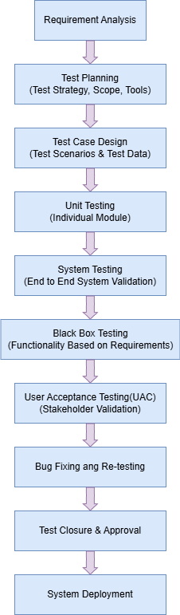
Figure 44 Testing Process Diagram
The Testing Process Diagram visually map out the sequence of testing activities to ensure comprehensive software validation, minimize risks, and provide a clear roadmap for quality assurance, from reviewing functional and non-functional requirements, identifying testing scope, strategies, loos and resources to confirming system readiness and final verification for system deployment.

11.2 Test Cases and Test Data
This section presents specific test cases and corresponding test data used to validate the functionality, accuracy, and reliability of the system. The test cases were designed based on functional requirements and real-world usage scenarios, ensuring that each module performed as expected under valid, invalid, and boundary conditions.
Test cases covered major system modules including user authentication, employee record management, payroll computation, approval workflows, reporting, and security controls. Each test case defined the test scenario, execution steps, expected results, and actual outcomes to verify system behavior.
Test data consisted of predefined input values such as user credentials, employee details, salary components, payroll identifiers, and date ranges. Both valid and invalid data sets were used to evaluate system responses, including data validation, error handling, access control enforcement, and calculation accuracy.
The execution of these test cases confirmed that the system correctly processed inputs, generated accurate outputs, enforced role-based access restrictions, and maintained data integrity across modules. Any defects identified during testing were addressed through corrective actions and re-testing to ensure system stability.
Tables presenting detailed test cases and test data are provided to demonstrate how the system was validated against its requirements.

Test Case Table
Test Case ID | Module | Test Scenario | Test Steps | Expected Result | Status
TC-01 | Login Module | Valid user login | 1. Enter valid username  2. Enter valid password  3. Click Login | User is successfully logged in and redirected to dashboard | Pass
TC-02 | Login Module | Invalid login attempt | 1. Enter invalid username/password  2. Click Login | Error message is displayed | Pass
TC-03 | Employee Management | Add new employee record | 1. Open Add Employee form  2. Fill required fields  3. Click Save | Employee record is saved in database | Pass
TC-04 | Payroll Module | Payroll computation | Click Compute Payroll | Correct salary, deductions, and net pay are calculated | Pass
TC-05 | Dashboard Module | Generate payroll report | 1. Select date range  2. Click Generate Report | Payroll report is displayed correctly | Pass
TC-06 | Security | Role-based access control | 1. Login as non-admin user  2. Access admin page | Access is denied | Pass
TC-07 | User Interface | Form validation | 1. Leave required fields empty  2. Click Submit | Validation error messages are shown | Pass
TC-08 | Database | Data persistence | 1. Add new record  2. Refresh page | Data remains saved | Pass
TC-09 | System | End-to-end workflow | Complete employee → payroll → enrollment process | Workflow completes without errors | Pass
Table 37 Test Case
Test case table presents the test cases executed during system testing to validate functional requirements, expected outcomes, and overall system behavior.

Test Data Table
Test Data ID | Module | Data Description | Input Data | Expected Output | Remarks
TD-01 | Login Module | Valid user credentials | Username: admin  Password: Admin@123 | Successful login | Valid data
TD-02 | Login Module | Invalid user credentials | Username: admin  Password: wrong123 | Login error message | Invalid data
TD-03 | Employee Management | New employee record | Name: Juan Dela Cruz  Position: HR Staff  Salary Grade: SG-5 | Employee record saved | Valid data
TD-04 | Employee Management | Missing required field | Name: (blank)  Position: HR Staff | Validation error displayed | Invalid data
TD-05 | Payroll Module | Payroll computation input | Basic Salary: 30,000  Allowance: 5,000  Deductions: 3,000 | Net Pay: 32,000 | Valid calculation
TD-06 | Payroll Module | Zero allowance | Basic Salary: 25,000  Allowance: 0  Deductions: 2,000 | Net Pay: 23,000 | Boundary case
TD-07 | Payroll Approval | Payroll approval data | Payroll ID: PR-1001 | Status updated to Approved | Valid data
TD-08 | Reporting Module | Report date range | From: 01/01/2025  To: 01/31/2025 | Payroll report generated | Valid range
TD-09 | Security | Unauthorized access attempt | User Role: Employee  Access: Admin page | Access denied | Security test
TD-10 | System | End-to-end transaction | Complete employee → payroll → approval | Successful workflow completion | Integration test
Table 38 Test Data

11.3 Test Results and Bug Reports
This section summarizes the results of the testing activities conducted on the system, as well as the defects identified and resolved during the testing process. Test execution was performed based on the defined test cases and test data to validate system functionality, performance, and security.
The majority of test cases were successfully executed, with core modules such as user authentication, employee management, payroll computation, approval workflows, and reporting producing the expected results. Passed test cases confirmed that the system met its functional requirements and handled valid and invalid inputs appropriately.
During testing, several bugs were identified, primarily related to input validation, calculation logic, and user interface behavior. These issues were documented in bug reports containing detailed descriptions, steps to reproduce, severity levels, and assigned resolutions. All critical and high-priority defects were addressed through code fixes and configuration updates.
After bug fixes were implemented, re-testing was conducted to ensure that the issues were fully resolved and did not introduce new defects. The successful re-execution of failed test cases confirmed the stability and correctness of the applied fixes. No critical unresolved defects remained at the conclusion of testing.
Overall, the test results demonstrate that the system is stable, reliable, and ready for deployment. Bug tracking and resolution activities contributed significantly to improving system quality and ensuring compliance with defined requirements.

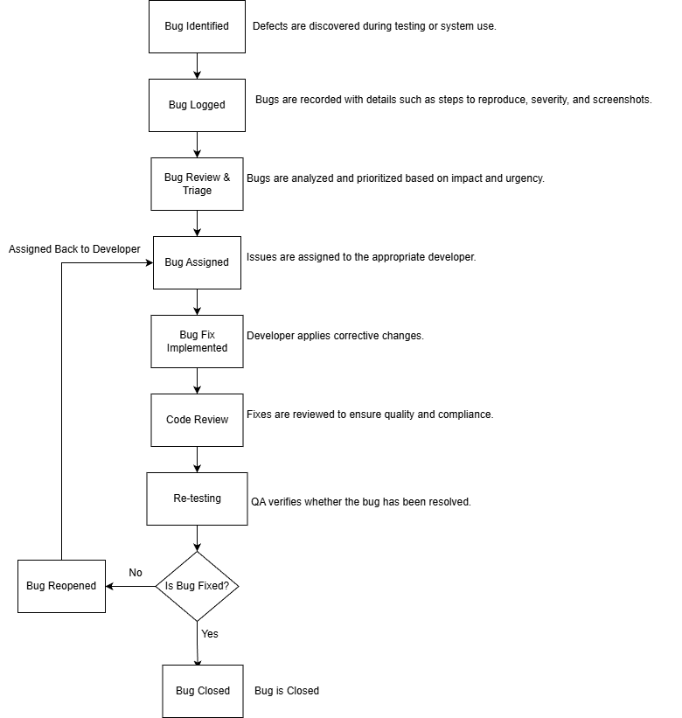
Figure 45 Bug Tracking Workflow Diagram
Figure 7 illustrates the bug tracking workflow used to identify, manage, resolve, and verify system defects throughout the development process. From discovering bug, handling and fixing bug, to closing it

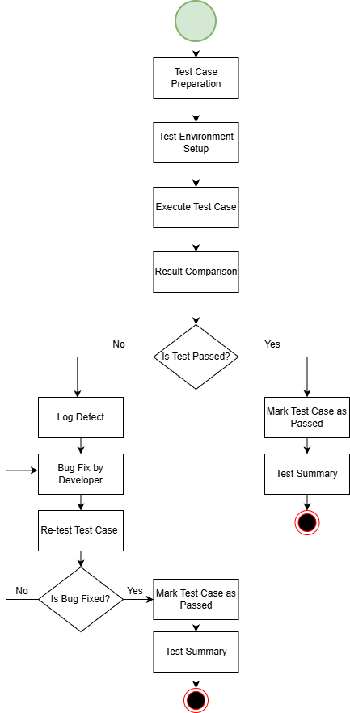
Figure 46 Test Case Executive Workflow Diagram
This figure illustrates the test case execution workflow, including test preparation, execution, defect handling, re-testing, and final test closure.

11.4 Quality Assurance Measures
To ensure high code quality, system reliability, and optimal performance, several quality assurance measures were implemented throughout the system development lifecycle. These measures focused on maintaining coding standards, reducing defects, and ensuring that the system met both functional and non-functional requirements.
Coding Standards and Best Practices were strictly followed to ensure code consistency, readability, and maintainability. Developers adhered to standardized naming conventions, modular coding practices, and proper documentation, which facilitated easier debugging and future enhancements.
Peer Code Reviews were conducted to identify potential issues early in the development process. Code changes were reviewed by other team members to validate logic correctness, security considerations, and adherence to development standards before integration into the main codebase.
Static Code Analysis techniques were applied to detect code smells, logical errors, and potential security vulnerabilities. This helped improve code reliability and reduce runtime errors.
Performance Optimization and Testing were performed to ensure efficient system operation. Key processes such as payroll computation, report generation, and database transactions were tested to confirm acceptable response times and resource utilization.
Security and Access Control Validation was enforced through role-based access control testing and data protection measures. This ensured that sensitive employee and payroll data were accessible only to authorized users.
Regression Testing was carried out after bug fixes and system enhancements to verify that existing functionalities remained unaffected by new changes.
Together, these quality assurance measures ensured that the system maintained a high level of quality, stability, and performance prior to deployment.

Quality Assurance Checklist Table
QA ID | Checklist Item | Description | Status
QA-01 | All functional requirements tested | System features were tested against documented requirements | Completed
QA-02 | Non-functional requirements verified | Performance, usability, and security requirements validated | Completed
QA-03 | Core modules working correctly | Core Human, Payroll, and Reporting modules function as expected | Completed
QA-04 | Input validation implemented | Required fields and data formats are enforced | Completed
QA-05 | Role-based access control enforced | Users can access only authorized features | Completed
QA-06 | Data consistency maintained | No data loss during create, update, and delete operations | Completed
QA-07 | Meaningful error messages displayed | System provides clear feedback on errors | Completed
QA-08 | System response time acceptable | Pages load within acceptable time limits | Completed
QA-09 | User interface is intuitive | Navigation and layout are user-friendly | Completed
QA-10 | Cross-browser compatibility tested | System works on supported browsers | Completed
QA-11 | Data backup procedures validated | Backup and restore processes tested | Completed
QA-12 | System ready for deployment | All critical issues resolved | Completed
Table 39 Quality Assurance Checklist Table

12 RESULTS AND EVALUATION

12.1 Project Outcomes and Deliverables
Even though there are some disturbances and challenges this project was successfully completed with all planned objectives achieved. The system was fully designed, developed, integrated, and tested to meet the defined functional and non-functional requirements. The final outcomes demonstrate a stable, secure, and user-friendly application that supports core business processes and improves operational efficiency.
Project Outcomes
- A fully functional Core Human Capital and Payroll Management System that automates employee management, payroll computation, compensation, and benefits administration.
- Successful integration of core modules, including HR Analytics Dashboard, Core Human, Payroll, Compensation, and HMO/Benefits, ensuring seamless data flow and interoperability.
- Implementation of role-based access control, enhancing system security and data confidentiality.
- Improved accuracy and efficiency in payroll processing, reducing manual errors and processing time.
- A responsive and intuitive web-based interface that enhances user experience for administrators and HR personnel.
- Completion of system testing (unit, integration, and user acceptance testing) confirming system reliability and performance.

Project Deliverables Table
Deliverable | Description | Status
Requirements Specification Document | Detailed functional and non-functional requirements of the system | Completed
System Design Documents | Application architecture, component diagrams, and database design | Completed
Developed HR-IV Core Human Capital Module | Employee record management and employment details | Completed
Payroll Module | Salary computation, deductions, allowances, and approvals | Completed
Compensation & Benefits Module | Allowances, bonuses, and HMO/benefits management | Completed
Security & Access Control | Role-based permissions and authentication | Completed
Database Implementation | Structured relational database for system data | Completed
Integration & Interoperability | Seamless interaction between all system modules including modules outside HR-IV | Completed
Testing & Quality Assurance | Unit, integration, and user acceptance testing | Completed
User Documentation | System user guide and technical documentation | Completed
Final Deployed System | Fully functional and deployable web application | Completed
Table 40 Project Deliverables Table
This table defines the items, functions that are delivered while also explaining what each deliverable contains and either it was completed or not.

12.2 Alignment with Project Objectives
The final system demonstrated somehow linear alignment with the original project objectives. Each defined goal was systematically addressed through the design, development, integration, and testing phases of the project. The implemented functionalities correspond directly to the intended outcomes, ensuring that the system fulfilled both business and technical requirements, from workflow to AI functionality.
The objective of developing a centralized Human Resource Management system was achieved through the successful implementation of the HR Core Human Capital Module, which enables efficient management of employee records and employment information. Payroll automation objectives were met through the Payroll Management Module, which accurately computes salaries, deductions, allowances, and bonuses. Compensation Planning enables the configuration and management of salary grades, allowances, bonuses, and compensation rules, HMO & Benefits Module supports the administration of healthcare plans and employee benefit coverage, integrating benefits data with employee records and payroll processing where applicable, and lastly the HR Analytics Dashboard that accurately consolidates data from all four modules into readable graphs and tables and provides early warnings on employee turnover trends using AI-driven predictive attrition based on the combined module data..
The system also met its security and data protection objectives by implementing role-based access control and authentication mechanisms. This ensured that sensitive employee and payroll data are accessible only to authorized users. Additionally, seamless integration between system modules confirmed the achievement of interoperability goals, allowing consistent data flow across HR, Payroll, and Benefits components.
Comprehensive testing results further validated the alignment of the system with project objectives. Unit testing, integration testing, and user acceptance testing confirmed that the system operates reliably, efficiently, and in accordance with the defined requirements. Overall, the final system fully met the original goals of improving operational efficiency, reducing manual processes, enhancing data accuracy, and providing a secure, user-friendly platform for human resource and payroll management.

Evaluation of Objectives Tables
Objective No. | Project Objective | Expected Outcome | Actual Outcome | Evaluation
1 | Develop a centralized Core Human Capital Management system | A system that stores and manages employee records efficiently | Employee records are stored, updated, and retrieved through the HR Core Module | Achieved
2 | Automate payroll computation and processing | Accurate and timely payroll computation with minimal manual intervention | Payroll calculations, deductions, and approvals are fully automated | Achieved
3 | Implement compensation and benefits management | Centralized management of allowances, bonuses, and HMO benefits | Compensation rules and benefits are configurable and integrated with payroll | Achieved
4 | Ensure secure access through role-based control | Controlled access based on user roles and permissions | Role-based authentication and authorization are enforced | Achieved
5 | Integrate all system modules seamlessly | Smooth data flow across HR, Payroll, and Benefits modules | Modules are fully integrated and interoperable | Achieved
6 | Provide reporting and monitoring capabilities | Generate accurate HR and payroll reports for management | System produces real-time and downloadable reports | Achieved
7 | Deliver a stable and user-friendly web application | Easy-to-use interface with reliable performance | Responsive UI and stable system performance observed during testing | Achieved
Table 41 Evaluation of Objectives Tables

12.3 Stakeholder and User Feedback
Stakeholder and user feedback were collected after system testing and demonstration to evaluate the effectiveness, usability, and overall performance of the developed system. The feedback was gathered from key stakeholders, including HR personnel, system user, system administrators, and mentors.
Overall, the feedback was somewhat positive. HR personnel noted that the system significantly improved the management of employee records, compensation structures, and HMO benefits by centralizing employee data and reducing manual processes. Payroll officers emphasized the accuracy and efficiency of payroll computations, highlighting the reduction in processing time and errors compared to previous manual methods.
System administrators commended the implementation of role-based access control and data security measures, stating that the system meets organizational security requirements. Management stakeholders expressed satisfaction with the reporting and monitoring features, which support informed decision-making related to payroll, compensation, and benefits administration.
End users, particularly employees even though they not actually accessing HR-IV system but they data they have, came from most of the systems submodules, appreciated the accessibility and transparency of their payroll and benefits information. Suggestions for improvement included the addition of more customizable reports.
In summary, stakeholder and user feedback confirmed that the system meets user expectations and project objectives, while also identifying opportunities for future enhancements to further improve system usability and functionality.
Stakeholder | Role / Involvement | Evaluation Criteria | Feedback Summary
HR-Manager/Staff | End Users | Functionality, usability | System effectively manages employee records, compensation, and HMO benefits; interface is user-friendly
System Administrator | System maintenance and creation | Security, access control | Role-based access control and data security measures meet organizational standards
Mentors | Project reviewers and advisors | System design, documentation, compliance | Provided guidance on system architecture, ensured alignment with project objectives, and suggested improvements for scalability and documentation
Table 42 Stakeholder Feedback and Summary Table

12.4 Lessons Learned
The completion of this project provided several valuable insights and takeaways that can guide the Researchers of HR-IV SLATE Freight Management System in their future system endeavors and development initiatives.
Time Management and Scheduling
Mismanaging time for the capstone project and other work responsibilities increased workload and created tension among team members. Proper planning and schedule management could prevent delays, reduce stress, and ensure smoother project execution.
Importance of Clear Requirements:
Early and thorough clarification of system requirements proved critical in minimizing scope changes and rework. Engaging stakeholders during the requirements-gathering phase ensured that HR, Payroll, Compensation, and HMO functionalities aligned with organizational needs.
Benefits of Modular Design:
Adopting a modular architecture simplified both development and maintenance. Separating the HR Core, Payroll, Compensation, and HMO Benefits modules allowed easier integration, testing, and future expansion of the system.
Continuous Testing and Validation:
Implementing iterative testing including unit testing, integration testing, and user acceptance testing improved system stability and reduced critical bugs. Early detection of issues in each module helped maintain high system reliability.
Active Stakeholder Involvement:
Regular feedback sessions with HR personnel, payroll officers, management, and employees ensured that the system met user expectations. Stakeholder input was crucial for designing intuitive interfaces, accurate payroll computations, and comprehensive benefits management.
Security and Access Control:
Implementing role-based access control highlighted the importance of securing sensitive data. This not only enhanced system trust but also reinforced the need to integrate security considerations at every development phase.
Time and Project Management:
Proper planning, task prioritization, and adherence to timelines improved overall productivity. Allocating buffer time for complex features, such as Compensation and HMO Benefits integration, proved essential to maintaining project milestones.
Value of Documentation:
Maintaining clear, up-to-date documentation throughout the project lifecycle facilitated system understanding, simplified troubleshooting, and will support future enhancements.
Overall, these lessons emphasize that successful system development requires a combination of clear requirements, modular architecture, continuous validation, stakeholder collaboration, security focus, disciplined project management, and thorough documentation. These insights will guide not only future enhancements to the current system but also inform best practices in subsequent projects.

Lessons Learned Table
Area | Lesson Learned | Impact on the Project | Recommendation for Future Projects
Time Management and Scheduling | Poor time management in balancing the capstone project and work led to increased workload and team tension | Prevent delays and reduce workload | Allocate sufficient time for the project and manage the schedule effectively
Requirements Analysis | Early clarification of system requirements is critical | Reduced scope changes and rework during development | Conduct more detailed requirement validation with stakeholders
System Design | Modular architecture simplifies development and maintenance | Easier integration of HR, Payroll, Compensation, and HMO modules | Continue using modular and scalable designs
Module Integration | Continuous integration helps identify issues early | Minimized compatibility and data flow issues | Perform integration testing after each major module
Testing Process | Early and repeated testing improves system stability | Reduced number of critical bugs during final testing | Implement automated testing where possible
Stakeholder Involvement | Regular feedback improves system usability | System features better matched user needs | Schedule frequent user reviews and demonstrations
Time Management | Proper sprint planning improves productivity | Tasks were completed within the project timeline | Allocate buffer time for complex features
Security Implementation | Role-based access control is essential for sensitive data | Improved data confidentiality and system trust | Incorporate security reviews at each development phase
Documentation | Clear documentation supports maintenance and handover | Easier system understanding for future developers | Maintain updated documentation throughout development
Table 43 Lessons Learned Table

Chapter V

13 CONCLUSION AND RECOMMENDATIONS

13.1 Key Takeaways and Summary
The project successfully demonstrated the full development lifecycle, from initial planning and requirements gathering to system design, implementation, and testing. Throughout the process, the team was able to analyze organizational needs, translate them into functional system modules, and integrate them into a cohesive application. Key findings include the identification of essential workflows, areas for automation, and the importance of user-friendly design for improving operational efficiency. The outputs of the project, including the fully functional system and supporting documentation, reflect a practical solution that addresses the targeted problems and requirements.

13.2 Project Achievements and Contributions
The project achieved several notable milestones. These include the successful deployment of the application, implementation of key features that streamline operations, and creation of an intuitive interface that enhances user experience. Additionally, the project contributed to the organization by providing a systematic approach to handling core processes, improving data management, and supporting decision-making through reliable reporting. The technical and organizational insights gained during this project serve as valuable contributions to both the team’s skillset and the broader organizational processes. Lastly the project helps the researchers to gained insights and important experience they will need in stepping on corporate world, with this project they gained an insight and understand how a proper project flows, how important is the every small actions they take and what sort of consequences it will lead to.

13.3 Future Work and Enhancements
While the project has achieved its objectives, there are opportunities for further improvement. Future development could focus on expanding system functionalities, integrating advanced analytics for better data-driven insights, and optimizing performance for scalability. Other recommended enhancements include adding mobile accessibility, implementing additional security measures, and incorporating a more complex AI-driven features to automate repetitive tasks. These enhancements would ensure the system remains adaptable and continues to meet evolving organizational needs.

13.4 Closing Remarks
In conclusion, the project demonstrates the team’s ability to develop a practical and effective solution that addresses the problem present in the HR-IV system that reflects real-world challenges. The success of this capstone project would not have been possible without the guidance and support of mentors, advisors, and collaborating stakeholders. For future capstone teams, this project serves as a foundation and reference, highlighting the importance of systematic planning, thorough testing, and continuous improvement. The experience gained from this project has been invaluable in building technical competence, problem-solving skills, and teamwork, all of which will benefit the team in future endeavors. The researchers would also like to thank the said mentors, advisors, and collaborating stakeholders for helping them achieve the capstone project’s objectives, while guiding them and helping them, by giving them the knowledge, tools and skills they needed.

REFERENCES
- chrome-extension://efaidnbmnnnibpcajpcglclefindmkaj/https://www.ipowerideas.com/wp-content/uploads/2023/07/What-Is-Agile-Scrum-Methodology.pdf
- https://ieeexplore.ieee.org/abstract/document/8935813/authors#authors
- https://sciforum.net/paper/view/13907
- https://ieeexplore.ieee.org/abstract/document/9725375
- https://www.mdpi.com/2078-2489/14/6/327
- https://www.sciencedirect.com/science/article/abs/pii/S0268401222000883
- https://www.mdpi.com/2071-1050/16/20/8865
- https://www.emerald.com/insight/content/doi/10.1108/dprg-04-2020-0044/full/html
- https://journals.sagepub.com/doi/abs/10.1177/0268396220977873
- https://www.mdpi.com/2071-1050/13/4/2237

- https://www.ijpe-online.com/EN/10.23940/ijpe.23.03.p6.203215
- https://www.sciencedirect.com/science/article/abs/pii/S095741742202382X
- https://ieeexplore.ieee.org/abstract/document/10672901
- https://koreascience.kr/article/JAKO202112362357851.page
- chrome-extension://efaidnbmnnnibpcajpcglclefindmkaj/https://d1wqtxts1xzle7.cloudfront.net/84207947/19810eaee67e851ad13775b78c94217a7908-libre.pdf?1650045582=&response-content-disposition=inline%3B+filename%3DPrediction_of_Employee_Turnover_in_Organ.pdf&Expires=1752922024&Signature=C~oQXDZjWg8Nz7bmXJBwcT0qK63aafOPkC3VLDlFderic12dy6XuMOKhK-pB-aBaVxNsXytaEqQfwrTXgxoFQy9-mpIFbMyucokowKe9J4~WmpXs1BdQgJVIGoeG1KDrS4nLQ0DvFV~B9URcYD~SmqWbNBh0nvcysJymSOE-DA4GpCxN0oD27uAcFscPqbmgkRhQSFD6qQv7b~KTJfKmfMhUeoCKjg7q3ahJmfjg0OmfasCsIJDejOUCa8kZcGbhHtjJgnndt3bTduHJJYI9879uJ9RmJsHu~efHDW4VISI3Tzn4k20qfR5wYkgA5jGpDEHCL3-vqlesqhPt~jDWrA__&Key-Pair-Id=APKAJLOHF5GGSLRBV4ZA

- https://scholar.kokanduni.uz/index.php/rb/article/view/5

APPENDICES
Appendix A: Detailed Technical Documentation
1. System Architecture
The system architecture is designed using a three-tier structure consisting of the presentation layer, application layer, and data layer to ensure scalability, security, and maintainability. The presentation layer is accessed through standard web browsers and provides user interfaces for different roles such as HR Staff and Manager, allowing users to interact with the system and submit requests. These requests are processed by the application layer, which runs on a PHP-based Apache server within a XAMPP environment and is responsible for executing business logic, handling authentication, enforcing role-based access control, and managing system operations such as bookings and data validation. The application layer communicates with the data layer, which utilizes a MySQL database to securely store and manage system information including employee profile, payroll calculations, HMO benefits, and compensation structure. Data flows from the user interface to the application server for processing and validation, then to the database for storage or retrieval, and finally back to the user interface for display. This architectural design clearly defines component responsibilities and relationships, improves system performance, prevents direct database access from users, and allows for easier future enhancements and maintenance.
2. Information Systems Integration
The information systems integration in the project focuses on enabling seamless communication and data sharing among the system’s internal modules and supporting services. The core system components including core human management, payroll, HMO, compensation planning, and reporting module the Dashboard are integrated within a centralized application layer, allowing them to exchange data through internal service calls and shared database access. When a user performs an action such as creating a booking or updating vehicle information, the request flows through the application server, where relevant modules interact to validate data, apply business rules, and maintain consistency across the system. Integration points are established between the presentation layer and application layer via HTTP requests, and between the application layer and the database layer through structured SQL queries, ensuring reliable data flow throughout the system. Data transformation and mapping processes are handled at the application layer, where user inputs from web forms are validated, formatted, and mapped to corresponding database fields before storage, while retrieved data is transformed into readable formats for display in the user interface. This integrated approach ensures synchronized data, reduces redundancy, supports real-time updates across modules, and allows the system to operate as a unified information platform.
3. Application Design and Development
The application was designed and developed using microservice architecture approach to ensure clarity, maintainability, and scalability of the system. The software is composed of several core modules, including HR Dashboard, Core Human, Payroll, Compensation, and HMO benefits administration, each responsible for handling specific system functionalities. These modules are structured within the application layer and interact through well-defined internal logic, allowing seamless coordination while maintaining separation of concerns. The code structure follows a logical organization where configuration files, database connection handlers, business logic scripts, and user interface components are separated to improve readability and ease of debugging. Common algorithms such as input validation, conditional decision-making, record searching, sorting, and date-based availability checking are implemented to support system operations, while data structures such as associative arrays and relational database tables are used to efficiently store and process system data. The application primarily utilizes PHP for server-side processing, MySQL for database management, and HTML, CSS, JavaScript, and Bootstrap for front-end development, providing a responsive and user-friendly interface. The Apache web server within the XAMPP environment serves as the runtime platform, enabling smooth integration of all components and supporting rapid development and testing. Overall, the application design emphasizes reusability, secure data handling, and efficient processing to deliver a reliable and functional information system.

4. Database Schema and Data Management
The database schema and data management of the system are designed to ensure data integrity, consistency, and efficient retrieval of information. The database follows a relational schema structure implemented using MySQL, where core entities such as users, roles, allowance_matrix, attendance_records, contracts, employees, employee_benefits, etc. are represented as separate tables with clearly defined primary and foreign keys. These relationships are illustrated through an entity-relationship diagram (ERD), which shows how entities are linked and how data flows between them within the system. Data modeling and normalization techniques up to the third normal form (3NF) are applied to eliminate redundancy, prevent data anomalies, and improve database performance by separating data into logically structured tables. The system supports full CRUD (Create, Read, Update, Delete) operations, allowing authorized users to insert new records, retrieve existing data, modify information, and remove records when necessary through controlled application level processes. All database interactions are handled by the application layer using structured SQL queries, ensuring secure access, accurate data manipulation, and reliable storage while supporting the system’s operational and reporting requirements.
5. Network Configuration
The network configuration of the system is designed to support secure, reliable, and efficient communication between users and system components. The system follows a client–server network topology, where user devices access the application through web browsers and communicate with the centralized web server over a local or wide-area network. The web server, hosted on an Apache server within a XAMPP environment, manages application requests and securely interacts with the database server hosted on the same or a separate network segment. Security measures are implemented to protect data and system resources, including the use of authentication mechanisms, role-based access control, input validation, and encrypted communication through HTTPS to prevent unauthorized access and data interception. Standard web protocols such as HTTP/HTTPS are used for client-server communication, while TCP/IP serves as the underlying transport protocol for reliable data transmission. Although the current implementation operates on a single-server setup suitable for academic and small-scale deployment, the architecture supports future enhancements such as load balancing and failover mechanisms by allowing the application to be deployed across multiple servers, ensuring improved availability, performance, and fault tolerance in larger production environments.
6. Deployment and Infrastructure
The deployment and infrastructure of the system are designed to support stable operation, efficient resource utilization, and future scalability. During development and testing, the system is deployed in an on-premises localhost environment using the XAMPP platform, which hosts the Apache web server, PHP application, and MySQL database for easy use of configuration and debugging. For production use, the system is deployed to a live domain, allowing users to securely access the application over the internet through standard web browsers. The domain-based deployment uses an Apache web server configured with HTTPS to ensure secure communication and reliable public access. The server runs on hardware or hosting infrastructure with adequate processing power, memory, and storage to handle concurrent users and database transactions. Server configurations such as database credentials, environment variables, and access permissions are managed through configuration files to maintain consistency across environments and minimize deployment errors. Although automation tools are limited in the current implementation, the system architecture supports future integration of deployment scripts and configuration management tools to simplify updates and maintenance. Scalability and resource optimization are achieved through modular application design and efficient database queries, enabling the system to be easily scaled or migrated to cloud-based infrastructure as user demand grows.

7. Security Measures
The system implements a range of security measures to protect data integrity, confidentiality, and availability. Authentication and authorization are enforced through a role-based access control (RBAC) system, ensuring that users can only access functionalities and data permitted for their roles, such as HR Staff and Manager. All sensitive data, including passwords and personal information, is encrypted using secure hashing algorithms and transmitted over HTTPS to prevent interception during communication. Input validation and server-side checks are applied to prevent common security threats such as SQL injection, cross-site scripting (XSS), and unauthorized data manipulation. Additionally, the system incorporates logging mechanisms to track user activities and detect potential security incidents. In case of a security breach or system anomaly, predefined incident response procedures guide administrators to isolate affected components, restore data from backups, and mitigate risks to maintain operational continuity. These combined measures ensure that the system provides a secure environment for end users and protects critical business data from unauthorized access or loss.
8. Testing and Quality Assurance
The HR-IV system underwent comprehensive testing and quality assurance to ensure it meets the specified requirements and functions reliably under various conditions. Detailed test cases were developed for each module, including user authentication, Employee profile management, payroll management, HMO & benefits, with clearly defined scenarios, test data, and expected outcomes. Functional testing verified that each feature behaves as intended, while validation ensured that the outputs match the system requirements. In addition to functional testing, performance testing was conducted to evaluate system responsiveness, page load times, and database query efficiency under different user loads. Identified issues and bugs were documented and resolved promptly, with regression testing performed to confirm that fixes did not introduce new errors. Optimization efforts included refining database queries, improving code efficiency, and minimizing resource consumption to enhance system performance. These testing and quality assurance measures collectively ensured that the system is reliable, accurate, and capable of handling user operations effectively.

9. System Monitoring and Maintenance
System monitoring and maintenance are integral to ensuring the reliability, availability, and optimal performance of the system. Monitoring is conducted using tools and techniques that track server uptime, application responsiveness, database performance, and user activity to detect anomalies or potential issues proactively. Logging mechanisms are implemented to record system events, errors, and user actions, providing a detailed audit trail that aids in troubleshooting and performance analysis. The system includes structured error-handling procedures that capture and manage runtime exceptions without disrupting user operations, ensuring stability and minimizing downtime. Regular scheduled maintenance, including updates to application code, database optimization, and server health checks, is performed to maintain system efficiency and security. Additionally, disaster recovery procedures are in place, which involve regular data backups and a defined recovery plan to restore the system promptly in the event of data loss, hardware failure, or other unforeseen incidents. Together, these monitoring and maintenance practices ensure that the system remains robust, secure, and continuously available to user

10. APIs and Integration Points
The system incorporates APIs and defined integration points to facilitate seamless interaction between internal modules and external systems. Each module exposes specific API endpoints that allow for data exchange using standardized HTTP methods such as GET, POST, PUT, and DELETE, with JSON as the primary data format for requests and responses. These APIs enable external systems, such as partner booking platforms or reporting tools, to retrieve information, submit new data, and update existing records in a controlled and secure manner. Internal modules also communicate through these APIs to maintain consistency across the system, ensuring that actions such as updating employee profile, creating salary grade, or user role changes are synchronized throughout the platform. Proper authentication and authorization mechanisms are enforced on all API endpoints to protect sensitive data and prevent unauthorized access. By clearly documenting each endpoint, its parameters, expected responses, and error handling, the system ensures that integrations are reliable, scalable, and maintainable, allowing for future extensions or connections with third-party services.

11. User Documentation
User documentation was developed to guide system users in effectively navigating and utilizing the platform while also keeping track and record of delivered functions and products Ei. Sprint and product backlog. Comprehensive manuals and guides provide step-by-step instructions for performing core tasks such as user registration and login, managing vehicles, creating and viewing bookings, accessing reports, and updating personal or system information. The documentation is organized according to user roles manager and staff role-specific functionalities and permissions. Clear instructions, supplemented with screenshots and examples, ensure that users can follow procedures without confusion. Additionally, troubleshooting guidelines and a frequently asked questions section address common issues, such as login errors, data entry problems, and navigation difficulties, providing solutions that minimize user downtime and support requests. Together, these resources empower users to interact with the system confidently and independently, enhancing overall usability and adoption.

12. Known Issues and Troubleshooting
The system maintains a record of known issues to inform users and support personnel of current limitations or minor bugs. Each issue is documented along with its status whether it is pending resolution, under investigation, or fixed to provide transparency and manage user expectations. Common problems, such as login errors, slow page loading, or incorrect data display, are accompanied by clear troubleshooting steps, including suggested actions, alternative workflows, or temporary workarounds, enabling users to resolve minor issues independently. In addition, contact information for technical support is provided so that users can report unresolved problems or seek assistance, ensuring timely intervention and minimizing disruption to system operations. By systematically tracking known issues and offering practical troubleshooting guidance, the system enhances reliability, user confidence, and overall operational efficiency.

13. Version Control and Source Code Repository
The project’s source code and documentation are managed using a version control system to ensure organized development, traceability, and collaboration. Git was utilized as the version control system, allowing the team to track changes, maintain a complete history of modifications, and revert to previous versions if necessary. The project repository is hosted on a secure platform, providing controlled access to team members, with permissions set according to roles to prevent unauthorized changes. A structured branching strategy is implemented, typically including a main branch for stable releases, feature branches for new developments, and bug-fix branches for addressing issues, with periodic merging back into the main branch after successful code review and testing. This approach ensures that development progress is well-coordinated, reduces conflicts during collaboration, and allows the team to maintain a clean and stable codebase throughout the project lifecycle.

14. DevOps and Continuous Integration/Continuous Deployment (CI/CD)
The project incorporates DevOps practices and a Continuous Integration/Continuous Deployment (CI/CD) approach to streamline development, testing, and deployment processes. A CI/CD pipeline is set up to automatically build, test, and deploy code changes, ensuring that updates are integrated into the main codebase efficiently and with minimal errors. Automation scripts are employed to handle repetitive tasks such as database migrations, environment configuration, and deployment to the web server, reducing manual intervention and the risk of human error. The deployment strategy follows a controlled release approach, where code is first validated in a staging environment before being deployed to production, ensuring stability and reliability. Rollback procedures are in place to revert to a previous stable version in case of deployment failures, minimizing downtime and impact on users. By implementing CI/CD practices and automation, the project enhances code quality, accelerates release cycles, and provides a robust mechanism for maintaining consistent and reliable system updates.

15. Licensing and Open Source Libraries
The HR-IV system utilizes various software tools and libraries, many of which are open-source, to accelerate development and enhance functionality. All third-party components are carefully reviewed to ensure compliance with their respective licenses. Open-source libraries, frameworks, and tools used in the project include PHP, Bootstrap, jQuery, and MySQL, which are governed by their respective permissive licenses allowing free use, modification, and distribution with proper attribution. Appropriate credits and acknowledgments are provided for each open-source component in the project documentation to comply with license requirements and give recognition to the original developers. By adhering to licensing guidelines and maintaining transparency regarding software usage, the project ensures legal compliance, ethical use of third-party resources, and promotes the responsible use of open-source technologies.

16. Performance Metrics and Monitoring
The system implements performance metrics and monitoring to ensure optimal operation, responsiveness, and user satisfaction. Key metrics collected include server uptime, response time for web requests, database query performance, number of concurrent users, and resource utilization such as CPU and memory usage. These metrics are monitored using available tools and dashboards, which provide real-time visualization and logging for easy analysis and trend tracking. Monitoring data enables the team to identify performance bottlenecks, optimize database queries, adjust server configurations, and improve code efficiency. Proactive actions, such as refining algorithms, caching frequently accessed data, and scheduling maintenance during off-peak hours, are taken based on the insights gained from performance analysis. By systematically collecting, monitoring, and acting upon performance data, the system maintains high reliability, responsiveness, and scalability, ensuring a consistent and efficient user experience.

Appendix B: Documents/URLs

1.Adviser Acceptance (signed)

Bestlink College of the Philippines
College of Computer Studies
1071 Brgy, Kaligayahan, Quirino Highway, Novaliches, Quezon City

ADVISER’S ACCEPTANCE LETTER
This is to formally acknowledge and accept my role as the Adviser of the Capstone Thesis Project entitled.
“SLATE: FRIEGHT MANAGEMENT HUMAN RESOURCE-IV SYSTEM WITH PREDICTIVE ATTRITION FOR ANALYTICS DASHBOARD USING TENSORFLOW”
Group: 44
Submitted by: Peros Jonathan, Tay Eldrian, Fababeir David John C.
Ramos Mariel Abuyabor Edmon
This study is being undertaken in partial fulfillment of the requirements for the degree of Bachelor of Science in Information Technology

As the Adviser, I understand my responsibilities to provide guidance, support, and official evaluation throughout the duration of the capstone project. I commit to assisting the students in adhering to academic standards and ensuring the successful completion of their research work.

Sincerely,
Ms. Richelyn A. Villasor
IT Instructor
College of Computer Studies

2. Company Confirmation (signed)




- Panel Evaluation and Signature (plus photo ops during defense)

Pre-Oral Defense

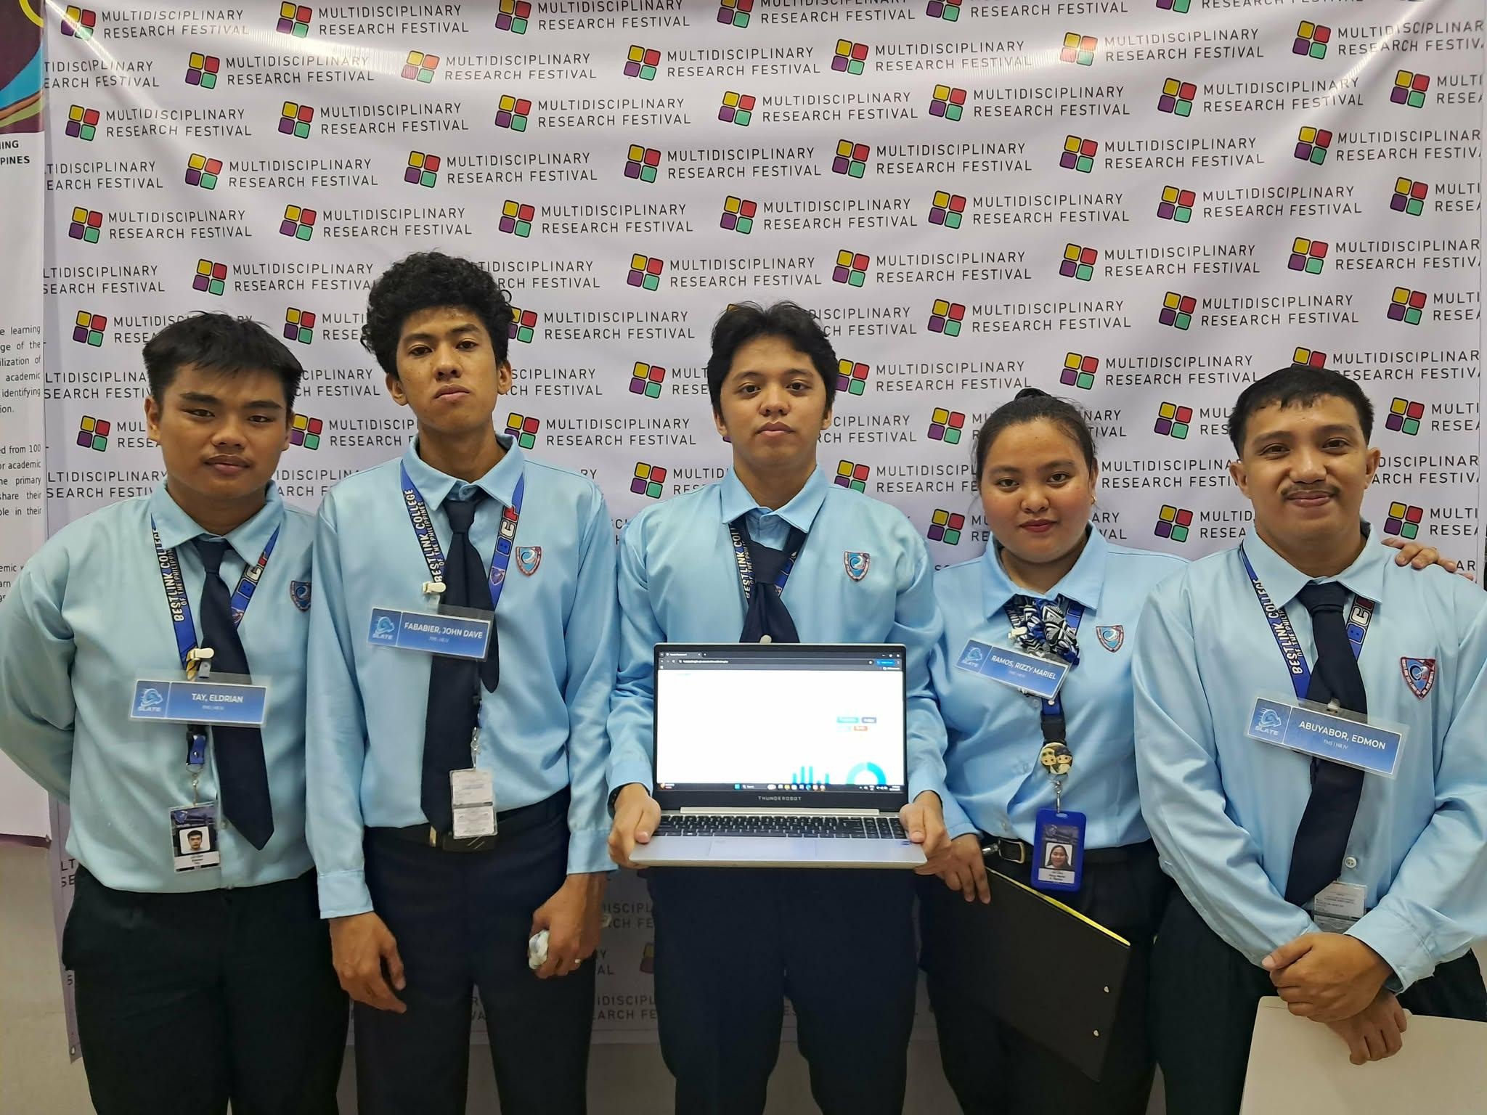

- Pilot Companies’ Background with proofs of interviews
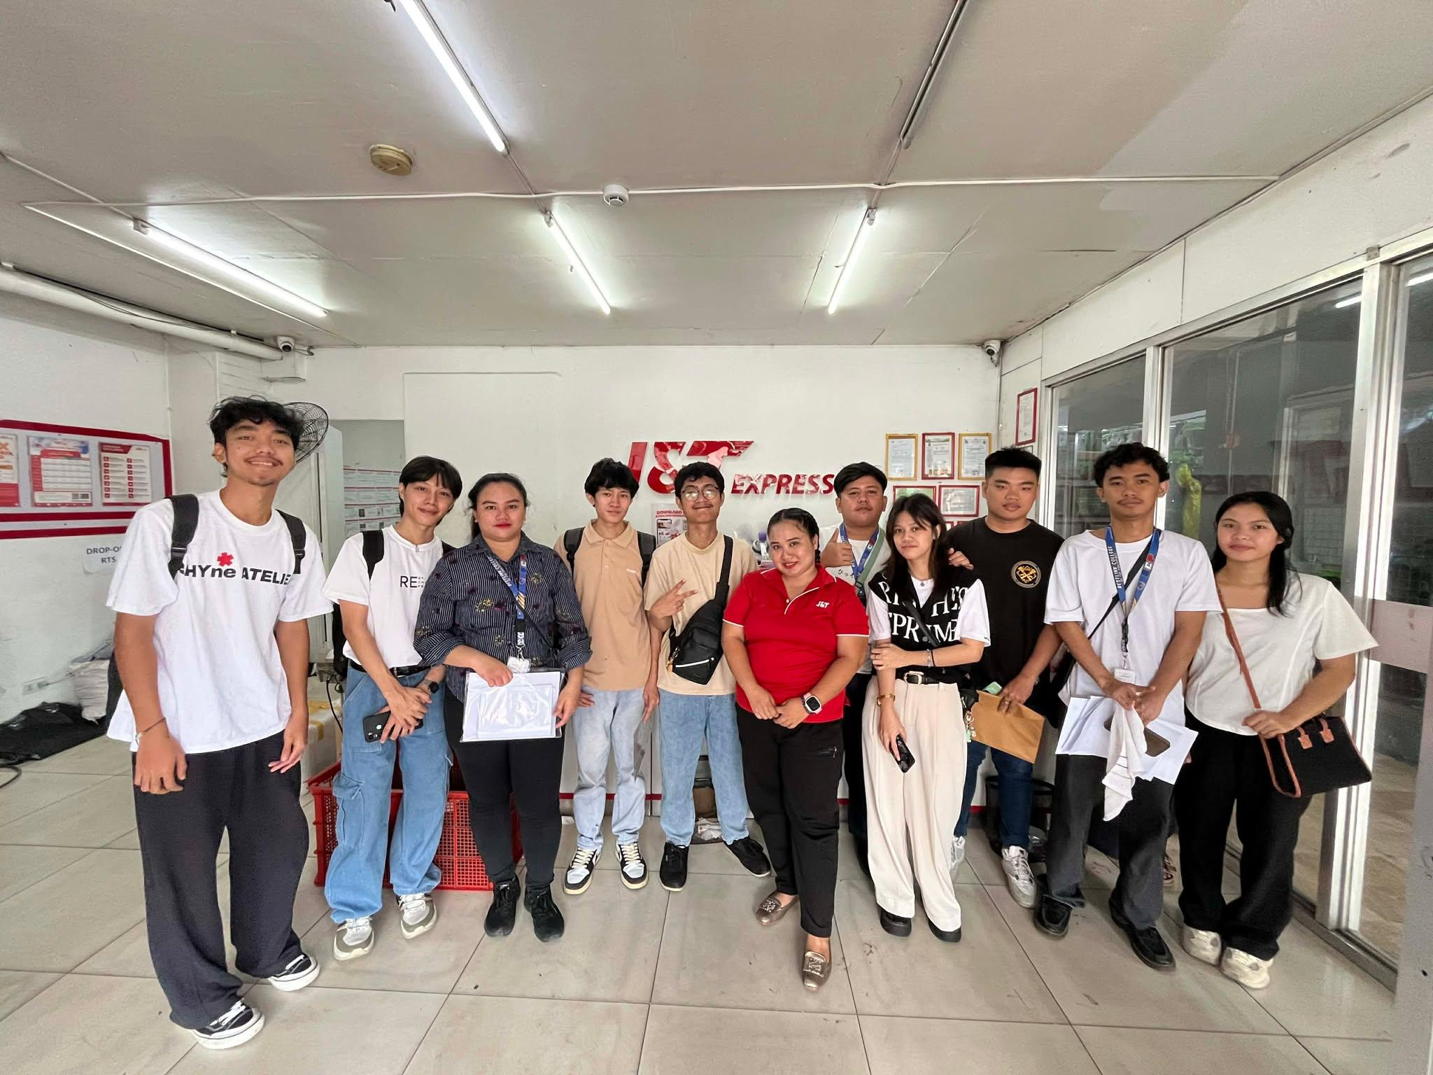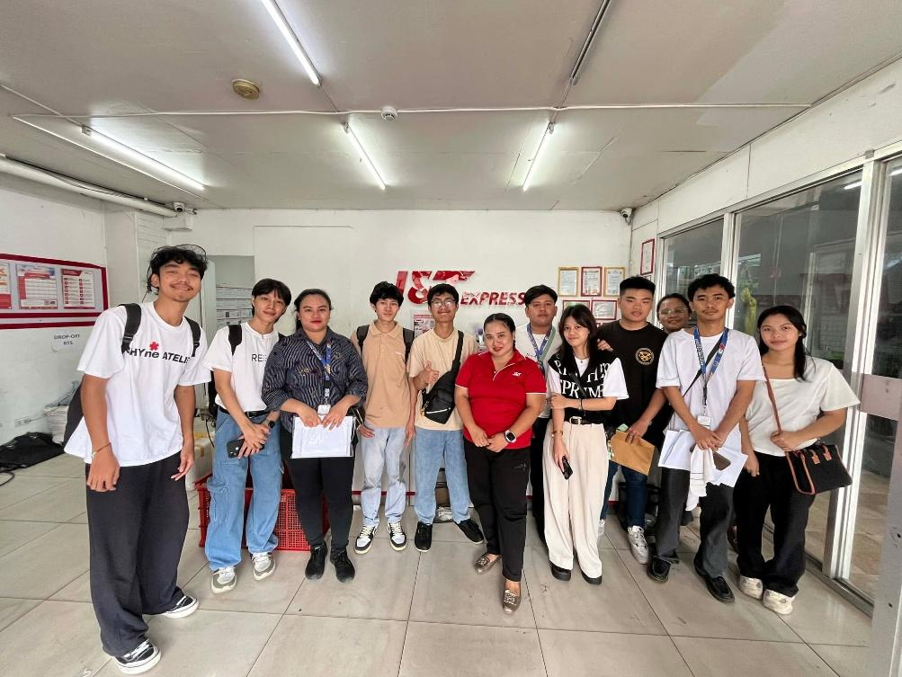
5. Link to codes (good for 3 years)
https://github.com/jamesariess/Freight/tree/97ffe2e33c4e0a7290359f7307f41ac1d47541b8/HR4

6. Link to documentation (good for 3 years)

7. Link to demo video guide (good for 3 years
https://drive.google.com/drive/folders/1r8C1Q_NbBnUMwFpVzhbz0W08yEDEesEv?usp=sharing

Appendix C: Certificate of Originality


Appendix D: Certificate of Grammarian

Bestlink College of the Philippines
College of Computer Studies
1071 Brgy, Kaligayahan, Quirino Highway, Novaliches, Quezon City

1 | Peros Jonathan M | 4 | Ramos Mariel
2 | Tay Eldrian | 5 | Abuyabor Edmon
3 | Fababeir David John C. | 6
SLATE: FREIGHT MANAGEMENT HR IV SYSTEM WITH PREDICTIVE ATTRITION FOR HR ANALYTICS
DASHBOARD USING TENSORFLOW
 | Technical Adviser | Grammarian
Name | Mr. Ronald Roldan Jr | Ms. Eliza Joyce E. Valdez
Designation | IT Instructor | SHS-INSTRUCTOR
Work Place  Address | Topaz St. and Sapphire St. Millionaire Village, Novaliches, Quezon City | Topaz St. and Sapphire St. Millionaire Village, Novaliches, Quezon City
Academic/  Professional  Qualifications/  Membership | Bachelor of Science in Information Technology Major in Information Security | Bachelor of Secondary Education / English
Email Address | Ronaldroldan101@gmail.com | Ejoyce.valdez@gmail.com
Telephone | 09057669976 | 09052194582
Signature | I hereby confirm that I have undertaken to supervise the project mentioned above and I do certify that I am not a member of the Project Examination Board (PEC)
 | Date: | Date:

Appendix E : Grammarian Curriculum Vitae


Appendix F : Technical Adviser Curriculum Vitae

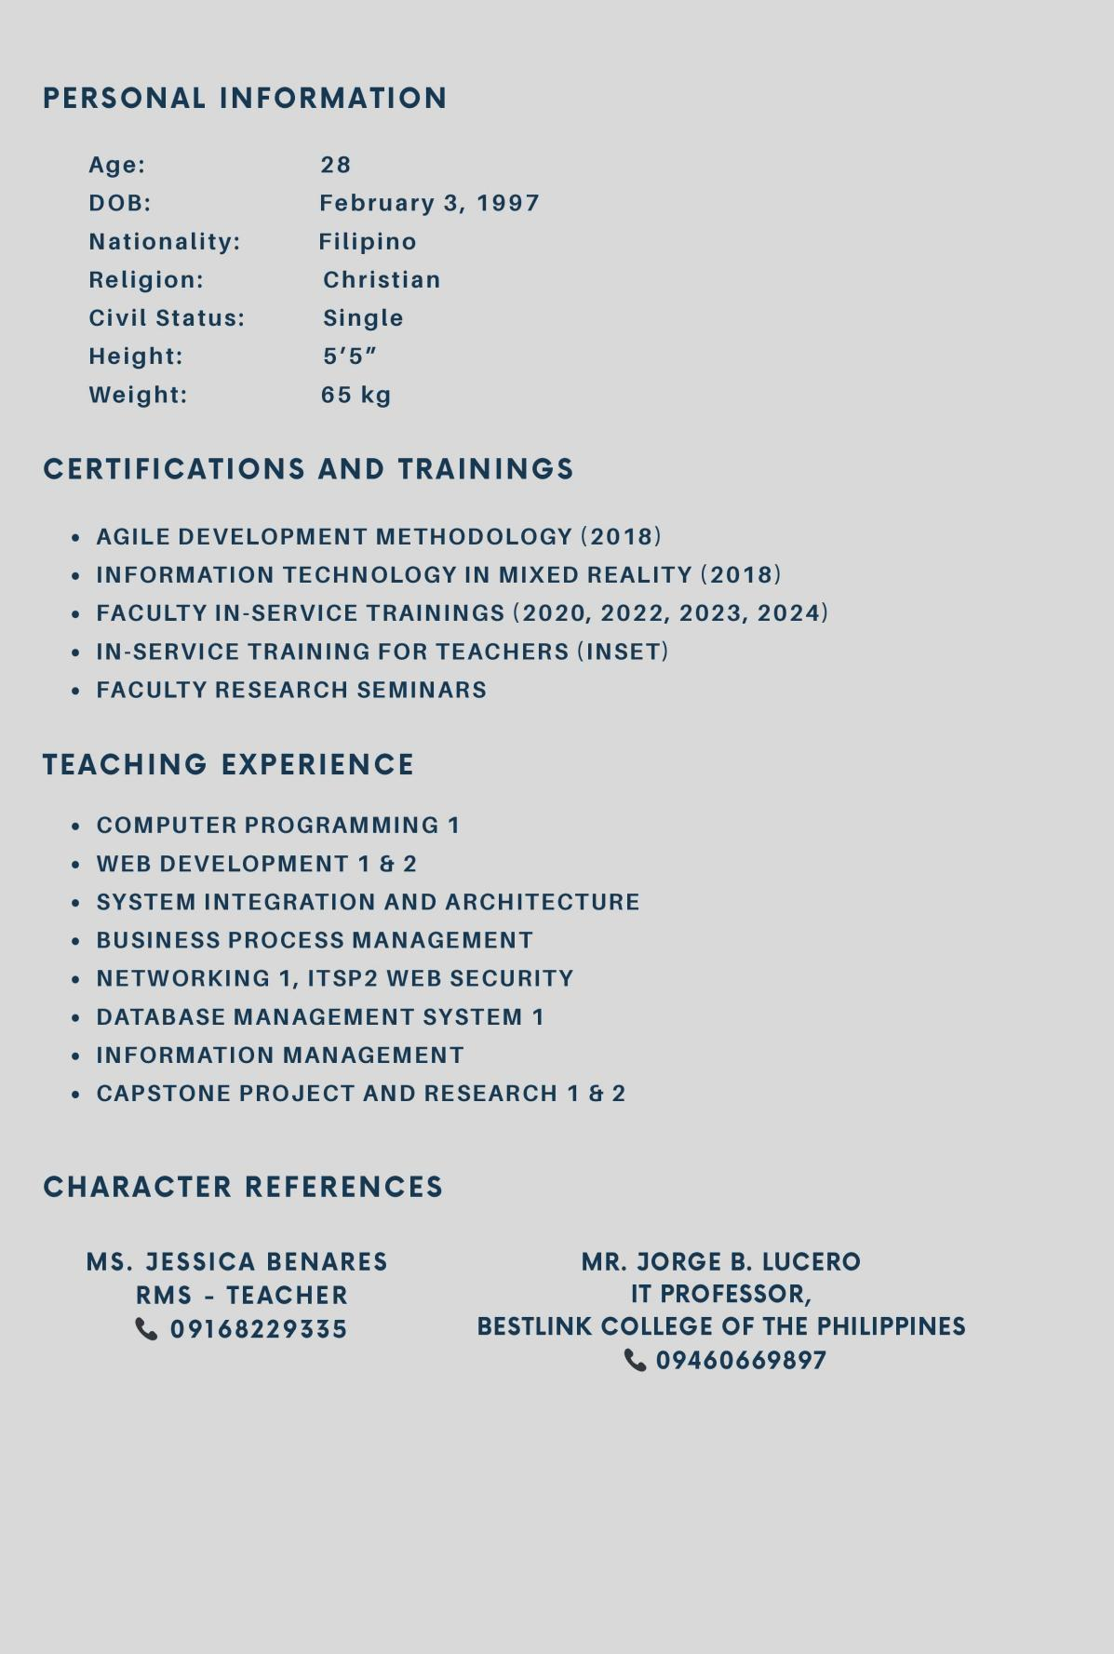
Appendix G: Research Adviser Curriculum Vitae


Appendix H: Researcher’s Curriculum Vitae
