BOARDERBASE: BOARDING HOUSE LEASE MANAGEMENT
DATABASE APPLICATION

A Database Design and Application Project
presented to the Faculty of the
College of Computer Studies

In Partial Fulfillment of the Requirements in
CCS 5 (Fundamentals of Information Management)
for the Degree Bachelor of Science in Computer Science

FRANZYL BJORN L. MACALUA

MARCH 2026
Table Of Contents

I. Introduction ------------------------------------------------------------------------------------ | 1
- Project Description ---------------------------------------------------------------------- | 1
- Modules and Features in the Project ----------------------------------------------- | 1
II. Database Design ---------------------------------------------------------------------------- | 2
- Business Rules -------------------------------------------------------------------------- | 2
- Conceptual Design ---------------------------------------------------------------------- | 3
- Logical Database Design -------------------------------------------------------------- | 4
- Data Dictionary -------------------------------------------------------------------------- | 7
III. Application Screenshots ----------------------------------------------------------------- | 19
- Dashboard -------------------------------------------------------------------------------- | 19
- Border Maintenance -------------------------------------------------------------------- | 20
- Room Maintenance --------------------------------------------------------------------- | 21
- Utility Maintenance ---------------------------------------------------------------------- | 22
- Facility Maintenance -------------------------------------------------------------------- | 23
- Resident Log ----------------------------------------------------------------------------- | 24
- Facility Complaints and Requests -------------------------------------------------- | 25
- Utilities Payment ------------------------------------------------------------------------- | 26
- Rental Payment -------------------------------------------------------------------------- | 27
- Rental Termination ---------------------------------------------------------------------- | 28

List of Figures

Fig. 1 Conceptual Database Design ERD / EERD --------------------------------------- | 3
Fig. 2 Dashboard with table viewer and basic statistics -------------------------------- | 19
Fig. 3 Boarder Maintenance Form Interface ----------------------------------------------- | 20
Fig. 4 Room Maintenance Form Interface ------------------------------------------------- | 21
Fig. 5 Utility Maintenance Form Interface -------------------------------------------------- | 22
Fig. 6 Facility Maintenance Form Interface ------------------------------------------------ | 23
Fig. 7 Resident Log Form Interface ---------------------------------------------------------- | 24
Fig. 8 Facility Complaints and Requests Form Interface ------------------------------- | 25
Fig. 9 Utility Payment Form Interface ------------------------------------------------------- | 26
Fig. 10 Rental Payment Form Interface ---------------------------------------------------- | 27
Fig. 11 Rental Termination Form Interface ------------------------------------------------- | 28

Introduction

Project Description
This project is an all-in-one boarding house lease management app, allowing landlords to manage boarder, room, utility, facility and financial information. It effectively stores all of these interconnected information in one database that can easily be modified and viewed. It focuses on information storage to make management and retrieval of renter and asset information simple. It is powered my MariaDB and made in Visual Basic.

Modules and Features in the Project.
The home module serves as a dashboard that allows the user to load all their current database information, showing tables for all the entities that they need to view. There are maintenance modules for the following items: Boarders, Rooms, Utilities and Facilities. These maintenance modules allow the user to add instances for each type of entity and to be able to update and delete them via table selection, typing, or selecting options. There are transaction modules which are for the following: Utility Payment, Facility Request and Complaint’s, Rent Payments and Termination. These modules make it easy to select information from existing information and be able to record any financial information that involves these information.

Database Design

Business Rules
These are the following business rules and constraints:
One BOARDER occupies One ROOM.
One ROOM is occupied by one or many BOARDER.
One ROOM includes one or many FACILITY.
One FACILITY is included in one ROOM.
One BOARDER can request maintenance on one or many FACILITY in one ROOM.
One FACILITY can be requested maintenance by one or many BOARDER in one ROOM.
One ROOM can be request maintenance for one or many FACILITY for one or many BOARDER.
One FACILITY is covered in one or many FACILITY_REQUEST.
One FACILITY REQUEST can cover one FACILITY.
One BOARDER is recorded in one RESIDENT_LOG.
One RESIDENT_LOG records one or many BOARDERS.
One BOARDER pays for one RENTAL_TERMINATION.
One RENTAL_TERMINATION is paid by One BOARDER.
One BOARDER pays for one or many RENTAL_PAYMENT.
One RENTAL_PAYMENT is paid for by one BOARDER.

Conceptual Design
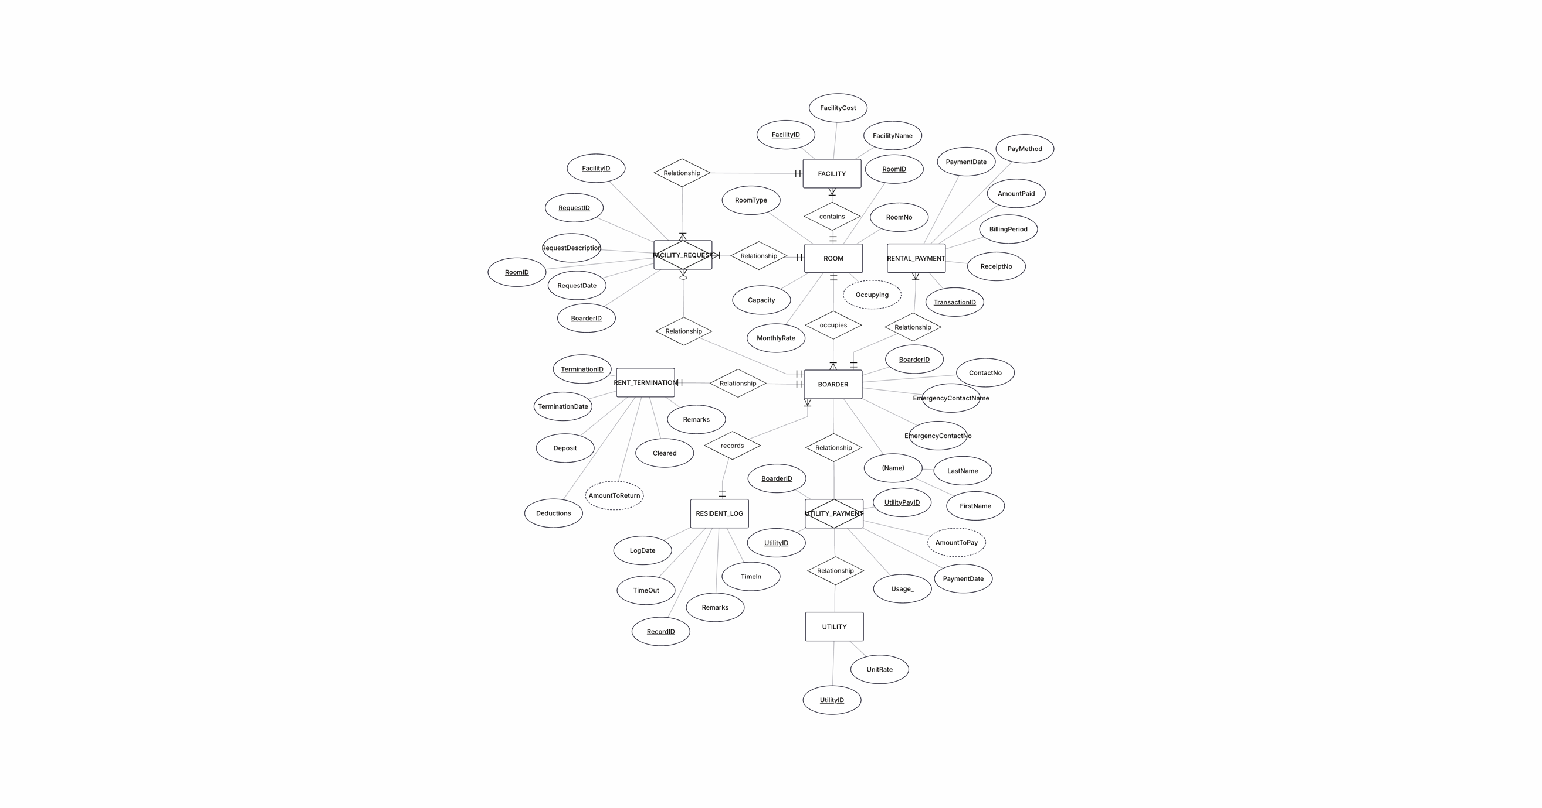
Fig. 1 Conceptual Database Design ERD / EERD

Logical Database Design
BOARDER
BoarderID (PK) | FirstName | LastName | ContactNo | EmergencyContactName | EmergencyContactNo | RoomID (FK)
1001 | John Paul | Casiwan | 09678939123 | Miguel Jumawan | 0977877563 | 501
1002 | Jordan | Steinberg | 09459302934 | Kendrick Yamamoto | 0933864283 | 502
1003 | Charleston | Winfrey | 09568744543 | Javier Cruz | 0956959503 | 503

ROOM
RoomID (PK) | RoomNo | RoomType | MonthlyRate | Capacity | Occupying
501 | 4 | Single | 6000 | 1 | 1
502 | 5 | Loft | 5200 | 2 | 1
503 | 6 | Shared | 5000 | 3 | 1

RESIDENT_LOG
RecordID (PK) | LogDate | TimeIn | TimeOut | Remarks | BoarderID (FK)
10005 | 5/23/2026 | 5:30:00 | 10:32:00 | Buying Food | 1001
10006 | 5/24/2026 | 5:40:00 | 10:50:00 | Going to school | 1002
10007 | 5/25/2026 | 5:42:00 | 11:02:00 | Drinking | 1003

FACILITY
FacilityID (PK) | FacilityName | FacilityCost | RoomID (FK)
8001 | Faucet | 200 | 501
8002 | Refrigerator | 18000 | 502
8003 | AC Unit | 30000 | 503

FACILITY_REQUEST
RequestID (PK) | FacilityID (FK) | FR_BoarderID (FK) | RequestDate | RequestDescription
1102 | 8001 | 1001 | 3/13/2026 | Pls Fix Faucet
1103 | 8002 | 1002 | 4/12/2026 | Fridge isn’t cold
1104 | 8003 | 1003 | 2/28/2026 | AC needs cleaning

UTILITY
UtilityID (PK) | UtilityName | UnitRate
2211 | Water | 61
2212 | Electricity | 13.82
2213 | LPG | 40

UTILITY_PAYMENT
UtilityPayID (PK) | UtilityID | UP_BoarderID | PaymentDate | Usage_
1001 | 2211 | 1001 | 1/1/2026 | 3
1002 | 2212 | 1002 | 1/3/2026 | 24
1003 | 2213 | 1003 | 3/2/2026 | 26

RENTAL_PAYMENT
TransactionID (PK) | AmountPaid | BillingPeriod | ReceiptNo | PayMethod | PaymentDate | RP_BoarderID (FK)
50210 | 6000 | 2026-01 | OR3003 | GCash | 1/23/2026 | 1001
50211 | 5200 | 2026-02 | OR3004 | Cash | 2/10/2026 | 1002
50212 | 5000 | 2026-02 | OR3005 | Bank Transfer | 2/12/2026 | 1003

RENT_TERMINATION
TerminationID (PK) | TerminationDate | Deposit | Deductions | Cleared | Remarks | RT_BoarderID (FK)
6412 | 1/25/2027 | 10000 | 2000 | True |  | 1001
6413 | 3/12/2027 | 5000 | 1000 | True |  | 1002
6414 | 2/15/2027 | 7500 | 3500 | False | Follow up about his repair fine | 1003

Data Dictionary
TABLE  NAME | ATTRIBUTE NAME | CONTENTS | TYPE | FORMAT | RANGE | REQUIRED | PK  or  FK | VALID VALUES | DEFAULT VALUE | FK  REFERENCED  TABLE
BOARDER | BoarderID | Boarder identification | INTEGER | #### | 1000-9999 | Y | PK
 | FirstName | Boarder’s First Name | VARCHAR(15) | A(15) | NA | Y
 | LastName | Boarder’s Last Name | VARCHAR(15 | A(15) | NA | Y
 | ContactNo | Cellphone or Telephone number | CHAR(11) | X(11) | NA | Y
 | EmergencyContactName | Immediate friends or family for emergency | VARCHAR(30) | A(30) | NA | Y
 | EmergencyContactNo | Contact in case of emergency | CHAR(11) | X(11) | NA | Y
 | RoomID | Occupied room | INTEGER | ### | 100-999 | Y | FK |  |  | ROOM
ROOM | RoomID | Occupied room | INTEGER | ### | 100-999 | Y | PK
 | RoomNo | Room’s number as indicated in the building | INTEGER | ## | 1-99
 | RoomType | Describes the size and style of the room | VARCHAR(15) | A(15) | NA | Y |  | ‘Single Room’, ‘Double Room’, ‘Loft’, ‘Shared Room’, ‘Dormitory’’
 | MonthlyRate | Lease Rate | NUMBER(8,2) | ########.## | 0.00-9999999.99 | Y
 | Capacity | Allowed number of renters | INTEGER | ## | 1-10 | Y
 | Occupying | Currently staying in the room. Calculated by getting the count of all boarders in that roomID | INTEGER | ## | 0-10 | Y |  |  | 0
RESIDENT_LOG | RecordID | Identifier for Log instance | INTEGER | ##### | 10000-99999 | Y | PK
 | LogDate | Date recorded | DATE | MM/DD/YYYY | NA | Y
 | TimeIn | Entering the building at this time | TIME | HH:MM:SS | NA | Y
 | TimeOut | Exiting the building at this time | TIME | HH:MM:SS | NA | Y
 | Remarks | Comments or details | VARCHAR(100) | X(100) | NA | N
 | BoarderID | Boarder identification | INTEGER | #### | 1000-9999 | Y | FK |  |  | BOARDER
FACILITY | FacilityID | Facility identifier | INTEGER | #### | 1000-9999 | Y
 | FacilityName | Name of facility | VARCHAR(15) | A(15) | NA | Y
 | FacilityCost | Cost of the unit | NUMBER(8,2) | ########.## | 0.00-9999999.99 | Y
 | RoomID | Occupied room | INTEGER | ### | 100-999 | Y | FK |  |  | ROOM
FACILITY_REQUEST | RequestID | Identifier for a complaint / request | INTEGER | XXXX | 1000-9999 | Y | PK
 | FacilityID | Facility identifier | INTEGER | #### | 1000-9999 | Y | FK |  |  | FACILITY
 | FR_BoarderID | Boarder identification | INTEGER | #### | 1000-9999 | Y | FK |  |  | BOARDER
 | RequestDate | Recorded Date of Request | DATE | MM/DD/YYYY | NA | Y
 | RequestDescription | Description of complaint | VARCHAR(100) | X(100) | NA | Y
UTILITY | UtilityID | Identifier Utility | INTEGER | XXXX | 1000-9999 | Y | PK
 | UtilityName | Utility label / type | VARCHAR(15) | X(15) | NA | Y
 | UnitRate | Refers to the base unit of that utility as placed on the bill: e.g the unit of electricity is /kWh. | NUMBER(4,2) | ####.## | 0.00-9999.99 | Y
UTILITY_PAYMENT | UtilityPayID | Identifier for payment instance | INTEGER | XXXX | 1000-9999 | Y | PK
 | UtilityID | Identifier Utility | INTEGER | XXXX | 0-9999 | Y | FK |  |  | UTILITY
 | UP_BoarderID | Boarder identification | INTEGER | #### | 1000-9999 | Y | FK |  |  | BOARDER
 | PaymentDate | Day of transaction payment | DATE | MM/DD/YYYY | NA | Y
 | Usage_ | Usage of given utility based on bill information | NUMBER(5,2) | #####.## | 0.00-99999.99 | Y
 | AmountToPay | Usage multiplied by UnitRate from the given UtilityID | NUMBER(6,2) | ######.## | 0.00-999999.99 | Y
RENTAL_PAYMENT | TransactionID | Rental pay identifier | INTEGER | ##### | 10000-99999 | Y | PK
 | AmountPaid | Total Amount to pay including other additions if present. | NUMBER(8,2) | ########.## | 0.00-9999999.99 | Y
 | BillingPeriod | Month to be paid for | DATE | YYYY-MM | NA | Y
 | ReceiptNo | Receipt identifier for physician receipt | CHAR(6) | ORXXXX | NA | Y
 | PayMethod | Payment channel e.g. Gcash, Maya, etc. | VARCHAR(15) | A(15) | NA | Y |  | ‘Cash’,  ‘Bank’, ‘Transfer’,  ‘G-Cash’,  ‘Credit Card’,  ‘Debit Card’,  ‘Maya’,  ‘Other’ | ‘ ’
 | PaymentDate | Day of transaction payment | DATE | MM/DD/YYYY | NA | Y
 | RP_BoarderID | Boarder identification | INTEGER | #### | 1000-9999 | Y | FK |  |  | BOARDER
RENT_TERMINATION | TerminationID | Rent Termination Clearance identifier | INTEGER | XXXX | 1000-9999 | Y | PK
 | TerminationDate | Day of Lease cancellation | DATE | MM/DD/YYYY | NA | Y
 | Deposit | Amount deposited upon moving in | NUMBER(8,2) | ########.## | 0.00-9999999.99 | Y
 | Deductions | Deductions for specific damages that go beyond daily use or for unfulfilled financial obligations | NUMBER(8,2) | ########.## | 0.00-9999999.99 | Y
 | Cleared | Confirm clearance | BOOLEAN | L | NA | Y |  | ‘True’, ‘False’ | ‘False’
 | Remarks | Comments | VARCHAR(100) | X(100) | NA | N
 | RT_BoarderID | Boarder identification | INTEGER | #### | 1000-9999 | Y | FK |  |  | BOARDER

Application Screenshots

Dashboard
Accesses all tables but only for viewing: BOARDER, ROOM, UTILITY, FACILITY, RESIDENT_LOG, FACILITY_REQUEST, UTILITY_PAYMENT, RENTAL_PAYMENT, RENT_TERMINATION. View can be switched using the buttons on the left.
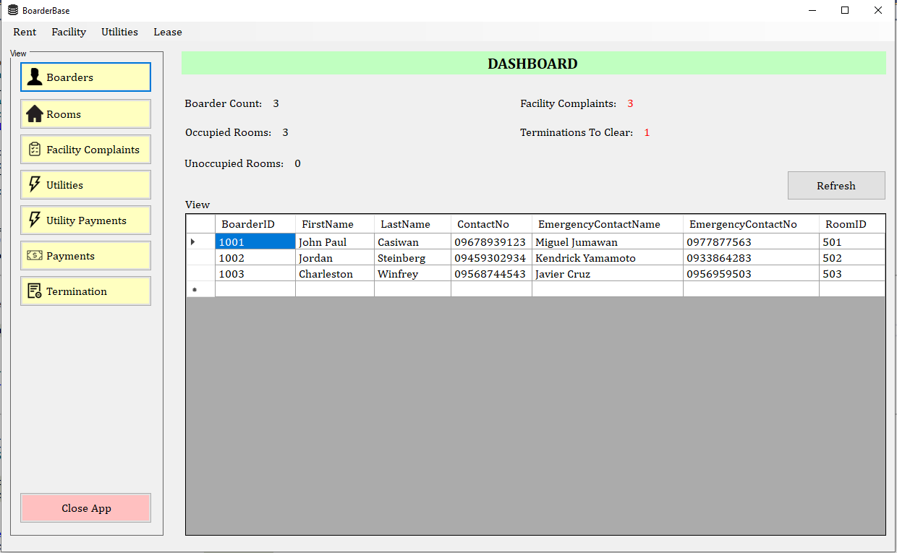
Fig. 2 Dashboard with table viewer and basic statistics

Boarder Maintenance
Accessed via the menu strip under ‘Rent’. It allows viewing, adding, updating, and deleting records from the BOARDER table but features a combo-box for the RoomID FK that automatically retrieves the option data from the RoomID column of the ROOM table. It can also search for an entry using the First or Last name.

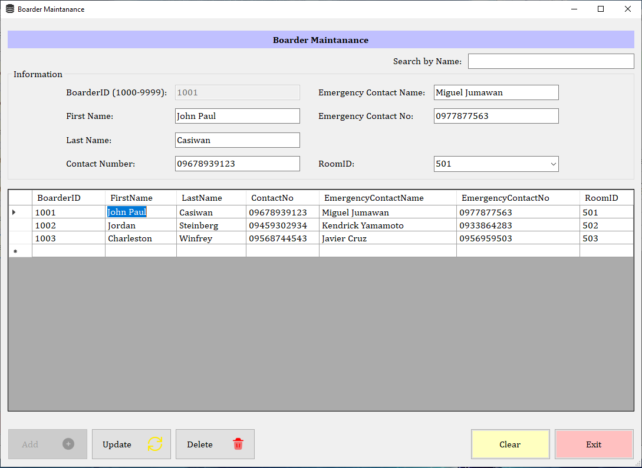
Fig. 3 Boarder Maintenance Form Interface

Room Maintenance
Accessed via the same submenu as Boarder Maintenance. It allows viewing, adding, updating, and deleting from the ROOM table. The occupying field is a derived value which is based off of the count of how many boarders are assigned to that very RoomID. It can also be filtered using the room number search bar or the room type combo-box.

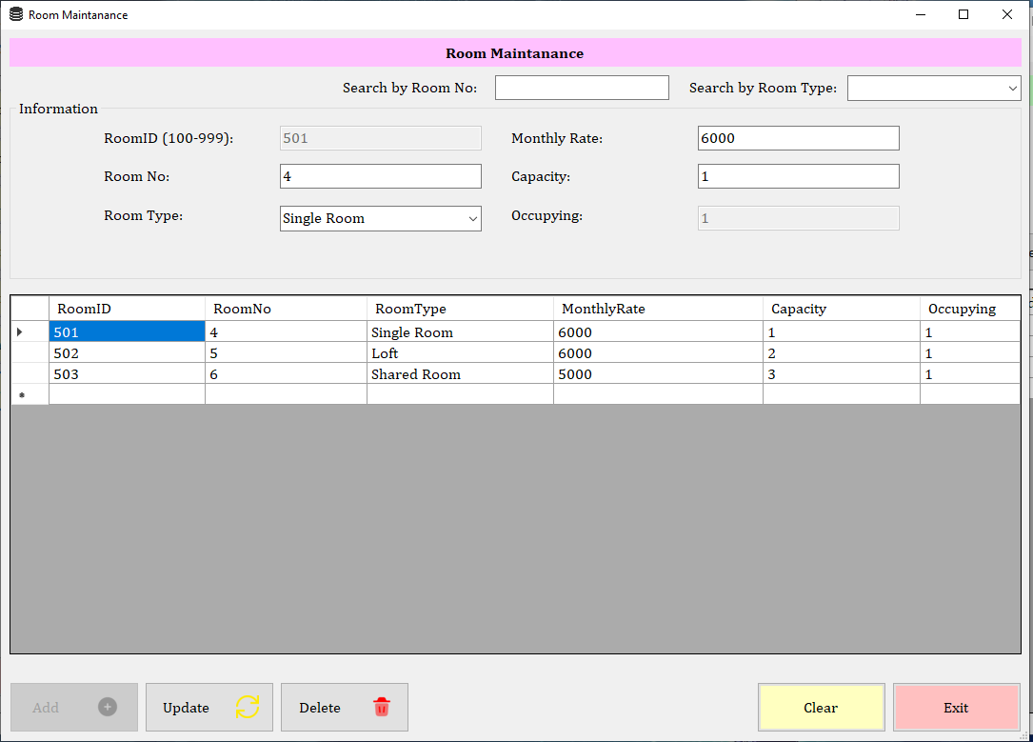
Fig. 4 Room Maintenance Form Interface

Utility Maintenance
This is accessed through the ‘Utility’ submenu. This allows viewing, adding, updating, and deleting from the UTILITY table. It can also search for an entry using it’s utility name.

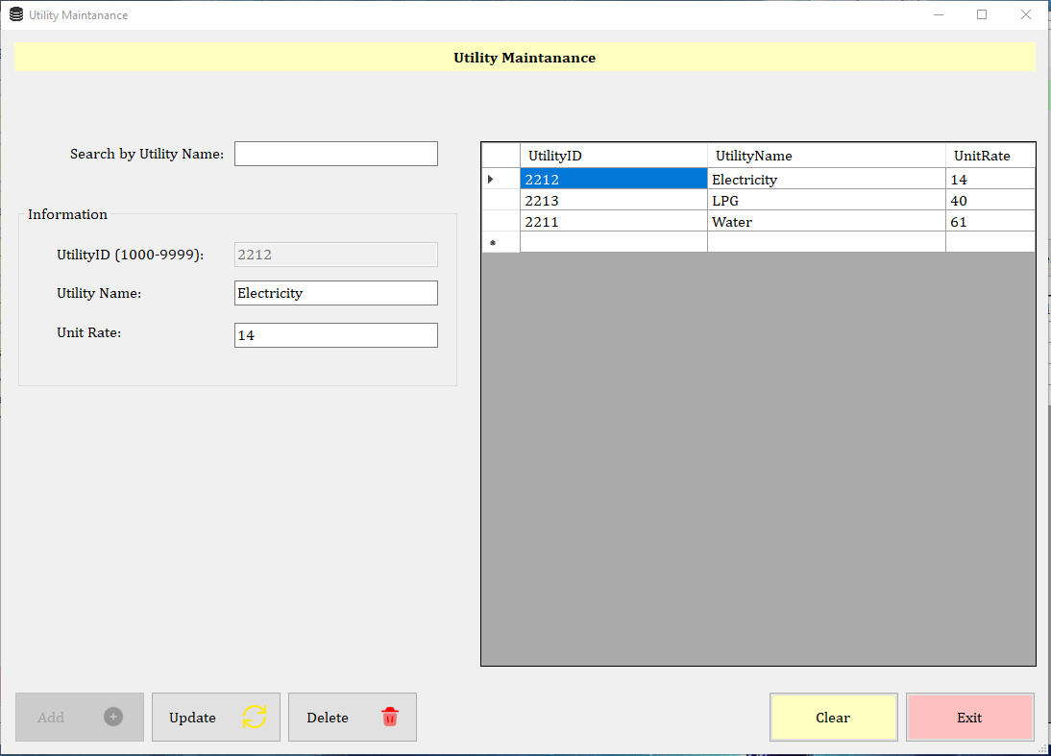
Fig. 5 Utility Maintenance Form Interface

Facility Maintenance
This can be accessed using the ‘Facility’ submenu. It allows viewing, adding, updating, and deleting of records from the FACILITY table. It also features a combo-box for the RoomID FK as well as a search bar using the facility name.

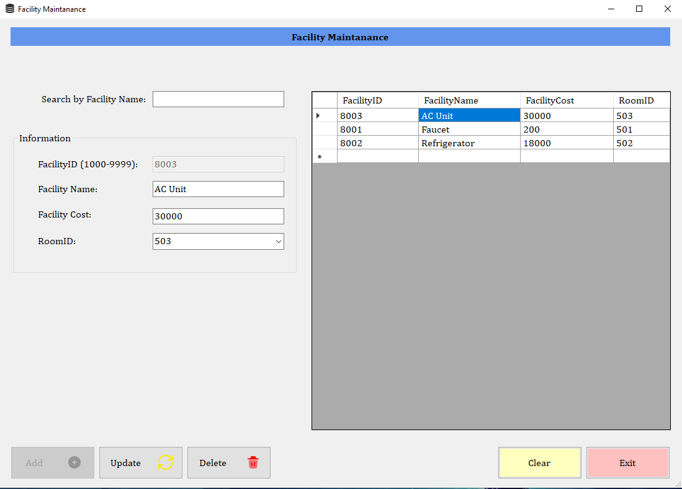
Fig. 6 Facility Maintenance Form Interface

Resident Log
This is accessed under ‘Rent’ in the menu strip. This form is for keeping track of boarders who go in and out of the boarding house. It allows viewing, adding, updating, and deleting the RESIDENT_LOG table and retrieves FK information from the BOARDER table. It features a selector for the boarder while showing their name and an optional remark textbox. The log date and time stamps are recorded using a calendar and time picker.

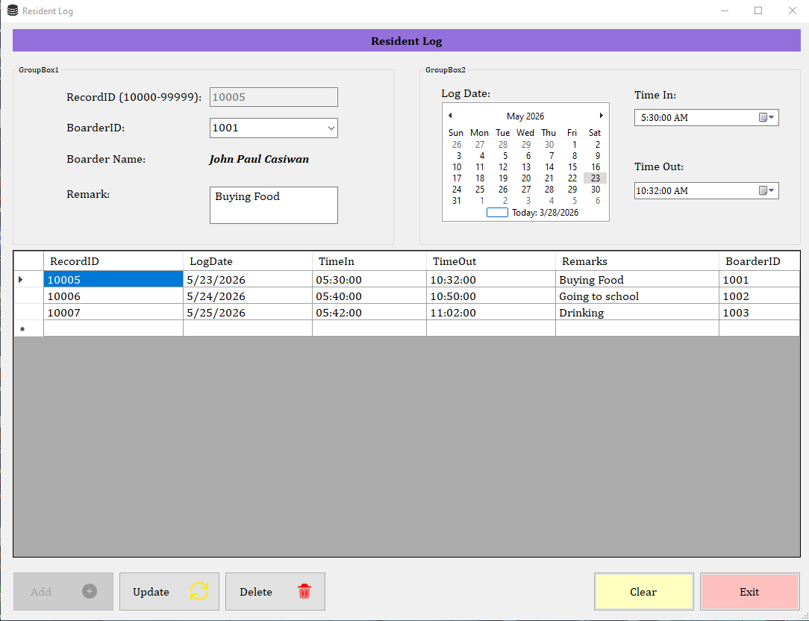
Fig. 7 Resident Log Form Interface

Facility Complaints and Requests
This is accessed through the ‘Facility’ submenu. This form is for those who would like to file a complaint about facilities. It allows viewing, adding, updating, and deleting of the FACILITY_REQUEST table as well as retrieve FK information from the FACILITY and BOARDER tables.

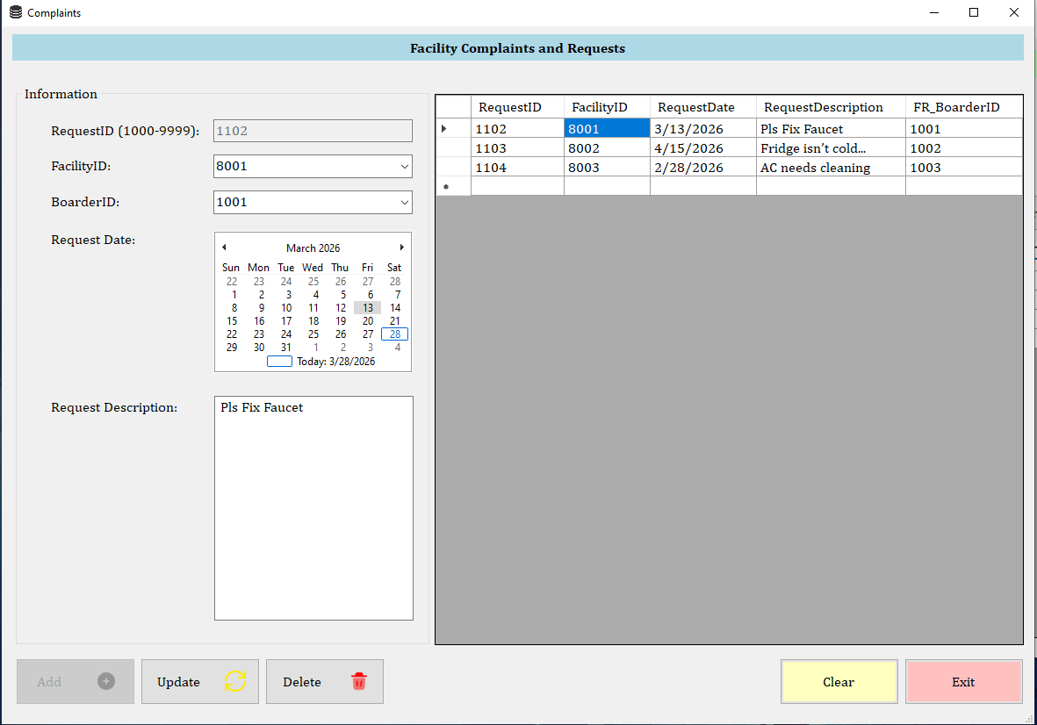
Fig. 8 Facility Complaints and Requests Form Interface

Utilities Payment
This form can also be accessed under the ‘Utility’ submenu. This allows viewing, adding, updating, and deleting from the UTILITY_PAYMENT table, as well as retrieve FK information from the BOARDER and UTILITY tables. The total amount is automatically calculated from the usage multiplied by the Unit Rate from the given Utility based on its UtilityID.

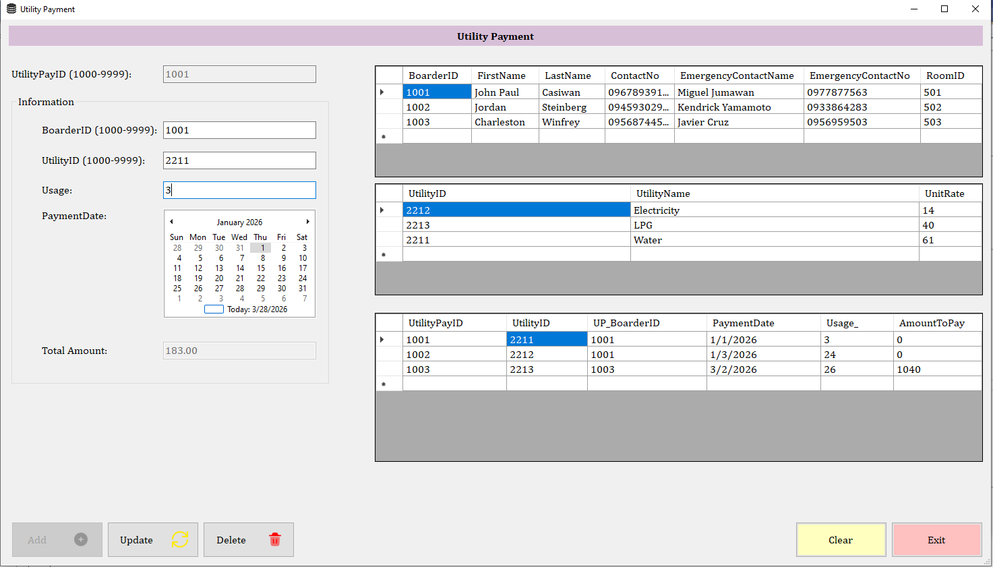
Fig. 9 Utility Payment Form Interface

Rental Payment
This is found under the ‘lease’ submenu. This form manages financial information on rental payment. It allows viewing, adding, updating, and deleting of information from the RENTAL_PAYMENT table. It also retrieves FK information from the BOARDER table.

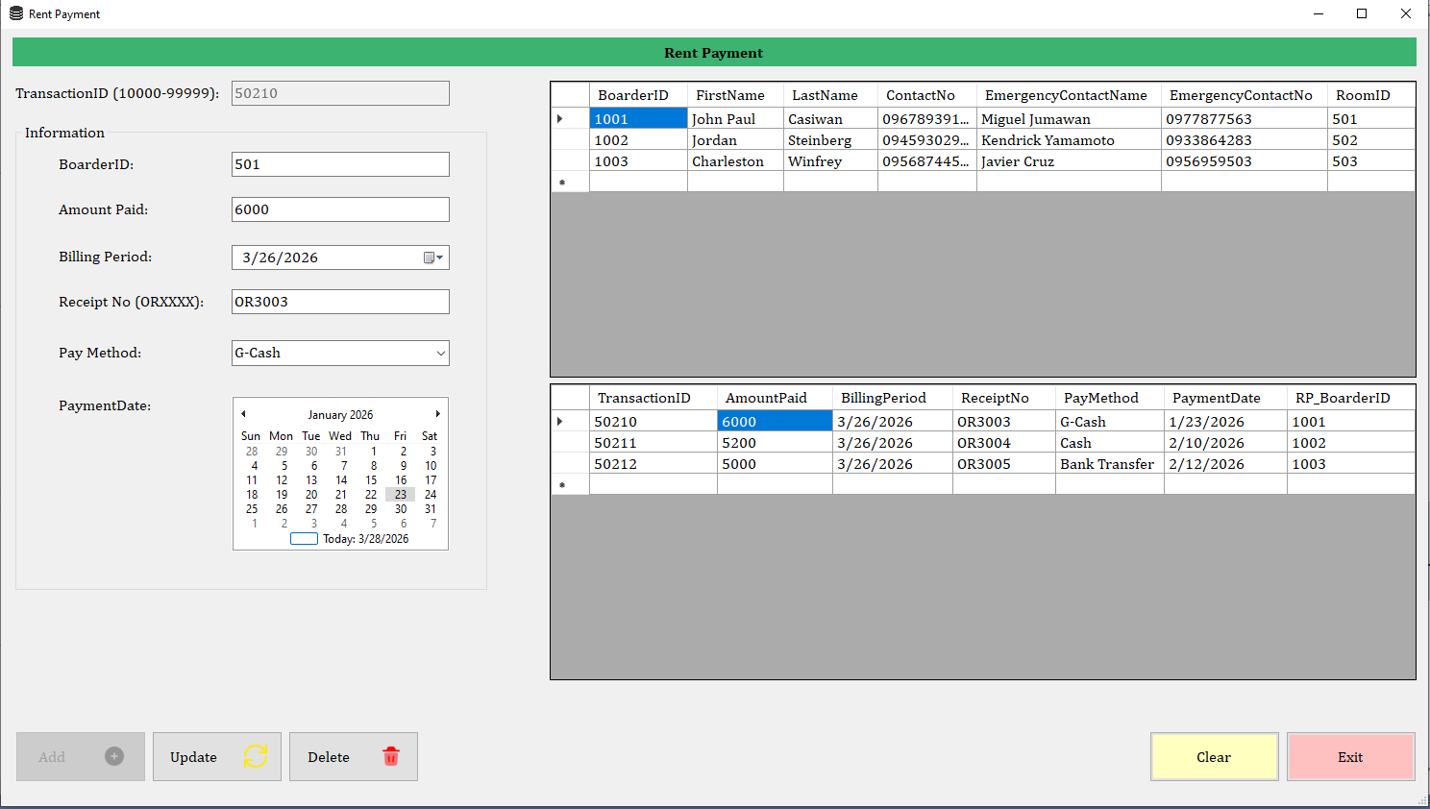
Fig. 10 Rental Payment Form Interface

Rental Termination
This is also found under the ‘lease’ submenu. This form manages information on a renter’s lease clearance. It allows viewing, adding, updating, and deleting information from the RENT_TERMINATION table as well as retrieve FK information from the BOARDER table.
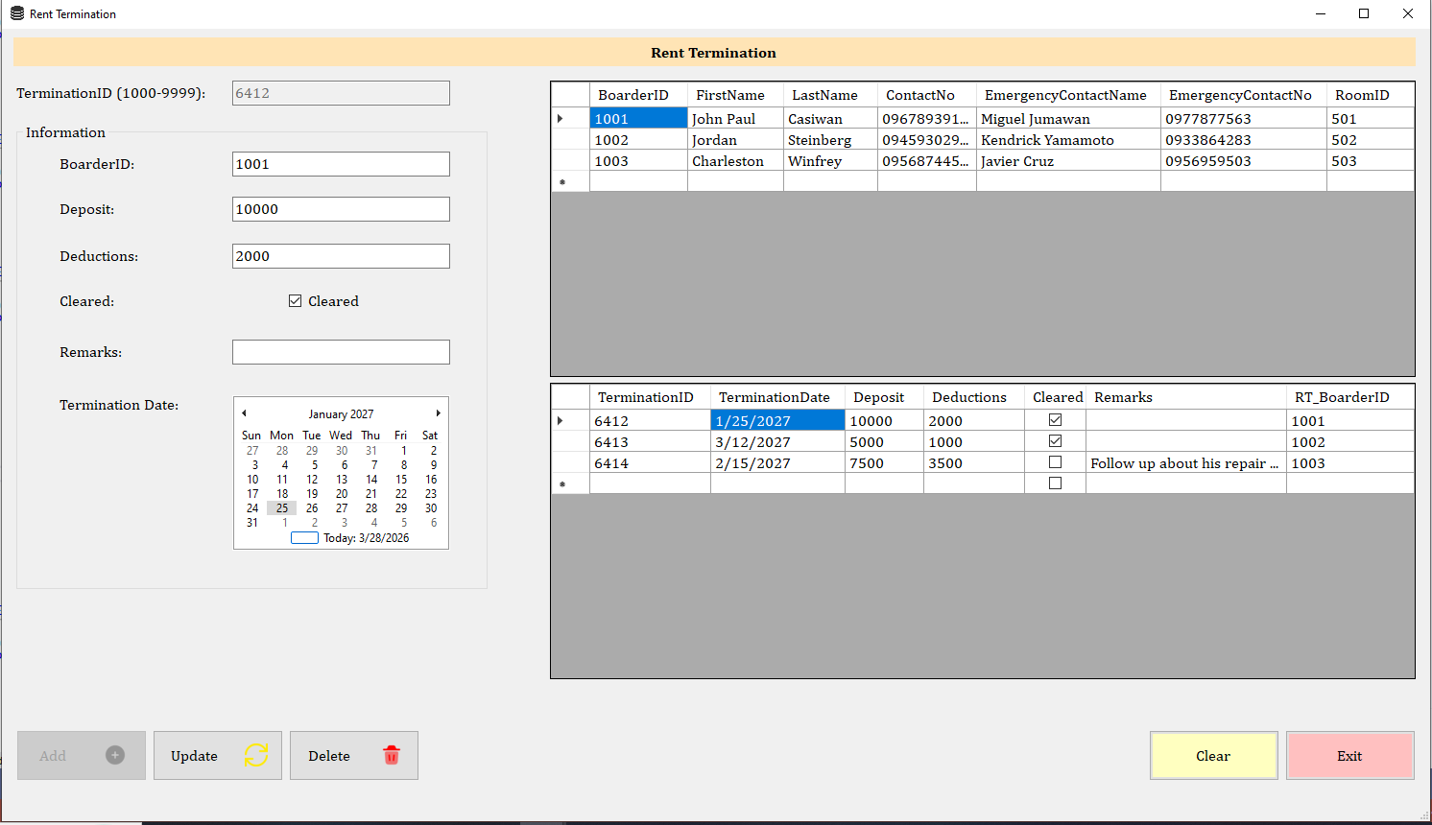
Fig. 11 Rental Termination Form Interface

