

**ADDIS ABABA UNIVERSITY**

**ADDIS ABABA INSTITUTE OF TECHNOLOGY**

**CENTER OF INFORMATION TECHNOLOGY AND SCIENTIFIC COMPUTING**

**BIG DATA ANALYSIS LAB ASSIGNMENT ONE**

**PREPARED BY:** -

Essey Bisrat ATR/3583/07

Fraol Kelbessa ATR/9007/08

Nathaniel Awoke ATR/6486/07

Big Data Analysis Assignment one

a) Design a simple database

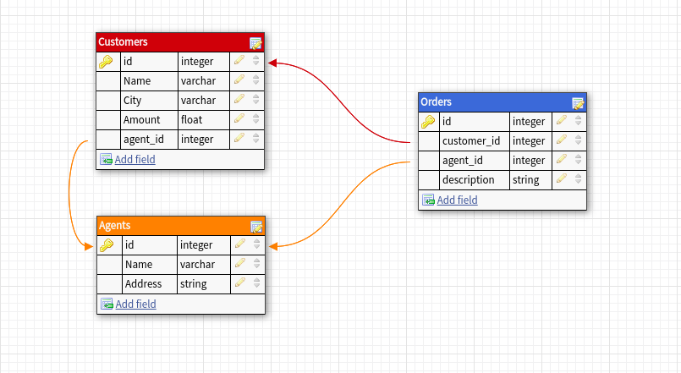

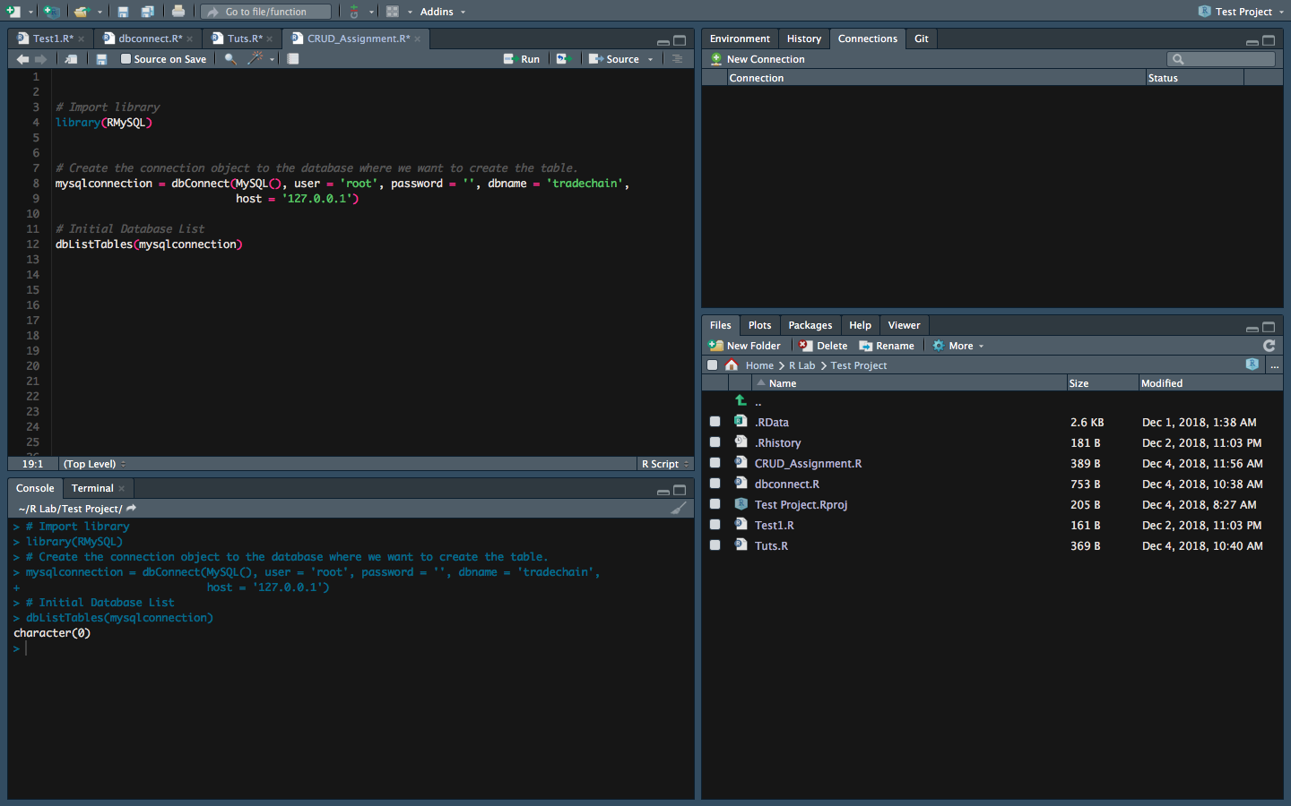

+

b) Create a table from R program: package used to connect to db is RmySQL.

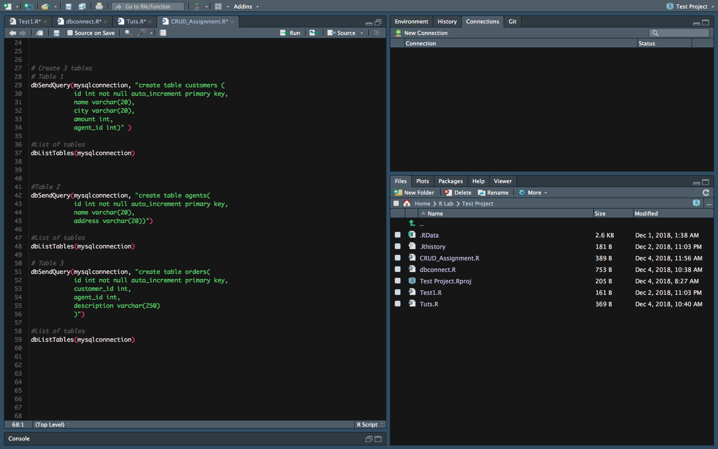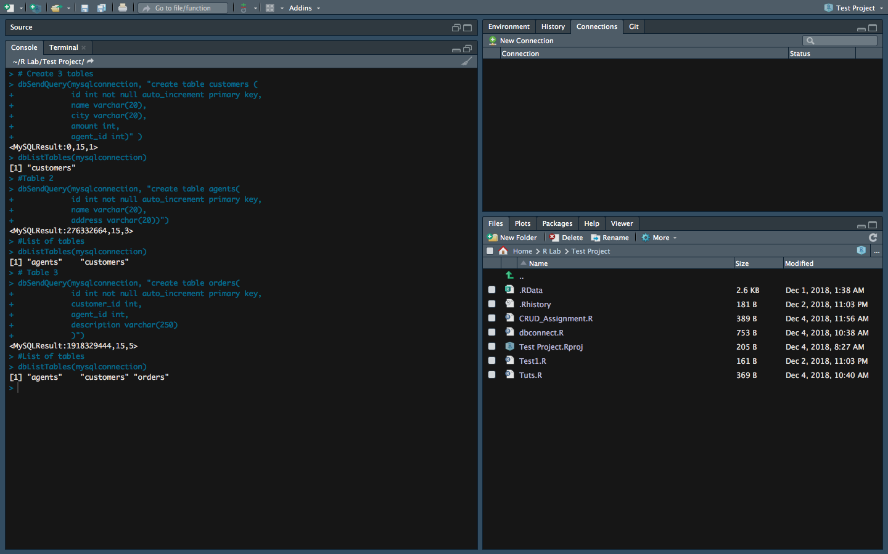

c) Demonstrate CRUD operation:

CREATE

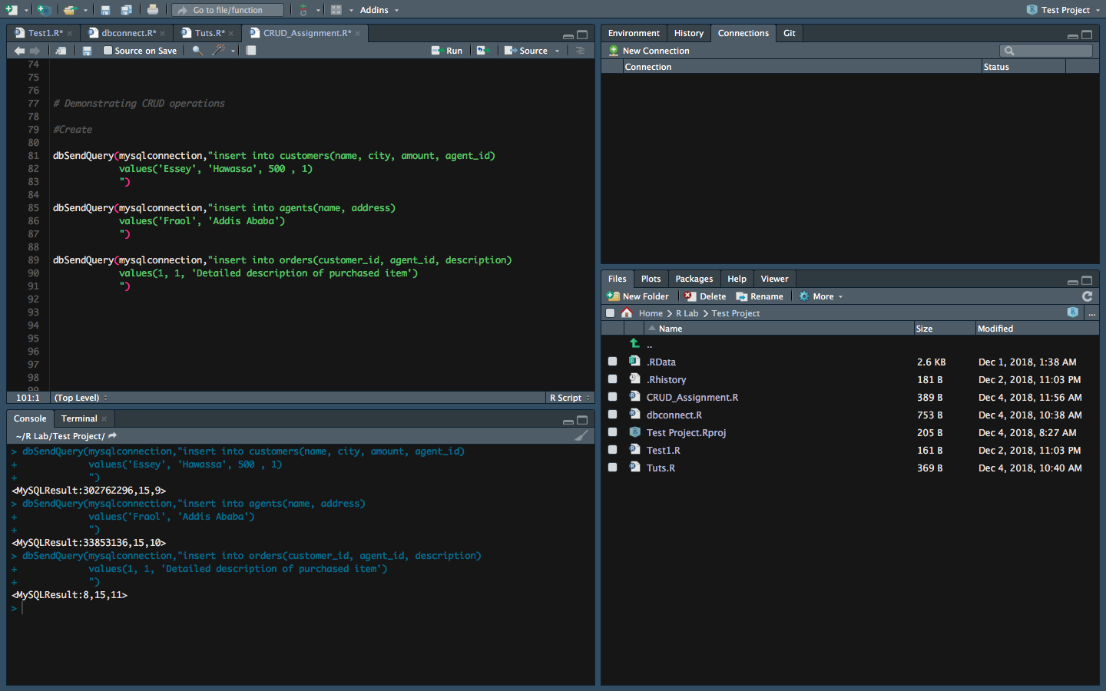READ

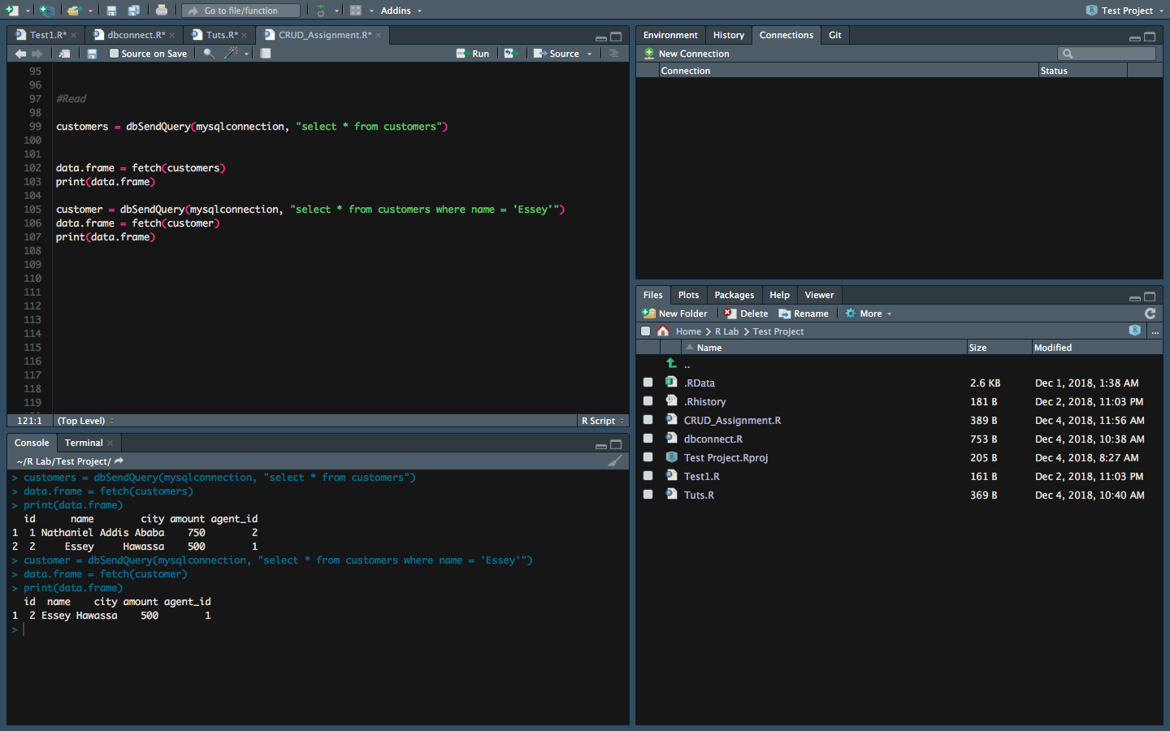

UPDATE

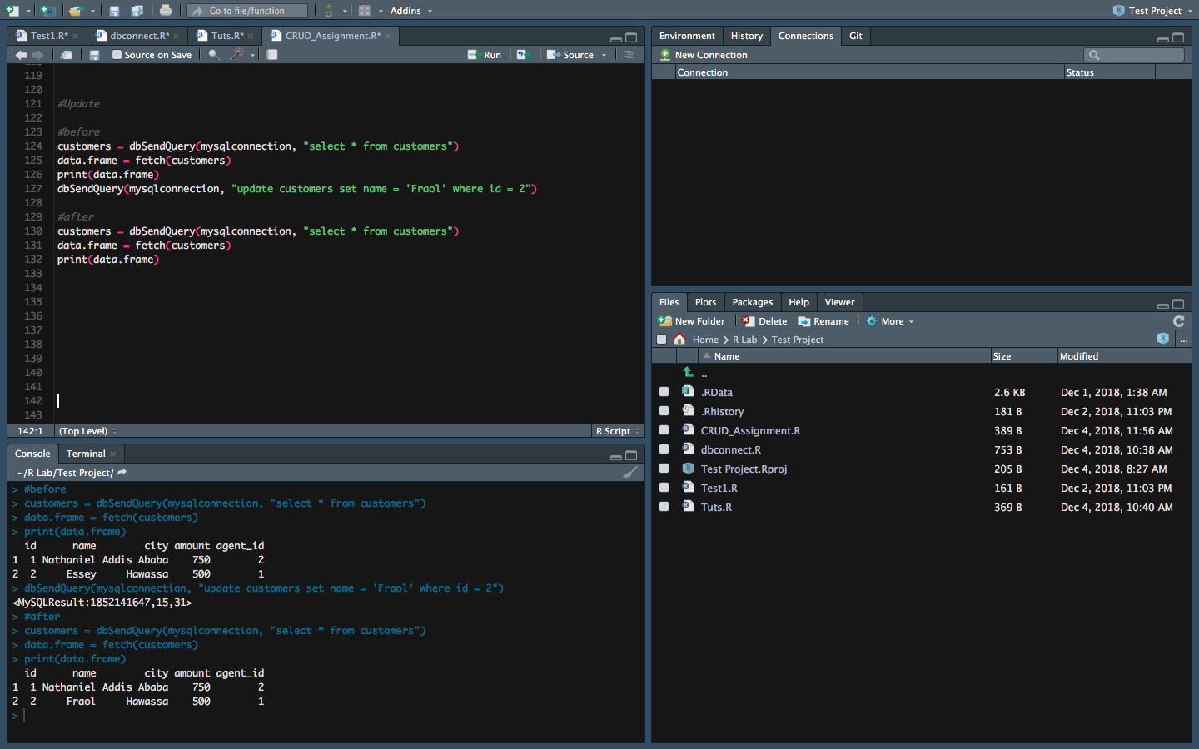DELETE

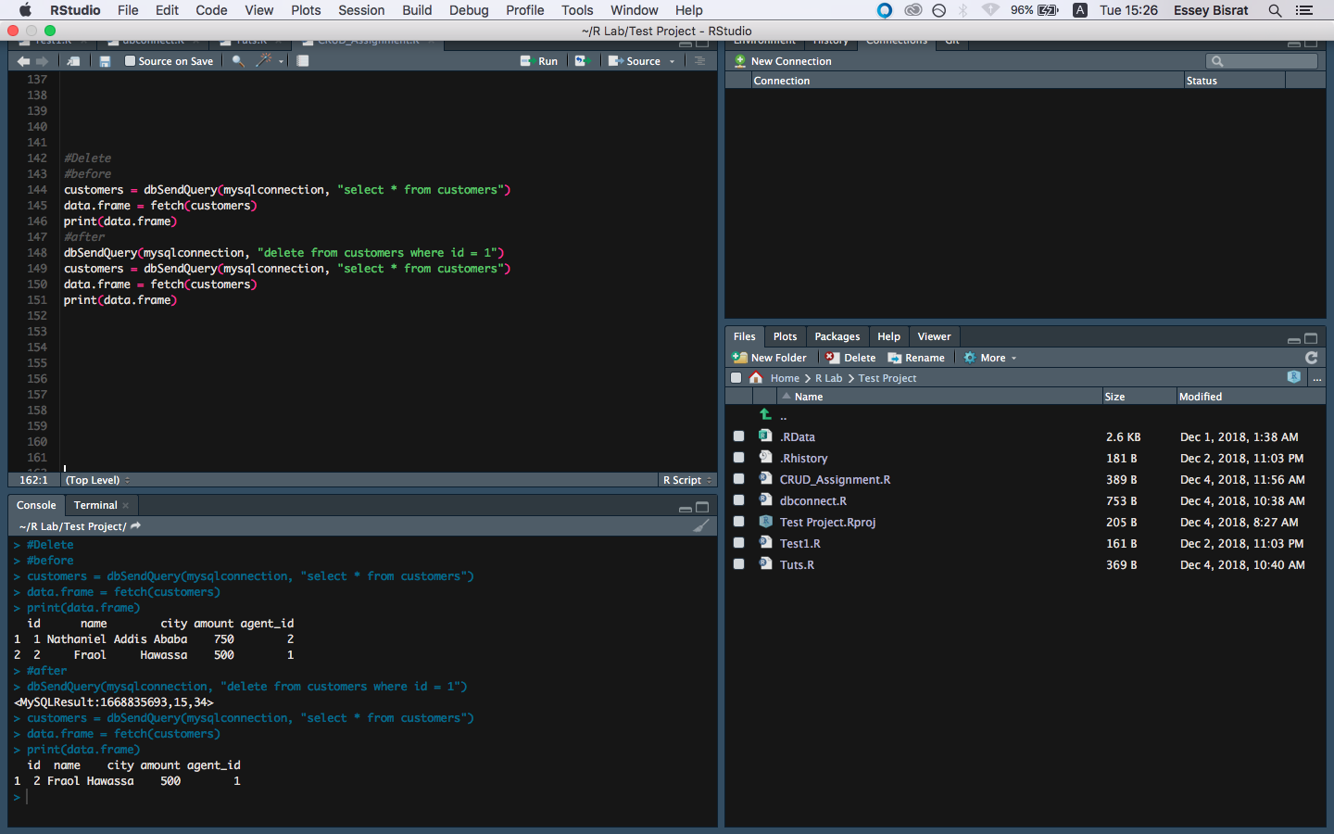

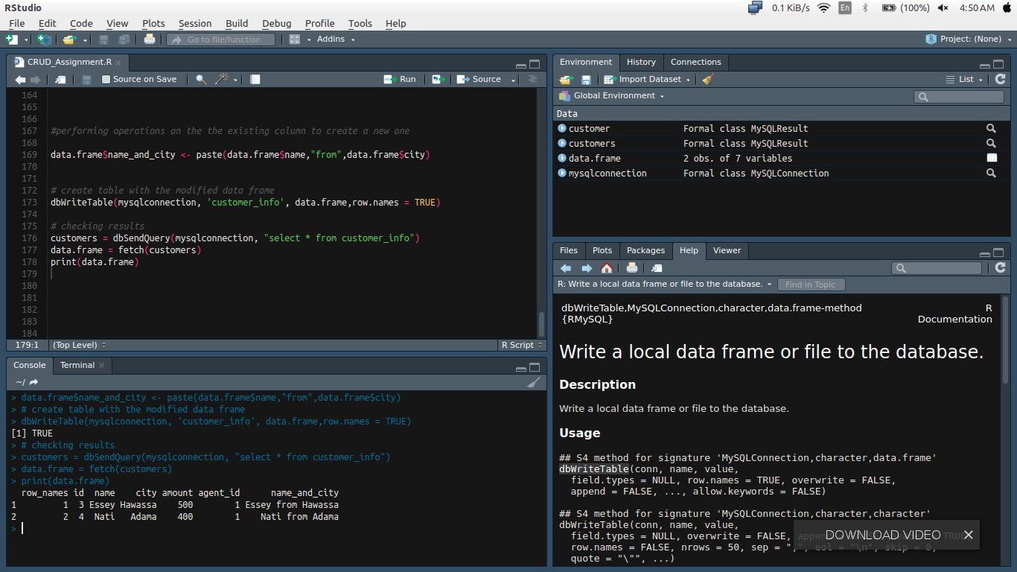d) Read rows from the database and add another column to it by performing some kind operations on the the existing column and either update or create a table and insert the data frames to the newly updated or created table