FRAPPER Software technology
Colin 1DV600

Assignment 3 – Reflection document

03/03/2017
I – Reflection about task 1

Time planned for this task : 4 hours.

Well, to have a better comprehension of what is useful to make a test plan, let's talk about the objective of a test plan, first came three “question” who should be the definition of a test plan ; why ? What ? And How ?
Why do we make test ? What should we test ? How should we test ?
I think those questions are the beginning of a test plan project, it permit to identify what is the objective of a test plan.
Writing a test plan project is very important and because it permit to avoid error in our code, and also it's a communication “tool” between you and your team, clearly the test plan should be realise by talking with other member of your team. Test plan serves as a guide to testing throughout the development. Like the project plan, it also permit to define the “goals” of your application, what sould be the output of this function, what should we do to make performance better in this special function. During implementation and because you writting test before any implementation, you can refer to this document and say “ok it should output this and not that”, also test plan should cover the mistake that a end-user can make.
But not only, one thing interesting is that it also avoid confusion between you and your client, once you have identify the test you are gonna implement or execute, you can discuss about those test with your client, so he can see the advancement of the project and some concrete implementation. And if he is agree with those tests, you can start making this test. I think you can have a meeting with your client after wrote the static testing process. After this meeting it's time to make the dynamic test process. Once this test are effectued and pass at 95% of them, and before the end of the project, you can make a quick presentation of your test to your client to show him that the application work as define in the requirement. This steps will instaure confidence between you and your client and this is the key.

Reflection on time log : Well i was pretty close from what I expected, the thing is that he took me long to understand how make a test plan, what I should include in this document.

II – Reflection about task 2

Time planned for this task : 2 hours.

What is useful to make test case ?

Well the last test scenario I made is the perfect example of what is useful, with a test case, you can (and should) cover all the possiblities of your function, and this is specially why it's interesting to make test before implement anything, here for my example when I made the test case for adding a book I realised that I didn't handle the case where the list is empty, and in this function I'm trying to reach the length to increase the id every time I added a book. And same for deleteBook, in the previous assignment, I didn't make test (at least not all of what I should test), and here I didn't make the test of delete all the list, now I realised that it's not working because when I'm reading the xml file I also use the length of the books in there to make a loop, but the length is undefined so it provide an error.
Test case is very powerful and as I said should cover all the possibilites of what the function can do. Beside you can refer it when you're implementing your function and saying to yourself “ok I must also handle this test, so is it better to implement the function like this or that”, anyway very interesting “tool”, honnestly.
Reflection on time log : I spent around 1 hour and half to make this test, around 45 minutes each test case. Maybe could spent a little bit more time on it, but didn't know what to add more.

III – Reflection about task 3

Time planned for this task : 4 hours.

I must say first that I was unable to make those test correct, I don't know why but there is something I don't understand, I implemented the function EditBookResource, and AddBookresource, and those methods work, I'm able to add or modify a book. But something I don't understand and if you can explain to me in the feedback (if you have time of course),

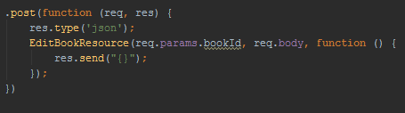
This is the API for the EditBookResource, but what I didn't understand is the last line
res.send(“{}”) . I mean how I'm suppose to expect something if everytime I run this method it will send an empty JSONObject. It shoudln't be : function(data) { res.send(data) } ?
And then we will be able to make test on this data ?

It's the same question for AddBookResource.

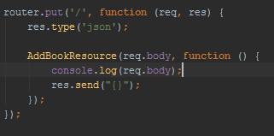
Like when I add a book I print out the req.body it print something like that :
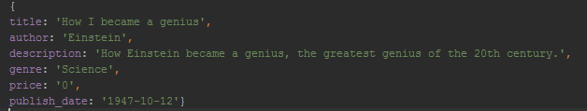
So when I make my test intead of req.body, I enter this kind of Json Object but nothing appear and I also print out the JsonObject I callback :
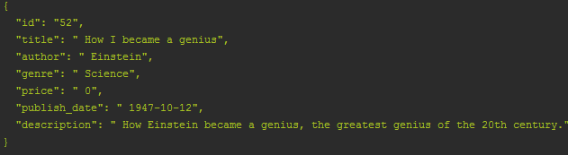
Note : Sorry about the number of id, just made a lot of test.

So this is the Json object that I callback but this object is never used, because we send '{}' so how I'm supposed to make test if I don't get the object. I guess I'm not supposed to change the API so I didn't.
Anyway I couln't make this unit test, maybe too difficult for me even if I hope I'm not that far from it.

Reflection :

Well making this test ensure you that your application will work, you must cover all the possiblities that your function can have. Beside, Unit Tests allows you to make big changes to code quickly. You know it works now because you have run the tests, when you make the changes you need to make, you need to get the tests working again. It will save a lot of time and give you confidence, because you are sure that there working, also confidence with your client, as I said in the reflection for task 1, you can organise meeting with him/her, and show him that something concrete here. Unit test also help you understand the design of the code you are going to implemented, how it should be organised, instead of coding directly, you are making some “boundaries” to what condition is required and what output you are supposed to have. Unit Tests give you instant visual feedback, and we all know how we like see something working as developers, those greenlights even if for this project and for me it was mostly red.

But clearly Unit test are very useful before starting implementing, and as I said the main point is that it define the “outlines” of your function and this is very important because as a developper you always want to improve the code, always find the best implementation (and this is perfectly ok), but it always good to definit limits, and unit test helps you to do that.

Reflection on time log : Well I planned four hours for this task, I spent 13 hours and it still not working. It show that I clearly didn't fully understand the task and one of my “mistake” is that I already had implemented the function EditBookresource and AddBookResource, so even if they work, maybe there is something wrong in the implementation and that's why I couldn't make test working. I also realise that every time (you can see in the time log document) I don't spend enough time on understanding the task before starting work on it, maybe I should take more time to research all the needs for the task.

IV – Reflection task 4

Time for this task : 2 hours.

Well this task is more likely as the previous one, make test on the API provided. Let's start with a quick definition to organise the reflection on this task : [From Wikipédia], In computer programming, an application programming interface (API) is a set of subroutine definitions, protocols, and tools for building application software. In general terms, it's a set of clearly defined methods of communication between various software components.

So, what is it good to making API test. As the definition of API says, it define the protocols, tools for building application software. So it's interesting to make test on it in the way that it should absolutly work for making run the application.
It permit, just like unit test does to explore boundary conditions, verifying the Sequence of API calls and check if the API's produce useful results from successive calls.

Conclusion : Just as Unit test, it permit to test the boundaries of the API and make some verification about API. It ensure that the API is correct and also it says that Unit testing is a type of API testing, so it's like API was the ground of a house, the main building and Unit testing who will test the method in the application is like what there is inside the house.

Reflection on time log : I said 2 hours for this task but I made it in around 1 hour and 30 minutes (see the time log document), the thing is we already have an example with the PingResourceTest file so it helped me.

