FRAPPER Software technology
Colin

Activity Diagram, Robustness diagram, Sequence diagram

03/16/2017
Reminder of use case :

View a list of book :

Activity diagram

Robustness diagram

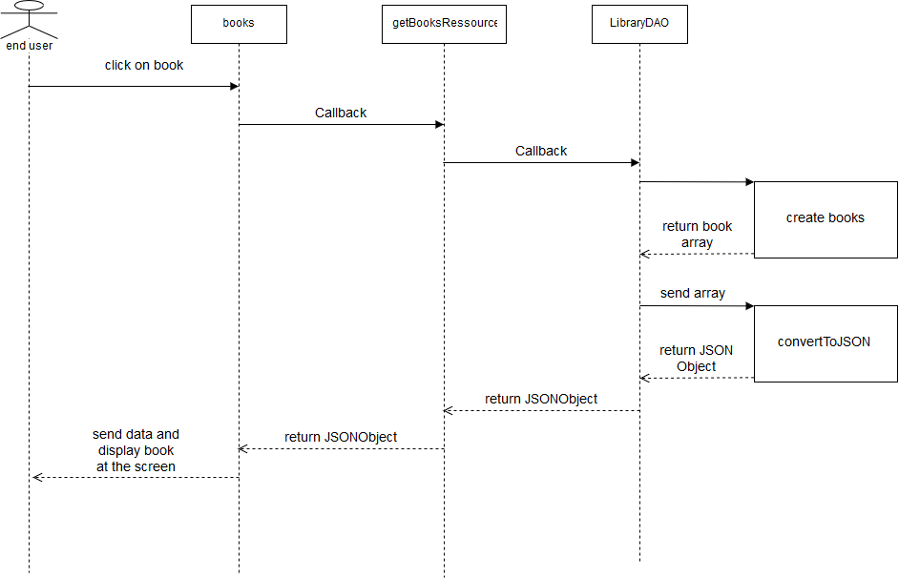
Sequence diagram

View a book :

Activity diagram

Robustness diagram

Sequence diagram
Add a book :

Activity diagram

Robustness diagram
Sequence diagram
Delete a book :

Activity diagram

Robustness diagram

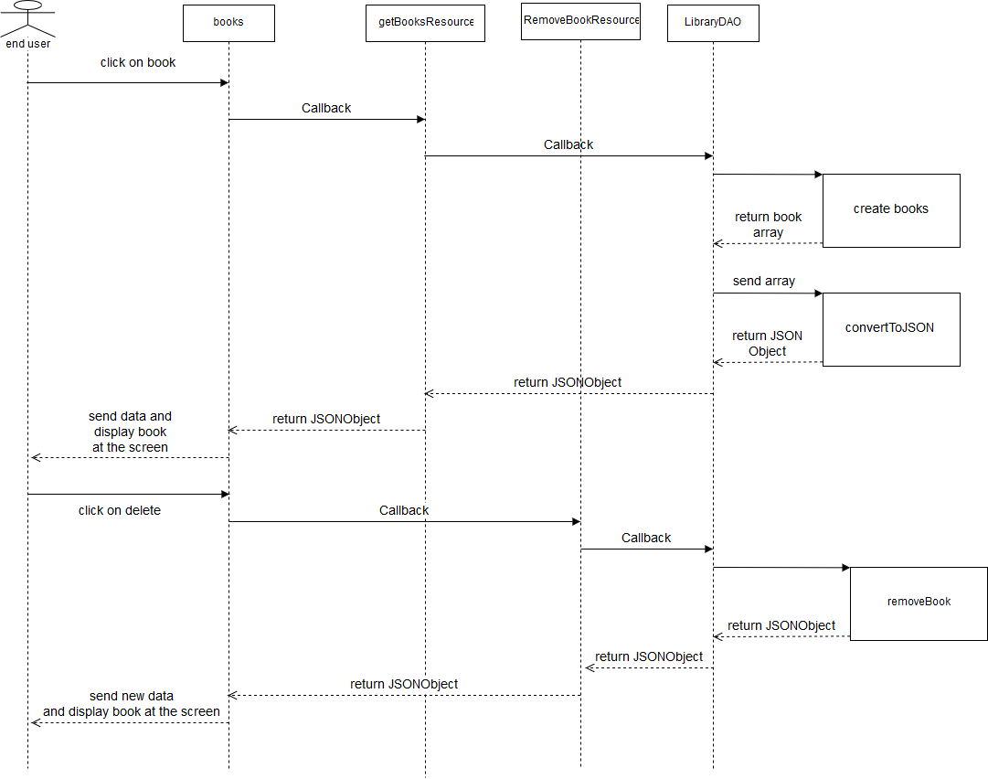
Sequence diagram

Edit book :

Activity diagram

Robustness diagram
Sequence diagram

