F28HS: Hardware-Software Interface CW2: Systems Programming (20%) 2017/18

Assessed Coursework 2 — Systems Programming

- Overview

The aim of this coursework is to develop a simple, systems-level application in C and assembler, running on an Raspberry Pi2 with attached devices.

The report needs to critically reflect on the software development process for (embedded) systems programming and contrast it to main stream programming.

- Embedded Systems Programming: Master Mind Application

In this assignment, you are required to implement a simple instance of the MasterMind board-game, using C and ARM assembler as implementation language. The application needs to run on an Raspberry Pi2, with the following attached devices: two LEDs, a button, and an LCD (with attached potentiometer). The devices should be connected to the RPi2 via a breadboard, using the RPi2 kit that was handed out early in the course.

Application: MasterMind is a two player game between a codemaker and a codebreaker. Before the game, a sequence length of N and a number of C colours for an arbitrary number of pegs are fixed. Then the codemaker selects N pegs and places them into a sequence of N slots. This (hidden) sequence comprises the code that should be broken. In turns, the codebreaker tries to guess the hidden sequence, by composing a sequence of N coloured pegs, choosing from the C colours. In each turn the codemaker answers by stating

Deadline: 3:30PM on Thursday 29nd March 2017 (pair project)

F28HS: Hardware-Software Interface CW2: Systems Programming (20%) 2017/18

how many pegs in the guess sequence are both of the right colour and at the right position, and how many pegs are of the right colour but not in the right position. The codebreaker uses this information in order to refine his guess in the next round. The game is over when the codebreaker successfully guesses the code, or if a fixed number of turns has been played. For details see this MasterMind Wikipedia page.

Below is a sample sequence of moves (R red, G green, B blue) for the board-game:

Secret: | R | G | G
================
Guess1: | B | R | G
Answ1: |  |  | 1 1
Guess2: | R | B | G
Answ2: |  |  | 2 0
Guess3: | R | G | G
Answ3: |  |  | 3 0

Game finished in 3 moves.

This is the sample sequence of input (IN) and output (OUT) operations in the running application when picking the Secret, followed by the first Guess1 and the first Answ1, corresponding to the example above. This uses an encoding of 1 for R (red), 2 for G (green) and 3 for B (blue). Press 1 means, press the button once, Green Blink 1 means blink the green LED once etc; // starts a comment for this example and is not part of the input/output):

OUT: | Secret: 1 2 2 | // show secret
IN: | <Press 3> <Pause> | // first input
OUT: | <Red Blink> | // first input accepted
OUT: | <Green Blink 3> | // echo the input value
IN: | <Press 1> <Pause> | // second input
OUT: | <Red Blink> | // second input accepted
OUT: | <Green Blink 1> | // echo the input value
IN: | <Press 2> <pause> | // third input
OUT: <Red Blink> |  | // third input accepted
OUT: <Green Blink 2> |  | // echo the input value
OUT: <Red Blink 2> |  | // input completed
OUT: <Green Blink 1> |  | // first no. in answer (exact matches)
OUT: <Red Blink 1> |  | // separator
OUT: <Green Blink 1> |  | // second no. in answer (contained matches)
OUT: <Red Blink 3> |  | // next round starts
... |  | // next round

Coding: The application should be developed on the Raspberry Pi2, using the device configuration below, with inlined ARM assembler code to directly control the attached devices through GPIO connections. No external libraries for programming the devices should be used in the final application. It is recommended to encode the C colours as numbers from 1 to C, and to display the sequence of pegs as a sequence of numbers. To test the application, a setting of 3 colours (C=3) and a sequence length of 3 should be used (N=3). In a “debug” mode the program should print the secret sequence at the beginning, so that the answers given can be checked, and each entered sequence (the guess) with the corresponding answer (as 2 numbers).

Deadline: 3:30PM on Thursday 29nd March 2017 (pair project)
F28HS: Hardware-Software Interface CW2: Systems Programming (20%) 2017/18

Wiring/Devices: Two LEDs should be used as output devices: one (green) LED for data, and another (red) LED for control information (e.g. to separate parts of the input and to start a new round). The green data LED (right) should be connected to the RPi2 using GPIO pin 13. The red control LED (left) should be connected to the RPi2 using GPIO pin 5. A button should be used as input device. It should be connected to GPIO pin 19. An LCD should be used as an additional output device. It should be connected as follows:

 | LCD | GPIO | LCD | GPIO
 | 1 | (GRND) | 9 | (unused)
 | 2 | (3v Power) | 10 | (unused)
 | 3 | (Potentiometer) | 11 (DATA4) | 23
 | 4 (RS) | 25 | 12 (DATA5) | 10
 | 5 (RW) | (GRND) | 13 (DATA6) | 27
 | 6 (EN) | 24 | 14 (DATA7) | 22
 | 7 | (unused) | 15 (LED+) | (3v Power)
 | 8 | (unused) | 16 (LED-) | (GRND)

This means that the 4 data connections to the LCD display are connected to these 4 GPIO pins on the RPi2: 23, 10, 27, 22. All devices should be connected to the RPi2 using a breadboard. This is a Fritzing diagram that visualises the entire wiring. Note that the middle pin of the potentiometer needs to be wired to LCD 3, and the other 2 legs to ground and power as shown in this version. Also, use the 3.3V and not the 5V power GPIO pin from the RPi2 to be on the safe side:¹
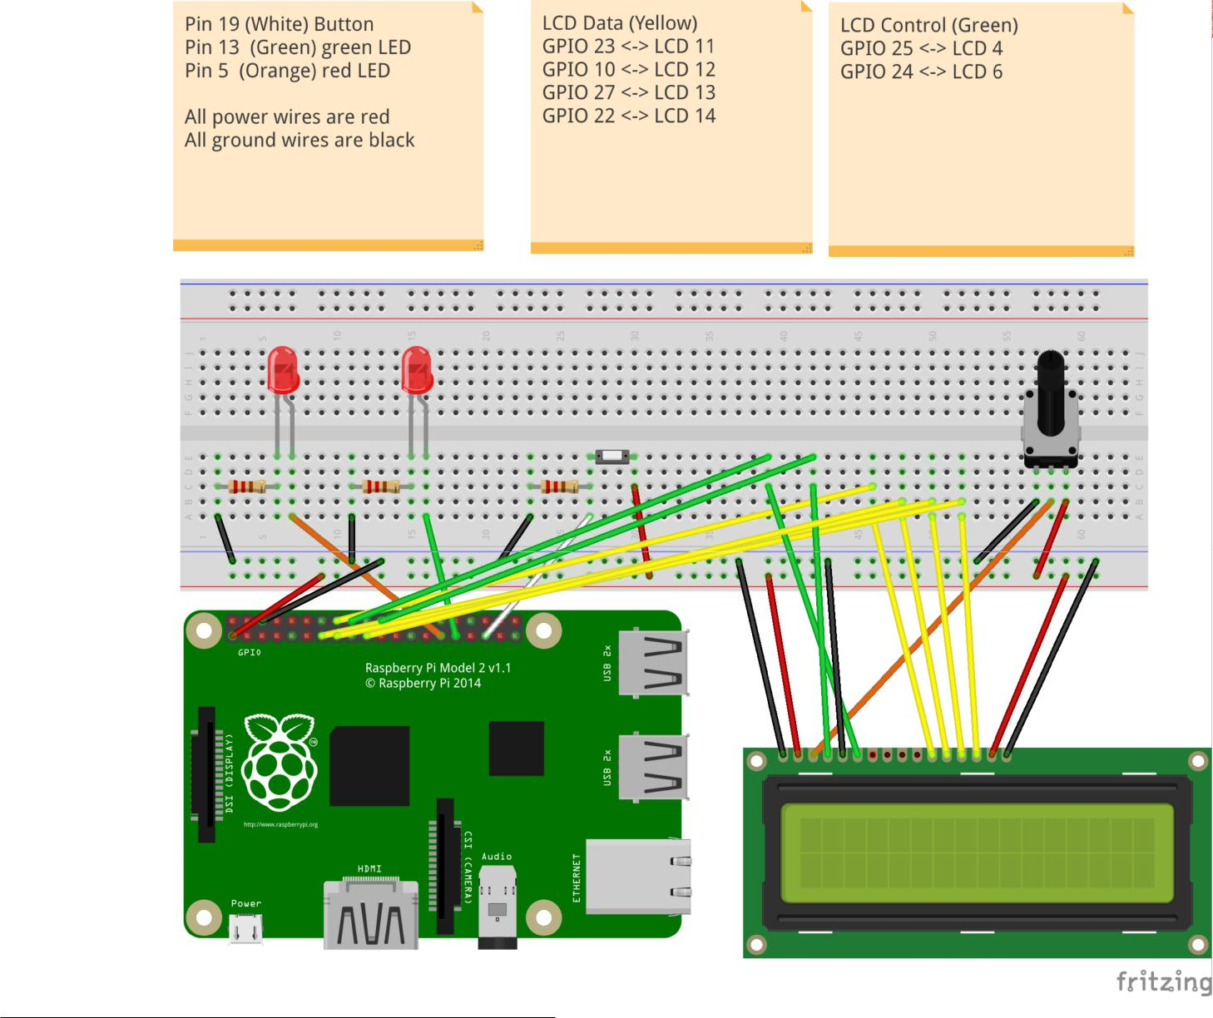

- you can connect the RPi2 GPIO pins directly to the LCD pins, but it’s usally easier to use a breadboard as shown

Deadline: 3:30PM on Thursday 29nd March 2017 (pair project)

F28HS: Hardware-Software Interface CW2: Systems Programming (20%) 2017/18

Note that the wiring for the LCD display matches the one discussed in Fig 9-2 (p 202), of the Adventures in Raspberry Pi book, and Chapter 9 has been handed out at the beginning of the course. The project file of the above Fritzing diagram application can be downloaded here. You can view it using the Fritzing diagram application. Follow this FAQ on how to download and install the Fritzing diagram application. The main advantage of viewing the diagram inside the application is that you can zoom in to examine the wiring, and you get info on the pin numbers when you hoover the mouse over them.

Sample code for the control of LED, button and LCD can be found on the sample sources section of the Course Information page for F28HS. Note that the low-level operations of setting the mode of a pin, writing to an LED or LCD, and reading from a button need to be encoded in ARM Assembler. The rest can be done in C, and you can draw on the sample code to build the functionality of the application.

It is strongly recommended that you do the lab sheets for LED, LCD and button control, before starting the CW. However, you have to adapt the wiring used in the lab-sheets to the one prescribed in the CW spec.

Functionality: The application must provide the following functionality (see the sample sequence above):

- The application proceeds in rounds of guesses and answers, as in the sample for the board game.

- In each round the player enters a sequence of numbers.

- A number is entered using the button as an input device. Each number is entered as the number of button presses, i.e. press twice for an input of two etc.

- A fixed time-out should be used to separate the input of successive numbers. Use timers (either on C or Assembler level), as introduced in the lectures.

- The red control LED should blink once to acknowledge input of a number.

- Then the green data LED should repeat the input number by blinking as many times as the button has been pressed.

- Repeat this sequence of button-input and LED-echo for each element of the input sequence.

- Once all values have been entered and echoed, the red control LED should blink two times to indicate the end of the input.

- As an answer to the guess sequence, the application has to calculate the numbers of exact matches (same colour and location) and approximate matches (same colour but different location).

- To communicate the answer, the green data LED should first blink the number of exact matches. Then, as a separator, the red control LED should blink once. Finally, the green data LED should blink the number of approximate matches.

- Finally, the red control LED should blink three times to indicate the start of a new round.

- If the hidden sequence has been guessed successfully, the green LED should blink three times while the red LED is turned on, otherwise the application should enter the next turn.

- When an LCD is connected, the output of exact and approximate matches should additionally be displayed as two separate numbers on an 16x2 LCD display.

- On successful finish, a message “SUCCESS” should be printed on the LCD, followed by the number of attempts required.

Deadline: 3:30PM on Thursday 29nd March 2017 (pair project)
F28HS: Hardware-Software Interface CW2: Systems Programming (20%) 2017/18

Command-line usage: The application shall provide a command-line interface to test its functionality in an automated way, like this:

./cw2 [options]

If run without any options, the program should show the behaviour specified above. If run with the -d option it should run in debug mode, and show the secret sequence, the guessed sequence and the answer, as shown in the example above.

- Submission

You must submit the complete project files, containing the source code, a stand-alone executable, and the report (in .pdf format) as one .zip file no later than 3:30 PM on Thursday 29nd March 2017. The main function driving the application should be called cw3, as discussed in “Command-line Usage” above. Submission must be through Vision, submitting all of the above files in one .zip file, as well as posting a hardcopy of the report with a cover sheet in the appropriate drop-box near the School Office 1.24. This coursework is worth 20% of the module’s mark.

You are marked for the functionality of the application, but also for code quality and the discussion in the short report. The marking scheme for this project is attached. This project should be done in pairs. Following the submission, there will be mandatory demos, where each pair will have to present the implementation, explain its functionality and implementation, and you must be prepared for answering knowledge questions about the implementation and about programming external devices in general.

- Report Format

The report should have at 2 – 5 pages and needs to cover the following:

A short problem specification

The hardware specification and wiring that is used as hardware platform

A short discussion of the code structure, specifying the functionality of the main functions

A list of functions directly accessing the hardware (for LEDs, Button, and LCD display) and which parts of the function use assembler and which use C

A sample execution of the program in debug mode

A summary, covering what was achieved (and what not), outstanding features, and what you have learnt from this coursework

Deadline: 3:30PM on Thursday 29nd March 2017 (pair project)

F28HS: Hardware-Software Interface CW2: Systems Programming (20%) 2017/18

Marking Scheme

Criteria | Marks
Meeting system requirements and functionality (as specified | 10
in Section 3)
Report Quality | 4
Contents matching the structure in Section 5; discussion of pro-
gram logic and of the core functions, controlling the GPIO inter-
face; summary of learning outcomes achieved.
The Application | 4
Code quality (both C and ARM Assembler), clear function inter-
faces, sufficient comments.
Assessed Lab | 2
The implementation of the “Traffic Lights” lab sheet needs to be
demo’ed in a lab slot.
Total marks | 20

Deadline: 3:30PM on Thursday 29nd March 2017 (pair project)

