Stuart Dunan, Fraser McAuley

Contents

PROJECT DESCRIPTION 2

CHARACTER 3

STORY 4

THEME 5

STORY PROGRESSION 6

GAMEPLAY 7

ART STYLE 10

MUSIC AND SOUNDS 11

TECHNICAL DESCRIPTION 12

MARKETING AND FUNDING 14

DEMOGRAPHICS 15

PLATFORMS AND MONETIZATION 16

LOCALIZATION 17

# PROJECT DESCRIPTION

This game design document or GDD is set out to describe how our ideas are represented within a game concept we have in mind to develop. The game will be a 2.5d platform/puzzle adventure with one main central playable character with a straightforward easy to understand story and end goal.

The game plays a lot like other platform games where the player has no attacks but instead relies on the player to make quick decisions to traverse each area completing the necessary goals to achieve the levels progression with unique puzzles and traps to fit the games genre and overall feel.

Names for the game so far before final decision are…….[insert names here……]

# CHARACTER

Main character description

1. Backstory
2. Description
3. Special powers??
4. Likes/dislikes

# STORY

After introducing the character’s backstory what events will transpire throughout the game to have the player empathize with our character, some introduction to our aims and goals.

1. Set a scenario
2. Is there a main boss at some point?
3. Will we introduce enemies?
4. Why are we hunting keys? Rescue from a prison? Open a treasure vault? Etc.
5. Description of the game world?
6. Give a story style explanation i.e. “Our character wakes up with a loud bang in their dwelling, looking round anxiously realises his keys are missing!! Rushing out the door he heads straight for the nearest teleporter………”

## Introduction to game world

The player character is a dwarf named Melvin who normally spends his days as a humble castle guard. On the day of the game’s events our character wakes up with a message ringing in his head: “The four corners of this labyrinth with yield your freedom.” Looking around his surroundings, he can see entrances to four distinct areas along with a large door, adorned with 4 padlocks.

## Player Challenges

In lieu of any actual enemies, the challenge of Melvin’s Quest will instead come from platforming challenges, hazards and various button-based puzzles. This type of challenge is the main source of difficulty within the game as we seek to create a gameplay experience free of pressure so that the player may enjoy the game world and take their time to figure out and complete the puzzles laid before them. Over the course of the game, these challenges will increase in difficulty as a way of testing the player’s understanding of the game’s mechanics and systems.

# THEME

## Tone

The game will have an overall light tone in keeping with the intended player experience. To keep up the upbeat and absurd nature of the world of Melvin’s Quest, the game will make use of both audio and visual comedy in the form of goofy sounds for certain actions or events as well as signs depicting what could go wrong if Melvin were to fail an upcoming challenge. Through the use of these elements we aim to make a game that has the player in a good mood the whole way through.

## Personality

Throughout the game we aim to bring personality to our player character through short lines of dialogue spoken by Melvin through text boxes. Melvin possesses a sharp tongue and a dry wit which will come across perfectly in written lines of text where sarcasm shines through.

# STORY PROGRESSION

Once we have our story set out and in stone how will our game have the story’s progression told to the player?

1. Do we have an intro animation or text story?
2. How do we show the player what to do from a gameplay screen in the UI? or have the first screen with our initial portal advising follow our arrow signs?
3. Do we have a quick scene before the portal having the player collect a key which opens a door to the main initial game area with a few jumps?
4. Do we allow the player to choose what level to go for first or constrain them to follow a set out path?
5. What theme do we have for both levels? Name them and theme them to be more interesting such as Cave Level/Sea Level etc? Allowing the game to feel like a journey?

# GAMEPLAY

* GOALS:

The player playing this game in the long term their goal will be to collect Keys in each stage which will ultimately be added to a key count which will guide the player to the end of the game. While collecting these keys the player must attempt to keep at least 1 life in their life pool keeping the player alive to be able to keep playing and achieve their goal. In the short term the player will have to traverse various levels with different themes each having their own unique pitfalls traps and puzzles. These will range from spike traps to burning lava but also have certain puzzles to traverse including pushing a block to a pressure pad to open a door, these will all have to be overcome and all keys collected in each level for the player to proceed to the next level.

* USER SKILLS:

The player will have two modes of controlling the game character in the forms of either Joypad or by Keyboard. For this title the skill is in having easy understanding controls for the player with simplified movement and a single jump function where the player will have to use their skills of concentration and strategize their movement to guide the player through each stage using puzzle solving abilities.

Here are the simplified character controls mapped out showing how the player will move left and right and the corresponding input to make the player jump on the keyboard the P key is mapped for pause which will also be used to pause for players using controllers.

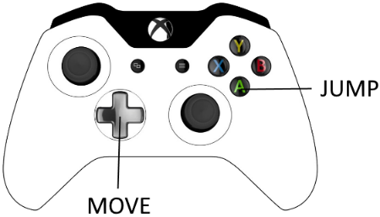

* GAME MECHANICS:
* The game will utilise simple platforming mechanics which many players may be used to having played other platformers. Additionally, the game will make creative use of button puzzles which work in conjunction with the aforementioned platforming mechanics. Additionally, there will be dangerous hazards to avoid such as swinging blades that move between and out of the foreground, emphasising the 2.5D nature of the game world.
* PLAYER LIVES AND KEYS COLLECTED:

The player as mentioned will need lives to keep playing and will initially be set at 3 they will be shown on the UI in the top left of the screen this allows the player to keep track of the remaining life pool. With having lives comes the challenge of losing them and the game finishing, in the game their will be extra lives placed in areas of each level where the player will have the ability to either add a life to their pool or replace a previously lost life during play, when a new life is picked up it will be shown in the correct area of the UI. In addition to the players lives being displayed the UI will also represent how many keys the player has collected in the style of 0/8 to 8/8 style so the player can see how many are needed to complete the game this will be located in the top right of the screen. As well as the amount needed for the games completion the number of keys needed to be collected in each individual level will be shown on the UI at the top middle also allowing the player to keep track and give a sense of objective during each level.

* PROGRESSION AND CHALLENGE:

The aim of the game is to collect keys level by level adding to an ultimate tally and the games completion, for our demonstration of this prototype we will showcase 2 unique levels both offering their own challenges to the player. We are aiming to use an old-style platform system where simply an arrow signpost will aim in the direction the player needs to go being a platform game a simple visual guide like this is usually enough to help the player progress. Both levels shown will have an easy first part having the player make a few jumps in order to collect the first key then ramp up as the player goes farther through till the end, each new obstacle adding another challenge to the player the skill level set to the player will be gradual with certain obstacles repeating where the player then knows what they need to do without over taxing the player helping the game feel fun in its playthrough but still having an element of challenge added in. The puzzle element will be set out in a fun manner without making the progression hindered but have the feel of excitement that the player has solved it and can move forward to the next key or stage completion which is important that the player feels goals being achieved as they play.

The challenges seen in each of the distinct areas will make use of both linear and puzzle-based level progression. The linear areas will make use of standard 2D platforming challenges such as precise platforming sections that steadily increase in difficulty. As seen in the left section of *Figure 1*, the player is first presented with a simple challenge wherein they must navigate a set of platforms. In this case, the only punishment for failure is falling down to the beginning of the area and having to climb up again. This is further expanded upon in the following section where the player is required to complete another platforming challenge except this time the punishment for failure is death followed by the loss of a Life and their position being reset. Through this simple difficulty curve in the linear sections of the games levels we aim to let players get accustomed to the rules of the game while also learning what to expect.

Contrary to the linear structure of certain areas of our game, other areas will make use of a non-linear, puzzle-centric gameplay loop. In the right section of *Figure 1*, it can be observed that we focused on switch-based puzzles that unlock doors at different ends of the level.

Figure - Level Area map

* LOSING:

We have set out that the 3-life system is a good choice and staple design of platformers which allows players to lose a life and learn what they need to overcome to beat the obstacle that lost the life for them. When the player interacts with hazards in the game be it a spike trap, Lava pit or swinging cleaver these will result in the player instantly losing a life from their stored pool. Upon losing a life the player will be transported back to the start of the level where they will have to traverse back to where they lost the life no need to collect keys again but will have to beat the traps and pitfalls to the previous loss of life. Even thought the player will have initially 3 lives and the ability to find more within the stages upon losing the last life in the pool will result in the player’s run ending and the game will end upon where a game over screen will be shown with the message on screen “GAME OVER” and prompted to press the jump input to take the player back to the main menu for another fresh start game.

* WINNING:

The player wins the game by keeping at least 1 life in their pool allowing the game to proceed, collect each key within each level add them to the total key tally ending for a successful playthrough. Upon reaching the last lock with all keys collected the player will unlock the door completing the game where upon a message to the UI will inform the player of their triumph “CONGRATULATIONS YOU HAVE FOUND THE ALL THE KEYS!!” as like game over the player will also be prompted here to press the jump input and return to the start screen for another fresh playthrough.

# ART STYLE

We aim to emulate the simplistic 3D art style of *Human Fall Flat* wherein colours are solid and objects are clearly defined and easy to recognise. We’ll also be taking cues in visual design from *Battleblock Theater*, another puzzle platformer, which makes use of visual cues in the form of signs that warn the player of imminent danger in the form of hazards.

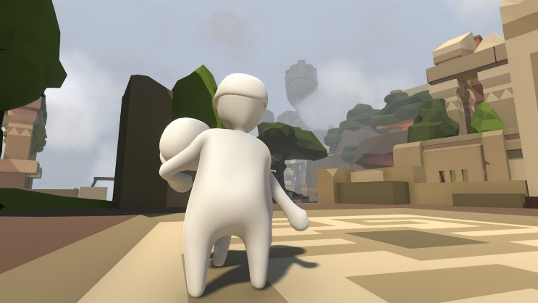

Figure 2 - Human Fall Flat, art style example

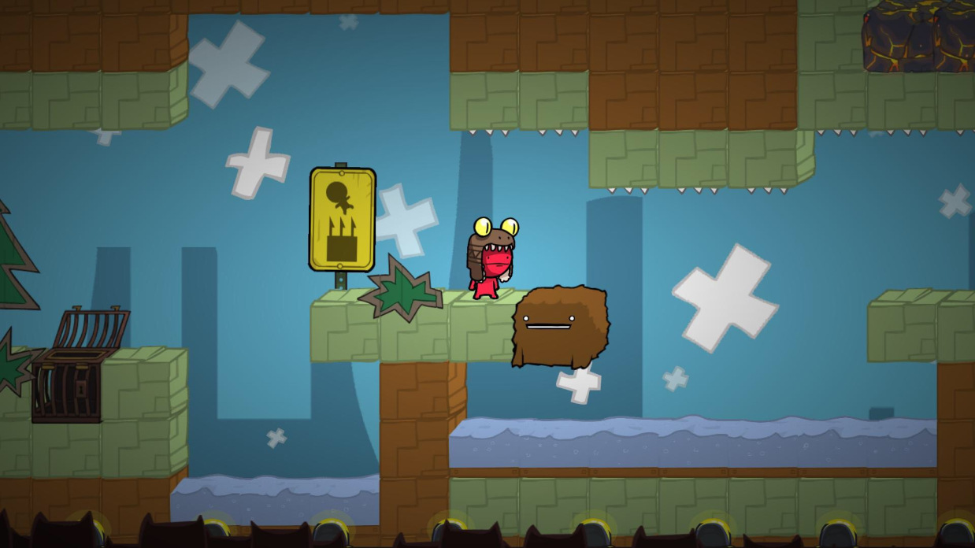

Figure 3 - Battleblock Theater, sign warning of spikes

# MUSIC AND SOUNDS

For Melvin’s Quest we will source a majority of the music and SFX from websites like freesound.org. For the game’s soundscape we will use some fantasy-esque music mixed with occasional use of environmental sounds based on which are the player is currently in. With the music we hope to emulate the tone of other fantasy games like *The Elder Scrolls V: Skyrim* or *Fable 2*. For the music we will look for royalty-free tracks from websites such as incompetech.com.

We will record sounds for Melvin ourselves, such as jumping or taking damage. Sounds like opening a door or collecting a key will be short, upbeat tunes that provide positive reinforcement for the player.

# TECHNICAL DESCRIPTION

* PLATFORM:

The platform the game is being aimed at is the PC for starters to see how the game is accepted and how successful. If the game gathers traction, then porting to Console will be a high priority as soon as available to do so while interest in the title is still gathering there is the possibility of a mobile version but will be discussed at length later as the game may not suit mobile devises style of gameplay.

* GAME ENGINE:

The game itself being at the prototype stage choosing the correct Engine to suit the needs of what we want to build was discussed through either Unity or the Unreal Engine. Both are very powerful, and both suit the needs of what we want to build, with Unity using scripting by the means of C# and Unreal using the Blueprint system with added C++ if desired. When deciding what we wanted to do we chose to use the Unreal Engine as we are familiar with the editor and adding elements and gameplay through the use of the Blueprint method which will be more than we need to build a prototype quickly giving us a great foundation to show of our concept and have the ability to progress if we take the project farther with the ability to port to all the platforms we would like to use.

* GRAPHICS ANIMATION AND SOFTWARE:

For the level design we will be using the Unreal Engines editor to create platforms ledges lifts etc which are deployed easily enough. Animations being created through Unreal’s Matinee feature for the movements of platforms doors opening etc. The character will be imported from Mixamo with animations for the character coming from this site as well the character movement animations. Assets we create will come from using Maya as our 3D creation software assets port to Unreal easily enough.

* SOURCE CONTROL:

We will be making use of Github in order to keep our files organised as well as track progress with various aspects of the game such as code and documentation.

* Charts for structure? UML
* Character Movement UML
* Level Interaction UML Movable platforms player movement collect items etc pseudocode UML?

# MARKETING AND FUNDING

Show the prototype levels we have do we aim it at a Kickstarter campaign, is there any funding that’s available to help the production, are we pitching the game at a publisher to gain funding? How are we going to promote the game to show off gaining an online presence for the title to help get the game and idea out there?

# DEMOGRAPHICS

* Who are we aiming at?
* What age group or groups?
* What type of player casual hardcore etc?
* Does our game fit the demographic we are stating and how?

With Melvin’s Quest we aim to reach a casual audience of gamers who will enjoy the challenging yet relaxing gameplay of a 2.5D puzzle platformer. Since our game will feature no violence of any kind, we will be able to market it to all ages which vastly increases the size of our potential playerbase.

# PLATFORMS AND MONETIZATION

If on Console and PC how will we market it?

* Free game?
* In game purchases?
* DLC?
* Cosmetics?
* If not, what price tag is acceptable?
* XBOX live, PlayStation Store, Steam Epic etc which is most viable for a first-time title attempt?

# LOCALIZATION

* Initially English
* What later? French, Spanish etc
* If the game takes off seek Asian Publisher to expand into Asia to help with localisation.