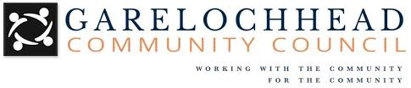

Community Helpline for local residents

The Garelochhead Community Council have set up a community helpline to direct you to services that can help support you and your family. We also have a pet scanner that can be used to identify lost or injured pets.

The community helpline has been set up to:

1. Help direct residents who need support
2. Provide advice on who to contact
3. Give assistance to those without internet access
4. Call if you have found a lost or injured pet

The phone **is not** manned 24 hours and isn’t for emergencies. You may have to leave a message with your details, and you will be called back. All our members are volunteers, so should you wish to help please do let us know.

COMMUNITY HELPLINE **Telephone: 07541020038**

www.garelochhead.info