**Instructions for using the Sound Localization System:**

**Step 1: Hydrophone Mounting & Locations**

Mount hydrophones to test frame or RoboSub, and make note of locations in (x,y,z) coordinate format. Hydrophone A must be at the origin of the coordinate system (0,0,0). The system performs at its best when hydrophones B, C, & D, are the greatest possible distance from hydrophone 1, because this provides the largest time difference of arrival values (TDOA) to be used in multilateration. The coordinates of each hydrophone must be entered at their respective lines in the multilateration code block (final block in system code). See figure 1, below.

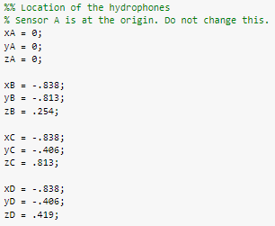

Figure 1: Coding hydrophone locations

**Step 2: Hardware Connections**

Connect hardware as detailed in figure 2 below. The ¼" hydrophone terminations are connected to the inputs of the Aquarian Audio PA1 Buffer/Amplifiers. The XLR outputs of the buffer/amplifiers are connected to the XLR inputs of the Behringer UMC404HD USB audio interface. Attach hydrophone A to Channel 1 (furthest left on the front facing panel of the UMC404HD), hydrophone B to channel 2, and so on. Connect one end of the power cable to the rear of the USB audio interface, and the other end to a wall outlet or portable power bank. Connect the USB cable to the rear end of the USB audio interface, and the other end to your PC’s USB port.

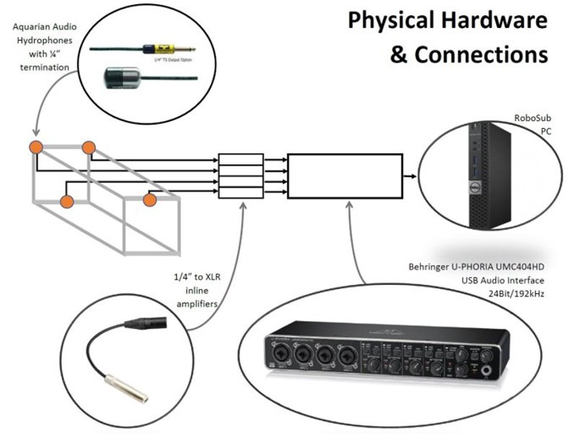

Figure 2: Hardware connections

**Step 3: Configuring the Behringer UMC404HD USB Audio Interface**

The use of the Aquarian Audio PA1 Buffer/Amplifiers requires the use of phantom power. Ensure that phantom power is turned on by looking for the +48 volt switch on the rear of the UMC404HD and ensuring it is set to “on”. The PA1 Buffer/Amplifiers bring the hydrophone signals up to “line level.” Ensure that the switches for line & instrument level signals for each channel on the front of the UMC404HD are set to “line level”. Additionally, ensure that the “pad” switch is enabled. Adjust the gain knobs as needed to compensate for variations in hydrophone sensitivity.

The driver required to configure the sampling rate to 192 kHz for the Behringer UMC404HD can be found on Behringer’s website at the following link:

<https://www.behringer.com/product.html?modelCode=P0BK1>

Look for the “software” drop down menu on the right side of the product page.

**Step 4: Configuring the System for your PC**

The system requires the following MatLab packages:

DSP System Toolbox

Signal Processing Toolbox

Audio Toolbox

Run the system, either using the python wrapper or the Matlab live script. For testing purposes, it advised that the MatLab live script which includes plots is used. Frequency selection can be made in the live script by changing the “freq” variable in the first line of code. In the following line, the “sensorArray” variable will likely need to be adjusted for your PC. Learn the name your PC has assigned to the UMC404HD by using the following commands in the MatLab command window:

deviceReader=audioDeviceReader;

devices=getAudioDevices(deviceReader)

devices

The name assigned to the UMC404HD must be used as the 2nd argument to the audioDeviceReader command, as in figure 3 below:

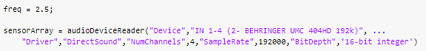

Figure 3: configuring audioDeviceReader

**Step 5: Running the System**

When the system is run, it will carry out the following functions:

1. Instantiate the recording device (Behringer UMC404HD)

2. Record 2.5 seconds of raw audio from the hydrophone array and read the audio into MatLab as a numeric array

3. Filter the numeric array for the specified frequency.

4. TDOA algorithm makes a best guess at TDOA values for hydrophone pairs AB, AC, & AD.

5. Cross correlation function attempts to “fine-tune” the guess made by the TDOA algorithm.

6. Mulltilateration function attempts at to solve the sound source location. One attempt is made using the “fine-tuned” TDOA values (solutions1), and another attempt is made using the “best guess” made by the TDOA algorithm (solutions2).

The use of the live script with plots included is advised for troubleshooting the system. The most likely culprit for the multilateration function providing inaccurate solutions, or no solutions, is inaccurate TDOA values.

The amplitude thresholds which the TDOA algorithm triggers on can be adjusted for better results.