Source Data Mapping Approach to CDMV5.4

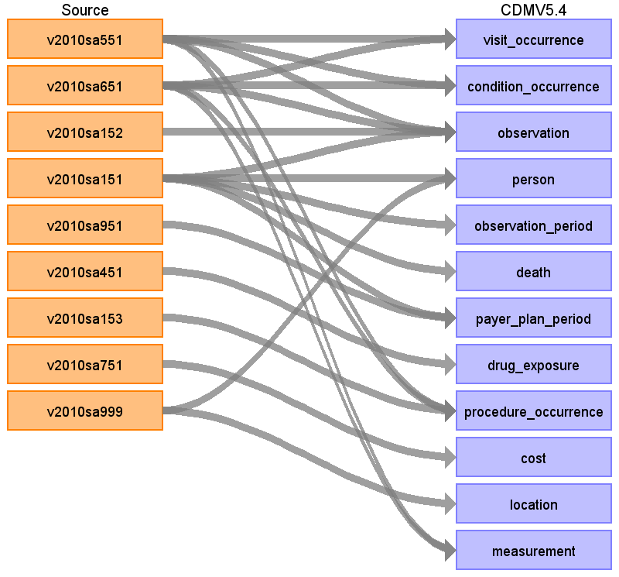

Table name: visit_occurrence

Reading from v2010sa551

“Stationäre Diagnosen” (Inpatient diagnosis) to visit occurrence

- visit duration

- visit concept (inpatient, outpatient, ...)

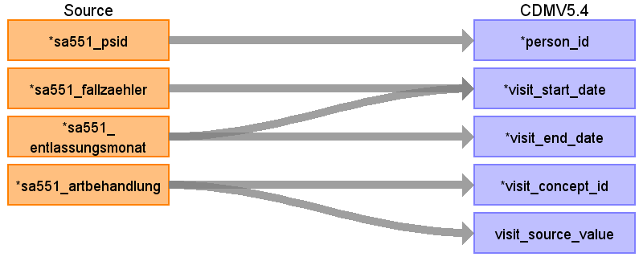

|  |  |  |  |
| --- | --- | --- | --- |
| Destination Field | Source Field | Logic | Comment |
| person_id | sa551_psid |  | join on psid of person table |
| visit_occurrence_id |  |  | Needs to be generated |
| visit_start_date | sa551_fallzaehler  sa551_entlassungsmonat |  | 1st of discharge month + sa551_fallzaheler  (to keep the order of cases)  Only year + month is given  Set to the 1st of the month |
| visit_start_datetime |  |  |  |
| visit_end_date | sa551_entlassungsmonat |  | Assumption: Stays till the end of the discharge month (Entlassungsmonat)  Not given; only year  Blood purification should take less than one day, but we do not know how many blood purification where done (only if at least one) |
| visit_end_datetime |  |  |  |
| visit_concept_id | sa551_artbehandlung |  | 1 => 9201 Inpatient Visit  2 =>38004207 Ambulatory Clinic / Center  3 => 8756 Outpatient Hospital  0 => otherwise 0 |
| visit_source_value | sa551_artbehandlung |  |  |
| visit_source_concept_id |  |  |  |
| visit_type_concept_id |  |  | 32810 Claim |
| provider_id |  |  |  |
| care_site_id |  |  |  |
| admitted_from_concept_id |  |  |  |
| admitted_from_source_value |  |  |  |
| discharged_to_concept_id |  |  |  |
| discharged_to_source_value |  |  |  |
| preceding_visit_occurrence_id |  |  |  |

Reading from v2010sa651

Ambulante Diagnosen (Outpatient diagnosis) to visit occurrence

- visit duration

- visit concept (outpatient, outpatient hospital ...)

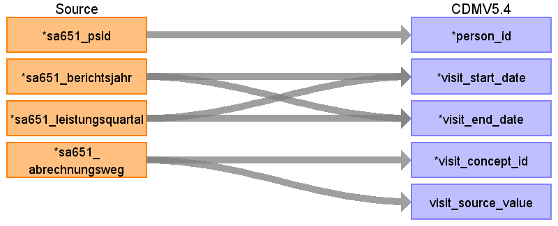

|  |  |  |  |
| --- | --- | --- | --- |
| Destination Field | Source Field | Logic | Comment |
| person_id | sa651_psid |  |  |
| visit_occurrence_id |  |  | Needs to be generated |
| visit_start_date | sa651_leistungsquartal  sa651_berichtsjahr |  | 1st day and 1st month of the quartal |
| visit_start_datetime |  |  |  |
| visit_end_date | sa651_leistungsquartal  sa651_berichtsjahr |  | 1st day and 1st month of the quartal.  Assume that it takes less than one day since it is an outpatient visit.  Not given; only year  Blood purification should take less than one day, but we do not know how many blood purifications where done (only if at least one) |
| visit_end_datetime |  |  |  |
| visit_concept_id | sa651_abrechnungsweg |  | 1 = Diagnose gem. § 295 SGB V => 9202 Outpatient Visit  2 = Diagnose aus ambulanter Behandlung  im Krankenhaus => 8756 Outpatient Hospital  3 = sonstiges => 0 |
| visit_source_value | sa651_abrechnungsweg |  |  |
| visit_source_concept_id |  |  |  |
| visit_type_concept_id |  |  | 32810 Claim |
| provider_id |  |  |  |
| care_site_id |  |  |  |
| admitted_from_concept_id |  |  |  |
| admitted_from_source_value |  |  |  |
| discharged_to_concept_id |  |  |  |
| discharged_to_source_value |  |  |  |
| preceding_visit_occurrence_id |  |  |  |

Table name: condition_occurrence

Reading from v2010sa551

Stationäre Diagnosen (Inpatient diagnosis) to condition occurrence

- visit date

- diagnosis

- conditions status (primary, secondary diagnosis)

Linked with visit_occurrence table to get information about visit_occurrence_id, dates, person_id

WHERE diagnosis.domain_id='Condition'

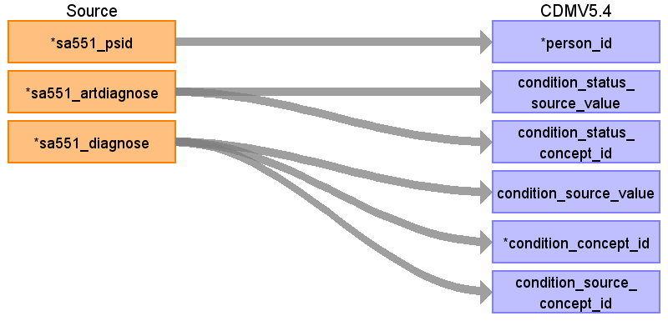

|  |  |  |  |
| --- | --- | --- | --- |
| Destination Field | Source Field | Logic | Comment |
| person_id | sa551_psid |  | link person_id by table visit_occurrence |
| condition_occurrence_id |  |  | Generated |
| visit_occurrence_id |  |  | link visit_occurrence_id by table visit_occurrence |
| condition_start_date |  |  | link condition_start_date by visit_occurrence |
| condition_start_datetime |  |  |  |
| condition_end_date |  |  |  |
| condition_end_datetime |  |  |  |
| condition_status_source_value | sa551_artdiagnose |  |  |
| condition_status_concept_id | sa551_artdiagnose |  | 1 => 32902 Primary diagnosis  2 => 32908 Secondary diagnosis |
| condition_type_concept_id |  |  | 32810 Claim |
| condition_source_value | sa551_diagnose |  | Since diagnose has special characters we do not map it for now. A source_concept with mapping to standard with special character should be done in the future.  We do not keep the localization |
| condition_concept_id | sa551_diagnose |  | get by materialized view; remove special characters  ICD10-GM to SNOMED |
| condition_source_concept_id | sa551_diagnose |  | get by materialized view; remove special characters |
| stop_reason |  |  |  |
| provider_id |  |  |  |
| visit_detail_id |  |  |  |

Reading from v2010sa651

Ambulante Diagnosen (Outpatient diagnosis) to condition occurrence

- visit date

- diagnosis

- conditions status (preliminary, confirmed, .. )

WHERE qualifizierung != 'A'; AND domain_id='Condition'

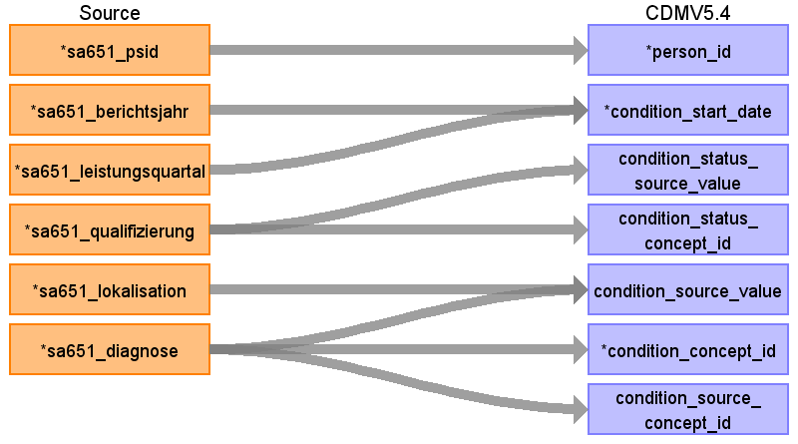

|  |  |  |  |
| --- | --- | --- | --- |
| Destination Field | Source Field | Logic | Comment |
| person_id | sa651_psid |  |  |
| condition_occurrence_id |  |  | Needs to be generated |
| visit_occurrence_id |  |  | link visit_occurrence_id by table visit_occurrence |
| condition_start_date | sa651_leistungsquartal  sa651_berichtsjahr |  | 1st day and 1st month  link condition_start_date by visit_occurrence |
| condition_start_datetime |  |  |  |
| condition_end_date |  |  |  |
| condition_end_datetime |  |  |  |
| condition_status_source_value | sa651_qualifizierung |  |  |
| condition_status_concept_id | sa651_qualifizierung |  | V = Verdachtsdiagnose => 32899 Preliminary diagnosis  Z = Zustand nach betreffender Diagnose => 32906 Resolved condition  G = gesicherte Diagnose => 32893 Confirmed diagnosis  0 = sonst  A = ausgeschlossene Diagnose => excluded here! |
| condition_type_concept_id |  |  | 32810 Claim |
| condition_source_value | sa651_diagnose  sa651_lokalisation |  | Since diagnose has special characters we do not map it for now. A source_concept with mapping to standard with special character should be done in the future. |
| condition_concept_id | sa651_diagnose |  | Special characters need to be removed  ICD10-GM to SNOMED |
| condition_source_concept_id | sa651_diagnose |  | Special characters need to be removed |
| stop_reason |  |  |  |
| provider_id |  |  |  |
| visit_detail_id |  |  |  |

Table name: observation

Reading from v2010sa151

Versichertenstammdaten 151 (Masta data) to observation

- observation date

- insured days because of taking care of child to observation_concept_id, value_as_number, observation_source_value

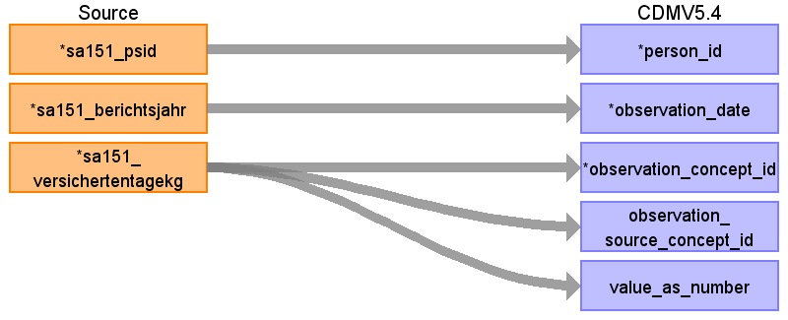

|  |  |  |  |
| --- | --- | --- | --- |
| Destination Field | Source Field | Logic | Comment |
| observation_id |  |  | Needs to be generated |
| person_id | sa151_psid |  |  |
| observation_date | sa151_berichtsjahr |  | Not given, set to first day of the year. |
| observation_concept_id | sa151_versichertentagekg |  | concept_id 0 |
| observation_source_concept_id | sa151_versichertentagekg |  | Custom concept: Versichertentage mit allgemeinem Anspruch auf Krankengeld gemäß § 30 Abs. 1 Nr. 11 RSAV |
| observation_source_value |  |  |  |
| observation_datetime |  |  |  |
| observation_type_concept_id |  |  | 32810 Claim |
| value_as_number | sa151_versichertentagekg |  | Number of days |
| value_source_value |  |  |  |
| value_as_string |  |  |  |
| value_as_concept_id |  |  |  |
| qualifier_concept_id |  |  |  |
| unit_concept_id |  |  |  |
| provider_id |  |  |  |
| visit_occurrence_id |  |  |  |
| visit_detail_id |  |  |  |
| unit_source_value |  |  |  |
| qualifier_source_value |  |  |  |
| observation_event_id |  |  |  |
| obs_event_field_concept_id |  |  |  |

Reading from v2010sa152

Versichertenstammdaten 152 (Masta data) to observation

- observation date

- insured days by category (e.g. days abroad) to observation_concept_id, value_as_number, observation_source_value

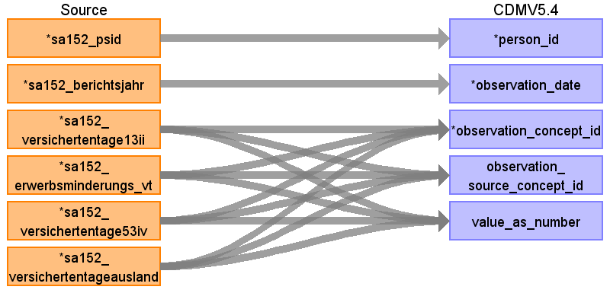

|  |  |  |  |
| --- | --- | --- | --- |
| Destination Field | Source Field | Logic | Comment |
| observation_id |  |  | Generated |
| person_id | sa152_psid |  |  |
| observation_date | sa152_berichtsjahr |  | Not given, set to first day of the year. |
| observation_concept_id | sa152_erwerbsminderungs_vt  sa152_versichertentageausland  sa152_versichertentage13ii  sa152_versichertentage53iv |  | concept_id 0  concept_id 0  concept_id 0  concept_id 0 |
| observation_source_concept_id | sa152_erwerbsminderungs_vt  sa152_versichertentage13ii  sa152_versichertentage53iv  sa152_versichertentageausland |  | Custom concept  Custom concept  Custom concept  Custom concept |
| observation_source_value |  |  |  |
| observation_datetime |  |  |  |
| observation_type_concept_id |  |  | 32810 Claim |
| value_as_number | sa152_versichertentage13ii  sa152_erwerbsminderungs_vt  sa152_versichertentage53iv  sa152_versichertentageausland |  |  |
| value_source_value |  |  |  |
| value_as_string |  |  |  |
| value_as_concept_id |  |  |  |
| qualifier_concept_id |  |  |  |
| unit_concept_id |  |  |  |
| provider_id |  |  |  |
| visit_occurrence_id |  |  |  |
| visit_detail_id |  |  |  |
| unit_source_value |  |  |  |
| qualifier_source_value |  |  |  |
| observation_event_id |  |  |  |
| obs_event_field_concept_id |  |  |  |

Reading from v2010sa651

1st script

Ambulante Diagnosen (Outpatient diagnosis) to observation of excluded diagnosis

- observation date

- excluded diagnosis

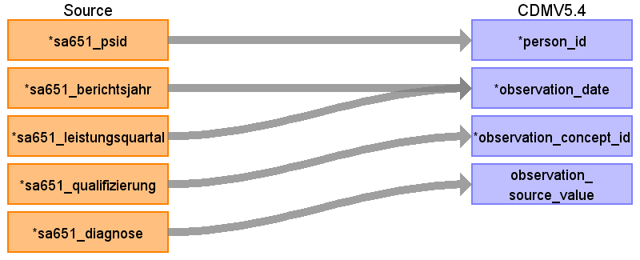

|  |  |  |  |
| --- | --- | --- | --- |
| Destination Field | Source Field | Logic | Comment |
| observation_id |  |  | Generated |
| person_id | sa651_psid |  |  |
| observation_date | sa651_leistungsquartal  sa651_berichtsjahr |  | 1st day of the 1st month of the quarter |
| observation_concept_id | sa651_qualifizierung |  | Only if == A  Disorder excluded  4199812 |
| observation_source_concept_id |  |  |  |
| observation_source_value | sa651_diagnose |  |  |
| observation_datetime |  |  |  |
| observation_type_concept_id |  |  | 32810 Claim |
| value_as_number |  |  |  |
| value_source_value |  |  |  |
| value_as_string |  |  |  |
| value_as_concept_id |  |  |  |
| qualifier_concept_id |  |  |  |
| unit_concept_id |  |  |  |
| provider_id |  |  |  |
| visit_occurrence_id |  |  |  |
| visit_detail_id |  |  |  |
| unit_source_value |  |  |  |
| qualifier_source_value |  |  |  |
| observation_event_id |  |  |  |
| obs_event_field_concept_id |  |  |  |

Reading from v2010sa651

2nd script

diagnosis WHERE domain_id='Observation' and qualifizierung != 'A'

Linked with visit_occurrence table to get information about visit_occurrence_id, dates, person_id



|  |  |  |  |
| --- | --- | --- | --- |
| Destination Field | Source Field | Logic | Comment |
| observation_id |  |  | Generated |
| person_id |  |  |  |
| observation_date |  |  |  |
| observation_concept_id | sa651_diagnose |  | get by materialized view; remove special characters |
| observation_source_concept_id | sa651_diagnose |  | get by materialized view; remove special characters |
| observation_source_value | sa651_diagnose |  |  |
| observation_datetime |  |  |  |
| observation_type_concept_id |  |  | 32810 Claim |
| value_as_number |  |  |  |
| value_source_value |  |  |  |
| value_as_string |  |  |  |
| value_as_concept_id |  |  |  |
| qualifier_concept_id |  |  |  |
| unit_concept_id |  |  |  |
| provider_id |  |  |  |
| visit_occurrence_id |  |  |  |
| visit_detail_id |  |  |  |
| unit_source_value |  |  |  |
| qualifier_source_value |  |  |  |
| observation_event_id |  |  |  |
| obs_event_field_concept_id |  |  |  |

Reading from v2010sa551

Linked with visit_occurrence table to get information about visit_occurrence_id, dates, person_id

WHERE diagnosis.domain_id='Observation'

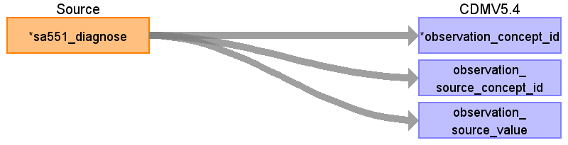

|  |  |  |  |
| --- | --- | --- | --- |
| Destination Field | Source Field | Logic | Comment |
| observation_id |  |  | Generated |
| person_id |  |  |  |
| observation_date |  |  |  |
| observation_concept_id | sa551_diagnose |  | get by materialized view; remove special characters |
| observation_source_concept_id | sa551_diagnose |  | get by materialized view; remove special characters |
| observation_source_value | sa551_diagnose |  |  |
| observation_datetime |  |  |  |
| observation_type_concept_id |  |  | 32810 Claim |
| value_as_number |  |  |  |
| value_source_value |  |  |  |
| value_as_string |  |  |  |
| value_as_concept_id |  |  |  |
| qualifier_concept_id |  |  |  |
| unit_concept_id |  |  |  |
| provider_id |  |  |  |
| visit_occurrence_id |  |  |  |
| visit_detail_id |  |  |  |
| unit_source_value |  |  |  |
| qualifier_source_value |  |  |  |
| observation_event_id |  |  |  |
| obs_event_field_concept_id |  |  |  |

Table name: person

Reading from v2010sa151

Versichertenstammdaten 151 (Masta data) to person

- gender

- year of birth

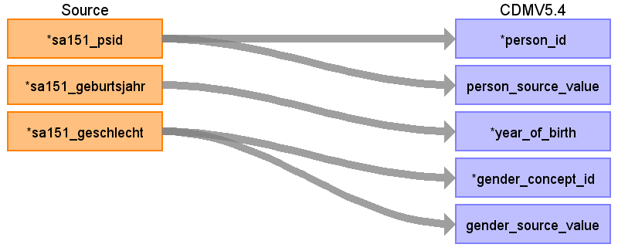

|  |  |  |  |
| --- | --- | --- | --- |
| Destination Field | Source Field | Logic | Comment |
| person_id | sa151_psid |  | generate |
| person_source_value | sa151_psid |  | psid as source person_source_value |
| year_of_birth | sa151_geburtsjahr |  |  |
| gender_concept_id | sa151_geschlecht |  | 1 => 8532 FEMALE  2 => 8507 MALE |
| month_of_birth |  |  |  |
| day_of_birth |  |  |  |
| location_id |  |  | look up in the location table |
| birth_datetime |  |  |  |
| race_concept_id |  |  | set to 0 (not given) |
| ethnicity_concept_id |  |  | set to 0 (not given) |
| provider_id |  |  |  |
| care_site_id |  |  |  |
| gender_source_value | sa151_geschlecht |  |  |
| gender_source_concept_id |  |  |  |
| race_source_value |  |  |  |
| race_source_concept_id |  |  |  |
| ethnicity_source_value |  |  |  |
| ethnicity_source_concept_id |  |  |  |

Reading from v2010sa999

SA999 - Amtlicher Gemeindeschlüssel to person

- Gemeindeschluessel to location_id

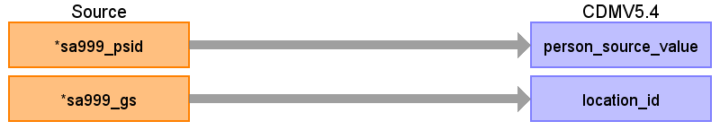

|  |  |  |  |
| --- | --- | --- | --- |
| Destination Field | Source Field | Logic | Comment |
| person_id |  |  |  |
| person_source_value | sa999_psid |  | join sa151 and sa999 to table person on psid |
| year_of_birth |  |  |  |
| gender_concept_id |  |  |  |
| month_of_birth |  |  |  |
| day_of_birth |  |  |  |
| location_id | sa999_gs |  | look up in the location table |
| birth_datetime |  |  |  |
| race_concept_id |  |  | set to 0 (not given) |
| ethnicity_concept_id |  |  | set to 0 (not given) |
| provider_id |  |  |  |
| care_site_id |  |  |  |
| gender_source_value |  |  |  |
| gender_source_concept_id |  |  |  |
| race_source_value |  |  |  |
| race_source_concept_id |  |  |  |
| ethnicity_source_value |  |  |  |
| ethnicity_source_concept_id |  |  |  |

Table name: observation_period

Reading from v2010sa151

Versichertenstammdaten 151 (Masta data) to observation_period:

- distinct on psid

- Assumption: period whole year

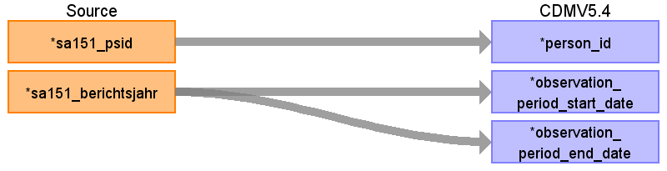

|  |  |  |  |
| --- | --- | --- | --- |
| Destination Field | Source Field | Logic | Comment |
| person_id | sa151_psid |  |  |
| observation_period_id |  |  | Needs to be generated |
| observation_period_start_date | sa151_berichtsjahr |  | 1st January of berichtsjahr |
| observation_period_end_date | sa151_berichtsjahr |  | Set to 31st of december |
| period_type_concept_id |  |  | 32810 Claim |

Table name: death

Versichertenstammdaten 151 (Masta data) to death:

- death

Reading from v2010sa151

Versichertenstammdaten 151 (Masta data) to death:

- if death, year of death

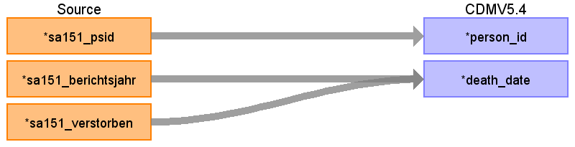

|  |  |  |  |
| --- | --- | --- | --- |
| Destination Field | Source Field | Logic | Comment |
| person_id | sa151_psid |  |  |
| death_date | sa151_berichtsjahr  sa151_verstorben |  | If quals 1 then last day of the year.  No date given, only if person is dead. |
| death_datetime |  |  |  |
| death_type_concept_id |  |  | 32810 Claim |
| cause_concept_id |  |  |  |
| cause_source_value |  |  |  |
| cause_source_concept_id |  |  |  |

Table name: payer_plan_period

Reading from v2010sa151

Versichertenstammdaten 151 (Masta data) to payer_plan_period:

- distinct on psid2

- assumption: duration whole year

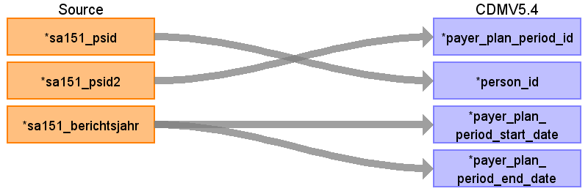

|  |  |  |  |
| --- | --- | --- | --- |
| Destination Field | Source Field | Logic | Comment |
| payer_plan_period_id | sa151_psid2 |  |  |
| person_id | sa151_psid |  |  |
| payer_plan_period_start_date | sa151_berichtsjahr |  | Start on 1st January. Note, if a insured person switched insurance, the person will have two periods with the duration of exactly one year.  This assumption is made because of several reasons:  -It is not possible to apply for data separated by psid2.  -Since we would need to check several tables to identify which insurance started first.  - If a person does not have any diagnosis we would either miss the person or could not say which insurance was first.  - If there exists a diagnosis/procedure/drug_exposure we kept the order in the according table  Given by 151sa |
| payer_plan_period_end_date | sa151_berichtsjahr |  | Assumption: 31st of December |
| payer_concept_id |  |  |  |
| payer_source_concept_id |  |  |  |
| payer_source_value |  |  |  |
| plan_concept_id |  |  |  |
| plan_source_value |  |  |  |
| plan_source_concept_id |  |  |  |
| sponsor_concept_id |  |  |  |
| sponsor_source_value |  |  |  |
| sponsor_source_concept_id |  |  |  |
| family_source_value |  |  |  |
| stop_reason_concept_id |  |  |  |
| stop_reason_source_value |  |  |  |
| stop_reason_source_concept_id |  |  |  |

Reading from v2010sa951

SA951 - Krankenkassenzugehörigkeit (Insurance membership) to payer_plan_period:

- Betriebsnummer as payer_concept_id

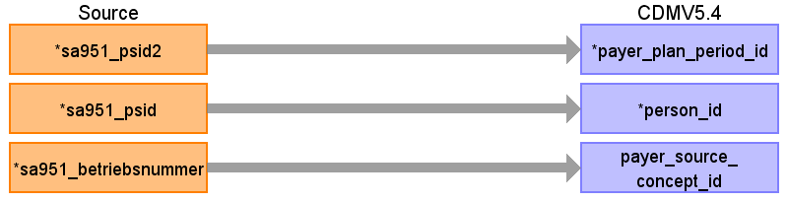

|  |  |  |  |
| --- | --- | --- | --- |
| Destination Field | Source Field | Logic | Comment |
| payer_plan_period_id | sa951_psid2 |  |  |
| person_id | sa951_psid |  |  |
| payer_plan_period_start_date |  |  | Given by 151sa |
| payer_plan_period_end_date |  |  | Assumption: 31st of December |
| payer_concept_id |  |  |  |
| payer_source_concept_id | sa951_betriebsnummer |  |  |
| payer_source_value |  |  |  |
| plan_concept_id |  |  |  |
| plan_source_value |  |  |  |
| plan_source_concept_id |  |  |  |
| sponsor_concept_id |  |  |  |
| sponsor_source_value |  |  |  |
| sponsor_source_concept_id |  |  |  |
| family_source_value |  |  |  |
| stop_reason_concept_id |  |  |  |
| stop_reason_source_value |  |  |  |
| stop_reason_source_concept_id |  |  |  |

Table name: drug_exposure

Reading from v2010sa451

Ambulante Arzneimittel (ambulatory drugs) to drug_exposure:

- Verordnungsdatum as start_date

- PZN to drug_concept_id (no mapping yet)

- anzahleneiniheitsfaktor to quantity

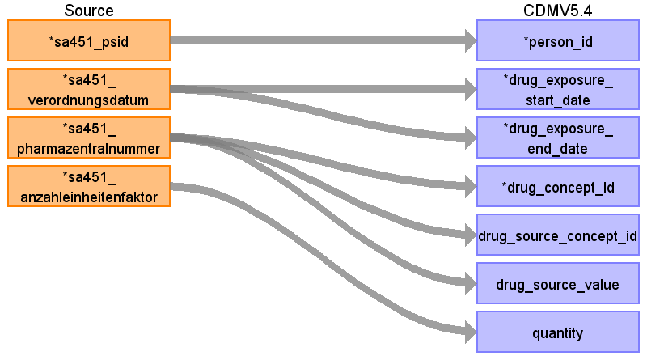

|  |  |  |  |
| --- | --- | --- | --- |
| Destination Field | Source Field | Logic | Comment |
| drug_exposure_id |  |  | Needs to be generated |
| visit_detail_id |  |  |  |
| person_id | sa451_psid |  |  |
| drug_exposure_start_date | sa451_verordnungsdatum |  |  |
| drug_exposure_end_date | sa451_verordnungsdatum |  | drug_exposure_end_date + 7 days |
| drug_concept_id | sa451_pharmazentralnummer |  | PZN to RxNorm not provided -> concept_id 0 |
| drug_source_concept_id | sa451_pharmazentralnummer |  | PZN not provided as source concept -> concept_id 0 |
| drug_source_value | sa451_pharmazentralnummer |  |  |
| drug_type_concept_id |  |  | 32810 Claim |
| quantity | sa451_anzahleinheitenfaktor |  |  |
| dose_unit_source_value |  |  |  |
| visit_occurrence_id |  |  |  |
| drug_exposure_start_datetime |  |  |  |
| drug_exposure_end_datetime |  |  |  |
| verbatim_end_date |  |  |  |
| stop_reason |  |  |  |
| refills |  |  |  |
| days_supply |  |  |  |
| sig |  |  |  |
| route_concept_id |  |  |  |
| lot_number |  |  |  |
| provider_id |  |  |  |
| route_source_value |  |  |  |

Table name: procedure_occurrence

Reading from v2010sa153

SA153 - Extrakorporale Blutreinigung to procedure_occurrence

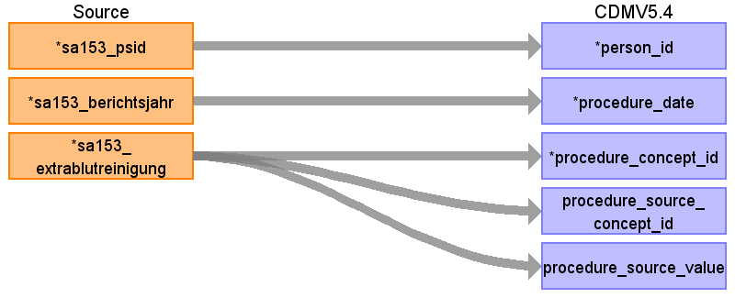

|  |  |  |  |
| --- | --- | --- | --- |
| Destination Field | Source Field | Logic | Comment |
| procedure_occurrence_id |  |  | Generated |
| visit_detail_id |  |  |  |
| person_id | sa153_psid |  | by joining with person table on psid |
| procedure_date | sa153_berichtsjahr |  | Only year is known. Set to the 1st of January |
| visit_occurrence_id |  |  | Visit_occurrence_id will be created in table visit_occurrence. Need to be linked here |
| procedure_concept_id | sa153_extrablutreinigung |  | 4032243 SNOMED |
| procedure_source_concept_id | sa153_extrablutreinigung |  | 37097686 |
| procedure_source_value | sa153_extrablutreinigung |  | ICD10GM Z49.1  Z49.1 |
| procedure_datetime |  |  |  |
| procedure_end_date |  |  |  |
| procedure_end_datetime |  |  |  |
| procedure_type_concept_id |  |  | 32810 Claim |
| modifier_concept_id |  |  |  |
| quantity |  |  |  |
| provider_id |  |  |  |
| modifier_source_value |  |  |  |

Reading from v2010sa551

Linked with visit_occurrence table to get information about visit_occurrence_id, dates, person_id

WHERE diagnosis.domain_id='Procedure' and qualifizierung != 'A'

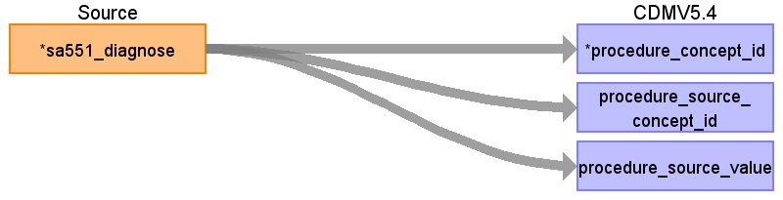

|  |  |  |  |
| --- | --- | --- | --- |
| Destination Field | Source Field | Logic | Comment |
| procedure_occurrence_id |  |  | Generated |
| visit_detail_id |  |  |  |
| person_id |  |  |  |
| procedure_date |  |  |  |
| visit_occurrence_id |  |  | Visit_occurrence_id will be created in table visit_occurrence. Need to be linked here |
| procedure_concept_id | sa551_diagnose |  | get by materialized view; remove special characters |
| procedure_source_concept_id | sa551_diagnose |  | get by materialized view; remove special characters |
| procedure_source_value | sa551_diagnose |  | Z49.1 |
| procedure_datetime |  |  |  |
| procedure_end_date |  |  |  |
| procedure_end_datetime |  |  |  |
| procedure_type_concept_id |  |  | 32810 Claim |
| modifier_concept_id |  |  |  |
| quantity |  |  |  |
| provider_id |  |  |  |
| modifier_source_value |  |  |  |

Reading from v2010sa651

Linked with visit_occurrence table to get information about visit_occurrence_id, dates, person_id

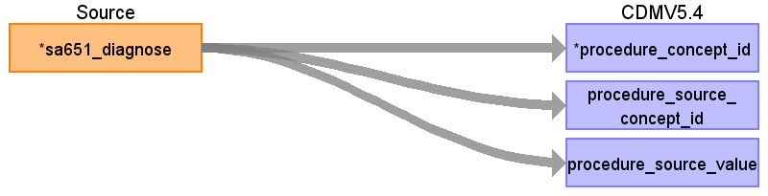

|  |  |  |  |
| --- | --- | --- | --- |
| Destination Field | Source Field | Logic | Comment |
| procedure_occurrence_id |  |  | Generated |
| visit_detail_id |  |  |  |
| person_id |  |  |  |
| procedure_date |  |  |  |
| visit_occurrence_id |  |  | Visit_occurrence_id will be created in table visit_occurrence. Need to be linked here |
| procedure_concept_id | sa651_diagnose |  | get by materialized view; remove special characters |
| procedure_source_concept_id | sa651_diagnose |  | get by materialized view; remove special characters |
| procedure_source_value | sa651_diagnose |  | Z49.1 |
| procedure_datetime |  |  |  |
| procedure_end_date |  |  |  |
| procedure_end_datetime |  |  |  |
| procedure_type_concept_id |  |  | 32810 Claim |
| modifier_concept_id |  |  |  |
| quantity |  |  |  |
| provider_id |  |  |  |
| modifier_source_value |  |  |  |

Table name: cost

Reading from v2010sa751

SA751 - Leistungsausgaben to cost

- costs

- and cost domain ( e.g. dental, pharmacy)

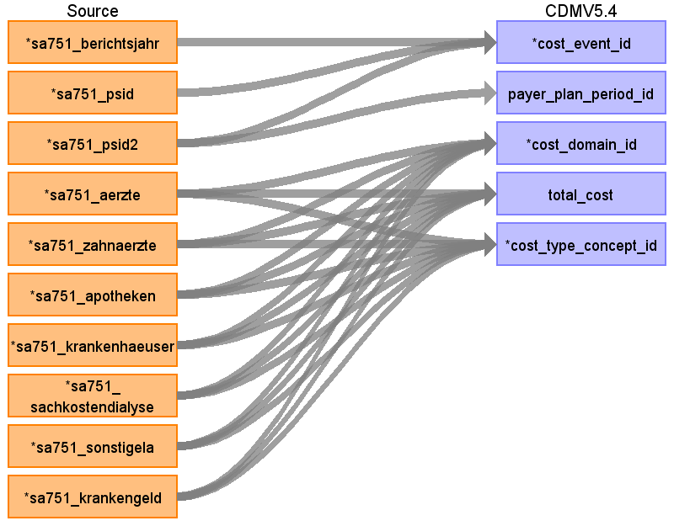

|  |  |  |  |
| --- | --- | --- | --- |
| Destination Field | Source Field | Logic | Comment |
| cost_id |  |  | Need to be generated |
| cost_event_id | sa751_psid2  sa751_psid  sa751_berichtsjahr |  | From payer_plan_period_id? |
| payer_plan_period_id | sa751_psid2 |  |  |
| cost_domain_id | sa751_aerzte  sa751_zahnaerzte  sa751_apotheken  sa751_krankenhaeuser  sa751_sonstigela  sa751_sachkostendialyse  sa751_krankengeld |  | Visit  Visit  Drug  Visit  Payer  Procedure  Payer  31985 Cost |
| total_cost | sa751_aerzte  sa751_zahnaerzte  sa751_apotheken  sa751_krankenhaeuser  sa751_sonstigela  sa751_sachkostendialyse  sa751_krankengeld |  |  |
| cost_type_concept_id | sa751_zahnaerzte  sa751_aerzte  sa751_krankenhaeuser  sa751_sachkostendialyse  sa751_krankengeld  sa751_apotheken  sa751_sonstigela |  | zahnaerzte => 32816 Dental claim  aerzte => 32871 Professional claim  krankenhaeuser => 32852 Hospital cost  sachkostendialyse => ?  krankengeld => ?  apotheken => 32869 Pharmacy claim  sonstigela => 0 |
| currency_concept_id |  |  |  |
| total_charge |  |  |  |
| total_paid |  |  |  |
| paid_by_payer |  |  |  |
| paid_by_patient |  |  |  |
| paid_patient_copay |  |  |  |
| paid_patient_coinsurance |  |  |  |
| paid_patient_deductible |  |  |  |
| paid_by_primary |  |  |  |
| paid_ingredient_cost |  |  |  |
| paid_dispensing_fee |  |  |  |
| amount_allowed |  |  |  |
| revenue_code_concept_id |  |  |  |
| revenue_code_source_value |  |  |  |
| drg_concept_id |  |  |  |
| drg_source_value |  |  |  |

Table name: location

Reading from v2010sa999

Take unique sa999_gs

SA999 - Amtlicher Gemeindeschlüssel to location

- Gemeindeschluessel to location_id

- state, county, zip

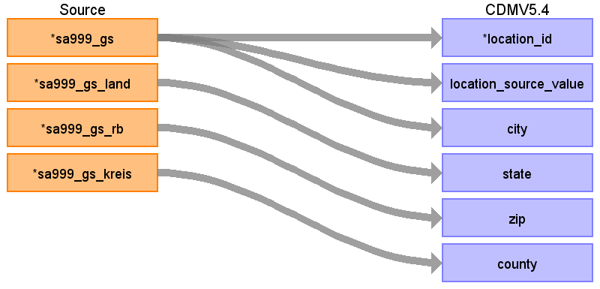

|  |  |  |  |
| --- | --- | --- | --- |
| Destination Field | Source Field | Logic | Comment |
| location_id | sa999_gs |  |  |
| address_1 |  |  |  |
| address_2 |  |  |  |
| location_source_value | sa999_gs |  |  |
| city | sa999_gs |  |  |
| state | sa999_gs_land |  |  |
| zip | sa999_gs_rb |  |  |
| county | sa999_gs_kreis |  |  |
| country_concept_id |  |  |  |
| country_source_value |  |  |  |
| latitude |  |  |  |
| longitude |  |  |  |

Table name: visit_detail

Table name: device_exposure

Table name: measurement

Reading from v2010sa551

Linked with visit_occurrence table to get information about visit_occurrence_id, dates, person_id

WHERE diagnosis.domain_id='Measurement'

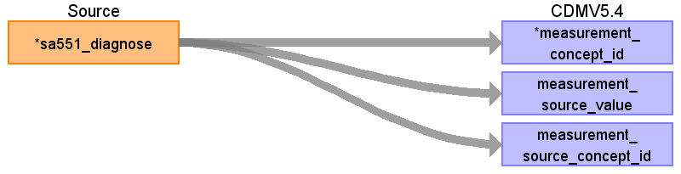

|  |  |  |  |
| --- | --- | --- | --- |
| Destination Field | Source Field | Logic | Comment |
| measurement_id |  |  | generated |
| person_id |  |  |  |
| measurement_concept_id | sa551_diagnose |  | get by materialized view; remove special characters |
| measurement_date |  |  |  |
| measurement_datetime |  |  |  |
| measurement_time |  |  |  |
| measurement_type_concept_id |  |  |  |
| operator_concept_id |  |  |  |
| value_as_number |  |  |  |
| value_as_concept_id |  |  |  |
| unit_concept_id |  |  |  |
| range_low |  |  |  |
| range_high |  |  |  |
| provider_id |  |  |  |
| visit_occurrence_id |  |  |  |
| visit_detail_id |  |  |  |
| measurement_source_value | sa551_diagnose |  |  |
| measurement_source_concept_id | sa551_diagnose |  | get by materialized view; remove special characters |
| unit_source_value |  |  |  |
| unit_source_concept_id |  |  |  |
| value_source_value |  |  |  |
| measurement_event_id |  |  |  |
| meas_event_field_concept_id |  |  |  |

Reading from v2010sa651

Linked with visit_occurrence table to get information about visit_occurrence_id, dates, person_id

WHERE diagnosis.domain_id='Measurement' and qualifizierung != 'A'

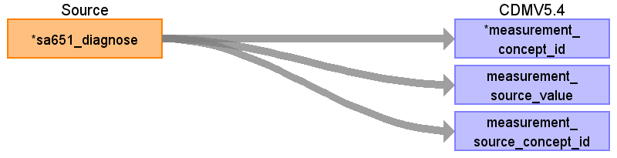

|  |  |  |  |
| --- | --- | --- | --- |
| Destination Field | Source Field | Logic | Comment |
| measurement_id |  |  | generated |
| person_id |  |  |  |
| measurement_concept_id | sa651_diagnose |  | get by materialized view; remove special characters |
| measurement_date |  |  |  |
| measurement_datetime |  |  |  |
| measurement_time |  |  |  |
| measurement_type_concept_id |  |  |  |
| operator_concept_id |  |  |  |
| value_as_number |  |  |  |
| value_as_concept_id |  |  |  |
| unit_concept_id |  |  |  |
| range_low |  |  |  |
| range_high |  |  |  |
| provider_id |  |  |  |
| visit_occurrence_id |  |  |  |
| visit_detail_id |  |  |  |
| measurement_source_value | sa651_diagnose |  | get by materialized view; remove special characters |
| measurement_source_concept_id | sa651_diagnose |  |  |
| unit_source_value |  |  |  |
| unit_source_concept_id |  |  |  |
| value_source_value |  |  |  |
| measurement_event_id |  |  |  |
| meas_event_field_concept_id |  |  |  |

Table name: note

Table name: note_nlp

Table name: specimen

Table name: fact_relationship

Table name: care_site

Table name: provider

Table name: drug_era

Table name: dose_era

Table name: condition_era

Table name: episode

Table name: episode_event

Table name: metadata

Table name: cdm_source

Table name: cohort

Table name: cohort_definition

Appendix: source tables

Table: v2010sa551

Stationäre Diagnoses

Inpatient diagnosis

|  |  |  |  |
| --- | --- | --- | --- |
| Field | Type | Most freq. value | Comment |
| sa551_psid | character |  |  |
| sa551_psid2 | numeric |  |  |
| sa551_fallzaehler | numeric | 1 | Start date is not known, only end date  Fallzaehler (case enumerator) gives the order of all happened cases |
| sa551_berichtsjahr | numeric | 2009 |  |
| sa551_entlassungsmonat | numeric | 200906 |  |
| sa551_satzart | numeric | 551 |  |
| sa551_artbehandlung | numeric | 3 |  |
| sa551_artdiagnose | numeric | 2 |  |
| sa551_ausgleichsjahr | numeric | 2010 |  |
| sa551_lokalisation | numeric | 0 |  |
| sa551_diagnose | character | Y65.4* |  |
| sa551_icd_code | character varying | U1604 |  |
| sa551_icd_zusatz | character | + |  |

Table: v2010sa651

Ambulante Diagnosen

|  |  |  |  |
| --- | --- | --- | --- |
| Field | Type | Most freq. value | Comment |
| sa651_ausgleichsjahr | numeric | 2010 |  |
| sa651_psid | character |  |  |
| sa651_berichtsjahr | numeric | 2009 |  |
| sa651_leistungsquartal | numeric | 1 |  |
| sa651_satzart | numeric | 651 |  |
| sa651_qualifizierung | character | V |  |
| sa651_psid2 | numeric |  |  |
| sa651_abrechnungsweg | numeric | 1 |  |
| sa651_lokalisation | numeric | 1 |  |
| sa651_diagnose | character | G24.4 |  |
| sa651_icd_zusatz | character | * |  |
| sa651_icd_code | character varying | P7707 |  |

Table: v2010sa152

Versichertenstammdaten

|  |  |  |  |
| --- | --- | --- | --- |
| Field | Type | Most freq. value | Comment |
| sa152_satzart | numeric | 152 |  |
| sa152_psid | character |  |  |
| sa152_berichtsjahr | numeric | 2009 |  |
| sa152_ausgleichsjahr | numeric | 2010 |  |
| sa152_psid2 | numeric |  |  |
| sa152_versichertentage13ii | numeric | 1 |  |
| sa152_erwerbsminderungs_vt | numeric | 1 |  |
| sa152_versichertentage53iv | numeric | 2 |  |
| sa152_versichertentageausland | numeric | 1 |  |
| sa152_kv_nr_kennzeichen | numeric | 0 |  |

Table: v2010sa151

|  |  |  |  |
| --- | --- | --- | --- |
| Field | Type | Most freq. value | Comment |
| sa151_psid | character |  |  |
| sa151_psid2 | numeric |  |  |
| sa151_berichtsjahr | numeric | 2010 |  |
| sa151_versichertentage | numeric | 365 |  |
| sa151_verstorben | numeric | 0 |  |
| sa151_ausgleichsjahr | numeric | 2010 |  |
| sa151_versichertentagekg | numeric | 4 |  |
| sa151_kv_nr_kennzeichen | numeric | 0 |  |
| sa151_satzart | numeric | 151 |  |
| sa151_geburtsjahr | numeric | 1959 |  |
| sa151_geschlecht | numeric | 2 |  |

Table: v2010sa951

Krankenkassenzugehörigkeit

|  |  |  |  |
| --- | --- | --- | --- |
| Field | Type | Most freq. value | Comment |
| sa951_psid2 | numeric |  |  |
| sa951_psid | character |  |  |
| sa951_ausgleichsjahr | numeric | 2010 |  |
| sa951_betriebsnummer | numeric | 2 |  |

Table: v2010sa451

Ambulante Arzneimittel

outpatient drugs

|  |  |  |  |
| --- | --- | --- | --- |
| Field | Type | Most freq. value | Comment |
| sa451_psid2 | numeric |  |  |
| sa451_satzart | numeric | 451 |  |
| sa451_psid | character |  |  |
| sa451_ausgleichsjahr | numeric | 2010 |  |
| sa451_berichtsjahr | numeric | 2009 |  |
| sa451_verordnungsdatum | numeric | 20090419 |  |
| sa451_pharmazentralnummer | numeric |  |  |
| sa451_anzahleinheitenfaktor | numeric | 951000 |  |

Table: v2010sa153

Extrakorporale Blutreinigung

Blood Purification

|  |  |  |  |
| --- | --- | --- | --- |
| Field | Type | Most freq. value | Comment |
| sa153_satzart | numeric | 153 |  |
| sa153_psid2 | numeric |  |  |
| sa153_psid | character |  |  |
| sa153_berichtsjahr | numeric | 2009 |  |
| sa153_ausgleichsjahr | numeric | 2010 |  |
| sa153_extrablutreinigung | numeric | 0 |  |
| sa153_kv_nr_kennzeichen | numeric | 1 |  |

Table: v2010sa751

Leistungsausgaben

|  |  |  |  |
| --- | --- | --- | --- |
| Field | Type | Most freq. value | Comment |
| sa751_satzart | numeric | 751 |  |
| sa751_berichtsjahr | numeric | 2010 |  |
| sa751_psid | character |  |  |
| sa751_psid2 | numeric |  |  |
| sa751_ausgleichsjahr | numeric | 2010 |  |
| sa751_aerzte | numeric |  |  |
| sa751_zahnaerzte | numeric |  |  |
| sa751_apotheken | numeric |  |  |
| sa751_krankenhaeuser | numeric | 198647 |  |
| sa751_sachkostendialyse | numeric | -4838 |  |
| sa751_sonstigela | numeric |  |  |
| sa751_krankengeld | numeric | -1369 |  |

Table: v2010sa999

Amtlicher Gemeindeschlüssel

|  |  |  |  |
| --- | --- | --- | --- |
| Field | Type | Most freq. value | Comment |
| sa999_psid | character |  |  |
| sa999_satzart | numeric | 999 |  |
| sa999_ausgleichsjahr | numeric | 2010 |  |
| sa999_berichtsjahr | numeric | 2010 |  |
| sa999_gs | numeric | 9892 |  |
| sa999_gs_land | numeric | 14 |  |
| sa999_gs_rb | numeric | 8 |  |
| sa999_gs_kreis | numeric | 60 |  |