Source Data Mapping Approach to CDMV5.4

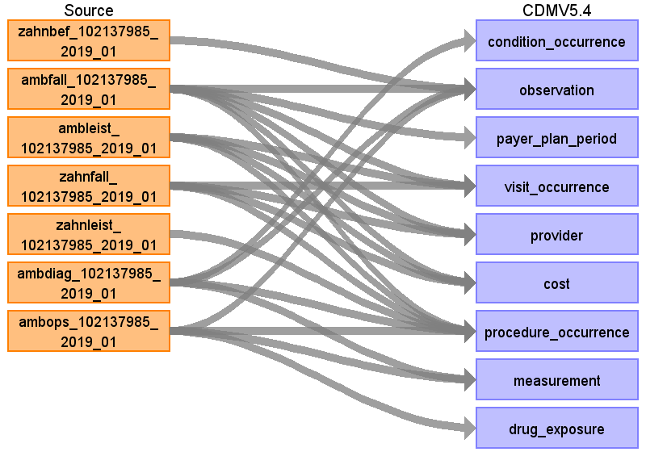

Table name: condition_occurrence

Reading from ambdiag_102137985_2019_01

Reported diagnosis to condition occurence

Where diagsich != 'A' and domain_id = 'Condition' OR domain_id IS NULL

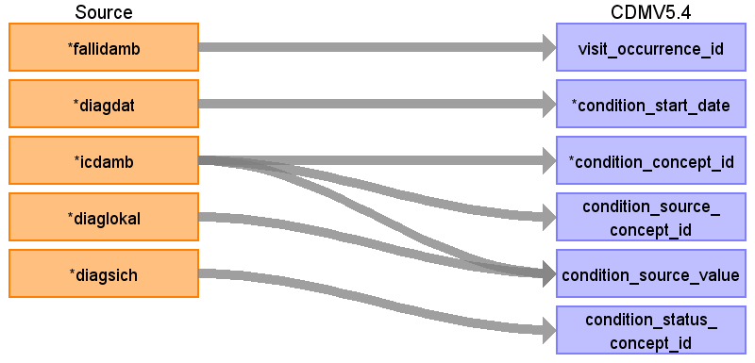

|  |  |  |  |
| --- | --- | --- | --- |
| Destination Field | Source Field | Logic | Comment |
| visit_occurrence_id | fallidamb |  | get visit_occurrence_id from table visit_occurrence; join by vsid and fallid |
| condition_occurrence_id |  |  | generate |
| condition_start_date | diagdat |  | if diagdat  elseif ambfall.beginndatamb  else if ambfall.endedatamb  else first of quartal ambfall.abrq |
| condition_concept_id | icdamb |  | ICD10-GM to SNOMED  special characters need to be removed |
| condition_source_concept_id | icdamb |  | special characters need to be removed |
| condition_source_value | icdamb  diaglokal |  | Use CONCAT (icdamb,',' , diaglokal) to keep location (left, right, both) |
| condition_status_concept_id | diagsich |  | V = Verdachtsdiagnose => 32899 Preliminary diagnosis  Z = Zustand nach betreffender Diagnose => 32906 Resolved condition  G = gesicherte Diagnose => 32893 Confirmed diagnosis  0 = sonst  A = ausgeschlossene Diagnose => excluded here! |
| person_id |  |  | link with ambfall.fallidamb |
| condition_start_datetime |  |  |  |
| condition_end_date |  |  |  |
| condition_end_datetime |  |  |  |
| condition_type_concept_id |  |  | 32810 Claim |
| stop_reason |  |  |  |
| provider_id |  |  |  |
| visit_detail_id |  |  |  |
| condition_status_source_value |  |  |  |

Table name: observation

Reading from ambfall_102137985_2019_01

Create observation if it was an accident

Keep only where variable Unfall = 2

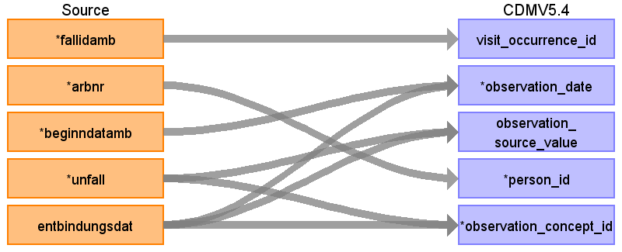

|  |  |  |  |
| --- | --- | --- | --- |
| Destination Field | Source Field | Logic | Comment |
| observation_id |  |  | for ambfall: generate |
| visit_occurrence_id | fallidamb |  | get visit_occurrence_id from table visit_occurrence; join by vsid and fallid |
| observation_date | beginndatamb  entbindungsdat |  | For accident:  IF ambfall.beginndatamb  ELSE IF ambfall.endedatamb  ELSE 1st of ambfall.abrq  For birth:  entbindungsdat  IF zahnfall.beginndatzahn  ELSEIF zahnfall.endedatzahn  ELSEIF zahnfall.leistq  ELSE zahnfall.berjahr |
| observation_source_concept_id |  |  |  |
| observation_source_value | unfall  entbindungsdat |  | If entbidungsdatum |
| person_id | arbnr |  | link to zahnfall for zahnbef |
| observation_concept_id | unfall  entbindungsdat |  | 2 => 432532 Accidental event  if entbindungsdatum:  36308290 |
| value_as_string |  |  |  |
| value_as_concept_id |  |  |  |
| provider_id |  |  |  |
| observation_datetime |  |  |  |
| observation_type_concept_id |  |  | 32810 Claim  for zahn* 32816 Dental Claim |
| value_as_number |  |  |  |
| qualifier_concept_id |  |  |  |
| unit_concept_id |  |  |  |
| visit_detail_id |  |  |  |
| unit_source_value |  |  |  |
| qualifier_source_value |  |  |  |
| value_source_value |  |  |  |
| observation_event_id |  |  |  |
| obs_event_field_concept_id |  |  |  |

Reading from zahnbef_102137985_2019_01

For finding (teeth)

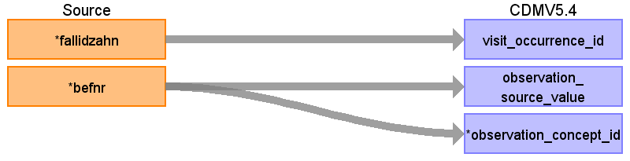

|  |  |  |  |
| --- | --- | --- | --- |
| Destination Field | Source Field | Logic | Comment |
| observation_id |  |  | for ambfall: generate |
| visit_occurrence_id | fallidzahn |  | get visit_occurrence_id from table visit_occurrence; join by vsid and fallidzahn |
| observation_date |  |  | IF zahnfall.beginndatzahn  ELSEIF zahnfall.endedatzahn  ELSEIF zahnfall.leistq  ELSE zahnfall.berjahr |
| observation_source_concept_id |  |  |  |
| observation_source_value | befnr |  |  |
| person_id |  |  | link to zahnfall for zahnbef |
| observation_concept_id | befnr |  | No mapping available yet.  For now observation_concept_id 0  later add concept |
| value_as_string |  |  |  |
| value_as_concept_id |  |  |  |
| provider_id |  |  |  |
| observation_datetime |  |  |  |
| observation_type_concept_id |  |  | 32810 Claim  for zahn* 32816 Dental Claim |
| value_as_number |  |  |  |
| qualifier_concept_id |  |  |  |
| unit_concept_id |  |  |  |
| visit_detail_id |  |  |  |
| unit_source_value |  |  |  |
| qualifier_source_value |  |  |  |
| value_source_value |  |  |  |
| observation_event_id |  |  |  |
| obs_event_field_concept_id |  |  |  |

Reading from ambdiag_102137985_2019_01

Two mappings:

Capture "excluded diagnosis" as observation

diagnosis with domain observation

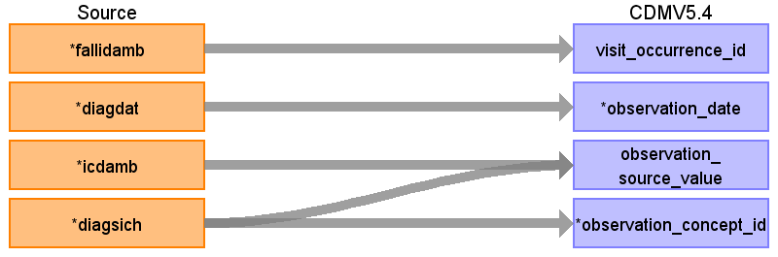

|  |  |  |  |
| --- | --- | --- | --- |
| Destination Field | Source Field | Logic | Comment |
| observation_id |  |  | for ambfall: generate |
| visit_occurrence_id | fallidamb |  | get visit_occurrence_id from table visit_occurrence; join by vsid and fallid |
| observation_date | diagdat |  | IF ambdiag.diagdat  ELSE IF ambfall.beginndatamb  ELSE IF ambfall.endedatamb  ELSE 1st of ambfall.abrq  IF zahnfall.beginndatzahn  ELSEIF zahnfall.endedatzahn  ELSEIF zahnfall.leistq  ELSE zahnfall.berjahr |
| observation_source_concept_id |  |  |  |
| observation_source_value | diagsich  icdamb |  |  |
| person_id |  |  | link to zahnfall for zahnbef |
| observation_concept_id | diagsich |  | Disorder excluded 4199812 |
| value_as_string |  |  |  |
| value_as_concept_id |  |  |  |
| provider_id |  |  |  |
| observation_datetime |  |  |  |
| observation_type_concept_id |  |  | 32810 Claim  for zahn* 32816 Dental Claim |
| value_as_number |  |  |  |
| qualifier_concept_id |  |  |  |
| unit_concept_id |  |  |  |
| visit_detail_id |  |  |  |
| unit_source_value |  |  |  |
| qualifier_source_value |  |  |  |
| value_source_value |  |  |  |
| observation_event_id |  |  |  |
| obs_event_field_concept_id |  |  |  |

Reading from ambops_102137985_2019_01

Reported diagnosis to procedure occurence

Where domain_id = '' Observation"

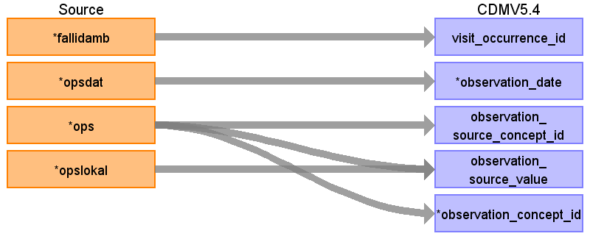

|  |  |  |  |
| --- | --- | --- | --- |
| Destination Field | Source Field | Logic | Comment |
| observation_id |  |  | for ambfall: generate |
| visit_occurrence_id | fallidamb |  | get visit_occurrence_id from table visit_occurrence; join by vsid and fallidzahn |
| observation_date | opsdat |  | IF tmp_ambops.opsdat  ELSE first day of ambfall.abrq  IF zahnfall.beginndatzahn  ELSEIF zahnfall.endedatzahn  ELSEIF zahnfall.leistq  ELSE zahnfall.berjahr |
| observation_source_concept_id | ops |  |  |
| observation_source_value | ops  opslokal |  |  |
| person_id |  |  | link to zahnfall for zahnbef |
| observation_concept_id | ops |  | map |
| value_as_string |  |  |  |
| value_as_concept_id |  |  |  |
| provider_id |  |  |  |
| observation_datetime |  |  |  |
| observation_type_concept_id |  |  | 32810 Claim  for zahn* 32816 Dental Claim |
| value_as_number |  |  |  |
| qualifier_concept_id |  |  |  |
| unit_concept_id |  |  |  |
| visit_detail_id |  |  |  |
| unit_source_value |  |  |  |
| qualifier_source_value |  |  |  |
| value_source_value |  |  |  |
| observation_event_id |  |  |  |
| obs_event_field_concept_id |  |  |  |

Table name: payer_plan_period

Reading from ambfall_102137985_2019_01

Payer_plan_period captures the basic information of the health insurance contract which is identified by svnr. (=> select distinct by svnr and use first and last quartal to determine overall duration of contract)

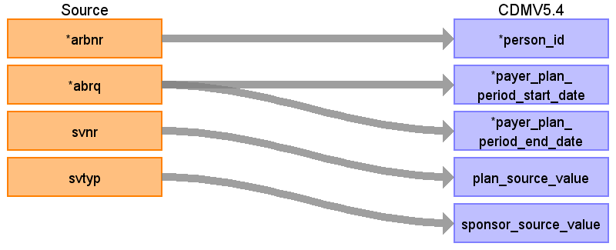

|  |  |  |  |
| --- | --- | --- | --- |
| Destination Field | Source Field | Logic | Comment |
| payer_plan_period_id |  |  |  |
| person_id | arbnr |  |  |
| payer_plan_period_start_date | abrq |  | Format JJJJQ  1st day of 1st month of quartal |
| payer_plan_period_end_date | abrq |  | last day of last month of the max quartal  Format JJJJQ  We assume a continouse period  E.g. MIN(Q)= 1 MAX(Q) =3 -> We assume insures by the insurance in Q2 |
| payer_concept_id |  |  |  |
| payer_source_value |  |  | kassenik (format was updated, therefore not part of the scanned data yet) |
| payer_source_concept_id |  |  |  |
| plan_concept_id |  |  |  |
| plan_source_value | svnr |  | LAST_VALUE(ambfall.svnr) OVER( PARTITION BY ambfall.arbnr ORDER BY ambfall.abrq) |
| plan_source_concept_id |  |  |  |
| sponsor_concept_id |  |  |  |
| sponsor_source_value | svtyp |  | LAST_VALUE(ambfall.svtyp) OVER( PARTITION BY ambfall.arbnr ORDER BY ambfall.abrq) |
| sponsor_source_concept_id |  |  |  |
| family_source_value |  |  |  |
| stop_reason_concept_id |  |  |  |
| stop_reason_source_value |  |  |  |
| stop_reason_source_concept_id |  |  |  |

Table name: visit_occurrence

Reading from ambfall_102137985_2019_01

To capture outpatient case

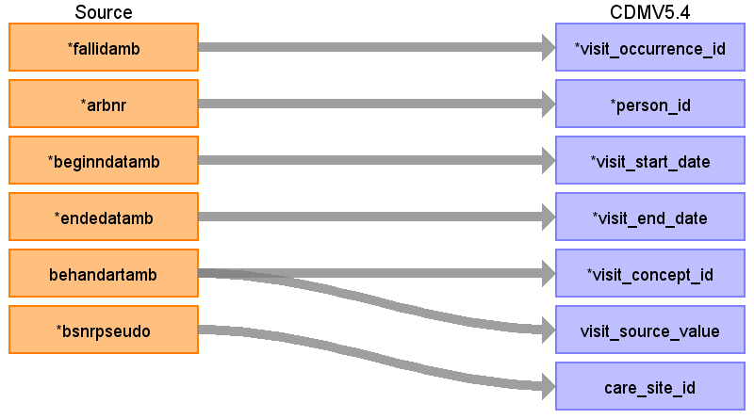

|  |  |  |  |
| --- | --- | --- | --- |
| Destination Field | Source Field | Logic | Comment |
| visit_occurrence_id | fallidamb |  | generating visit_occurrence_id; join by vsid and fallidzahn |
| person_id | arbnr |  |  |
| visit_start_date | beginndatamb |  | IF ambfall.beginndatamb  ELSE IF ambfall.endedatamb  ELSE 1st of ambfall.abrq |
| visit_end_date | endedatamb |  | IF ambfall.endedatamb  ELSE IF ambfall.beginndatamb  ELSE 1st of ambfall.abrq |
| visit_start_datetime |  |  |  |
| visit_concept_id | behandartamb |  | 1 = ambulant (default) => 9202 Outpatient Visit  2 = stationär => 9201 Inpatient Visit |
| visit_source_concept_id |  |  |  |
| provider_id |  |  | for ambfall to visit occurrence:  ambleist.lanrpseudo |
| visit_source_value | behandartamb |  |  |
| visit_end_datetime |  |  |  |
| visit_type_concept_id |  |  | For table Zahnfall 32816 Dental Claim  o.w. 32810 Claim |
| care_site_id | bsnrpseudo |  |  |
| admitted_from_concept_id |  |  |  |
| admitted_from_source_value |  |  |  |
| discharged_to_concept_id |  |  |  |
| discharged_to_source_value |  |  |  |
| preceding_visit_occurrence_id |  |  |  |

Reading from zahnfall_102137985_2019_01

Full join on pseudonym physician identifier number

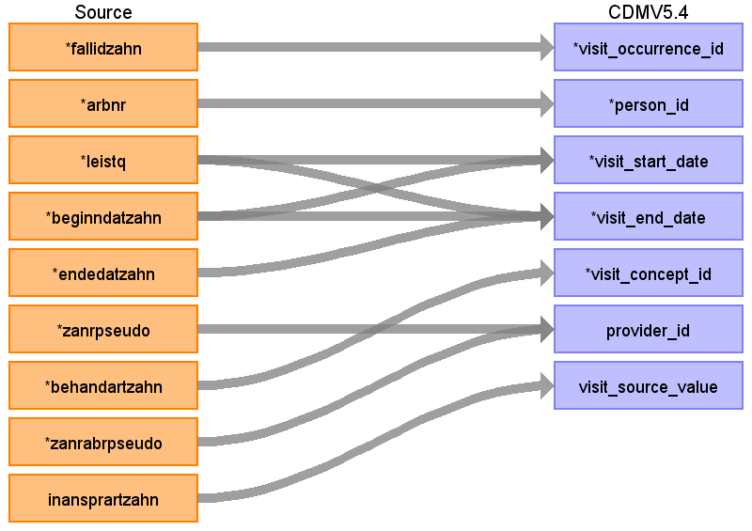

|  |  |  |  |
| --- | --- | --- | --- |
| Destination Field | Source Field | Logic | Comment |
| visit_occurrence_id | fallidzahn |  | generating visit_occurrence_id; join by vsid and fallid |
| person_id | arbnr |  |  |
| visit_start_date | beginndatzahn  leistq |  | If is none 1st of leistq else beginndatzahn (Format in example data JJJJMMDD, data description differs)  IF zahnfall.beginndatzahn  ELSEIF zahnfall.endedatzahn  ELSEIF zahnfall.leistq  ELSE zahnfall.berjahr |
| visit_end_date | endedatzahn  leistq  beginndatzahn |  | IF zahnfall.endedatzahn  ELSEIF zahnfall.beginndatzahn  ELSEIF zahnfall.leistq  ELSE zahnfall.berjahr  In case endedatzahn is empty use begindatzzahn  if beginndatzahn is empty use first day of first month of quartal (We assume, visit duration equals one day)  If quarter is none use berjahr |
| visit_start_datetime |  |  |  |
| visit_concept_id | behandartzahn |  | 38004218 Ambulatory Dental Clinic / Center |
| visit_source_concept_id |  |  |  |
| provider_id | zanrabrpseudo  zanrpseudo |  | In case zanrpseoudo is NULL  for ambfall to visit occurrence:  ambleist.lanrpseudo |
| visit_source_value | inansprartzahn |  | Type of treatment (  A = regular treatment  F = early treatment  V = Prolonged treatment  L = Empty quarter  D = Diagnostics before treatment or individual measures outside ongoing treatment  N = Emergency stand-in  R = Retention quarter  ) |
| visit_end_datetime |  |  |  |
| visit_type_concept_id |  |  | For table Zahnfall 32816 Dental Claim  o.w. 32810 Claim |
| care_site_id |  |  |  |
| admitted_from_concept_id |  |  |  |
| admitted_from_source_value |  |  |  |
| discharged_to_concept_id |  |  |  |
| discharged_to_source_value |  |  |  |
| preceding_visit_occurrence_id |  |  |  |

Reading from ambleist_102137985_2019_01

Join with ambfall

We only get provider as information of table ambleist

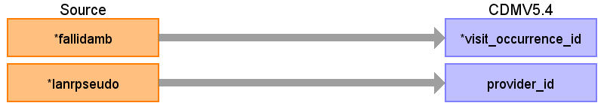

|  |  |  |  |
| --- | --- | --- | --- |
| Destination Field | Source Field | Logic | Comment |
| visit_occurrence_id | fallidamb |  | generating visit_occurrence_id; join by vsid and fallidzahn |
| person_id |  |  |  |
| visit_start_date |  |  |  |
| visit_end_date |  |  |  |
| visit_start_datetime |  |  |  |
| visit_concept_id |  |  |  |
| visit_source_concept_id |  |  |  |
| provider_id | lanrpseudo |  | for ambfall to visit occurrence:  ambleist.lanrpseudo |
| visit_source_value |  |  |  |
| visit_end_datetime |  |  |  |
| visit_type_concept_id |  |  | For table Zahnfall 32816 Dental Claim  o.w. 32810 Claim |
| care_site_id |  |  |  |
| admitted_from_concept_id |  |  |  |
| admitted_from_source_value |  |  |  |
| discharged_to_concept_id |  |  |  |
| discharged_to_source_value |  |  |  |
| preceding_visit_occurrence_id |  |  |  |

Table name: provider

Reading from ambleist_102137985_2019_01

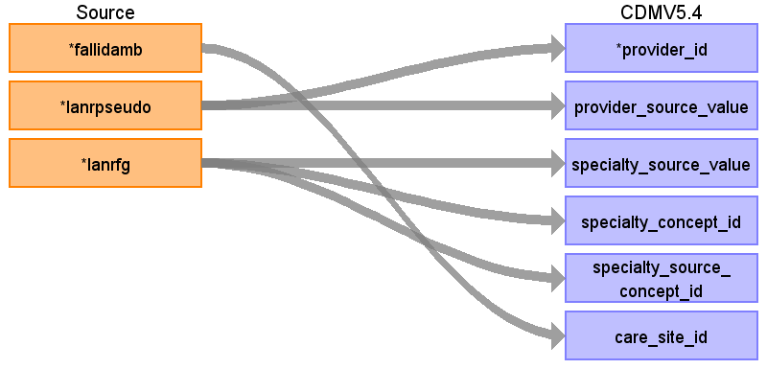

|  |  |  |  |
| --- | --- | --- | --- |
| Destination Field | Source Field | Logic | Comment |
| provider_id | lanrpseudo |  | link to care_site with fallidamb |
| provider_source_value | lanrpseudo |  |  |
| provider_name |  |  |  |
| npi |  |  |  |
| dea |  |  |  |
| specialty_source_value | lanrfg |  |  |
| specialty_concept_id | lanrfg |  | https://applications.kbv.de/S_BAR2_ARZTNRFACHGRUPPE_V1.03.xhtml |
| specialty_source_concept_id | lanrfg |  | customized concept  create customized concept  https://applications.kbv.de/S_BAR2_ARZTNRFACHGRUPPE_V1.03.xhtml |
| care_site_id | fallidamb |  | Link ambfall.bsnrpseudo by fallidamb |
| year_of_birth |  |  |  |
| gender_concept_id |  |  |  |
| gender_source_value |  |  |  |
| gender_source_concept_id |  |  |  |

Reading from zahnfall_102137985_2019_01

Full join on pseudonym physician identifier number

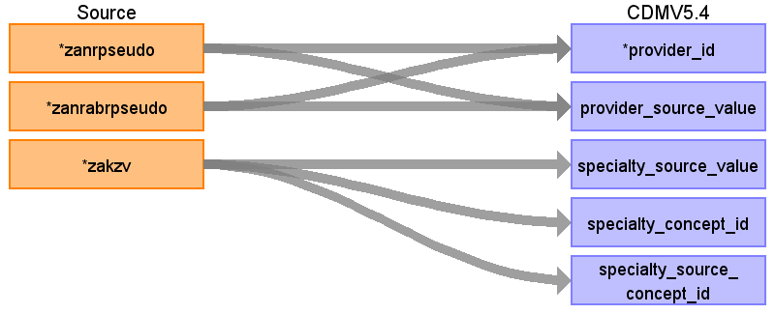

|  |  |  |  |
| --- | --- | --- | --- |
| Destination Field | Source Field | Logic | Comment |
| provider_id | zanrabrpseudo  zanrpseudo |  | In case zanrpseudo is NULL |
| provider_source_value | zanrabrpseudo  zanrpseudo |  | Run twice, once for zanrpseudo, once for zanrabpseudo |
| provider_name |  |  |  |
| npi |  |  |  |
| dea |  |  |  |
| specialty_source_value | zakzv |  |  |
| specialty_concept_id | zakzv |  | For now: 38003675 General Dentistry  Asked BfArM for definition of catgeories  https://applications.kbv.de/S_BAR2_ARZTNRFACHGRUPPE_V1.03.xhtml |
| specialty_source_concept_id | zakzv |  | 0  create customized concept  https://applications.kbv.de/S_BAR2_ARZTNRFACHGRUPPE_V1.03.xhtml |
| care_site_id |  |  | Link ambfall.bsnrpseudo by fallidamb |
| year_of_birth |  |  |  |
| gender_concept_id |  |  |  |
| gender_source_value |  |  |  |
| gender_source_concept_id |  |  |  |

Reading from ambfall_102137985_2019_01

Link to ambleist to get Betriebsstätte (care_site) of treating physician

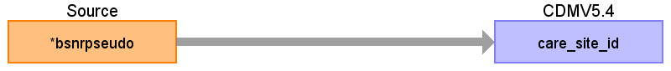

|  |  |  |  |
| --- | --- | --- | --- |
| Destination Field | Source Field | Logic | Comment |
| provider_id |  |  |  |
| provider_source_value |  |  |  |
| provider_name |  |  |  |
| npi |  |  |  |
| dea |  |  |  |
| specialty_source_value |  |  |  |
| specialty_concept_id |  |  | https://applications.kbv.de/S_BAR2_ARZTNRFACHGRUPPE_V1.03.xhtml |
| specialty_source_concept_id |  |  | create customized concept  https://applications.kbv.de/S_BAR2_ARZTNRFACHGRUPPE_V1.03.xhtml |
| care_site_id | bsnrpseudo |  | Use fallidamb to combine with physician pseudonym  Link ambfall.bsnrpseudo by fallidamb |
| year_of_birth |  |  |  |
| gender_concept_id |  |  |  |
| gender_source_value |  |  |  |
| gender_source_concept_id |  |  |  |

Table name: cost

Reading from ambfall_102137985_2019_01

One entry for dialysesachkosten and one for all other costs

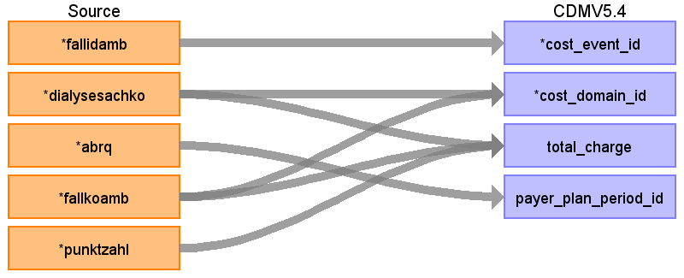

|  |  |  |  |
| --- | --- | --- | --- |
| Destination Field | Source Field | Logic | Comment |
| cost_id |  |  | generate |
| cost_event_id | fallidamb |  | fallidamb is used as either procedure or visit_occurence_id |
| cost_domain_id | dialysesachko  fallkoamb |  | Visit  Visit  Visit |
| cost_type_concept_id |  |  | Based on mapped table  32810 Claim  32816 Dental Claim |
| currency_concept_id |  |  | 44818568 Euro |
| total_charge | dialysesachko  fallkoamb  punktzahl |  | Either given as fallkoamb or punktzahl (therefore just add them up)  punktzahl * 5,82873 Cent |
| total_cost |  |  |  |
| total_paid |  |  |  |
| paid_by_payer |  |  |  |
| paid_by_patient |  |  |  |
| paid_patient_copay |  |  |  |
| paid_patient_coinsurance |  |  |  |
| paid_patient_deductible |  |  |  |
| paid_by_primary |  |  |  |
| paid_ingredient_cost |  |  |  |
| paid_dispensing_fee |  |  |  |
| payer_plan_period_id | abrq |  | LEFTpayer_plan_period ON ambfall.arbnr=person_id  and abrq BETWEEN pp.payer_plan_period_start_date AND pp.payer_plan_period_end_date |
| amount_allowed |  |  |  |
| revenue_code_concept_id |  |  |  |
| revenue_code_source_value |  |  |  |
| drg_concept_id |  |  |  |
| drg_source_value |  |  |  |

Reading from ambleist_102137985_2019_01

Total costs in terms of tarif number

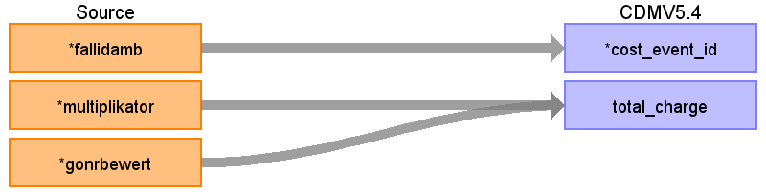

|  |  |  |  |
| --- | --- | --- | --- |
| Destination Field | Source Field | Logic | Comment |
| cost_id |  |  | generate |
| cost_event_id | fallidamb |  | We link to the Visit with fallidamb as visit_occurence_id |
| cost_domain_id |  |  | Visit |
| cost_type_concept_id |  |  | Based on mapped table  32810 Claim  32816 Dental Claim |
| currency_concept_id |  |  | 44818568 Euro |
| total_charge | multiplikator  gonrbewert |  | multiplikator* gonrbewert |
| total_cost |  |  |  |
| total_paid |  |  |  |
| paid_by_payer |  |  |  |
| paid_by_patient |  |  |  |
| paid_patient_copay |  |  |  |
| paid_patient_coinsurance |  |  |  |
| paid_patient_deductible |  |  |  |
| paid_by_primary |  |  |  |
| paid_ingredient_cost |  |  |  |
| paid_dispensing_fee |  |  |  |
| payer_plan_period_id |  |  |  |
| amount_allowed |  |  |  |
| revenue_code_concept_id |  |  |  |
| revenue_code_source_value |  |  |  |
| drg_concept_id |  |  |  |
| drg_source_value |  |  |  |

Reading from zahnfall_102137985_2019_01

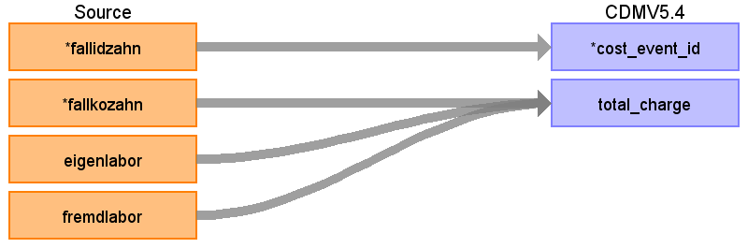

|  |  |  |  |
| --- | --- | --- | --- |
| Destination Field | Source Field | Logic | Comment |
| cost_id |  |  | generate |
| cost_event_id | fallidzahn |  | Link to Visit with visit_occurence_id with fallidamb |
| cost_domain_id |  |  | Visit |
| cost_type_concept_id |  |  | Based on mapped table  32810 Claim  32816 Dental Claim |
| currency_concept_id |  |  | 44818568 Euro |
| total_charge | fremdlabor  fallkozahn  eigenlabor |  | Waiting for BfArM to reply if fallkozahn includes eigenlabor and fremdlabor or if it is in addition. |
| total_cost |  |  |  |
| total_paid |  |  |  |
| paid_by_payer |  |  |  |
| paid_by_patient |  |  |  |
| paid_patient_copay |  |  |  |
| paid_patient_coinsurance |  |  |  |
| paid_patient_deductible |  |  |  |
| paid_by_primary |  |  |  |
| paid_ingredient_cost |  |  |  |
| paid_dispensing_fee |  |  |  |
| payer_plan_period_id |  |  |  |
| amount_allowed |  |  |  |
| revenue_code_concept_id |  |  |  |
| revenue_code_source_value |  |  |  |
| drg_concept_id |  |  |  |
| drg_source_value |  |  |  |

Table name: procedure_occurrence

Reading from ambops_102137985_2019_01

Reported diagnosis to procedure occurence

Where domain_id = '' Procedure" OR domain_id is None

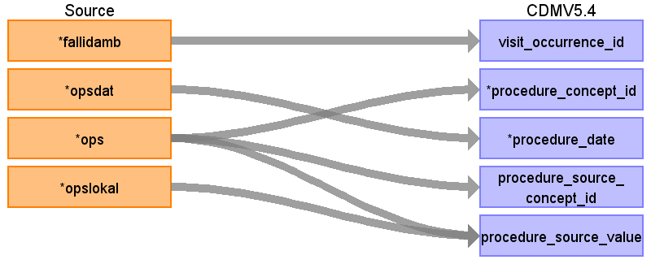

|  |  |  |  |
| --- | --- | --- | --- |
| Destination Field | Source Field | Logic | Comment |
| visit_occurrence_id | fallidamb |  | get visit_occurrence_id from table visit_occurrence; join by vsid and fallid |
| procedure_concept_id | ops |  |  |
| person_id |  |  | link by ambfall.fallidamb |
| procedure_date | opsdat |  | IF tmp_ambops.opsdat  ELSE first day of ambfall.abrq  Use quarter if beginddatamb is None |
| procedure_source_concept_id | ops |  |  |
| procedure_occurrence_id |  |  | Generate |
| procedure_source_value | ops  opslokal |  | CONCAT (ops,',',opslokal) to keep tlocation (left, right, both) |
| procedure_datetime |  |  |  |
| procedure_end_date |  |  |  |
| provider_id |  |  |  |
| procedure_end_datetime |  |  |  |
| procedure_type_concept_id |  |  | 32810 Claim  (for Zahnfall 32816 Dental claim ) |
| modifier_concept_id |  |  |  |
| quantity |  |  |  |
| visit_detail_id |  |  |  |
| modifier_source_value |  |  |  |

Reading from zahnfall_102137985_2019_01

Capture kind of service

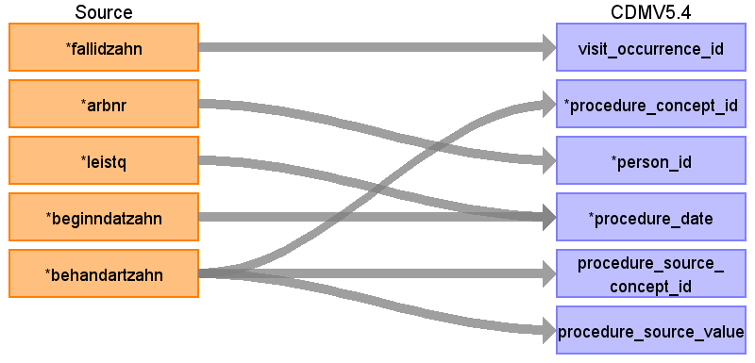

|  |  |  |  |
| --- | --- | --- | --- |
| Destination Field | Source Field | Logic | Comment |
| visit_occurrence_id | fallidzahn |  | get visit_occurrence_id from table visit_occurrence; join by vsid and fallid |
| procedure_concept_id | behandartzahn |  | WHEN 'KC'then 4208099  WHEN 'KB' then 4142524  WHEN 'KF' then 4323584  WHEN 'PA' then 4136086  WHEN 'ZE' then 4265926 |
| person_id | arbnr |  | link by ambfall.fallidamb |
| procedure_date | beginndatzahn  leistq |  | If not None o.w. first of quartal  IF zahnfall.beginndatzahn  ELSEIF zahnfall.endedatzahn  ELSEIF zahnfall.leistq  ELSE zahnfall.berjahr  Use quarter if beginddatamb is None |
| procedure_source_concept_id | behandartzahn |  | 0 (since no source concept available) |
| procedure_occurrence_id |  |  | Generate |
| procedure_source_value | behandartzahn |  | WHEN 'KC'then 'KC: Conservative surgical services'  WHEN 'KB' then 'KB: Jaw fracture, TMJ disorder'  WHEN 'KF' then 'KF: Orthodontic services'  WHEN 'PA' then 'PA: Benefits for paradonthosis'  WHEN 'ZE' then 'ZE: Dental prosthesis services' |
| procedure_datetime |  |  |  |
| procedure_end_date |  |  |  |
| provider_id |  |  |  |
| procedure_end_datetime |  |  |  |
| procedure_type_concept_id |  |  | 32810 Claim  (for Zahnfall 32816 Dental claim ) |
| modifier_concept_id |  |  |  |
| quantity |  |  |  |
| visit_detail_id |  |  |  |
| modifier_source_value |  |  |  |

Reading from zahnleist_102137985_2019_01

Map tarif number

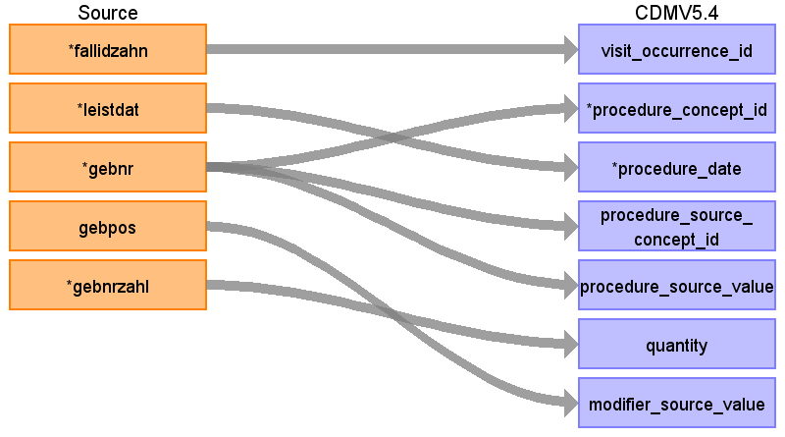

|  |  |  |  |
| --- | --- | --- | --- |
| Destination Field | Source Field | Logic | Comment |
| visit_occurrence_id | fallidzahn |  | get visit_occurrence_id from table visit_occurrence; join by vsid and fallid |
| procedure_concept_id | gebnr |  | 0 since no mapping to standard |
| person_id |  |  | link by ambfall.fallidamb |
| procedure_date | leistdat |  | IF leistdat  ELSEIF zahnfall.leistq  ELSE zahnfall.berjahr  Use quarter if beginddatamb is None |
| procedure_source_concept_id | gebnr |  | Custom EBM mapping |
| procedure_occurrence_id |  |  | Generate |
| procedure_source_value | gebnr |  |  |
| procedure_datetime |  |  |  |
| procedure_end_date |  |  |  |
| provider_id |  |  |  |
| procedure_end_datetime |  |  |  |
| procedure_type_concept_id |  |  | 32810 Claim  (for Zahnfall 32816 Dental claim ) |
| modifier_concept_id |  |  |  |
| quantity | gebnrzahl |  |  |
| visit_detail_id |  |  |  |
| modifier_source_value | gebpos |  |  |

Reading from ambfall_102137985_2019_01

Capture dialyse

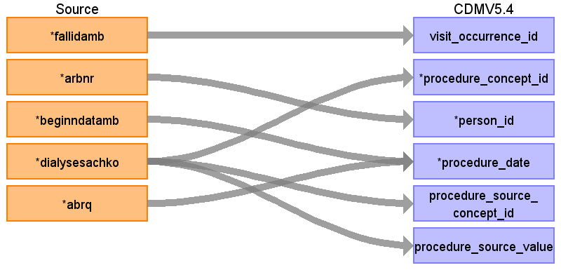

|  |  |  |  |
| --- | --- | --- | --- |
| Destination Field | Source Field | Logic | Comment |
| visit_occurrence_id | fallidamb |  | get visit_occurrence_id from table visit_occurrence; join by vsid and fallid |
| procedure_concept_id | dialysesachko |  | Map only if dialysesachkosten is not None or zero  Z49.1 -> 37097686 ICD10GM => 4032243 SNOMED |
| person_id | arbnr |  | link by ambfall.fallidamb |
| procedure_date | beginndatamb  abrq |  | IF ambfall.beginndatamb  ELSE IF ambfall.endedatamb  ELSE 1st of ambfall.abrq  Use quarter if beginddatamb is None |
| procedure_source_concept_id | dialysesachko |  |  |
| procedure_occurrence_id |  |  | Generate |
| procedure_source_value | dialysesachko |  |  |
| procedure_datetime |  |  |  |
| procedure_end_date |  |  |  |
| provider_id |  |  |  |
| procedure_end_datetime |  |  |  |
| procedure_type_concept_id |  |  | 32810 Claim  (for Zahnfall 32816 Dental claim ) |
| modifier_concept_id |  |  |  |
| quantity |  |  |  |
| visit_detail_id |  |  |  |
| modifier_source_value |  |  |  |

Reading from ambleist_102137985_2019_01

To capture Gebührenordnungsnummer (it is used to determine the settlement amount but also gives information of services which was provided)

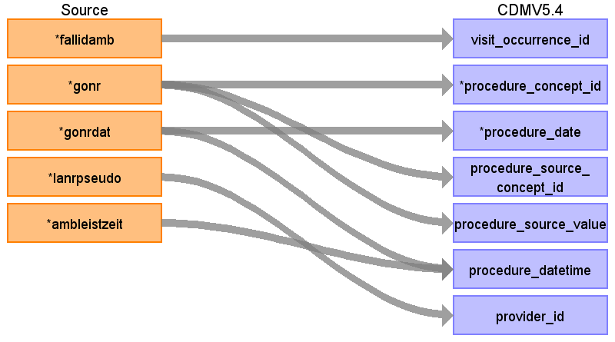

|  |  |  |  |
| --- | --- | --- | --- |
| Destination Field | Source Field | Logic | Comment |
| visit_occurrence_id | fallidamb |  | get visit_occurrence_id from table visit_occurrence; join by vsid and fallid |
| procedure_concept_id | gonr |  | 0 since no mapping to standard |
| person_id |  |  | link by ambfall.fallidamb |
| procedure_date | gonrdat |  | Use quarter if beginddatamb is None |
| procedure_source_concept_id | gonr |  | Custom EBM mapping |
| procedure_occurrence_id |  |  | Generate |
| procedure_source_value | gonr |  |  |
| procedure_datetime | ambleistzeit  gonrdat |  |  |
| procedure_end_date |  |  |  |
| provider_id | lanrpseudo |  |  |
| procedure_end_datetime |  |  |  |
| procedure_type_concept_id |  |  | 32810 Claim  (for Zahnfall 32816 Dental claim ) |
| modifier_concept_id |  |  |  |
| quantity |  |  |  |
| visit_detail_id |  |  |  |
| modifier_source_value |  |  |  |

Reading from ambdiag_102137985_2019_01

Reported diagnosis to condition occurence

Where diagsich != 'A' and domain_id = '' Procedure"

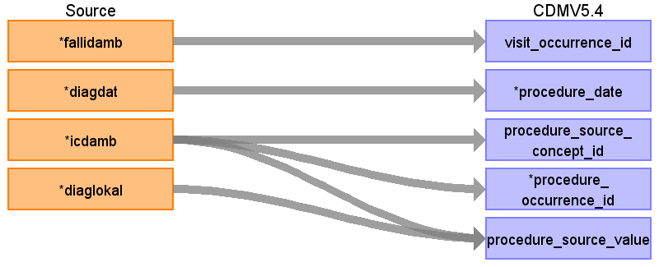

|  |  |  |  |
| --- | --- | --- | --- |
| Destination Field | Source Field | Logic | Comment |
| visit_occurrence_id | fallidamb |  | get visit_occurrence_id from table visit_occurrence; join by vsid and fallid |
| procedure_concept_id |  |  |  |
| person_id |  |  | link by ambfall.fallidamb |
| procedure_date | diagdat |  | if diagdat  elseif ambfall.beginndatamb  else if ambfall.endedatamb  else first of quartal ambfall.abrq  Use quarter if beginddatamb is None |
| procedure_source_concept_id | icdamb |  |  |
| procedure_occurrence_id | icdamb |  | Generate |
| procedure_source_value | icdamb  diaglokal |  |  |
| procedure_datetime |  |  |  |
| procedure_end_date |  |  |  |
| provider_id |  |  |  |
| procedure_end_datetime |  |  |  |
| procedure_type_concept_id |  |  | 32810 Claim  (for Zahnfall 32816 Dental claim ) |
| modifier_concept_id |  |  |  |
| quantity |  |  |  |
| visit_detail_id |  |  |  |
| modifier_source_value |  |  |  |

Table name: visit_detail

Table name: observation_period

Table name: measurement

Reading from ambdiag_102137985_2019_01

Reported diagnosis to condition occurence

Where diagsich != 'A' and domain_id = '' Measurement"

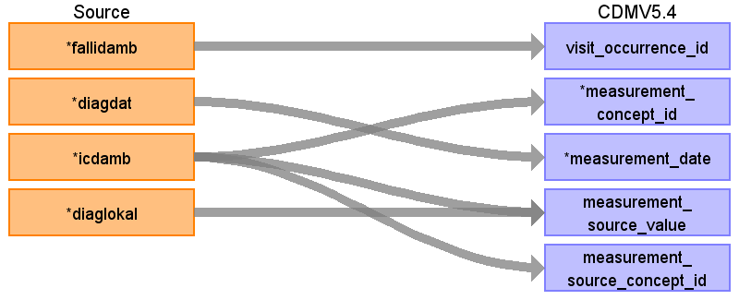

|  |  |  |  |
| --- | --- | --- | --- |
| Destination Field | Source Field | Logic | Comment |
| visit_occurrence_id | fallidamb |  | get visit_occurrence_id from table visit_occurrence; join by vsid and fallid |
| measurement_id |  |  | Generate |
| person_id |  |  | link bei fallid |
| measurement_concept_id | icdamb |  |  |
| measurement_date | diagdat |  | if diagdat  elseif ambfall.beginndatamb  else if ambfall.endedatamb  else first of quartal ambfall.abrq |
| measurement_datetime |  |  |  |
| measurement_time |  |  |  |
| measurement_type_concept_id |  |  | claim |
| operator_concept_id |  |  |  |
| value_as_number |  |  |  |
| value_as_concept_id |  |  |  |
| unit_concept_id |  |  |  |
| range_low |  |  |  |
| range_high |  |  |  |
| provider_id |  |  |  |
| visit_detail_id |  |  |  |
| measurement_source_value | diaglokal  icdamb |  |  |
| measurement_source_concept_id | icdamb |  |  |
| unit_source_value |  |  |  |
| unit_source_concept_id |  |  |  |
| value_source_value |  |  |  |
| measurement_event_id |  |  |  |
| meas_event_field_concept_id |  |  |  |

Reading from ambops_102137985_2019_01

Reported diagnosis to procedure occurence

Where domain_id = '' Measurement"

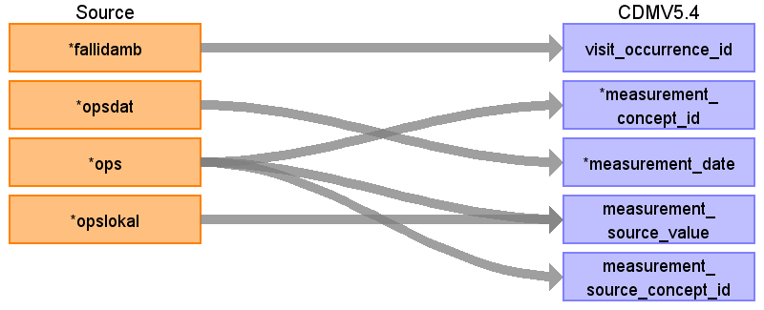

|  |  |  |  |
| --- | --- | --- | --- |
| Destination Field | Source Field | Logic | Comment |
| visit_occurrence_id | fallidamb |  | get visit_occurrence_id from table visit_occurrence; join by vsid and fallid |
| measurement_id |  |  | Generate |
| person_id |  |  | link bei fallid |
| measurement_concept_id | ops |  |  |
| measurement_date | opsdat |  | IF tmp_ambops.opsdat  ELSE first day of ambfall.abrq |
| measurement_datetime |  |  |  |
| measurement_time |  |  |  |
| measurement_type_concept_id |  |  | claim |
| operator_concept_id |  |  |  |
| value_as_number |  |  |  |
| value_as_concept_id |  |  |  |
| unit_concept_id |  |  |  |
| range_low |  |  |  |
| range_high |  |  |  |
| provider_id |  |  |  |
| visit_detail_id |  |  |  |
| measurement_source_value | opslokal  ops |  |  |
| measurement_source_concept_id | ops |  |  |
| unit_source_value |  |  |  |
| unit_source_concept_id |  |  |  |
| value_source_value |  |  |  |
| measurement_event_id |  |  |  |
| meas_event_field_concept_id |  |  |  |

Table name: person

Table name: drug_exposure

Reading from ambops_102137985_2019_01

Reported diagnosis to procedure occurence

Where diagsich != 'A' and domain_id = '' Drug"

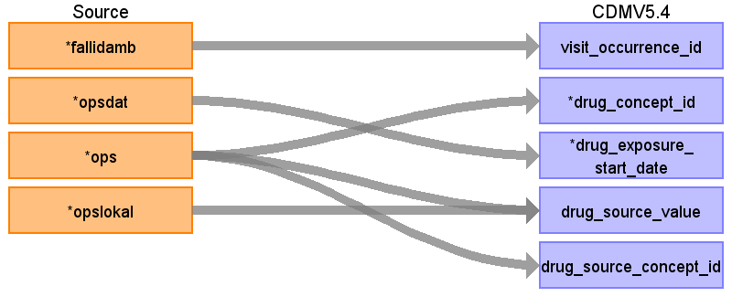

|  |  |  |  |
| --- | --- | --- | --- |
| Destination Field | Source Field | Logic | Comment |
| visit_occurrence_id | fallidamb |  | get visit_occurrence_id from table visit_occurrence; join by vsid and fallidzahn |
| drug_exposure_id |  |  |  |
| person_id |  |  |  |
| drug_concept_id | ops |  |  |
| drug_exposure_start_date | opsdat |  | IF tmp_ambops.opsdat  ELSE first day of ambfall.abrq |
| drug_exposure_start_datetime |  |  |  |
| drug_exposure_end_date |  |  |  |
| drug_exposure_end_datetime |  |  |  |
| verbatim_end_date |  |  |  |
| drug_type_concept_id |  |  |  |
| stop_reason |  |  |  |
| refills |  |  |  |
| quantity |  |  |  |
| days_supply |  |  |  |
| sig |  |  |  |
| route_concept_id |  |  |  |
| lot_number |  |  |  |
| provider_id |  |  |  |
| visit_detail_id |  |  |  |
| drug_source_value | ops  opslokal |  |  |
| drug_source_concept_id | ops |  |  |
| route_source_value |  |  |  |
| dose_unit_source_value |  |  |  |

Table name: care_site

Table name: device_exposure

Table name: death

Table name: note

Table name: note_nlp

Table name: specimen

Table name: fact_relationship

Table name: location

Table name: drug_era

Table name: dose_era

Table name: condition_era

Table name: episode

Table name: episode_event

Table name: metadata

Table name: cdm_source

Table name: cohort

Table name: cohort_definition

Appendix: source tables

Table: zahnbef_102137985_2019_01

|  |  |  |  |
| --- | --- | --- | --- |
| Field | Type | Most freq. value | Comment |
| fallidzahn | numeric |  |  |
| befnr | character varying | 893 |  |
| zahn | character varying | Supercalifragilisticexpialigetisch |  |
| refart | character varying |  |  |
| befnrzahl | numeric | 200 |  |

Table: ambfall_102137985_2019_01

|  |  |  |  |
| --- | --- | --- | --- |
| Field | Type | Most freq. value | Comment |
| fallidamb | numeric |  |  |
| arbnr | numeric |  |  |
| beginndatamb | numeric | 20190526 |  |
| lanruebpseudo | numeric |  |  |
| dialysesachko | money | 98,21 € |  |
| abrq | numeric | 20192 |  |
| fallkoamb | money | 31,09 € |  |
| endedatamb | numeric | 20190529 |  |
| behandartamb | numeric |  |  |
| bsnrpseudo | numeric |  |  |
| unfall | numeric | 3 | 0 = default  2 = Unfall/-folgen  3 = Versorgungsleiden (-> confirmed by an official service, Causes might be disease/diability caused by military service, vaccination, victim of act of violence, .. ) |
| punktzahl | money | 801,70 € |  |
| lanruebfg | numeric |  |  |
| inansprartamb | character varying | 4 | 0 = direkt  O/1 = Originalschein (Default)  V/2 = Vertreterschein  N/3 = Notfallschein  Z/4 = Auftragsleistungen  K/5 = Konsiliaruntersuchung  M/6 = Mit-/ Weiterbehandlung  7 = Abrechnung Verträge nach §§ 73b,c SGB V  8 = Abrechnung Verträge nach § 140a SGB V |
| lanruebpruef | character varying |  |  |
| svnr | character varying |  |  |
| svtyp | numeric |  |  |
| bsnrkv | numeric | 52 | Regional code of the operating facility of the attending physician |
| bsnruebpseudo | numeric |  |  |
| bsnruebkv | numeric |  |  |
| entbindungsdat | numeric |  |  |

Table: ambleist_102137985_2019_01

|  |  |  |  |
| --- | --- | --- | --- |
| Field | Type | Most freq. value | Comment |
| fallidamb | numeric |  |  |
| gonr | character varying | 03030 | tarif number (it defines the "service" (like consultation, examination) and justifies the costs) |
| gonrdat | numeric | 20190526 |  |
| nbsnrpseudo | numeric |  |  |
| lanrpseudo | numeric | 182042383407 |  |
| nbsnrkv | numeric | 58 |  |
| lanrfg | numeric | 99 | https://applications.kbv.de/S_BAR2_ARZTNRFACHGRUPPE_V1.03.xhtml |
| ambleistzeit | character varying | 2121 |  |
| lanrpruef | character varying | 0 |  |
| multiplikator | numeric | 6 |  |
| abrbegr | character varying | Dies ist eine Abrechnungsbegründung! |  |
| sachkobez | character varying | Dies ist eine Sachkostenbezeichnung! |  |
| tsvgart | numeric |  |  |
| tsvgdat | numeric |  |  |
| tsvgarzt | character varying |  |  |
| tsvgbsnrpseudo | numeric |  |  |
| zweitmein | character varying |  |  |
| gonrbewert | money | 8,81 € | Based on EBM "the value of the service" in Euro  (Bewertung der Gebührenordnungsnummer) |

Table: zahnfall_102137985_2019_01

|  |  |  |  |
| --- | --- | --- | --- |
| Field | Type | Most freq. value | Comment |
| fallidzahn | numeric |  |  |
| arbnr | numeric |  |  |
| leistq | numeric | 20193 |  |
| beginndatzahn | numeric | 20190923 | This field is not obligatory |
| endedatzahn | numeric | 20190930 | This field is not obligatory |
| zanrpseudo | numeric |  | pseudonym of dentist  It seems like zanrpseudo replaces zahnrabrpseudo from July 2022 on. |
| behandartzahn | character varying | ZE | KC = Conservative surgical services  KB = Services for jaw fracture and temporomandibular joint disorders  KF = Orthodontic services  PA = service for periodontosis  ZE = Dental prosthesis services |
| zanrabrpseudo | numeric |  | pseudonym of dentist  It seems like zanrpseudo replaces zahnrabrpseudo from July 2022 on. Check again with BfArM |
| inansprartzahn | character varying |  | A = regular treatment  F = early treatment  V = Prolonged treatment  L = Empty quarter  D = Diagnostics before treatment or individual measures outside ongoing treatment  N = Emergency stand-in  R = Retention quarter |
| zakzv | numeric | 15 |  |
| fallkozahn | money |  |  |
| eigenlabor | money |  |  |
| fremdlabor | money |  |  |

Table: zahnleist_102137985_2019_01

|  |  |  |  |
| --- | --- | --- | --- |
| Field | Type | Most freq. value | Comment |
| fallidzahn | numeric |  |  |
| leistdat | numeric | 20190210 |  |
| zahn | character varying |  |  |
| gebnr | character varying | 100 |  |
| gebpos | character varying |  |  |
| gebnrzahl | numeric | 1 |  |

Table: ambdiag_102137985_2019_01

|  |  |  |  |
| --- | --- | --- | --- |
| Field | Type | Most freq. value | Comment |
| fallidamb | numeric |  |  |
| diagdat | numeric | 20191212 |  |
| icdamb | character varying | P39.2 |  |
| diaglokal | character varying | B |  |
| diagsich | character varying | A | V = Verdachtsdiagnose => 32899 Preliminary diagnosis  Z = Zustand nach betreffender Diagnose => 32906 Resolved condition  G = gesicherte Diagnose => 32893 Confirmed diagnosis  0 = sonst  A = ausgeschlossene Diagnose => excluded for condition_occurrence -> capture it in observation |

Table: ambops_102137985_2019_01

|  |  |  |  |
| --- | --- | --- | --- |
| Field | Type | Most freq. value | Comment |
| fallidamb | numeric |  |  |
| opsdat | numeric | 20190730 |  |
| ops | character varying | 5-782.16 |  |
| opslokal | character varying | R |  |