Source Data Mapping Approach to CDMV5.4

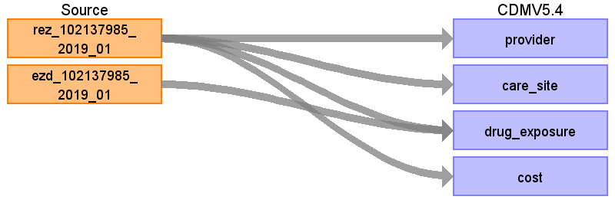

Table name: person

Table name: provider

Reading from rez_102137985_2019_01

Keep information of prescriping physican

Check if physican entry already exists

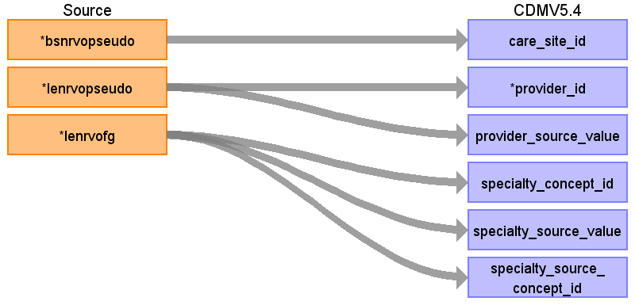

|  |  |  |  |
| --- | --- | --- | --- |
| Destination Field | Source Field | Logic | Comment |
| provider_name |  |  |  |
| npi |  |  |  |
| care_site_id | bsnrvopseudo |  | Pseudonym der verordnenden Betriebsstätte  "pesudonym of the prescriping care site" |
| provider_id | lenrvopseudo |  | Pseudonym des verordnenden Leistungserbringers  "pesudonym of the prescriping physican" |
| provider_source_value | lenrvopseudo |  |  |
| dea |  |  |  |
| specialty_concept_id | lenrvofg |  | custom concept |
| year_of_birth |  |  |  |
| gender_concept_id |  |  |  |
| specialty_source_value | lenrvofg |  |  |
| specialty_source_concept_id | lenrvofg |  | Custom concept |
| gender_source_value |  |  |  |
| gender_source_concept_id |  |  |  |

Table name: care_site

Reading from rez_102137985_2019_01

Keep information about prescriping care site

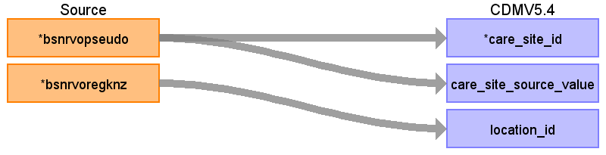

|  |  |  |  |
| --- | --- | --- | --- |
| Destination Field | Source Field | Logic | Comment |
| care_site_id | bsnrvopseudo |  | Check if care_site_id already exists  Check wiht Bfarm if this should be rather lenrvopseudo  d |
| care_site_source_value | bsnrvopseudo |  |  |
| care_site_name |  |  |  |
| place_of_service_concept_id |  |  |  |
| location_id | bsnrvoregknz |  |  |
| place_of_service_source_value |  |  |  |

Table name: observation_period

Table name: visit_occurrence

Table name: drug_exposure

Reading from rez_102137985_2019_01

Prescriped drugs

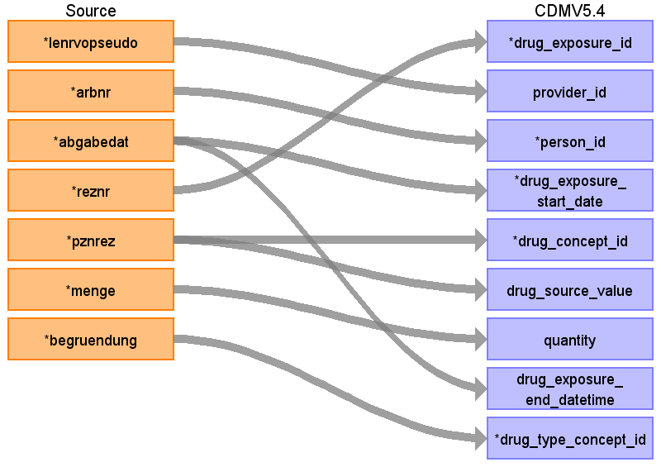

|  |  |  |  |
| --- | --- | --- | --- |
| Destination Field | Source Field | Logic | Comment |
| drug_exposure_id | reznr |  | one common entry for ezd and rez. join by reznr (FULL JOIN!) |
| provider_id | lenrvopseudo |  |  |
| person_id | arbnr |  |  |
| drug_exposure_start_date | abgabedat |  | JJJJMMTT ;  If it is not indicated on prescription sheet, cannot be processed by machine, or does not yield a plausible value, billing month shall be indicated in the format "YYYYMM00""  => For implementation: +1 day if YYYYMM00 |
| drug_concept_id | pznrez |  | 0 since no mapping exists |
| drug_source_value | pznrez |  |  |
| quantity | menge |  |  |
| drug_exposure_start_datetime |  |  |  |
| drug_exposure_end_date |  |  |  |
| drug_exposure_end_datetime | abgabedat |  | as in start_date +7 days  Note: If mapping will be available, we might can say something regarding drug exposure duration |
| verbatim_end_date |  |  |  |
| drug_type_concept_id | begruendung |  | If 1=> dental claim o.w. claim  32810 Claim |
| stop_reason |  |  |  |
| refills |  |  |  |
| days_supply |  |  |  |
| sig |  |  |  |
| route_concept_id |  |  |  |
| lot_number |  |  |  |
| visit_occurrence_id |  |  |  |
| visit_detail_id |  |  |  |
| drug_source_concept_id |  |  |  |
| route_source_value |  |  |  |
| dose_unit_source_value |  |  |  |

Reading from ezd_102137985_2019_01

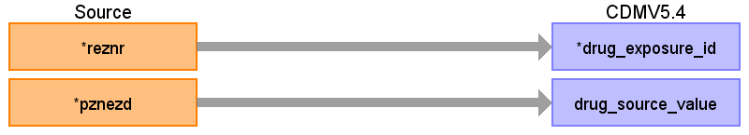

|  |  |  |  |
| --- | --- | --- | --- |
| Destination Field | Source Field | Logic | Comment |
| drug_exposure_id | reznr |  | one common entry for ezd and rez. join by reznr (FULL JOIN!) |
| provider_id |  |  |  |
| person_id |  |  |  |
| drug_exposure_start_date |  |  |  |
| drug_concept_id |  |  |  |
| drug_source_value | pznezd |  | We use the actual picked up PZN. If not available, we use the prescribed PZN. |
| quantity |  |  |  |
| drug_exposure_start_datetime |  |  |  |
| drug_exposure_end_date |  |  |  |
| drug_exposure_end_datetime |  |  |  |
| verbatim_end_date |  |  |  |
| drug_type_concept_id |  |  | 32810 Claim |
| stop_reason |  |  |  |
| refills |  |  |  |
| days_supply |  |  |  |
| sig |  |  |  |
| route_concept_id |  |  |  |
| lot_number |  |  |  |
| visit_occurrence_id |  |  |  |
| visit_detail_id |  |  |  |
| drug_source_concept_id |  |  |  |
| route_source_value |  |  |  |
| dose_unit_source_value |  |  |  |

Table name: visit_detail

Table name: condition_occurrence

Table name: cost

Reading from rez_102137985_2019_01

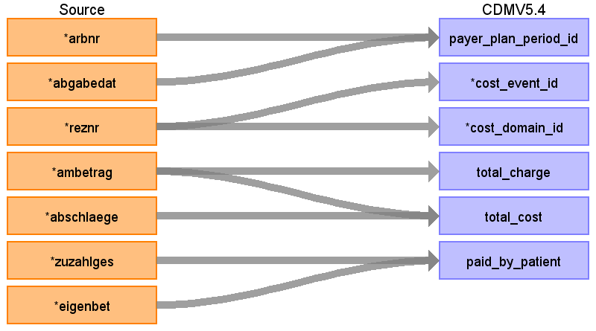

|  |  |  |  |
| --- | --- | --- | --- |
| Destination Field | Source Field | Logic | Comment |
| cost_id |  |  | generate |
| payer_plan_period_id | arbnr  abgabedat |  | link by arbnr and quarter of abgabedat |
| cost_event_id | reznr |  | reznr is key of drug table  generate |
| cost_domain_id | reznr |  | Drug |
| cost_type_concept_id |  |  | 32810 Claim |
| currency_concept_id |  |  | Euro |
| total_charge | ambetrag |  | It is the actual price the drug is sold |
| total_cost | ambetrag  abschlaege |  | Can be negative, if company sells drug cheaper than it would be covered by the health insurance. |
| total_paid |  |  |  |
| paid_by_payer |  |  |  |
| paid_by_patient | eigenbet  zuzahlges |  |  |
| paid_patient_copay |  |  |  |
| paid_patient_coinsurance |  |  |  |
| paid_patient_deductible |  |  |  |
| paid_by_primary |  |  |  |
| paid_ingredient_cost |  |  |  |
| paid_dispensing_fee |  |  |  |
| amount_allowed |  |  |  |
| revenue_code_concept_id |  |  |  |
| revenue_code_source_value |  |  |  |
| drg_concept_id |  |  |  |
| drg_source_value |  |  |  |

Table name: procedure_occurrence

Table name: device_exposure

Table name: measurement

Table name: observation

Table name: death

Table name: note

Table name: note_nlp

Table name: specimen

Table name: fact_relationship

Table name: location

Table name: payer_plan_period

Table name: drug_era

Table name: dose_era

Table name: condition_era

Table name: episode

Table name: episode_event

Table name: metadata

Table name: cdm_source

Table name: cohort

Table name: cohort_definition

Appendix: source tables

Table: rez_102137985_2019_01

|  |  |  |  |
| --- | --- | --- | --- |
| Field | Type | Most freq. value | Comment |
| bsnrvopseudo | numeric |  | pseudonym of care site of prescirping physican |
| lenrvopseudo | numeric |  |  |
| arbnr | numeric |  |  |
| bsnrvoregknz | numeric | 55 | Regionalkennzeichen der verordnenden Betriebsstätte  "regional indicator of care site" |
| lenrvofg | numeric | 44 | "Fachgruppe des verordnenden Leistungserbringers "  Specality of the prescribing physician |
| abgabedat | numeric | 20191207 |  |
| reznr | numeric |  |  |
| pznrez | character varying |  |  |
| vodat | numeric | 20190201 |  |
| ambetrag | money | 83,20 € | gross price of durg |
| menge | numeric | 2 | amount |
| abschlaege | money | 3,50 € |  |
| zuzahlges | money | 0,00 € |  |
| eigenbet | money | 66,90 € |  |
| bsnrvovb | numeric |  | leer bzw NULL -> not transmitted |
| begruendung | numeric | 0 |  |
| lenrvopruef | numeric | 0 |  |
| lenrvopseudoarztnr | numeric | 0 |  |
| vertragskz | character varying |  |  |
| apopseudo | numeric | 234478230393 |  |
| apoklass | numeric | 30 |  |
| aporegknz | numeric | 49 |  |
| apopruef | numeric | 0 |  |
| apositz | numeric | 1 |  |
| apotyp | character varying |  | leer bzw NULL => not transmitted |
| noctu | character varying |  |  |
| autidem | character varying | 0 |  |
| wirkstoffvo | character varying | 1 |  |
| zuzahlkz | character varying | 0 |  |
| zuzahl | money |  | leer bzw NULL => not transmitted |
| mehrkosten | money |  | leer bzw NULL => not transmitted |

Table: ezd_102137985_2019_01

"Elektronische Zusatzdaten"

Additional electronic Data

(Only "factor" will be transfered, which is similar to menge of REZ, therefore we do not have any addtional information. No need to map)

|  |  |  |  |
| --- | --- | --- | --- |
| Field | Type | Most freq. value | Comment |
| reznr | numeric |  | Join REZ and EZD by reznr ( not unique (but in 99.996%) in db, ask KGSV again) |
| pznezd | character varying |  |  |
| zaehler | numeric |  | leer bzw NULL => not transmitted |
| einheit | character varying |  | leer bzw NULL => not transmitted |
| faktor | numeric | 27 |  |
| faktorkennzeichen | character varying | 55 |  |