Source Data Mapping Approach to CDMV5.4

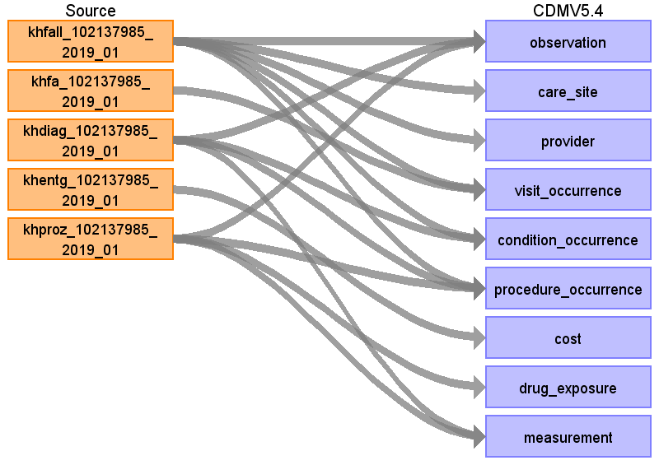

Table name: person

Table name: observation_period

Table name: observation

Reading from khfall_102137985_2019_01

Capture reason of admission

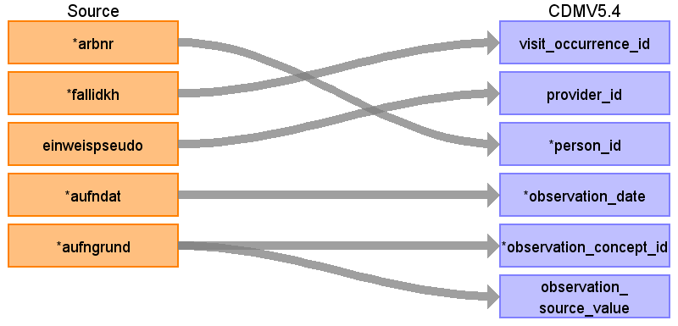

|  |  |  |  |
| --- | --- | --- | --- |
| Destination Field | Source Field | Logic | Comment |
| observation_type_concept_id |  |  | 32810 Claim |
| visit_occurrence_id | fallidkh |  |  |
| provider_id | einweispseudo |  |  |
| observation_id |  |  | Generate |
| person_id | arbnr |  |  |
| observation_date | aufndat |  |  |
| observation_concept_id | aufngrund |  | Only last two digits are important :  XX01 Normalfall  XX02 Arbeitsunfall / Berufskrankheit (§ 11 Abs. 5 SGB V) -> 42689803 - Injury whilst engaged in work activity  XX03 Verkehrsunfall / Sportunfall / Sonstiger Unfall (z. B. § 116 SGB X) 432532 Accidental event  XX04 Hinweis auf Einwirkung von äußerer Gewalt 35811215 Victim of physically violent crime  XX06 Kriegsbeschädigten-Leiden / BVG-Leiden (= war-disabled) mapping ??? -> 4170645 - War injury  XX07 Notfall -> 4093606 Emergency  Keep only the ones, which are not mapped to 0  (WHERE RIGHT(aufngrund::VARCHAR,2) IN ('02','03','04' ,'06','07')) |
| observation_source_value | aufngrund |  | Map all 4 digits |
| observation_source_concept_id |  |  |  |
| observation_datetime |  |  |  |
| value_as_number |  |  |  |
| value_as_string |  |  |  |
| value_as_concept_id |  |  |  |
| qualifier_concept_id |  |  |  |
| unit_concept_id |  |  |  |
| visit_detail_id |  |  |  |
| value_source_value |  |  |  |
| unit_source_value |  |  |  |
| qualifier_source_value |  |  |  |
| observation_event_id |  |  |  |
| obs_event_field_concept_id |  |  |  |

Reading from khdiag_102137985_2019_01

Use khfall for person_id, date, provider_id

link by fallid

Primary and secondary diagnosis

In original table primary and secondary diagnosis in one row (to columns) Therefore, two entries per row.

WHERE domain_id='Observation'

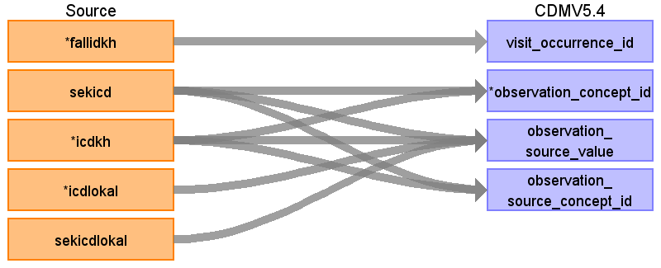

|  |  |  |  |
| --- | --- | --- | --- |
| Destination Field | Source Field | Logic | Comment |
| observation_type_concept_id |  |  | 32810 Claim |
| visit_occurrence_id | fallidkh |  |  |
| provider_id |  |  |  |
| observation_id |  |  | Generate |
| person_id |  |  |  |
| observation_date |  |  |  |
| observation_concept_id | sekicd  icdkh |  |  |
| observation_source_value | sekicd  sekicdlokal  icdlokal  icdkh |  |  |
| observation_source_concept_id | sekicd  icdkh |  |  |
| observation_datetime |  |  |  |
| value_as_number |  |  |  |
| value_as_string |  |  |  |
| value_as_concept_id |  |  |  |
| qualifier_concept_id |  |  |  |
| unit_concept_id |  |  |  |
| visit_detail_id |  |  |  |
| value_source_value |  |  |  |
| unit_source_value |  |  |  |
| qualifier_source_value |  |  |  |
| observation_event_id |  |  |  |
| obs_event_field_concept_id |  |  |  |

Reading from khproz_102137985_2019_01

Use khfall for person_id, provider_id

link by fallid

WHERE domain_id='Observation'

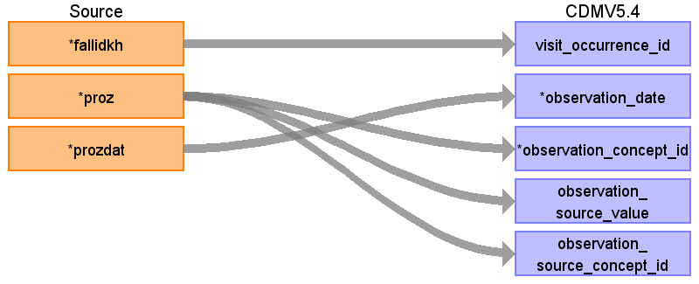

|  |  |  |  |
| --- | --- | --- | --- |
| Destination Field | Source Field | Logic | Comment |
| observation_type_concept_id |  |  | 32810 Claim |
| visit_occurrence_id | fallidkh |  |  |
| provider_id |  |  |  |
| observation_id |  |  | Generate |
| person_id |  |  |  |
| observation_date | prozdat |  |  |
| observation_concept_id | proz |  |  |
| observation_source_value | proz |  |  |
| observation_source_concept_id | proz |  |  |
| observation_datetime |  |  |  |
| value_as_number |  |  |  |
| value_as_string |  |  |  |
| value_as_concept_id |  |  |  |
| qualifier_concept_id |  |  |  |
| unit_concept_id |  |  |  |
| visit_detail_id |  |  |  |
| value_source_value |  |  |  |
| unit_source_value |  |  |  |
| qualifier_source_value |  |  |  |
| observation_event_id |  |  |  |
| obs_event_field_concept_id |  |  |  |

Table name: care_site

Reading from khfall_102137985_2019_01

To capture treating hospital and transfering (since this is kept in visit_occurence( admitted from))

Note:

- Since a hospital might appear in several tables we apply a full join to report every hospital, but none twice.

- select distinct on khpseudo/veranlasskhpseudo

- we do the process twice: Once for khpseudo, once for veranlasskhpseudo

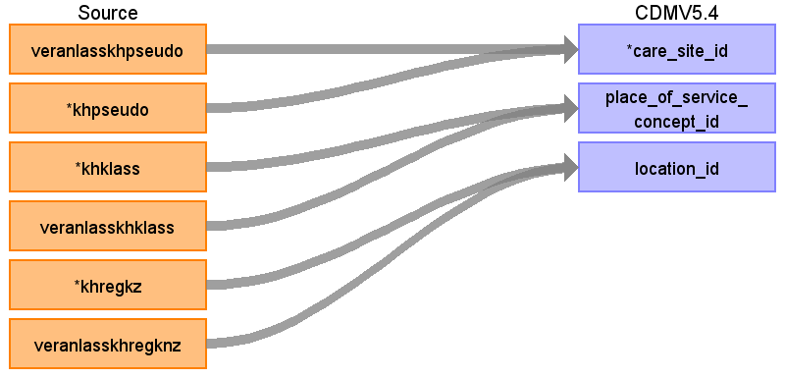

|  |  |  |  |
| --- | --- | --- | --- |
| Destination Field | Source Field | Logic | Comment |
| care_site_id | khpseudo  veranlasskhpseudo |  |  |
| care_site_name |  |  |  |
| place_of_service_concept_id | khklass  veranlasskhklass |  | 38004515 Hospital  38004515 Hospital |
| location_id | khregkz  veranlasskhregknz |  |  |
| care_site_source_value |  |  |  |
| place_of_service_source_value |  |  |  |

Table name: provider

Reading from khfall_102137985_2019_01

To capture (only!) treating physican

Note:

- Since provider might appear in several tables we apply a full join to report every provider, but none twice.

- select distinct on einweispseudo

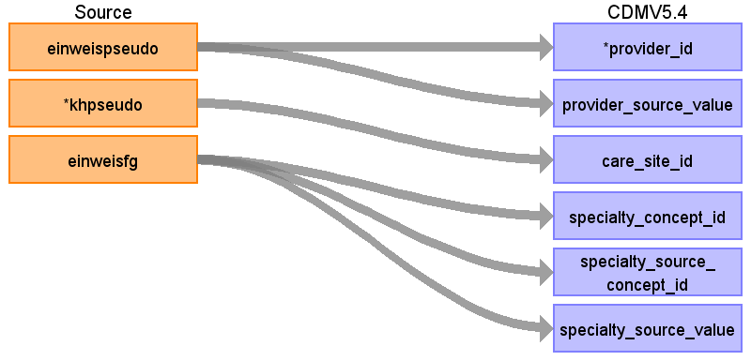

|  |  |  |  |
| --- | --- | --- | --- |
| Destination Field | Source Field | Logic | Comment |
| provider_id | einweispseudo |  |  |
| provider_source_value | einweispseudo |  |  |
| provider_name |  |  |  |
| care_site_id | khpseudo |  |  |
| npi |  |  |  |
| dea |  |  |  |
| specialty_concept_id | einweisfg |  | Customized concept |
| specialty_source_concept_id | einweisfg |  | Custom concept |
| specialty_source_value | einweisfg |  |  |
| year_of_birth |  |  |  |
| gender_concept_id |  |  |  |
| gender_source_value |  |  |  |
| gender_source_concept_id |  |  |  |

Table name: visit_occurrence

Reading from khfall_102137985_2019_01

Join khfall and khfa for visit occurence

khfall for all visit details, except end date and discharge time (from khfa)

Visit details

Admission reason is kept in source value and discharge reason is mapped to discharged_to and kept in discharge_to_source_value

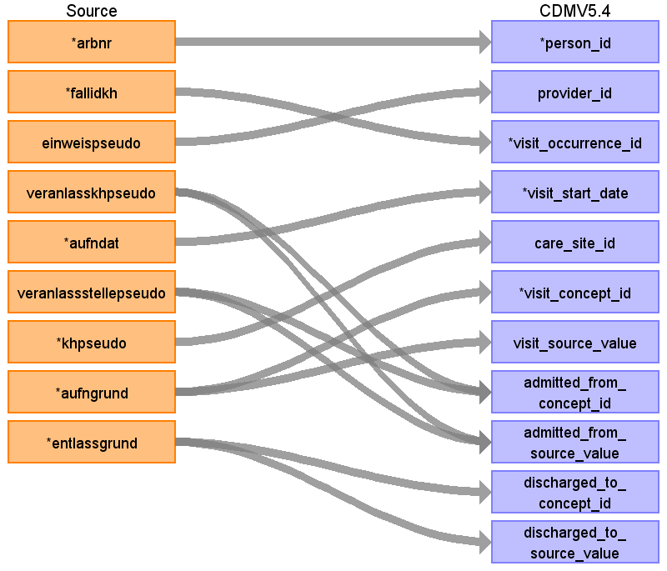

|  |  |  |  |
| --- | --- | --- | --- |
| Destination Field | Source Field | Logic | Comment |
| person_id | arbnr |  |  |
| provider_id | einweispseudo |  |  |
| visit_occurrence_id | fallidkh |  |  |
| visit_type_concept_id |  |  | 32810 Claim |
| visit_start_date | aufndat |  |  |
| visit_end_date |  |  |  |
| visit_end_datetime |  |  |  |
| care_site_id | khpseudo |  |  |
| visit_concept_id | aufngrund |  | Use digit 1 and 2 :  when IN ('03', '04', '10') then 8756 --outpatient hospital  else 8717 -- inpatient hospital |
| visit_source_value | aufngrund |  |  |
| visit_source_concept_id |  |  | Hospital |
| visit_start_datetime |  |  |  |
| admitted_from_concept_id | veranlassstellepseudo  veranlasskhpseudo |  | 8870 (Emergency Room - Hospital) if veranlassstellepseudo is not None  38004515 (Hospital) if veranlasskhpseudo is not None (transfered from another hospital) |
| admitted_from_source_value | veranlassstellepseudo  veranlasskhpseudo |  |  |
| discharged_to_concept_id | entlassgrund |  | khfall.entlassgrund  when 11 then 8546 -- hospice  when in (23, 16, 10, 24) then 8676 --nursing facility  when in (18, 17,8,12,6) then 8717 -- inpatient hospital  when in (14,15) then 8756 --outpatient hospital  when 13 then 8976 --Psychiatric Residential Treatment Center  when 26 then 9201 --inpatient visit  when 9 then 38004285 --Rehabilitation Hospital  else 0 -- discharged, death, transferred but not clear to which facility |
| discharged_to_source_value | entlassgrund |  |  |
| preceding_visit_occurrence_id |  |  |  |

Reading from khfa_102137985_2019_01

Join khfa only for visit end date

Link by fallidkh

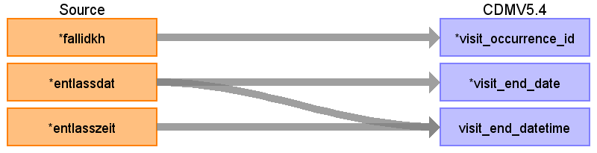

|  |  |  |  |
| --- | --- | --- | --- |
| Destination Field | Source Field | Logic | Comment |
| person_id |  |  |  |
| provider_id |  |  |  |
| visit_occurrence_id | fallidkh |  | Join with KHFALL - do not create additional entry! |
| visit_type_concept_id |  |  | 32810 Claim |
| visit_start_date |  |  |  |
| visit_end_date | entlassdat |  | Format JJJJMMTT |
| visit_end_datetime | entlasszeit  entlassdat |  | Format HHMM  Format JJJJMMTT |
| care_site_id |  |  |  |
| visit_concept_id |  |  |  |
| visit_source_value |  |  |  |
| visit_source_concept_id |  |  | Hospital |
| visit_start_datetime |  |  |  |
| admitted_from_concept_id |  |  |  |
| admitted_from_source_value |  |  |  |
| discharged_to_concept_id |  |  |  |
| discharged_to_source_value |  |  |  |
| preceding_visit_occurrence_id |  |  |  |

Table name: condition_occurrence

Reading from khdiag_102137985_2019_01

Primary and secondary diagnosis

In original table primary and secondary diagnosis in one row (to columns) Therefore, two entries per row.

Use khfall for person_id, date, provider_id

link by fallid

WHERE domain_id = 'Condition'

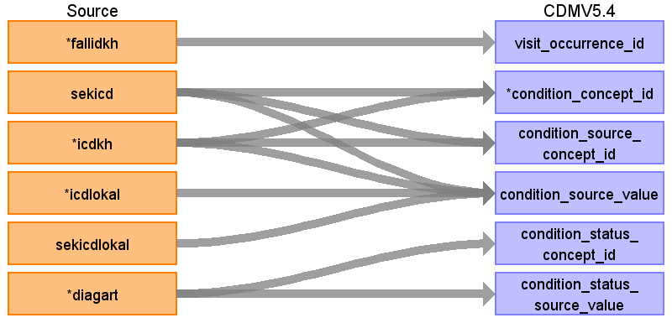

|  |  |  |  |
| --- | --- | --- | --- |
| Destination Field | Source Field | Logic | Comment |
| visit_occurrence_id | fallidkh |  |  |
| condition_occurrence_id |  |  | generate |
| person_id |  |  | link by visit_occurence_id |
| condition_concept_id | icdkh  sekicd |  | Map ICD10GM to SNOMED  Remove special character  Map ICD10GM to SNOMED  Remove special character  Check domain -> Map to right domain (condition, procedure, observation) but same approach |
| condition_source_concept_id | icdkh  sekicd |  | ICD10GM  Remove special character  ICD10GM  Remove special character |
| condition_source_value | sekicd  icdlokal  sekicdlokal  icdkh |  |  |
| condition_status_concept_id | diagart |  | One entry for "icdkh":  A (Aufhnahmediagnose) => 32890 Admission diagnosis  H (Hauptdiagnose) =>32902 Primary diagnosis  N (Nebendiagnose) => 32908 Secondary diagnosis  For "secicd" we always assume N (Nebendiagnose) => 32908 Secondary diagnosis |
| condition_status_source_value | diagart |  |  |
| condition_start_date |  |  | Use visit_occurence start date |
| condition_start_datetime |  |  |  |
| condition_end_date |  |  |  |
| condition_end_datetime |  |  |  |
| condition_type_concept_id |  |  | 32810 Claim |
| stop_reason |  |  |  |
| provider_id |  |  | Use visit_occurence provider_id |
| visit_detail_id |  |  |  |

Reading from khfall_102137985_2019_01

Use khfall only for date, provider, and abrnr

(Note: conditions (diagnosis are saved in khdiag)

link by fallidkh

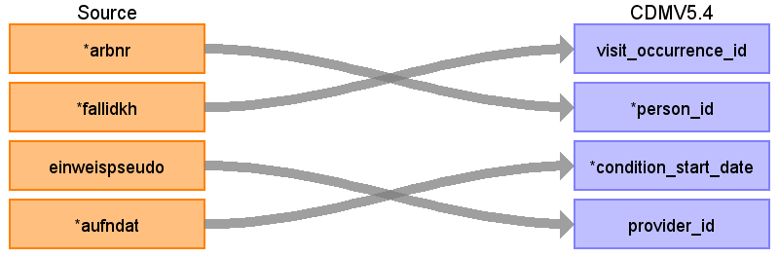

|  |  |  |  |
| --- | --- | --- | --- |
| Destination Field | Source Field | Logic | Comment |
| visit_occurrence_id | fallidkh |  |  |
| condition_occurrence_id |  |  | generate |
| person_id | arbnr |  | link by visit_occurence_id |
| condition_concept_id |  |  | Check domain -> Map to right domain (condition, procedure, observation) but same approach |
| condition_source_concept_id |  |  |  |
| condition_source_value |  |  |  |
| condition_status_concept_id |  |  |  |
| condition_status_source_value |  |  |  |
| condition_start_date | aufndat |  | Use visit_occurence start date |
| condition_start_datetime |  |  |  |
| condition_end_date |  |  |  |
| condition_end_datetime |  |  |  |
| condition_type_concept_id |  |  | 32810 Claim |
| stop_reason |  |  |  |
| provider_id | einweispseudo |  | Use visit_occurence provider_id |
| visit_detail_id |  |  |  |

Table name: fact_relationship

Table name: procedure_occurrence

Reading from khproz_102137985_2019_01

Use khfall for person_id, provider_id

link by fallid

WHERE domain_id='Procedure' OR domain_id IS NULL

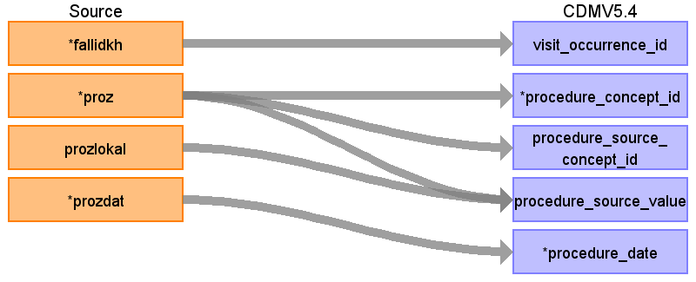

|  |  |  |  |
| --- | --- | --- | --- |
| Destination Field | Source Field | Logic | Comment |
| procedure_occurrence_id |  |  | generated |
| person_id |  |  | link by fallidkh of visit_occurence |
| visit_occurrence_id | fallidkh |  |  |
| procedure_concept_id | proz |  | Map OPS to standard procedure |
| quantity |  |  |  |
| procedure_source_concept_id | proz |  |  |
| procedure_source_value | proz  prozlokal |  | Combine proz with prozlokal in source value to keep (left, right, both) => code, loc |
| procedure_date | prozdat |  | Format JJJJMMTT |
| provider_id |  |  | can be linked through visit_occurence |
| procedure_type_concept_id |  |  | 32810 Claim |
| procedure_datetime |  |  |  |
| procedure_end_date |  |  |  |
| procedure_end_datetime |  |  |  |
| modifier_concept_id |  |  |  |
| visit_detail_id |  |  |  |
| modifier_source_value |  |  |  |

Reading from khfall_102137985_2019_01

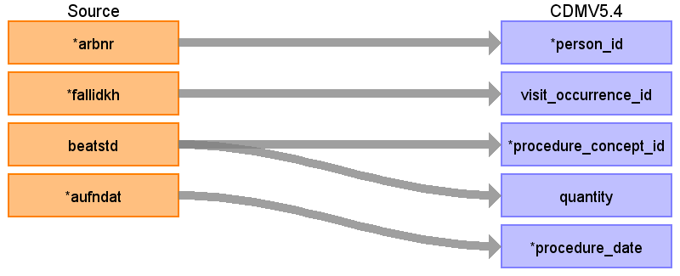

|  |  |  |  |
| --- | --- | --- | --- |
| Destination Field | Source Field | Logic | Comment |
| procedure_occurrence_id |  |  | generated |
| person_id | arbnr |  | link by fallidkh of visit_occurence |
| visit_occurrence_id | fallidkh |  |  |
| procedure_concept_id | beatstd |  | Artificial respiration  Concept ID: 40378394  Concept code: 182693002 |
| quantity | beatstd |  | hours |
| procedure_source_concept_id |  |  |  |
| procedure_source_value |  |  |  |
| procedure_date | aufndat |  | Assumption that artificial respiration starts with admission |
| provider_id |  |  | can be linked through visit_occurence |
| procedure_type_concept_id |  |  | 32810 Claim |
| procedure_datetime |  |  |  |
| procedure_end_date |  |  |  |
| procedure_end_datetime |  |  |  |
| modifier_concept_id |  |  |  |
| visit_detail_id |  |  |  |
| modifier_source_value |  |  |  |

Reading from khdiag_102137985_2019_01

Use khfall for person_id, date, provider_id

link by fallid

Primary and secondary diagnosis

In original table primary and secondary diagnosis in one row (to columns) Therefore, two entries per row.

WHERE domain_id='Procedure'

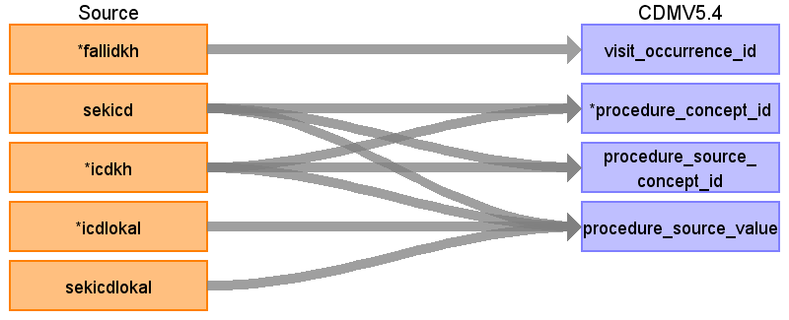

|  |  |  |  |
| --- | --- | --- | --- |
| Destination Field | Source Field | Logic | Comment |
| procedure_occurrence_id |  |  | generated |
| person_id |  |  | link by fallidkh of visit_occurence |
| visit_occurrence_id | fallidkh |  |  |
| procedure_concept_id | sekicd  icdkh |  |  |
| quantity |  |  |  |
| procedure_source_concept_id | sekicd  icdkh |  |  |
| procedure_source_value | sekicd  icdkh  icdlokal  sekicdlokal |  |  |
| procedure_date |  |  |  |
| provider_id |  |  | can be linked through visit_occurence |
| procedure_type_concept_id |  |  | 32810 Claim |
| procedure_datetime |  |  |  |
| procedure_end_date |  |  |  |
| procedure_end_datetime |  |  |  |
| modifier_concept_id |  |  |  |
| visit_detail_id |  |  |  |
| modifier_source_value |  |  |  |

Table name: cost

Reading from khentg_102137985_2019_01

Payment (hospital, lump sum)

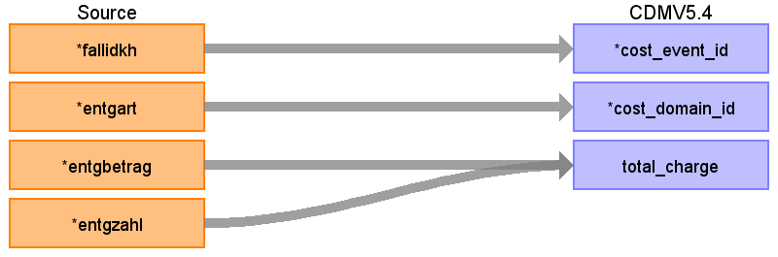

|  |  |  |  |
| --- | --- | --- | --- |
| Destination Field | Source Field | Logic | Comment |
| cost_id |  |  | generate |
| cost_event_id | fallidkh |  | link to visit_occurence since visit_occurence_id = fallidkh |
| cost_domain_id | entgart |  | 'Visit' |
| cost_type_concept_id |  |  | 32810 Claim |
| currency_concept_id |  |  | 44818568 EUR |
| total_charge | entgbetrag  entgzahl |  | khentg.entgbetrag *khentg.entgzahl  Multiplicator of entgbetrag |
| total_cost |  |  |  |
| total_paid |  |  |  |
| paid_by_payer |  |  |  |
| paid_by_patient |  |  |  |
| paid_patient_copay |  |  |  |
| paid_patient_coinsurance |  |  |  |
| paid_patient_deductible |  |  |  |
| paid_by_primary |  |  |  |
| paid_ingredient_cost |  |  |  |
| paid_dispensing_fee |  |  |  |
| payer_plan_period_id |  |  |  |
| amount_allowed |  |  |  |
| revenue_code_concept_id |  |  |  |
| revenue_code_source_value |  |  |  |
| drg_concept_id |  |  |  |
| drg_source_value |  |  |  |

Table name: visit_detail

Table name: drug_exposure

Reading from khproz_102137985_2019_01

Use khfall for person_id, provider_id

link by fallid

WHERE domain_id='Drug'

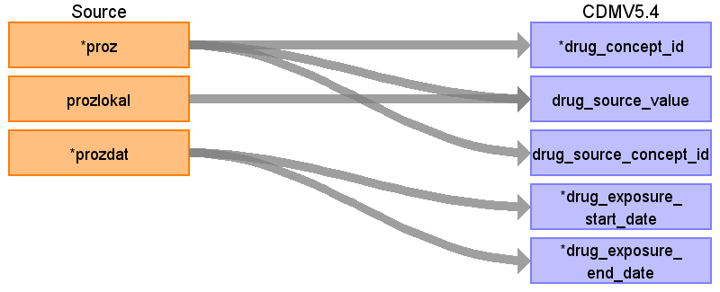

|  |  |  |  |
| --- | --- | --- | --- |
| Destination Field | Source Field | Logic | Comment |
| drug_exposure_id |  |  | Generate |
| person_id |  |  |  |
| drug_concept_id | proz |  |  |
| drug_source_value | prozlokal  proz |  |  |
| drug_source_concept_id | proz |  |  |
| drug_exposure_start_date | prozdat |  |  |
| drug_exposure_start_datetime |  |  |  |
| drug_exposure_end_date | prozdat |  |  |
| drug_exposure_end_datetime |  |  |  |
| verbatim_end_date |  |  |  |
| drug_type_concept_id |  |  | claim 32810 |
| stop_reason |  |  |  |
| refills |  |  |  |
| quantity |  |  |  |
| days_supply |  |  |  |
| sig |  |  |  |
| route_concept_id |  |  |  |
| lot_number |  |  |  |
| provider_id |  |  |  |
| visit_occurrence_id |  |  |  |
| visit_detail_id |  |  |  |
| route_source_value |  |  |  |
| dose_unit_source_value |  |  |  |

Table name: device_exposure

Table name: measurement

Reading from khdiag_102137985_2019_01

Use khfall for person_id, date, provider_id

link by fallid

Primary and secondary diagnosis

In original table primary and secondary diagnosis in one row (to columns) Therefore, two entries per row.

WHERE domain_id='Measurement'

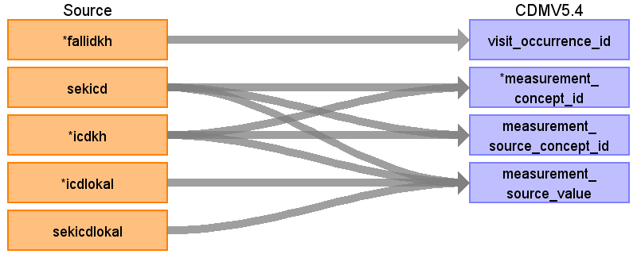

|  |  |  |  |
| --- | --- | --- | --- |
| Destination Field | Source Field | Logic | Comment |
| visit_occurrence_id | fallidkh |  |  |
| measurement_id |  |  |  |
| person_id |  |  |  |
| measurement_concept_id | sekicd  icdkh |  |  |
| measurement_source_concept_id | sekicd  icdkh |  |  |
| measurement_source_value | icdlokal  sekicdlokal  sekicd  icdkh |  |  |
| measurement_date |  |  |  |
| measurement_datetime |  |  |  |
| measurement_time |  |  |  |
| measurement_type_concept_id |  |  | claim |
| operator_concept_id |  |  |  |
| value_as_number |  |  |  |
| value_as_concept_id |  |  |  |
| unit_concept_id |  |  |  |
| range_low |  |  |  |
| range_high |  |  |  |
| provider_id |  |  |  |
| visit_detail_id |  |  |  |
| unit_source_value |  |  |  |
| unit_source_concept_id |  |  |  |
| value_source_value |  |  |  |
| measurement_event_id |  |  |  |
| meas_event_field_concept_id |  |  |  |

Reading from khproz_102137985_2019_01

Use khfall for person_id, provider_id

link by fallid

WHERE domain_id='Measurement'

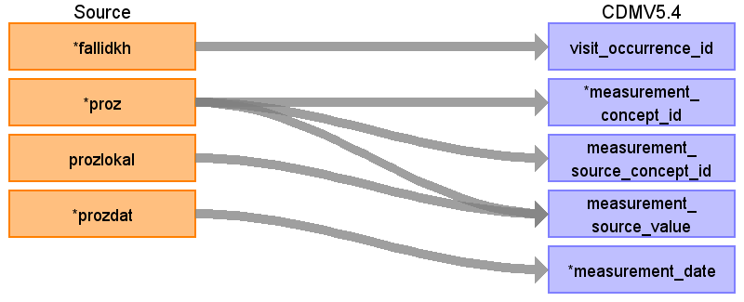

|  |  |  |  |
| --- | --- | --- | --- |
| Destination Field | Source Field | Logic | Comment |
| visit_occurrence_id | fallidkh |  |  |
| measurement_id |  |  |  |
| person_id |  |  |  |
| measurement_concept_id | proz |  |  |
| measurement_source_concept_id | proz |  |  |
| measurement_source_value | proz  prozlokal |  |  |
| measurement_date | prozdat |  |  |
| measurement_datetime |  |  |  |
| measurement_time |  |  |  |
| measurement_type_concept_id |  |  | claim |
| operator_concept_id |  |  |  |
| value_as_number |  |  |  |
| value_as_concept_id |  |  |  |
| unit_concept_id |  |  |  |
| range_low |  |  |  |
| range_high |  |  |  |
| provider_id |  |  |  |
| visit_detail_id |  |  |  |
| unit_source_value |  |  |  |
| unit_source_concept_id |  |  |  |
| value_source_value |  |  |  |
| measurement_event_id |  |  |  |
| meas_event_field_concept_id |  |  |  |

Table name: death

Table name: note

Table name: note_nlp

Table name: specimen

Table name: location

Table name: payer_plan_period

Table name: drug_era

Table name: dose_era

Table name: condition_era

Table name: episode

Table name: episode_event

Table name: metadata

Table name: cdm_source

Table name: cohort

Table name: cohort_definition

Appendix: source tables

Table: khfall_102137985_2019_01

|  |  |  |  |
| --- | --- | --- | --- |
| Field | Type | Most freq. value | Comment |
| arbnr | numeric |  |  |
| fallidkh | numeric |  | case identifier for hospital visits |
| einweispseudo | numeric |  | pseudonym of admisison physican |
| beatstd | character varying |  |  |
| veranlasskhpseudo | numeric | 738063629238 |  |
| aufndat | character varying | 20190131 |  |
| veranlassstellepseudo | character varying |  | Is veranlasskhpseudo of the emergency room |
| khpseudo | numeric | 873101070836 | pseudonym of hospital |
| khklass | numeric | 26 | It is always set to 26 (=Hospital) |
| aufngrund | character varying | 2399 | Reason of admission  Digits 1 and 2:  01  Krankenhausbehandlung, vollstationär  02  Krankenhausbehandlung vollstationär mit vorausgegangener vorstationärer Behandlung  03  Krankenhausbehandlung, teilstationär  04  Vorstationäre Behandlung ohne anschließende vollstationäre Behandlung  05  Stationäre Entbindung  06  Geburt  07  Wiederaufnahme wegen Komplikationen (Fallpauschale) nach KFPV 2003  08  Stationäre Aufnahme zur Organentnahme  09  - frei -  10  Stationsäquivalente Behandlung  11  Übergangspflege  Digits 3 and 4  01  Normalfall  02  Arbeitsunfall / Berufskrankheit (§ 11 Abs. 5 SGB V)  03  Verkehrsunfall / Sportunfall / Sonstiger Unfall (z. B. § 116 SGB X)  04  Hinweis auf Einwirkung von äußerer Gewalt  05  - frei -  06  Kriegsbeschädigten-Leiden / BVG-Leiden  07  Notfall |
| veranlasskhklass | numeric | 26 |  |
| khregkz | numeric | 49 |  |
| einweisfg | numeric |  | https://applications.kbv.de/S_SLE2_FACHABTEILUNGHSA_V1.01.xhtml |
| veranlasskhregknz | numeric | 66 |  |
| aufnfa | character varying | 7728 |  |
| khpruef | numeric | 1 |  |
| einweispruef | numeric |  |  |
| entlassgrund | character varying | 457 |  |
| veranlasskhpruef | numeric | 1 |  |

Table: khfa_102137985_2019_01

|  |  |  |  |
| --- | --- | --- | --- |
| Field | Type | Most freq. value | Comment |
| fallidkh | numeric |  |  |
| fa | character varying | 6975 |  |
| entlassdat | character varying | 20190203 |  |
| entlasszeit | character varying | 1655 | Format HH(00-23)MM(00-59) |

Table: khdiag_102137985_2019_01

|  |  |  |  |
| --- | --- | --- | --- |
| Field | Type | Most freq. value | Comment |
| fallidkh | numeric |  |  |
| sekicd | character varying |  | secondary diagnosis |
| icdkh | character varying | M66 | admission diagnosis |
| icdlokal | character varying | L |  |
| sekicdlokal | character varying |  |  |
| diagart | character varying | N | A (Aufhnahmediagnose)  H (Hauptdiagnose)  N (Nebendiagnose) |

Table: khentg_102137985_2019_01

|  |  |  |  |
| --- | --- | --- | --- |
| Field | Type | Most freq. value | Comment |
| fallidkh | numeric |  |  |
| entgart | character varying |  | type of payment (e.g. payment of carer, supplement , ...) |
| entgbetrag | money |  | "flat-rate remuneration" |
| abrvondat | character varying | 20191107 | billing start date |
| abrbisdat | character varying | 20191112 | billing end date |
| entgzahl | numeric | 5 | Number of charges  (Not sure what is ment) |
| tageobe | numeric | 2 | days without charge |

Table: khproz_102137985_2019_01

|  |  |  |  |
| --- | --- | --- | --- |
| Field | Type | Most freq. value | Comment |
| fallidkh | numeric |  |  |
| proz | character varying |  | procedure (OPS coded) |
| prozlokal | character varying |  | left or right side |
| prozdat | character varying | 20191107 | date format JJJJMMDD |