Source Data Mapping Approach to CDMV5.4

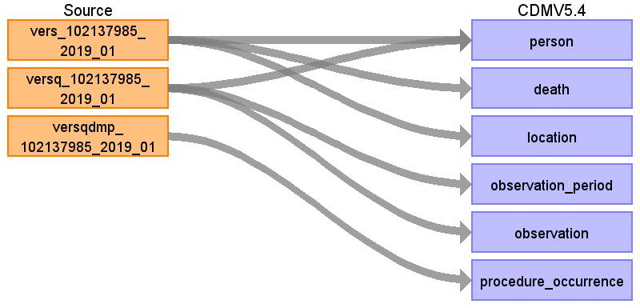

Table name: person

Map from table "vers" (insured person) birthyear and postal code. We join table "vers" (insured party relationship) to get the gender.

Note: We use entries of two tables to create one entry in OMOP table person by joining by identifier "arbnr"

Reading from vers_102137985_2019_01

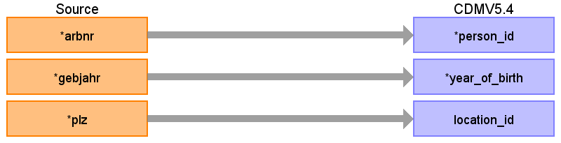

|  |  |  |  |
| --- | --- | --- | --- |
| Destination Field | Source Field | Logic | Comment |
| person_id | arbnr |  |  |
| gender_concept_id |  |  |  |
| gender_source_value |  |  |  |
| gender_source_concept_id |  |  |  |
| year_of_birth | gebjahr |  |  |
| location_id | plz |  |  |
| month_of_birth |  |  |  |
| day_of_birth |  |  |  |
| birth_datetime |  |  |  |
| race_concept_id |  |  | 0 since not given |
| ethnicity_concept_id |  |  | 0 since not given |
| provider_id |  |  |  |
| care_site_id |  |  |  |
| person_source_value |  |  |  |
| race_source_value |  |  |  |
| race_source_concept_id |  |  |  |
| ethnicity_source_value |  |  |  |
| ethnicity_source_concept_id |  |  |  |

Reading from versq_102137985_2019_01

Map gender

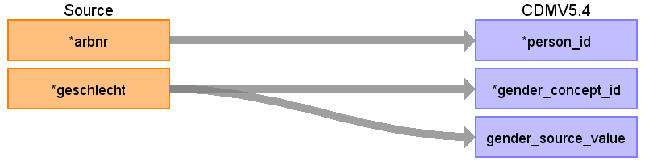

|  |  |  |  |
| --- | --- | --- | --- |
| Destination Field | Source Field | Logic | Comment |
| person_id | arbnr |  |  |
| gender_concept_id | geschlecht |  | 1 female => 8532  2 male => 8507  3,4 (missing, divers) => 0 ow |
| gender_source_value | geschlecht |  | 1 = weiblich  2 = männlich  3 = fehlende Geschlechtsangabe gemäß § 30 Abs. 1 Satz Nr. 1 RSAV  4 = divers gemäß § 22 Abs. 3 PStG  Most current gender |
| gender_source_concept_id |  |  |  |
| year_of_birth |  |  |  |
| location_id |  |  |  |
| month_of_birth |  |  |  |
| day_of_birth |  |  |  |
| birth_datetime |  |  |  |
| race_concept_id |  |  | 0 since not given |
| ethnicity_concept_id |  |  | 0 since not given |
| provider_id |  |  |  |
| care_site_id |  |  |  |
| person_source_value |  |  |  |
| race_source_value |  |  |  |
| race_source_concept_id |  |  |  |
| ethnicity_source_value |  |  |  |
| ethnicity_source_concept_id |  |  |  |

Table name: death

Reading from vers_102137985_2019_01

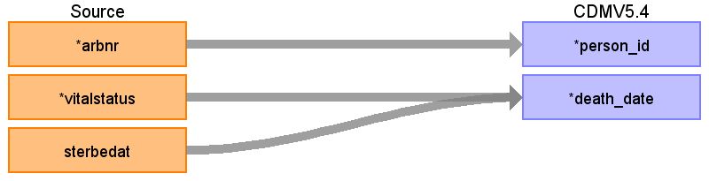

|  |  |  |  |
| --- | --- | --- | --- |
| Destination Field | Source Field | Logic | Comment |
| person_id | arbnr |  | only if |
| death_date | sterbedat  vitalstatus |  | original format: JJJJMMTT  only if vitalstatus = 1 |
| death_datetime |  |  |  |
| death_type_concept_id |  |  |  |
| cause_concept_id |  |  |  |
| cause_source_value |  |  |  |
| cause_source_concept_id |  |  |  |

Table name: location

Reading from vers_102137985_2019_01

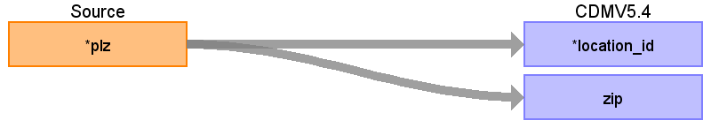

|  |  |  |  |
| --- | --- | --- | --- |
| Destination Field | Source Field | Logic | Comment |
| location_id | plz |  | Select distinct on plz |
| address_1 |  |  |  |
| address_2 |  |  |  |
| city |  |  |  |
| state |  |  |  |
| zip | plz |  |  |
| county |  |  |  |
| location_source_value |  |  |  |
| country_concept_id |  |  |  |
| country_source_value |  |  |  |
| latitude |  |  |  |
| longitude |  |  |  |

Table name: observation_period

Reading from versq_102137985_2019_01

Observation_periods are given in quarters.

We define ONE observation_period from the first reported quarter to the last reported quarter. We do not expect gaps between start and end quarter since it is not switching between private and statutory health insurance are attached to conditios.

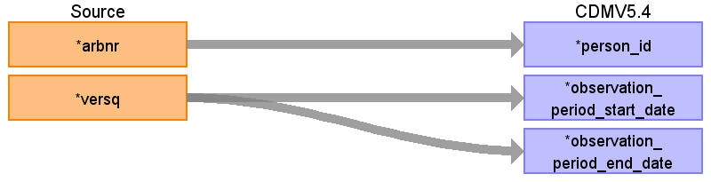

|  |  |  |  |
| --- | --- | --- | --- |
| Destination Field | Source Field | Logic | Comment |
| observation_period_id |  |  | generate |
| person_id | arbnr |  |  |
| observation_period_start_date | versq |  | Format JJJJQ  1st dayquarter  Check for which quarter person appears and then create continues obersvation_period (E.g.quarter 1 and 2 => 01.01. till 30.06)  Format JJJJQ  Grouped by subject: start_quarter = min(Q)  1st of start_quarter |
| observation_period_end_date | versq |  | Format JJJJQ  Grouped by subject: last_quarter = Max(Q)  30/31st of last_quarter  Assumption: No insurance gaps between quarters  E.g. Min(Q)=1, MAX(Q)=3 => We assume that person was also insured in Q2  Format JJJJQ  31st of quarter ((quarter)*3) |
| period_type_concept_id |  |  | 32810 Claim |

Table name: observation

Reading from versq_102137985_2019_01

We capture insured days which are used in a specific category (i.e. abroad)

Note:

Needs to be called three times for each category, which equals the columns:

- verstageausl,

- verstagekg,

- verstagekosterstwahlt

in the original format .

Customized concept of format 1 can be reused.

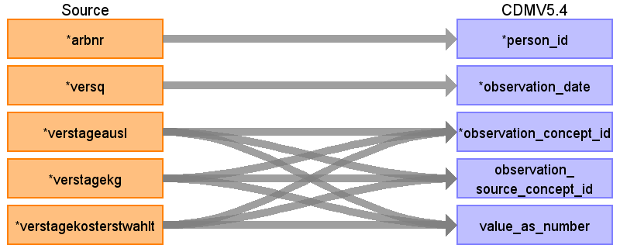

|  |  |  |  |
| --- | --- | --- | --- |
| Destination Field | Source Field | Logic | Comment |
| observation_id |  |  | Generate |
| person_id | arbnr |  |  |
| observation_date | versq |  | 1st of quarter ((quarter-1)*3)+1  Format JJJJQ  1st of quarter ((quarter-1)*3)+1  Format JJJJQ |
| observation_datetime |  |  |  |
| observation_concept_id | verstageausl  verstagekg  verstagekosterstwahlt |  | 0 as concept_id since no suitable concept_id was found  0 as concept_id since no suitable concept_id was found  0 as concept_id since no suitable concept_id was found |
| observation_source_concept_id | verstageausl  verstagekg  verstagekosterstwahlt |  | Custom concept  Custom concept  Custom concept |
| value_as_number | verstageausl  verstagekg  verstagekosterstwahlt |  | number of days  number of days  number of days |
| observation_type_concept_id |  |  | 32810 Claim |
| value_as_string |  |  |  |
| value_as_concept_id |  |  |  |
| qualifier_concept_id |  |  |  |
| unit_concept_id |  |  |  |
| provider_id |  |  |  |
| visit_occurrence_id |  |  |  |
| visit_detail_id |  |  |  |
| observation_source_value |  |  |  |
| unit_source_value |  |  |  |
| qualifier_source_value |  |  |  |
| value_source_value |  |  |  |
| observation_event_id |  |  |  |
| obs_event_field_concept_id |  |  |  |

Table name: procedure_occurrence

Reading from versqdmp_102137985_2019_01

Disease-Management-Programms -> These programs are not kept in OPS or ICD. Needs to be captured individually.

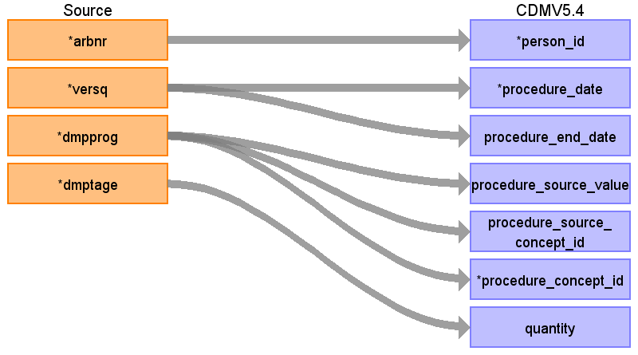

|  |  |  |  |
| --- | --- | --- | --- |
| Destination Field | Source Field | Logic | Comment |
| procedure_occurrence_id |  |  | Generate |
| person_id | arbnr |  |  |
| procedure_date | versq |  | Assumption: 1st day of the quarter |
| procedure_end_date | versq |  | Assumption: Last day of the quarter |
| procedure_datetime |  |  |  |
| procedure_source_value | dmpprog |  | Create customized concept  Disease-Management-Program  01 = Diabetes mellitus Type 2  02 = Breast cancer  03 = coronary heart disease  04 = Diabetes mellitus Type 1  05 = Asthma bronchial  06 = COPD  07 = chronic heart failure  08 = Depression  09 = back pain  10 = rheumatoid arthritis  11 = osteoporosis |
| procedure_source_concept_id | dmpprog |  | No official source concept  -> 0 |
| procedure_concept_id | dmpprog |  | Map directly to target concept  01 and 04 = Diabetes => 45765969 Agreeing on diabetes care plan  05 = Asthma bronchiale =>  37396658 Asthma action care planning  06 = COPD => 44809305 Management of chronic obstructive pulmonary disease  08 = Depression =>  44810259 Agreeing on mental health care plan  otherwise 4123847 Agreement of care plan |
| quantity | dmptage |  | The exact number of days |
| procedure_end_datetime |  |  |  |
| procedure_type_concept_id |  |  | 32810 Claim |
| modifier_concept_id |  |  |  |
| provider_id |  |  |  |
| visit_occurrence_id |  |  |  |
| visit_detail_id |  |  |  |
| modifier_source_value |  |  |  |

Table name: payer_plan_period

Table name: visit_occurrence

Table name: visit_detail

Table name: drug_exposure

Table name: device_exposure

Table name: condition_occurrence

Table name: measurement

Table name: note

Table name: note_nlp

Table name: specimen

Table name: fact_relationship

Table name: care_site

Table name: provider

Table name: cost

Table name: drug_era

Table name: dose_era

Table name: condition_era

Table name: episode

Table name: episode_event

Table name: metadata

Table name: cdm_source

Table name: cohort

Table name: cohort_definition

Appendix: source tables

Table: vers_102137985_2019_01

|  |  |  |  |
| --- | --- | --- | --- |
| Field | Type | Most freq. value | Comment |
| arbnr | numeric |  | subject identifier |
| gebjahr | numeric | 2015 |  |
| plz | character varying | 53119 | German postal code |
| vitalstatus | numeric | 0 | Only if 1  (1 died in reported year, 0 still alive) |
| sterbedat | numeric |  | date of death |

Table: versq_102137985_2019_01

|  |  |  |  |
| --- | --- | --- | --- |
| Field | Type | Most freq. value | Comment |
| arbnr | numeric |  |  |
| versq | numeric | 20194 | Insured quarter: Format JJJJQ |
| geschlecht | numeric | 1 | 1 = weiblich  2 = männlich  3 = fehlende Geschlechtsangabe gemäß § 30 Abs. 1 Satz Nr. 1 RSAV  4 = divers gemäß § 22 Abs. 3 PStG  Most current gender |
| verstage | numeric | 91 |  |
| verstageausl | numeric | 5 | Insured days abroad |
| verstagekg | numeric | 91 | Anzahl Versichertentage mit Krankengeldbezug  (insured days with sicknessbenefit) |
| versstatus | numeric | 10010 |  |
| verstagekosterstwahlt | numeric | 0 | Anzahl Versichertentage mit Kostenerstattung oder Wahltarif  (Insured days with selective health insurance plan) |

Table: versqdmp_102137985_2019_01

|  |  |  |  |
| --- | --- | --- | --- |
| Field | Type | Most freq. value | Comment |
| arbnr | numeric |  |  |
| versq | numeric | 20194 |  |
| dmpprog | character varying | 11 | 01 = Diabetes mellitus Typ 2  02 = Brustkrebs  03 = Koronare Herzkrankheit  04 = Diabetes mellitus Typ 1  05 = Asthma bronchiale  06 = COPD  07 = Chronische Herzinsuffizienz  08 = Depression  09 = Rückenschmerz  10 = Rheumatoide Arthritis  11 = Osteoporose |
| dmptage | numeric | 91 |  |

Table: liefer_102137985_2019_01

no ID which could link to other tables. Therefore, we can probablly not use this information

|  |  |  |  |
| --- | --- | --- | --- |
| Field | Type | Most freq. value | Comment |
| bnr | character varying |  | company number of the health insurance |
| kassenik | numeric |  | health insurance regitration number |
| bjahr | numeric |  | reporting year |
| version | character varying |  |  |
| erstzeit | numeric |  | creation time |