Week 01 Assignment 1.2
Deana Akimov
Bellevue University
CSD340-O307 Web Development with HTML and (2255-DD)
Darren Osier
March 17, 2025

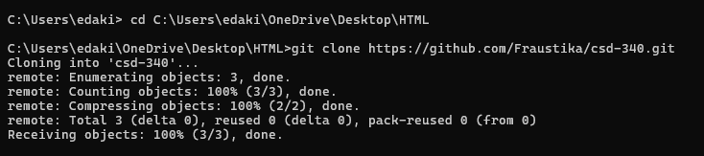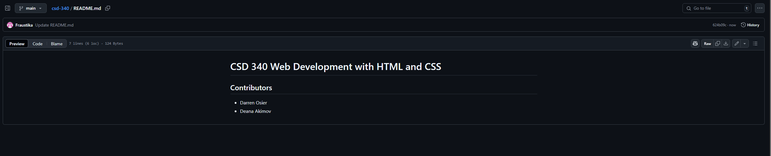

https://github.com/Fraustika/csd-340/blob/624b09c3877f4482e4bc81a079e8eb0cf4b8102e/README.md

