**Blinkit Analysis**

* See all the data imported:

SELECT * FROM blinkit_data

* **DATA CLEANING:**

UPDATE blinkit_data

SET Item_Fat_Content =

CASE

WHEN Item_Fat_Content IN ('LF', 'low fat') THEN 'Low Fat'

WHEN Item_Fat_Content = 'reg' THEN 'Regular'

ELSE Item_Fat_Content

END;

>> After executing this query check the data has been cleaned or not using below query

SELECT DISTINCT Item_Fat_Content FROM blinkit_data;

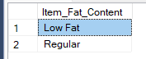

**Queries and Questions:**

1. **Find the total Revenue.**

SELECT ROUND(SUM(Total_Sales)/1000000,3) AS Revenue_in_Mn

FROM blinkit_grocery;

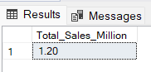

**2. Find the AVERAGE SALES**

SELECT ROUND(AVG(Total_Sales),1) AS Average_Sales

FROM Blinkit_Grocery;

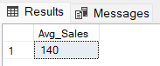

**3. NO OF ITEMS**

SELECT COUNT(*) AS Number_of_Items

FROM blinkit_Grocery;

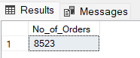

**4. AVG of RATING**

SELECT ROUND(AVG(Rating),2) AS Average_Rating

FROM blinkit_Grocery;

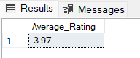

**B. Avg Sales, Total sales, Count, Avg rating By "Fat_content"**

SELECT Blinkit_Grocery.Item_Fat_Content,

ROUND(SUM(total_sales),2) AS Revenue,

ROUND(AVG(total_sales),2) AS Avg_Revenue,

ROUND(AVG(rating),2) AS Avg_rating,

COUNT(*) AS No_of_items

FROM Blinkit_Grocery

GROUP BY Item_Fat_Content;

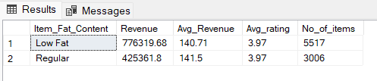

**C. Avg Sales, Total sales, Count, Avg rating By "Item_Type"**

SELECT Blinkit_Grocery.Item_Type,

ROUND(SUM(total_sales),2) AS Revenue,

ROUND(AVG(total_sales),2) AS Avg_Revenue,

ROUND(AVG(rating),2) AS Avg_rating,

COUNT(*) AS No_of_items

FROM Blinkit_Grocery

GROUP BY Item_type

ORDER BY Revenue DESC;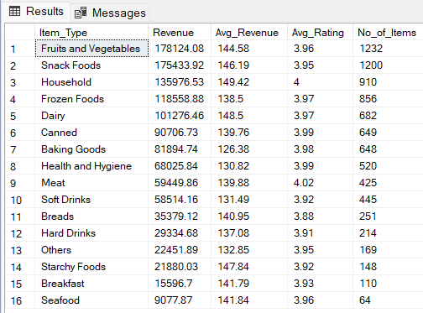

**D. Fat Content by Outlet for Total Sales**

SELECT item_fat_content, outlet_location_type,

ROUND(SUM(total_sales),2) AS Revenue

FROM blinkit_grocery

GROUP BY Item_Fat_Content, Outlet_Location_Type

ORDER BY Revenue DESC;

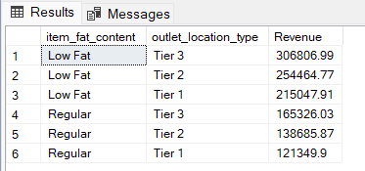

**E. Total Sales by Outlet Establishment**

SELECT Outlet_Establishment_Year, ROUND(SUM(Total_Sales),2) AS Revenue

FROM blinkit_Grocery

GROUP BY Outlet_Establishment_Year

ORDER BY Outlet_Establishment_Year:

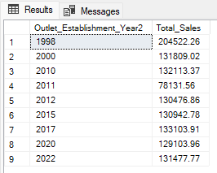

**F. Percentage of Sales by Outlet Size**

SELECT outlet_size, SUM(Total_sales),

ROUND(((SUM(total_sales)/

(SELECT SUM(Total_sales) as Revenue_Overall FROM Blinkit_Grocery))*100),2) AS Revenue_percentage

FROM Blinkit_Grocery

GROUP BY Outlet_Size

ORDER BY Revenue_percentage DESC:

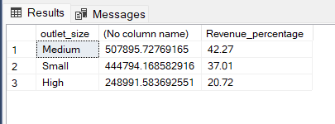

**G. Sales by Outlet Location**

SELECT Outlet_Location_Type, ROUND(SUM(Total_Sales),2) AS Revenue

FROM blinkit_Grocery

GROUP BY Outlet_Location_Type

ORDER BY Revenue DESC:

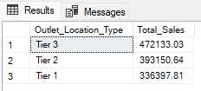

**H. All Metrics by Outlet Type:**

SELECT Outlet_Type,

ROUND(SUM(Total_Sales),2) AS Revenue,

ROUND(AVG(Total_Sales),2) AS Avg_Revenue,

COUNT(*) AS No_Of_Items,

ROUND(AVG(Rating),2) AS Avg_Rating,

FROM blinkit_Grocery

GROUP BY Outlet_Type

ORDER BY Revenue DESC

