**INDIA GENERAL ELECTIONS RESULT ANALYSIS 2024**

1. **Total Seats**

SELECT COUNT (Parliament_Constituency) AS Total_Seats

FROM constituencywise_results;



1. **Calculate seats according to states**

SELECT S.state, COUNT(CR.parliament_constituency) AS Seats

FROM constituencywise_results AS CR

JOIN

statewise_results AS SR

ON SR.parliament_constituency = CR.parliament_constituency

JOIN

States AS S

ON SR.state_id = S.state_id

GROUP BY S.state

ORDER BY Seats DESC

;

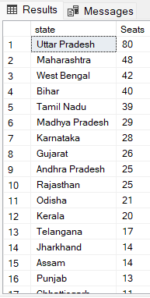

1. **Total seats won by NDA alliance**

SELECT SUM(PR.won) AS NDA_Total_Seats FROM partywise_results AS PR

where PR.party in ('Bharatiya Janata Party - BJP',

'Telugu Desam - TDP',

'Janata Dal (United) - JD(U)',

'Shiv Sena - SHS',

'AJSU Party - AJSUP',

'Apna Dal (Soneylal) - ADAL',

'Asom Gana Parishad - AGP',

'Hindustani Awam Morcha (Secular) - HAMS',

'Janasena Party - JnP',

'Janata Dal (Secular) - JD(S)',

'Lok Janshakti Party(Ram Vilas) - LJPRV',

'Nationalist Congress Party - NCP',

'Rashtriya Lok Dal - RLD',

'Sikkim Krantikari Morcha - SKM')

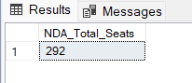

1. **Seats Won by NDA Allianz Parties**

SELECT PR.party AS NDA_Party, PR.won AS NDA_Seats_Won FROM partywise_results AS PR

WHERE PR.party in

('Bharatiya Janata Party - BJP',

'Telugu Desam - TDP',

'Janata Dal (United) - JD(U)',

'Shiv Sena - SHS',

'AJSU Party - AJSUP',

'Apna Dal (Soneylal) - ADAL',

'Asom Gana Parishad - AGP',

'Hindustani Awam Morcha (Secular) - HAMS',

'Janasena Party - JnP',

'Janata Dal (Secular) - JD(S)',

'Lok Janshakti Party(Ram Vilas) - LJPRV',

'Nationalist Congress Party - NCP',

'Rashtriya Lok Dal - RLD',

'Sikkim Krantikari Morcha - SKM')

ORDER BY PR.won DESC;

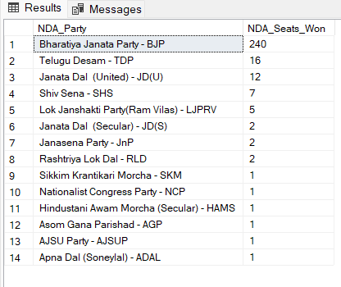

1. **Total Seats Won by I.N.D.I.A. Allianz**

SELECT SUM(PR.won) AS Total_INDIA_Seats FROM partywise_results AS PR

WHERE PR.party in ('Indian National Congress - INC',

'Aam Aadmi Party - AAAP',

'All India Trinamool Congress - AITC',

'Bharat Adivasi Party - BHRTADVSIP',

'Communist Party of India (Marxist) - CPI(M)',

'Communist Party of India (Marxist-Leninist) (Liberation) - CPI(ML)(L)',

'Communist Party of India - CPI',

'Dravida Munnetra Kazhagam - DMK',

'Indian Union Muslim League - IUML',

'Nat`Jammu & Kashmir National Conference - JKN',

'Jharkhand Mukti Morcha - JMM',

'Jammu & Kashmir National Conference - JKN',

'Kerala Congress - KEC',

'Marumalarchi Dravida Munnetra Kazhagam - MDMK',

'Nationalist Congress Party Sharadchandra Pawar - NCPSP',

'Rashtriya Janata Dal - RJD',

'Rashtriya Loktantrik Party - RLTP',

'Revolutionary Socialist Party - RSP',

'Samajwadi Party - SP',

'Shiv Sena (Uddhav Balasaheb Thackrey) - SHSUBT',

'Viduthalai Chiruthaigal Katchi - VCK'

) ;

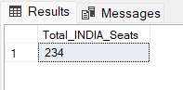

1. **Seats Won by I.N.D.I.A. Allianz Parties**

SELECT PR.party AS INDIA_Parties, PR.won AS INDIA_Seats FROM partywise_results AS PR

WHERE PR.party in ('Indian National Congress - INC',

'Aam Aadmi Party - AAAP',

'All India Trinamool Congress - AITC',

'Bharat Adivasi Party - BHRTADVSIP',

'Communist Party of India (Marxist) - CPI(M)',

'Communist Party of India (Marxist-Leninist) (Liberation) - CPI(ML)(L)',

'Communist Party of India - CPI',

'Dravida Munnetra Kazhagam - DMK',

'Indian Union Muslim League - IUML',

'Nat`Jammu & Kashmir National Conference - JKN',

'Jharkhand Mukti Morcha - JMM',

'Jammu & Kashmir National Conference - JKN',

'Kerala Congress - KEC',

'Marumalarchi Dravida Munnetra Kazhagam - MDMK',

'Nationalist Congress Party Sharadchandra Pawar - NCPSP',

'Rashtriya Janata Dal - RJD',

'Rashtriya Loktantrik Party - RLTP',

'Revolutionary Socialist Party - RSP',

'Samajwadi Party - SP',

'Shiv Sena (Uddhav Balasaheb Thackrey) - SHSUBT',

'Viduthalai Chiruthaigal Katchi - VCK'

) ORDER BY INDIA_Seats DESC;

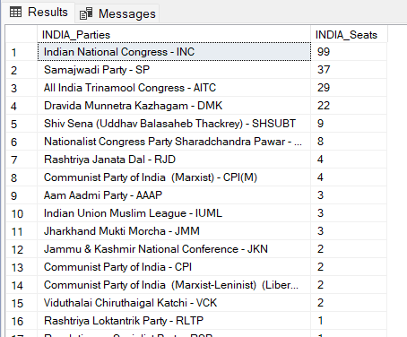

**Add new column field in table partywise_results to get the Party Allianz as NDA, I.N.D.I.A and OTHER**

ALTER TABLE **partywise_results**

ADD **party_alliance** VARCHAR**(50);**

1. **I.N.D.I.A Alliance**

UPDATE **partywise_results**

SET **party_alliance =** 'I.N.D.I.A'

WHERE **party IN (**

'Indian National Congress - INC',

'Aam Aadmi Party - AAAP',

'All India Trinamool Congress - AITC',

'Bharat Adivasi Party - BHRTADVSIP',

'Communist Party of India (Marxist) - CPI(M)',

'Communist Party of India (Marxist-Leninist) (Liberation) - CPI(ML)(L)',

'Communist Party of India - CPI',

'Dravida Munnetra Kazhagam - DMK',

'Indian Union Muslim League - IUML',

'Jammu & Kashmir National Conference - JKN',

'Jharkhand Mukti Morcha - JMM',

'Kerala Congress - KEC',

'Marumalarchi Dravida Munnetra Kazhagam - MDMK',

'Nationalist Congress Party Sharadchandra Pawar - NCPSP',

'Rashtriya Janata Dal - RJD',

'Rashtriya Loktantrik Party - RLTP',

'Revolutionary Socialist Party - RSP',

'Samajwadi Party - SP',

'Shiv Sena (Uddhav Balasaheb Thackrey) - SHSUBT',

'Viduthalai Chiruthaigal Katchi - VCK'

**);**

1. **NDA Alliance:**

UPDATE partywise_results

SET party_alliance = 'NDA'

WHERE party IN (

'Bharatiya Janata Party - BJP',

'Telugu Desam - TDP',

'Janata Dal (United) - JD(U)',

'Shiv Sena - SHS',

'AJSU Party - AJSUP',

'Apna Dal (Soneylal) - ADAL',

'Asom Gana Parishad - AGP',

'Hindustani Awam Morcha (Secular) - HAMS',

'Janasena Party - JnP',

'Janata Dal (Secular) - JD(S)',

'Lok Janshakti Party(Ram Vilas) - LJPRV',

'Nationalist Congress Party - NCP',

'Rashtriya Lok Dal - RLD',

'Sikkim Krantikari Morcha - SKM'

);

1. **Others**

UPDATE partywise_results

SET party_alliance = 'OTHER'

WHERE party_alliance IS NULL;

**Advanced Queries:**

1. **Which party alliance (NDA, I.N.D.I.A, or OTHER) won the most seats across all states?**

SELECT PR.party_alliance AS Alliance, SUM(PR.won) AS Total_Seats_Won FROM partywise_results AS PR

GROUP BY PR.party_alliance

ORDER BY Total_Seats_Won DESC;

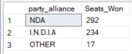

1. **What is the distribution of EVM votes versus postal votes for candidates in a specific constituency?**

SELECT cd.Candidate,

cd.Party,

cd.EVM_Votes,

cd.Postal_Votes,

cd.Total_Votes,

cr.Constituency_Name FROM constituencywise_details AS cd

JOIN constituencywise_results as cr

ON cd.Constituency_ID = cr.Constituency_ID

WHERE constituency_name = 'GWALIOR'

ORDER BY Total_Votes DESC

;

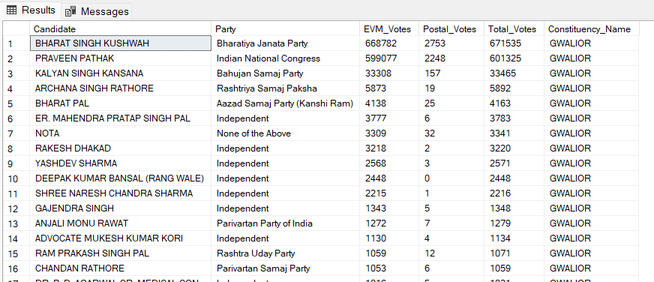

1. **Which parties won the most seats in specific state, and how many seats did each party win?**

SELECT PR.party, COUNT(CR.Parliament_Constituency) AS Seats_Won FROM partywise_results AS PR

JOIN constituencywise_results AS CR

ON PR.party_id = CR.party_id

JOIN statewise_results AS SR

ON CR.Parliament_Constituency = SR.Parliament_Constituency

JOIN states AS S

ON SR.State_ID = S.State_ID

WHERE S.state = 'Madhya Pradesh'

GROUP BY PR.party;

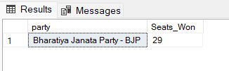

1. **Winning candidate's name, their party name, total votes, and the margin of victory for a specific state and constituency?**

SELECT CR.winning_candidate, PR.party, CR.total_votes, CR.margin, S.state, CR.constituency_name

FROM constituencywise_results AS CR

JOIN partywise_results AS PR

ON CR.party_id = PR.party_id

JOIN statewise_results AS SR

ON CR.parliament_constituency = SR.parliament_constituency

JOIN states AS S

ON S.state_id = SR.state_id

WHERE S.state = 'MADHYA PRADESH' AND constituency_name = 'GWALIOR'

;

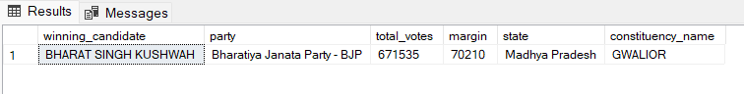

1. **What is the total number of seats won by each party alliance (NDA, I.N.D.I.A, and OTHER) in each state for the India Elections 2024**

SELECT

s.State AS State_Name,

SUM(CASE WHEN p.party_alliance = 'NDA' THEN 1 ELSE 0 END) AS NDA_Seats_Won,

SUM(CASE WHEN p.party_alliance = 'I.N.D.I.A' THEN 1 ELSE 0 END) AS INDIA_Seats_Won,

SUM(CASE WHEN p.party_alliance = 'OTHER' THEN 1 ELSE 0 END) AS OTHER_Seats_Won

FROM constituencywise_results cr

JOIN partywise_results p ON cr.Party_ID = p.Party_ID

JOIN statewise_results sr ON cr.Parliament_Constituency = sr.Parliament_Constituency

JOIN states s ON sr.State_ID = s.State_ID

WHERE p.party_alliance IN ('NDA', 'I.N.D.I.A', 'OTHER')

GROUP BY s.State

ORDER BY s.State

;

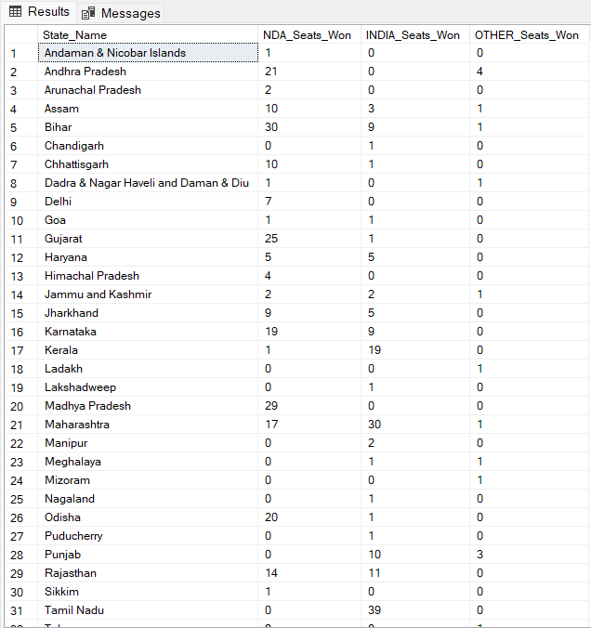

1. **Which candidate received the highest number of EVM votes in each constituency (Top 10)?**

SELECT TOP 10

cr.Constituency_Name,

cd.Constituency_ID,

cd.Candidate,

cd.EVM_Votes

FROM constituencywise_details cd

JOIN constituencywise_results cr ON cd.Constituency_ID = cr.Constituency_ID

WHERE cd.EVM_Votes = (

SELECT MAX(cd1.EVM_Votes)

FROM constituencywise_details cd1

WHERE cd1.Constituency_ID = cd.Constituency_ID

)

ORDER BY

cd.EVM_Votes DESC;

