1. Count the number of orders.

SELECT COUNT(DISTINCT orders.order_id) AS Total_Orders FROM orders;

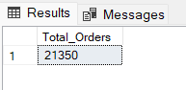

1. Calculate the total revenue?

SELECT ROUND(SUM(pizzas.price*order_details.quantity),2) as Total_revenue FROM pizzas

JOIN order_details

ON pizzas.pizza_id = order_details.pizza_id;

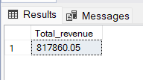

1. Identify the highyest priced Pizza?

SELECT TOP 1 pizza_types. name, pizzas.price FROM pizza_types

JOIN pizzas

ON pizza_types.pizza_type_id = pizzas.pizza_type_id

ORDER BY price DESC

;

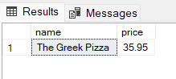

1. Identify the most common pizza ordered?

SELECT TOP 1 pizza_types.name, COUNT (quantity) AS Quantities FROM pizza_types

JOIN pizzas

ON pizza_types.pizza_type_id = pizzas.pizza_type_id

JOIN order_details

ON pizzas.pizza_id = order_details.pizza_id

GROUP BY pizza_types.name

ORDER BY Quantities DESC;

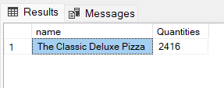

1. Identify the most common pizza size ordered?

SELECT pizzas.size, COUNT(order_details.quantity) AS Pizza_count FROM pizzas

JOIN order_details

ON pizzas.pizza_id = order_details.pizza_id

GROUP BY pizzas.size

ORDER BY Pizza_count DESC;

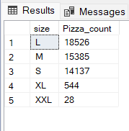

1. Identify the most common pizza types along with quantity?

SELECT TOP 5 pizza_types.name, SUM(order_details.quantity) AS Most_common FROM pizza_types

JOIN pizzas

ON pizza_types.pizza_type_id = pizzas.pizza_type_id

JOIN order_details

ON pizzas.pizza_id = order_details.pizza_id

GROUP BY pizza_types.name

ORDER BY Most_common DESC;

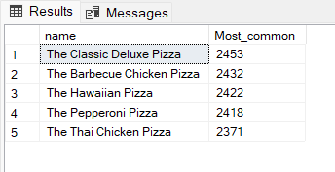

1. Find the total quantity of each pizza?

SELECT pizza_types.category, SUM(order_details.quantity) AS Total_Quantity FROM pizza_types

JOIN pizzas

On pizza_types.pizza_type_id = pizzas.pizza_type_id

JOIN order_details

ON pizzas.pizza_id = order_details.pizza_id

GROUP BY category

ORDER BY Total_Quantity DESC;

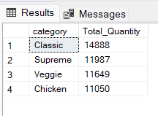

1. Determine the distribution of orders by hour of the day?

SELECT DATEPART(HOUR, orders.time) AS Order_hour, COUNT (orders.order_id) AS Count_of_order FROM orders

GROUP BY DATEPART(HOUR, orders.time)

ORDER BY DATEPART(HOUR, orders.time) DESC

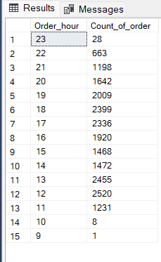

1. Find the category wise distribution of pizzas?

SELECT pizza_types.category AS Category, COUNT(pizza_types.category) AS Count

FROM pizza_types

GROUP BY Category

ORDER BY COUNT(pizza_types.category) DESC

;

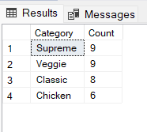

1. Group the orders by date and calculate the average number of pizzas ordered per day?

SELECT AVG(Quantity) AS Average_count FROM

(SELECT orders.date, SUM(order_details.quantity) AS Quantity

FROM orders JOIN order_details

ON orders.order_id = order_details.order_id

GROUP BY orders.date) AS Order_quantity;

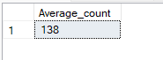

1. Determine the top 3 most ordered piza based on Revenue?

SELECT TOP 3 pizza_types.name, SUM(pizzas.price*order_details.quantity) AS Summation

FROM pizza_types

JOIN pizzas

ON pizza_types.pizza_type_id = pizzas.pizza_type_id

JOIN order_details

ON pizzas.pizza_id = order_details.pizza_id

GROUP BY pizza_types.name

ORDER BY Summation DESC;

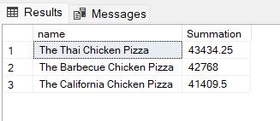

1. Calculate the percentage distribution of each pizza type to total revenue?

SELECT pizza_types.category,

ROUND((SUM(pizzas.price*order_details.quantity)/

(SELECT SUM(pizzas.price*order_details.quantity) FROM

pizzas

JOIN order_details

ON pizzas.pizza_id = order_details.pizza_id))*100,2) AS Revenue

FROM pizza_types

JOIN pizzas

ON pizza_types.pizza_type_id = pizzas.pizza_type_id

JOIN order_details

ON order_details.pizza_id = pizzas.pizza_id

GROUP by category

ORDER by Revenue;

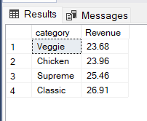

1. Analyze the cumulative revenue generated over time?

SELECT date, SUM(Revenue) OVER (ORDER BY date) AS Cum_Revenue

FROM

(SELECT orders.date, SUM(pizzas.price*order_details.quantity) AS Revenue FROM pizzas

JOIN order_details

ON pizzas.pizza_id = order_details.pizza_id

JOIN orders

ON order_details.order_id = orders.order_id

GROUP BY orders.date) AS totals

;

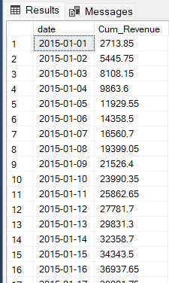

1. Determine the top 3 most ordered pizza types based on revenue for each pizza?

SELECT category, name, Revenue

FROM

(SELECT category, name, REVENUE, RANK () over (PARTITION BY category ORDER BY REVENUE DESC) AS Ranks FROM

(SELECT pizza_types.category, pizza_types.name, SUM(order_details.quantity*pizzas.price) AS REVENUE FROM pizza_types

JOIN pizzas

ON pizza_types.pizza_type_id = pizzas.pizza_type_id

JOIN order_details

ON order_details.pizza_id = pizzas.pizza_id

GROUP BY category, name) AS Table_1) AS Table_2

WHERE Ranks<=3;

