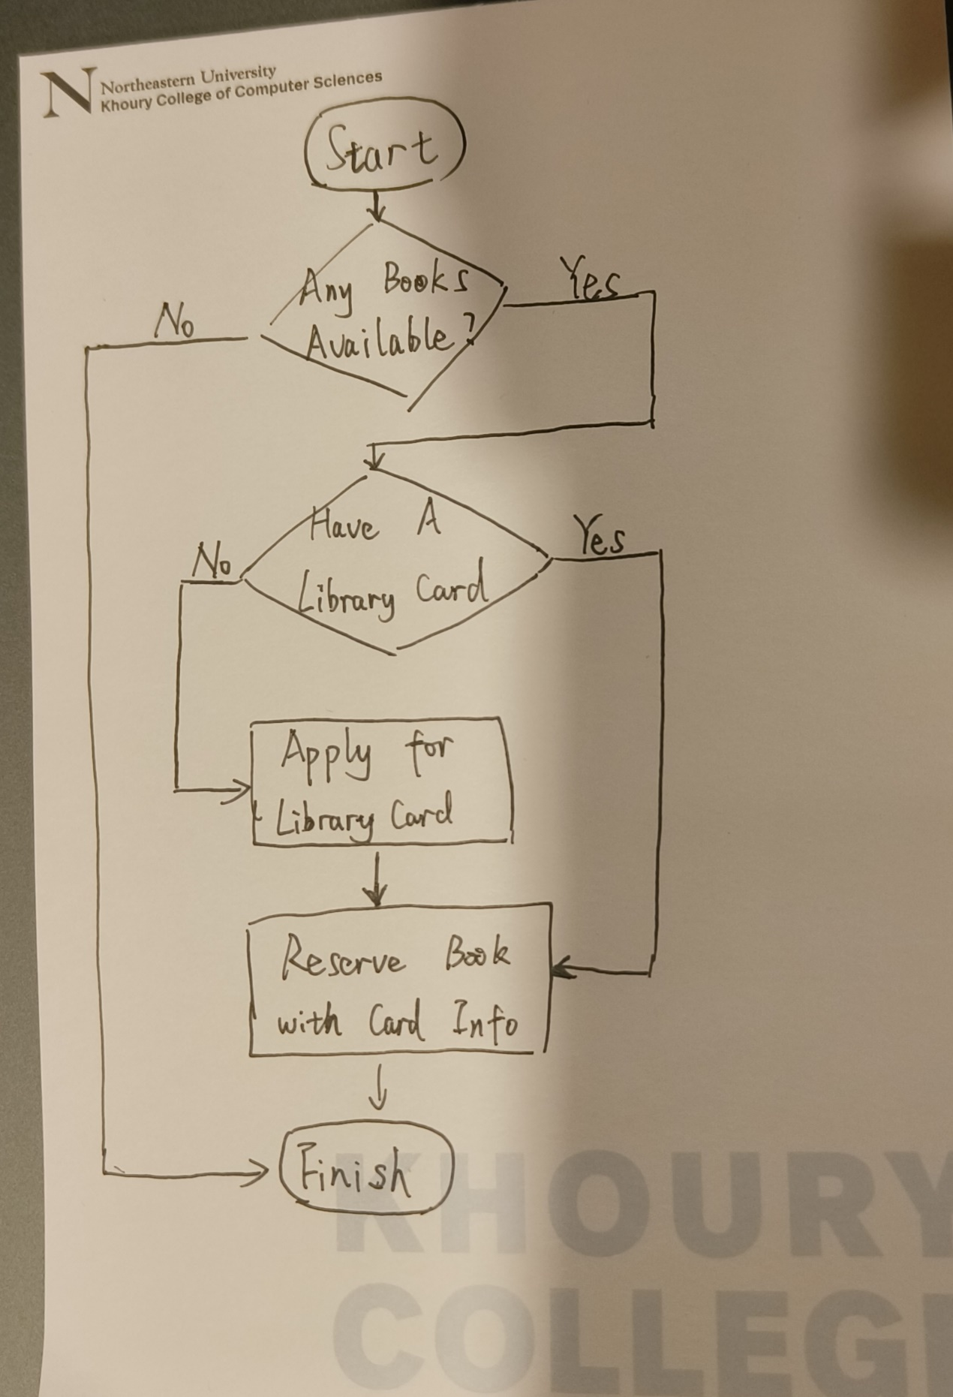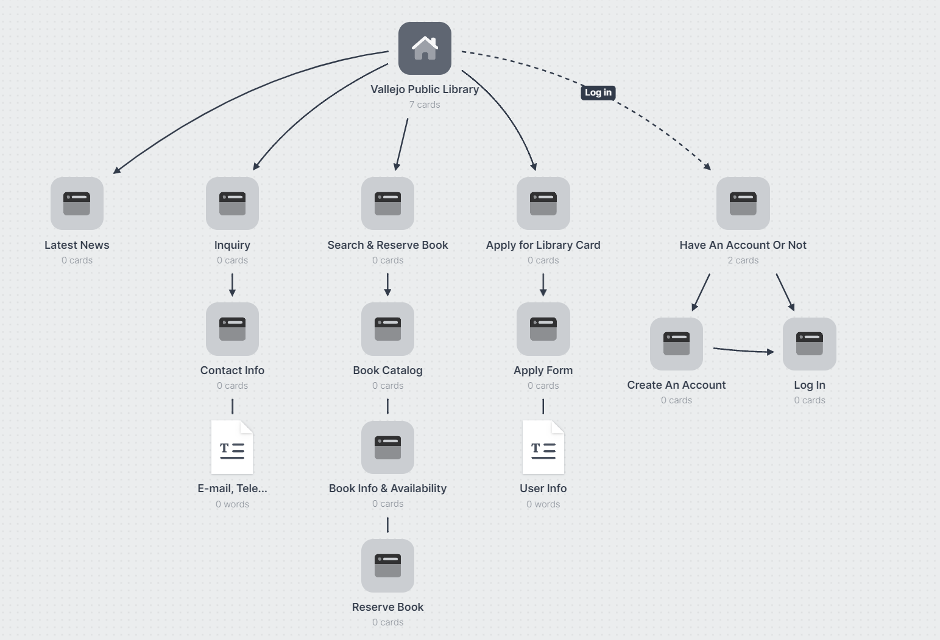

Cite：

<https://www.hayward-ca.gov/public-library>

<https://solanolibrary.com/>

<https://www.cdclib.org/>