**Persona Analysis**

Two primary personas were identified for this project:

1. **Tech-Savvy User:** Yu Zhang

A 25-year-old IT professional who prefers real-time technology updates and sports news, and he values accessibility features like dark mode.

- Age: 25-year-old

- Sexual identification/orientation: male

- Culture/language: English, Cantonese

- Familiarity with technology: IT professional

- Disabilities (including temporary): None

- Being in a hurry (e.g., need to find something / do something now): Sometimes

- Poor data connection: No

- Urgency (is it a life-or-death situation? Not really?): No

- Is this a professional setting? Yes

- Is the person acting on behalf of someone else? No

1. **Casual Reader:** May Ray

A 51-year-old user who enjoys a mix of business and health news, with an emphasis on simplicity and ease of use.

- Age: 51-year-old

- Sexual identification/orientation: female

- Culture/language: English, Mandarin Chinese

- Familiarity with technology: Not very familiar

- Disabilities (including temporary): None

- Being in a hurry (e.g., need to find something / do something now): Never

- Poor data connection: Sometimes

- Urgency (is it a life-or-death situation? Not really?): No

- Is this a professional setting? No

- Is the person acting on behalf of someone else? No

**User Journeys**

Base requirements: Two user journeys, with two opportunities discovered in each

User Journey 1: Tech-Savvy User, Yu Zhang

Steps: Sign up → Select preferences → Enable dark mode → Browse technology and sports news → Save favorite articles for future reference

Opportunities:

1. Provide quick-access toggles for accessibility settings.
2. Offer machine-learning-based recommendations to enhance engagement.

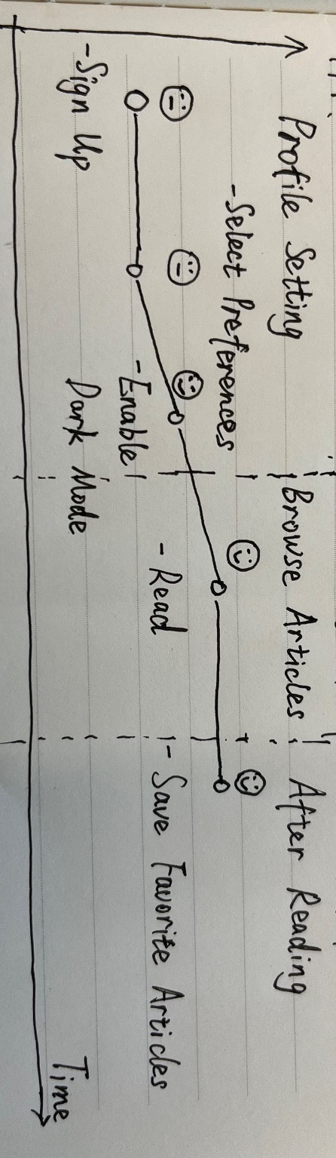

User Journey 2: Casual Reader, May Ray

Steps: Visit homepage → Select business and health categories → Browse articles → Share articles with friends and family members on social media.

Opportunities:

1. Simplify the onboarding process for quicker engagement.
2. Enable cross-device synchronization for seamless reading.
3. Make the font size adjustment button easier to find

