|  |  |
| --- | --- |
| Internship Project Title | RIO-210: Classification Model - Build a Model that Classifies the Side Effects of a Drug |
| Name of the Company | TCS iON |
| Name of the Industry Mentor | Himdweep Walia |
| Name of the Institute | Amity University Online |

|  |  |  |  |  |
| --- | --- | --- | --- | --- |
| Start Date | End Date | Total Effort (hrs.) | Project Environment | Tools used |
| 23-05-2024 | 06-07-2024 | 210 | Jupyter Notebook | PYTHON  Library: Pandas, NumPy, seaborn, matplotlib, pyplot, sklearn, etc |

**TABLE OF CONTENT**

* Acknowledgements
* Objective
* Introduction / Description of Internship
* Internship Activities
* Approach / Methodology
* Assumptions
* Exceptions / Exclusions
* Charts, Table, Diagrams
* Algorithms
* Challenges & Opportunities
* Risk Vs Reward
* Reflections on the Internship
* Recommendations
* Outcome / Conclusion
* Enhancement Scope
* Link to code and executable file
* Research questions and responses

1. **ACKNOWLEDGEMENT**

I extend my sincere gratitude to TCS iON for granting me the opportunity to undertake this internship.

I am highly indebted to TCS iON authorities for the facilities provided to accomplish this internship.

I would like to thank my industry mentor, Mrs. Himdweep Walia for her insightful feedback and guidance throughout the internship. Her expertise significantly contributed to my growth.

I would also like to thank my academic mentor, Mr. Saqib Sarwar for his support and guidance during this project. His vast knowledge of machine learning significantly helped me complete this internship.

I am extremely grateful to my colleagues and friends who helped me in the successful completion of this internship.

With a great sense of pleasure and immense gratitude, I acknowledge the help and support of all these individuals.

**Md. Azeem**

1. **OBJECTIVE**

The primary objectives of this internship project are:

* **Data Collection and Preprocessing**: Collect and clean a detailed dataset including patient demographics, drug ratings, and reviews. This step involves sourcing data from reputable healthcare databases and ensuring its quality by addressing missing values, eliminating duplicates, and correcting inconsistencies. Effective data preprocessing is crucial for the success of subsequent analyses as it ensures that the dataset is accurate, complete, and ready for machine learning (ML) model development. This step may also include feature engineering to create new, meaningful variables from the existing data.
* **Exploratory Data Analysis (EDA)**: Analyze the data to find patterns and relationships among key variables. EDA involves using statistical techniques and visualization tools to gain insights into the dataset’s structure and distributions. This step helps in identifying trends, anomalies, and correlations that could influence the occurrence of drug side effects. It includes the use of descriptive statistics, histograms, box plots, scatter plots, and heat maps to summarize and visualize data characteristics, thus guiding the feature selection process for model development.
* **Model Development**: Create and compare various machine learning models to predict drug side effects. This objective involves selecting a range of different machine learning algorithms, such as logistic regression, decision trees, random forests, support vector machines (SVM), and K-nearest neighbor(KNN). The models are developed using training data and are designed to identify patterns and make predictions about the likelihood of drug side effects based on patient demographics and drug usage data. The diversity of models allows for a comprehensive comparison to find out the best-performing algorithm.
* **Model Evaluation**: Assess the models based on accuracy, precision, recall, and F1 score. Model evaluation is essential to determine the effectiveness and reliability of each ML model. This involves partitioning the dataset into training and testing subsets and using performance metrics to evaluate the models' predictive capabilities. Accuracy measures the overall correctness of the model, precision indicates the proportion of true positive predictions among all positive predictions, recall measures the ability to identify true positives, and F1 score provides a balance between precision and recall.
* **Insights and Recommendations**: Provide practical insights and advice for healthcare providers based on the analysis. This final objective focuses on translating the findings from the ML models and EDA into actionable recommendations for clinical practice. These insights can help healthcare providers make informed decisions about drug prescriptions, identify high-risk patients, and develop personalized treatment plans. Additionally, the study’s results could inform public health strategies and policy-making to enhance patient safety and improve medication adherence.

1. **INTRODUCTION**

Machine learning (ML) is a state-of-the-art approach that has extensive applications in categorization, prediction, and forecasting across diverse fields including medicine, engineering, education, manufacturing, weather forecasting, traffic management, robotics, and more. It is one of the most advanced concepts of artificial intelligence (AI), and provides a strategic approach to developing automated, intricate, and unbiased algorithmic techniques for multimodal and dimensional biomedical or mathematical data analysis. Machine learning has demonstrated significant potential in pharmaceuticals and medicine by enhancing the collection and utilization of diverse data types to improve analysis, prevention, and individualized treatment strategies.

Healthcare is an important industry that offers value-based care to millions of people. Machine learning (ML) applications integrated with real-time patient data from various healthcare systems across multiple countries can enhance the effectiveness of personalized treatment options. ML has extensive use in precision medicine and personalized treatments. Using ML techniques, both beneficial and adverse drug side effects can be categorized, enabling more informed decisions for precision medicine and personalized treatments. Drug classifiers based on side effects also serve as valuable resources to support licensed healthcare professionals in patient care.

A side effect is an unwanted drug reaction caused by a drug or medication, occurring alongside its intended therapeutic benefits. These effects can vary widely among individuals based on factors like their health condition, age, weight, gender, ethnicity, and overall well-being. They can occur when starting, decreasing/increasing dosages, or ending a medication and may lead to non-compliance with prescribed treatment. Side effects not only affect patient compliance and satisfaction but can also result in serious health issues. Severe side effects may require dose adjustments or prescription of alternative medications. Lifestyle changes or dietary adjustments may also help minimize side effects. Classifying side effects for each drug is a challenging task, but machine learning techniques have facilitated this task with improved accuracy. Pharmacogenetic research has revealed significant differences among racial and ethnic groups in how drugs are metabolized, their clinical effectiveness, and their side effect profiles, highlighting the importance of personalized medical approaches.

1. **DESCRIPTION OF INTERNSHIP**

Machine learning models have been developed to classify side effects of drugs based on age and gender using patient review dataset obtained from Kaggle. The dataset comprises 362,806 instances and includes 12 features containing categorical, numerical, and text data. It provides both demographic and clinical data and provides user reviews of specific drugs along with related conditions, side effects, age, sex, and ratings (ease of use, effectiveness, satisfaction) reflecting overall patient satisfaction. Each entry details user reviews for drugs based on purchased medications, illness conditions, ratings, and useful counts based on review helpfulness.

The insights obtained from these models will help healthcare providers in making informed decisions and personalize treatment plans to minimize adverse effects. By analyzing patterns in patient demographics and feedback, healthcare providers can customize treatments more effectively, potentially enhancing patient outcomes and satisfaction. Moreover, the dataset's comprehensive nature facilitates a deeper understanding of how different factors influence drug efficacy and patient experiences across various demographic groups.

1. **INTERNSHIP ACTIVITIES**

**Activity 1: Familiarize the topic and search for a dataset.**

* Familiarize with the TCSION platform and understand the needs of the project and dataset required. For that, I searched on various sites like Kaggle.

**Activity 2: Finalize a dataset from Kaggle and do a basic analysis.**

* Finalized a WebMD dataset of 368,206 entries from Kaggle. After that, I performed some basic analysis on the dataset such as info, describe, columns, shape, null values, datatypes, unique count, unique values, etc.

**Activity 3: Data preprocessing**

* Data preprocessing was done, which includes Missing value handling, Cleaning irrelevant data, etc.

**Activity4: Exploratory data analysis non-graphical**

* Performed some EDA like No. of users based on gender, Top 15 recommended drugs for each condition, Drug mostly used by the patient and most common condition, etc.

**Activity 5: Exploratory data analysis graphical**

* Graphical EDA was done such as Most commonly used drugs, Top 10 drugs used for Pain, Most common conditions, Race Count plot, Gender Distribution by Race, Effectiveness of Drug, Side Effects by Age Group, etc.

**Activity 6: New feature creation**

* A new feature Sideeffect was created and mapped to the dataset.

**Activity 7: Text processing**

* Import the stopwords module from the nltk library.
* Text cleaning was performed
* Make text lowercase, remove text in square brackets, remove punctuation, and remove words containing numbers.

**Activity 8: Splitting dataset**

* Split the dataset into two parts, train dataset and test dataset.
* Train dataset was used to train the model.
* Test dataset was used for prediction.

**Activity 9: Train dataset.**

* For training the data, I used the TfidfVectorizer class from the sklearn. feature_extraction.text module to create a term frequency-inverse document frequency (TF-IDF) matrix for the given corpus of text data.

**Activity 10: Model Development and Evaluation**

* Created various machine learning model which includes Logistic Regression, SVM, KNN, Decision Trees, Random Forest, etc.
* Confusion Matrix, Classification Report was created to conclude the most accurate model.

**Activity 11: COMPARING ALL ALGORITHMS**

* Compared all the developed machine learning models and concluded that Random Forest and Bagging Classifier are the most accurate models.

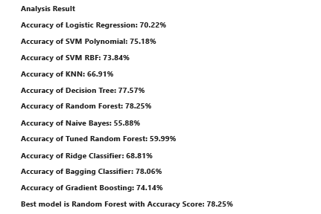

**Activity 12.: Uploaded all documents including python file on GitHub.**

**Activity 13: Prepared the final project report.**

1. **APPROACH / METHODOLOGY**

The dataset ("drugdata.csv") used for the project includes both demographic and clinical data. It contains both structured and unstructured data allowing to perform a multifaceted analysis. It contains 3,62,806 instances and 12 features including categorical, numerical, and text data. The dataset provides user reviews on specific drugs along with related conditions, side effects, age, gender, and ratings (ease of use, satisfaction, effectiveness) reflecting overall patient satisfaction.

The methodology involves rigorous data preprocessing to handle missing values, feature creation, and transforming skewed data. Exploratory Data Analysis (EDA) uses different visual techniques to discover patterns and relationships in the data. Machine learning models including Logistic Regression, SVM, KNN, Decision Trees, Random Forests, Naive Bayes, and Gradient Boosting are developed to predict drug side effects effectively.

1. **ASSUMPTIONS**

* The data collected by WebMD is representative of the population as a whole.
* The data collected is accurate and free from errors.
* The age and gender information provided in the dataset is accurate and complete.
* The machine learning techniques used to classify side effects are appropriate for the dataset.
* The classification model developed is generalizable to other datasets.

1. **EXCEPTIONS / EXCLUSIONS**

* The dataset may not include all possible side effects for each drug.
* The dataset may not include information on all drugs or medications.
* The dataset may not be up-to-date or accurate.
* The classification model developed may not be able to accurately predict side effects for all individuals.
* The classification model developed may not be generalizable to other datasets.
* The classification model developed may not be able to account for all the factors that can impact side effects.

1. **CHARTS, TABLES, DIAGRAMS**

**Exploratory Data Analysis**

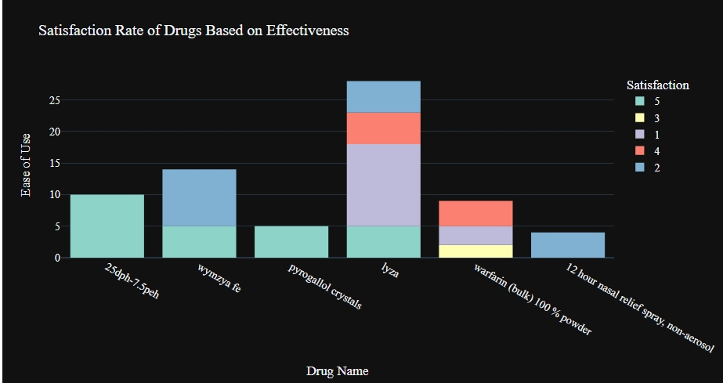

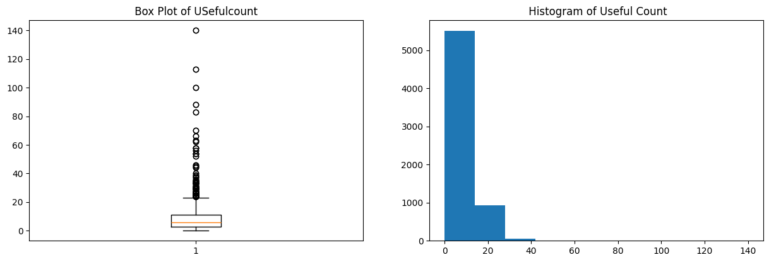

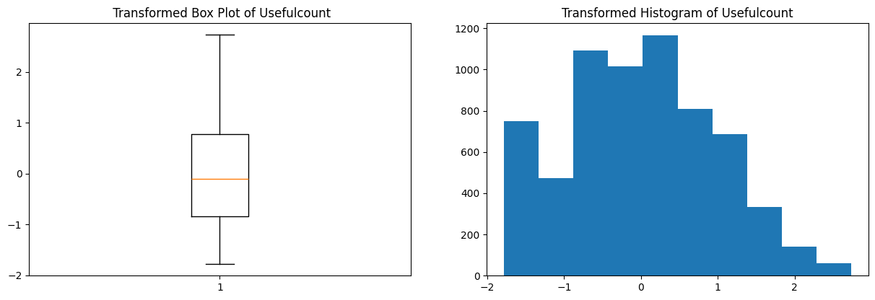

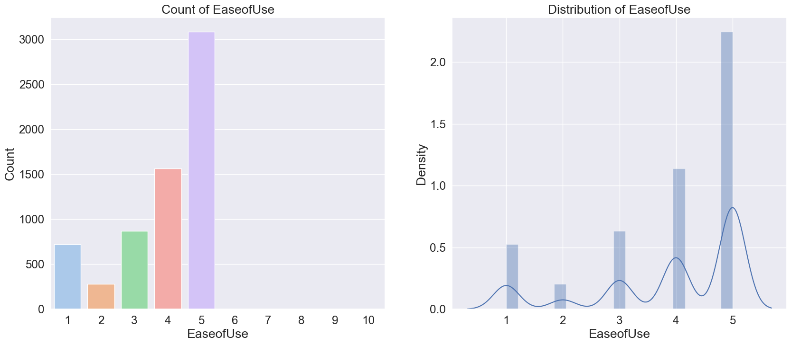

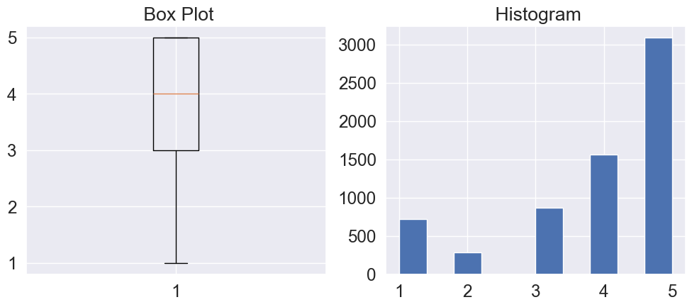

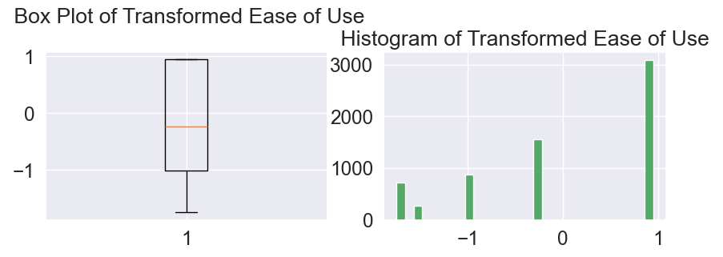

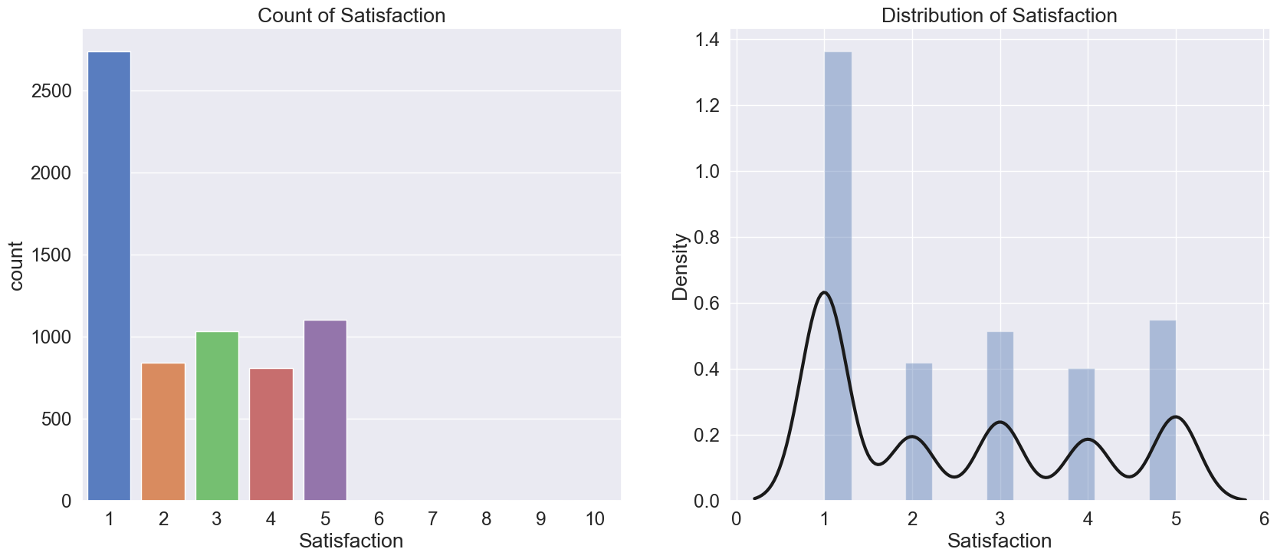

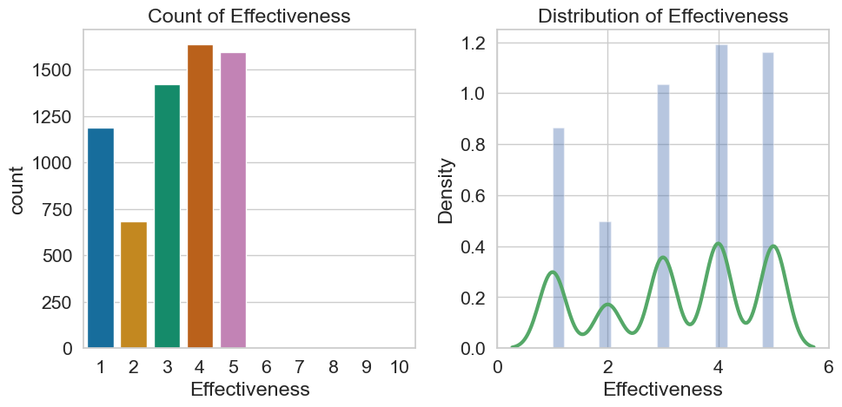

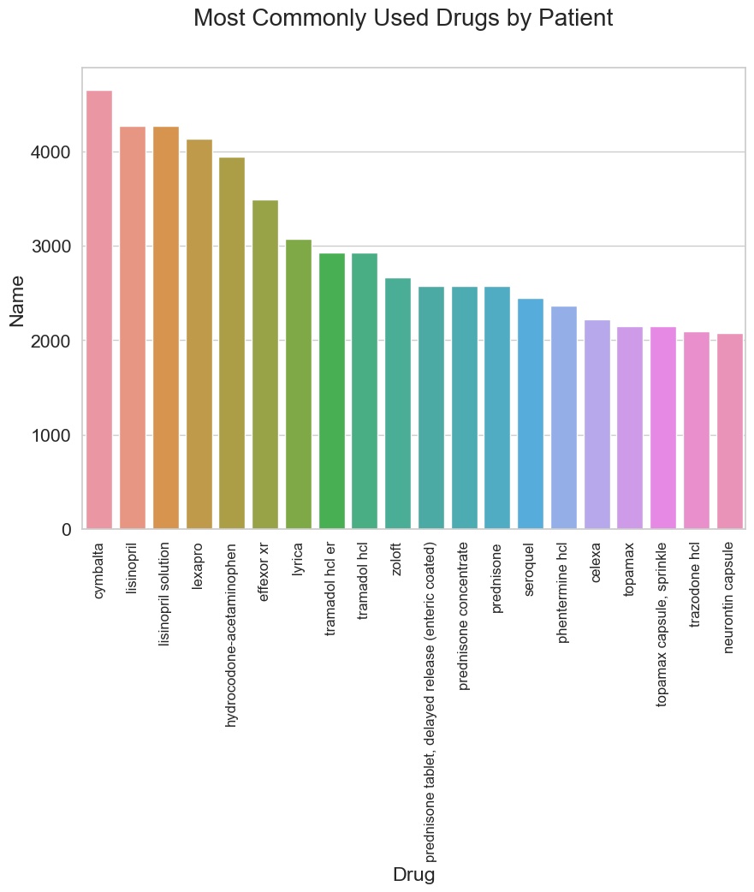

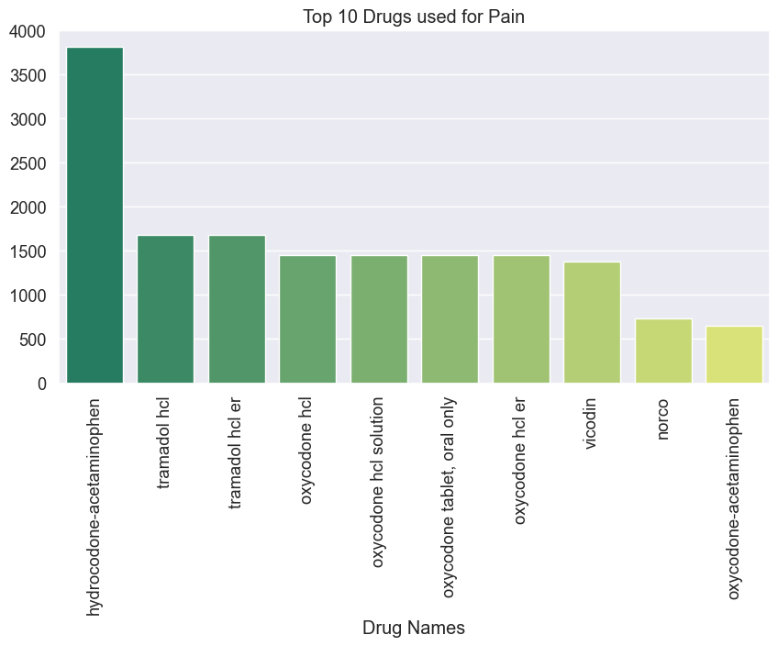

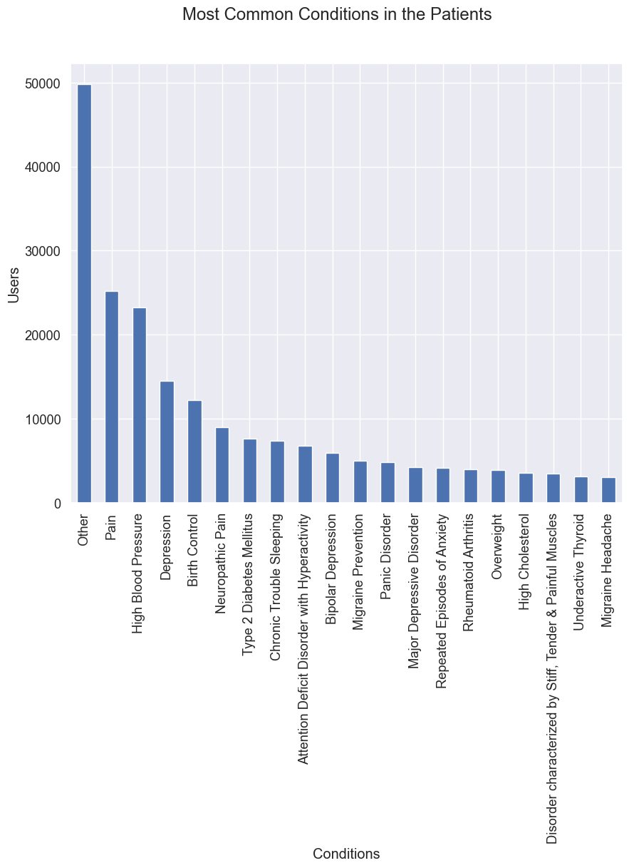

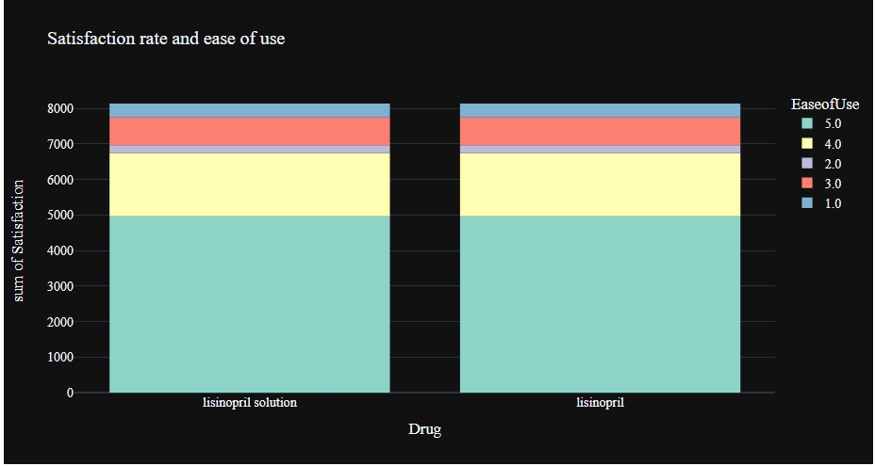

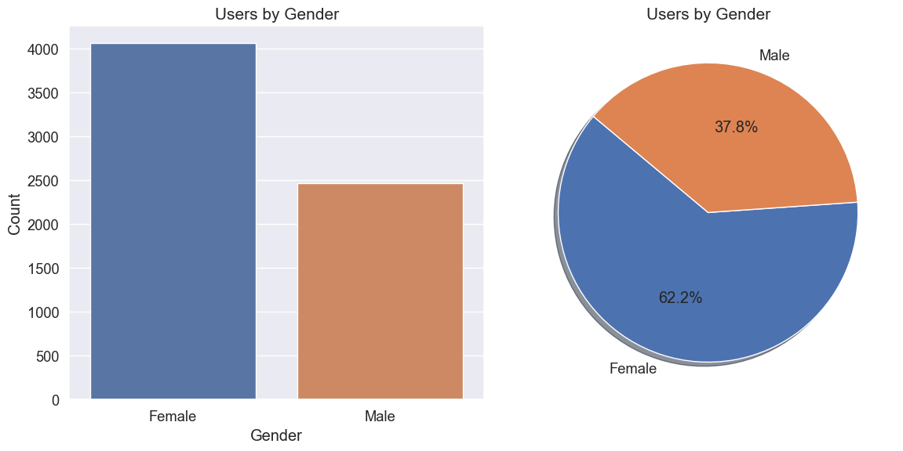

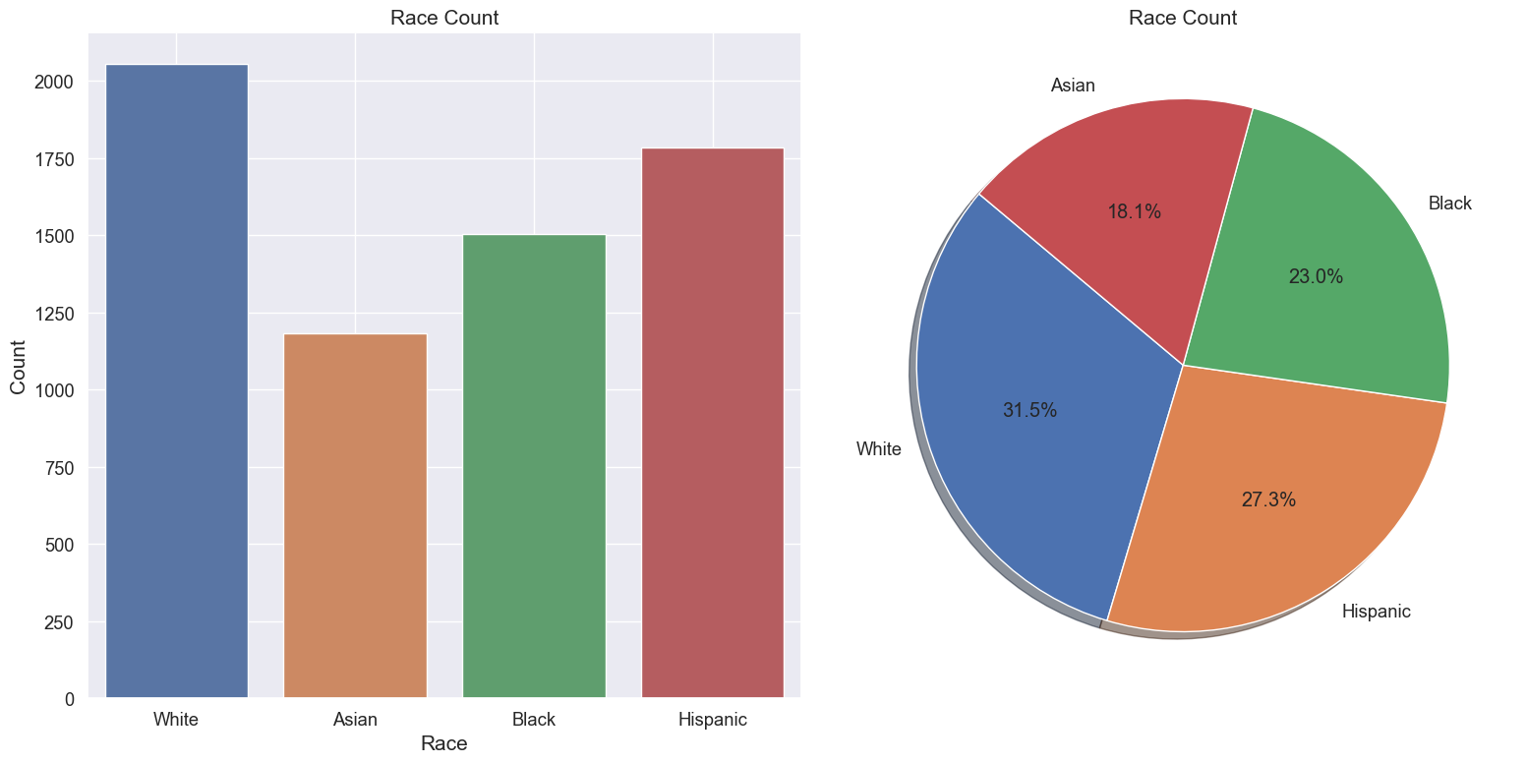

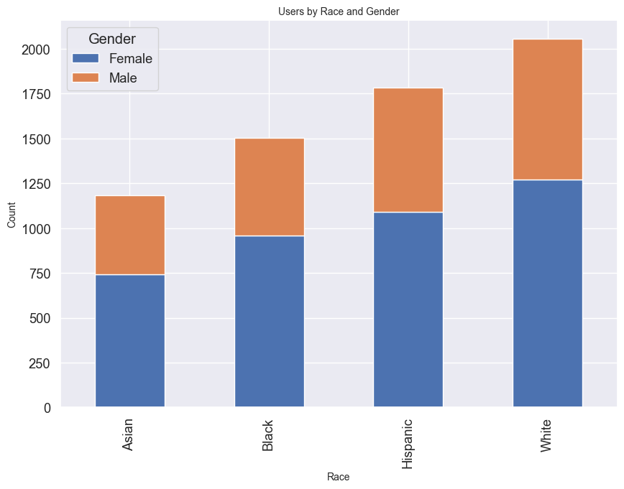

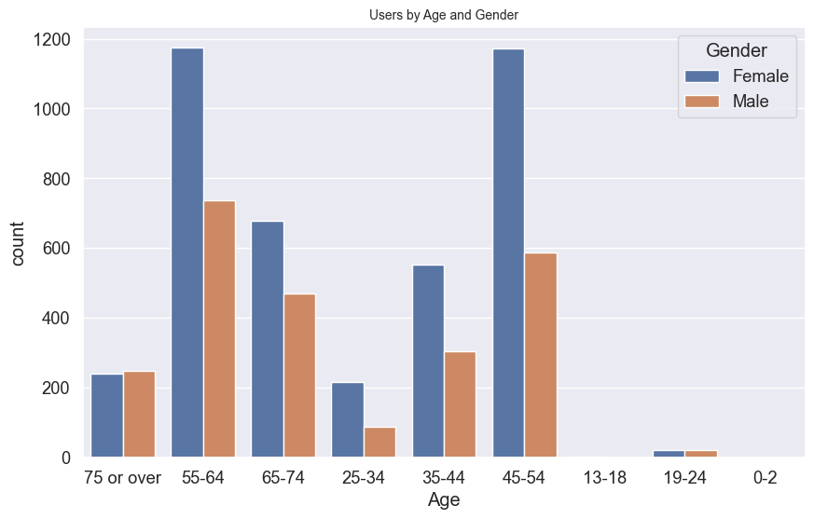

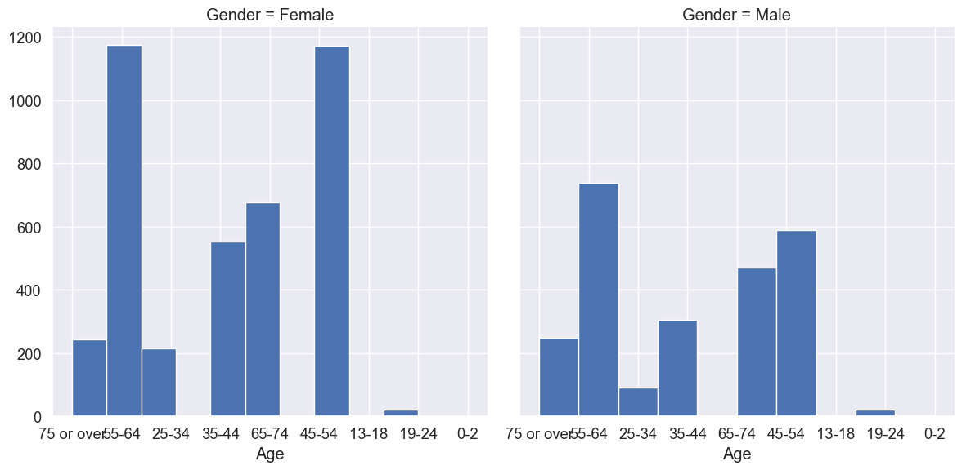

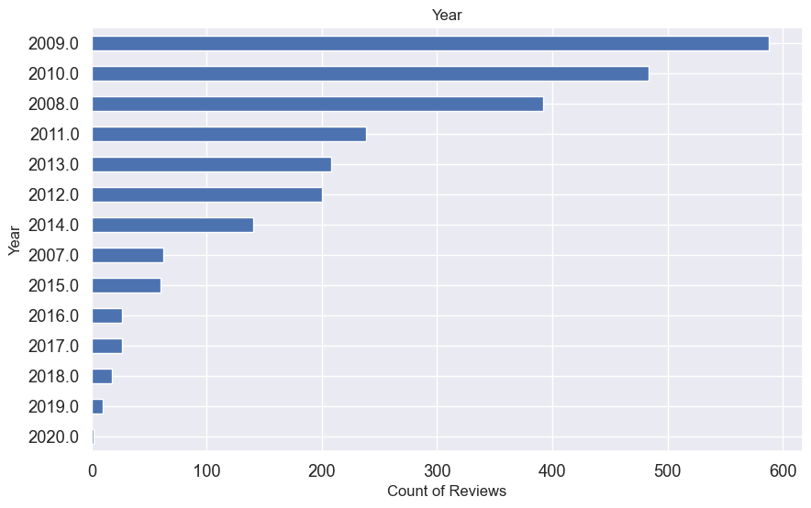

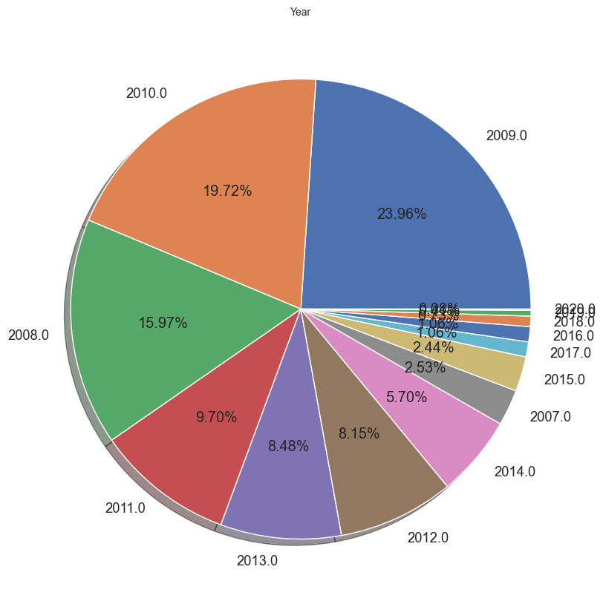

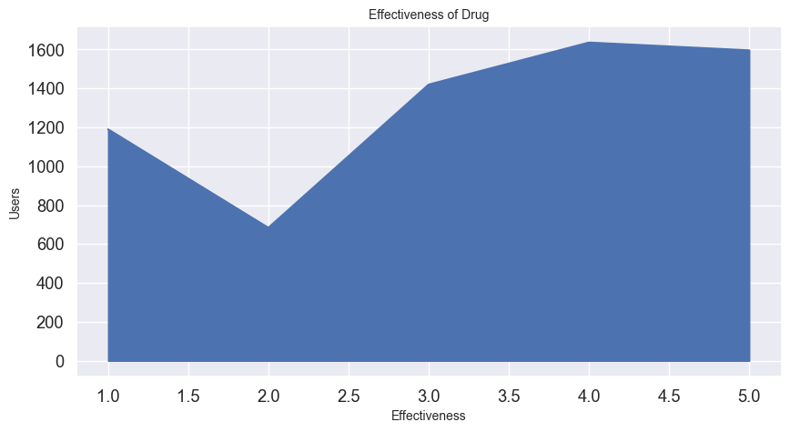

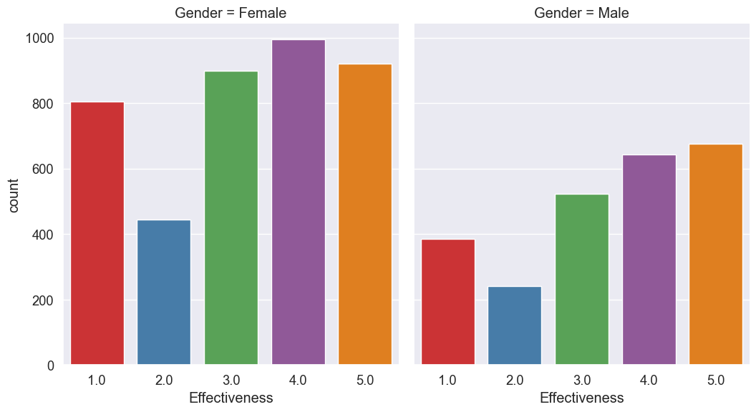

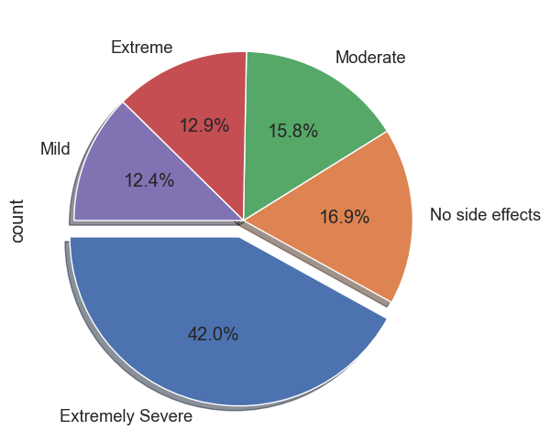

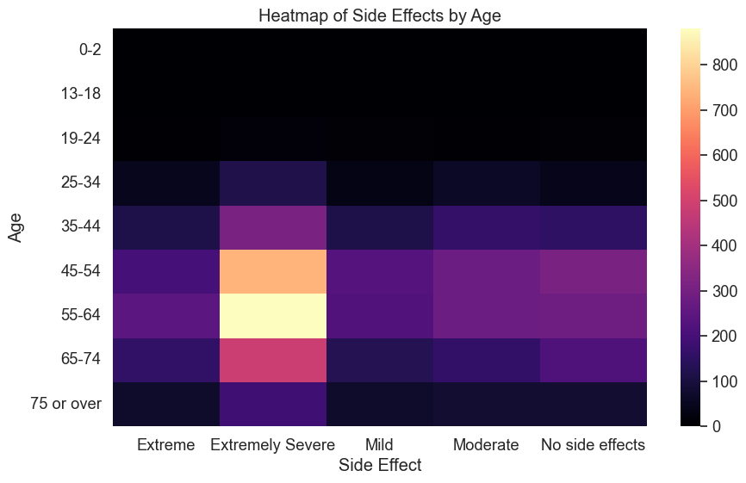

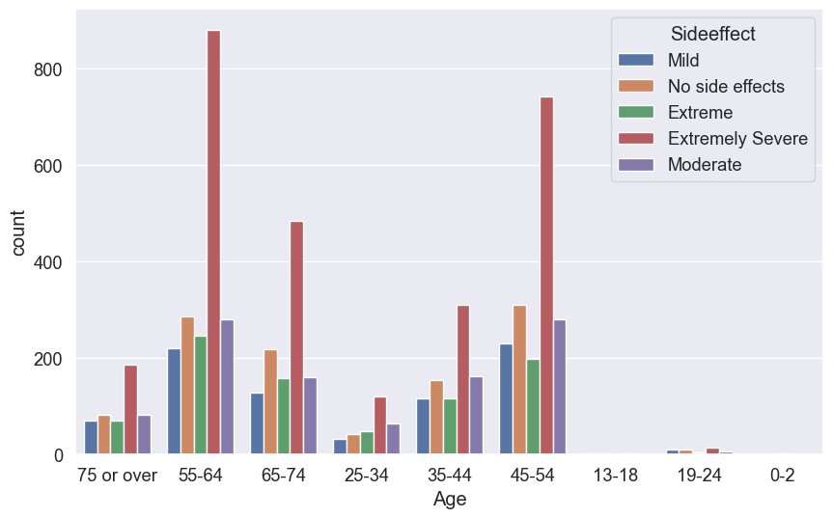

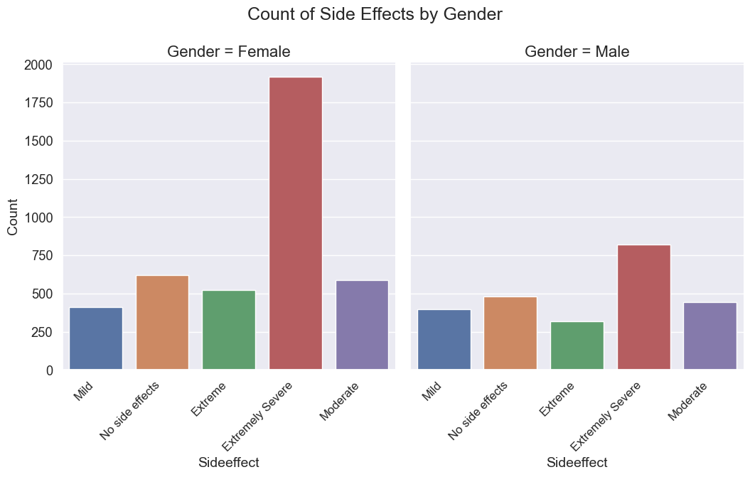

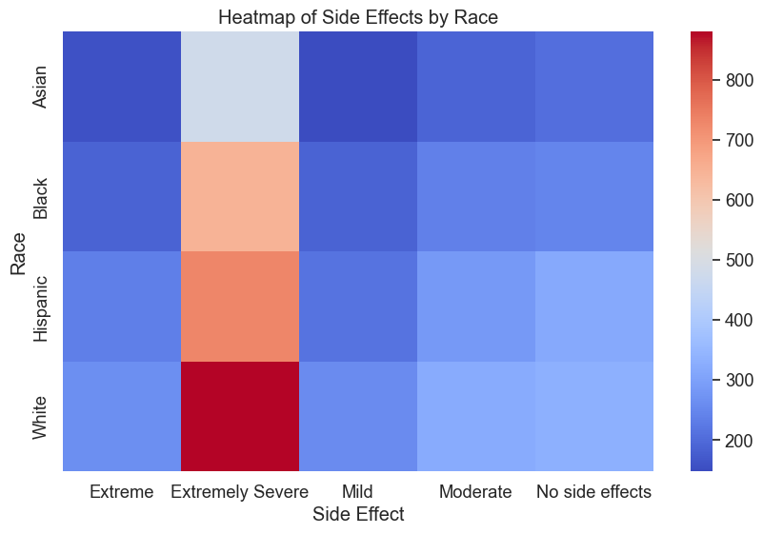

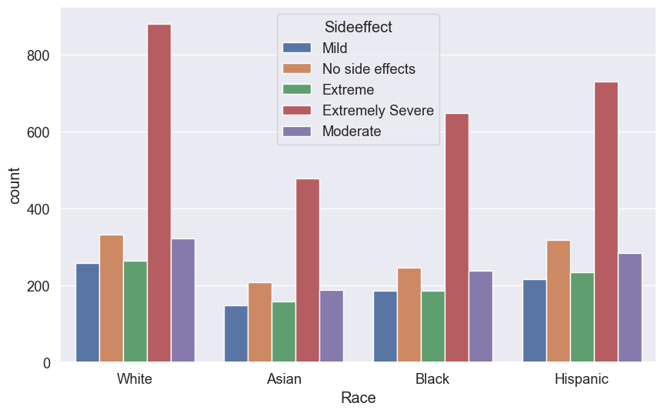

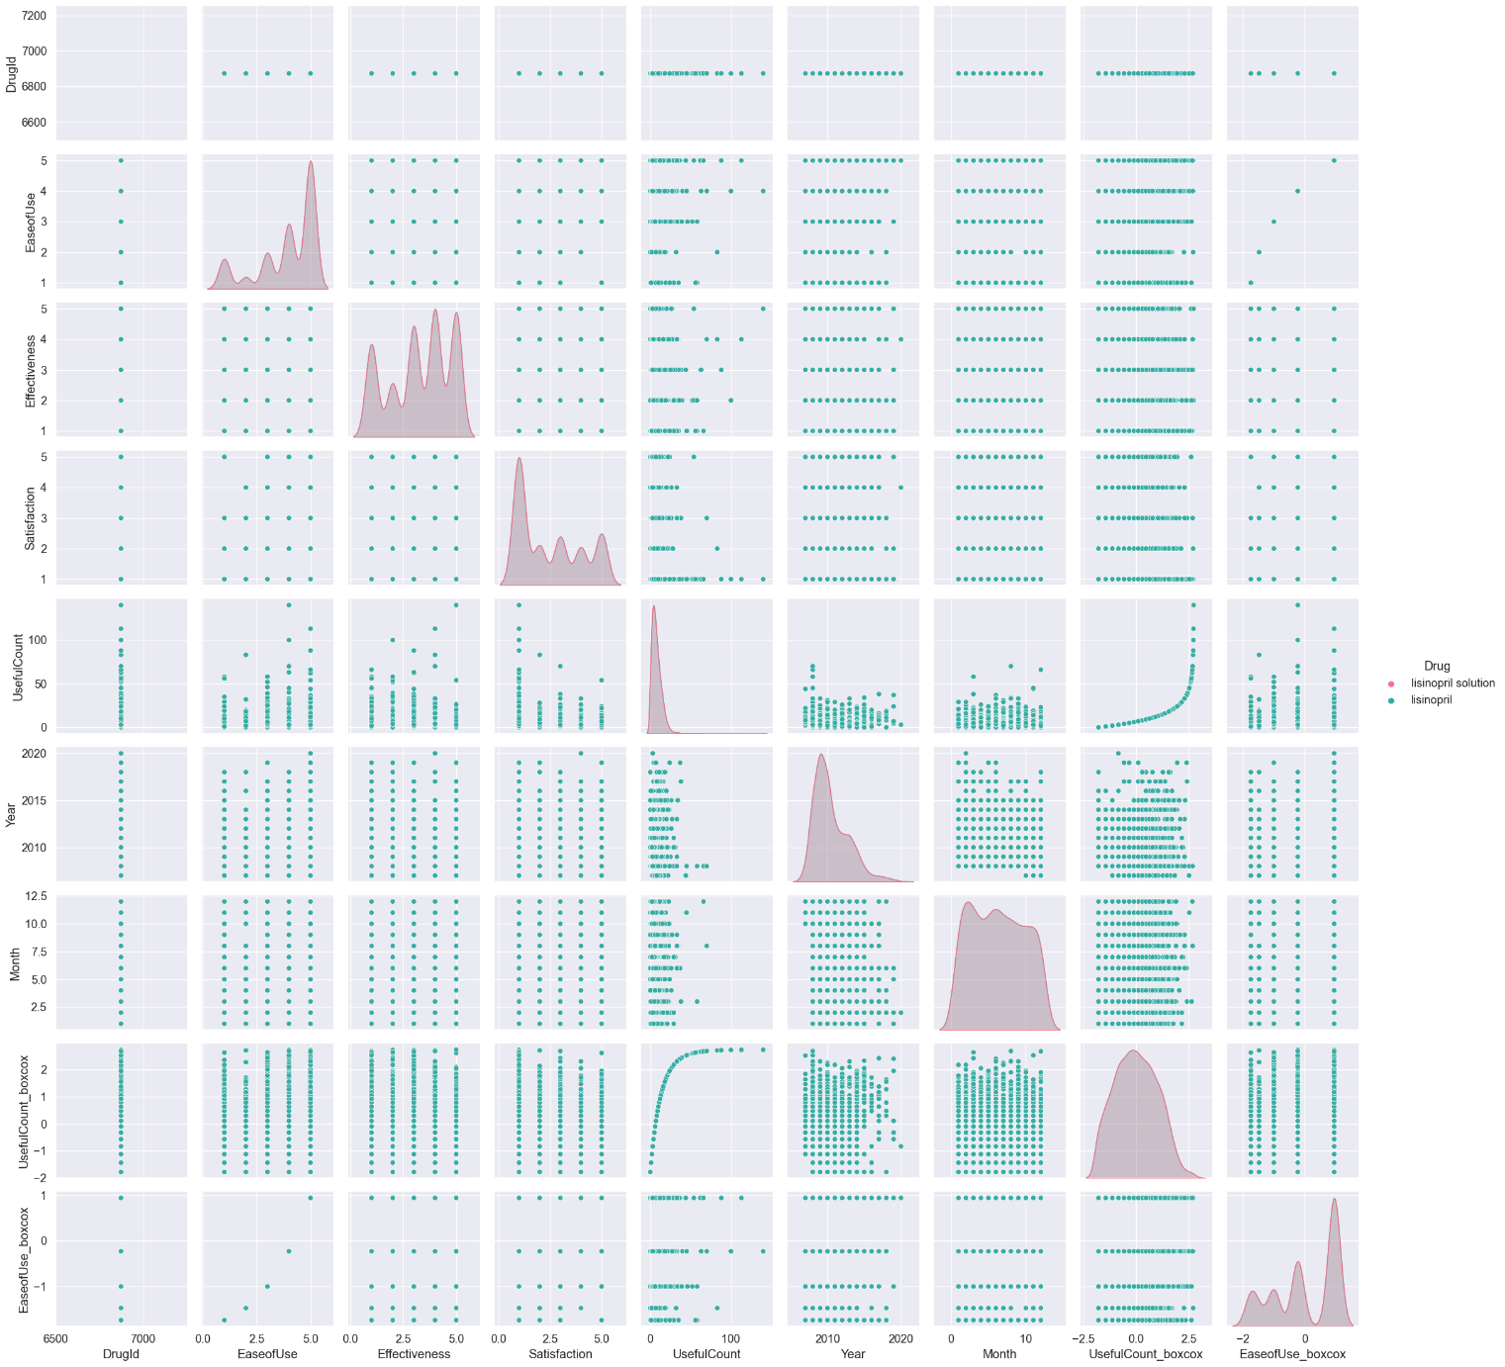

Lisinopril, the most commonly used drug shows side effects but its effectiveness and satisfaction rate are good. The proportion of female users is consistently higher across all racial and age groups. Females reported more severe side effects as well as higher drug effectiveness compared to male users. The race distribution of users revealed that White individuals were the most predominant users. The Heat map analysis also revealed that the 60+ age group reported the most side effects. The number of reviews increased until 2014, then slightly declined, possibly indicating users' adaptation to side effects or a focus on treating illness with less concern for side effects.

1. **ALGORITHMS**

For this project, various machine learning (ML) algorithms has been developed and then models are compared for predicting adverse drug reactions (ADRs). Machine learning algorithms used for this project are:

**1. Logistic Regression**

A linear model used for binary classification tasks. It estimates the probability of a binary outcome (e.g., the presence or absence of side effects) by combining input features linearly. The model applies the logistic function to convert linear combinations into probabilities.

**2. Decision Tree**

Non-linear models that partition data into subsets based on feature values to make predictions. They recursively split the data into branches, aiming to increase the purity of the resulting subsets.

**3. Random Forest**

An ensemble learning method that improves the accuracy and robustness of predictions by constructing multiple decision trees and combining their outputs. Each tree is trained on a random subset of the data and a random subset of features.

**4. Support Vector Machine (SVM)**

SVM is a powerful classification algorithm that finds the optimal hyperplane to separate classes by maximizing the margin between the closest points of different classes. SVMs can handle non-linear relationships using kernel functions.

**5. K-Nearest Neighbors (KNN)**

KNN is a simple, instance-based learning algorithm that predicts the class of a sample based on the majority class of its closest neighbors. The distance between samples is typically measured using Euclidean distance.

**6. Naive Bayes**

A probabilistic classifier based on Bayes' theorem, assuming independence between features. Despite its simplicity, Naive Bayes is efficient and often performs well in high-dimensional datasets, particularly in text classification.

**7. Gradient Boosting**

An ensemble technique that builds models sequentially, each one correcting the errors of its predecessor. It combines weak learners to form a strong predictive model.

These algorithms collectively provide a robust framework for predicting drug side effects, each contributing unique strengths to handle the complexity and variability of the dataset.

1. **CHALLENGES & OPPORTUNITIES**

**CHALLENGES:-**

* The data collected may not be accurate or complete.
* The dataset may not represent the entire population.
* The age and gender information provided in the dataset may not be accurate or complete.
* The dataset may not include all possible side effects for each drug.
* The dataset may not include information on all drugs or medications.
* The dataset may not be up-to-date or accurate.
* Developing a classification model that can accurately predict side effects for all individuals is a challenging task.
* The classification model developed may not be generalizable to other datasets.

**OPPORTUNITIES:-**

* Despite inherent limitations, such as the necessity of considering all factors affecting side effects and ensuring dataset accuracy, developing such a model can help healthcare professionals make more informed decisions about prescribing medications and help patients make more informed decisions about their health.
* Another opportunity is that the model can be used to identify previously unknown side effects of drugs, which can lead to new discoveries and better treatment options.
* The model can be used to identify patterns in side effects across different drugs and patients, which can help researchers better understand the underlying mechanisms of drug side effects.
* The model can be used to develop personalized treatment plans based on an individual's age, gender, and other factors that may impact their risk of experiencing side effects.
* Enhanced classification models can support healthcare professionals in making more informed medication decisions and enable patients to make better health decisions.

1. **RISK VS REWARD**

|  |  |
| --- | --- |
| **Risk** | **Reward** |
| As a risk, developing a classification model that can accurately predict side effects for all individuals is a challenging task. It's crucial to account for all factors that can impact side effects, and the dataset may not include all possible side effects for each drug. The dataset may also not include information on all drugs or medications, and it may not be up-to-date or accurate. It is important to carefully consider the risks and rewards of any treatment or intervention thoughtfully before making a decision. Healthcare providers should work closely with their patients to ensure that they understand the potential benefits and possible adverse reactions of different treatments and can make well-informed decisions about their healthcare. | As a reward, Healthcare professionals can make more informed decisions while prescribing medications and assist patients make more informed decisions regarding their health. Moreover, it enables the identification of previously undisclosed drug side effects, potentially uncovering new insights and improving treatment options. Additionally, the model can be used to identify patterns in side effects across various drugs and patient groups, which can help researchers better understand the underlying mechanisms of drug side effects. |

1. **REFLECTIONS ON THE INTERNSHIP**

Developing a classification model that can accurately predict drug side effects based on age and gender. The project also highlighted the importance of data preprocessing and cleaning to ensure data accuracy and completeness. Additionally, the project demonstrated the potential of machine learning techniques to identify adverse drug reactions and patterns in side effects across different medications and patient demographics.

By analyzing a dataset containing patient demographics, drug usage, and ratings, we aim to develop a reliable predictive model. Future research could focus on developing more accurate classification models to comprehensively address factors influencing side effects and their generalization to other datasets. The insights obtained from these models could empower healthcare providers to make well-informed decisions and personalize treatment plans to minimize adverse effects.

1. **RECOMMENDATIONS**

* **Data Collection**: Collect data from multiple sources to increase the diversity of the dataset and improve the generalizability of the model.
* **Feature Engineering**: Explore different feature engineering techniques to extract meaningful information from the dataset. Consider incorporating additional features such as drug dosage, treatment duration, and patient medical history to improve the model’s performance.
* **Model Selection**: Experiment with various machine learning algorithms. Consider ensemble methods or deep learning models to further enhance the model’s predictive capabilities.
* **Hyperparameter Tuning**: Optimize the hyper parameters of the selected model using techniques such as grid search or random search. This can help improve the model’s generalization ability and prevent overfitting.
* **Validation and Testing**: Use appropriate validation techniques such as cross-validation to estimate the model’s performance on unseen data. Perform rigorous testing on an independent test set to assess the model’s real-world performance.
* **Interpretability**: Use interpretable machine learning models such as decision trees or logistic regression to provide insights into the factors influencing side effects.
* **Continual Improvement**: Regularly update the model with new data to ensure its relevance and accuracy over time. Monitor its performance in real-world scenarios and refine it based on feedback from healthcare professionals and end-users.

1. **OUTCOME / CONCLUSION**

In conclusion, from the EDA analysis, I concluded that the lisinopril drug has side effects but its effectiveness and satisfaction rate are good. The proportion of female users is consistently higher across all racial and age groups. Females reported more severe side effects as well as higher drug effectiveness compared to male users. The gender distribution indicates that females are more proactive in managing their health and sharing their review of medications. The race distribution of users revealed that White individuals were the most predominant users, followed by Hispanic, Black, and Asian individuals. The stacked bar plot indicated a higher prevalence of female users across all races, with the highest user count observed in the White community. The bar plot analysis revealed that female users generally reported higher drug effectiveness compared to male users. A lower effectiveness rating could potentially signal the presence of side effects. The side effects varied between genders, with female users reporting more extreme side effects compared to male users. The data indicated that female users dominate across all age groups, except in the ‘0-17’ age group where male users were slightly more in number. The analysis revealed that the 60+ age group reported the most side effects, suggesting that older individuals experience more side effects than other age groups. The distribution of the pie chart provides valuable insights into the side effects profile of the drug. 42% of users reported extreme side effects. Analysis done on the reviews collected over the years revealed an increasing trend in the number of reviews until 2014, followed by a slight decline. This trend indicates an increasing awareness and use of online platforms for reporting drug experiences during the early 2010s, followed by a stabilization or shift in user behavior in subsequent years.

Despite inherent limitations, such as the necessity of considering all factors affecting side effects and ensuring dataset accuracy, there are significant opportunities to enhance patient care and advance medical research. Enhanced classification models can support healthcare professionals in making more informed medication decisions and enable patients to make better health decisions.

1. **ENHANCEMENT SCOPE**

Regularly update the model with new data to ensure its relevance and accuracy over time. Monitor its performance in real-world scenarios and refine it based on the feedback received from healthcare professionals and patients.

1. **LINK TO THE CODE AND EXECUTABLE FILE**

* <https://github.com/Frazahmed98/Side-Effects-Classification>