 | 3–8 PLAYERS • AGES 13+ • 15–45 MIN  80 CARDS • 160 TOTAL POINTS
   | MADE YOU SAY IT  PLAY A CARD. MAKE A MEMORY. — Official Quick-Start Rules Sheet

1. SETUP & PREPARATION  • 1. Shuffle: Thoroughly shuffle all 80 cards into one central deck.  • 2. Deal 3 Cards: Deal 1 card at a time to each player until everyone has 3.  • 3. Draw Pile: Place the remaining cards face-down in the center.  • 4. Starting Player: The group picks who starts; play proceeds clockwise.  • 5. Start at 0: Everyone begins the game with 0 points.  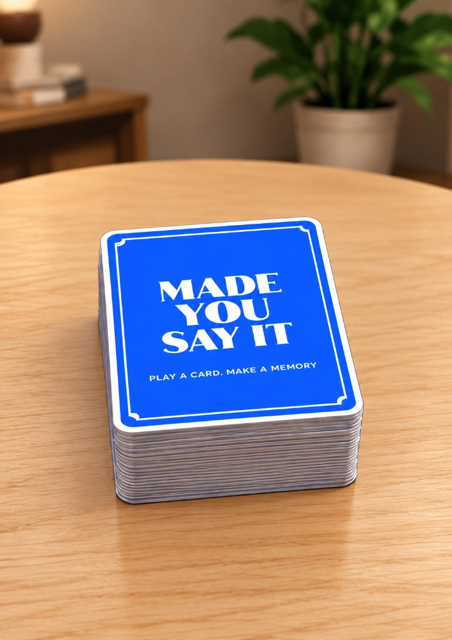  2. YOUR TURN (THE 6-STEP CYCLE)  DRAW → CHOOSE → PLAY/PASS → DO IT → SCORE → NEXT  • Step 1: Draw: Draw 1 card from the Draw Pile.  • Step 2: Choose: Choose 1 card from your hand to play (or pass).  • Step 3: Play or Pass: Read chosen card aloud to play, or discard it to pass.  • Step 4: Do It: Follow the card's action or challenge prompt.  • Step 5: Score: Complete it → earn printed points → place in your Score Pile.  • Step 6: Next: Your turn ends. Play passes clockwise to the next player.  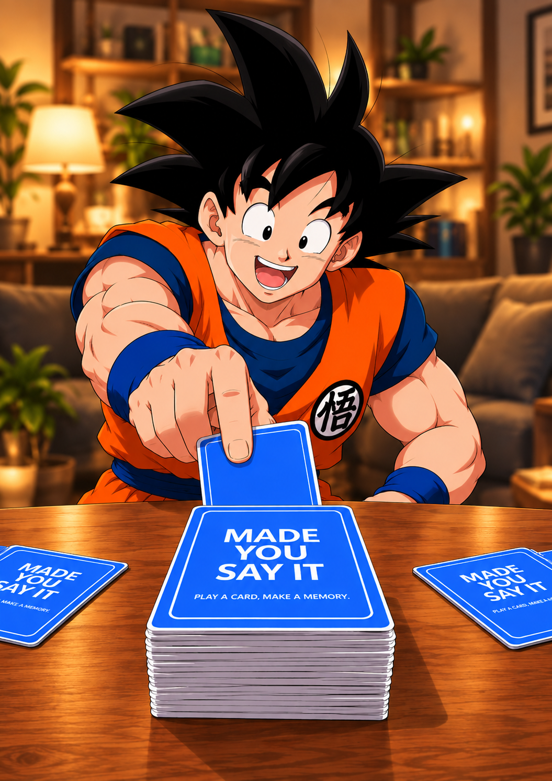  5. PASS OR FAIL (ZERO PRESSURE)  • PASS: Don't want to do the card? Discard it, score 0 points, and end your turn.  • FAIL: Attempted but could not complete? Discard it and score 0 points.  💡 Golden Reminder: You can always pass without penalty. |  | 3 & 4. CARD TYPES & SCORING  The large number on each card shows its point value (1, 2, or 3 points).  • SOLO ACTIONS (Chaos, Create, Love, Connect): Follow instructions. Complete it → earn printed points → place in your personal Score Pile.  • GUESS (Group Play): Everyone guesses! The player who played the card scores the points. The fun is everyone's crazy guesses.  • BATTLE (1-on-1 Showdown): Challenge an opponent. Other players vote winner. Winner takes card into Score Pile (ties discard). Rotate opponents!  6. THE TABLE LAYOUT & PILES  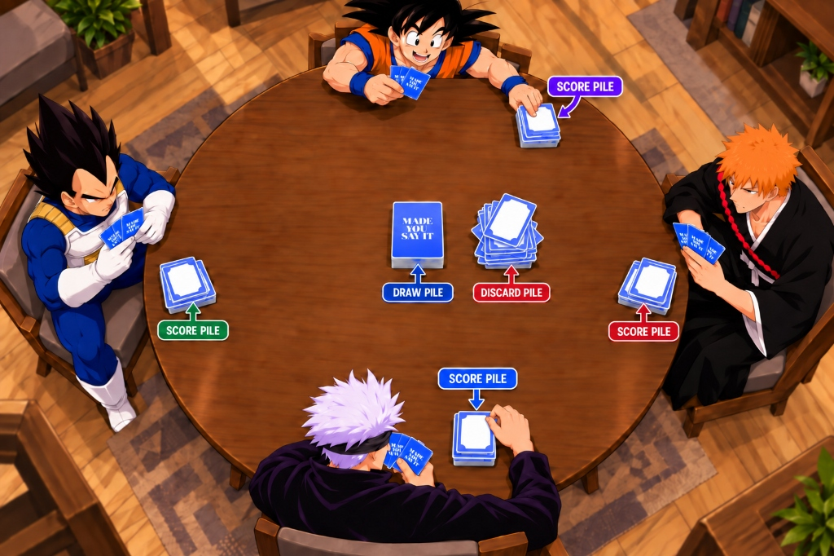  • Draw Pile (Center): Face-down cards waiting to be drawn during turns.  • Score Pile (Your Area): Cards you earned! Their printed points count toward your score.  • Discard Pile (Center): Face-up pile for passed, failed, or tied cards.  7. END OF GAME & WINNING  • Trigger: When the Draw Pile is empty, play or pass 1 card each turn until everyone has no cards left.  • Scoring: Count the points in your Score Pile. The player with the most points wins!  • Lowest Score: The player with the lowest score gets 1 question from each other player. They can answer or pass. Follow the Golden Rule!
  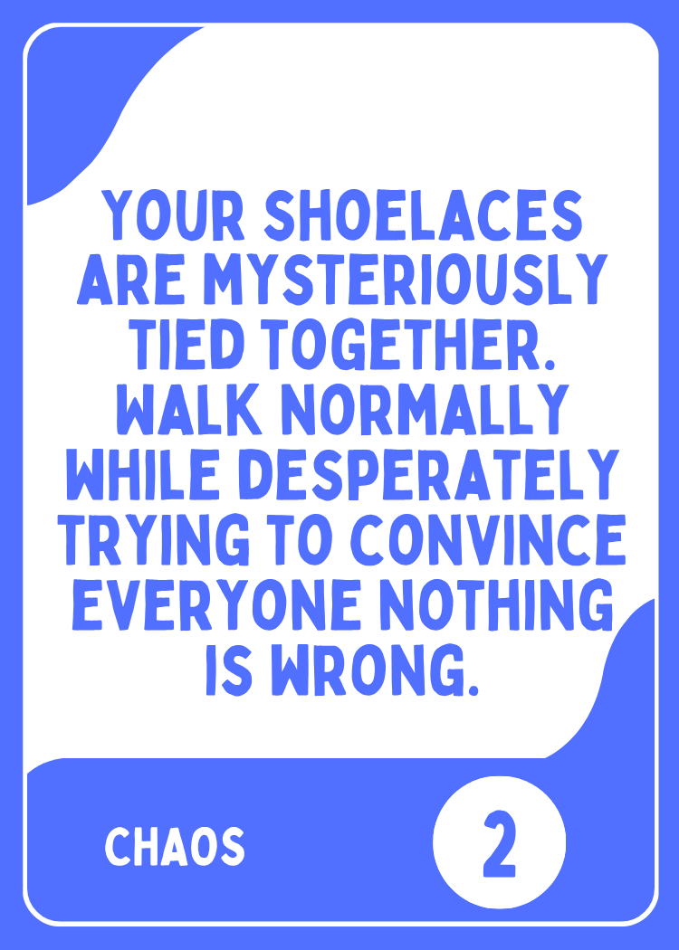  ACTION | 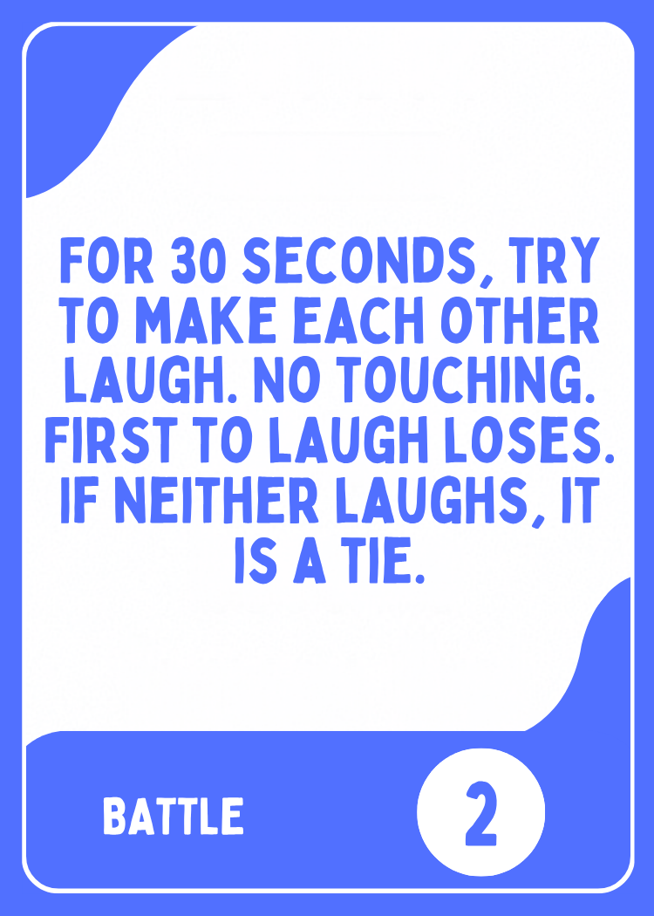  BATTLE |   GUESS
  ★ 8. THE GOLDEN RULE
  The goal is not to win, it’s to have fun and make good memories. You can always pass. Never pressure anyone to reveal a real crush, private information, touch another person, or do anything dangerous, sexual, humiliating, or genuinely uncomfortable.
MADE YOU SAY IT © 2026 • PLAY A CARD. MAKE A MEMORY. • OFFICIAL SINGLE-PAGE PRINTABLE INSERT

