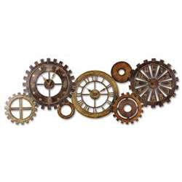***From the work of Bronwyn Herndon***

***Rodpbur***

***Game Concept Document***

1.0 Recent Changes 3

2.0 Game Analysis 4

2.1 Game Concept 4

2.2 Key Features 4

2.3 Competitive Analysis 4

3.0 Game Design Elements 4

3.1 Gameplay Style 4

3.2 Camera 4

3.3 Core Controls 4

4.0 Sound 5

4.1 Overview 5

4.2 Considerations 5

# Recent Changes

|  |  |  |
| --- | --- | --- |
| **Date** | **Change Made** | **Team Member** |
| 4/15/2015 | * Section 2- Game Concept added * Section 3 – Design Elements added * Section 4 – Sound added | Bronwyn |
|  |  |  |
|  |  |  |
|  |  |  |
|  |  |  |
|  |  |  |

# Game Analysis

## Game Concept

Rodpbur is going to be an endless runner. You will dodge obstacles and collect items.

## Key Features

### Player dodges obstacles and collects coins

## Competitive Analysis

### Temple Run

### Temple Run II

# Game Design Elements

## Gameplay Style

### Run and dodge

Run forever, collect coins and dodge blocks.

### Collect items for health

There will be several items generated around the scene for the player to collect that will heal or give power ups.

### A certain Number of points may unlock a new level

Coins will give points

## Camera

### Camera and player are stationary, the ground moves

## Core Controls

A and D will be used to move left and right. Space to jump.

# Sound

## Overview

The sound in this game will be from the internet. It will be a surprise.

## Considerations

### Genre – Endless Runner

I will add different background music for the different levels, there will be a sound effect for collecting coins and hitting obstacles.