Essential Features

Revenue generation

* Will keep track of trade volume and will charge their account balance at a set fee based on the volume

Users

* Separated into trade groups with a leader being the owner of the paxful account and employees which have the option to give different permissions
* Admin for myself to monitor all activities

Trade Features

* Ability to receive incoming trades to send and receive messages
* Ability to send and receive images
* Ability to release funds in a trade
* Ability to dispute a trade
* Ability to automatically leave feedback for users after a trade
* Ability to mark trades for review or as scams and have them moved to the bottom of the page to make sure they dont get in the way of the legit trades
* Ability to see all applicable user data and trade data such as the username, reputation, offer type, offer amount, etc. There is a lot of data that related to users that will need to be organized so the traders can vet users and have info about the specific transaction in an easy concise way
  + 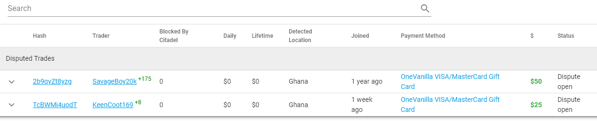
  + Here is an example

Offer Related Features

* Ability to adjust offer rates
* Ability to turn on and off the offer
* Ability to exclude and include the offer on the program (incase they don't want certain offers to show on the software)

Secondary Features

Accounting

* Track trade data such as
  + Amount traded
  + Amount spent
  + Amount canceled
  + Amount disputed
* Option to organize data by offer type allowing users to see trade stats per offer
* Allow user to see all their trades and enter data on how the money was spent
  + For example, in a trade for a $50 onevanilla gift card they will be able to enter the place they used the card and the expected return on it so that accurate profit and loss data can be tracked.
  + I want the data to be easily referable and tracked so the best way may be to allow them to create variables for the different places they spend. For example if they process using walmart, paypal, stripe, and Saber they can create custom things to select so they can keep track and easily be able to see where they are spending their money.
* The main goal of the accounting is to allow users to do as little work as possible to get accurate profit loss data daily and be able to interact with all the different data points with ease.

Inventory Feature

* Allows users to submit data on the inventory they are holding with various data points such as the item info, projected value, status ( sold, for sale, loss, fraud),
* Can easily interact and sort the inventory
* Will be used primarily to store gift card data so will be more to accommodate that with info like gift card number, pin, brand, amount but also to support physical product orders for dropshipping purposes.

Would be nice

* Ability to create automated trade messages at the start and end of the trade and apply them to specific offers
* Ability to create pre written chats that are selectable by those conducting trades to quickly send tedious messages
* Ability to sort offers by the various data points accessible by the paxful api such as trade status, offer type, offer amount, and user data to allow for more organization when dealing with a large number of trades
* Ability to track specific user activity when doing important things like releasing funds or editing offers

I want the program features to be very segmented so that it's easy to customize things exactly for the users' needs. It would be best i show you exactly what I mean on a call.