
SkyNode
SonarQube Code Quality Report
Static analysis, remediation timeline, and final quality result

Report date: June 4, 2026
Table of Contents

Document Information 3
1. Introduction 3
2. Analysis Environment 3
SonarQube configuration 4
Quality gate strategy 4
3. Initial Analysis 5
Initial overview metrics 5
Initial issue distribution 5
4. Quality Gate Creation 6
Quality gate conditions 6
5. High-Severity Issue Remediation 7
Main files refactored 7
Result after high issue fixes 8
6. Security Hotspot Review 9
Security hotspot distribution 9
DoS hotspot root cause 10
Weak cryptography root cause 11
7. Security Hotspot Remediation 11
DoS remediation examples 11
Weak cryptography remediation 12
8. Final Analysis Result 12
Final overview metrics 12
New code status 13
9. Testing and Build Verification 13
Verification commands 14
Verification result 14
10. Conclusion 14

Document Information

Field | Value
Project | SkyNode travel planning application
Report type | Static code analysis and remediation report
Tool | SonarQube Community Build
Analysis mode | Local Docker-based SonarQube analysis
Project key | skynode
Main source directory | src
Test directory | tests
Report date | June 4, 2026

1. Introduction

This report documents the static code analysis process performed on the SkyNode application using SonarQube. SkyNode is a full-stack travel planning platform that includes a React/Vite frontend, a Node/Express backend, database repositories, third-party API integrations, itinerary generation, flight search, travel missions, and trip collaboration features.

The purpose of this analysis was to evaluate the project from the perspective of maintainability, reliability, security, duplication, and new-code quality. The report follows the analysis timeline shown in the SonarQube screenshots: initial analysis, issue triage, quality gate configuration, high-severity issue remediation, security hotspot remediation, and final overview.

SonarQube was used as a local quality assurance tool to measure and improve the quality of the SkyNode codebase. The analysis helped identify maintainability issues, reliability risks, duplication, and security hotspots, and it provided a structured way to verify that the codebase improved after remediation. Automated tests and production builds remain the main deployment gates, while SonarQube documents the static quality review performed on the project.

2. Analysis Environment

SonarQube was executed locally using Docker. The project configuration is stored in sonar-project.properties, and the SonarQube server is defined in docker-compose.sonar.yml.

SonarQube configuration

Configuration item | Value
SonarQube runtime | Docker container
Project name | SkyNode
Project key | skynode
Source analysis | src
Test analysis | tests
Excluded folders | dist, node_modules, coverage, docs, assets, debug
Quality gate | SkyNode Quality Gate

Quality gate strategy

A custom quality gate named SkyNode Quality Gate was created to match the current maturity of the project. The goal was to keep the project professional and strict on new code without blocking deployment because of unavailable coverage reporting.

The custom quality gate focused on:

• zero new issues;
• all new security hotspots reviewed;
• duplicated lines on new code not greater than 3.0%.

Coverage was intentionally not used as a blocking condition at this stage because SonarQube showed 0.0% coverage due to missing LCOV coverage import, even though the project has automated unit, integration, and database tests. Coverage can be added later after the test runner exports a coverage report.

3. Initial Analysis

The first SonarQube analysis provided a baseline view of the overall project quality. The project had approximately 22k lines of code and the Quality Gate was passing on the overall view, but the issue list showed a significant amount of technical debt.

Initial overview metrics

Metric | Initial result
Total issues | 420
High severity issues | 32
Security open issues | 1
Reliability open issues | 40
Maintainability open issues | 380
Security hotspots | 19
Security hotspot rating | E
Coverage | 0.0%
Duplications | 2.4%
Lines of code | Approximately 22k

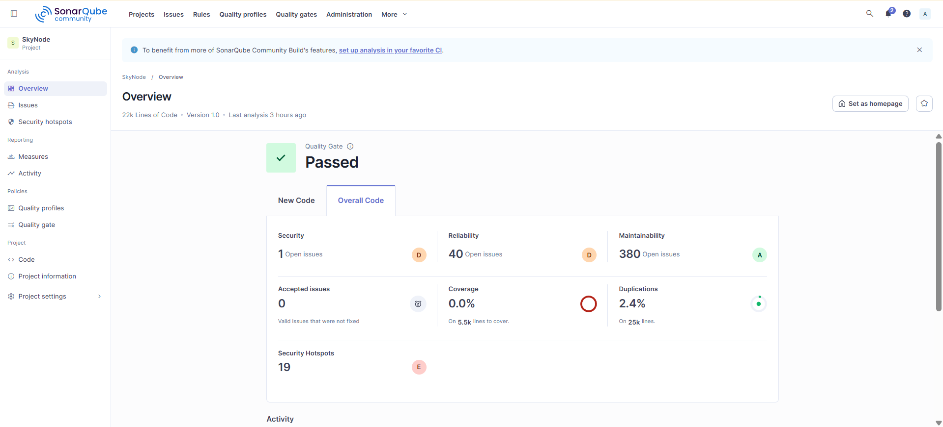

Initial issue distribution

The issue page showed 420 total issues. Out of these, 32 issues were classified as high severity. Most high issues were related to maintainability and adaptability, especially excessive cognitive complexity and deeply nested functions.

The most important high-severity categories were:

• React components with high cognitive complexity;
• deeply nested functions inside UI mapping and rendering logic;
• backend helper functions with complex branching;
• maintainability issues in shared route, repository, and parsing logic.

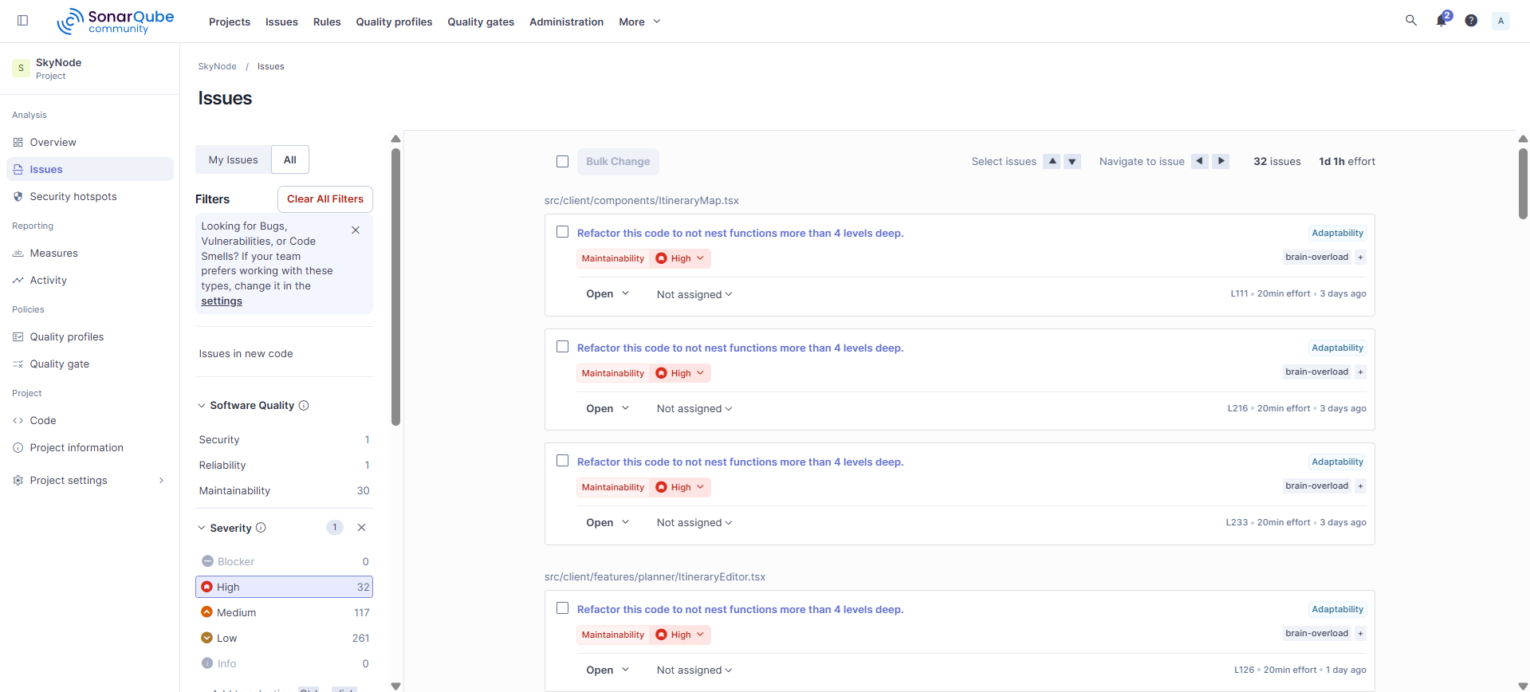

4. Quality Gate Creation

After reviewing the initial results, a custom quality gate was created for the project. The gate was named SkyNode Quality Gate and assigned as the default quality gate.

Quality gate conditions

Condition | Operator | Value
New issues | greater than | 0
New security hotspots reviewed | less than | 100%
New duplicated lines (%) | greater than | 3.0%

This gate is strict enough to prevent new quality degradation while remaining practical for the current state of the project. It avoids using coverage as a deployment blocker until proper coverage reporting is configured.
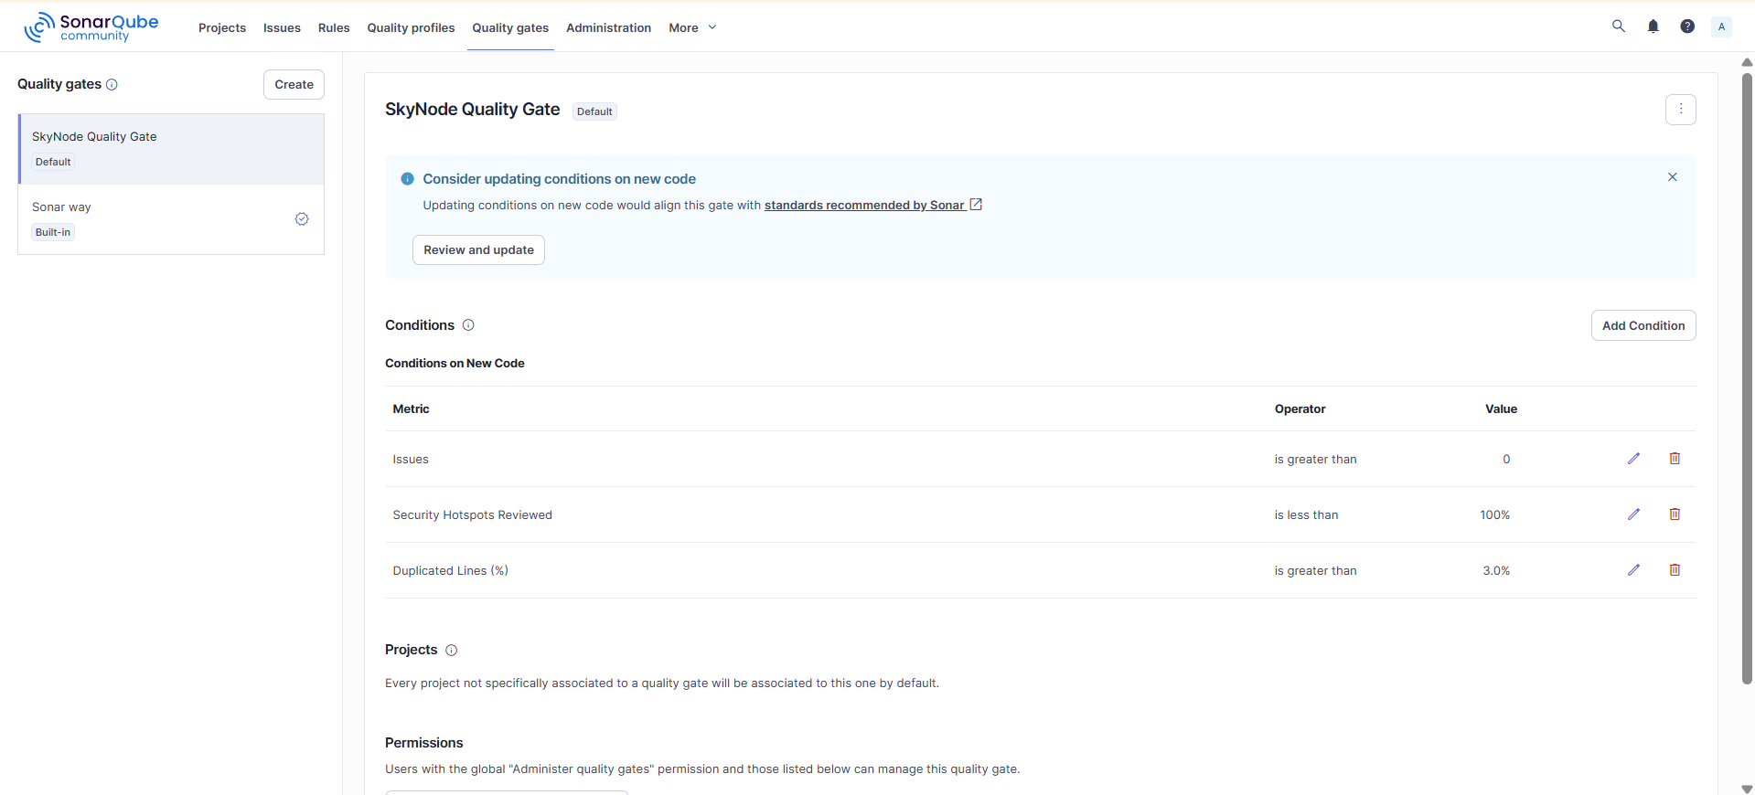

5. High-Severity Issue Remediation

The next remediation phase focused only on high-severity issues. This was the highest-impact step because high issues are the most likely to affect maintainability, future development, and review quality.

Main files refactored

File | Main problem | Remediation approach
src/client/components/ItineraryMap.tsx | Deeply nested map and marker logic | Extracted marker, route, geocoding, and fallback-route helpers
src/client/features/planner/ItineraryEditor.tsx | Large nested editor rendering logic | Extracted day, activity row, city selector, icon picker, and field components
src/client/features/planner/ItineraryTimeline.tsx | Complex timeline rendering | Extracted day, activity, metadata, and icon selection helpers
src/client/features/planner/PlannerHero.tsx | Complex conditional action rendering | Extracted action buttons, tabs, visibility controls, and save/delete actions
src/client/features/planner/TripSetupForm.tsx | Nested ternary and wizard step logic | Extracted step status, step completion, and step button logic
src/client/pages/AuthPage.tsx | Complex signup/signin flow | Extracted validation and submission helpers
src/client/pages/PlannerPage.tsx | Nested itinerary editing operations | Extracted pure day/activity manipulation helpers
src/client/pages/SearchResultsPage.tsx | High cognitive complexity and nested callbacks | Extracted initial state parsing, flight grouping, filtering, sorting, and card rendering
src/client/pages/TripDetailPage.tsx | High cognitive complexity | Extracted hero actions, tabs, overview, itinerary, members, chat, settings, and delete modal components
src/server/modules/geocoding/geocodingRoute.ts | Complex route geocoding logic | Extracted geocode point resolution and boundary validation helpers
src/server/modules/trips/tripSocialRepository.ts | Complex notification/member update logic | Extracted member status notification helpers
src/scrapingbee.ts | Debug output path warning | Restricted debug output to project-local debug path and disabled it for Vercel
src/server/infrastructure/database/schema.ts | Sorting issue | Replaced default sort with deterministic localeCompare ordering

Result after high issue fixes

After the high-severity remediation, SonarQube no longer showed high-severity issues in the filtered issue list.

Metric | Result after high issue remediation
Total issues | 321
High severity issues | 0
Medium issues | 100
Low issues | 236
Reliability issues | 37
Maintainability issues | 310
Quality gate | Passed

The remaining issues were mostly lower-severity maintainability recommendations, such as browser global usage, small JSX readability warnings, and non-critical refactoring suggestions.
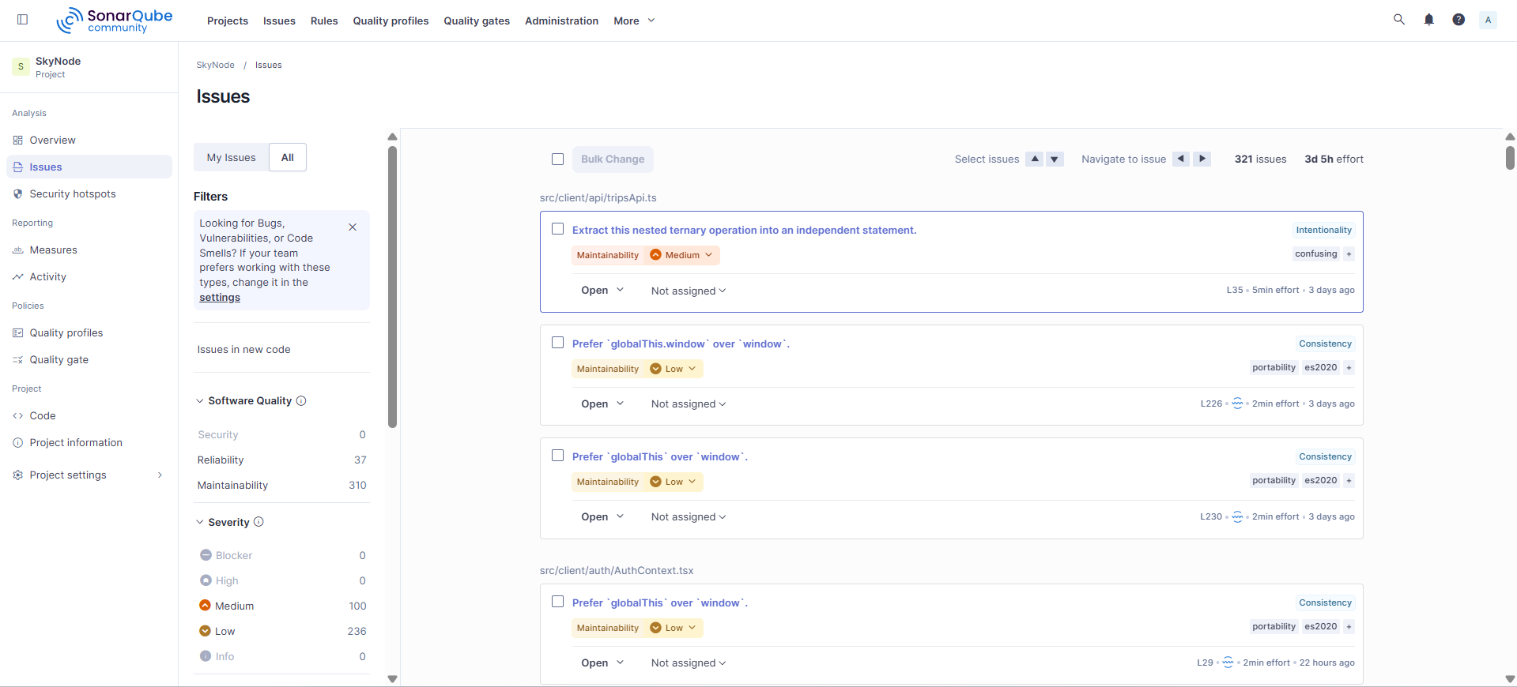

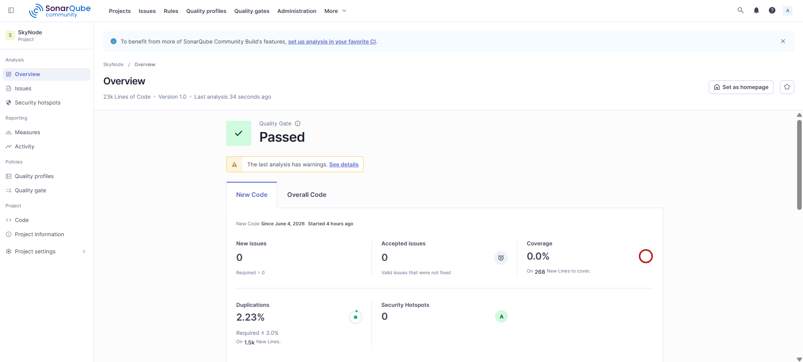

6. Security Hotspot Review

After high-severity issues were resolved, the next priority was security hotspots. SonarQube reported 19 security hotspots, producing a security hotspot grade of E.

Security hotspot distribution

Hotspot category | Count
Denial of Service (DoS) risk from regular expressions | 17
Weak cryptography / pseudorandom generator usage | 2
Total hotspots | 19

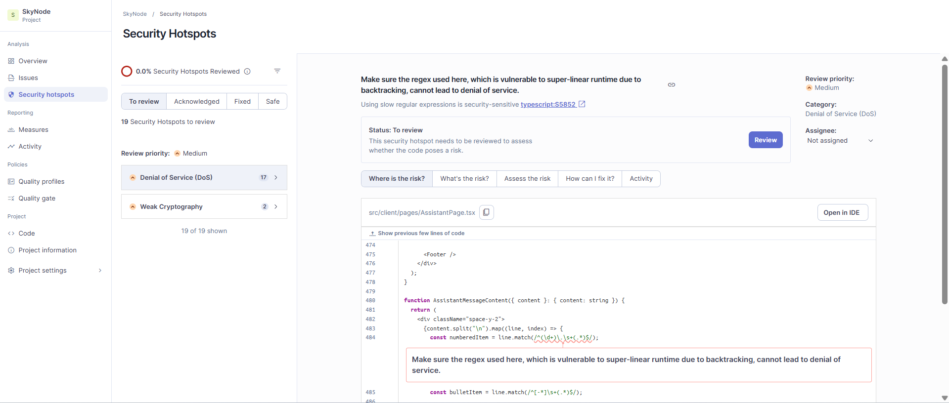

DoS hotspot root cause

Most DoS hotspots came from regular expressions that SonarQube considered vulnerable to super-linear runtime due to backtracking. The flagged code was mostly used for:

• parsing assistant message lines;
• formatting flight clock times;
• parsing Kayak HTML extraction results;
• extracting JSON blocks from LLM responses;
• parsing Authorization headers;
• parsing durations, stops, and airport labels.

Although many of these expressions were used on short strings, the review treated the hotspots seriously and replaced them with deterministic linear parsing where possible.

Weak cryptography root cause

Two hotspots were related to Math.random() usage:

• generating temporary client notification IDs;
• shuffling assistant quick prompts.

These were not used for authentication or cryptographic secrets, but they were still changed to stronger browser crypto APIs to satisfy the security review.

7. Security Hotspot Remediation

The security remediation focused on eliminating the hotspot sources rather than only marking them as safe.

DoS remediation examples

File | Previous risk | Remediation
src/client/pages/AssistantPage.tsx | Regex parsing numbered and bullet lines | Replaced with indexOf, slice, startsWith, and character checks
src/client/pages/SearchResultsPage.tsx | Regex removing AM/PM suffix | Replaced with suffix-based string parsing
src/extract.ts | Regex parsing Kayak layovers, stations, and time ranges | Replaced with explicit string helpers such as parseLayoverCity, parseTrailingAirportCode, and splitTimeRange
src/server/infrastructure/llm/ollamaClient.ts | Regex extracting JSON block | Replaced with indexOf and lastIndexOf block extraction
src/server/middleware/authMiddleware.ts | Regex parsing bearer token | Replaced with indexOf, slice, and scheme comparison
src/server/modules/chat/chatService.ts | Regex extracting JSON object | Replaced with linear object block extraction
src/server/modules/travel-missions/huggingFaceMissionValidator.ts | Regex extracting JSON object | Replaced with linear object block extraction
src/shared/flightParsing.ts | Regex parsing clock, duration, and stops | Replaced with manual token scanning and character validation

Weak cryptography remediation

File | Previous implementation | Remediation
src/client/components/GlobalTripNotifications.tsx | Math.random() for notification IDs | Replaced with crypto.randomUUID()
src/client/pages/AssistantPage.tsx | Math.random() prompt shuffle | Replaced with crypto.getRandomValues() Fisher-Yates shuffle

8. Final Analysis Result

After resolving high-severity issues and all security hotspots, the final SonarQube overview showed the project in a significantly improved state.

Final overview metrics

Metric | Final result
Security open issues | 0
Security rating | A
Reliability open issues | 37
Reliability rating | C
Maintainability open issues | 296
Maintainability rating | A
Security hotspots | 0
Security hotspot rating | A
Accepted issues | 0
Coverage | 0.0%
Duplications | 2.2%
Lines of code | Approximately 23k
Quality gate | Passed

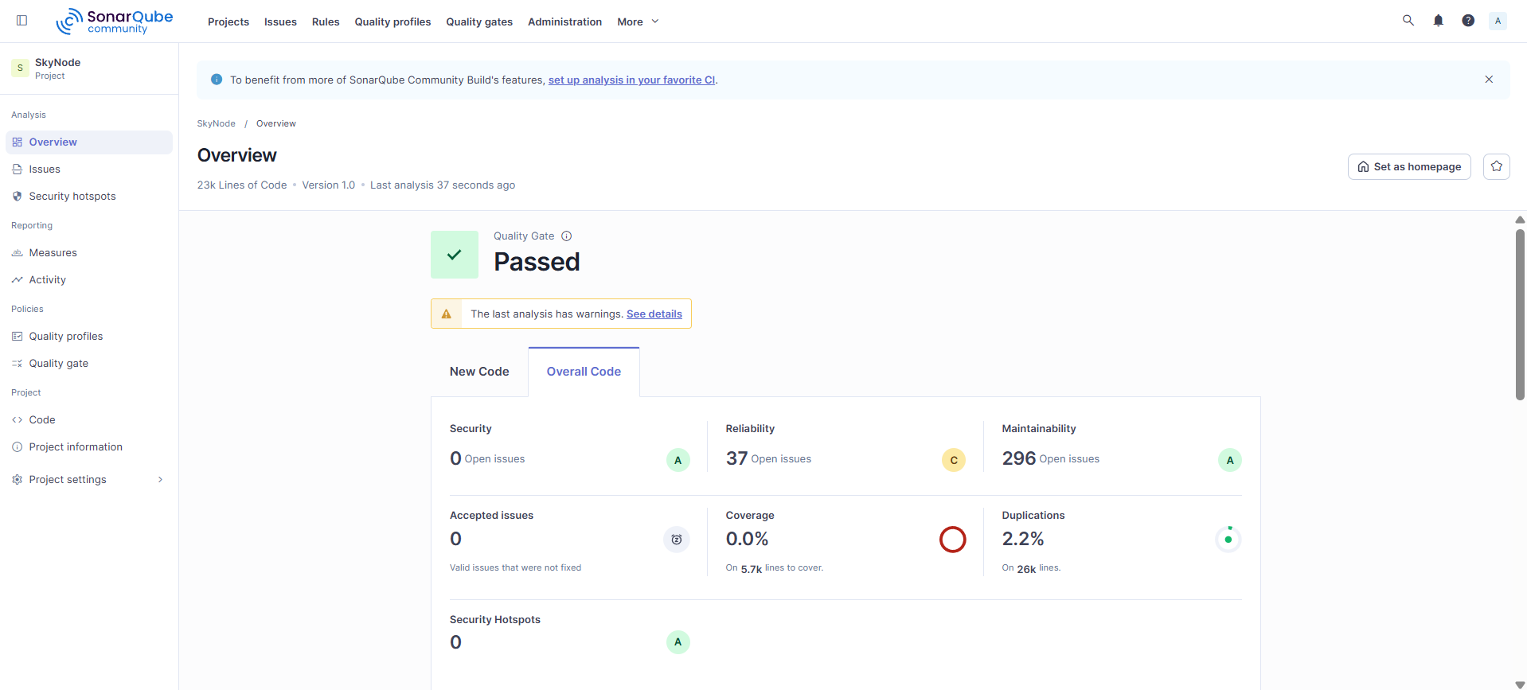

New code status

New-code metric | Final result
New issues | 0
Security hotspots | 0
Duplicated lines | 2.23%
Coverage | 0.0%
Quality gate | Passed

The final analysis still shows 0.0% coverage because SonarQube has not yet been connected to an LCOV coverage report. This does not mean that tests are missing. The project includes automated unit tests, route integration tests, and database integration tests, but coverage export/import is planned as a later improvement.

9. Testing and Build Verification

After the remediation work, the project was verified using the existing automated test suite and production build.

Verification commands

npm test
npm run build

Verification result

Verification step | Result
Unit tests | Passed
Route integration tests | Passed
Database integration tests | Passed
Full test suite | Passed, 31/31 tests
Production build | Passed

The production build still reports a Vite chunk-size warning. This warning is not a build failure and does not affect the SonarQube quality gate. It can be addressed later through code splitting or manual chunk configuration.

10. Conclusion

The SonarQube analysis improved the SkyNode codebase by identifying high-priority maintainability issues and security hotspots before deployment automation. The remediation process reduced high-severity issues to zero, removed all 19 security hotspots, improved the security hotspot rating from E to A, and kept new-code quality at zero issues.

