

SkyNode
Technical Documentation Chapter
Bachelor-Project Web Application

Application name | SkyNode
Document type | Technical documentation chapter
Technology stack | React, TypeScript, Vite, Express, Node.js, Supabase, PostgreSQL, Gemini/Ollama, Travelpayouts, Geoapify, OpenRouteService, Vercel
Purpose | Explain the technical architecture and implementation structure of the system

Table of Contents
1. Frontend Architecture
2. Backend Architecture
3. Authentication Flow
4. API Route Structure
5. Third-Party Integrations
6. Deployment Architecture
7. Error Handling and Limitations
8. Security Considerations
9. Future Improvements
Summary

Technical Documentation Chapter – SkyNode
SkyNode is an AI-assisted travel planning web application. It allows users to search for flights, explore destinations, view destination maps and travel cards, generate AI-supported itineraries, save trips, invite members, join shared trips, communicate inside trip contexts, and manage their account. The application is implemented as a modern full-stack web system with a React frontend, an Express/Node.js backend, Supabase authentication and PostgreSQL storage, AI integrations, external travel APIs, and Vercel-based deployment.
The purpose of this chapter is to describe the technical structure of SkyNode in a way that is suitable for a bachelor-project report. The chapter explains the frontend and backend architecture, authentication flow, API route organization, third-party integrations, deployment structure, error handling, security considerations, and possible future improvements.
Figure 1 shows the high-level technical architecture of the SkyNode system.
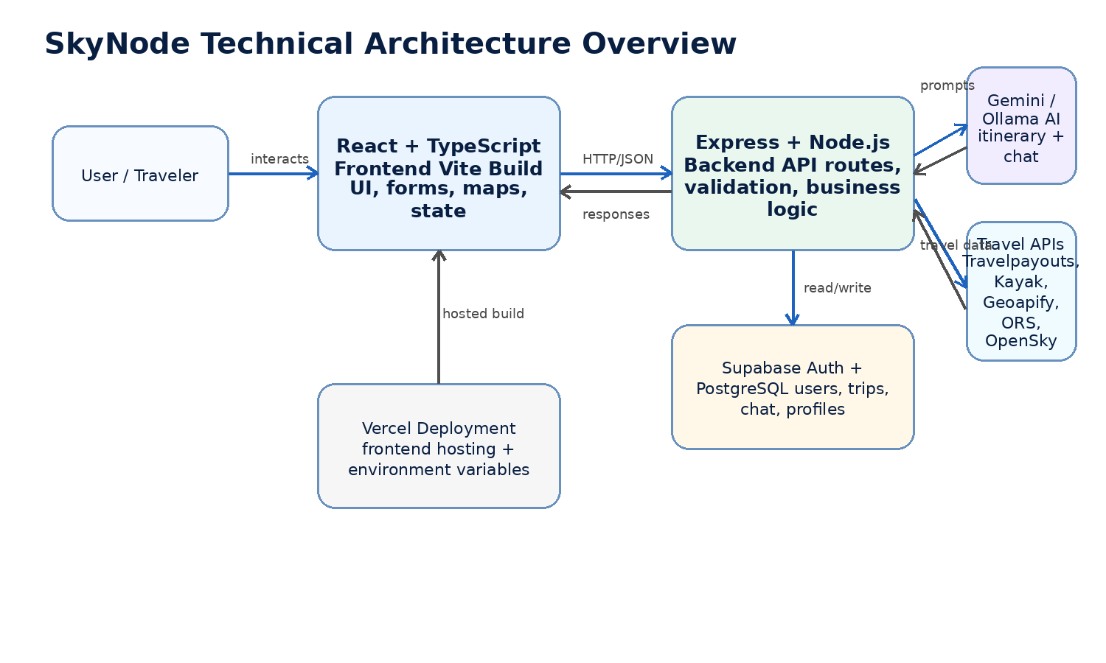
Figure 1: SkyNode technical architecture overview

1. Frontend Architecture
The frontend of SkyNode is implemented with React, TypeScript, and Vite. React is used to build the user interface as a collection of reusable components. TypeScript improves code reliability by adding static typing, while Vite provides a fast development server and optimized production builds.
The frontend is responsible for all user-facing interaction. It displays pages for flight search, destination exploration, trip planning, saved trips, community trips, the AI assistant, authentication, and account management. Since the application behaves as a single-page application, page transitions and user interactions can happen dynamically without a full browser reload.
- Display the landing page, navigation, and main application layout.
- Collect user input through forms, such as flight search fields, trip preferences, and chat messages.
- Perform basic frontend validation before requests are sent to the backend.
- Display flight results, fare cards, destination information, maps, itineraries, and saved trips.
- Maintain authentication state and show different interface options for guest and logged-in users.
- Send HTTP requests to the backend API and Supabase authentication services.
- Handle loading states, success messages, and user-facing error messages.
A typical frontend structure contains pages, reusable UI components, API helper functions, context or state management utilities, and type definitions. This separation makes the frontend easier to maintain because visual components, data-fetching logic, and type definitions are not mixed into one large file.

2. Backend Architecture
The backend of SkyNode is implemented with Express and Node.js. It acts as the central server-side layer between the frontend, database, authentication provider, AI services, and external travel APIs. The backend receives requests from the frontend, validates them, applies business logic, communicates with external services, and returns structured JSON responses.
A key reason for using a backend layer is that private API keys and sensitive logic should not be placed directly in frontend code. The backend can safely store environment variables, control external API requests, normalize data from different providers, and prevent the frontend from becoming tightly coupled to third-party APIs.
- Receive and process API requests from the React frontend.
- Validate request bodies, route parameters, query parameters, and authenticated sessions.
- Communicate with Supabase PostgreSQL for persistent application data.
- Generate AI responses or itineraries through Gemini or Ollama.
- Retrieve flight, attraction, route, and live aircraft data from external services.
- Convert third-party API responses into simplified response objects for the frontend.
- Return appropriate status codes and error messages when requests fail.
The backend can be organized into route modules, controller functions, service modules, validation utilities, and configuration files. Route modules define endpoint paths, controller functions handle request and response logic, and service modules isolate external API communication.

3. Authentication Flow
SkyNode uses Supabase Auth for account registration, email confirmation, login, logout, and session management. This allows the application to avoid implementing authentication from scratch while still supporting secure account-based functionality.
- The user opens the SkyNode application and chooses to register.
- The frontend sends the registration details to Supabase Auth.
- Supabase Auth creates the user account and sends a confirmation email.
- The user confirms the email address through the confirmation link.
- The user signs in using valid credentials.
- Supabase returns an authenticated session to the frontend.
- The frontend uses the active session when accessing protected features.
- The backend or Supabase checks whether the session is valid before processing protected actions.
- When the user signs out, the session is removed and protected functionality becomes unavailable.
Protected features include saving trips, viewing saved trips, inviting trip members, joining shared trips, chatting inside trip contexts, updating the profile, and deleting the account. If a user is not authenticated, the interface should either redirect the user to the sign-in page or display a clear message explaining that login is required.

4. API Route Structure
The API routes are organized according to the main functional areas of the application. The exact names can vary depending on final implementation, but the following structure represents a suitable route organization for SkyNode.
Route group | Example endpoints | Responsibility
Flight routes | POST /api/flights/search  GET /api/flights/live | Search flights, retrieve fare data, and optionally retrieve live aircraft information.
Destination routes | GET /api/destinations  GET /api/attractions  GET /api/routes | Retrieve destination details, attractions, points of interest, and route information.
Trip routes | POST /api/trips  GET /api/trips  GET /api/trips/:id  POST /api/trips/:id/invite  POST /api/trips/:id/join | Create, save, retrieve, share, invite, and join trips.
Assistant routes | POST /api/assistant/chat  POST /api/itinerary/generate | Generate AI chat responses and day-by-day travel itineraries.
Account routes | GET /api/profile  PATCH /api/profile  DELETE /api/account | Retrieve profile data, update user profile information, and process account deletion.
The backend should return consistent response formats. Successful responses should contain the requested data, while failed responses should contain an error message and an appropriate HTTP status code. This makes frontend error handling simpler and more predictable.

5. Third-Party Integrations
SkyNode depends on third-party integrations to provide authentication, persistent storage, AI-generated content, flight information, attractions, route planning, and optional live aircraft data. These services are accessed directly by the backend or, in the case of Supabase Auth, also by the frontend authentication client.
Service | Used for | Notes
Supabase Auth | Registration, email confirmation, login, logout, and session management. | Handles user identity and reduces custom authentication complexity.
Supabase PostgreSQL | Profiles, trips, itineraries, invitations, memberships, and chat messages. | Persistent relational database for application data.
Gemini / Ollama | AI assistant responses and itinerary generation. | Gemini can be cloud-hosted; Ollama can support local or self-hosted model execution.
Travelpayouts | Flight offers, fare estimates, and destination-based flight data. | Useful for flight search and affordable destination features.
ScrapingBee / Kayak | Additional flight data source where official API coverage is limited. | Scraped data can be less stable and should be treated carefully.
Geoapify | Attractions, points of interest, and location-based destination data. | Supports destination exploration and itinerary planning.
OpenRouteService | Route calculation, directions, distance, and travel duration. | Useful for planning movement between attractions.
OpenSky Network | Optional live aircraft data. | Live data may be incomplete, delayed, or rate-limited.

6. Deployment Architecture
SkyNode is deployed using Vercel. Vercel hosts the frontend build generated by Vite and provides production environment variable management. Depending on the final project setup, the backend can be deployed as serverless API routes, a separate Node.js service, or another compatible hosting service.
- The React and TypeScript frontend is built by Vite into optimized static files.
- Vercel serves the production frontend to users through a public web URL.
- The frontend communicates with the backend API and Supabase services using production URLs.
- Environment variables are configured separately for development and production.
- Supabase authentication redirect URLs must include the deployed Vercel domain.
- If the Express backend is hosted separately, CORS must allow requests from the Vercel frontend domain.
A clear separation is required between public frontend variables and private backend variables. Variables prefixed with VITE_ are included in the frontend bundle and should only contain values that are safe to expose. Private keys for AI providers, scraping services, or server-side APIs should remain on the backend.
VITE_SUPABASE_URL
VITE_SUPABASE_ANON_KEY
SUPABASE_SERVICE_ROLE_KEY
GEMINI_API_KEY
TRAVELPAYOUTS_API_KEY
SCRAPINGBEE_API_KEY
GEOAPIFY_API_KEY
OPENROUTESERVICE_API_KEY

7. Error Handling and Limitations
SkyNode must handle errors from user input, authentication, external APIs, AI services, database operations, and deployment configuration. The application should avoid failing silently and should provide clear feedback when an operation cannot be completed.
- Missing or invalid flight search fields.
- Failed registration, failed login, or unconfirmed email address.
- Expired or invalid user session.
- External API rate limits or temporary service outages.
- Unavailable flight, attraction, route, or live aircraft data.
- AI response timeout, malformed response, or low-quality generated content.
- Database insert, update, delete, or read failures.
- Incorrect environment variable or deployment configuration.
Important system limitations should be clearly understood. Flight prices may not always be real-time, scraped flight data can break if source websites change, AI-generated itineraries require user review, and third-party APIs may impose rate limits. Therefore, SkyNode should present its results as planning assistance rather than guaranteed booking information.

8. Security Considerations
Security is important because SkyNode handles user accounts, saved trips, trip memberships, chat content, and external API keys. The system should protect user data and prevent private credentials from being exposed.
- Authentication should be handled through Supabase Auth, and protected operations should require a valid session.
- Private API keys must be stored as backend environment variables and must not be committed to the repository.
- Supabase Row Level Security policies should restrict users to their own data or trips they are allowed to access.
- The backend should validate incoming request data before processing or storing it.
- Account deletion should define how related trips, memberships, invitations, and chat messages are handled.
- External API responses should be checked before being forwarded to the frontend.
- AI-generated content should be presented as assistance, not as guaranteed factual or official travel advice.
- Production deployments should use HTTPS and should avoid exposing debug information in error responses.
The most important security boundary is between frontend-safe data and backend-only secrets. Supabase public keys can be used in the frontend when combined with proper database access rules. However, private service keys, AI keys, and scraping API keys should remain server-side only.

9. Future Improvements
Several improvements could be added to SkyNode after the basic bachelor-project implementation. These improvements would increase reliability, collaboration, and user value.
- Add a full booking workflow or integrate with more reliable official flight APIs.
- Improve itinerary personalization based on user travel history and preferences.
- Add real-time collaborative editing for shared trips.
- Add notifications for trip invitations, accepted members, and itinerary changes.
- Add role-based permissions for trip owners, editors, and viewers.
- Improve AI context handling by using saved trip data more effectively.
- Add calendar export for generated itineraries.
- Add map-based day-by-day itinerary visualization.
- Add automated frontend and backend tests.
- Improve mobile responsiveness and accessibility.
- Add multilingual support.
- Add monitoring, structured logging, and better production error tracking.
A particularly important future improvement would be a clearer separation between estimated planning data and verified real-time booking data. This would improve user trust and make the application more reliable for real-world travel planning.

Summary
SkyNode is built as a full-stack AI-assisted travel planning application. The React, TypeScript, and Vite frontend provides the user interface, while the Express and Node.js backend manages business logic, API communication, AI interaction, and data processing. Supabase provides authentication and PostgreSQL storage, while third-party APIs provide flight, location, route, live aircraft, and AI functionality. Vercel is used for deployment and production hosting.
The architecture separates the user interface, backend logic, authentication, database storage, AI processing, and external travel data sources. This separation makes the system easier to document, maintain, test, and extend as a bachelor-project web application.

