
SkyNode
User Manual
AI-assisted travel planning platform

Document type | User manual
Project | Bachelor-project web application
Application | SkyNode
Version | 1.0

Table of Contents
Table of Contents 2
1. Introduction 3
2. Target users 3
3. System requirements 4
4. Account registration and email confirmation 4
Creating an account 4
If the confirmation email does not arrive 4
5. Logging in and signing out 5
Logging in 5
Signing out 5
6. Searching for flights 5
Basic flight search procedure 5
Good search practice 5
7. Exploring destinations 6
Using the destination map and boards 6
8. Using the AI assistant 6
General assistant chat 7
Trip-context assistant chat 7
9. Creating and saving a trip 7
Creating a trip 8
Before saving 8
10. Viewing saved trips 8
Viewing personal trips 8
Using saved trips with the assistant 9
11. Inviting or joining trip members 9
Inviting members to a trip 9
Joining a public or invited trip 9
12. Managing account/profile 10
Common profile actions 10
Account deletion 10
13. Troubleshooting 10
14. FAQ 11

Purpose of this document: This manual explains how an end user can operate the SkyNode application. It is written for project documentation and does not describe internal source-code implementation.

1. Introduction
SkyNode is an AI-assisted travel planning web application designed to help users discover flights, compare affordable destinations, generate itinerary ideas, save trip plans, and collaborate with other travelers. The application combines flight search, destination discovery, interactive maps, saved trips, member invitations, account management, and an AI assistant into one workspace.
The main goal of SkyNode is to reduce the manual work normally required when planning a trip. Instead of using separate tools for route search, destination research, itinerary planning, and group coordination, users can perform these actions in one interface.
Important: SkyNode is a planning and discovery tool. It does not sell tickets or complete bookings. Flight prices and route availability should always be checked with the final airline or booking provider before purchase.

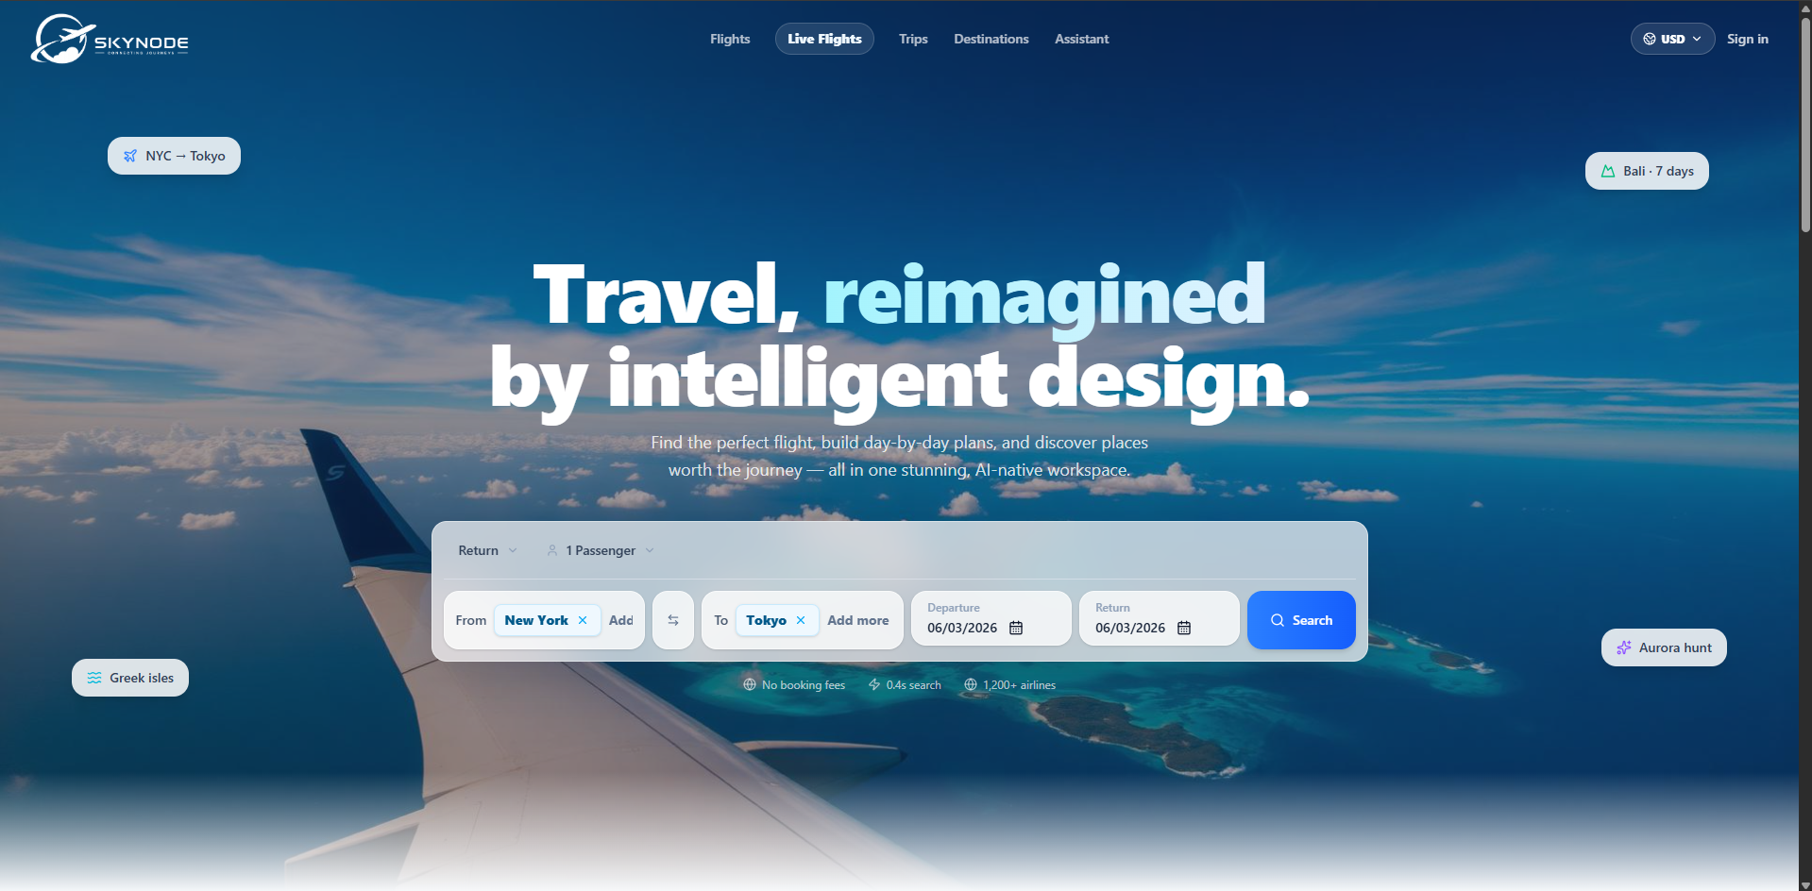
Figure 1: SkyNode landing page and flight search entry point.

2. Target users
SkyNode is intended for users who want a faster and more organized way to plan trips. The platform is suitable for individual travelers, students, small groups, and users who want AI support during the early planning phase.
- Individual travelers who want to compare flight options and destination ideas.
- Students or young travelers searching for affordable trips and short getaways.
- Groups that need to save trips, invite members, and coordinate travel details.
- Users who want destination suggestions, daily plans, attractions, and budget-oriented travel ideas.
- Project evaluators or university staff who need to test the main functions of the SkyNode prototype.
The application is not intended to replace professional travel agents, airline booking systems, visa services, or official travel advisories.

3. System requirements
SkyNode is a web application, so no desktop installation is required for normal users. The user must access it through a supported browser and an active internet connection.
Requirement | Recommended configuration
Device | Laptop or desktop computer recommended. Mobile use may work, but the interface is optimized for larger screens.
Browser | Recent version of Chrome, Edge, Firefox, or Safari.
Internet connection | Required for flight search, maps, AI responses, authentication, and saved-trip features.
Account | Required for saving trips, viewing joined trips, managing profile data, and using member-related features.
Email access | Required for email confirmation and password recovery.
JavaScript | Must be enabled because the frontend is a React-based web interface.

Prototype limitation: Some live data depends on external services. If a provider is slow, unavailable, or rate-limited, SkyNode may show an empty state, a timeout message, or cached-style results.

4. Account registration and email confirmation
Users can browse some parts of SkyNode without an account, but saved trips, joined trips, profile settings, and collaborative features require authentication.

Creating an account
- Open SkyNode in a supported browser.
- Select Sign in from the top navigation bar.
- Choose the option to create a new account or register.
- Enter the required account details, such as email address and password.
- Submit the registration form.
- Check the inbox of the email address used during registration.
- Open the confirmation email and follow the confirmation link.
- Return to SkyNode and sign in with the confirmed account.
Email confirmation: If email confirmation is enabled, the account may not be fully usable until the email address is confirmed. The confirmation link may expire, so users should complete this step soon after registration.

If the confirmation email does not arrive
- Check the spam, junk, promotions, or updates folder.
- Confirm that the email address was typed correctly.
- Wait a few minutes and refresh the inbox.
- Try the registration or resend-confirmation process again if available.
- Use password recovery only after the account has been created successfully.

5. Logging in and signing out
Logging in gives the user access to account-based features such as saved trips, trip membership, profile management, and personalized travel context.

Logging in
- Open the SkyNode application.
- Click Sign in in the navigation bar.
- Enter the registered email address and password, or choose an available OAuth sign-in method if configured.
- Submit the login form.
- Confirm that the navigation bar shows the authenticated user state, such as an avatar or profile menu.

Signing out
- Open the profile or account menu from the navigation bar.
- Select Sign out.
- Confirm that protected sections no longer show saved account data.
Shared devices: Always sign out after using SkyNode on a public or shared computer.

6. Searching for flights
The flight search page is the main entry point for users who already know their departure and destination. The search form allows the user to choose route details, travel dates, passenger count, and trip type.

Basic flight search procedure
- Open the Flights page or use the search form on the landing page.
- Select the trip type, such as return or one-way if available.
- Enter the departure city or airport in the From field.
- Enter the destination city or airport in the To field.
- Select departure and return dates where required.
- Choose the number of passengers.
- Click Search.
- Review the returned flight options, fares, or route cards.
- Open a result to inspect more details, or use it as a starting point for a trip plan.

Good search practice
- Use city names or recognized airport names to improve autocomplete accuracy.
- Avoid impossible date combinations, such as a return date before the departure date.
- Refresh the search if the data looks stale or the provider returns no results.
- Treat shown prices as planning estimates until confirmed by the final booking provider.
Result interpretation: Flight results may come from different provider paths, including cached fare discovery data or live search experiments. This means availability and final prices can change.

7. Exploring destinations
The Destinations page helps users discover affordable routes and browse cities before deciding where to travel. It is useful when the user knows the departure point but has not yet selected a destination.
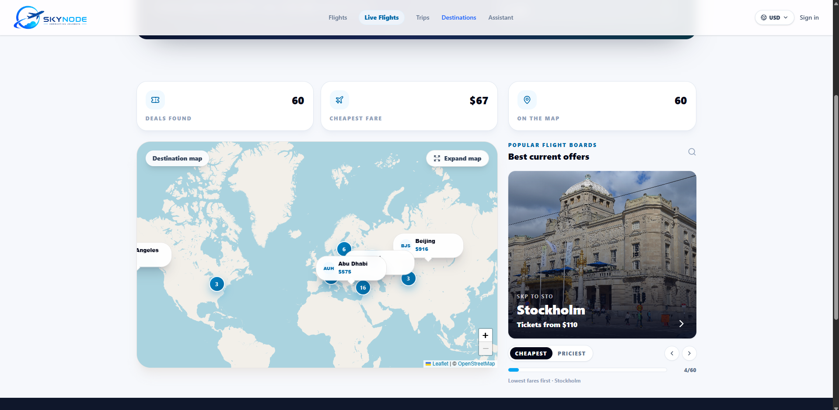
Figure 2: Destination discovery page with map, fare cards, and destination boards.

Using the destination map and boards
- Open Destinations from the main navigation bar.
- Review the summary cards showing available deals, cheapest fare, and map coverage.
- Use the destination map to view route clusters or city markers.
- Open a destination marker or fare card to see route and price information.
- Use the best-offers carousel to browse highlighted destinations.
- Switch between sorting options such as cheapest and priciest where available.
- Start a flight search for a selected destination when ready.
Map behavior: The destination map is designed for exploration. It can display clusters, markers, city labels, and fare cards depending on the current data set and zoom level.

8. Using the AI assistant
The AI assistant supports general travel questions and trip-specific planning. It can help with destination ideas, itinerary structure, budget adjustments, attraction suggestions, food ideas, and explanations of saved trip context.
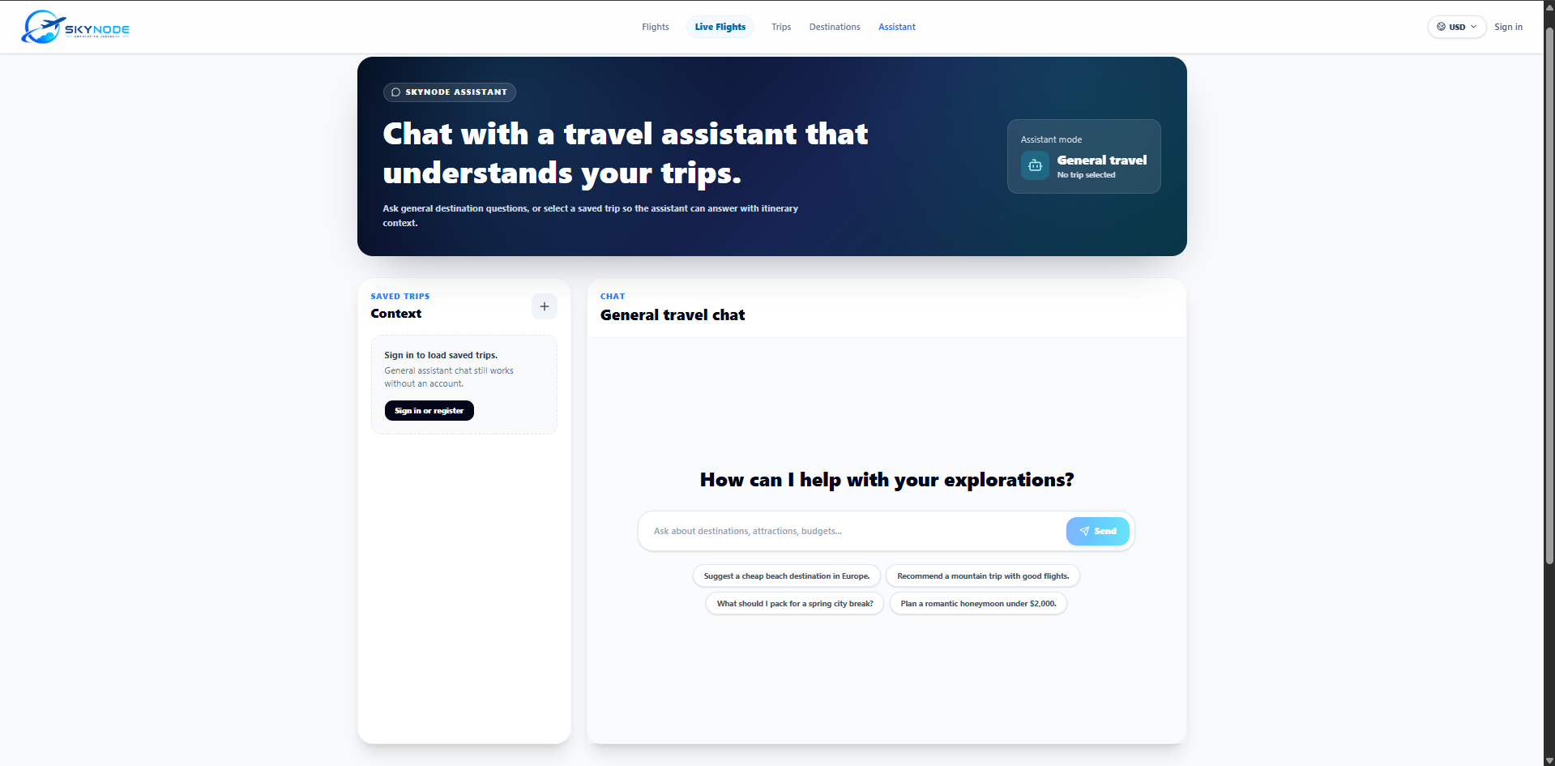
Figure 3: General travel assistant page with saved-trip context panel.

General assistant chat
- Open Assistant from the navigation bar.
- Use the chat input to type a travel question.
- Submit the message.
- Review the assistant response and ask a follow-up question if needed.
- Use suggested prompts only if they match the travel problem being solved.

Trip-context assistant chat
- Sign in to load saved trips.
- Select a saved trip from the context panel if available.
- Ask a question that refers to that trip, such as budget, daily plan, attractions, or schedule.
- Review the response and apply only the parts that fit the real trip constraints.
AI verification: AI-generated plans can be incomplete or inaccurate. Always verify transport times, prices, opening hours, local rules, and safety information before traveling.

9. Creating and saving a trip
The trip planner guides the user through the process of building a structured travel plan. It is organized as a multi-step flow that collects basic details, travel style, logistics, and review information.
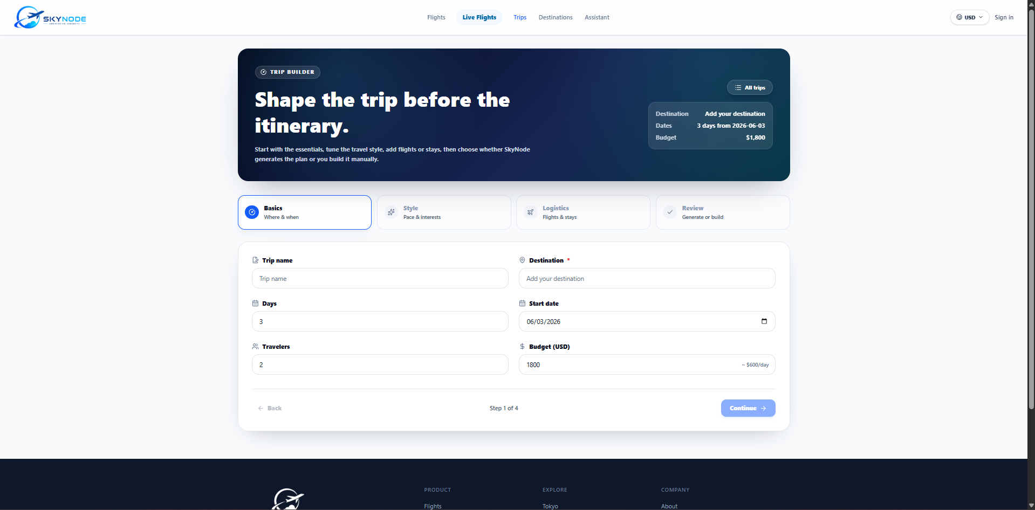
Figure 4: Trip builder form for creating a new itinerary.

Creating a trip
- Open Trips or the trip-planning flow from a flight or destination result.
- Enter a trip name that is easy to recognize later.
- Enter the destination city.
- Choose the number of days.
- Select the start date.
- Enter the number of travelers.
- Enter the expected budget and currency if available.
- Continue to the style step and select preferences such as pace and interests.
- Continue to logistics and add flight or stay details where available.
- Review the generated or manually created plan.
- Save the trip.

Before saving
- Check that the destination name is correct.
- Confirm that the start date and number of days match the intended travel period.
- Use realistic budget values, especially for group trips.
- Review each day of an AI-generated itinerary before treating it as final.
- Decide whether the trip should remain private or be shared publicly if visibility options are available.

10. Viewing saved trips
Saved trips are available from the Trips area after the user signs in. This section allows users to continue planning, review existing itineraries, and access collaborative trip context.

Viewing personal trips
- Sign in to SkyNode.
- Open Trips from the navigation bar.
- Open the saved trips list or dashboard.
- Select the trip card that should be reviewed.
- Inspect the itinerary, destination details, budget, member status, and available actions.

Using saved trips with the assistant
- Open the Assistant page.
- Select a saved trip from the context panel.
- Ask a question about the selected trip.
- Use the answer to refine the plan, but verify any external facts separately.
Data availability: If no saved trips are visible, confirm that the user is signed in with the same account that originally saved the trip.

11. Inviting or joining trip members
SkyNode supports collaborative travel planning through saved trips, joined trips, public trip visibility, invite links, member context, and trip chat where configured.
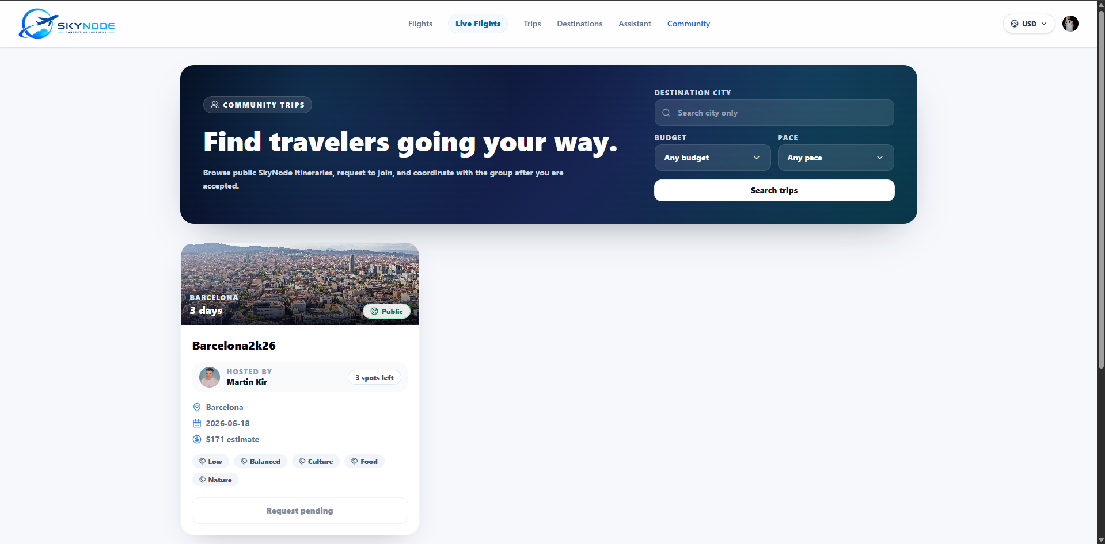
Figure 5: Community trips page for discovering and joining public itineraries.

Inviting members to a trip
- Sign in and open the saved trip that should be shared.
- Open the trip sharing, members, or invite option.
- Create or copy the invite link if available.
- Send the invite link to the intended traveler through an appropriate communication channel.
- Ask the invited user to sign in and open the link.
- Confirm that the member appears in the trip member list after joining.

Joining a public or invited trip
- Open Community or the public trips area if available.
- Search or filter trips by destination, budget, or pace.
- Open the relevant public trip card.
- Select the join or request option.
- Wait for acceptance if the trip requires approval.
- After joining, open the trip from joined trips and use the trip chat or context tools if available.
Privacy: Only share trip links with people who should have access to the trip information. Public trips may expose destination, dates, rough budget, and profile-related details depending on the application configuration.

12. Managing account/profile
The account or profile area allows authenticated users to review and manage profile-related information. Depending on the current build, this may include profile details, travel mission progress, trip statistics, saved trips, and account deletion.

Common profile actions
- View the current signed-in account.
- Update profile display details where editing is available.
- Review saved trips, joined trips, and travel activity statistics.
- Check notifications or unread trip updates where available.
- Use password recovery from the sign-in area if the password is forgotten.
- Request account deletion if the application provides that option.

Account deletion
If account deletion is available, users should treat it as a permanent action. Deleting an account may remove profile information and access to saved data. Before confirming deletion, users should export or copy any important trip information they still need.

13. Troubleshooting
The following table lists common user-facing problems and suggested actions.
Problem | Possible cause | Recommended action
No confirmation email | Email delay, spam filtering, or incorrect address. | Check spam folders, wait a few minutes, confirm the address, and retry registration or resend confirmation if available.
Cannot log in | Incorrect password, unconfirmed email, or session issue. | Confirm the email first, reset the password if needed, and try again in a fresh browser tab.
Flight search returns no results | No available provider data, unsupported route, bad date combination, or external API timeout. | Try different dates, check city spelling, simplify the route, and search again later.
Destination map does not load | Slow map tiles, blocked scripts, poor connection, or provider issue. | Refresh the page, check internet connection, allow JavaScript, and try a supported browser.
AI assistant gives weak or wrong answer | Prompt too vague, missing trip context, or AI limitation. | Provide destination, dates, budget, pace, and constraints. Verify important facts manually.
Saved trips are missing | User is signed out or using another account. | Sign in with the original account and refresh the Trips page.
Invite link does not work | Expired link, wrong account, private trip setting, or permission issue. | Ask the trip owner to generate a new invite link or check membership settings.
Page looks broken | Unsupported browser, browser cache, zoom level, or temporary frontend error. | Refresh, clear cache, reset zoom to 100%, and try another browser.

Reporting issues: When reporting a problem, include the page name, action performed, browser, approximate time, and screenshot if possible. This helps the developer reproduce the issue.

14. FAQ
Does SkyNode book flights?
No. SkyNode helps users search, compare, discover, and plan. Final booking must be completed through the relevant airline or booking provider.
Are shown prices final?
No. Prices are planning estimates and may change depending on provider data, availability, currency, and booking time.
Do I need an account?
An account is recommended and required for saved trips, joined trips, trip collaboration, profile features, and personalized trip context.
Can I use SkyNode without signing in?
Some discovery and general assistant features may be usable without signing in, but account-specific data will not be available.
Can the AI assistant plan the entire trip for me?
It can generate a useful draft, but the user must review and verify the plan. AI output should not be treated as an official travel document.
Can I invite friends to a trip?
Yes, where trip sharing and invite links are enabled. The invited user may need to sign in before joining.
Why does live flight data sometimes not appear?
Live flight data depends on external aircraft telemetry availability and provider response time. In some environments, the app may show an empty state instead of live aircraft.
What should I do before traveling?
Verify flight details, booking conditions, accommodation, local transport, travel documents, opening hours, safety advice, and local regulations through official or provider sources.
Can I delete my account?
If the account page provides account deletion, use it carefully. Deletion may remove profile information and access to saved SkyNode data.

