Above is a sample packet of a SSH connection. As we can see, the connection is made using the SSHv2 Protocol, the latest version of the SSH Protocol. Further more, we are communicating over TCP. Before two host can communicate, there needs to be a key exchange between the client and the server.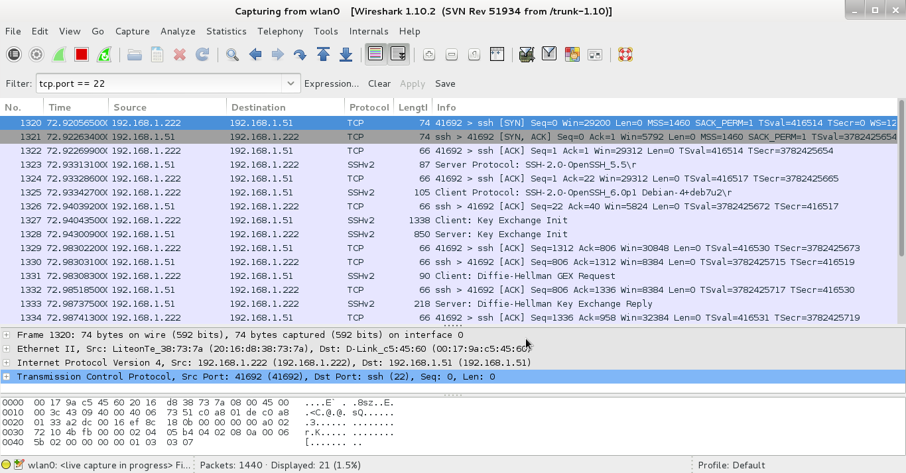

Above is a sample capture of Gentoo's 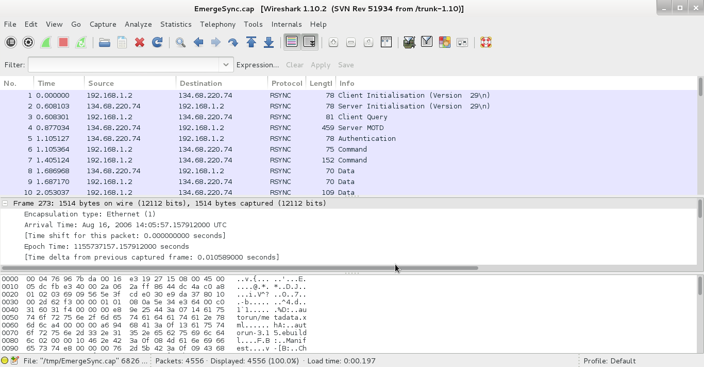*emerge-sync* tool which uses the *rsync* protocol. The transmission is made up of a few main parts: 1) A packet is sent from the client to the server saying “hey! I want to communicate with you”. 2) The authentication between the client and server is performed. 3) The rsync commands are sent. 4) The data that is to be copied is transmitted.

T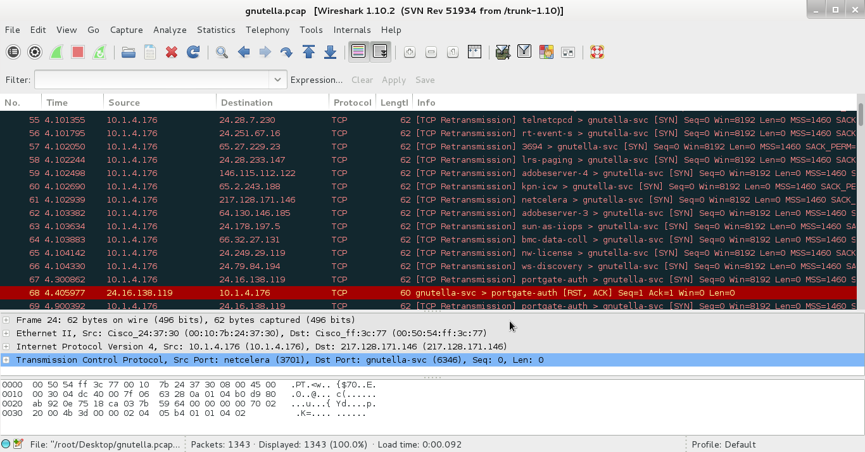he *gnutella* protocol uses the TCP protocol to transmit data. The above capture shows a series of TCP transmission packets between gnutella clients.